Review of the 2.5 GHz spectrum licence technical framework
Technical liaison group paper
MArch 2026

Canberra
Level 3
40 Cameron Avenue
Belconnen ACT
PO Box 78
Belconnen ACT 2616
T +61 2 6219 5555
F +61 2 6219 5353
Melbourne
Level 32
Melbourne Central Tower
360 Elizabeth Street
Melbourne VIC
PO Box 13112
Law Courts
Melbourne VIC 8010
T +61 3 9963 6800
F +61 3 9963 6899
Sydney
Level 5
The Bay Centre
65 Pirrama Road
Pyrmont NSW
PO Box Q500
Queen Victoria Building
NSW 1230
T +61 2 9334 7700
F +61 2 9334 7799
Copyright notice
https://creativecommons.org/licenses/by/4.0/
Except for the Commonwealth Coat of Arms, logos, emblems, images, other third-party material or devices protected by a trademark, this content is made available under the terms of the Creative Commons Attribution 4.0 International (CC BY 4.0) licence.
All other rights are reserved.
The Australian Communications and Media Authority has undertaken reasonable enquiries to identify material owned by third parties and secure permission for its reproduction. Permission may need to be obtained from third parties to re-use their material.
We request attribution as © Commonwealth of Australia (Australian Communications and Media Authority) 2025.

Version control 1
Introduction 2
Outline 3
Scope 3
Timeline 3
Discussion on proposed technical framework 5
2.5 GHz mid band gap spectrum licence technical framework 5
2.5 GHz band spectrum licence technical framework 5
Conditions on the spectrum licence 5
Radiocommunications advisory guidelines 16
Provisions to support wideband amplifiers 18

Version control
Version | Comments
Version 1.0 | Initial release: 10 March 2026
Version 2.0 | Final release: May 2026

Introduction
The Australian Communications and Media Authority (ACMA) develops a technical framework for every band subject to spectrum licensing. Each framework is a collection of technical and regulatory conditions applicable to the use of radiocommunications devices in the spectrum-licensed band. The purpose of the technical framework is to define the technical conditions and constraints under which a device may be deployed and operated within the specified geographic area and frequency band of the licence.
Although the technical framework is optimised for technologies or services most likely to be deployed in the band, it is intended to be technology flexible. This means licensees can operate any type of radiocommunications device for any purpose, provided they comply with the technical framework relevant to the licence.
The paired frequency ranges 2500–2570 MHz and 2620–2690 MHz (the 2.5 GHz band) were designated for the issue of spectrum licences on an Australia wide basis. The most recent modification of the technical framework of the 2.5 GHz band was finalised in 2016. This optimised the use of the band for 4G technologies. Since then, 5G standards and advanced antenna systems (AAS) have been introduced and are now commercially available in the 2.5 GHz band. Therefore, it was considered, in consultation with stakeholders, that a revision to the 2.5 GHz technical framework to account for these developments was warranted.
The frequency range 2570–2620 MHz (the 2.5 GHz mid band gap) was designated for the issue of spectrum licences on an Australia wide basis with the associated technical framework optimised for the purposes of providing Television Outside Broadcast (TOB) services.
We have stated our intention to progressively review the technical framework for all spectrum-licensed bands in the Five-year spectrum outlook 2019–23.
To assist with this work, we formed the 2.5 GHz technical liaison group (TLG) in October 2025. Members of the TLG included 2.5 GHz spectrum licensees, in-band and adjacent-band apparatus licensees, equipment manufacturers and accredited persons.
The TLG is the first step in the process of reviewing or establishing a technical framework. We will consider the outcomes of the TLG when we publicly consult on proposed changes to existing, or new, spectrum licence conditions as well as the relevant instruments that form the 2.5 GHz band technical frameworks. TLG members are able to comment on the technical frameworks both as part of the informal TLG and the subsequent formal public consultation processes.
While we strive to achieve consensus with members, the final decision on the content of, or changes to, a spectrum or apparatus licence technical framework rests with the ACMA. This is particularly relevant in cases where consensus cannot be achieved on an issue, or advice from the TLG is not provided within a reasonable time frame.
The purpose of this paper is to summarise changes to the 2.5 GHz band spectrum licence technical framework proposed by the TLG.

Outline
This paper has been divided into discussion on the relevant instruments that form a spectrum licence technical framework as follows:
- The conditions on spectrum licences, specifically:
- unwanted emission limits
- other conditions on the licence.
- The s.145(4) determination on unacceptable levels of interference, specifically:
- the device boundary criteria (controlling emissions across geographical boundaries)
- deployment constraints.
- The advisory guidelines made under s.262 for:
- managing interference from spectrum licensed transmitters to the following:
  - spectrum licensed receivers, including television outside broadcast (TOB) spectrum services operating in the 2.5 GHz mid band gap
  - fixed point to point links
  - space services
  - class-licensed services
  - radio-astronomy services
  - radiodetermination services
- managing interference to spectrum-licensed receivers.

Scope
This paper is focused on potential modifications to the technical framework for the areas and frequencies subject to spectrum licensing in the 2.5 GHz band to cater for the use of 5G technologies including advanced antenna systems.

Timeline
The proposed timeline for updating the 2.5 GHz spectrum licence technical framework is:
Key steps | Proposed date
TLG process | October 2025 to  February 2026
Public consultation on the draft updates to the following technical framework instruments:  - Draft update to spectrum licences  - Draft update to Radiocommunications Advisory Guidelines (Managing Interference from Spectrum Licensed Transmitters — 2.5 GHz Band) 2023. | Q2 2026
Finalisation of technical framework | Q3 2026
It is noted that:
- The TLG is the first step in the process of developing or updating a technical framework. We will consider the outcomes of the TLG when we publicly consult on the relevant instruments that will form the 2.5 GHz band technical framework. This means TLG members will be able to provide comments on the technical framework both as part of the informal TLG and subsequent formal public consultation processes.
- A TLG is a short-term advisory body convened by the ACMA. Its purpose is to provide advice on the development of, or possible changes to, a spectrum or apparatus licence technical framework. While we strive to achieve consensus with members, the final decision on the content of, or changes to, a spectrum or apparatus licence technical framework rests with the ACMA. This is particularly relevant in cases where consensus cannot be achieved on an issue or advice from the TLG is not provided within a reasonable time frame.

Discussion on proposed technical framework
A technical framework consists of 3 interlocking regulatory elements provided for under the Radiocommunications Act 1992 (the Act):
- The conditions specified on the spectrum licence – in particular, the core conditions that define the spectrum space (both frequency and geographical area) and the level of emissions permitted inside and across the frequency boundaries of the licence (section 66 of the Act).
- A determination of unacceptable interference for the purpose of device registration in each band (section 145 of the Act). This defines permissible levels of emissions across geographical licence boundaries and can also define various deployment constraints.
- Radiocommunications advisory guidelines (RAG) that provide assistance and advice for coordination with stations in other services when and where required (section 262 of the Act). This includes detailing interference management criteria with incumbent apparatus and other spectrum licences.
A more comprehensive explanation of spectrum licence technical frameworks is provided in the document Spectrum licensees – know your obligations.
This section of the paper considers the development of each of these components. This would normally include the standard trading unit and minimum contiguous bandwidth, however, as these will not change, they are not discussed.

2.5 GHz mid band gap spectrum licence technical framework
As TOB services do not use AAS, the ACMA made an initial proposal to the TLG that no necessary changes to this band were required. The ACMA requested TLG members present any issues relevant to the 2.5 GHz mid band gap that may need to be considered. No issues were raised by TLG members and no further discussion were undertaken with regards to the technical framework for the 2.5 GHz mid band gap in this TLG.

2.5 GHz band spectrum licence technical framework
The current 2.5 GHz spectrum licence technical framework is optimised for the use of frequency division duplex (FDD) technologies. We remain of the view that this is appropriate for the 2.5 GHz band.
The relevant 2.5 GHz band technical framework instruments are the:
- Spectrum licence (current licence holders and copies of licences)
- Radiocommunications (Unacceptable Levels of Interference — 2.5 GHz Band) Determination 2023 (ULoI)
- Radiocommunications Advisory Guidelines (Managing Interference from Spectrum Licensed Transmitters — 2.5 GHz Band) 2023 (RAG Tx)
- Radiocommunications Advisory Guidelines (Managing Interference to Spectrum Licensed Receivers – 2.5 GHz Band) 2023 (RAG Rx)

Conditions on the spectrum licence
Each spectrum licence includes both core conditions and statutory conditions specified under relevant sections of the Act. The Act also provides that other specific conditions may be included by the ACMA.
- Core conditions — required under section 66, these conditions define the spectrum space within which the licensee is authorised to operate radiocommunications devices under the licence, and the maximum permitted level of radio emissions inside and outside the band. They are included in all spectrum licences.
- Statutory conditions — required under sections 67 to 69A, these conditions include information about payment of charges, use by third parties, residency, registration of transmitters and devices exempt from registration. They are included in all spectrum licences.
- Other conditions — conditions placed on licences under section 71 generally provide for the efficient management of the spectrum and administration of the Act. They may vary from one band or licence to another.
The core conditions of a spectrum licence form the fundamental building blocks for operation of a spectrum-licensed device, and for managing interference with adjacent frequency bands and geographic areas. Section 66 of the Act states spectrum licences must specify the following core conditions:
- The part or parts of the spectrum in which operation of radiocommunications devices is authorised under the licence (frequency range of operation).
- The maximum permitted level of radio emission, in parts of the spectrum outside the frequency range specified on the licence, that may be caused by operation of radiocommunications devices under the licence (outside-the-band emission).
- The area within which operation of radiocommunications devices is authorised under the licence (geographic area of operation).
- The maximum permitted level of radio emission that may be caused by the operation of radiocommunications devices under the licence (outside-the-area emission).

In-band emission limits
The current in-band emission limit for 2.5 GHz band spectrum licences is:
- 45 dBm/30 kHz EIRP.
While traditionally emission limits in technical and regulatory frameworks have been defined in terms of EIRP, there is a general preference to define emission limits for services using AAS in the form of total radiated power (TRP). This is considered to more accurately reflect and limit the risk of interference presented by systems that employ AAS (refer to section 6.3.2.1 of ECC Report 281).
Section 6.3.2.1 of ECC Report 281 provides a comparison on the use of TRP vs EIRP metrics to specify AAS emissions. Based on 3GPP studies, the impact of unwanted emissions on the adjacent mobile systems is best represented and limited by use of TRP. While these studies apply to mobile systems, similar logic is considered to apply for interference to other services.
Importantly, it is not intended that the use of TRP replace the need for spectrum licensees to coordinate with other services, with known locations, using actual EIRP values. This requirement, along with the defined protection criteria for other services will not change.
The use of TRP also provides a level of flexibility to the technical framework that may help future technologies be accommodated without further changes to the technical framework.
Considering the current EIRP in-band limit of 45 dBm/30 kHz, the ACMA proposed a TRP limit of 50.2 dBm/5 MHz for all transmitters.
TLG members requested an increase the AAS limit to 53 dBm/5MHz TRP. It was suggested that the increase to 53dBm/5MHz TRP would be in line with the lower end of ECC Decision 05(05). The ACMA reviewed the ECC Decision 05(05) and found that while it did propose a limit of 53 dBm/5MHz, it also stated that “For locations where coordination procedure with adjacent services applies an upper bound on output power can be set by administrations.”. The ACMA argued that the proposed level of TRP of 50.2 dBm/5 MHz continues to meet the current requirements. A potential increase to this limit could be explored under the expiring spectrum licence (ESL) process.
The following in-band limit was proposed and agreed by 2.5 GHz band spectrum licensees:
- TRP of 50.2 dBm/5 MHz for all transmitters.
Adopting this level also ensures existing registered devices operating in the 2.5 GHz band are not affected by the change.

Unwanted emission limits
Existing unwanted emission limits that apply to 2.5 GHz band spectrum licences are reproduced at Appendix B. While current 2.5 GHz band spectrum licence refers to spurious and non-spurious emissions, the ACMA has been moving toward using the term unwanted emission limits to encompasses both spurious and non-spurious emission limits. 3GPP standards define different limits for both cases.

Proposed unwanted emission limits for devices operating in the frequency range 2620 – 2690 MHz (the upper 2.5 GHz band)
The TLG considered changes to the unwanted emission limits for devices operating in the 2620–2690 MHz band (the upper 2.5 GHz band).
Key points raised in the TLG on this issue were:
- Mobile network operators (MNOs) Optus and Telstra currently operate 4G services using the 2.5 GHz spectrum licences. However, there is a desire to be able to deploy AAS and migrate to 5G technologies in the future.
- The current unwanted emission limits were defined to provide a degree of coexistence with services operating inside and adjacent to the 2.5 GHz band.
- Upper 2.5 GHz band unwanted emission limits above 2690 are derived to support coexistence with adjacent services above 2700 MHz.
- Upper 2.5 GHz band unwanted emission limits below 2620 are derived to support coexistence with adjacent 2.5 GHz mid band gap spectrum licenced TOB services.
- The unwanted emission limits for non-AAS base station transmitters in the upper 2.5 GHz band below 2620 MHz and above 2690 MHz are more restrictive than Category B (Option 1) limits defined in 3GPP standards. Category B (Option 1) limits are preferred by the MNOs.
- All unwanted emission limits are defined as EIRP levels. However, AAS networks are more effectively defined in terms of TRP.
Taking into account the above issues, the TLG agreed a revision of the current upper 2.5 GHz band unwanted emission limits was required. The aim of the revision was to:
- ensure existing devices deployed under the current 2.5 GHz band framework can continue operating unaffected by any changes
- support the deployment of new technologies (for example, 5G and AAS)
- where possible, avoid unnecessary costs and burdens on licensees to implement strict unwanted emission limits that are only required to enable compatibility in specific situations
- align the way unwanted emission limits are defined with international standards except where appropriate to support coexistence with other services.

Upper 2.5 GHz band transmitter unwanted emission limits in the frequency range 2620–2690 MHz
The TLG agreed to adopt the 3GPP 38.104 Category B option 1 limits for AAS devices and for non-AAS devices. Non-AAS limits are defined as conducted powers (that is, mean power) per antenna port, see Table 1. AAS limits are defined in terms of TRP, which means they apply to the aggregate emissions from all transmitters and receivers contained in a piece of equipment, see Table 2. This is consistent with the approach adopted in other spectrum licensed band reviews to support AAS.
- Unwanted emission limits in 2620 MHz to 2690 MHz for transmitters operating in the upper 2.5 GHz band – non-AAS devices
Frequency offset (f_{offset}) | Mean power (dBm) per transmitter port | Measurement bandwidth
0 MHz ≤ f_{offset} < 5 MHz | $$-7dBm-\frac{7}{5}\left(\frac{f_{offset}}{MHz}-0.05\right)dB$$ | 100 kHz
5 MHz ≤ f_{offset} < 10 MHz | -14 | 100 kHz
10 MHz ≤ f_{offset} | -15 | 1 MHz

- Unwanted emission limits in 2620 MHz to 2690 MHz for transmitters operating in the upper 2.5 GHz band – AAS devices
Frequency offset (f_{offset}) | Total radiated power per cell/sector (dBm) | Measurement bandwidth
0 MHz ≤ f_{offset} < 5 MHz | $$2dBm-\frac{7}{5}\left(\frac{f_{offset}}{MHz}-0.05\right)dB$$ | 100 kHz
5 MHz ≤ f_{offset} < 10 MHz | -5 | 100 kHz
10 MHz ≤ f_{offset} | -6 | 1 MHz
Note: f_{offset} is the frequency offset from the upper or lower frequency limits set out in Part 2 of Licence Schedule 1. The closest -3dB point of the measurement bandwidth to the upper or lower frequency limits is placed at f_{offset}.

Upper 2.5 GHz band transmitter unwanted emission limits in the frequency range 2690–2700 MHz
The existing unwanted emissions limits are defined as an EIRP based on requirements to protect adjacent services above 2690 MHz. The unwanted emission limits above 2690 MHz are less stringent than the limits below 2620 MHz, as they are only required to meet the -45 dBm/5MHz at an offset of 10 MHz. The ACMA initially proposed the following emission limits (offset from 2690 MHz):
- Adopt 3GPP Category B option 1 between 0 and 1 MHz offset;
- adopt a slope transitioning from 3GPP Category B option 1 emission limits at 1 MHz offset to the existing emission limits at 5 MHz offset; and
- maintain the existing emission limits from 5 MHz to 10 MHz offset.
The ACMA discussed with a TLG member the ability to reduce the transition between the 3GPP limit at 1 MHz and the existing limit. The TLG member indicated that this transition could be reduced to a transition between 1 MHz and 3 MHz offsets.
The TLG members agreed to the proposed limits with the transition between 1 MHz and 3 MHz offsets, noting that AMTA proposed that greater alignment with 3GPP could be achieved for the renewed spectrum licences post-2029. A comparison between the existing unwanted emissions limits above 2690 MHz (amended from EIRP to conducted power for comparison purposes) and the proposed emission limits are shown in Figure 1.
Unwanted emission limits comparison between 2690 MHz - 2700 MHz for upper band devices
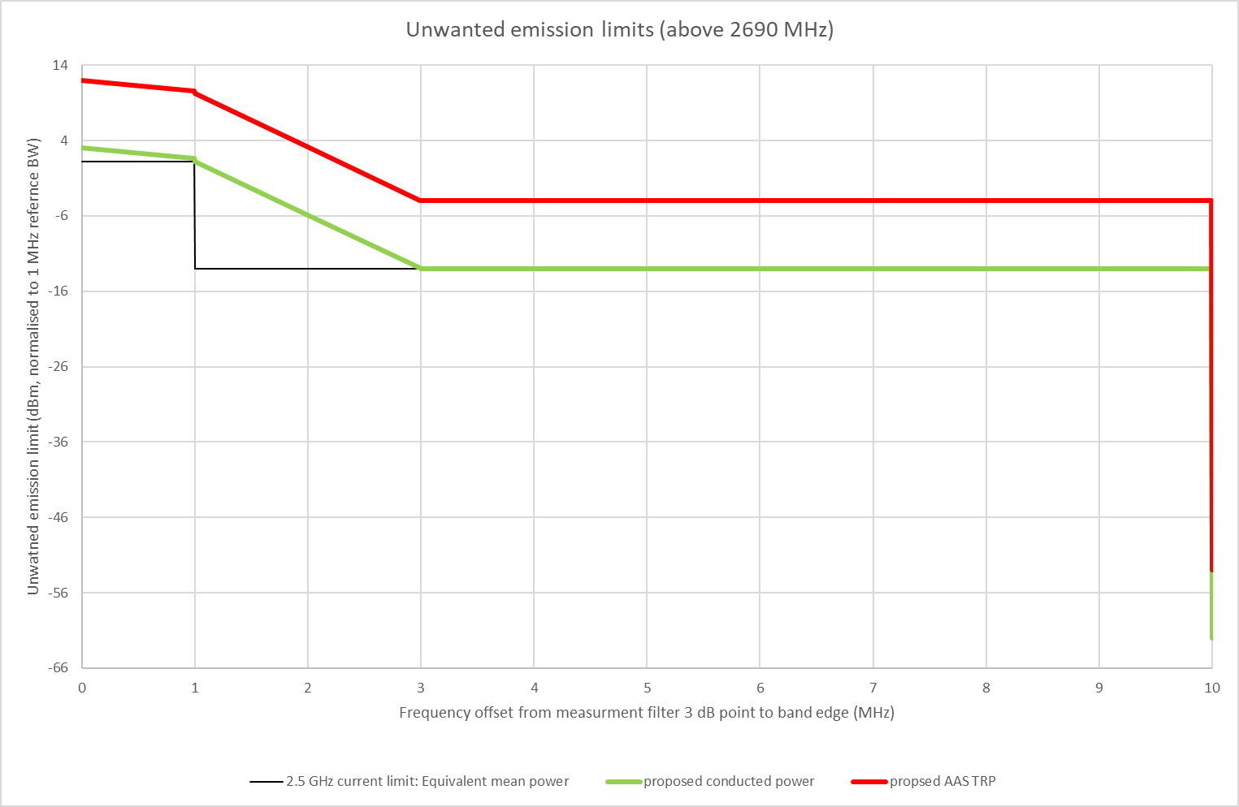

These limits will be specified for both non AAS (specified as a conducted power) and AAS (TRP). See Table 3 for non-AAS limits and Table 4 for AAS limits.

- Unwanted emission limits in 2690 MHz to 2700 MHz for transmitters operating in the upper 2.5 GHz band – non-AAS devices
Frequency offset from 2690 MHz (f_{offset}) | Mean power (dBm) per transmitter port | Measurement bandwidth
0 MHz ≤ f_{offset} < 1 MHz | $$-7dBm-\frac{7}{5}\left(\frac{f_{offset}}{MHz}-0.05\right)dB$$ | 100 kHz
1 MHz ≤ f_{offset} < 3 MHz | $$-1.66 dBm-7.12\left(\frac{f_{offset}}{MHz}-0.05\right)dB$$ | 100 kHz
3 MHz ≤ f_{offset} < 10 MHz | -13 | 1 MHz

- Unwanted emission limits in 2690 MHz to 2700 MHz for transmitters operating in the upper 2.5 GHz band – AAS devices
Frequency offset from 2690 MHz (f_{offset}) | Total radiated power per cell/sector (dBm) | Measurement bandwidth
0 MHz ≤ f_{offset} < 1 MHz | $$2dBm-\frac{7}{5}\left(\frac{f_{offset}}{MHz}-0.05\right)dB$$ | 100 kHz
1 MHz ≤ f_{offset} < 3 MHz | $$7.34 dBm-7.12\left(\frac{f_{offset}}{MHz}-0.05\right)dB$$ | 100 kHz
3 MHz ≤ f_{offset} < 10 MHz | -4 | 1 MHz
Note: The closest -3dB point of the measurement bandwidth to the upper or lower frequency limits is placed at f_{offset}.

The agreed proposed limits will have negligible impact to the existing interference environment for adjacent band services as no change to the unwanted emission limits is proposed at offsets greater than 3 MHz.

Upper 2.5 GHz band transmitter unwanted emission limits in the frequency range 2615–2620 MHz
The discussion regarding the emission limits between 2690 MHz to 2700 MHz helped inform the limits between 2615 MHz to 2620 MHz. The only difference is the requirement to maintain the current unwanted emission limit of -45 dBm/MHz limit at an offset of 5 MHz below 2620 MHz (compared to the -45 dBm/MHz limit applying at a 10 MHz offset for unwanted emissions above 2690 MHz). A comparison between the existing unwanted emissions limits below 2620 MHz (amended from an EIRP to a conducted power for comparison purposes) and the proposed emission limits are shown in Figure 2.
Unwanted emission limits comparison between 2615 MHz - 2620 MHz for upper band devices
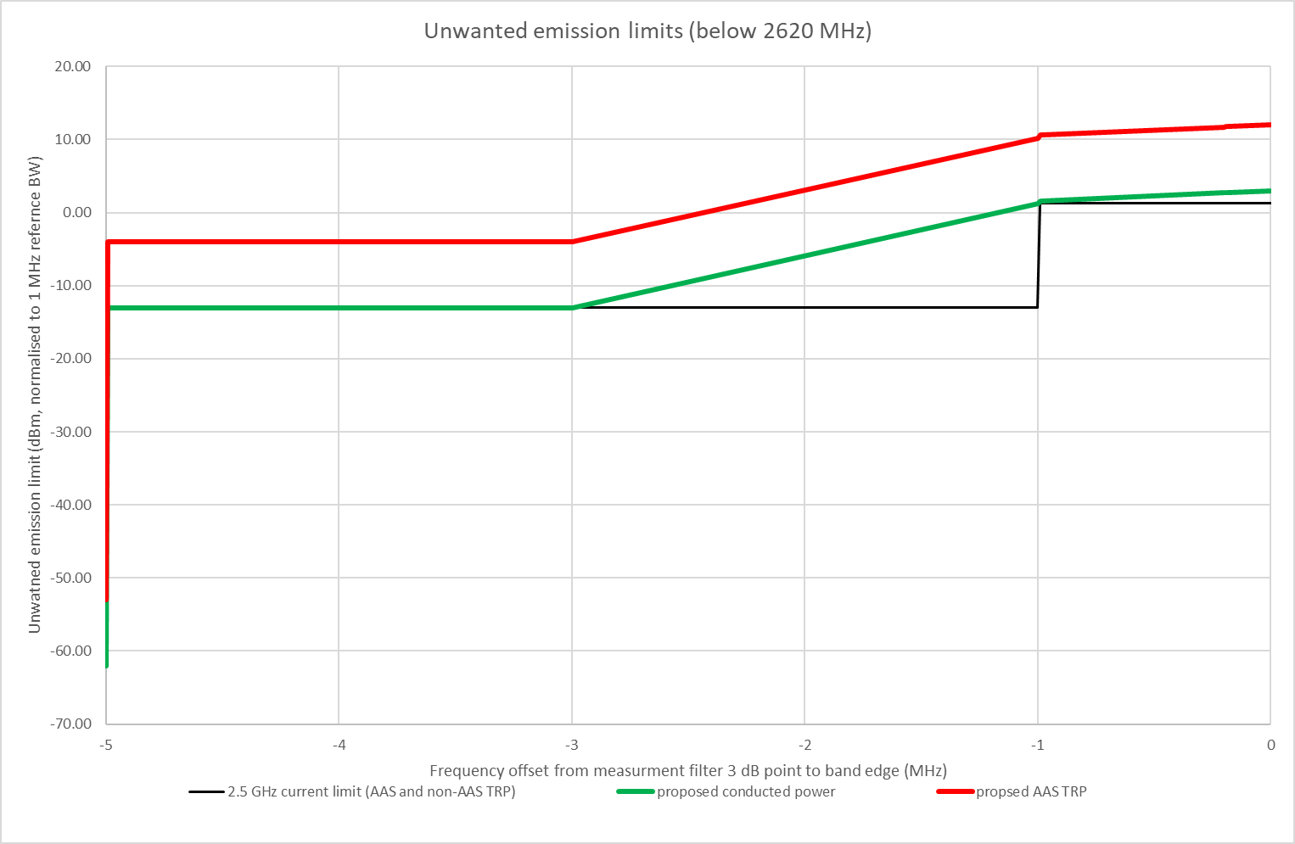

The TLG members agreed to the proposed limits, noting that AMTA proposed that greater alignment with 3GPP could be achieved for the renewed spectrum licences post-2029. These limits will be specified for both non AAS (specified as a conducted power) and AAS (TRP). See Table 5 for non-AAS limits and Table 6 for AAS limits.
- Unwanted emission limits in 2615 MHz to 2620 MHz for transmitters operating in the upper 2.5 GHz band – non-AAS devices
Frequency offset from 2620 MHz(f_{offset}) | Mean power (dBm) per transmitter port | Measurement bandwidth
0 MHz ≤ f_{offset} < 1 MHz | $$-7dBm-\frac{7}{5}\left(\frac{f_{offset}}{MHz}-0.05\right)dB$$ | 100 kHz
1 MHz ≤ f_{offset} < 3 MHz | $$-1.66 dBm-7.12\left(\frac{f_{offset}}{MHz}-0.05\right)dB$$ | 100 kHz
3 MHz ≤ f_{offset} < 5 MHz | -13 | 1 MHz

- Unwanted emission limits in 2615 MHz to 2620 MHz for transmitters operating in the upper 2.5 GHz band – AAS devices
Frequency offset from 2620 MHz(f_{offset}) | Total radiated power per cell/sector (dBm) | Measurement bandwidth
0 MHz ≤ f_{offset} < 1 MHz | $$2dBm-\frac{7}{5}\left(\frac{f_{offset}}{MHz}-0.05\right)dB$$ | 100 kHz
1 MHz ≤ f_{offset} < 3 MHz | $$7.34 dBm-7.12\left(\frac{f_{offset}}{MHz}-0.05\right)dB$$ | 100 kHz
3 MHz ≤ f_{offset} < 5 MHz | -4 | 1 MHz
Note: The closest -3dB point of the measurement bandwidth to the upper or lower frequency limits is placed at f_{offset}.

Upper 2.5 GHz band transmitter unwanted emission limits in the frequency range 2490 – 2800 MHz excluding 2615 – 2700 MHz
The ACMA’s initial proposal was to maintain unwanted emission limits outside 2615 – 2700 MHz at an EIRP of -45 dBm/MHz for non-AAS devices and a TRP limit of -53 dBm/MHz for AAS devices.
Some TLG members supported the proposal to provide a TRP limit for AAS transmitters, however requested that the TRP limit be relaxed to -52 dBm/MHz for AAS transmitters for emissions below 2615 MHz. The request was based on the intention to align with ECC Decision 05(05). For emissions in 2700-2800 MHz, some members proposed alignment with 3GPP limits (-30 dBm/MHz for non-AAS and -21 dBm/MHz for AAS). The ACMA indicated that those limits are significantly different from the current limits which are in place for coexistence of adjacent services.
The ACMA’s initial view is that a 1 dB increase in TRP from -53 dBm/MHz to -52 dBm/MHz will not significantly increase the potential of interference. Manufacturers have indicated that their systems operate at much lower levels than -53 dBm/MHz, however indicated that adopting the level of -52 dBm/MHz will align with international standards and will reduce the burden on manufacturers to undergo further Australia-specific testing.
TLG members agreed to maintain emission limits outside 2615 – 2700 MHz to a max EIRP of -45 dBm/MHz for non-AAS devices and adopt a TRP limit of -52 dBm/MHz for AAS devices, noting that AMTA proposed that greater alignment with 3GPP could be achieved for the renewed spectrum licences post-2029 for unwanted emissions in the range 2700-2800 MHz. Maintaining the non-AAS limit as an EIRP (instead of a TRP), will help ensure the interference environment from these transmitters is unchanged.

The TLG members agreed to the proposed emission limits in Table 7 for non-AAS and Table 8 for AAS.
- Unwanted emission limits inside 2490 MHz to 2800 MHz excluding 2615 – 2700 MHz for transmitters operating in the upper 2.5 GHz band – non-AAS transmitters
Frequency offset f_{offset}) | Radiated maximum true mean power  (dBm EIRP) | Measurement bandwidth
f_{offset} ≥ 0 Hz | -45 | 1 MHz

- Unwanted emission limits inside 2490 MHz to 2800 MHz excluding 2615 – 2700 MHz for transmitters operating in the upper 2.5 GHz band – AAS transmitters
Frequency offset f_{offset}) | Total radiated power per cell/sector (dBm) | Measurement bandwidth
f_{offset} ≥ 0 Hz | -52 | 1 MHz
Note: The closest -3dB point of the measurement bandwidth to the upper or lower frequency limits is placed at f_{offset}.

Upper 2.5 GHz band transmitter unwanted emissions outside the frequency range 2490 – 2800 MHz)
The ACMA proposed maintaining the current transmitter unwanted emissions limits outside the range 2490-2800 MHz with the clarification that the limits apply for non-AAS transmitters are apply per port. This is consistent with 3GPP TS 38.104. For AAS transmitters, the ACMA proposed to also adopt the limits in 3GPP TS 38.104 that are defined in terms of TRP, which means they apply to the aggregate emissions from all transmitters/receivers that form a device.
These proposed emission limits in contained in Table 9 for non-AAS and Table 10 for AAS, and were supported by TLG members.
- Unwanted emission limits outside 2490 MHz to 2800 MHz for transmitters operating in the upper 2.5 GHz band – non-AAS transmitters
Frequency range  (f) | Mean power (dBm) per transmitter port | Measurement bandwidth
9 kHz ≤ f < 150 kHz | -36 | 1 kHz
150 kHz ≤ f < 30 MHz | -36 | 10 kHz
30 MHz ≤ f < 1 GHz | -36 | 100 kHz
1 GHz ≤ f < 12.75 GHz | -30 | 1 MHz

- Unwanted emission limits outside 2490 MHz to 2800 MHz for transmitters operating in the upper 2.5 GHz band – AAS transmitters
Frequency range  (f) | Total radiated power per cell/sector (dBm) | Measurement bandwidth
9 kHz ≤ f < 150 kHz | -27 | 1 kHz
150 kHz ≤ f < 30 MHz | -27 | 10 kHz
30 MHz ≤ f < 1 GHz | -27 | 100 kHz
1 GHz ≤ f < 12.75 GHz | -21 | 1 MHz

Upper 2.5 GHz band Receiver unwanted emissions outside the frequency range 2490 – 2700 MHz frequency range)
We proposed to maintain the current unwanted emissions limits for receivers but to define them as TRP.
This was supported by TLG members. The TLG members agreed to the proposed emission limits in Table 11.
- Unwanted emission limits for receivers operating in the upper 2.5 GHz band – All receivers
Frequency range  (f) | Total radiated power (dBm) | Measurement bandwidth
30 MHz ≤ f < 1 GHz | -57 | 100 kHz
1 GHz ≤ f < 12.75 GHz | -47 | 1 MHz

Proposed in-band emission limits for devices operating in the frequency range 2500 – 2570 MHz (the lower 2.5 GHz band)
The ACMA proposed to maintain the unwanted emission limits that are consistent with 3GPP TS 38.101-1 for in-band emission limits. Importantly this standard does not define separate limits for AAS transmitters. To future-proof arrangements for possible AAS use, we proposed to implement the 3GPP limits as TRP rather than conducted power – see Table 12. The TLG agreed with the ACMA’s proposals.
3GPP TS 38.101-1 defines spurious emission limits as applying +/- (channel bandwidth + 5 MHz) outside a device’s assigned channel. This means non-spurious emissions apply at offsets of +/- (channel bandwidth + 5 MHz). So, these limits also encompass possible LTE operating bandwidths of 5 MHz or less, the term max(Channel BW, 5) is used.
- Unwanted emission limits for transmitters operating in the lower 2.5 GHz band at frequency offsets of channel bandwidth + 5 MHz – all transmitters
Frequency offset  (f_{offset}) | Total radiated power (dBm) | Measurement bandwidth
0 MHz ≤ f_{offset} < 1 MHz | -15 | 30 kHz
1 MHz ≤ f_{offset} < 5 MHz | -10 | 1 MHz
5 MHz ≤ f_{offset} < max(Channel BW, 5) | -13 | 1 MHz
max(Channel BW, 5) ≤ f_{offset} < max(Channel BW + 5, 10) | -19 | 1 MHz

Lower 2.5 GHz band transmitter unwanted emissions
As per the transmitter spurious emission limits in the upper 2.5 GHz band, the TLG supported the ACMA’s proposal to maintain the current transmitter spurious emissions limits in the lower 2.5 GHz band however specify them as a TRP instead of an EIRP for consistency with 3GPP TS 38.101-1. The proposed emission limits for all transmitters in the lower 2.5 GHz band are provided in Table 13.
- Unwanted emission limits for transmitters operating in the lower 2.5 GHz band at frequency offsets greater than channel bandwidth + 5 MHz – all transmitters
Frequency range  (f) | Total radiated power (dBm) | Measurement bandwidth
9 kHz ≤ f < 150 kHz | -36 | 1 kHz
150 kHz ≤ f < 30 MHz | -36 | 10 kHz
30 MHz ≤ f < 1 GHz | -36 | 100 kHz
1 GHz ≤ f < 12.75 GHz | -30 | 1 MHz

Lower 2.5 GHz band receiver unwanted emissions
As per the receiver unwanted emission limits in the upper 2.5 GHz band, the TLG supported the ACMA’s proposal to align the receiver unwanted emissions limits in the lower 2.5 GHz band with the limits specified in 3GPP TS 38.101-1.
The TLG members noted that for a radiocommunications receiver where the antenna or transceiver array boundary connectors support both a radiocommunications receiver and a radiocommunications transmitter, the limits for the transmitter unwanted emission limits should be adopted.
The TLG agreed to the proposed emission limits in Table 14 for non-AAS devices, Table 15 for non-AAS devices that are connected to transmitter antenna array and Table 16 for AAS devices.
- Unwanted emission limits for receivers operating in the lower 2.5 GHz band - non-AAS receivers
Frequency range  (f) | Mean power (dBm) per receiver port | Measurement bandwidth
30 MHz ≤ f < 1 GHz | -57 | 100 kHz
1 GHz ≤ f < 12.75 GHz | -47 | 1 MHz

- Unwanted emission limits for receivers operating in the lower 2.5 GHz band connected to Tx array – non-AAS receivers (same as Table 9)
Frequency range  (f) | Mean power (dBm) per receiver port | Measurement bandwidth
9 kHz ≤ f < 150 kHz | -36 | 1 kHz
150 kHz ≤ f < 30 MHz | -36 | 10 kHz
30 MHz ≤ f < 1 GHz | -36 | 100 kHz
1 GHz ≤ f < 12.75 GHz | -30 | 1 MHz

- Unwanted emission limits for receivers operating in the lower 2.5 GHz band - AAS receivers (same as Table 10)
Frequency range  (f) | Total radiated power per cell/sector (dBm) | Measurement bandwidth
9 kHz ≤ f < 150 kHz | -27 | 1 kHz
150 kHz ≤ f < 30 MHz | -27 | 10 kHz
30 MHz ≤ f < 1 GHz | -27 | 100 kHz
1 GHz ≤ f < 12.75 GHz | -21 | 1 MHz

Devices exempt from registration
The current limit for devices that are exempt from registration is “a radiated maximum true mean power of less than or equal to 35 dBm EIRP per 5MHz”. For other recent spectrum licence framework reviews, the TLG has agreed to maintain the limit but change the measurement from an EIRP to a TRP. However, in those instances the power level was 25 dBm per bandwidth. In the 2.5 GHz band, with the current power being 35 dBm EIRP per 5MHz, changing this to 35 dBm TRP per 5 MHz could permit high powered transmitters to be operated unregistered. For this reason, the ACMA proposed a limit of 25 dBm TRP per occupied bandwidth
The TLG members rejected the ACMA’s proposal as it may unduly affect a number of services that would be above this limit. However, the TLG members also noted the potential for interference with a 35 dBm TRP per bandwidth. As a result, the TLG members proposed to maintain the existing criteria. The ACMA accepted the TLG’s proposal.
The devices exempt from registration criteria will not be amended.

Other conditions on the licence
It is proposed to maintain all of the ‘other conditions’ (that is, those other than core and statutory conditions) that are currently contained in 2.5 GHz band spectrum licences. Please refer to the PDF image of current 2.5 GHz band spectrum licences available on the RRL for more details.

Radiocommunications advisory guidelines
Further guidance on interference management with other licensed services is provided in Radiocommunications Advisory Guidelines (RAGs) made under section 262 of the Act. RAGs can refer to any aspect of radiocommunications or radio emissions.
Generally, RAGs include provisions to help assess the possible interference between spectrum-licensed devices and services operating under spectrum, apparatus or class licences. Potentially affected services are identified in the RAGs to enable licensees to assess and mitigate the risk of interference between these services.
It is important to note that where a case of interference arises between a spectrum-licensed device and another licensed device, the ACMA will refer to the provisions of the RAGs in resolving the matter. In general, affected licensees also have the ability to negotiate their own arrangements in order to manage interference. Such arrangements will also be taken into account when resolving any interference disputes.
Currently, there are 2 section 262 guidelines relevant to the deployment of services under 2.5 GHz band spectrum licences:
- Radiocommunications Advisory Guidelines (Managing Interference from Spectrum Licensed Transmitters — 2.5 GHz Band) 2023 (RAG Tx)
- Radiocommunications Advisory Guidelines (Managing Interference to Spectrum Licensed Receivers – 2.5 GHz Band) 2023 (RAG Rx)
The Bureau of Meteorology (BoM) raised a concern with the current provision in the RAG Tx for coordination with radiolocation services (including weather radars operated by BoM). BoM indicated their belief that the protection criteria in Part 7 of RAG Tx was not concise enough and could lead to the insufficient protection for its services. BoM proposed that a power flux density (PFD) interference limit of -133 dBm/MHz/m² be included in the RAG TX for RLS services, based on the typical parameters of radars operated by BoM and consistent with the ITU-R Recommendations already listed in the RAG Tx.
The ACMA noted to the TLG that this inclusion did not represent a new criterion for spectrum licences, it just provided clarification on the criterion they were already been required to meet. In principle the TLG agreed to the inclusion on the basis it did not provide an additional interference mitigation burden.
The ACMA proposed using a dBm/MHz power limit rather than a dBm/MHz/m² pfd limit. The ACMA argued that a pfd limit assumed antenna criteria, while a dBm/MHz power limit would allow site specific antenna criteria to be considered. Given the multiple BoM sites, with each having different antenna characteristics, and the RRL provides the actual antenna criteria for these different BoM sites, the TLG agreed to use a dBm/MHz power limit criterion.
The following power limit were proposed:
- BoM: -119 dBm/MHz at the radar antenna connector
- AMTA: -118 dBm/MHz at the input connector of the radar receiver
While the TLG agreed to the level of -119 dBm/MHz, there was further discussion on where in the receive-chain this level should be measured. BoM proposed that specifying the limit at the radar antenna connector would be simpler, while AMTA proposed that specifying the limit at the input connector of the radar receiver was more common industry practice. The ACMA propose to use the “input connector of the radar receiver” as this would allow any feeder losses as specified in the RRL (or agreed to) to be accounted for when calculating potential interference. The TLG members agreed to the ACMA’s proposal.
The final proposed text to be included in Part 7 of the RAG Tx is:

“(6) Protection is to be afforded to all licensed fixed receivers used for RLS, including weather radars operated by the Bureau of Meteorology, operating in the frequency band 2700–2900 MHz, that were included in the Register before a fixed transmitter operating under a 2.5 GHz spectrum licence was included in the Register.
Protection is achieved if the out-of-band emissions falling within the receiver’s licensed bandwidth does not exceed a maximum unwanted signal received level of –119 dBm/MHz at the input connector of the radar receiver.
Additional consideration of blocking/overload and other interference checks is not required.”

No substantial updates were proposed by the TLG to the RAG Rx.

Provisions to support wideband amplifiers
The ACMA identified an increasing desire by stakeholders to deploy and operate base stations with wideband power amplifiers under spectrum licences. In simple terms, wideband amplifiers operate over more than one frequency band, with carriers in each operating band mapped to a single antenna connector. While operation could be permitted using spectrum licences held in the different bands, there is a regulatory conflict with how conditions are currently specified on licences. That is, the licensee would need to meet different (conflicting) wanted and unwanted emission limits, as specified on the separate spectrum licences, within the same frequency ranges. An example is illustrated in the below diagram.
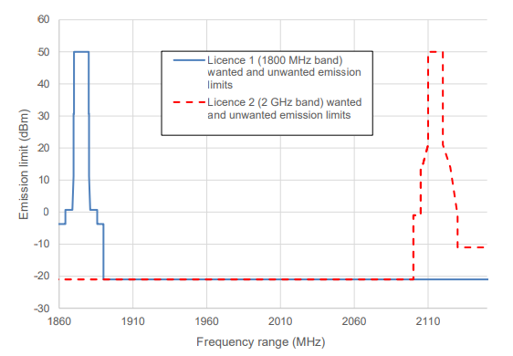
The ACMA recently applied conditional regulatory forbearance as a temporary measure to support the deployment of wideband amplifiers in certain situations until permanent arrangements can be considered and implemented. We are now taking this opportunity to discuss potential modifications to spectrum licences to support wideband amplifiers. Our intention is that the same regulatory solution can then be applied to spectrum licences in other bands.
The ACMA provided 2 initial broad options for consideration by TLG members to support wideband amplifiers:
- Option 1: provide a ‘carve-out’ where specific unwanted emission limits do not apply for wideband amplifiers.
- This could be similar to the carve-out in 3GPP standards: ‘for a multi-band connector, for each supported operating band together with ΔfOBUE around the band is excluded from the transmitter spurious emissions requirement’.
- Option 2: expand the current ‘agreement’ provisions in spectrum licences, to permitted unwanted emission limits to be exceeded when there is an agreement with non-adjacent spectrum licensees.
- This option would allow licensees to exceed unwanted emission limits in the frequency ranges authorised by the other licence(s), where there is a written agreement with other impacted spectrum licensees in the other frequency band.

AMTA supports Option 1 (the ‘carve-out’ for “operating band + ΔfOBUE”), over the ACMA’s regulatory forbearance approach.
AMTA is cautious of potential unintended consequences, for example, where radios able to operate in certain 3GPP bands used overseas (but not here) may be unintentionally exempted from unwanted emission limits imposed by the ACMA in Australia. As such, they are considering whether the “operating band” exempted needs to be limited to a band that is either spectrum-licensed, re-allocated for spectrum licensing, and/or allocated for wireless broadband (WBB) in Australia.
This should help to avoid exempting bands which are not used in Australia for WBB.
Ericsson’s preferred approach is for Option 1 which would be similar to 3GPP.
A concern Ericsson may have is if this applies only to 2 x Spectrum licences. While this might not be of concern for 2.5GHz (being Australia wide), the “other” band could potentially be Spectrum Licenced, AWL licensed or Apparatus Licenced in the future.
The ACMA identified 2 potential variations on Option 1 that attempt to address issues identified by TLG members could be:
- Option 1a: wideband amplifiers must not exceed the higher of the wanted or unwanted emission limits as applicable on all licences held by the operator (similar to the regulatory forbearance requirements but potentially expanded to cover more than two licences as well as apparatus licences.
- This would contain emissions to within the envelope of licences held by the licensee, however it would not permit relaxed emissions in bands that an operator does not hold a licence in.
- Option 1b: On each spectrum licence, specify the actual unwanted emission limit applicable in the frequency range of all other spectrum licenced bands. For example, on the 1800 MHz licence, specify that unwanted emissions from wideband amplifiers in the range 2100-2180 MHz (2 GHz upper band + 10 MHz) need comply with the 2 GHz band unwanted emission limits.
- This would permit relaxed unwanted emissions is all specified spectrum licensed bands, regardless of if a licensee holds a licences in each particular band. However, drafting on the licence may be complex, if the specified relaxed limits for each spectrum licensed band need to be included on every licence.
The issue of how to deal with wideband amplifiers was deferred to a subsequent consultation process (i.e. 850/1800 MHz), with the intention that whatever comes out of that process would be applied across all other spectrum licensed bands (including the 2.5 GHz band).. This proposal is discussed further in the 850/1800 MHz bands technical framework consultation paper that was released in February 2026.

Equivalent isotropic radiated power.
3GPP R4-168430, ‘On NRb BS ACLR requirement’, Huawei, 3GPP TSG-RAN WG4 Meeting #80bis, October 2016.
A gain of 17 dBi (based on agreed parameters from the 2016 2.5 GHz TLG) was used to convert from EIRP to TRP.
3GPP TS 38.104, available at: https://portal.3gpp.org/desktopmodules/Specifications/SpecificationDetails.aspx?specificationId=3202.
3GPP TS 38.101-1 is available at: https://portal.3gpp.org/desktopmodules/Specifications/SpecificationDetails.aspx?specificationId=3283.
3GPP TS 38.101-1 is available at: https://portal.3gpp.org/desktopmodules/Specifications/SpecificationDetails.aspx?specificationId=3283.
Agreements are only currently permitted between frequency- and area-adjacent spectrum licensees

