Apparatus licence fee schedule
April 2026
Canberra
Level 3
40 Cameron Avenue
Belconnen ACT
PO Box 78
Belconnen ACT 2616
T +61 2 6219 5555
F +61 2 6219 5353
Melbourne
Level 32
Melbourne Central Tower
360 Elizabeth Street
Melbourne VIC
PO Box 13112
Law Courts
Melbourne VIC 8010
T +61 3 9963 6800
F +61 3 9963 6899
Sydney
Level 5
The Bay Centre
65 Pirrama Road
Pyrmont NSW
PO Box Q500
Queen Victoria Building
NSW 1230
T +61 2 9334 7700
F +61 2 9334 7799
Copyright notice
https://creativecommons.org/licenses/by/4.0/
Except for the Commonwealth Coat of Arms, logos, emblems, images, other third-party material or devices protected by a trademark, this content is made available under the terms of the Creative Commons Attribution 4.0 International (CC BY 4.0) licence.
All other rights are reserved.
The Australian Communications and Media Authority has undertaken reasonable enquiries to identify material owned by third parties and secure permission for its reproduction. Permission may need to be obtained from third parties to re-use their material.
We request attribution as © Commonwealth of Australia (Australian Communications and Media Authority) 2026.

Introduction 2
About apparatus licence fees 2
Taxes and charges 2
Annual tax for assigned and non-assigned licences 2
Chargeable spectrum access 3
Accredited persons 3
Licence terms 3
Minimum tax amount 3
How to calculate your assigned licence fee 4
1. Find the applicable division 4
2. Calculate the charge 4
3. Calculate the tax 4
4. Add the charge and tax 5
Where to find your division 7
Division 1: General assigned licences 10
Division 1A: Scientific assigned licences 12
Division 2: Fixed point-to-point licences 13
Division 3: Fixed point-to-multipoint licences 14
Division 4: Assigned licences in high demand frequency bands 15
Division 4A: Harmonised government spectrum area licences 16
Division 5: Television outside broadcast station licences 17
Division 5A: Television outside broadcast network or system licences 18
Division 6: Assigned licences subject to a fixed tax 19
Division 7: Non-assigned licence fees 21
Division 8: Narrowcasting service (HPON) licence 22
Division 8A: Space system licences 23
Division 9: Other charges 26
Appendix A – History of changes to the fee schedule 29
Appendix B – Licence types and licensing options 36
Aeronautical 36
Aircraft 36
Amateur 36
Area-wide 37
Broadcasting 37
Datacasting 38
Defence 38
Defence receive 39
Earth 39
Earth receive 39
Fixed 39
Fixed receive 41
Land mobile 41
Major coast receive 42
Maritime coast 42
Maritime ship 43
Outpost 43
Public telecommunications service 44
Radiodetermination 44
Scientific 45
Space 45
Space receive 45
Appendix C – Assigned licence tax formula 46
Normalisation factor 46
Bandwidth 47
Power 47
Location weighting 49
Adjustment factor 50
Appendix D – Administrative charges 52
Issue charge 52
Renewal charge 52
Instalment charge 52
Appendix E – Exemptions, concessions and refunds 54
Exemptions 54
Concessions 54
Refunds on surrender of licence 55
Appendix F – Bandwidth definition and maps 56
Applicable definition of bandwidth 56
Geographic area maps 57
Sydney/Wollongong high-density area 58
Melbourne/Geelong high-density area 59
Brisbane/Gold Coast high-density area 60
Perth medium-density area 61
Adelaide medium-density area 62
Newcastle medium-density area 63
East Australia low-density area 64
Western Australia low-density area 66
Tasmania low-density area 67
Darwin low-density area 68
Appendix G – Estimating population: using the hierarchical cell identification scheme (HCIS) 69
Using the HCIS to Placemark Converter 70
Appendix H – Contact information 72

Licence fee information

Introduction
The Australian Communications and Media Authority (the ACMA) is Australia’s regulator for broadcasting, some internet content, radiocommunications and telecommunications. The ACMA allocates access to the radiofrequency spectrum through one of 3 licence types: spectrum, apparatus or class licences.
This publication describes the rationale for apparatus licence fees and provides the necessary information for licensees to calculate their own fees. This publication is intended as a guide only. For this reason, the information should not be relied on as legal advice or regarded as a substitute for legal advice in individual cases.

About apparatus licence fees
The ACMA uses a system of apparatus licence types to apply common licence conditions to categories of radiocommunications services. Most licence types have associated licensing options suitable for specific purposes. Fees charged vary according to the licensing option. See Appendix B for detailed descriptions of licence types and options.
Apparatus licences can be either assigned or non-assigned. Assigned licences are issued where licensees require individual frequencies to be allocated. Non-assigned licences are issued when an individual frequency assignment is not required, or if a frequency can be selected from a predefined suite.

Taxes and charges
There are 2 types of fees applicable to apparatus licences:
administrative charges to recover the direct costs of spectrum management
annual taxes to recover the indirect costs of spectrum management and provide incentives for efficient spectrum use.
Indirect costs are those that cannot be directly attributed to individual licensees. These activities include international coordination and domestic planning and interference management.
Appendix D explains each type of administrative charge: issue, renewal and instalment, while Appendix C has a detailed description of the tax formula.

Annual tax for assigned and non-assigned licences
The annual licence tax is applied to each chargeable ‘spectrum access’ of an assigned licence, and each licence for non-assigned licences.
The annual tax for most assigned spectrum accesses (for licences in divisions 1, 1A, 2, 3, 4, 5, and 8A) is calculated by the licence tax formula. However, most of the components of the tax formula have been calculated and the results placed in the ‘annual licence tax ($ per kHz)’ tables in these divisions. Licensees should refer to the tables in the applicable division, multiply the relevant figure by the bandwidth of their spectrum access (per kHz) and apply the low-power discount if necessary.
The annual tax for the other assigned spectrum accesses (for licences in divisions 4A, 5A, 6, and 8) and all non-assigned licences (Division 7) is set at a fixed amount.

Chargeable spectrum access
Spectrum access is the right to use of the spectrum and requires frequency coordination before issue. Each spectrum access specifies the allowable bandwidth, frequency, geographical site and power of the transmission.
All transmit spectrum accesses are chargeable spectrum accesses. Receive spectrum accesses are only chargeable if there are no transmit spectrum accesses on the same licence.

Accredited persons
Before a spectrum access is assigned, frequency coordination is necessary to ensure that the service will neither suffer from, nor cause, interference. This frequency coordination can be performed by either the ACMA or a person accredited by the ACMA – an ‘accredited person’ (AP). After completing the coordination, an AP will provide their client with a frequency assignment certificate (FAC).
When provided with a FAC by an AP, the ACMA charges a lower fee for the issue of the associated licence.

Licence terms
Apparatus licences can be issued for any period up to a maximum of 20 years. Licences may be renewed on expiry, subject to changes in spectrum planning policy.

Minimum tax amount
The minimum tax for a spectrum access or non-assigned licence is $43.75.

How to calculate your assigned licence fee

1. Find the applicable division
Refer to Table 1: Licence reference table and identify the division for your licensing option. Appendix B describes the various licensing options.
For example:
Table 1 shows that for a fixed point-to-point licence, Division 2 lists the relevant licence charges and taxes.

2. Calculate the charge
Find the administrative charge – issue, renewal or instalment – applicable to your licensing option, and multiply by the number of chargeable spectrum accesses.
For example:
- charges for fixed point-to-point licences are listed in Table 6:
- a new issue will incur an administrative charge of $498.00
- for a new point-to-point licence with 2 transmit spectrum accesses, the total administrative charge will be $996.00.

3. Calculate the tax
Find the ‘annual licence tax ($ per kHz)’ table for your licensing option, then find the applicable spectrum/geographic location weighting (maps and coordinates for each geographic location are in Appendix F). Multiply the weighting by the bandwidth (in kHz) of each spectrum access and apply the low-power discount if necessary. Add the total for each spectrum access of the licence, then round to the nearest dollar.
For example:
- the annual taxes (in $ per kHz) for point-to-point services are in Table 7
- for a point-to-point licence operating in a high-density area, between 403 and 520 MHz, the tax per kHz is: $41.2484
- if a spectrum access has a bandwidth of 12.5 kHz, the annual tax will be:
12.5 x $41.2484 = $515.605
- if the licence period is different from one year, proportion the tax for the number of days of the licence period compared with 365
- if the spectrum access is low power, reduce the tax by 90%. Low power is not applicable to point-to-point licences (refer Appendix C for details)
- apply the minimum tax amount ($43.75) if the tax is less than the minimum
- add the tax for both spectrum accesses. For a point-to-point licence with 2
12.5 kHz spectrum accesses in a high-density area, operating between 403 and 520 MHz, the tax will be:
$515.605 + $515.605 = $1,031.21
- round the total tax amount to the nearest dollar:
$1,031.21→ $1,031.00

4. Add the charge and tax
Add the total charge amount and total tax amount.
For example:
The total licence fee for a new point-to-point licence with 2 spectrum accesses, both with 12.5 kHz bandwidth, operating between 403 and 520 MHz in high-density areas, will be:
$996.00 + $1,031.00 = $2,027.00
An existing point-to-point licence would not pay the initial charge of $996.00, but they will be subject to applicable renewal or instalment charges in addition to the annual licence tax.
Taxes and charges

Where to find your division
This reference table lists the relevant charges and taxes applicable for each licensing option.
Licence reference table
Licence type | Licensing options | Division
Aeronautical | Aeronautical assigned system | 1
Aircraft | Aircraft assigned | 1
Amateur assigned | Beacon | 6
Amateur assigned | Repeater | 6
Amateur  non-assigned | Advanced | 7
Amateur  non-assigned | Foundation | 7
Amateur  non-assigned | Standard | 7
Area-wide and area-wide receiveArea-wide | Area-wide (26/28 GHz band) | 6
Area-wide and area-wide receiveArea-wide | Area-wide (3.4 to 4 GHz band) | 6
Area-wide and area-wide receiveArea-wide | Area-wide receive (3.75 to 4 GHz band) | 6
Broadcasting | Broadcast service | 6
Broadcasting | HF domestic service | 1
Broadcasting | HF overseas IBL service | 1
Broadcasting | HF overseas service | 1
Broadcasting | Narrowband area service (70–960 MHz) | 4
Broadcasting | Narrowband area service (Outside 70–960 MHz) | 4
Broadcasting | Open narrowcasting service (LPON) | 1
Broadcasting | Open narrowcasting service (HPON) | 8
Datacasting |  | 6
Defence |  | 1
Defence receive |  | 1
Earth | Fixed earth | 8A
Earth | Mobile earth | 8A
Earth receive |  | 8A
Fixed | 900 MHz studio to transmitter link | 1
Fixed | Point-to-multipoint station | 3
Fixed | Point-to-multipoint (land mobile spectrum) | 4
Fixed | Point-to-multipoint system | 4
Fixed | Point-to-multipoint system (3.4 GHz band) | 3
Fixed | Point-to-point | 2
Fixed | Point-to-point (5.8 GHz band) | 6
Fixed | Point-to-point (self-coordinated) stations | 6
Fixed | Sound outside broadcast | 7
Fixed | Television outside broadcast network | 5A
Fixed | Television outside broadcast station | 5
Fixed | Television outside broadcast system | 5A
Fixed | Temporary fixed link | 7
Fixed receive |  | 2
Land mobile | Ambulatory station | 1
Land mobile | Ambulatory system | 4
Land mobile | CBRS repeater | 1
Land mobile | Harmonised government spectrum area | 4A
Land mobile | Land mobile system | 4
Land mobile | PABX cordless telephone service | 6
Land mobile | Paging system (interior) | 4
Land mobile | Paging system (exterior) | 4
Land mobile | Wireless audio system | 6
Major coast receive |  | 1
Maritime coast | Limited coast assigned system | 1
Maritime coast | Limited coast marine rescue | 7
Maritime coast | Limited coast non-assigned | 7
Maritime coast | Major coast A | 1
Maritime coast | Major coast B | 1
Maritime ship | Ship station class B or C assigned | 1
Maritime ship | Ship station class B non-assigned | 7
Maritime ship | Ship station class C non-assigned | 7
Outpost | Outpost assigned | 1
Public Telecommunications Service (PTS) | PMTS Class B (859–869 MHz) | 6
Public Telecommunications Service (PTS) | PMTS Class B (870–890 MHz) | 1
Public Telecommunications Service (PTS) | PMTS Class B (935–960 MHz) | 6
Public Telecommunications Service (PTS) | PMTS Class B (1805–1880 MHz) | 6
Public Telecommunications Service (PTS) | PMTS Class B (2110–2170 MHz) | 6
Public Telecommunications Service (PTS) | PMTS Class C | 6
Radiodetermination | Radiodetermination | 1
Radiodetermination | RNSS Repeater system | 6
Scientific | Scientific assigned | 1A
Scientific | Scientific non-assigned | 7
Space |  | 8A
Space receive |  | 8A

Division 1: General assigned licences
Licence charges
Licensing option | Issue charge  (GST excl.) | Renewal/  instalment charge
900 MHz studio to transmitter link | $498 per spectrum access | $4
Aeronautical assigned system | $530 per station | $4
Aircraft assigned | $530 per station | $4
All high frequency broadcasting options | $518 per spectrum access | $4
Ambulatory station | *$498/**$239 per spectrum access | $4
CB repeater station | $498 per spectrum access | $4
Defence | Hourly rate | $4
Defence receive | Hourly rate | $4
Limited coast assigned system | $498 per spectrum access | $4
Major coast A | $498 per spectrum access | $4
Major coast B | $498 per spectrum access | $4
Major coast receive | $498 per spectrum access | $4
Narrowcasting service (LPON) | Hourly rate | $4
Outpost assigned | $510 per spectrum access | $4
PMTS Class B (870–890 MHz) † | $550 per spectrum access | $4
Radiodetermination ‡ | $550 per spectrum access | $4
Ship station class B assigned | $239 | $4
Ship station class C assigned | $239 | $4
* This new issue charge will be for the initial assigned frequency.
**When an existing ambulatory station or ambulatory system frequency assignment for a client is copied to another licence, this new issue charge applies.
† The PMTS Class A licence option is no longer issued by the ACMA. Licences in the 870–890 MHz frequency range have been converted to PMTS Class B apparatus licences.
‡ This includes charges and taxes relating to body scanners.
For the issue charge when the frequency assignment is carried out by an AP, see Division 9: Other charges.

Annual licence tax ($ per kHz)
Spectrum location | Geographic location
Spectrum location | Australia-wide | High  density | Medium density | Low  density | Remote density
0 to 30 MHz | 1.2874 | 1.2992 | 1.2990 | 1.2607 | 1.2582
>30 to 403 MHz | 2.9081 | 1.1463 | 0.5654 | 0.1230 | 0.0612
>403 to 520 MHz | 2.9835 | 2.2316 | 0.7713 | 0.1277 | 0.0000
>520 to 960 MHz | 2.9835 | 1.6861 | 0.7713 | 0.1277 | 0.0636
>960 to 2,690 MHz | 2.9791 | 0.6748 | 0.3119 | 0.1522 | 0.0758
>2.69 to 5.0 GHz | 2.9758 | 0.5579 | 0.2261 | 0.1817 | 0.0907
>5.0 to 8.5 GHz | 1.2562 | 0.2344 | 0.1091 | 0.0482 | 0.0233
>8.5 to 14.5 GHz | 0.1107 | 0.0402 | 0.0095 | 0.0007 | 0.0003
>14.5 to 31.3 GHz | 0.1107 | 0.0297 | 0.0065 | 0.0007 | 0.0003
>31.3 to 51.4 GHz | 0.0302 | 0.0162 | 0.0035 | 0.0001 | 0.0001
>51.4 GHz to 100 GHz | 0.0030 | 0.0003 | 0.0003 | 0.0000 | 0.0000
>100 GHz | 0.0000 | 0.0000 | 0.0000 | 0.0000 | 0.0000

The minimum tax is $43.75. For low-power discount, see Appendix C.
Before adding administrative charges, add tax for each spectrum access and round to the nearest dollar.

Division 1A: Scientific assigned licences
Licence charges
Licensing option | Issue charge  (GST excl.) | Renewal/instalment charge
Scientific assigned | $550 per spectrum access | $4

For the issue charge when the frequency assignment is carried out by an AP, see Division 9: Other charges.
Annual licence tax ($ per kHz)*
Spectrum location | Geographic location
Spectrum location | Australia-wide | High  density | Medium density | Low  density | Remote density
0 to 30 MHz | 0.1287 | 0.1299 | 0.1299 | 0.1261 | 0.1258
>30 to 403 MHz | 0.2908 | 0.1146 | 0.0565 | 0.0123 | 0.0061
>403 to 520 MHz | 0.2984 | 0.2232 | 0.0771 | 0.0128 | 0.0000
>520 to 960 MHz | 0.2984 | 0.1686 | 0.0771 | 0.0128 | 0.0064
>960 to 2,690 MHz | 0.2979 | 0.0675 | 0.0312 | 0.0152 | 0.0076
>2.69 to 5.0 GHz | 0.2976 | 0.0558 | 0.0226 | 0.0182 | 0.0091
>5.0 to 8.5 GHz | 0.1256 | 0.0234 | 0.0109 | 0.0048 | 0.0023
>8.5 to 14.5 GHz | 0.0111 | 0.0040 | 0.0010 | 0.0001 | 0.0000
>14.5 to 31.3 GHz | 0.0111 | 0.0030 | 0.0007 | 0.0001 | 0.0000
>31.3 to 51.4 GHz | 0.0030 | 0.0016 | 0.0004 | 0.0000 | 0.0000
>51.4 GHz to 100 GHz | 0.0003 | 0.0000 | 0.0000 | 0.0000 | 0.0000
>100 GHz | 0.0000 | 0.0000 | 0.0000 | 0.0000 | 0.0000
* Where a licence authorises multiple scientific assigned stations, then the amount of tax payable is the sum of the amounts calculated in accordance with Table 5 divided by the number of stations authorised by the licence.
If a scientific licence has multiple spectrum accesses, the total annual tax for the licence is the average of the annual tax amount calculated for each spectrum access (subject to minimum tax).
The minimum tax is $43.75. For low-power discount, see Appendix C.
Before adding administrative charges, add tax payable and round to the nearest dollar.

Division 2: Fixed point-to-point licences
Licence charges
Licensing option | Issue charge  (GST excl.) | Renewal/instalment charge
Point-to-point | $498 per spectrum access | $4
Fixed receive | $550 per spectrum access | $4

For the issue charge when the frequency assignment is carried out by an AP,
see Division 9: Other charges.
Services with 2 transmit frequencies incur 2 tax amounts and 2 administrative charges (whether issue, renewal or instalment).
Annual licence tax ($ per kHz)
Spectrum location | Geographic location
Spectrum location | Australia-wide | High  density | Medium density | Low  density | Remote density
0 to 30 MHz | 23.7964 | 24.0153 | 24.0109 | 23.3021 | 14.7672
>30 to 403 MHz | 53.7528 | 21.1880 | 10.4502 | 2.2735 | 0.7187
>403 to 520 MHz | 55.1481 | 41.2484 | 14.2563 | 2.3599 | 0.0000
>520 to 960 MHz | 55.1481 | 31.1670 | 14.2563 | 2.3599 | 0.7461
>960 to 2,690 MHz | 1.3017 | 0.2948 | 0.1363 | 0.0665 | 0.0331
>2.69 to 5.0 GHz | 1.3002 | 0.2438 | 0.0988 | 0.0794 | 0.0396
>5.0 to 8.5 GHz | 0.5489 | 0.1024 | 0.0477 | 0.0211 | 0.0102
>8.5 to 14.5 GHz | 0.0484 | 0.0176 | 0.0042 | 0.0003 | 0.0001
>14.5 to 31.3 GHz | 0.0484 | 0.0130 | 0.0029 | 0.0003 | 0.0001
>31.3 to 51.4 GHz | 0.0132 | 0.0071 | 0.0015 | 0.0001 | 0.0000
>51.4 GHz to 100 GHz | 0.0013 | 0.0001 | 0.0001 | 0.0000 | 0.0000
>100 GHz | 0.0000 | 0.0000 | 0.0000 | 0.0000 | 0.0000

The minimum tax is $43.75.
Before adding administrative charges, add tax for each spectrum access and round to the nearest dollar.

Division 3: Fixed point-to-multipoint licences
Licence charges
Licensing option | Issue charge  (GST excl.) | Renewal/  Instalment charge
Point-to-multipoint (station) | $498 per spectrum access | $4
Point-to-multipoint system (3.4 GHz band) | $498 per spectrum access | $4

For the issue charge when the frequency assignment is carried out by an AP, see Division 9: Other charges.
To calculate the annual licence tax for harmonised government spectrum area licences, go to Division 4A.
Annual licence tax ($ per kHz)
Spectrum location | Geographic location
Spectrum location | Australia-wide | High  density | Medium density | Low  density | Remote density
0 to 30 MHz | 95.1856 | 96.0611 | 96.0438 | 93.2084 | 58.3175
>30 to 403 MHz | 215.0113 | 84.7519 | 41.8007 | 9.0940 | 2.8382
>403 to 520 MHz | 220.5923 | 164.9935 | 57.0253 | 9.4396 | 0.0000
>520 to 960 MHz | 220.5923 | 124.6679 | 57.0253 | 9.4396 | 2.9463
>960 to 2,690 MHz | 1.3017 | 0.2948 | 0.1363 | 0.0665 | 0.0331
>2.69 to 5.0 GHz | 1.3002 | 0.2438 | 0.0988 | 0.0794 | 0.0396
>5.0 to 8.5 GHz | 0.5489 | 0.1024 | 0.0477 | 0.0211 | 0.0102
>8.5 to 14.5 GHz | 0.0484 | 0.0176 | 0.0042 | 0.0003 | 0.0001
>14.5 to 31.3 GHz | 0.0484 | 0.0130 | 0.0029 | 0.0003 | 0.0001
>31.3 to 51.4 GHz | 0.0132 | 0.0071 | 0.0015 | 0.0001 | 0.0000
>51.4 GHz to 100 GHz | 0.0013 | 0.0001 | 0.0001 | 0.0000 | 0.0000
>100 GHz | 0.0000 | 0.0000 | 0.0000 | 0.0000 | 0.0000

The minimum tax is $43.75. Before adding administrative charges, add tax for each spectrum access and round to the nearest dollar.

Division 4: Assigned licences in high demand frequency bands
Licence charges
Licensing option | Issue charge  (GST excl.) | Renewal/  instalment charge
Narrowband area service | $498 per spectrum access | $4
Point-to-multipoint system | $498 per spectrum access | $4
Point-to-multipoint (land mobile spectrum) | $498 per spectrum access | $4
Ambulatory system | $498 per spectrum access | $4
Land mobile system (less than 30 MHz) | $518 per spectrum access | $4
Land mobile system (greater than 30 MHz) | $498 per spectrum access | $4
Paging system (interior) | $239 per spectrum access | $4
Paging system (exterior) | $498 per spectrum access | $4

For the issue charge when the frequency assignment is carried out by an AP, see Division 9: Other charges.
Annual licence tax ($ per kHz)
Spectrum location | Geographic location
Spectrum location | Australia-wide | High density | Medium density | Low density | Remote density
0 to 30 MHz | 95.1856 | 96.0611 | 96.0438 | 93.2084 | 93.0235
>30 to 403 MHz | 215.0113 | 84.7519 | 41.8007 | 9.0940 | 4.5272
>403 to 520 MHz | 220.5923 | 164.9935 | 57.0253 | 9.4396 | 0.0000
>520 to 960 MHz | 220.5923 | 124.6679 | 57.0253 | 9.4396 | 4.6997
The minimum tax is $43.75. For low-power discount, see Appendix C.
Before adding administrative charges, add tax for each spectrum access and round to the nearest dollar.

Division 4A: Harmonised government spectrum area licences
Licence charges
Licensing option | Issue charge  (GST excl.) | Renewal/  instalment charge
Harmonised government spectrum area | $498 per spectrum access* | $4
* These harmonised government spectrum area licences are a type of land mobile licence, so they will share the same issue charges. As these licences contain frequencies above 30 MHz, the charge is the same as for land mobile system licences (greater than 30 MHz).

Harmonised government spectrum area licences
State or territory of the licence | Annual licence tax ($ per MHz)
Australian Capital Territory | $1,312.18
New South Wales | $124,824.09
Northern Territory | $3,412.81
Queensland | $94,619.50
South Australia | $20,925.20
Tasmania | $486.34
Victoria | $108,675.14
Western Australia | $24,426.14

Division 5: Television outside broadcast station licences
Licence charges
Licensing option | Issue charge (GST excl.) | Renewal/  instalment charge
Television outside broadcast station | $510 per spectrum access | $4

For the issue charge when the frequency assignment is carried out by an AP, see Division 9: Other charges.
Annual licence tax television outside broadcast station ($ per kHz)
Spectrum location | Geographic location
Spectrum location | Australia-wide | High density | Medium density | Low density | Remote density
>960 to 2,690 MHz | 1.5283 | 0.3462 | 0.1600 | 0.0781 | 0.0389
>2.69 to 5.0 GHz | 1.5266 | 0.2862 | 0.1160 | 0.0932 | 0.0465
>5.0 to 8.5 GHz | 0.6445 | 0.1203 | 0.0560 | 0.0247 | 0.0120
>8.5 to 14.5 GHz | 0.0568 | 0.0206 | 0.0049 | 0.0003 | 0.0002
>14.5 to 31.3 GHz | 0.0568 | 0.0153 | 0.0034 | 0.0003 | 0.0002
>31.3 to 51.4 GHz | 0.0155 | 0.0083 | 0.0018 | 0.0001 | 0.0000
>51.4 to 100 GHz | 0.0015 | 0.0002 | 0.0002 | 0.0000 | 0.0000
Above 100 GHz | 0.0000 | 0.0000 | 0.0000 | 0.0000 | 0.0000

The minimum tax is $43.75.
Before adding administrative charges, add tax for each spectrum access then round to the nearest dollar.

Division 5A: Television outside broadcast network or system licences
Licence charges
Licensing option | Issue charge (GST excl.) | Renewal/  instalment charge
Television outside broadcast network | $510 | $4
Television outside broadcast system | $510 | $4

Annual licence tax for television outside broadcast system or network
Licensing option | Geographic location
Licensing option | Australia-wide | High  density | Medium density | Low  density | Remote density
Television outside broadcast network (per licence) | $223,901.27 | n/a | n/a | n/a | n/a
Television outside broadcast system | $47,131.15 | $8,796.09 | $4,093.65 | $1,810.33 | $904.41

Division 6: Assigned licences subject to a fixed tax
Licence charges and annual tax
Item | Licensing option | Issue charge  (GST excl.) | Renewal/  instalment charge | Annual licence tax
1 | Amateur beacon or repeater | $187 | $4 | $53.69
2 | Area-wide (26/28 GHz band) | $896/$737* | $4 | $0.0003/MHz/pop**
3 | Area-wide (3.4 to 4 GHz band) | †$896 | $4 | $0.0041/MHz/pop
4 | Area-wide receive (3.75 to 4 GHz band) | †$896 | $4 | $0.0041/MHz/pop
5 | Broadcast service | Hourly rate | $4 | ‡$43.75 per transmitter
6 | Datacasting | $448 | $4 | $43.75 per transmitter
7 | PABX cordless telephone service | $498 per spectrum access | $4 | $43.75
8 | Point-to-point (5.8 GHz band) | $498 per spectrum access | $4 | $43.75 per pair of spectrum accesses
9 | Point-to-point (self-coordinated) stations | $498 per spectrum access | $4 | $249.60  per pair of spectrum accesses
10 | PMTS Class B (859–869 MHz) and (935–960 MHz) (paired) | $550 per spectrum access | $4 | $0.133/MHz/pop
11 | PMTS Class B (1805–1880 MHz) (paired) | $550 per spectrum access | $4 | $0.01/MHz/pop
12 | PMTS Class B (2110–2170 MHz) (paired) | $550 per spectrum access | $4 | $0.06/MHz/pop
13 | PMTS Class C | $498 | $4 | $43.75
14 | RNSS repeater system | $510 | $4 | $43.75
15 | Wireless Audio System | Hourly rate | $4 | $43.75
16 | Underground PMTS Class B § | $550 per spectrum access | $4 | $43.75 per HCIS level 2 block
* The first issue charge is for the consideration of a standard area-wide licence, the second issue charge is for the consideration of an FSS-only area-wide licence.
**The annual tax amount for a $/MHz/pop rate, which applies to both AWL and PTMS Class B licences, is determined by multiplying the rate by the total bandwidth excluding overlapping frequencies and the population of the relevant HCIS level 2 block. Minimum tax applies on the HCIS level 2 block. For information on calculating the population relating to PMTS Class B (except underground PMTS class B) and area-wide licences, please see Appendix G.
† An additional amount may apply if the application for the AWL needs to be assessed against one or more other applications (i.e., there are multiple applications for the same spectrum in the same area). Additional information can be found in the Radiocommunications (Charges) Determination 2022.
‡ The Radiocommunications (Transmitter Licence Tax) Act 1983 no longer imposes transmitter licence tax on transmitter licences associated with a commercial broadcasting licence. Such transmitters are subject to tax under the Commercial Broadcasting (Tax) Act 2017. Information about the commercial broadcasting tax can be found on the ACMA website.
§ This item refers to Underground PMTS Class B licences in the 3.4–4.0 GHz range.

Division 7: Non-assigned licence fees
Non-assigned licences
Licensing option | Issue charge  (GST excl.) | Renewal/  instalment charge | Annual licence tax
Amateur non-assigned* | - | -† | $53.69
Limited coast marine rescue | $38 | $4 | $43.75
Limited coast non-assigned | $38 | $4 | $43.75
Scientific non-assigned* | - | $4 | $43.75
Ship station class B non-assigned | $38 | $4 | $43.75
Ship station class C non-assigned | $38 | $4 | $43.75
Sound outside broadcast | $38 | $4 | $43.75
Temporary fixed link | $38 | $4 | $2,437.32
* Activities that were previously undertaken under non-assigned apparatus licences are now supported by class licences – the Radiocommunications (Amateur Stations) Class Licence 2023, the Radiocommunications (Outpost Stations) Class Licence 2022 and Radiocommunications (Science and Research) Class Licence 2023 respectively.
† Non-assigned amateur licences will no longer be eligible for renewal due to the Radiocommunications (Amateur Licences – Renewal Statement) Determination 2023.
Please read the cost recovery implementation statement for information about charges related to the amateur class licences, including charges for call signs.

Division 8: Narrowcasting service (HPON) licence
High power open narrowcasting service (HPON) licences are allocated according to the specifications of licence area plans (LAPs).
Licence charges
Licensing option | Issue charge  (GST excl.) | Renewal/  instalment charge
High power open narrowcasting service (HPONS) | By allocation* | $4
*A separate entry fee of $498 applies.
Annual licence tax
Location | FM/TV | AM
Melbourne | $8,218.02 | $739.87
Sydney | $8,090.88 | $727.75
Brisbane | $4,130.29 | $371.54
Perth | $3,481.09 | $313.50
Adelaide | $2,190.20 | $196.92
Gold Coast – Tweed Heads | $1,169.90 | $104.89
Newcastle – Maitland | $802.46 | $72.19
Canberra – Queanbeyan | $745.73 | $66.66
Sunshine Coast | $578.50 | $51.81
Central Coast | $528.16 | $47.83
Wollongong | $494.90 | $44.71
Geelong | $463.54 | $43.75
Hobart | $341.55 | $43.75
Townsville | $294.64 | $43.75
Cairns | $251.07 | $43.75
Elsewhere | $43.75 | $43.75

The minimum tax for HPON licences is $43.75.
If the LAP for the licence provides that:
- the maximum effective radiated power for the relevant station is not more than
100 watts, or
- the maximum cymomotive force for the relevant station is not more than 100 volts, or
- the coverage radius for the service is not more than 15 kilometres from the nominal location of the transmitter within the meaning given by the licence area plan,
then the annual amount for the licence is half the amount stated in the table above, subject to the minimum tax for HPON licences of $43.75.

Division 8A: Space system licences
Licence charges
Licensing option | Issue charge  (GST excl.) | Renewal/  instalment charge
Earth receive | $590 per spectrum access | $4
Fixed earth | $590 per spectrum access | $4
Mobile earth | $590 per spectrum access | $4
Space | $291 per spectrum access | $4
Space receive | $291 per spectrum access | $4

For the issue charge when the frequency assignment is carried out by an AP, see Division 9: Other charges.
Annual licence tax ($ per kHz)
Spectrum location | Geographic location
Spectrum location | Australia-wide | High  density | Medium density | Low  density | Remote density
0 to 30 MHz | 1.2874 | 1.2992 | 1.2990 | 1.2607 | 1.2582
>30 to 403 MHz | 2.9081 | 1.1463 | 0.5654 | 0.1230 | 0.0612
>403 to 520 MHz | 2.9835 | 2.2316 | 0.7713 | 0.1277 | 0.0000
>520 to 960 MHz | 2.9835 | 1.6861 | 0.7713 | 0.1277 | 0.0636
>960 to 2,690 MHz | 2.9791 | 0.6748 | 0.3119 | 0.1522 | 0.0758
>2.69 to 5.0 GHz | 2.9758 | 0.5579 | 0.2261 | 0.1817 | 0.0907
>5.0 to 8.5 GHz | 1.2562 | 0.2344 | 0.1091 | 0.0482 | 0.0233
>8.5–17.3 GHz | 0.1107 | 0.0402 | 0.0095 | 0.0007 | 0.0003
>17.3–31.3 GHz | 0.0775 | 0.0208 | 0.0033 | 0.0003 | 0.0000
>31.3 to 51.4 GHz | 0.0211 | 0.0114 | 0.0018 | 0.0001 | 0.0000
>51.4 to 100 GHz | 0.0030 | 0.0003 | 0.0003 | 0.0000 | 0.0000
>100 GHz | 0.0000 | 0.0000 | 0.0000 | 0.0000 | 0.0000

The minimum tax is $43.75. For low-power discount, see Appendix C.
If an earth receive or a space receive licence contains a spectrum access that consists of frequencies between 4.0–4.2 GHz, minimum tax is applied to that access.
Before adding administrative charges, add tax for each spectrum access and round to the nearest dollar.

Space licences
The tax for space licences is reduced by 75% where CDMA technology is used for a space licence in the 2483.5–2500 MHz band or a space receive licence in the 1610–1626.5 MHz band.
The minimum tax amount applies to spectrum access under space licences in the following frequency ranges: 10.7–11.7 GHz, 18.2–18.8 GHz and 19.3–19.7 GHz. These changes in taxes are to complement new licensing arrangements in the Radiocommunications (Communication with Space Object) Class Licence 2015, which will allow for the use of uncoordinated, unprotected earth station receivers.
Reductions in taxes when there are co-located and co-frequency earth/earth receive stations
If the licence is an earth licence/earth receive licence that relates to a fixed earth station/earth receive station (the first station), which:
- is located within:
  - a high-density area and at a fixed point within a circle of radius 500 metres from the fixed location of another earth station or earth receive station; or
  - a medium-density area and at a fixed point within a circle of radius 1,000 metres from the fixed location of another earth station or earth receive station; or
  - a low- or remote-density area and at a fixed point within a circle of radius 2000 metres from the fixed location of another earth station or earth receive station;
- and operates on a transmit/receive frequency that is coincident or overlaps with the receive or transmit frequency of the other earth station or earth receive station,
then the amount of tax for the spectrum access under the licence for the first station is multiplied by 70%.
Co-located and co-frequency earth stations authorised by single licence
If the licence is an earth licence/earth receive licence that relates to the operation of 2 or more fixed earth stations or earth receive stations, where:
- one of the following applies:
- if at least one of the co-located earth stations or earth receive stations is located within a high-density area – all of the co-located earth stations or earth receive stations are located within a circle that has a radius of 500 metres; or
- if at least one of the co-located earth stations or earth receive stations is located in a medium-density area, and none of the co-located earth stations or earth receive stations are located within a high-density area – all of the co-located earth stations or earth receive stations are located within a circle that has a radius of 1 kilometre; or
  - in any other case – all of the co-located earth stations or earth receive stations are located within a circle that has a radius of 2 kilometres;
- and if, for co-located earth stations or earth receive stations operated under the earth licence/earth receive licence, there are two or more spectrum accesses (component accesses), then the licence may be eligible for the following apparatus licence tax treatment:
- the component accesses are taken to be a single spectrum access (combined access); and
- the bandwidth (in kHz) of the combined access is the difference between the highest frequency authorised by the component accesses and the lowest frequency authorised by the component accesses; and
- the amount of tax for the licence is based on the bandwidth of the combined access.
Note that this discount is not automatically implemented in the ACMA licensing system. It is manually implemented and needs to be requested when applying for a licence.

Division 9: Other charges
Issue a licence with a frequency assignment certificate (FAC)
Type of FAC | Service | Charge  (GST excl.)
Via licensing system | Issued by an accredited person (earth and space licences) | $120.00 for each frequency assignment or paired frequency assignment to which the application relates
Via licensing system | Issued by an accredited person for the following licences:  amateur licence (amateur beacon station)  amateur repeater (amateur repeater station)  fixed licence (sound outside broadcast station)  fixed licence (television outside broadcast network)  fixed licence (television outside broadcast  system)  maritime ship licence (ship station class B assigned)  maritime ship licence (ship station class C assigned) | $28
Via licensing system | Issued by an accredited person (other) | $28 per spectrum access

Varying a licence condition
Service | Charge  (GST excl.)
Assigned or non-assigned licence where the ACMA does not perform technical co-ordination | $38
Licence variation without FAC where the ACMA performs technical co-ordination | The applicable charge for first issue of the licence
Licence variation accompanied by a FAC issued by an accredited person | $28 for each frequency assignment or paired frequency assigned to which the application relates
Earth and space licences | $120 for each frequency assignment or paired frequency assignment to which the application relates
Low power open narrowcasting service (LPON) | Hourly rate
Area-wide (standard) / Area-wide receive (standard) | $896
Area-wide (FSS) | $737

Licensing hourly rate
Service | Charge  (GST excl.)
Standard hourly rate for radiocommunications licensing activities | $239
Special hourly rate A | $254

Transfer of a licence
Service | Charge  (GST excl.)
Consideration or transfer of a licence or group of licences where the licences are contained in one application | $100

Documents
Service | Charge  (GST incl.)
Issue of duplicate document | $40

Providing a list of services within a specified frequency range
Service | Charge  (GST incl.)
Supply of an adjacent services listing | Hourly rate
Supply of a frequency scan report | Hourly rate

Accreditation application
Service | Charge  (GST excl.)
General licensing accreditation | $578
Specific licensing accreditation | $303

Amateur radio qualifications
Service | Charge  (GST excl.)
ACMA recognition certificates | $48
Application to be exempt from amateur radio examinations | $199
Conducting an examination for either: a Long Range Operator Certificate of Proficiency, a Short Range Certificate of Proficiency or a Marine Satellite Communications Endorsement | $518

Appendix A –
History of changes to the fee schedule

April 2026: Updates to figures using the population-based methodology
In January 2026, we created the Radiocommunications (Transmitter Licence Tax) Amendment Determination 2026 (No. 1) and Radiocommunications (Receiver Licence Tax) Amendment Determination 2026 (No. 1), which set all relevant tax figures to increase on 5 April 2026 by geographically specific population changes in the method laid out in our consultation. We also made minor amendments for clarity throughout the document.

September 2025: Introduction of point-to-multipoint system and underground PMTS Class B licences in the 3.4–4.0 GHz band
In September 2025, we made the Radiocommunications (Transmitter Licence Tax) Amendment Determination 2025 (No. 2), which introduced new tax arrangements to support highly localised wireless broadband (HL WBB) technologies and underground public telecommunications service use cases in the 3.4–4.0 GHz band.
For HL WBB, we introduced the point-to-multipoint system (3.4 GHz band) licence in
Division 3, which is available in the 3400–3475 MHz and 3950–4000 MHz frequency bands, and is taxed at a lower rate than other point-to-multipoint system licences in Division 4. The power factor discount table was also amended to document the low/micro power discounts for this licence configuration. We also introduced the underground PMTS licence, which is available in the 3.4–4.0 GHz band at a rate of minimum tax per HCIS level 2 block (see Appendix G). These licence options were introduced as a result of our ‘Remaking the Fixed Licence LCD and revised arrangements for the 3.4–4 GHz band’ consultation. You can find our outcomes paper on the same page.

August 2025: Adjustments to charges, introducing taxes for radionavigation-satellite service (RNSS) repeater system licences, and additional information about scientific licences and space system discounts
In August 2025, we made changes to the listed charges for apparatus licences to reflect updates to the Radiocommunications (Charges) Determination 2022 as per the cost recovery implementation statement for 2025–26.
In Division 6, we introduced the tax rate for the RNSS repeater system licence following the new framework for licensing radionavigation-satellite service retransmission technologies. The RNSS repeater licence is offered at minimum tax.
In addition, we included a bit of additional information about how taxes are calculated for scientific licences with multiple spectrum accesses, and clarified that the space system receive licence minimum tax discount applies to both earth receive and space receive licences in the 4.0–4.2 GHz frequency band.

May 2025: Adjustments to charges for apparatus licences
In May 2025, we made changes to the listed charges for apparatus licences to reflect previous updates to the Radiocommunications (Charges) Determination 2022. We also included additional information about the basis of the charge, including whether the charge applies to a spectrum access, licence, hourly rate or another basis.
We also incorporated information about a minimum tax discount available for space system receive licences in the 4.0–4.2 GHz frequency band.

April 2025: Updates to figures using the population-based methodology
In February 2025, we made the Radiocommunications (Transmitter Licence Tax) Determination 2025 and the Radiocommunications (Receiver Licence Tax) Determination 2025 to replace the previous sunsetting tax determinations. In the new determinations,
we indexed relevant tax rates by population changes, in the method laid out in our August 2023 consultation.
This version of the fee schedule reflects these new tax rates that are effective on 5 April 2025. We have updated the 5 underlying normalisation factors that underpin these changes (see Appendix C). In previous versions of the fee schedule, many of the tax rates were rounded to the nearest dollar. In this version we publish tax rates including cents.

October 2024: Correction to the tax arrangements for co-located and co-frequency earth stations authorised by single licence in Division 8A
Division 8A incorrectly stated that this tax arrangement applied to co-located earth stations or earth receive stations:
- on the one centre frequency; and
- using the same bandwidth.
This was the original specification for this tax arrangement. However, in mid-2022 following stakeholder feedback during the implementation of the spectrum pricing review recommendations the ACMA broadened the eligibility to accommodate a greater range
of earth station system configurations. The detail of this is now reflected correctly in
Division 8A.

April 2024: Updates to figures using the new population-based methodology
In December 2023, we created the Radiocommunications (Transmitter Licence Tax) Amendment Determination 2023 (No. 3) and the Radiocommunications (Receiver Licence Tax) Amendment Determination 2023 (No. 1), which set all relevant tax figures to increase by geographically specific population changes in the method laid out in our August 2023 consultation. This new methodology replaces the previous approach that updated tax rates based on inflation as measured by the Consumer Price Index (CPI). The first annual tax amendments using the new methodology became effective on 5 April 2024.
To implement the new methodology, there are now 5 different normalisation factors (one for each density area that will be updated based on its specific population change), rather than a single normalisation factor that reflected CPI adjustments. The description of the normalisation factor as part of the apparatus licence tax formula in Appendix C has been updated to reflect the change.

February 2024: Update to AWL receive licence and non-assigned licence charges information
In December 2023, we made the Radiocommunications (Charges) Amendment Determination 2023 (No. 1). In February 2024, we made the Radiocommunications (Receiver Licence Tax) Amendment Determination 2024 (No. 1) to establish fees for area-wide receive licences. The new amendment charges involved rehoused charges for amateur licences, including charges for recognition certificates and applications to be exempt from exam processes.
The new tax for area-wide receive licences is shown in Table 18, item 4 (this item
also shows the issue and renewal charges for this licence). The variation charge for area-wide receive (standard) licences is shown in Table 25.
Additional contextual information was added regarding the availability of several
non-assigned stations given new class licence made available, such as the Radiocommunications (Amateur Stations) Class Licence 2023.

August 2023: Update to the Television Outside Broadcast Network (TOBN) licence
tax rate
In August 2023, the ACMA made the Radiocommunications (Transmitter Licence Tax) Amendment Determination 2023 (No. 2). This instrument reduces the annual tax rate of TOBN licences from $415,899 p.a. to $211,701 p.a. More information about the change can be found in the Proposed changes to apparatus licence pricing structures consultation paper.

July 2023: Adjustments for a new area-wide licence tax and Census updates
In June 2023, the ACMA made the Radiocommunications (Transmitter Licence Tax) Amendment Determination 2023 (No. 1) to introduce a new licence tax for area-wide licences in the 3.4 to 4 GHz band.
In September 2022, the ACMA made the Radiocommunications (Transmitter Licence Tax) Amendment Determination 2022 (No. 3) to update population figures to account for the 2021 Census data. A complementary change to the PMTS Class B licence tax rate for the 850/900 MHz early access licences was also made.

March 2023: Adjustments to Table 24 and 25
In Table 24 we’ve clarified that the charge for an FAC for a new licence is charged per spectrum access, consistent with the Radiocommunications (Charges) Determination 2022. In Table 25 the term ‘per assignment’ was updated to ‘per spectrum access’ for consistency.

October 2022: Adjustments to charges for apparatus licences
In September 2022, the ACMA made the Radiocommunications (Charges) Determination 2022, coming into effect on 1 October 2022. Further information can be found in the Proposed ACMA fees for service 2022–23 consultation paper.
The determination was the result of a comprehensive review undertaken by the ACMA of all existing fees for radiocommunications, telecommunications and broadcasting services to ensure that cost recovery fees and the methodology used to calculate them remained relevant. As such, the determination amended the charges regime for apparatus licences.

August 2022: Adjustments for tranche 2 of Spectrum Pricing Review reforms
In June 2022, the ACMA made the Radiocommunications (Transmitter Licence Tax) Amendment Determination 2022 (No. 2), and the Radiocommunications (Receiver Licence Tax) Amendment Determination 2022 (No. 2), coming into effect on 21 August 2022. Further information can be found in the outcomes paper to the implementation of the Spectrum Pricing Review.
These determinations amended the taxing regime for radiocommunications transmitter and receiver licences to:
- simplify the location weightings tables by amalgamating the >30–403 MHz frequency range into a single band; and
- add a new spectrum location band for >100 GHz where licences will generally incur the minimum tax, reflecting the potential for interference at these higher frequencies; and
- reduce tax rates for transmitter licences used to provide high-power open narrowcasting services and set different tax rates that distinguish between television, FM and AM services.

February 2022: Early access for 850/900 MHz band
The Radiocommunications (Transmitter Licence Tax) Amendment Determination 2022 (No. 1) commenced on 29 January 2022, and makes early access arrangements available to winning bidders in the 850/900 MHz band auction, so they can apply to access spectrum won prior to spectrum licence commencement on 1 July 2024 (see Division 6). The determination also allows incumbent licensees to transition to more modular licensing and taxation arrangements than the current national 900 MHz band licences. The ACMA welcomes applications for these arrangements from 1 February 2022.

2021: Adjustments for tranche 1 of Spectrum Pricing Review reforms
In May 2021, the ACMA made the Radiocommunications (Transmitter Licence Tax) Amendment Determination 2021 (No. 2), and the Radiocommunications (Receiver Licence Tax) Amendment Determination 2021 (No. 2), coming into effect on 12 July 2021.
These determinations amended the taxing regime for radiocommunications transmitter and receiver licences to:
- reduce taxes for services above 5 GHz by between 50% to 90% to acknowledge use of large bandwidths in these higher frequencies and to adjust for the lower potential for interference and spectrum denial at those higher frequencies; and
- introduce a ‘systems price’ for earth stations with multiple antennas to reward spectrum sharing and set prices more commensurate with the spectrum denial of those systems; and
- introduce an additional ‘micro’ price discount to encourage more use of land-mobile enclosed and short-range service models.

2021: Adjustments for inflation
In February 2021, the ACMA made the Radiocommunications (Transmitter Licence Tax) Amendment Determination 2021 (No. 1), and the Radiocommunications (Receiver Licence Tax) Amendment Determination 2021 (No. 1), coming into effect on 5 April 2021.
These determinations amended the taxing regime for radiocommunications transmitter and receiver licences to adjust almost all taxes by a 0.3% decrease based on the decrease in the CPI over the year to June 2020. In real terms, there should be no effect on businesses.

2020: Introduction of area-wide licences
In October 2020, the ACMA made the Radiocommunications (Transmitter Licence Tax) Amendment Determination 2020 (No. 3).
This determination amends the taxing regime for radiocommunications transmitter licences to introduce area-wide licences. The area-wide licences will be offered in the 26 GHz (24.7–27.5 GHz) and 28 GHz (27.5–30 GHz) millimetre wave bands. The ACMA has implemented a $/MHz/pop tax construct with the fixed base rate of $0.0003.

2020: Adjustments for the Electromagnetic (EME) Program
In May 2020, the ACMA made the Radiocommunications (Transmitter Licence Tax) Amendment Determination 2020 (No. 2) and the Radiocommunications (Receiver Licence Tax) Amendment Determination 2020 (No. 2).
These determinations amend the taxing regime for radiocommunications transmitter and receiver licences to implement the Australian Communications and Media Authority (Modifications to Apparatus and Spectrum Licences Taxes) Direction 2020 (the Direction), which directs the ACMA to change the taxation arrangements in relation to revenue collected for the enhanced EME Program. As a result of the government’s changes, the EME Program requires the collection of revenue of $2.6m p.a. over the next 3 financial years (2020–21 to 2022–23) and $1.9m p.a. (indexed for inflation) from 2023–24 onwards.
The Direction instructs the ACMA to:
- reduce most apparatus licence taxes (both transmitter licence taxes and receiver licence taxes) by 0.8% (reflecting the amount collected by these taxes that the government directed toward the EME Program)
- recover the EME Program’s costs from the tax imposed on spectrum licences, subject to some exceptions.
The Amendment Determination reduces most transmitter licence taxes by 0.8%. Consistent with the Direction, however, the following transmitter licence taxes are not reduced:
- taxes for transmitter licences covered by item 704A of Schedule 2 to the Tax Determination, as the tax rates for these licences never included any funding for the EME Program)
- taxes for those transmitter licences where the tax rates are so low that they cannot practically be reduced by 0.8%.

2020: Adjustments for inflation and other changes
In February 2020, the ACMA made the Radiocommunications (Transmitter Licence Tax) Amendment Determination 2020 (No. 1), and the Radiocommunications (Receiver Licence Tax) Amendment Determination 2020 (No. 1), coming into effect on 5 April 2020.
The determinations amended the taxing regime for radiocommunications transmitter and receiver licences to adjust almost all taxes by a 1.6% increase based on the increase in the CPI over the year to June 2019. In real terms, there should be no effect on businesses.
In addition to adjustments for inflation, the determinations also:
- removed the freeze on taxes applied on point-to-point and point-to-multipoint fixed wireless access services below 960 MHz in remote-density areas. Those taxes were frozen at rates originally set in 2008. Those tax rates will now increase by the CPI inflation rate, similar to the other transmitter apparatus licences.
- extended the frequency range to which taxes apply for Public Mobile Telecommunications Service (PMTS) Class B licences in the 3.5 GHz band. The amendment is intended to extend the relevant frequency ranges to include the 2435–2475 MHz range.
- set the minimum tax amount as the tax payable for spectrum accesses under space licences in the following frequency ranges: 10.7–11.7 GHz, 18.2–18.8 GHz, and 19.3–19.7 GHz. These changes in taxes complement new licensing arrangements in the Radiocommunications (Communication with Space Object) Class Licence 2015 that will allow for the use of uncoordinated, unprotected earth station receivers.

2019: Adjustments for inflation and other changes
In January 2019, the ACMA made the Radiocommunications (Transmitter Licence Tax) Amendment Determination 2019 (No. 1) and the Radiocommunications (Receiver Licence Tax) Amendment Determination 2019 (No. 1), coming into effect on 5 April 2019.
These determinations amended the taxing regime for radiocommunications transmitter and receiver licences to adjust almost all taxes by a 2.1% increase based on the increase in the CPI over the year to June 2018. In real terms, there should be no effect on businesses.
In addition to adjustments for inflation, the determinations also:
- removed the taxes associated with body scanners at international airports. The ACMA introduced class licensing arrangements for body scanners at airports.
- removed the taxes for Public Mobile Telecommunications Service (PMTS) Class B licences in the 700 MHz band.

2018: Early access to 3.6 GHz band spectrum and other changes
In July 2018, the ACMA made the Radiocommunications (Transmitter Licence Tax) Amendment Determination 2018 (No. 2) and the Radiocommunications (Receiver Licence Tax) Amendment Determination 2019 (No. 2), coming into effect on 22 August 2018.
These determinations amended the taxing regime for radiocommunications transmitter and receiver licences to introduce an apparatus licence tax for early access to the 3.6 GHz spectrum licensed band. The Radiocommunications (Transmitter Licence Tax) Amendment Determination also set a rate of tax for PMTS Class B transmitter licences issued in the 3.6 GHz band of $0.0039/MHz/pop, based on the spectrum access charges in the 3.4 GHz band.

2018: Adjustments for inflation and other changes
In February 2018, the ACMA made the Radiocommunications (Transmitter Licence Tax) Amendment Determination 2018 (No. 1) and the Radiocommunications (Receiver Licence Tax) Amendment Determination 2018 (No. 1), coming into effect on 5 April 2018.
These determinations amended the taxing regime for radiocommunications transmitter and receiver licences to adjust almost all taxes by a 1.9% increase based on the increase in the CPI over the year to June 2017. In real terms, there should be no effect on businesses.
In addition to adjustments for inflation, the determinations also:
- updated the population information from the 2016 Census for taxes for PMTS Class B licences and to clarify the taxes imposed on PMTS Class B licences where those licences authorise the operation of transmitters in areas that are not covered by the Australian Spectrum Map Grid (ASMG).
- included consequential amendments resulting from changes to the Radiocommunications (Transmitter Licence Tax) Act 1983 to provide that transmitter licences associated with a commercial broadcasting licence are not subject to tax imposed by the Radiocommunications (Transmitter Licence Tax) Act.

2017: Adjustment of taxes for scientific apparatus licences
In November 2017, the ACMA made the Radiocommunications (Transmitter Licence Tax) Amendment Determination 2017 (No. 1) and the Radiocommunications (Receiver Licence Tax) Amendment Determination 2017 (No. 1), coming into effect on 25 January 2018.
These determinations amended the taxing regime for radiocommunications transmitter and receiver licences to reduce taxes for scientific licences by applying a discount of 90% to the scientific apparatus licence taxes, and charging a single tax for the licence, rather than on a per spectrum access/transmitter basis.

2016: Adjustments for inflation and other changes
In December 2016, the ACMA made the Radiocommunications (Transmitter Licence Tax) Amendment Determination 2016 (No. 1) and the Radiocommunications (Receiver Licence Tax) Amendment Determination 2016 (No. 1), coming into effect on 5 April 2017.
These determinations amended the taxing regime for radiocommunications transmitter and receiver licences to adjust almost all taxes by a 1.0% increase based on the increase in the CPI over the year to June 2016. In real terms, there should be no effect on businesses.
In addition to adjustments for inflation, the determinations also:
- adjusted some of the transmitter and receiver licence taxes for satellite licensees to encourage more efficient use of the spectrum between 17.3 GHz and 51.4 GHz.
- set taxes to allow holders of spectrum licences in the 700 MHz band to access the spectrum before their spectrum licences begin in April 2018.

2015: Adjustments for inflation and other changes
In December 2015, the ACMA made the Radiocommunications (Transmitter Licence Tax) Amendment Determination 2015 (No. 1) and the Radiocommunications (Receiver Licence Tax) Amendment Determination 2015 (No. 1), coming into effect on 5 April 2016.
These determinations amended the taxing regime for radiocommunications transmitter and receiver licences to adjust almost all taxes by a 1.5% increase based on the increase in the CPI over the year to June 2015. In real terms, there should be no effect on businesses.
In addition to adjustments for inflation, the determinations also:
- introduced opportunity cost pricing in the frequency range of 403 to 520 MHz, reducing the licence tax rate to $0.00/kHz in remote-density areas subject to the minimum tax amount.
- strengthened opportunity cost pricing in high-density areas of the 400 MHz band by introducing a second 15% increase in taxes.

Appendix B –
Licence types and licensing options

Aeronautical
An aeronautical licence is issued to authorise a station that:
- is not fixed to an aircraft
- is operated on aeronautical frequencies
- is operated for purposes relating to aircraft, airport or aerodrome operations
- may be a mobile station on board the aircraft or on the ground in communication with aircraft.
An aeronautical licence is necessary to authorise the operation of stations providing:
- air traffic control services
- aerodrome radio information services
- private company radiocommunications
- other airport or aerodrome services.

Aeronautical licensing options:
- aeronautical assigned system.

Aircraft
An aircraft licence is issued to authorise a station fixed on board:
- aircraft
- recreational aircraft (for example, ultralights, trikes, hang gliders, paragliders, gyrocopters, gliders, sailplanes and balloons).
A separate aircraft licence is only issued for a station not covered by the Radiocommunications (Aircraft and Aeronautical Mobile Stations) Class Licence 2006.

Aircraft licensing option:
- aircraft assigned.

Amateur
An amateur licence is issued to authorise a station that:
- is operated for the purposes of self-training in radiocommunications, intercommunication using radiocommunications, and technical investigation into radiocommunications by persons who do so solely with a personal aim and who have no pecuniary interest in the outcome of the operations of the station
- is operated on amateur frequencies or amateur frequency bands
- may participate in the amateur-satellite service.

Amateur licensing options:
- advanced
- beacon
- foundation
- repeater
- standard.
Please note: the advanced, foundation and standard licences will no longer be
made available since the introduction of the Radiocommunications (Amateur Stations) Class Licence 2023, which is expected to support these use cases in place of the
non-assigned licences.

Area-wide
The key attributes of the area-wide licence (AWL) and area-wide receive licence (AWL rx) type include:
- Area-based: A licence authorises radiocommunications devices within a specified area, rather than at specific location(s). Interference with other services is primarily managed through the use of technical conditions that apply to the geographic and frequency boundary of the licence, rather than by detailed technical specifications for radiocommunications devices authorised under the licence.
- Space communications: Depending on the band and the relevant technical framework, AWLs may authorise earth stations to communicate with space receive stations on space objects.
- Broad application: The licences may be used for a wide range of purposes, uses, services, applications and technologies, subject to the technical framework for the relevant band set out in Radiocommunications Assignment and Licensing Instructions (RALIs) and licence conditions.
- Scalable: The licences are capable of being adapted to a variety of technologies and/or uses, with different sized areas and frequency bandwidths.
- Aggregable: A number of AWLs, adjacent in geography, frequency or both, can be consolidated into a single transmitter licence, with boundary conditions applying to the boundary of the aggregated licence.

Broadcasting
A broadcasting licence is issued to authorise transmitters delivering, by means other than by satellite, television or radio programs to persons having commonly available equipment to receive the service. Such licences may also authorise engineering tests for stations intended to be used to broadcast television or radio programs.
Broadcasting services must comply with both the Radiocommunications Act 1992 and the Broadcasting Services Act 1992.

Broadcasting licensing options:
- broadcast service
- HF domestic service
- HF overseas (IBL) service
- HF overseas service
- narrowband area service
- narrowcasting service (LPON)
- narrowcasting service (HPON).
A broadcast service licence authorises transmissions by a holder of a national, commercial or community broadcasting licence under the Broadcasting Services Act.
A narrowcasting service licence is issued for narrowcasting services operating in broadcasting services bands. Radio narrowcasting services can be either high power open narrowcasting services (HPONs) or low-power open narrowcasting services (LPONs).
HPON licence means a transmitter licence which authorises the operation of a transmitter for the provision of an open narrowcasting service at a maximum power which exceeds:
- if the transmitter is operated in a residential area – 1 watt
- if the transmitter is operated in a non-residential area – 10 watts.
LPON service means an open narrowcasting service operating with an effective radiated power not exceeding 1 watt (W) in a residential area and an effective radiated power not exceeding 10 W in a non-residential area.
A narrowband area service licence is issued for narrowcasting services operating outside broadcasting services bands.
HF broadcasting licences authorise broadcasting transmissions in the frequency range 2.3 MHz to 26.1 MHz.
An HF domestic service licence is issued for services serving Australia and its territories. An HF overseas service licence is issued for a national broadcaster (ABC or SBS) broadcasting to overseas locations. HF overseas (IBL) service licences are issued to other broadcasters broadcasting to overseas locations.

Datacasting
A datacasting licence is issued to authorise transmitters operated for the purpose of delivering a datacasting service by means other than satellite. See the Broadcasting Services Act for more details.

Defence
A defence station must operate principally for the purposes of defence. The station must either operate within bands designated to be used principally for the purposes of defence; or be used for a service intended to be used principally for the purpose of defence under the Australian Radiofrequency Spectrum Plan.

Defence receive
A defence receive station must operate principally for the purposes of defence and not be capable of transmitting messages of any kind. The station must either operate within bands designated to be used principally for the purposes of defence, or be used for a service intended to be used principally for the purpose of defence under the Australian Radiofrequency Spectrum Plan.

Earth
An earth licence is issued to authorise operation of a terrestrial transmitter that is communicating with a satellite.
If a terrestrial transmitter is communicating with a satellite and the operation of the associated receiver on the satellite is authorised by a space receive licence, operation of the transmitter is authorised by a class licence.
In all other cases, the operation of terrestrial transmitters to communicate with satellites must be authorised by an earth licence.

Earth licensing options:
- fixed earth
- mobile earth.

Earth receive
An earth receive licence is issued to authorise operation of a terrestrial receiver that is communicating with a satellite.
If a terrestrial receiver is communicating with a satellite and the operation of the associated transmitter on the satellite is authorised by a space licence, operation of the receiver is generally authorised by a class licence.
If operation of the associated transmitter on the satellite is not authorised by a space licence, operation of the terrestrial receiver may be authorised by an earth receive licence.

Fixed
A fixed licence is issued for stations that:
- are located principally:
  - at fixed points specified in the station’s transmitter licence; or
  - in an area specified in the licence; and
- are operated principally for communications with stations located:
  - at one or more other fixed points specified in the licence; or
  - in an area specified in the licence; and
- if permitted by the station’s transmitter licence, may communicate with:
  - an aircraft station, but not on an aeronautical frequency
  - a ship station, but not on a maritime frequency
  - a land mobile station, but not on a land mobile frequency.

Fixed licensing options:
- 900 MHz studio to transmitter link
- point-to-multipoint
- point-to-multipoint (land mobile spectrum)
- point-to-multipoint system
- point-to-point
- point-to-point (5.8 GHz band)
- point-to-point (self-coordinated) stations
- sound outside broadcast
- television outside broadcast network
- television outside broadcast station
- television outside broadcast system
- temporary fixed link.
A point-to-point licence authorises communications between 2 fixed stations. Each transmitter must be separately licensed.
Point-to-point (5.8GHz band) and point-to-point (self-coordinated) stations are licensed as a pair.
A point-to-multipoint licence authorises communications between a base station and more than one remote station within an area specified on the licence. It may also authorise the operation of remote control-stations and supplementary base stations.
Point-to-multipoint licences in land mobile segments of the 400 MHz band attract a land mobile fee.
A point-to-multipoint system is a network of point-to-multipoint stations operating within a specified coverage area.
A 900 MHz studio to transmitter link is a point-to-point station within the frequency range greater than 820 MHz and less than 960 MHz that transmits sound broadcasting programs from a studio to a broadcasting transmitter site.
Sound outside broadcast and television outside broadcast licences authorise temporary fixed links established to provide radio or television broadcasting coverage of an event remotely located from a broadcasting studio.
A temporary fixed link licence authorises a fixed link that may be deployed anywhere in Australia for a period of up to 14 days on available channels in the 13, 15 or 22 GHz bands. Frequency coordination is necessary before every deployment.

Fixed receive
A fixed receive licence is issued for fixed stations:
- that are used only for receiving messages
- that are not capable of transmitting messages of any kind
- for which the ACMA or an AP undertakes coordination procedures to minimise interference to reception.
Although receivers at fixed stations do not have to be licensed, it is the only means by which they can be protected from interference.

Land mobile
A land mobile licence is issued for a radiocommunications service that:
- comprises one or more land stations or land mobile stations
- is used for communications between:
  - land stations and land mobile stations; or
  - land mobile stations; or
  - land mobile stations through another land station; or
  - land stations through another land station; and
- may communicate with:
  - an aircraft station, but not on an aeronautical frequency; or
  - a maritime ship station, but not on a maritime frequency.

Land mobile licensing options:
- land mobile system
- ambulatory station
- ambulatory system
- citizen band radio service (CBRS) repeater
- PABX cordless telephone service
- paging system
- wireless audio system
- harmonised government spectrum area (HGSA).
A land mobile system licence authorises communications between base stations and land mobile stations. Individual licences are not issued for mobile stations, remote control stations of one watt or less, standby base stations and supplementary base stations within the operating range of the main base station. All of these are considered to be part of a land mobile system.
Networks consisting only of mobiles may be licensed under the ambulatory system licensing option, or individual mobiles may be licensed under the ambulatory station option.
A CBRS repeater is a fixed station established for the reception and automatic retransmission of citizen band (CB) radio signals.
Wireless PABX services using CT3 technology in the 857–861 MHz band are licensed under the PABX cordless telephone service option. Handsets are authorised under a class licence.
A paging system licence facilitates the operation of portable receiving devices used to contact or convey messages to individuals.
A wireless audio system consists of more than one wireless audio transmitter that uses assigned frequencies in the 520–694 MHz frequency range, has an emission bandwidth greater than 100 kHz and operates at a power not exceeding 250 mW EIRP. Wireless audio transmitters that do not meet these specifications are authorised under the Radiocommunications (Low Interference Potential Devices) Class Licence 2000.
A HGSA Licence can be issued to a suitable representative of a state or territory, which authorises the use of land mobile stations throughout the relevant state or territory in one or more segments of the HGS in the 400 MHz band.

Major coast receive
The major coast receive licence is issued for stations:
- that are used on land principally for receiving messages transmitted by maritime ship stations
- that are not capable of transmitting messages of any kind
- that may be used for receiving messages transmitted by aircraft stations, land mobile stations and outpost stations
- for which the ACMA or an AP undertakes coordination procedures to minimise interference to reception.

Maritime coast
A maritime coast licence is issued for stations that:
- are operated on land principally for transmitting messages to, and receiving messages from, maritime ship stations
- may communicate with land mobile stations, remotely located land stations and stations on an aircraft that are not aircraft stations
- are operated on maritime frequencies.
Maritime coast licensing options:
- limited coast:
  - limited coast assigned system
  - limited coast marine rescue
  - limited coast non-assigned
- major coast A
- major coast B.
Major coast A stations are operated on maritime frequencies to provide a range of radiocommunications, including weather broadcasts, navigation warnings and telephone calls with vessels at sea.
Major coast B stations, in addition to services allowed in major coast A, may be used to transmit or receive public correspondence to ships, land mobile stations, remotely located land stations and stations on an aircraft that are not aircraft stations.
Limited coast stations are used to provide a range of safety-related radiocommunications facilities to vessels for purposes including maritime search and rescue, maritime recreational activities, port operations, professional fishing and other commercial maritime activities.
Limited coast marine rescue stations are used to provide a comprehensive emergency radiocommunications service to all vessels.

Maritime ship
A maritime ship licence is issued for a station that:
- is operated on board a ship for communicating with:
  - maritime coast stations; or
  - on-board communication stations associated with the maritime ship station, whether or not those stations are operated on board ships
- may include equipment that is in a survival craft of the ship
- may include a mobile earth station on board the ship
- operates on maritime frequencies
- operates on maritime mobile-satellite frequencies or radiodetermination frequencies.
Maritime ship licensing options:
- ship station class B assigned
- ship station class B non-assigned
- ship station class C assigned
- ship station class C non-assigned.
The operation of 27 MHz and VHF marine equipment is authorised under the Radiocommunications (Maritime Ship Station 27 MHz and VHF) Class Licence 2001. Ship station class B licences are needed for marine MF/HF equipment. Ships subject to the Navigation Act 1912 need ship station class C licences.

Outpost
An outpost licence is issued to authorise a station that operates in the MF or HF bands and is principally established:
- to provide radiocommunications in a remote locality where a connection to a telecommunications network operated by a carrier or carriage service provider is not provided
- if a connection to a telecommunications network operated by a carrier or carriage service provider is provided at the remote locality where the station is situated – to provide radiocommunications in the locality for the purposes of an emergency that involves:
  - prejudice to the security or defence of Australia
  - a serious threat to the environment
  - risk of injury to, or death of, persons
  - risk of damage to, or substantial loss of, property.
An outpost assigned option is the only available apparatus licence option since the introduction of the Radiocommunications (Outpost Stations) Class Licence 2022 to replace the function of the outpost non-assigned licence.
The Royal Flying Doctor Service is the only organisation holding outpost
assigned licences.

Public telecommunications service
A public telecommunications service (PTS) licence is:
(a) issued for a service that consists of one or more stations that are operated the provision of a public mobile telecommunications service
(b) that authorises the operation of one or more stations, where:
(i) the licensed stations communicate with mobile stations
(ii) the mobile stations are ordinarily used for or in relation to the supply of a public mobile telecommunications service, but when used in conjunction with the licensed stations, do not involve the use of the mobile stations for or in relation to the supply of a public mobile telecommunications service.
PTS licensing options:
- PMTS class B – a service that consists of 2 or more land stations that are operated under a PTS licence.
- PMTS Class C – a service that consists of one or more stations that:
(a) are located on an aircraft
(b) are operated under a PTS licence
(c) are operated on a frequency, or frequencies, specified in a PTS licence.

Radiodetermination
A radiodetermination licence is issued for a station that uses the propagation properties of radio waves:
- to determine the position, velocity or other characteristics of an object
- to obtain information relating to those characteristics.
Use of radiodetermination frequencies by aircraft and maritime ship stations is authorised by the relevant aircraft and maritime ship licence. A separate radiodetermination licence is not required. This licence type is not appropriate for the demonstration or testing of equipment.
Radiodetermination licensing options:
- Radiodetermination
- Radionavigation-satellite service (RNSS) repeater system

Scientific
A scientific licence is issued for a station that is established only for the purpose of:
- research into radiocommunications
- investigation of radiocommunications
- instruction in radiocommunications
- demonstration of equipment
- testing of equipment
- radio propagation path testing.
A scientific licence is appropriate where radiocommunications equipment is only used for a purpose listed above. A scientific assigned option is the only available apparatus licence option since the introduction of the Radiocommunications (Science and Research) Class Licence 2023 to replace the scientific non-assigned licence.

Space
A space licence is issued to authorise operation of a transmitter on a satellite. If a space licence authorises operation of a transmitter on a satellite, the operation of terrestrial receivers associated with the transmitter on the satellite are generally authorised by a class licence.

Space receive
A space receive licence is issued to authorise operation of a receiver on a satellite.
If a space receive licence authorises operation of a receiver on a satellite, the operation of terrestrial transmitters associated with the receiver on the satellite are generally authorised by a class licence.

Appendix C –
Assigned licence tax formula
It is not necessary for licensees to use the tax formula to calculate their annual tax, as the ‘annual licence tax ($ per kHz)’ tables in the divisions display the results of the formula for each licence type at every spectrum/geographic location and include the normalisation factor. This means that licensees only need to refer to the tables in the applicable division, multiply the relevant figure by the bandwidth of their spectrum access (per kHz) and apply the low-power discount if necessary.
However, an explanation of the licence tax formula is provided below in the interests of transparency.
The annual tax is calculated by multiplying the factors listed below:
X | Normalisation factor
X | Bandwidth
X | Power
X | Location weighting
X | Adjustment factor
= Annual tax

Normalisation factor
The normalisation factor converts the relative spectrum values provided by the rest of the formula to an actual dollar figure. There are separate normalisation factors for each density area, which are updated based on geography specific population changes every year. These adjustments utilise ‘significant urban areas’ (SUAs) provided by the Australian Bureau of Statistics (ABS). For example, if the population in high-density area SUAs collectively increase by 1.5%, then the normalisation factor for the high-density area is increased by 1.5%. More information about SUAs may be found on the ABS website. The normalisation factors will be updated in April each year.
The current normalisation factors for each density area are the following:
Normalisation factors
Geographic location | Normalisation factor
Australia-wide | 0.29835390482468
High density | 0.30109807212930
Medium density | 0.30104385441297
Low density | 0.29215641601005
Remote density | 0.29157698240102

Bandwidth
Taxes also vary depending on the bandwidth within which a service is licensed to operate – see Appendix F for the applicable definition of bandwidth.

Power
The power factor allows a reduced tax for low-power spectrum accesses and ‘micro’ service models, which deny spectrum to other users over a small area. Spectrum accesses that are not low power or micro power have a power factor of one.
Low-power spectrum accesses permit the operation of one or more devices, each with a radiated power level of 8.3 watts EIRP or less and designed for operation within a radius of 2 kilometres. These types of services pay one-tenth of the annual tax that would otherwise apply (subject to the minimum tax of $43.75).
A ‘micro-power’ factor is eligible for enclosed and short-range land mobile services that permit the operation of one or more devices, each with a radiated power level of 1.7 watts EIRP or less and designed for operation within a radius of 200 m. These types of services pay one-twentieth of the annual tax that would otherwise apply (subject to a minimum tax of $43.75). Licences eligible for this discount include ambulatory stations, ambulatory systems and land mobile systems.
Power factors
Power type | Power factor
Standard | 1
Low | 0.1
Micro | 0.05

A full list of licences eligible for a power discount are detailed in the following table:
Power discount eligibility
Licence type | Licence sub type | Power discount available
Aeronautical | Aeronautical assigned system | Low power
Aircraft | Aircraft assigned | Low power
Broadcasting | HF domestic service | Low power
Broadcasting | HF overseas IBL service | Low power
Broadcasting | HF overseas service | Low power
Broadcasting | Narrowband area service | Low power
Broadcasting | Open narrowcasting service (LPON) | Low power
Broadcasting | Open narrowcasting service (HPON) | Adjustment for limited power or coverage
Fixed | Point-to-multipoint station (land mobile spectrum) | Low power
Fixed | Point-to-multipoint station* | Low power
Fixed | Point-to-multipoint system (3.4 GHz band) | Low power and micro power
Land mobile | Ambulatory station | Low power and micro power
Land mobile | Ambulatory system | Low power and micro power
Land mobile | Land mobile system † | Low power and micro power
Land mobile | CBRS repeater | Low power
Land mobile | Paging system (interior) | Low power
Land mobile | Paging system (exterior) | Low power
Maritime coast | Limited coast assigned system | Low power
Maritime coast | Major coast A or B | Low power
Maritime ship | Ship station class B or C assigned | Low power
Outpost | Outpost assigned | Low power
Public Telecommunications Service (PTS) | PMTS Class B (870–890 MHz) | Low power
Radiodetermination | Radiodetermination | Low power
Scientific | Scientific assigned | Low power
* Only for frequencies lower than 960 MHz.
† Other than wireless audio systems.
For some licensing options, there is weak correlation between the power level and the area over which spectrum is denied to other users. Such licence types include point-to-point, point-to-multipoint (above 960 MHz), point-to-multipoint system, television outside broadcast, or licences that attract a fixed fee. For this reason, these options are not eligible for a discount.

Location weighting
There are 60 spectrum and geographic location combinations, which have each been assigned a location weighting. The location combinations reflect the density of services and demand for spectrum at different frequencies and geographic areas. Higher taxes in locations of higher density and demand encourage efficient spectrum use. See maps in Appendix F for precise area boundaries.
Location weighting
 | Geographic location
Spectrum location | Australia-wide | High density | Medium density | Low density | Remote density
30 MHz and below | 4.3150 | 4.3150 | 4.3150 | 4.3150 | 4.3150
>30 to 403 MHz | 9.7470 | 3.8070 | 1.8780 | 0.4210 | 0.2100
>403 to 520 MHz | 10.0000 | 7.4114 | 2.5620 | 0.4370 | 0.0000
>520 to 960 MHz | 10.0000 | 5.6000 | 2.5620 | 0.4370 | 0.2180
>960 to 2,690 MHz | 9.9850 | 2.2410 | 1.0360 | 0.5210 | 0.2600
>2,690 to 5,000 MHz | 9.9740 | 1.8530 | 0.7510 | 0.6220 | 0.3110
>5.0 to 8.5 GHz | 4.2105 | 0.7785 | 0.3625 | 0.1650 | 0.0800
>8.5 to 14.5 GHz | 0.3711 | 0.1336 | 0.0316 | 0.0023 | 0.0011
>14.5 to 31.3 GHz | 0.3711 | 0.0988 | 0.0217 | 0.0023 | 0.0011
>31.3 to 51.4 GHz | 0.1012 | 0.0539 | 0.0117 | 0.0004 | 0.0002
>51.4 to 100 GHz | 0.0100 | 0.0010 | 0.0010 | 0.0001 | 0.0001
Above 100 GHz | 0.0000 | 0.0000 | 0.0000 | 0.0000 | 0.0000

Adjustment factor
There are adjustment factors that modify the tax levels of some licensing options. This introduces the flexibility to vary taxes according to parameters that are not included in the tax formula.
Adjustment factor
Division | Licensing option | Frequency/notes | Adjustment factor
Division 1 | Most licensing options |  | 1
Division 1A | Scientific assigned |  | 0.1
Division 2 | Fixed point-to-point | Below 960 MHz except remote density (Note 1) | 18.484115
Division 2 | Fixed point-to-point | Below 960 MHz remote density | 11.737205
Division 2 | Fixed point-to-point | Above 960 MHz (Note 2) | 0.436933
Division 3 | Fixed point-to-multipoint | Below 960 MHz except remote density (Note 1) | 73.93646
Division 3 | Fixed point-to-multipoint | Below 960 MHz remote density | 46.351636
Division 3 | Fixed point-to-multipoint | Above 960 MHz (Note 2) | 0.436933
Division 4 | Licences in high demand frequency bands | (Note 3) | 73.93646
Division 5 | Television outside broadcast station |  | 0.513008
Division 8a | Space system licences (Note 4) | Australia-wide and high-density above 17.3 GHz and below 51.4 GHz | 0.7
Division 8a | Space system licences (Note 4) | Medium-density and low-density above 17.3 GHz and below 51.4 GHz | 0.5
 |  | Remote-density above 17.3 GHz and below 51.4 GHz | 0

Note 1:
Previously, fixed services in bands below 960 MHz were charged a lower tax than land mobile services in Division 4, even if they occupied the same bands, albeit in different segments. This was because the original adjustment factors were set in 1995 when demand for fixed segments was lower. However, segments allocated for fixed services had become so congested that some licensees had been prepared to pay the much higher land mobile rate for access to adjacent land mobile spectrum. This meant that the opportunity cost of fixed channels was at least as high as the land mobile tax. Accordingly, the ACMA increased taxes for fixed point-to-point and point-to-multipoint licences below 960 MHz towards equivalence with land mobile taxes.
The licence type factor for point-to-point licences in bands below 960 MHz was set at a lower level than for point-to-multipoint licences as they involved relatively efficient use of spectrum by virtue of the directionality of their transmissions.

Note 2:
The factor for both fixed point-to-point and point-to-multipoint licences above 960 MHz was similar and was set below one as these services involved relatively efficient use of spectrum. Point-to-multipoint system (3.4 GHz band) licences are also subject to this adjustment factor.

Note 3:
Taxes for services operating in high demand bands below 960 MHz (such as narrowband area service, point-to-multipoint system, point-to-multipoint land mobile spectrum and most land mobile licensing options) were given a high adjustment factor.

Note 4:
These adjustment factors were originally introduced as discounts to space system licences above 17.3 and 51.4 GHz. Now that the discounts have already been applied, the new adjustment factors display the information in a more transparent way.

Appendix D –
Administrative charges
There are 3 kinds of administrative charges:
- issue
renewal
instalment.
Charges apply per spectrum access for assigned licences, and per licence for non-assigned licences.

Issue charge
For assigned licences, there is an issue charge for each spectrum access, which covers the direct costs incurred by the ACMA in issuing the licence (the major cost of which is the frequency assignment task).
The issue charge is also payable when the ACMA carries out the assessment for spectrum access but does not issue it. This may occur when there is no suitable frequency available at the site nominated by the applicant.
An AP may also perform the frequency assignment task and provide a client with a frequency assignment certificate. The ACMA will then issue a licence. This incurs a smaller issue charge (see Division 9).
Most non-assigned licences attract a standard issue charge.

Renewal charge
For assigned licences, a renewal charge of $4 is payable for each chargeable spectrum access. If a renewal request for an assigned licence is not received within 60 days after the expiry of the old licence, the frequency assignment and call sign become available for assignment to other services. Applications are required for a new issue of the licence, and the issue of a new licence depends on whether the frequency is still available. A new issue charge will be payable.
The renewal charge for non-assigned licences is $4 per licence. If a renewal request for a non-assigned licence is not received by 60 days after the expiry of the old licence, applications for a new issue of the licence are required and new issue charges will be payable.

Instalment charge
Where a licence is taken out for more than a year, a licensee can choose to pay the tax by annual instalment. Instalments for assigned licences will incur a charge of $4 per chargeable spectrum access; for non-assigned licences, the instalment charge is $4 per licence.
If payment is not received by the instalment date, the licensee will become liable for penalty interest on the unpaid tax amount. If payment is not received within 60 days of the instalment date, the licensee loses the right to pay by instalments, and will become liable to pay all remaining instalments plus the penalty interest. Licensees are encouraged to contact the Customer Service Centre prior to the instalment date if payments cannot be paid by this date.
A multi-year licence holder can elect to pay the full licence fee upfront. If the licensee initially elects to pay by instalment, but later chooses to pay the balance owing for the remaining licence period as a lump sum, he or she will be exempt from any further instalment charges.

Appendix E –
Exemptions, concessions and refunds

Exemptions
Provision for exemptions is made under section 7 of the Radiocommunications Taxes Collection Regulations 2023 and under the Radiocommunications (Charges)
Determination 2022.
Licence fee exemptions provide relief from the payment of the annual licence tax and administrative charges to licensees who fulfil the prescribed requirements. Licence fee exemptions apply to:
- diplomatic and consular missions
- bodies, the principal purpose of which is to provide surf life-saving and remote area ambulance services
- bodies, the principal purpose of which is to provide emergency services or services for the safe-guarding of human life – including rural fire fighting, search and rescue and coast guard services – where the body is staffed principally by volunteers and is exempt from paying income tax.

Concessions
Provision for concessions is made under the Radiocommunications (Transmitter Licence Tax) Determination 2025. Licence fee concessions only apply to:
- the Royal Flying Doctor Service
- the narrowcasting service licensing option of the broadcasting licence type, where the person proposes to operate the station solely to provide open narrowcasting television services for community and educational non-profit purposes.
The amount charged for licences fulfilling one of these criteria is 28.5% of the annual
licence tax.

Applying for an exemption or concession
An applicant is required to attach a completed application for licence fee exemption or concession form to each licence application, as the exemption does not apply to the client but to individual licences.
If the request for exemption or concession covers a number of licences at the same time, then it is not necessary to submit separate requests for each licence. One form can cover multiple licences in the one application. The ACMA will assess each licence to confirm that it accords with the requirements for exemption or concession.
On licence renewal, the exemption or concession will continue so long as the licensee provides written confirmation that their circumstances have not changed.

Refunds on surrender of licence
When a licensee surrenders a licence before the expiry date, they may be entitled to a pro-rata refund of the tax paid for the licence. However, refunds of under $41 are not payable.
Refundable amount = Licence tax paid x no. of days remaining until expiry
Licence term (days)

Appendix F –
Bandwidth definition and maps

Applicable definition of bandwidth
The word ‘bandwidth’ used in the transmitter or receiver licence tax determination is interpreted so that spectrum is priced on the amount of bandwidth denied to other services.
As a guide:
- Where only one channel spacing is specified by a relevant frequency band plan or by relevant administrative arrangements (Note 1), the greater (Note 2) of:
- that channel spacing; or
- the necessary bandwidth (Note 3) of the emission.
- Where 2 or more channel spacing (for example, a maximum channel spacing and subdivisions of it) are specified by a relevant frequency band plan or by relevant administrative arrangements (Note 1):
- in the case of the necessary bandwidth of the emission not exceeding the maximum specified channel spacing, the smallest specified channel spacing that is greater than, or equal to, that necessary bandwidth; or
- in any other case, the necessary bandwidth of the emission.
For example: if a relevant frequency band plan or administrative arrangement specified a channel spacing of 28 MHz, 14 MHz or 7 MHz, and the necessary bandwidth of the emission was 10 MHz, the channel bandwidth of the emission would be 14 MHz. If instead, the necessary bandwidth was 30 MHz, that is, exceeding the maximum channel spacing, the channel bandwidth would be 30 MHz.
- Where no such relevant frequency band plan or administrative arrangements exist:
- in the case of equipment designed or intended for operation on one or more channel spacings, the smallest channel spacing that is greater than, or equal to, the necessary bandwidth of the emission; or
- in any other case, the necessary bandwidth of the emission.
Note 1: That is, ‘relevant’ in the sense that the plan or arrangements are applicable to the original assignment of the frequency authorised by the licence. Where a transition period is allowed for the introduction of a new frequency band plan, the old band plan may apply to the original assignment of the frequency that the licence authorises. (A frequency band plan may be prepared by the ACMA under section 32 of the Radiocommunications Act 1992.)
Note 2: Use of necessary bandwidth greater than the channel spacing specified in the relevant frequency band plan would generally not be allowed. However, it may be allowed by section 104 of the Radiocommunications Act in limited situations.
Note 3: The term ‘necessary bandwidth’ (referred to in the above definition) is defined in accordance with Article s1.152 of the International Telecommunication Union (ITU) Radio Regulations as ‘the width of the frequency band which is just sufficient to ensure the transmission of information at the rate and with the quality required under specified conditions’ for a given class of emission.

Geographic area maps
The following pages show maps and coordinates for each area.
High density:
Sydney/Wollongong
Melbourne/Geelong
Brisbane/Gold Coast
Medium density:
Perth
Adelaide
Newcastle
Low density:
East Australia low-density area
Western Australia low-density area
Tasmania low-density area
Darwin low-density area
Remote density:
Elsewhere
Australia-wide
An assigned apparatus licence authorising Australia-wide operation:
- authorises operation on a transitory basis at any place in Australia, but normally only authorises operation in an external territory of Australia where frequency coordination is undertaken for that territory
- does not normally authorise exclusive use of a frequency
  - frequencies assigned for Australia-wide use are normally assigned on a shared basis with other licensees because of the shortage of available spectrum
- only authorises the operation of one station, system or service
  - under present licensing arrangements, each separate station, system or service will require a separate licence (for example, an Australia-wide land mobile licence authorising a land mobile system would not authorise simultaneous operation in Adelaide and Perth, as this would constitute 2 separate land mobile systems, with the licence for each system attracting the relevant tax for a medium-density geographic area)
  - in the case of a system of hand-held equipment authorised by a Land Mobile (Ambulatory System) Licence, operations between groups of units at multiple locations throughout Australia is permitted
- generally requires that operation be on a ‘no interference, no protection’ basis
  - this condition is normally specified on an Australia-wide licence, given that Australia-wide frequency coordination is likely to be impracticable
- requires frequency coordination of stations for each operational location, where it authorises the operation of land stations (including those for land mobile systems)
- for other than short-term use, it is necessary to undertake frequency coordination at each operational location to minimise interference to radiocommunications
- does not guarantee that the licensee will be able to operate at any site in particular.

Sydney/Wollongong high-density area
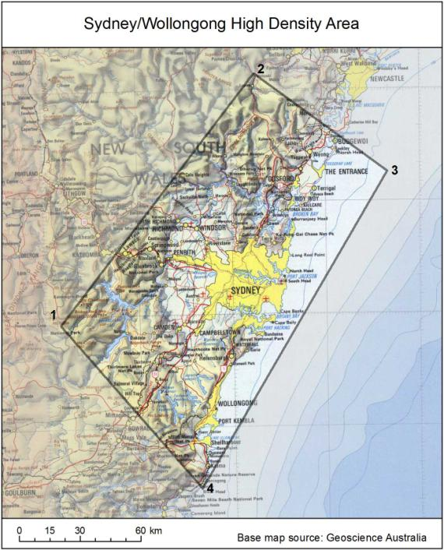
Coordinates
Point number | Zone | Easting | Northing
1 | 56 | 230000 | 6230000
2 | 56 | 325000 | 6355000
3 | 56 | 391000 | 6307000
4 | 56 | 300000 | 6150000

Melbourne/Geelong high-density area
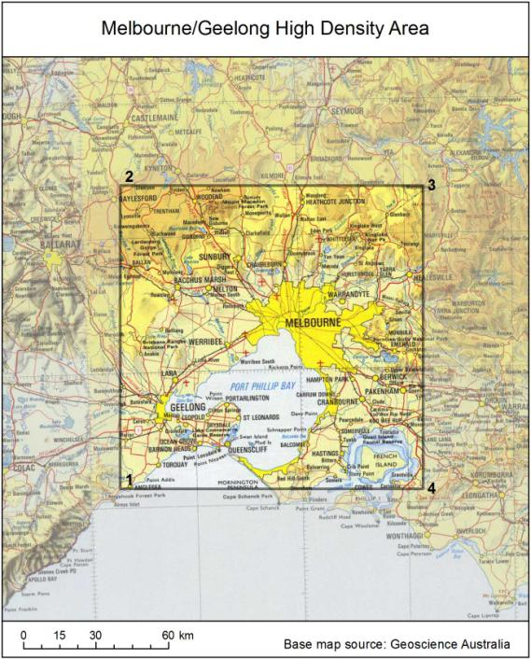
Coordinates
Point number | Zone | Easting | Northing
1 | 55 | 250000 | 5743000
2 | 55 | 250000 | 5868000
3 | 55 | 375000 | 5868000
4 | 55 | 375000 | 5743000

Brisbane/Gold Coast high-density area
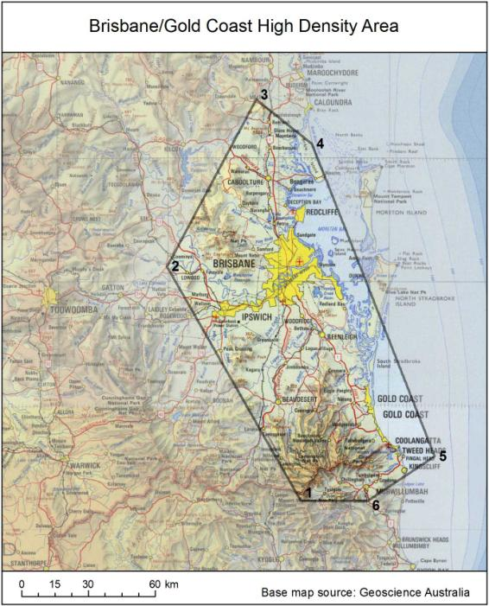
Coordinates
Point number | Zone | Easting | Northing
1 | 56 | 510000 | 6860000
2 | 56 | 450000 | 6965000
3 | 56 | 490000 | 7040000
4 | 56 | 515000 | 7020000
5 | 56 | 570000 | 6880000
6 | 56 | 540000 | 6860000

Perth medium-density area
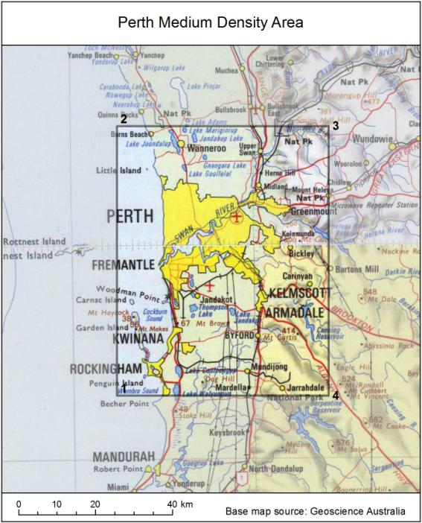
Coordinates
Point number | Zone | Easting | Northing
1 | 50 | 370000 | 6420000
2 | 50 | 370000 | 6490000
3 | 50 | 425000 | 6490000
4 | 50 | 425000 | 6420000

Adelaide medium-density area
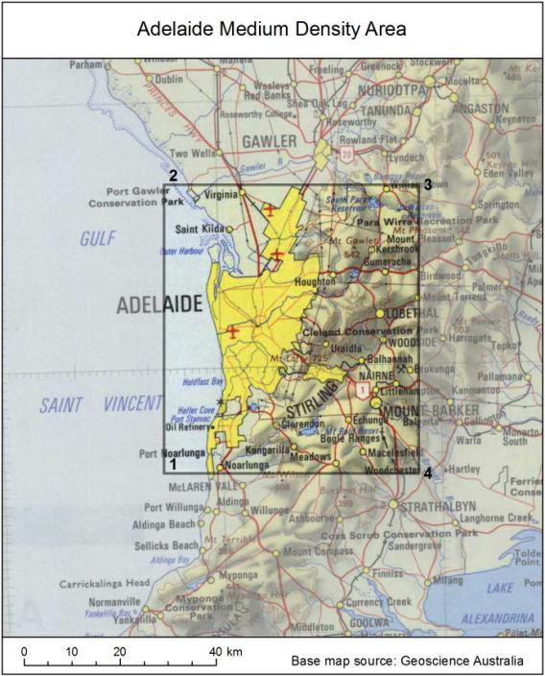
Coordinates
Point number | Zone | Easting | Northing
1 | 54 | 260000 | 6102250
2 | 54 | 260000 | 6162250
3 | 54 | 313000 | 6162250
4 | 54 | 313000 | 6102250

Newcastle medium-density area
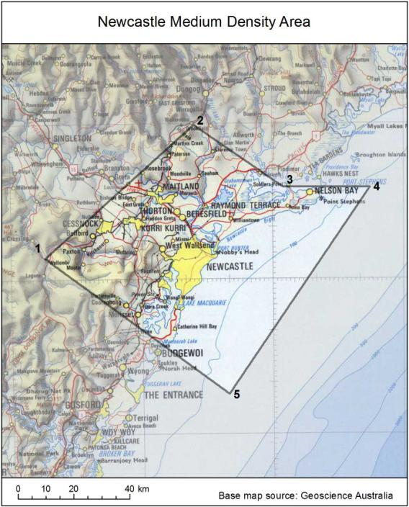
Coordinates
Point number | Zone | Easting | Northing
1 | 56 | 325000 | 6355000
2 | 56 | 378000 | 6403000
3 | 56 | 410000 | 6381000
4 | 56 | 441000 | 6381000
5 | 56 | 391000 | 6307000

East Australia low-density area
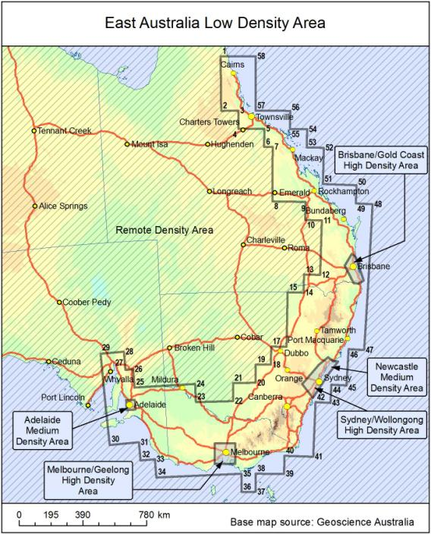
Coordinates
Point number | Zone | Easting | Northing
1 | 55 | 285979 | 8230029
2 | 55 | 289466 | 7897969
3 | 55 | 394745 | 7898866
4 | 55 | 395390 | 7788199
5 | 55 | 552303 | 7788433
6 | 55 | 551965 | 7677763
7 | 55 | 603933 | 7677519
8 | 55 | 601715 | 7345403
9 | 56 | 194772 | 7342512
10 | 56 | 197180 | 7231690
11 | 56 | 298153 | 7233553
12 | 56 | 303332 | 6901175
13 | 56 | 204955 | 6899158
14 | 56 | 207728 | 6788292
15 | 55 | 694822 | 6790354
16 | 55 | 688928 | 6457804
17 | 55 | 594458 | 6459115
18 | 55 | 593418 | 6348256
19 | 55 | 500000 | 6348700
20 | 55 | 500000 | 6237831
21 | 55 | 361472 | 6236817
22 | 55 | 363117 | 6125916
23 | 54 | 682517 | 6125116
24 | 54 | 684711 | 6236028
25 | 54 | 315289 | 6236028
26 | 54 | 313152 | 6346924
27 | 54 | 266429 | 6345924
28 | 54 | 263828 | 6456821
29 | 53 | 688928 | 6457804
30 | 53 | 677963 | 5903244
31 | 54 | 322037 | 5903244
32 | 54 | 324396 | 5792283
33 | 54 | 412201 | 5793699
34 | 54 | 413407 | 5682733
35 | 55 | 413407 | 5682733
36 | 55 | 414639 | 5571749
37 | 55 | 500000 | 5572227
38 | 55 | 500000 | 5683208
39 | 55 | 673192 | 5681306
40 | 55 | 675604 | 5792283
41 | 56 | 324396 | 5792283
42 | 56 | 317483 | 6125116
43 | 56 | 408746 | 6126487
44 | 56 | 407650 | 6237380
45 | 56 | 500000 | 6237831
46 | 56 | 500000 | 6459552
47 | 56 | 594458 | 6459115
48 | 56 | 601715 | 7345403
49 | 56 | 500000 | 7345764
50 | 56 | 500000 | 7456471
51 | 56 | 295007 | 7455073
52 | 56 | 292110 | 7676544
53 | 56 | 188106 | 7674916
54 | 56 | 186073 | 7785698
55 | 55 | 709244 | 7787262
56 | 55 | 710534 | 7897969
57 | 55 | 500000 | 7899165
58 | 55 | 500000 | 8231059

Western Australia low-density area
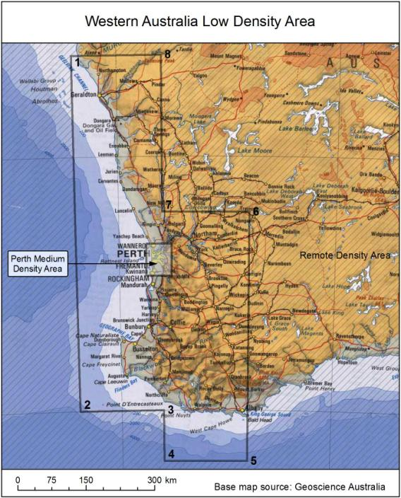
Coordinates
Point number | Zone | Easting | Northing
1 | 50 | 204955 | 6899158
2 | 50 | 226201 | 6122830
3 | 50 | 408746 | 6126487
4 | 50 | 409871 | 6015575
5 | 50 | 590129 | 6015575
6 | 50 | 595369 | 6559624
7 | 50 | 404620 | 6559624
8 | 50 | 401674 | 6902384

Tasmania low-density area
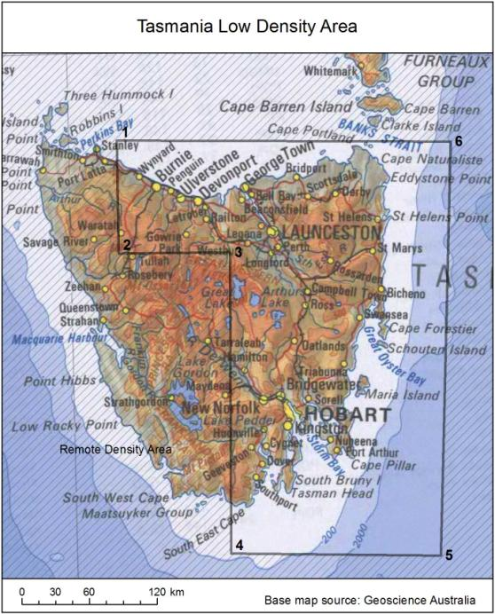
Coordinates
Point number | Zone | Easting | Northing
1 | 55 | 373275 | 5493447
2 | 55 | 374996 | 5393531
3 | 55 | 473608 | 5394569
4 | 55 | 474609 | 5128061
5 | 55 | 660350 | 5126166
6 | 55 | 668969 | 5492606

Darwin low-density area
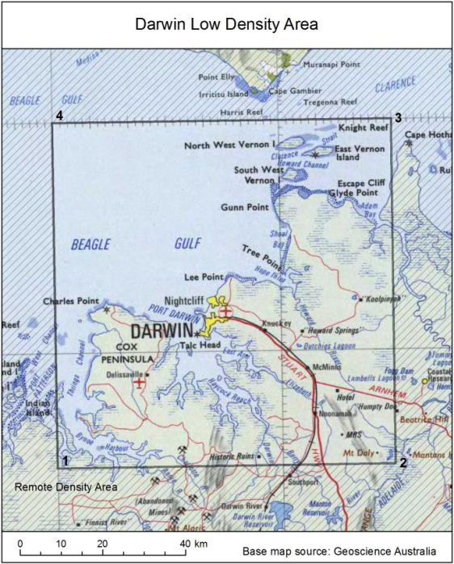
Coordinates
Point number | Zone | Easting | Northing
1 | 52 | 662841 | 8590035
2 | 52 | 744293 | 8589447
3 | 52 | 744992 | 8672441
4 | 52 | 663306 | 8672997

Appendix G –
Estimating population: using the hierarchical cell identification scheme (HCIS)
The Radiocommunications (Transmitter Licence Tax) Determination 2025 (the Tax Determination) sets out the assigned apparatus licences that are subject to an annual apparatus licence tax. An annual apparatus licence tax is payable by holders of Public Mobile Telecommunications Service Class B (PMTS Class B) licences and area-wide licences as specified in the Tax Determination, which is equal to a dollar amount multiplied by the bandwidth in MHz and population for each relevant HCIS block. This appendix describes the methodology for determining the population of geographic areas for the purpose of the Tax Determination, where the ACMA uses the HCIS framework to define the geographic area.
The ACMA is using the HCIS framework to determine the population of an area for the purposes of calculating the tax payable for PMTS Class B licences and area-wide licences. HCIS identifiers are used to describe the relevant geographic area applicable to a licence.
The HCIS is a naming convention developed by the ACMA that applies unique labels to each 5-minute of arc square cell (ASMG cell) in the ASMG, derived from the cell’s position in a hierarchically arranged grouping of cells. The hierarchy has 6 levels – the smallest level being HCIS Level 00 for the 20 x 15 seconds of arc (approximately 500 m x 500 m) and the largest being HCIS Level 4 (approximately 330 km x 330 km).
To determine the population of a geographic area, the ACMA has published, for licensees, the Hierarchical cell identification scheme (HCIS) – List of population data (Population document). The Population document identifies each ASMG cell and ASMG block (a grouping of ASMG cells) by its HCIS identifier and lists the corresponding population.
The population figures listed in the Population document have been calculated by reference to the population estimates and dispersion reported in the 2021 Census.

PMTS Class B
The first step in calculating the total population of the HCIS area is to identify the geographic area specified in the PMTS Class B licence by reference to the HCIS identifiers for the HCIS cells and HCIS blocks that constitute the geographic area. It is strongly recommended that the licensee review the definition of ‘population of an HCIS block’ in Part 1 of the Transmitter Licence Tax Determination to consider the appropriate geographic area to be included in the calculation of the tax. It is noted that the minimum geographic area is based on the HCIS Level 2 block.
The licensee must then use the Population document to calculate the total population applicable to the licence by determining the sum of the population of the HCIS blocks.

Area-wide
To determine the total population of the HCIS area for an area-wide licence, the licensee must identify the geographic area to be specified in the licence by reference to the HCIS identifiers for the HCIS cells and HCIS blocks that constitute the geographic area. It is strongly recommended that the licensee review Part 10 of the Tax Determination to consider the appropriate geographic area to be included in the calculation of the tax. It is noted that the minimum geographic area will vary depending on the licensing arrangements for the area-wide licence, for licences in:
- the 26/28 GHz band, the minimum geographic area is based on the HCIS Level 00 cell
- the 3.4 to 4 GHz band, the minimum geographic area is based on the HCIS Level 0 cell.
The licensee can then use the Population document to calculate the total population applicable to the licence by determining the sum of the population of the HCIS blocks. However, it is noted that the ACMA has developed area-wide licence tax calculators to assist licensees with these calculations.

Using the HCIS to Placemark Converter
To further assist licensees, the ACMA has also developed an electronic database, the HCIS to Placemark Converter.
The HCIS to Placemark Converter converts the HCIS identifiers specified in the licence to a placemark on the ASMG. The placemark is generated using the HCIS to KML converter. The HCIS to Placemark Converter will display the geographic area for a licensee, represented as a map (placemark), which is identified in the licence by reference to the HCIS identifiers for the area.
The population estimate for the placemark generated using the converter is available by viewing the description of the ‘Geographic area for HCIS description’ feature in the displayed placemark. The population estimate displayed using the placemark converter is based on the population data in the Population document. The population determined using the Population document and the population displayed using the placemark converter will be the same for a geographic area. Licensees can use the placemark converter to verify population calculations made using the Population document.
Geographic Information System (GIS) software is used to identify the location of an ASMG cell or ASMG block within the ASMG by using a ‘point-in-polygon’ query.
ASMG boundary data, including HCIS labels, is available on the ACMA website in Shapefile format for use with GIS software:
- GDA94 datum (ZIP archive):
http://channelfinder.acma.gov.au/interforms/placemarks/asmg/ASMG_2012_GDA94.zip
- AGD66 datum (ZIP archive):
http://channelfinder.acma.gov.au/interforms/placemarks/asmg/ASMG_2012_AGD66.zip.
Please note that an application capable of displaying placemarks (also known as KML files) will be required to use the ACMA’s HCIS to Placemark Converter database. The HCIS to Placemark Converter webpage also contains instructions on how to use the converter.

Appendix H –
Contact information
For licensing enquiries, contact the ACMA on:
Telephone: 1300 850 115
Website: www.acma.gov.au
Email: info@acma.gov.au
Mail:
Canberra office
PO Box 78
Belconnen ACT 2616
Melbourne office
PO Box 13112
Law Courts
Melbourne Vic 8010
Sydney office
PO Box Q500
Queen Victoria Building
NSW 1230

Local terrain clutter may reduce practicably achievable ranges to substantially less than a 2-kilometre radius. Frequency re-use distances applicable to low power spectrum accesses are such that ranges will ultimately be interference limited to a maximum of approximately 2 kilometres.
See RALI LM8.
For a PMTS Class B licence, if the amount for an HCIS level 2 block is below minimum tax, the amount is rounded to the minimum tax for that block. For an area-wide licence, the minimum tax is applied on the licence level.
Access further information about the ASMG and the HCIS scheme is provided at https://www.acma.gov.au/australian-spectrum-map-grid.
The Population document is available on the ACMA website at https://www.acma.gov.au/convert-hcis-area-description-placemark
The census is the Census of Population and Housing conducted by the Australian Bureau of Statistics (ABS). The 2021 Census data can be accessed on the ABS website at www.abs.gov.au.
The HCIS to Placemark Converter is an electronic database published by the ACMA, which allows the conversion of HCIS identifiers to geographic locations (placemarks) on the ASMG.

