Frequency plan for services in the 900 MHz band
890-960 MHz
Radiocommunications Assignment and Licensing Instruction
rali: MS 41
date of effect: 5 MARCH 2026

.
Amendment history
Date | Comments
August 2015 | Initial draft covering material taken from the Radiocommunications 900 MHz Band Plan 1992
September 2015 | Finalised RALI following public consultation.
August 2018 | Updated to provide incremental allocation changes to support the 803-960 MHz review implementation plan until completion.
July 2020 | Updated to include provisions previously contained in Embargo 64 (See IFC 12/2020).
March 2026 | Editorial update to remove transitional text which was included to support the 803-960 MHz review implementation plan.

Suggestions for improvements to Radiocommunications Assignment and Licensing Instruction MS 41 may be addressed to:
The Manager, Spectrum Planning Section
Australian Communications and Media Authority
PO Box 78
Belconnen ACT 2616
or by email to: freqplan@acma.gov.au.
Please notify the ACMA of any inaccuracy or ambiguity found in this RALI, so that it can be investigated and appropriate action taken.

Contents
1 Frequency plan for services in the 900 MHz band 1
1.1 Purpose 1
1.2 History 1
1.3 Spectrum arrangements 1
1.3.1 Assignment conditions 2
1.4 Relationship with RALI MS 40 2
2 Exceptions 3
3 RALI Authorisation 4
Appendix A: Allocation and channelling arrangements 5

Frequency plan for services in the 900 MHz band

Purpose
The purpose of this Radiocommunications Assignment and Licensing Instruction (RALI) is to set out spectrum planning arrangements for radiocommunications services in the frequency band 890 to 960 MHz (known as the 900 MHz Band). The RALI specifies the service allocations including the frequency limits of each allocation segment, and the channelling arrangements within these segments (where applicable).
In making decisions, accredited frequency assigners and the ACMA’s officers should take all relevant factors into account and decide each case on its merits. Issues relating to this document that appear to fall outside the enunciated policy should be referred to:
The Manager, Spectrum Planning Section
Australian Communications and Media Authority
PO Box 78
Belconnen ACT 2616
or by email to: freqplan@acma.gov.au.

History
The ACMA commenced a review of arrangements in the 803–960 MHz frequency band in May 2011 (the Review). The scope of the Review included services operating within the band 820-960 MHz, as well as consideration of future use of the 803-820 MHz segment vacated as part of the digital dividend. In November 2015, the ACMA completed the Review and released its decision in the paper: ‘The ACMA’s long-term strategy for the 803-960 MHz band’ (the Decision paper). The Decision paper contains a range of decisions on reforms to the 803-960 MHz band, as well as a detailed plan for the implementation of these reforms (see Section 3.3 of the Decision paper).
This RALI previously contained incremental changes to the spectrum allocations in the 900 MHz band to support the implementation of the new arraignments in the 900 MHz band. These incremental changes aligned with the Review implementation plan detailed in the Decision paper. This implementation process concluded on 1 July 2021.
This RALI now reflects the final arrangements in the band at the completion of the review implementation process.

Spectrum arrangements
Spectrum allocation and channelling arrangements for the 900 MHz band are contained in Appendix A to this RALI.

Assignment conditions
Services are to be assigned in accordance with this RALI.
Arrangements other than those specified in this RALI may be authorised where such arrangements provide for more efficient use of the spectrum, when compared to the arrangements specified for that segment in this RALI.

Relationship with RALI MS 40
One outcome of the Review was to separate planning arrangements for the 803-960 MHz band into two distinct band plans – RALI MS 40 for the 803-890 MHz band and RALI MS 41 for the 890-960 MHz band. The reasons for creating two separate band plans are twofold:
- To provide the flexibility needed to make future revisions, in particular to implement the outcomes of the Review; and
To reflect a general change in community and industry-accepted nomenclature on the frequency extremes of both bands.
Although the planning arrangements in the range 803-960 MHz are split between the two administrative band plans, radiolocation services in the range 850-915 MHz are currently covered by both plans.

Exceptions
Exceptions to the requirements of this RALI for prospective assignments require case-by-case consideration by the Manager, Spectrum Planning Section.
A request for exemption from the requirements of this RALI would need to be accompanied by evidence to support the request.
All requests for exemptions should be submitted to freqplan@acma.gov.au.

RALI Authorisation
[Approved] 05/03/2026
Manager
Spectrum Planning Section
Spectrum Planning and Engineering Branch
Communications Infrastructure Division
Australian Communications and Media Authority

Appendix A: Allocation and channelling arrangements
The allocation and channelling arrangements for the 900 MHz band are set out in the following figure and tables:
Figure 1: 900 MHz band services (890 - 960 MHz) diagram
Table 1: Service allocations and channelling arrangements for primary services
Table 2: Service allocations and channelling arrangements for secondary services

- 900 MHz band (890 – 960 MHz) services diagram
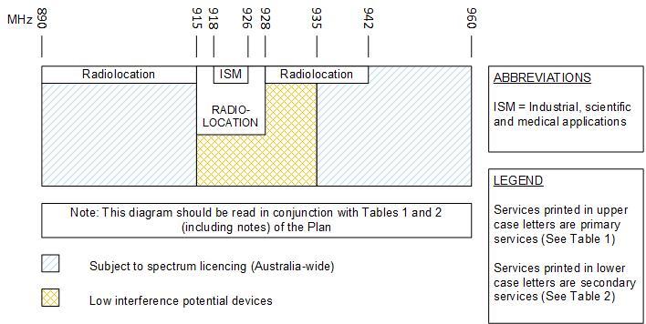

- Service allocations and channelling arrangements for primary services (note 1)
Item | Segment frequency limits (MHz)  (lower limit exclusion, upper limit inclusive) | Service allocation
1 | 890 – 915 | Subject to spectrum licensing (Australia-wide) (see note 2)
2 | 915 – 918 | Radiolocation (see note 3)
2 | 915 – 918 | Low interference potential devices (see note 4)
3 | 918 – 926 | Radiolocation (see note 3)
3 | 918 – 926 | Industrial, Scientific and Medical Applications
3 | 918 – 926 | Low interference potential devices (see note 4)
4 | 926 – 928 | Radiolocation (see note 3)
4 | 926 – 928 | Low interference potential devices (see note 4)
5 | 928 – 935 | Low interference potential devices (see note 4)
6 | 935 – 960 | Subject to spectrum licensing (Australia-wide) (see note 2)
Notes:
- The allocations for these primary services are represented in Figure 1.
- Information regarding the technical framework and current spectrum licence holders in the 890–915/935–960 MHz band is available on the ACMA website.
- Assignments to users other that the Department of Defence or the Australian Defence Force will not normally be authorised for this service.
- Stations operating in this allocation are authorised under the Radiocommunications (Low Interference Potential Devices) Class Licence 2025, as in force from time to time.

- Service allocations and channelling arrangements for secondary services (note 1)
Item | Segment frequency limits (MHz)  (lower limit exclusion, upper limit inclusive) | Service allocation
1 | 890 - 915 | Radiolocation (see note 2)
2 | 928 – 942 | Radiolocation (see note 2)
Notes:
- The allocations for these secondary services are represented in Figure 1.
- Assignments to users other than the Department of Defence or the Australian Defence Force will not normally be authorised for this service. In this segment the service is primary in offshore areas.

