Frequency coordination requirements for self-coordinated fixed point-to-point links in the 58 GHz, 75 GHz and 85 GHz bands

Radiocommunications Assignment and Licensing Instruction
rali: FX20
date of effect: 12th September 2025

Amendment history
Date | Comments
December 2007 | Initial release.
July 2015 | Updated 58 GHz band arrangements. The update includes:  - Widening the frequency range from 57.2–58.2 GHz to 57.1–‍58.9 GHz band in line with ITU–R Recommendation F.1497-‍2;  - Explicitly authorising channel aggregation.  - Removal of restrictions on use of two frequency (FDD) systems;  - Increasing the maximum EIRP from 15 dBW to 25 dBW;  Introduction of a maximum transmitter output power limit.
February 2016 | Updates to 58 GHz band arrangement:  - Decreasing the minimum antenna gain from 32 to 30 dBi in line with the ECC/REC/(09)/01;  Updates to 75 and 85 GHz bands arrangements:  - Replacing the minimum antenna gain from 43 dBi to be in line with the ETSI EN 302 217-4-2;  - Replacing the explicit EIRP limit (45 dBW) by the limits as defined by ETSI EN 302 217;  Introducing the minimum antenna radiation pattern requirement from ETSI EN 302 217-4-2 class 2 in addition to FCC Title 47 Part 101.115.
September 2025 | Updated coordination criteria for enhanced understanding. Other updates include:  - Improved description of the coordination criteria;  - Clarification of the ‘self-coordinated’ nature of these links and the role of Accredited Persons;  - Refinement of the no-interference/no-protection condition;  - Moving notification distance for Radio Astronomy Stations to RALI MS31.

Suggestions for improvements to Radiocommunications Assignment and Licensing Instruction FX20 may be addressed to:
The Manager, Spectrum Planning Section
Australian Communications and Media Authority
PO Box 78
Belconnen ACT 2616
or by email to: freqplan@acma.gov.au.
Please notify the ACMA of any inaccuracy or ambiguity found in this RALI so that it can be investigated, and appropriate action taken.

Contents
1 Introduction 1
1.1 Purpose 1
1.2 Scope 1
2 Background 2
2.1 Millimetre Wave Fixed Link 2
2.2 Equipment Standards 2
2.3 Licensing 2
3 System Planning 4
3.1 Band by Band Requirements 4
3.2 Radio Equipment Considerations 4
3.3 Minimum antenna performance requirements 4
3.4 Emission Criteria 4
4 Self-coordination 6
4.1 Equipment-based Self-coordination 6
4.2 Industry-based or Licensee Self-coordination 6
4.3 Self-coordination & Interference Management 7
5 Coordination Criteria 8
5.1 Self-coordination with links not yet operating 9
5.2 Coordination with other services 10
6 Exceptions 11
7 RALI Authorisation 12
Appendix 1 13
The 58 GHz Band (57–59 GHz) 13
The 75 GHz Band (71–76 GHz) 17
The 85 GHz Band (81–86 GHz) 20

Introduction

Purpose
The purpose of Radiocommunications Assignment and Licensing Instruction (RALI) FX20 ‘Millimetre Wave Point to Point (Self-coordinated) Stations’ is to provide information about, and outline, the necessary steps in the coordination and licensing of, fixed point to point (PTP) links in the 58, 75, and 85 GHz bands; 57–59 GHz, 71–76 GHz and 81–86 GHz respectively.
This RALI is primarily intended for use by the Australian Communications and Media Authority (ACMA), industry representatives, licensees or accredited assigners engaged in the coordination and licensing of millimetre wave point to point (self-coordinated) stations. It also provides links to useful background information of possible interest to telecommunications network operators, system planners and equipment manufacturers or importers.
Given the relatively short signal propagation distances at frequencies covered by this RALI, it is expected that services will be able to coexist with only minimal regulatory intervention, so this RALI only contains limited coordination and operating criteria. This means that while an accredited person is required to undertake an assessment for a proposed assignment in accordance with this RALI, there is an expectation that industry will work cooperatively through self-coordination, to ensure efficient use of the band.
The information in this document reflects the ACMA’s statement of current policy in relation to the coordination and licensing of millimetre wave point to point (self-coordinated) stations. In making decisions, accredited persons and ACMA officers should take all relevant factors into account and decide each case on its merits.
Issues relating to this document that appear to fall outside the policy should be referred to The Manager of the Spectrum Planning Section (contact details on page ii).

Scope
The scope of this RALI concerns the coordination and licensing of PTP (self-coordinated) stations operating in the Fixed Service comprising PTP radiocommunications links in the 58, 75, and 85 GHz bands; 57–‍59 GHz, 71–‍76 GHz and 81–86 GHz respectively.
This RALI provides instructions and guidance for the management of interference and compliance with relevant domestic and international radiocommunications regulatory requirements.
This RALI does not cover all matters relevant to the coordination and licensing of PTP links in the 58, 75, and 85 GHz bands. Arrangements for coexistence with other services in these bands, or adjacent bands, may be contained in other RALIs. In addition, other administrative documents produced by the ACMA from time to time may also be relevant.

Background

Millimetre Wave Fixed Link
The term ‘millimetre wave’, refers to the wavelengths of free space electromagnetic emissions in the frequency range 30 to 300 GHz. The frequencies in this range have physical properties including high propagation spreading and atmospheric absorption losses that limits their use to short-range applications. However, these losses together with the availability of conveniently sized highly directional antennas mean that dense frequency reuse patterns are possible. The state of technology development and the high level of frequency reuse that can be achieved, mean that there is greater bandwidth availability in these bands than in lower frequencies bands.
Regulatory arrangements for millimetre wave links vary around the world but in the particular bands that fall within the scope of this RALI, these arrangements are sometimes referred to as ‘light licensing’ arrangements. In Australia, we have adopted a similar light-touch approach, where access to the bands is via equipment or industry self-coordination, coupled with a minimal set of regulatory conditions contained in this RALI.

Equipment Standards
It is a requirement that equipment be operated in compliance with the technical conditions specified in a relevant ACMA licence. The arrangements in this RALI are based on an expectation that equipment is manufactured to conform with the requirements of ITU Radio Regulations, relevant ITU Recommendations and/or other recognised global or regional standards. For links in the 58 GHz band, the relevant standard is ETSI EN 302 217 v2.1.1, and for links in the 75 GHz and 85 GHz bands the relevant standards are either ETSI EN 302 217 v2.1.1 or FCC Rule 101.

Licensing
This section provides an overview of the licensing arrangements for PTP links in the 58, 75, and 85 GHz bands. Further information on apparatus licensing, including on how to apply for a licence, can be found on the ACMA website.

Licence conditions
The operation of stations that make up PTP links in the 58, 75, and 85 GHz band are authorised by a fixed licence, namely the Point-to-Point (Self-coordinated) Station licence option. As with all apparatus licences authorising fixed services, the operation of stations under this licence type are subject to:
- Conditions specified in the Radiocommunications Act 1992 (the Act), including an obligation to comply with the Act;
- Relevant conditions specified in an applicable determination made by the ACMA under section 107(1)(f) of the Act, including the:
- Radiocommunications Licence Conditions (Apparatus Licence) Determination 2025 (as is force from time to time),
- Radiocommunications Licence Conditions (Fixed Licence) Determination 2025 (as in force from time to time),
- Conditions specified in the licence.

Licence Fees
Licence fees for the PTP (self-coordinated) stations licence type are independent of the bandwidth used by the link and its geographic location (unlike most other licence options under the fixed licence type). The licence fee authorises two spectrum accesses covering both stations that make up the link.
This low-cost fixed fee structure reflects the bandwidth availability, spectrum reuse capability and the fact that the links are self-coordinated. A summary of ACMA Apparatus Licence fees is provided in the ACMA document Apparatus Licence Fees which also incorporates an overview of the Apparatus Licence Fee Framework and the available licence types.

Licence Applications & Station Registration
Licence applications should be made via an accredited person.
Once a licence has been issued, the station details provided in the licence application will be placed on the Register of Radiocommunications Licences (RRL). The information listed in the RRL includes technical parameters from the licence. In general, the details provided will be recorded on a first-in-time basis. Note that the applicants are required to submit the antenna radiation pattern envelope data to the ACMA. Data on the RRL can be referred to for the planning and coordination of millimetre wave PTP (self-coordinated) stations and other radiocommunications services.

System Planning

Band by Band Requirements
Band by band requirements are detailed in Appendix 1 for millimetre wave PTP (self-coordinated) stations. These band-by-band requirements include advice on bandwidth utilisation, minimum antenna performance, maximum EIRP and/or maximum transmit output power, and channelling or spectrum utilisation options.

Radio Equipment Considerations
In order to meet the minimum requirements for licensing, millimetre wave (self-coordinated) PTP station equipment must comply with the requirements set out in both Section 2.2 and Appendix 1 of this RALI.

Minimum antenna performance requirements
Minimum antenna performance requirements for millimetre wave self-coordinated links are specified in Appendix 1, in the form of antenna radiation patterns and/or minimum gain and other requirements.
For links in the 58 GHz band, the minimum antenna performance requirements are based on the class 2 radiation pattern envelope specified in the ETSI standard EN 302 217-4 Part 4.4.8 Figure 34.
For links in the 75 and 85 GHz bands, minimum antenna performance requirements are based on the ETSI standard EN 302 217-4 or FCC Rules Title 47 Part 101.115 ‘Directional antennas’.
Antennas used for millimetre wave links are highly directional, that is they have ‘pencil beam’ radiation patterns. However, it is still important that when registering a link that antenna details are provided to enable more accurate coordination, based on actual rather than nominal antenna characteristics. The ACMA has issued the antenna radiation pattern envelope data submission process to assist with data submission.

Emission Criteria
The relative power spectral density of a given radiofrequency emission may be defined as consisting of two components:
- the major ‘wanted signal’ portion of the transmitted spectra is normally defined as being within the ‘necessary bandwidth’. The necessary bandwidth is a key parameter in frequency coordination and its value is recorded in the ACMA's RRL database as part of the emission designator field used to characterise the nature of a given radiocommunications service emission; and
- the remaining ‘unwanted emissions’ that fall outside of the necessary bandwidth. Unwanted emissions include out-of-band and spurious emissions, which are defined in the ITU’s Radio Regulations.
It is expected that the bandwidth of a fixed service emission is wholly contained within the frequency limits of the relevant channel (see Appendix 1 for channel arrangements) as recorded in the ACMA's RRL database.

Self-coordination
This section provides an overview of the self-coordination process intended to facilitate successful coordination and improved spectrum utility. Self-coordination is made possible in millimetre wave bands by the physical characteristics of propagation and fixed link equipment used.
There are two types of self-coordination that are described in the following sections: equipment-based and industry-based self-coordination. While the ACMA encourages self-coordination between affected parties, an Accredited Person (AP) is still required to certify that an assignment of a proposed link is made in accordance with this RALI, preferably taking into account any arrangements developed through the self-coordination process. APs will also usually submit the licence application on behalf of the applicant.

Equipment-based Self-coordination
Equipment-based self-coordination systems rely on the equipment monitoring available channels in the band at the station site and ‘negotiating’ with the equipment at other station sites to use a common or a pair of common channels that do not contain emissions from other PTP link equipment, which is a listen before transmit protocol. As it is possible that transmissions from another station in the area might not be detected, because of weather conditions or other reasons at one or both ends of a link, the stations should be capable of re-selecting an appropriate channel within the band to use.
The equipment self-coordination procedure is typically carried out for the 58 GHz links. Equipment self-coordination is not permitted in the 75 and 85 GHz bands.

Industry-based or Licensee Self-coordination
Industry-based self-coordination refers to negotiation, discussion, and agreements between relevant stakeholders to improve the efficient assignment and use of PTP stations in these bands. As discussed previously, this RALI only provides a minimal set of coordination and licensing requirements, therefore additional self-coordination between industry parties is encouraged, as a supplement to the mandatory requirements.
In many cases it might be possible for a PTP link to be assigned and operated only using the coordination criteria in this RALI, that is without any additional negotiations with other licensees, particularly in regional and rural areas where the numbers of millimetre wave self-coordinated links are low. In metropolitan or other areas where there is significant demand for millimetre wave self-coordinated links, the coordination arrangements in this RALI alone may not provide for the most efficient use of the band. In these cases, more detailed coordination processes, developed by industry, may be beneficial. While the ACMA encourages industry self-coordination (and expects that industry self-coordination will be applied in high-demand areas), any self-coordination arrangements developed by industry are applied on a voluntary basis and will not be enforced by the ACMA.
The range of potential stakeholders involved in industry self-coordination may include equipment suppliers/manufacturers, existing and future licensees and APs. A common coordination desk or body could also be set up in-house within industry. The ACMA expects that suppliers, users and APs could benefit from cooperating to establish such arrangements, particularly in high demand areas.

Self-coordination & Interference Management
Consistent with the light-touch approach to point-to-point self-coordinated access to the 58, 75 and 85 GHz bands, the ACMA expects that licensees of self-coordinated stations will cooperate to manage and resolve interference between PTP self-coordinated stations without intervention from the ACMA. The following pre-defined special conditions must be included on new self-coordinated station licences:
- For 58 GHz band stations: Special condition 27: ‘No interference shall be caused to any radiocommunications station or service and no protection from interference by such stations or services shall be afforded.’
- For 75 and 85 GHz band stations: Special condition FX20A: ‘No interference shall be caused to, and no protection from interference shall be afforded from, other fixed point-to-point stations.’

Coordination Criteria
Coordination typically involves the calculation of the unwanted signal level of the proposed stations at each existing station in the database that potentially might suffer interference from the operation of the proposed link and vice versa. The calculation takes into account the antenna patterns of the existing and the proposed stations, antenna heights, antenna polarisation, buildings or other obstructions, antenna down tilt, emission overlap and other relevant factors considered as part of good engineering practice.
Self-coordinated link equipment typically has a built-in channel allocation procedure for selecting a channel with the interference level below the defined threshold. The technical details regarding the channel allocation procedure, including the interference avoidance requirements, are presented in the ETSI EN 302 217-3 standard.
Industry self-coordinated links have the coordination goal that the Carrier to Interference Ratio (C/I) of an existing link in the presence of emissions from the proposed link is not less than the Threshold to Interference Ratio (T/I) specified by the manufacturer of the existing link equipment.
Where information regarding the T/I for equipment making up an existing link is not available, then coordination may be based on a maximum interference level of –‍112 dBm/MHz. Derivation of this value was based on:
- An I/N of 6 dB
- A receiver noise figure (NF) of 8 dB (typical for equipment operating in these bands)
- Receiver noise (dBm/MHz) = 10log(kTB) + 30 + NF
Where:
k = Boltzmann’s constant
T = 290 K (the typical ambient temperature for terrestrial services)
B = receiver bandwidth (normalised to 1 MHz)
NF = receiver noise figure
Propagation in these bands is typically line of sight and a propagation model combining free space attenuation (ITU-R Rec. P.525) plus atmospheric absorption should be used for assessing the levels of potential interference. However, for interference emissions over potentially obstructed paths the use of more complex propagation models might be used.
Note that oxygen gas abortion attenuation, especially for the 58 GHz links, is considerable, and has to be taken into account while planning and coordinating the links. The level of attenuation by atmospheric gases should be taken from the ITU-R Rec. P.676. The radio propagation in those frequency bands is also characterized by very high rain attenuation (ITU-R Rec P.530 and ITU-R Rec. P.838). Licensees should take into account this effect when planning links as the rain attenuation significantly affect the path length of the links.

Self-coordination with links not yet operating
While recognising that it takes time to establish new radiocommunications services because of the need to import equipment, gain building approvals or arrange for supply of utilities, ACMA encourages licensees to start operating services as soon as practicable after licence issue noting the first-in-time status envisioned in this RALI and described in the following.
For self-coordinated links in the millimetre wave bands, 12 months is considered a reasonable length of time after licence issue for a link to be operational.
When a prospective licence applicant is undertaking self-coordination or licensees of self-coordinated stations are working to manage and resolve interference between self-coordinated stations, ACMA encourages applicants and licensees to adopt the following principles:
Self-coordinated stations should commence operation within the first 12 months of the date of licence issue.
Should self-coordinated stations not commence operation within 12 months of licence issue, then the first in time principle does not need to be applied, that is, self-coordination with those stations is not required.
Licensees should retain documents or other evidence as to the commencement date of operation to assist resolution of interference between licensees of self-coordinated stations.
Because self-coordinated stations operate on a no interference/no protection basis with each other, the ACMA expects that licensees operating self-coordinated stations will cooperate to manage and resolve questions of interference between self-coordinated stations.

Coordination with other services
As per the Australian Radiofrequency Spectrum Plan, the following radiocommunications services are allocated in relevant or adjacent bands:
- Fixed-Satellite Service
- Mobile Service
- Mobile-Satellite Service
- Amateur and Amateur-Satellite Service
- Broadcasting Service
- Broadcasting Service
- Radionavigation Service
- Radiolocation Service
- Space Research Service
- Radio-Astronomy Service
Coordination with stations operating in other services is required. In some cases, coordination arrangements have been established either in the below sections, or in other policy documents, for example RALIs and embargoes. In the absence of explicit coordination procedures, APs are to assess coexistence using best engineering practice. This includes using applicable provisions and parameters contained in relevant legislation and the ITU Radio Regulations, recommendations and reports, as well as any special conditions on individual licences.

Radio-astronomy Service
Prospective licensees intending to operate in the 58 GHz band are required to provide notification information to the CSIRO if the proposed sites of the stations are within 10 km of the Paul Wild Observatory, the Mopra Observatory and the Canberra Deep Space Communications Complex, coordinates of which can be found in Table 1. The notification procedure and contact details can be found in RALI MS31.
- Co-ordinates of Observatory Locations (Geocentric Datum of Australia 1994)
Location | Latitude | Longitude
Paul Wild Observatory Narrabri | 30° 18' 46.40" S | 149° 33' 0.44" E
Mopra Observatory Coonabarabran | 31° 16' 04.12" S | 149° 05' 58.72" E
Canberra Deep Space Communication Complex Tidbinbilla | 35° 23' 54.46" S | 148° 58' 39.66" E

Devices Operated Under Class Licences
Under the Radiocommunications (Low Interference Potential Devices) Class Licence, there are currently arrangements in place allowing the use of transmitters in and adjacent to the 58, 75 and 85 GHz bands. While there is no requirement to coordinate with such devices it is useful in the planning of millimetre wave self-coordinated links to be aware of their existence.

Exceptions
Exceptions to the requirements of this RALI for prospective assignments require case-by-case consideration by the Manager, Spectrum Planning Section.
A request for exemption from the requirements of this RALI would need to be accompanied by evidence to support the request.
All requests for exemptions should be submitted to freqplan@acma.gov.au.

RALI Authorisation
Approved 8th September 2025

Manager
Spectrum Planning Section
Spectrum Planning and Engineering Branch
Communications Infrastructure Division
Australian Communications and Media Authority

Appendix 1

The 58 GHz Band (57–59 GHz)
- RF Channel Arrangements
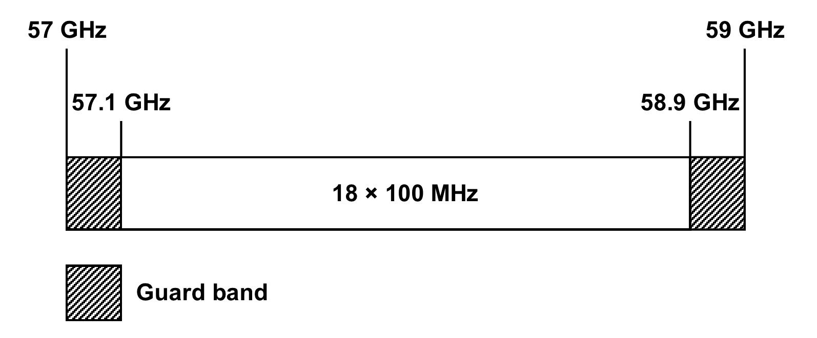
The centre frequencies of individual channels are expressed by the following relationship:
$$f_{n}=f_{r}+100n (\text{MHz})$$
Where:
- $f_{n}$ is the centre frequency of a channel in the band 57.1–58.9 GHz
- $f_{r}$ is the reference frequency, 57050 MHz
- $n$ is the channel number, 1 to 18
Assignment Requirements
This band is designated for use by self-coordinated fixed point-to-point links. Self-coordination will typically be carried out by the link station equipment.
Typical Use : fixed local area network extension
Assignment Priority : not specified.
Minimum Path Length : not specified.
Antenna Requirements : minimum gain 30 dBi.
Notes:
- Detailed frequency coordination is not required in this band. Licensing and technical details of the self-coordinated link are required to recorded in the register of radiocommunications licences (RRL).
- For equipment self-coordination, equipment should listen for a free channel before transmission to recognise existing transmissions to minimise the risk of interference and to ensure continued operation of existing transmissions (see ref. 2).
- Channel aggregation is permitted to enable wider bandwidth. Single frequency (TDD) systems and two frequency (FDD) systems may use any channel. (see refs. 1 and 2).
- Licences are to include Special Condition 27: ‘No interference shall be caused to any Radiocommunication station or service and no protection from interference by such stations or services shall be afforded.’
- System EIRP is limited to a maximum of 25 dBW.
- The maximum output power should be limited to 10 dBm.

- Antenna Compliance Requirements
For the 58 GHz band, the minimum requirements for antenna compliance have been specified in terms of minimum antenna gain and radiation pattern envelope shown in Figure 1 and Table 2 (ref 3, class 2 antennas for the 47–‍66 GHz band).
- Radiation pattern for antennas used in the 58 GHz band.
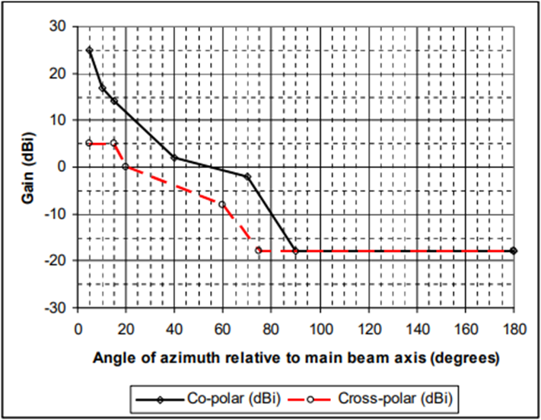

- Radiation pattern for antennas used in the 58 GHz band.
Angle  (°) | Co-polar  (dBi) | Angle  (°) | Cross-polar  (dBi)
5 | 25 | 5 | 5
10 | 17 | 15 | 5
15 | 14 | 20 | 0
40 | 2 | 60 | –8
70 | –2 | 75 | –18
90 | –18 | 180 | –18
180 | –18

References
- ITU-R Recommendation F.1497-2 ‘Radio-frequency channel arrangements for fixed wireless systems operating in the 55.78–‍66 GHz band’.
- ECC Recommendation (09)01 ‘Use of the 57–64 GHz Frequency Band for Point-to-Point Fixed Wireless Systems’, May 2009.
- ETSI EN 302 217-4-2 v2.1.1 (2017-05) Fixed Radio Systems; Characteristics and Requirements for Point-to-point Equipment and Antennas; Part 4: Antennas.

The 75 GHz Band (71–76 GHz)
- RF Channel Arrangements
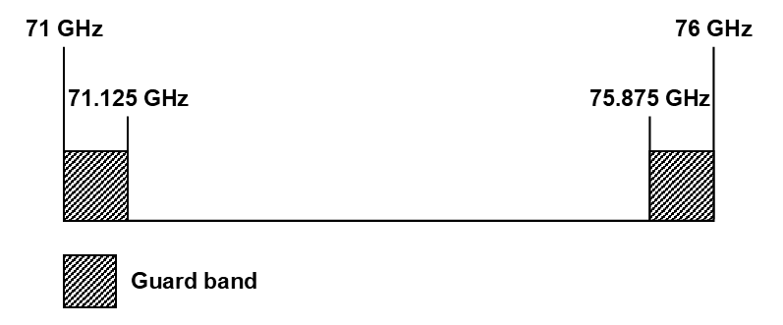
Assignment Requirements
This band is designated for use by self-coordinated fixed point-to-point links. Self-coordination by link station equipment is not permitted in this band.
Typical Use : high capacity, short haul data links.
Assignment Priority : none.
Minimum Path Length : not specified.
Antenna Requirements : see note 5.
Notes:
- Licensing and technical details of the self-coordination link are required to recorded in the register of radiocommunications licences (RRL).
- No channel plan between the guard bands is specified. Single frequency (TDD) systems and two frequency (FDD) systems may use all or any portion of the band between the guard bands.
- Licences are to include Special Condition FX20A: ‘No interference shall be caused to, and no protection from interference shall be afforded from, other fixed point-to-point stations’.
- EIRP limits and minimum antenna gain requirements are defined by the ETSI EN 302 217-3 (see ref. 2).
- Maximum transmitter power shall not exceed 30 dBm.

- Antenna Compliance Requirements
For the 75 GHz band, the minimum requirements for antenna radiation pattern are defined by either ETSI standard EN 302 217-4 v2.1.1 class 2 antennas for the 66–86 GHz band shown in Figure 2 and Table 3, or the requirements specified in the FCC Title 47 Part 101.115 shown in Table 4.
- Radiation pattern for antennas used in the 75 GHz band (ETSI standard).
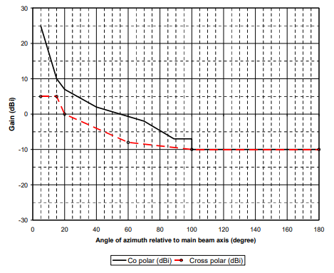
- Radiation pattern for antennas used in the 75 GHz band (ETSI standard).
Angle  (°) | Co-polar  (dBi) | Angle  (°) | Cross-polar  (dBi)
5 | 25 | 5 | 5
15 | 10 | 15 | 5
20 | 7 | 20 | 0
40 | 2 | 60 | –8
70 | –2 | 100 | –10
88.75 | –7 | 180 | –10
100 | –7
100 | –10
180 | –10

- Minimum antenna gain and minimum radiation suppression to angle requirement for antennas used in the 75 GHz band (FCC rules).
Polar discrimination | Maximum beamwidths to 3 dB points (included angle in degrees) | Minimum antenna gain (dBi) | Minimum radiation suppression to angle in degrees from centreline of main beam in decibels
Polar discrimination |  | Minimum antenna gain (dBi) | 5°  to 10° | 10° to 15° | 15° to 20° | 20° to 30° | 30° to 100° | 100° to 140° | 140° to 180°
Co-polar | 1.2 | 43 | 35 | 40 | 45 | 50 | 50 | 55 | 55
Cross-polar | 1.2 | 43 | 35 | 50 | 50 | 55 | 55 | 55 | 55

References
- ETSI EN 302 217-4 v2.1.1 (2017–05) Fixed Radio Systems; Characteristics and Requirements for Point-to-point Equipment and Antennas; Part 4: Antennas.
- ETSI EN 302 217-3 v2.2.1 (2014–04) ‘Fixed Radio Systems; Characteristics and requirements for point-to-point equipment and antennas; Part 3: Equipment operating in frequency bands where both frequency coordinated and uncoordinated deployment might be applied’.
- The FCC Title 47 Part §101.115 ‘Directional antennas’.

The 85 GHz Band (81–86 GHz)
- RF Channel Arrangements
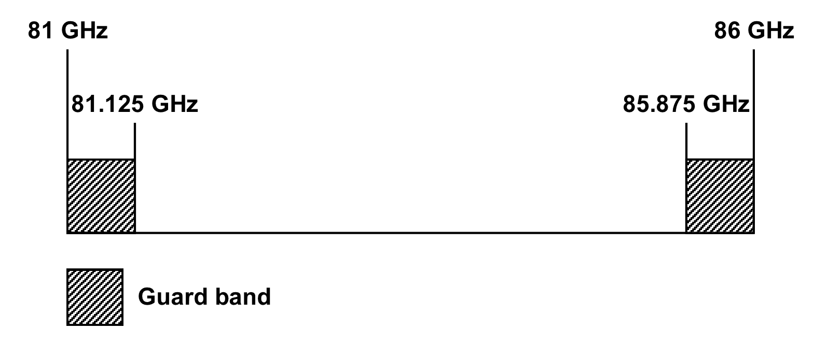
Assignment Requirements
This band is designated for use by fixed point-to-point links. Self-coordination by link station equipment is not permitted in this band.
Typical Use : high capacity, short haul data links.
Assignment Priority : none.
Minimum Path Length : not specified.
Antenna Requirements : see note 5.
Notes:
- Licensing and technical details of the self-coordination link are required to recorded in the register of radiocommunications licenses (RRL).
- No channel plan between the guard bands is specified. Single frequency (TDD) systems and two frequency (FDD) systems may use all or any portion of the band between the guard bands.
- Licenses are to include Special Condition FX20A: ‘No interference shall be caused to, and no protection from interference shall be afforded from, other fixed point-to-point’.
- EIRP limits and minimum antenna gain requirements are defined by the ETSI EN 302 217-3 (see ref. 2).
- Maximum transmitter power shall not exceed 30 dBm.

- Antenna Compliance Requirements
For the 85 GHz band, the minimum requirements for antenna radiation pattern are defined by either ETSI standard EN 302 217-4-2 class 2 antennas for the 66–86 GHz band show in Figure 3 and Table 5, or the requirements specified in the FCC Title 47 Part 101.115 shown in Table 6.
- Radiation pattern for antennas used in the 85 GHz band (ETSI standard).
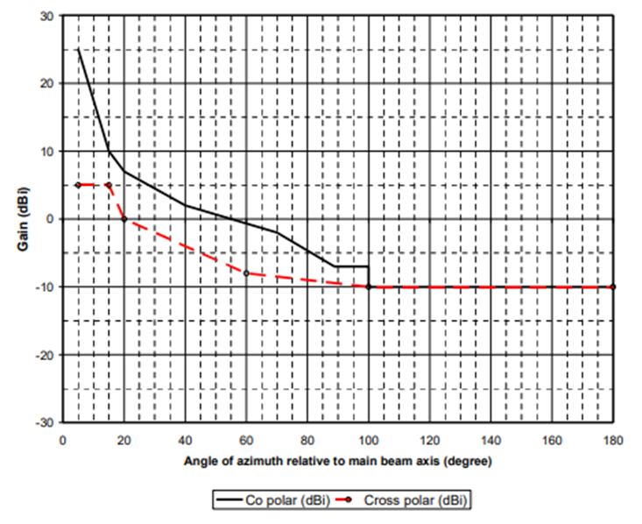
- Radiation pattern for antennas used in the 85 GHz band (ETSI standard).
Angle  (°) | Co-polar  (dBi) | Angle  (°) | Cross-polar  (dBi)
5 | 25 | 5 | 5
15 | 10 | 15 | 5
20 | 7 | 20 | 0
40 | 2 | 60 | –8
70 | –2 | 100 | –10
88.75 | –7 | 180 | –10
100 | –7
100 | –10
180 | –10

- Minimum antenna gain and minimum radiation suppression to angle requirement for antennas used in the 85 GHz band (FCC rules).
Polar discrimination | Maximum beamwidths to 3 dB points (included angle in degrees) | Minimum antenna gain (dBi) | Minimum radiation suppression to angle in degrees from centreline of main beam in decibels
Polar discrimination |  | Minimum antenna gain (dBi) | 5°  to 10° | 10° to 15° | 15° to 20° | 20° to 30° | 30° to 100° | 100° to 140° | 140° to 180°
Co-polar | 1.2 | 43 | 35 | 40 | 45 | 50 | 50 | 55 | 55
Cross-polar | 1.2 | 43 | 35 | 50 | 50 | 55 | 55 | 55 | 55

References
- ETSI EN 302 217-4 v2.1.1 (2017-05) Fixed Radio Systems; Characteristics and Requirements for Point-to-point Equipment and Antennas; Part 4: Antennas;
- ETSI EN 302 217-3 v2.2.1 (2014-04) ‘Fixed Radio Systems; Characteristics and requirements for point-to-point equipment and antennas; Part 3: Equipment operating in frequency bands where both frequency coordinated and uncoordinated deployment might be applied’;
- The FCC Title 47 Part §101.115 ‘Directional antennas’.

