Frequency coordination and licensing procedures for point to multipoint and short range wireless broadband apparatus licensed services in the 1900−1920 MHz band

Radiocommunications Assignment and Licensing Instruction
RALI FX19
date of effect: [date when made]

Amendment history
Date | Comments
[insert date when update finalised] | Updates to introduce arrangements for short-range wireless broadband (SR WBB) services in the range 1900-1920 MHz.
June 2023 | Removal of reference to the 1900-1920 MHz band plan after it sunset on 1 April 2023
December 2022  (approved but not released) | Removal of the 3575–3700 MHz band as arrangements for apparatus licensed point to multipoint services in this band are now contained in RALI MS47.  Coordination procedures between 1900–1920 MHz BWA services and Spectrum Licences have been updated to reflect current Spectrum Licence arrangements.  Previous Attachment 1A has been modified to include a HCIS description of the area available for apparatus licensed point to multipoint services and is now at Appendix A. References to Attachment 1 have been updated.  The references section has been removed. References are now contained in hyperlinks throughout the RALI.
July 2018 | Updated coordination criteria between BWA and spectrum licence services due to the increased frequency range of spectrum licence services up to 3700 MHz
March 2017 | Minor update to correct the frequency for channel 3 in Figure 1 and to add areas to the maps at Attachment 1a and 1b to reflect the permitted deployment areas described in the document.
July 2015 | Due to the Revocation of the 1900–1920 MHz and 2010–2025 MHz Bands Frequency Band Plan 2004 and the creation of the 1900–1920 MHz Frequency Band Plan 2012 all references to the 2010–2025 MHz band have been removed from this RALI.  Incorporated 20 MHz channelling arrangements into the 3575–3700 MHz band. Noting 15 MHz and 30 MHz channelling no longer apply to new licences. References updated.
8 August 2011 | Removed 30 MHz assignment limit on licensees operating in the same area in the 3.6 GHz band.
24 March 2010 | Updated coordination between BWA base stations and Fixed link receivers.
11 March 2010 | Updated to include coordination criteria between BWA in the 1900–1920 MHz band and PTS in the 1920–1980 MHz band, as well as specific criteria for coordination between 10 MHz and 20 MHz BWA systems in the 1900–1920 MHz band.
11 September 2009 | Update to include the 3575–3700 MHz band and coordination procedures with BWA services, point to point links, amateur services, radiolocation services, FSS Earth Stations, adjacent band spectrum licensed devices as well as the Radio Quiet Zone and other specific areas.  Removal of “roll out goals” and the 10 MHz spectrum acquisition limit in the 1900–1920 MHz and 2010–2025 MHz bands.  Addition of Attachment 5: ‘Coordination of BWA licences with adjacent channel 3.4 GHz spectrum licensed devices.  Addition of Attachment 6: ‘Coordination of BWA licences with Earth Stations’.  Removal of special conditions and specific advisory notes from RALI FX19 and placement in the Radiocommunications Licence Conditions (Fixed Licence) Determination 1997.
15 August 2007 | Update to clarify coordination requirements between BWA services as well as spectrum licensed areas.
26 April 2005 | Initial release.

Suggestions for improvements to Radiocommunications Assignment and Licensing Instruction FX19 may be addressed to:
The Manager, Spectrum Planning Section
Australian Communications and Media Authority
PO Box 78
Belconnen ACT 2616
or by email to: freqplan@acma.gov.au.
Please notify the ACMA of any inaccuracy or ambiguity found in this RALI.

Contents
1 Introduction 1
1.1 Purpose 1
1.2 Principles 1
1.3 Scope 2
1.4 Legislative and administrative background 4
1.4.1 BWA arrangements 4
1.5 Overview of coordination procedures 5
1.6 Overview of licensing 7
1.6.1 BWA licensing 7
1.6.2 SR WBB licensing 7
2 Potential interference mechanisms 8
2.1 BWA into BWA 8
2.1.1 Co-channel frequency coordination 8
2.1.2 Adjacent channel frequency coordination 8
2.2 BWA transmitter into fixed link receiver 9
2.3 Fixed link transmitter into BWA receiver 9
2.4 BWA services and 2 GHz Spectrum Licences 9
2.5 DECT services in the 1880–1900 MHz band 10
2.6 Coordination with specific regional areas 11
2.6.1 Australian Radio Quiet Zone Western Australia 11
2.7 BWA transmitters into PTS receivers in the 1920–1980 MHz band 11
2.8 Coexistence of SR WBB services with point to point and BWA 12
2.9 SR WBB transmitters into FRMCS receivers in the 1900–1920 MHz band 12
3 BWA coordination procedure 13
3.1 Overview coordination procedure 13
3.2 Detailed description of coordination procedure 13
3.3 Further options if coordination is unsuccessful 18
3.4 Assessing BWA into fixed links interference 18
3.5 Assessing fixed links into BWA interference 20
3.6 Assessing BWA into BWA interference 22
3.7 Assessing BWA transmitter to spectrum licensed receiver adjacent channel interference 23
3.8 Site engineering aspects 24
3.9 Assignment rules 25
3.9.1 Rules relating to applications for two or more 5 MHz channels 25
3.9.2 Rules relating to applications for one 5 MHz channel 25
3.9.3 Rules relating to applications for one 10 MHz channel 26
3.9.4 Rules relating to the application for one 15 MHz channel 26
4 SR WBB coordination procedure 27
5 Licensing 28
5.1 BWA licensing 28
5.1.1 Overview of licensing 28
5.1.2 Licence conditions 28
5.1.3 Advisory notes 28
5.1.4 Special conditions 29
5.1.5 Spectrum access records 29
5.2 SR WBB licensing 29
5.2.1 Overview of licensing 29
5.2.2 Licence conditions 29
5.2.3 Assignment Rules 30
5.2.4 Special conditions 30
5.2.5 Spectrum access records 30
6 Exceptions 31
7 RALI Authorisation 32
8 List of acronyms 33
Appendix A: Area available for apparatus licensed BWA and SR WBB services in the 1900–1920 MHz band 34
Appendix B: Protection criteria for BWA receivers in the 1900–1920 MHz band 36
B.1 Protection of BWA from fixed link transmitters 36
B.2 Protection of BWA from BWA 36
Appendix C: Protection criteria for fixed point to point receivers in the 1.8 and 2.1 GHz bands 37
Appendix D: Protection ratio correction factors 38
Appendix E: BWA service model 39
E.1 Equipment types 39
E.2 Deployment model and general equipment characteristics 39
E.3 Notional remote station 40
E.4 Deployment scenarios 40
E.5 Emission masks 41
E.6 Protection criteria 41

Introduction

Purpose
The purpose of this Radiocommunications Assignment and Licensing Instruction (RALI) is to provide information about and describe necessary steps for the frequency coordination and licensing of the following apparatus licensed services in the 1900–1920 MHz band:
- point to multipoint fixed broadband wireless access (BWA)
indoor-only short range wireless broadband (SR WBB) services.
This document reflects the ACMA’s statement of current policy in relation to frequency coordination and apparatus licensing of BWA and SR WBB services in the 1900–1920 MHz band. In making decisions, Accredited Persons and the ACMA’s officers must take all relevant factors into account and decide each case on its merits. Issues relating to this document that appear to fall outside the enunciated policy should be referred to:
The Manager, Spectrum Planning Section
Australian Communications and Media Authority
PO Box 78
Belconnen ACT 2616
or by email to: freqplan@acma.gov.au
A list of acronyms is provided at the List of acronyms section.
For coordination requirements and procedures between apparatus licensed point to multipoint services in the 3400–3700 MHz band with spectrum licences refer to RALI MS47 — Frequency coordination and licensing procedures for Area-Wide Licence (AWL) in the 3400–4000 MHz band.

Principles
The principles for coordination and operation of BWA services in the 1900–1920 MHz band are that:
- Apparatus licensed BWA services may only be licensed in defined regional and remote areas for 1900–1920 MHz.
- The operation of apparatus licensed BWA services must not cause unacceptable interference to other previously licensed BWA services or other licensed co-primary services as defined in the 1900–1920 MHz Frequency Band Plan 2012 and the Australian Radiofrequency Spectrum Plan 2021.
- The 1900–1920 MHz Frequency Band Plan 2012 previously defined the regulatory relationships between BWA and point to point fixed services in the 1900–1920 MHz band. It sunset on 1 April 2023 so point-to-point services are now co-primary with BWA services. Consequently, coordination of BWA with point to point fixed services will generally now need to be successful to licence the BWA service.

Remote stations are authorised to operate with a BWA base station as detailed in the Radiocommunications Licence Conditions (Fixed Licence) Determination 2025. A remote station means a fixed station that communicates with a base station or a supplementary base station (if any).
The principles for coordination and operation of SR WBB services in the 1900–1920 MHz band are that:
- Apparatus licenses for 1900–1920 MHz SR WBB services may only be issued for operation in defined metropolitan areas.
- Operation is limited to indoor only and on a ‘no interference, no protection’ basis.
- SR WBB services operate on a co-channel and adjacent channel basis with Future Rail Mobile Communications Services (FRMCS) in the frequency range 1900-1910 MHz. Arrangements for FRMCS are detailed in RALI [XX]. Proposed SR WBB assignments within a specified distance of defined railway lines will need to be coordinated with a nominal FRMCS at all locations along the railway line.
SR WBB devices are expected to adhere to the DECT 2020 NR Standard (ETSI TS 103 636)
An ACMA assigner or Accredited Person will conduct the frequency coordination in accordance with this RALI and other applicable RALIs. To satisfy themselves of the feasibility of a proposed BWA or SR WBB service, applicants may undertake coordination studies in accordance with the procedures in this RALI and other applicable RALIs prior to submitting the application.

Scope
The scope of the RALI involves detailing the steps necessary for frequency coordination and licensing of proposed BWA and SR WBB services. It covers frequency coordination between proposed BWA and SR WBB services and other previously licensed radiocommunications services identified in Table 1.
The RALI provides instructions that may be used by ACMA assigners and Accredited Persons for assessing whether proposed new BWA and SR WBB services will cause (or receive) unacceptable interference to (or from):
- existing BWA services
- point to point fixed links
- Pubic telecommunications service (PTS) base station receivers
- spectrum licensed spaces
- Future rail mobile communications services (FRMCS) operating in the range 1900-1910 MHz
other specific areas defined in section 2.6 such as the Australian Radio Quiet Zone
It is a requirement that coordination calculations be performed to assess potential interference to and from BWA and SR WBB services, as applicable. In some cases, the effect of remote BWA stations will need to be considered. Interference protection and requirements to protect other services are based upon the assumption that remote station deployments conform to the deployment model described in Appendix E.
If interference occurs after a licence is issued and the issue cannot be resolved between the affected parties, licensees can expect the ACMA to have regard to this RALI and relevant legislative instruments in dealing with the dispute.
If calculations indicate a likelihood of unacceptable interference, different processes apply according to the regulatory status of the service suffering the predicted unacceptable interference. As mentioned previously, for the 1900–1920 MHz band, in cases where potential unacceptable interference between the prospective BWA licensee and the point to point fixed link licensee is identified, it is intended that this should, in the first instance, trigger negotiation between the prospective BWA licensee and the point to point fixed link licensee.

Legislative and administrative background

BWA arrangements
Apparatus licensing arrangements in the 1900–1920 MHz band apply only outside the areas defined in Appendix A. Apparatus licensing arrangements previously also had to comply with the 1900–1920 MHz Frequency Band Plan 2012. The objectives of that frequency band plan were to:
- Promote the deployment of BWA by retaining the primary allocation for the mobile service and for the fixed service where used for point to multipoint applications in the 1900–1920 MHz band.
Give priority to BWA by demoting the regulatory status of the allocation for the fixed service where used for point to point applications from primary to secondary status in the 1900–1920 MHz band.
The frequency band plan established precedence for BWA services but did that in a way that pre-existing fixed point to point links need not be cleared unless they affect proposed BWA deployments.
That band plan is no longer in force so there is no longer precedence for new BWA services over fixed point to point links.
Prior to the preparation of the frequency band plan, the 1900–1920 MHz spectrum was predominantly used (in regional and remote areas) for point to point fixed services. Two point to point fixed service bands, the 1.8 and 2.1 GHz bands as detailed in Appendix 1 of RALI FX3 overlap in this frequency range. One main and two interleaved channels of the 1.8 GHz fixed band overlap the 1900–1920 MHz frequency band, as do the lowest main and interleaved channels of the 2.1 GHz fixed band. These relationships are illustrated in Figure 1.
Figure 1: Relationships between the 1900–1920 MHz band and the 1.8 and 2.1 GHz fixed point to point channels.

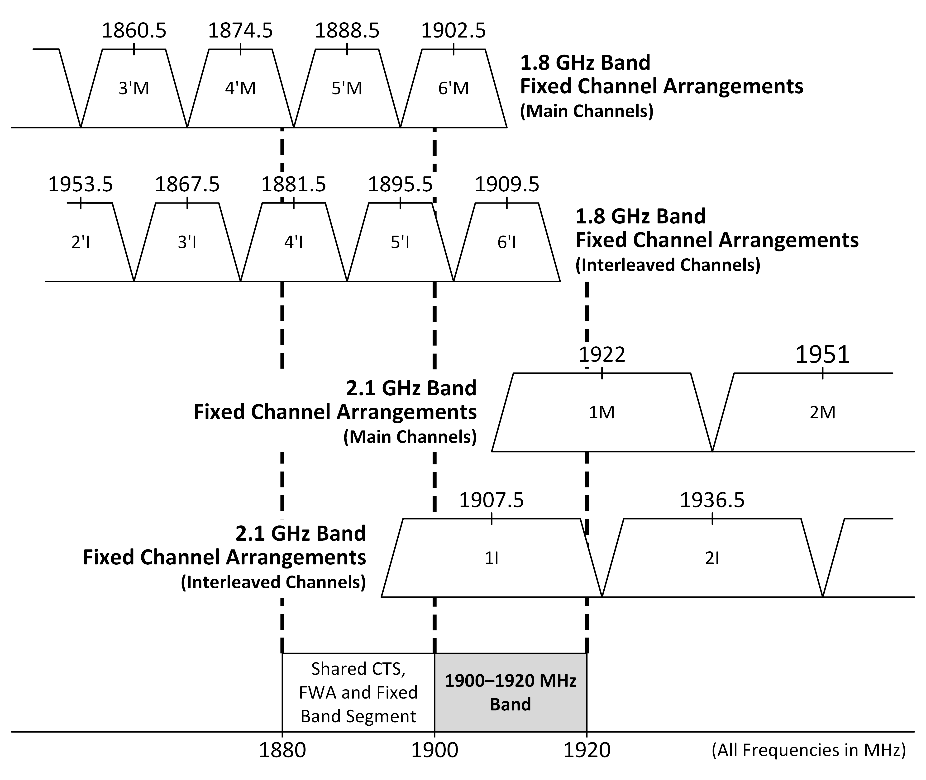
In November 2022, the ACMA realised the planning outcomes of the 1.9 GHz band with the release of Replanning of the 1880-1920 MHz band: Outcomes paper (the 1.9 GHz band outcomes paper). While no changes were proposed to point-to-point fixed links and BWA services, it was decided that FRMCS would be implemented in the 1900-1910 MHz frequency range and SR WBB would be implemented in metro areas on an indoor basis. The relationship of these services are shown in Figure 2.
Figure 2: Planning arrangements for 1.9 GHz spectrum
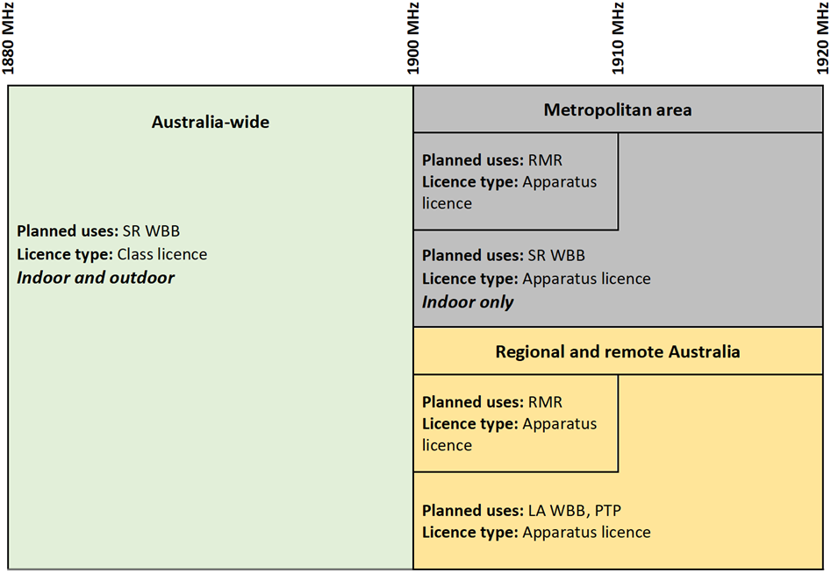
SR WBB operation is class licensed Australia wide in the 1880-1900 MHz band on an uncoordinated basis.
Arrangements for SR WBB in 1900-1920 MHz are intended to facilitate short range devices on a secondary basis to railway FRMCS. Therefore, SR WBB in this band will operate under a land mobile system apparatus license on a coordinated basis with respect to FRMCS systems.

Overview of coordination procedures
Information on BWA equipment characteristics and an assumed deployment model are provided in Appendix E. The deployment model provides assumed characteristics for the base station and for related remote stations. This RALI requires that coordination calculations be performed to assess potential interference, mainly to and from the BWA base station. In some cases, however, remote stations will need to be considered in the coordination process.
Section 2 of this RALI describes a range of potential co-channel and adjacent channel interference mechanisms that must be considered when making assessments of potential interference.
Section 3 provides details of a procedure for performing assessments of potential interference. Appendices B, C and D provide the applicable protection criteria to be used in performing the assessments.
Section 4 contains details of a procedure for performing assessments of potential interference from SR WBB services to FRMCS. This coordination procedure uses parameters and protection criteria included in RALI [XX].
A summary of potential interference scenarios and the applicable coordination procedure is given in Table 1. Not all interference scenarios are relevant for all deployments.
Table 1: Summary of potential interference mechanisms.
Interference mechanism | Coordination procedure
BWA into BWA  (see section 2.1) | Section 3 of this RALI
BWA Tx into Point to point Rx  (see section 2.2) | Section 3 of this RALI
Point to point Tx into BWA Rx  (see section 2.3) | Section 3 of this RALI
PTS Tx into BWA Rx  (see section 2.7) | RALI MS33
BWA Tx into spectrum licensed Rx  (see section 2.4 | Section 3 of this RALI
BWA Tx into class licensed DECT services  (see section 2.5) | No procedure required
Class licensed DECT services into BWA Rx  (see section 2.5) | No procedure required
Coordination required with specific regional areas  (see section 2.6) | Section 2.6 of this RALI
Coexistence of SR WBB with point to point and BWA  (see section 2.8) | No procedure required
FRMCS BS Tx into SR WBB | No procedure required
SR WBB into FRMCS BS Rx  (see section 2.9) | Section 4 of this RALI

Overview of licensing
This section provides a brief summary of licensing arrangements for BWA and SR WBB services. Detailed information about the licensing arrangements is provided in section 5 of this RALI.

BWA licensing
All transmitters in a BWA service (comprising one base station and any number of remote stations communicating with that base station) are to be licensed under one Fixed licence authorising a point to multipoint station.
Licences will only be issued for BWA services in the 1900–1920 MHz band outside the area defined in Appendix A.
In the 1900–1920 MHz band channel widths of 5, 10, 15 and 20 MHz apply.

SR WBB licensing
SR WBB transmitters (including land stations and land mobile stations) are to be licensed under a land mobile system licence.
Licences will only be issued for SR WBB services in the 1900–1920 MHz band inside the areas defined in Appendix A.
Given the expectation that SR WBB services will utilise DECT technologies, licences would typically authorise the operation of the entire 1900-1920 MHz frequency range. This will allow the DECT technology to dynamically allocate and operate channels within this frequency range. Also see special conditions in section 5.1.4.

Potential interference mechanisms

BWA into BWA

Co-channel frequency coordination
Frequency coordination procedures for assessing whether a proposed new BWA base station will cause (or suffer) unacceptable interference to (or from) previously licensed BWA base station receivers are detailed in section 3 of this RALI. These procedures deal only with the coordination of co-channel BWA base stations. The coordination of adjacent channel BWA base stations is not required for the assignment of new BWA base stations. Issues relating to the operation of base stations using adjacent channels are considered below.

Adjacent channel frequency coordination
The case of adjacent channel interference needs to be carefully considered. If time domain duplexing (TDD) technology is used in an uncontrolled manner, then adjacent channel transmitters and receivers could operate at the same time on immediately adjacent channels. This scenario is highly likely to cause adjacent channel interference, but it is not necessarily inevitable. However, it places significant demands on site engineering and co-operation between the adjacent channel licensees if interference is to be avoided.
The most straightforward method of avoiding risk of adjacent channel interference is for adjacent channel licensees to align the timing of the transmission and reception of signals from their base stations. There are also a wide range of other techniques (or more probably combinations of techniques) that might also be able to achieve the necessary levels of transmitter-to-receiver isolation. These could include use of very tightly specified transmitter and receiver filtering; guard bands; where multi carrier modulation systems are used switching off carriers; and/or, careful site engineering to minimise transmitter to receiver coupling at common sites.
Because of the difficulty of achieving the isolation required, the ACMA’s preference is that the timing alignment approach be followed. But if other approaches are followed the ACMA intends to encourage licensees to cooperate and, where necessary, equally compromise to resolve any adjacent channel interference. This approach recognises that with TDD systems the interference risk is bi-directional and will fall on both adjacent channel licensees.
The adjacent channel interference risk management principles outlined above are captured in the Radiocommunications Licence Conditions (Fixed Licence) Determination 2025. The conditions contained in this determination require that:
- No harmful adjacent channel interference shall be caused to base station receivers operating in accordance with RALI FX19.
Protection from harmful adjacent channel interference caused by base stations operating in accordance with RALI FX19 is not afforded.
It is noted that compliance with this licence condition will be considered satisfied where, in response to such interference:
- Affected licensees align their transmit/receive timing to avoid interference, or
Such other measures as may be agreed between affected licensees.

BWA transmitter into fixed link receiver
A consequence of the BWA deployment model is that BWA base station transmitters are the element of the BWA service most likely to interfere with incumbent point to point fixed service receivers.
For the 1900–1920 MHz band, interference mechanisms between BWA base transmitters and point to point fixed service receivers in the 1.8 GHz band arrangements and the 2.1 GHz band arrangements must be assessed.
Frequency coordination procedures for assessing whether a proposed new BWA base station transmitter will cause unacceptable interference to previously licensed point to point fixed service receivers must be performed according to the frequency coordination process outlined in section 3.

Fixed link transmitter into BWA receiver
For the 1900–1920 MHz band, interference mechanisms between BWA base station receivers and point to point fixed service transmitters in the 1.8 GHz band arrangements and the 2.1 GHz band arrangements must be assessed.
Frequency coordination procedures for assessing whether a proposed new BWA base station receiver will receive unacceptable interference from previously licensed fixed point to point fixed service transmitters must be performed according to the frequency coordination process outlined in section 3.

BWA services and 2 GHz Spectrum Licences
BWA services located near a 2 GHz Spectrum Licence boundary have the potential to cause interference to, and receive interference from, services operating under those spectrum licences. Unlike the BWA services described in this RALI, the 2 GHz Spectrum Licences are optimised to employ frequency division duplexing (FDD) with 1920–1980 MHz in capital cities and 1960–1980 MHz in regional areas used for base station receive. Interference consideration between BWA and spectrum licensed services is limited to adjacent channel cases between adjacent areas only. (Same-area adjacent-channel interference is not considered because it only applies to regional areas, in which there is a 40 MHz guard band between 1.9 GHz band BWA transmitters and 2 GHz base station receivers.)
There are four possible interference mechanisms:
- BWA base station transmitter into upper adjacent spectrum licensed base station receiver.
- BWA remote station transmitter into upper adjacent spectrum licensed base station receiver.
- Spectrum licensed remote station transmitter into lower adjacent BWA base station receiver.
Spectrum licensed remote station transmitter into lower adjacent BWA remote station receiver.
Of these mechanisms the first, involving BWA base station transmitters, is predominant and will need to be assessed for proposed new BWA services located near 2 GHz Spectrum Licence boundaries. Due to the difference in transmitter power between BWA base stations and remote stations, assessment of the first mechanism is normally considered sufficient to manage interference in most cases. However, in some cases where remote stations are near the boundary of 2 GHz Spectrum Licences interference could occur. If there is doubt, the procedure in section 3.7, modified by the operating characteristics and likely locations of the BWA remote station/s, should be used to assess the potential when then BWA transmitter is within 20 km of a Spectrum Licence boundary.
Potential adjacent channel interference to spectrum licensed base stations from BWA base stations is a similar situation to that of PTS base stations in the 2 GHz band receiving adjacent channel interference from the same BWA base stations. Consequently, similar processes for adjacent channel coordination have been adopted in this RALI.
Conditions in the Radiocommunications Licence Conditions (Fixed Licence) Determination 2025 and on all existing 2 GHz spectrum licences state that remote stations (or devices exempt from registration on spectrum licences) operate on ‘no interference’ basis. This means that in the event interference is caused by a remote station transmitter, it is the responsibility of the licensee authorised to operate the remote station to resolve the issue.

DECT services in the 1880–1900 MHz band
Spectrum in the 1880–1900 MHz band is used by class licensed digital enhanced cordless telecommunications (DECT) cordless telephone services that may operate in all parts of Australia. These services have a lower adjacent relationship with the 1900–1920 MHz band.
Interference to and from adjacent band class licensed DECT cordless telephone services could potentially occur in situations where DECT equipment is operated in the vicinity of 1900–1920 MHz band BWA equipment. However, in practice it is expected that the operation of the DECT technology will mitigate the potential interference risks. DECT technology incorporates a Dynamic Channel Assignment algorithm; when a DECT receiver senses interference above a threshold level on a given channel the DECT service will seek an alternative less interference affected channel.
In the case of BWA base stations and the DECT handsets or DECT base (“land”) stations the interference risk is expected to be low because the DECT equipment will generally be operated indoors and in the event that the DECT service detects an interfering signal the Dynamic Channel Assignment system will operate to move the service to an alternate channel.
In the case of BWA remote stations there is a higher level of potential interference as they may operate in the vicinity DECT handsets or DECT base (“land”) stations inside buildings. This potential interference risk is minimised/managed by the following considerations:
- Dynamic Channel Assignment will, in most situations, cause the DECT service to shift its operating frequency away from the potential interference.
- As detailed in section 3.9, BWA point to multipoint fixed assignments would be attempted first on the channel(s) furthest from the 1880–1900 MHz band.
Because of the difficulty of controlling the proximity of DECT and BWA equipment in domestic and office situations, BWA receivers operating in the 1900–1920 MHz band will not be afforded protection if interference is caused by DECT equipment.

Coordination with specific regional areas

Australian Radio Quiet Zone Western Australia
The ACMA established Australia’s first Radio Quiet Zone (RQZ) on 11 April 2005. The Australian Radio Quiet Zone Western Australia (ARQZWA) aims to maintain the current “radio-quietness” of a site in remote Western Australia, near Boolardy Station, around 200 km East of Meekatharra. The area has very low levels of radiofrequency energy because of its low population and lack of industrial development. The ARQZWA is intended to facilitate the development and use of new radio astronomy technologies at that location, and support Australia’s involvement with the Square Kilometre Array (SKA).
On 24 September 2006, the ACMA released RALI MS32 — Coordination of Apparatus Licences within The Australian Radio Quiet Zone Western Australia. The RALI defines the ARQZWA as inner restricted zones where new frequency assignments are not usually permitted (with exceptions assessed on a case by case basis), and outer coordination zones within which new frequency assignments require coordination. The frequency span of the ARQZWA is from 100 MHz to 25.25 GHz. RALI MS32 contains the relevant procedures and criteria required in order to coordinate with the ARQZWA.
A summary of the restricted and coordination zones for the frequency band 1900–1920 MHz is in Table 2. No new assignments are to be made within the restricted zone. If a proposed assignment lies within the coordination zone, then the coordination procedures outlined in RALI MS32 must be followed.
Table 2: ARQZWA Coordination and Exclusion zone radii. The ARQZWA is centred at latitude 26˚42’15” South and longitude 116˚39’32” East (GDA94 Datum).
Frequency Range | Restricted Zone Radius | Coordination Zone Radius
1900–1920 MHz | 100 km | 140 km

BWA transmitters into PTS receivers in the 1920–1980 MHz band
RALI MS33 — Frequency Coordination and Licensing Procedures for Apparatus Licensed Public Telecommunications Services in the 2 GHz Band contains conditions that support the provision of Public Telecommunications Services (PTS) in regional and remote areas of Australia in the 1920–1980 and 2110–2170 MHz bands.
A BWA base station transmitter operating in the 1900–1920 MHz band has the potential to cause interference to an adjacent channel PTS base station receiver operating in the 1920–1980 MHz band. This is due to the different duplex schemes utilised. Frequency coordination procedures for assessing whether a BWA base station transmitter will cause unacceptable interference to a PTS base station receiver are in RALI MS33.
Other interference mechanisms related to BWA remote station transmitters and receivers as well as PTS mobile station transmitters are largely covered by the coordination of BWA and PTS base stations and the respective assignment planning models.
If interference does occur the ACMA encourages licensees to cooperate and, where necessary, compromise to find a resolution. If the matter cannot be resolved between affected parties, BWA remote stations and PTS mobile stations operate on a ‘no interference no protection’ basis, therefore licensees will be required to rectify any interference issues into base station receivers caused by these devices.

Coexistence of SR WBB services with point to point and BWA
As detailed in section 1.4, the planning arrangements the 1900-1920 MHz range limits SR WBB services to metropolitan areas and point to point and BWA to regional and remote areas. Given this geographic separation, the risk for interference between SR WBB services and point to point and BWA services is low. Therefore, there are no prescribed coordination measures for this scenario.

SR WBB transmitter interference into FRMCS receivers in the 1900–1920 MHz band
SR WBB services will be operating co-channel with FRMCS rail services in the 1900–1910 MHz band and frequency-adjacent to those services when operating in the 1910-1920 MHz band. While SR WBB services will be limited to indoor-only locations and limited to an maximum EIRP of 30 dBm (see section 5.2), there is still a risk of interference to FRMCS receivers when operating in close proximity. Therefore, coordination of proposed new SR WBB services is required.
Noting that SR WBB services will operate on a ‘no interference, no protection’ basis, and that the coordination requirements for new SR WBB services will provide a level of inherent protection for SR WBB services, there are no prescribed coordination requirements for new FRMCS transmitters against SR WBB receivers.

BWA coordination procedure

Overview coordination procedure
This part provides an overview of the coordination procedure to be followed.
To perform the coordination, access to licence data for existing assignments is required. This data is available on the ACMA’s Register of Radiocommunications Licences (RRL).
The basic coordination procedure described aims to minimise the number of situations requiring close analysis by eliminating as many potential coordination cases from consideration as possible using simple, conservative, calculation methods (Stage 1). If, after this, cases remain for which potential unacceptable interference is identified then assumptions can be refined and more detailed information and propagation models can be used (Stage 2). For typical coordination assessments the steps outlined below (or relevant parts thereof) need to be completed.
Stage 1:
Step 1. Identify potentially affected receivers and potentially interfering transmitters.
Step 2. Determine the path length for the wanted and unwanted (interference) paths for each identified potential victim receiver.
Step 3. Determine the antenna discrimination between the proposed service and each identified victim receiver, and each identified interfering transmitter.
Step 4. Calculate propagation losses for the unwanted paths using a simple method (free space propagation model).
Step 5. Calculate propagation losses for the wanted path using a simple method (free space propagation model).
Step 6. Determine the wanted power at each receiver from its transmitter.
Step 7. Determine the unwanted power at each receiver from the proposed transmitter and the unwanted power at the proposed receiver from each identified potential interfering transmitter.
Step 8. Determine the required protection criteria for each identified victim receiver.
Step 9. Compare the calculated level or wanted-to-unwanted ratio for each receiver against the applicable protection criteria; and, if required,
Stage 2:
Step 10. Re-calculate propagation losses using alternative propagation model(s) possibly including more sophisticated models using terrain database information; and,
Step 11. Repeat Steps 7 through 9.

Detailed description of coordination procedure
Stage 1:
Step 1: Identify potentially affected receivers and interfering transmitters
Step 1 is to identify all receivers that may be affected by the operation of the proposed new service. Only those receivers operating within a frequency cull range and located within a distance cull radius need to be considered. If no potential victim receivers are identified within the frequency and distance cull ranges, then no further coordination calculations are required.
To assess the effects of other services into a proposed service it is also necessary to identify all transmitters falling within specified frequency and distance cull limits.
Step 2: Determine wanted and unwanted path lengths for each potential victim receiver
Step 2 of the coordination procedure can be split into two cases:
Case 1: interference from a proposed new service
In the case of point to point links, the wanted paths will be the transmit-to-receive pairs identified in Step 1, which may be affected by the proposed transmitter.
The unwanted path is from the proposed transmitter into potential victim receivers.
Case 2: interference to a proposed new service
The unwanted paths are from transmitters identified within Step 1 into a proposed receiver.
The path lengths of the unwanted and wanted paths are required for calculation of propagation losses in later steps.
Step 3: Determine the discrimination between services
In Step 3 of the coordination procedure the discrimination angle (azimuth) between the wanted path and each unwanted path is determined. Figure 2 illustrates this requirement.
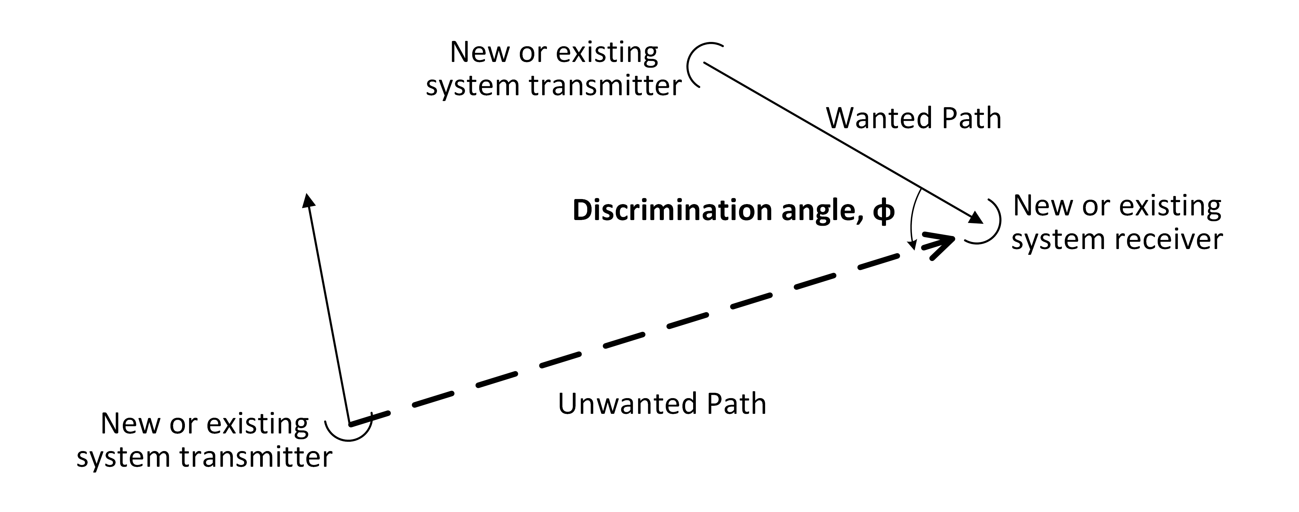
Figure 2: Discrimination angle between a wanted and an unwanted path.
The discrimination angle is used to determine the antenna discrimination from the corresponding antenna radiation pattern envelope (RPE). In accordance with Appendix 11 of RALI FX3, wherever possible, actual antenna RPEs for all relevant transmitters and receivers must be used when determining the antenna discrimination at the relevant angle.
Step 4: Calculate free space propagation losses for unwanted paths
Step 4 of the coordination procedure is to calculate the propagation loss between each transmitter that may cause interference to the victim receiver (proposed or existing) as identified in Step 1 (unwanted path). In the Stage 1 coordination procedure, the free space propagation model is used as defined in Recommendation ITU-R P.525.
Note that when assessing interference into Earth Station receivers, assigners must use the propagation model defined in Recommendation ITU-R P.452.
Step 5: Calculate free space propagation loss for wanted paths
Step 5 of the coordination procedure, which is only relevant for interference into point to point links, is to calculate the propagation loss between each receiver of the wanted transmit to receive pair (wanted path). In the Stage 1 coordination procedure, the free space propagation model is used.
Step 6: Determine wanted signal power at each receiver from its associated transmitter
Step 6 of the coordination procedure is to calculate the level of wanted power at each receiver identified in Step 1, using the wanted path propagation loss from Step 5. This step is only relevant in the case of interference into point to point link receivers.
The data required for these calculations include the service transmitter power, the service transmit antenna gain and the propagation loss of the wanted path calculated in Step 5. (In the case of interference into point to point links, the power levels for both the wanted and unwanted signals are calculated at the input to the victim receiver antenna, and therefore the receiver antenna gain is not required; only the antenna discrimination needs to be considered).
Step 7: Determine the unwanted power at each receiver from each potential interfering transmitter
Step 7 of the coordination procedure is to calculate the level of unwanted power at each receiver identified in Step 1, using the unwanted path propagation loss from Step 4.
The data required for these calculations includes the transmitter EIRP in the direction of the victim receiver, the victim receiver antenna gain, the discrimination of the victim receive antenna in the direction of the unwanted service and the propagation loss.
Step 8: Determine the required protection criteria for each identified victim receiver
Step 8 of the coordination procedure is to determine the applicable protection criteria for each victim receiver identified in Step 1. To protect receivers from unacceptable interference, the wanted and/or unwanted power levels at a victim receiver must not exceed the required protection criteria for that receiver.
In this RALI, protection ratios are used for protection of fixed link receivers while a maximum allowable unwanted level criterion is used for protection of BWA, and other services receivers.
When applying protection ratios for the protection of fixed link receivers, the protection ratios must be adjusted to take account of actual path length and geoclimatic zone. Protection ratio correction factor graphs are provided at Appendix D.
For the point-to-area BWA service, the receiver protection criterion used must reflect the channel bandwidth of the service. BWA service protection criteria is provided in Appendix B.

Example of Protection Ratio correction factor adjustment
An example calculation of the protection ratio for a digital fixed link receiver with the following parameters is shown below:
PR = PR_{co} + CF
where:
PR = protection ratio
PR_{co} = co-channel protection ratio
CF = Correction Factor

Parameters:
Centre Frequency = 1.9 GHz
bandwidth = 14 MHz
P_{L} = 10
link path length = 50 km

Result:
PR_{co} = 60 dB
CF = –7 (adjustment for d = 50 km and P_{L}=10)
PR = 60 + (–7) = 53 dB
Step 9: Comparison with protection criteria
Step 9 of the coordination procedure compares the calculated levels from Step 6 and Step 7 with the protection values obtained from Step 8. Two cases are detailed below depending on which type of protection criteria is required.
Case one — protection ratio
The protection criterion is met for a victim receiver if the wanted-to-unwanted power ratio equals or exceeds the required protection ratio for that receiver. That is:
Wanted Signal – Unwanted Signal – Protection ratio ≥ 0
If the wanted-to-unwanted power ratio equals or exceeds the protection ratio for each victim receiver then the protection criteria has been met and spectrum sharing is possible. However, if the wanted-to-unwanted power ratio is less than the protection ratio at any of the victim receivers then, for those receivers, further coordination assessments using a more refined propagation model can be undertaken (refer to Stage 2, following).
Case two — maximum unwanted level
The unwanted signal level at the victim receiver is compared to a maximum allowed unwanted level. This is generally expressed in dBm per bandwidth (e.g. dBm/5 MHz). It is important to note that the levels being compared must be measured in the same reference bandwidth (i.e. it is not correct to compare dBm/5 MHz with dBm/10 MHz).
If the unwanted signal level exceeds the maximum unwanted level for each victim receiver then the transmitter is deemed to be causing unacceptable interference. However, if the unwanted signal level is equal to or less than the maximum unwanted level for each victim receiver then the protection criteria has been met and spectrum sharing is possible.
Note that where Protection Ratios and Protection Criteria are required for frequency offset values other than those shown in the tables in Appendix B or Appendix C; the value applying to the smaller offset case must be used.
Stage 2
For protection criteria comparisons that fail the initial (Stage 1) coordination assessment, further assessment (Stage 2) of the interference potential is required.
In Stage 1, the free space propagation model does not consider obstructions due to terrain, buildings or vegetation. These factors can significantly increase the loss on each interference path (but particularly for long unwanted paths). Consideration of this and other factors in Stage 2 is likely to reduce the calculated interference levels and may lead to a successful coordination of the system.
Note that the decision on the propagation model to be applied for any path in Stage 2 is to be determined by the frequency assigner, taking all relevant factors into account. In the case of assessing interference into Earth Station receivers, assigners must use the propagation model defined in the latest revision of Recommendation ITU-R P.452.
Step 10: Re-calculate propagation losses using alternative propagation model(s)
For the victim receivers that fail the Stage 1 coordination assessment, propagation losses between the proposed service and the victim receivers can be re-calculated, using relevant alternative propagation models.
It should be noted however, that the free space propagation model may, in many cases, be the most appropriate model. However, due to the wide variability in antenna heights, no single model can be recommended as being the most appropriate for all paths. In determining which propagation model is most appropriate for a given path, consideration must be given to factors such as:
- The terrain between the radio path end points.
- Any obstructions on the path either natural or man-made.
- The heights of the transmit and receive antennas.
The limitations of applicability of the various propagation models.
Determination of an appropriate propagation model for a given path may be aided by plotting a terrain profile for the path. The following discussion may assist frequency assigners in considering suitable propagation models for use in Stage 2.
Propagation Models
Path losses between services may arise through a range of propagation mechanisms, depending on the factors described above. The main propagation mechanisms include line of sight (free-space loss as used in Stage 1), diffraction including smooth earth diffraction and diffraction over obstacles and irregular terrain, ducting and tropospheric scatter.
Information on how to determine propagation losses due to diffraction over obstacles and irregular terrain can be found in Recommendation ITU R P.526, which also covers spherical Earth diffraction.
The interference protection criteria specified in RALI FX3 are applicable for interference levels exceeded for 20% of the time. Therefore, when drawing a path profile to calculate diffraction losses an Earth curvature factor of k = 3 must be used. This will give results corresponding to signal levels exceeded for 20% of the time. There is no need to apply a correction factor for location variability as the method yields results only appropriate to the one receiver location.
Information on how to determine propagation losses due to diffraction over obstacles and irregular terrain, spherical Earth diffraction, tropospheric scatter as well as ducting can also be found in Recommendation ITU-R P.452.
Step 11: Re-calculate unwanted power and compare against protection ratio
The level of unwanted power at each fixed link receiver that could not be co-ordinated at Stage 1 must be re-calculated as described in Step 7, using the revised propagation loss value.
The revised wanted-to-unwanted power ratio must be compared against the protection ratio as described in Step 9. If the wanted-to-unwanted power ratio at each of the remaining victim receivers equals or exceeds the required protection ratio for each receiver then the protection criteria is met, and spectrum sharing is possible.

Further options if coordination is unsuccessful
If the wanted-to-unwanted power ratio is less than the required protection ratio at a fixed link receiver, or the protected receiver input level at a victim receiver (BWA or other services) is not met, then spectrum sharing is not possible unless further steps are taken by the applicant. If the proposal is to be pursued further, the applicant may consider the following options:
- Modifying the configuration of the proposed service to meet the protection criteria (this may include modifying the equipment to limit operation to a smaller portion of the band, or changing the locations, antenna height, proposed EIRP, etc.).
- Negotiating an agreement with the affected or affecting service(s) regarding changes to the service(s) and/or the BWA service.
Applying for a licence to conduct test transmissions to assess the actual propagation loss.

Assessing BWA into fixed links interference
Interference from a BWA service into a fixed point to point receiver is assessed using the steps described in section 3.2. Steps 1 to 9, and then Steps 10 and 11 (if required) in conjunction with the additional clarifications given below are to be followed.
Two scenarios are considered together in this section:
- Interference from a proposed BWA transmitter to a licensed Fixed Link receiver.
Interference from a licensed BWA transmitter to a proposed Fixed Link receiver.
The coordination process calculates a wanted-to-unwanted signal level ratio at the fixed link receiver input and compares it against the relevant protection ratio value(s) given in the tables in Appendix C.
Figure 3 illustrates the wanted and unwanted paths based on the BWA deployment model detailed in Appendix E.
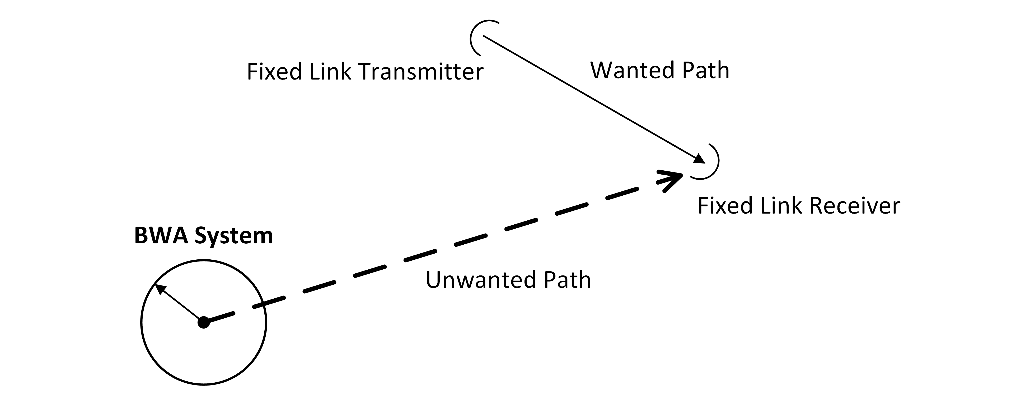
Figure 3: BWA into Fixed Link interference scenario.
Specific step clarification for BWA into fixed links interference
Step 1:
To identify the potentially affected fixed link receivers, a recommended minimum distance cull around the site of the proposed BWA base station of 200 km is required. Anything within this radius must be included in the following steps.
A frequency cull is then applied to further reduce the number of cases requiring more detailed coordination calculations. The required frequency cull is shown in Table 3.
Table 3: Fixed link receiver frequency cull range.
BWA band | Fixed Link Receiver Frequency Cull Range
1900–1920 MHz | 1867.5–1980 MHz
If a BWA base station occupies spectrum at or within the second adjacent channel of the fixed link receiver channel and the geographical location of the BWA base station is within 10 km of the fixed link receiver, coordination is deemed to fail, and a licence will not be granted.
Step 3:
For a BWA transmitter
Calculation of the BWA transmitter antenna gain detailed in Step 3 is done based on the licensed or proposed antenna data. Note that the BWA transmitter gain value can be reduced by the amount of antenna discrimination (if any) at the given azimuth by using the actual RPE and polarisation discrimination if applicable. If the RPE is not available, then the worst-case (maximum gain) value is to be used.
For a fixed receiver
The actual antenna discrimination of the fixed link receive antenna must be used for the calculations.
Step 7:
This step requires two parallel calculations to be made and the more conservative (i.e. higher EIRP) resulting value to be used in subsequent stages of the calculation procedure. The two cases are:
Case 1: Calculate the unwanted power level (EIRP) on the basis of the proposed or licensed details for the base transmitter using the above calculated antenna gain (with any discrimination considered) and the proposed or licensed transmitter power, considering the path loss calculated in step 4.
Case 2: Calculate the unwanted power level (EIRP) on the basis of the remote station notional details, this requires using a 14 dBi omni-directional antenna, located at the base station transmitter site, placed at the same height as the base station antenna and taking into account the path loss calculated in Step 4.
Step 9:
A comparison of the calculated wanted-to-unwanted ratio from Steps 6 and 7 with the relevant protection ratio value(s) in the tables in Appendix C will determine if the protection criteria at the victim fixed link receiver is achieved.

Assessing fixed links into BWA interference
Interference from a point to point fixed link transmitter into a BWA service receiver is assessed using the steps described in section 3.2. Steps 1 to 9, and then Steps 10 and 11 (if required) in conjunction with the additional clarifications given below are to be followed.
Two scenarios are considered together in this section:
- Interference from a proposed Fixed Link to a licensed BWA receiver.
Interference from a licensed Fixed Link to a proposed BWA receiver.
The coordination process is to calculate the unwanted signal level at the potential BWA victim receiver and compare it against relevant protection criteria given in the tables in Appendix B.
Figure 4 illustrates the wanted and unwanted paths based on the BWA deployment model detailed in Appendix E.
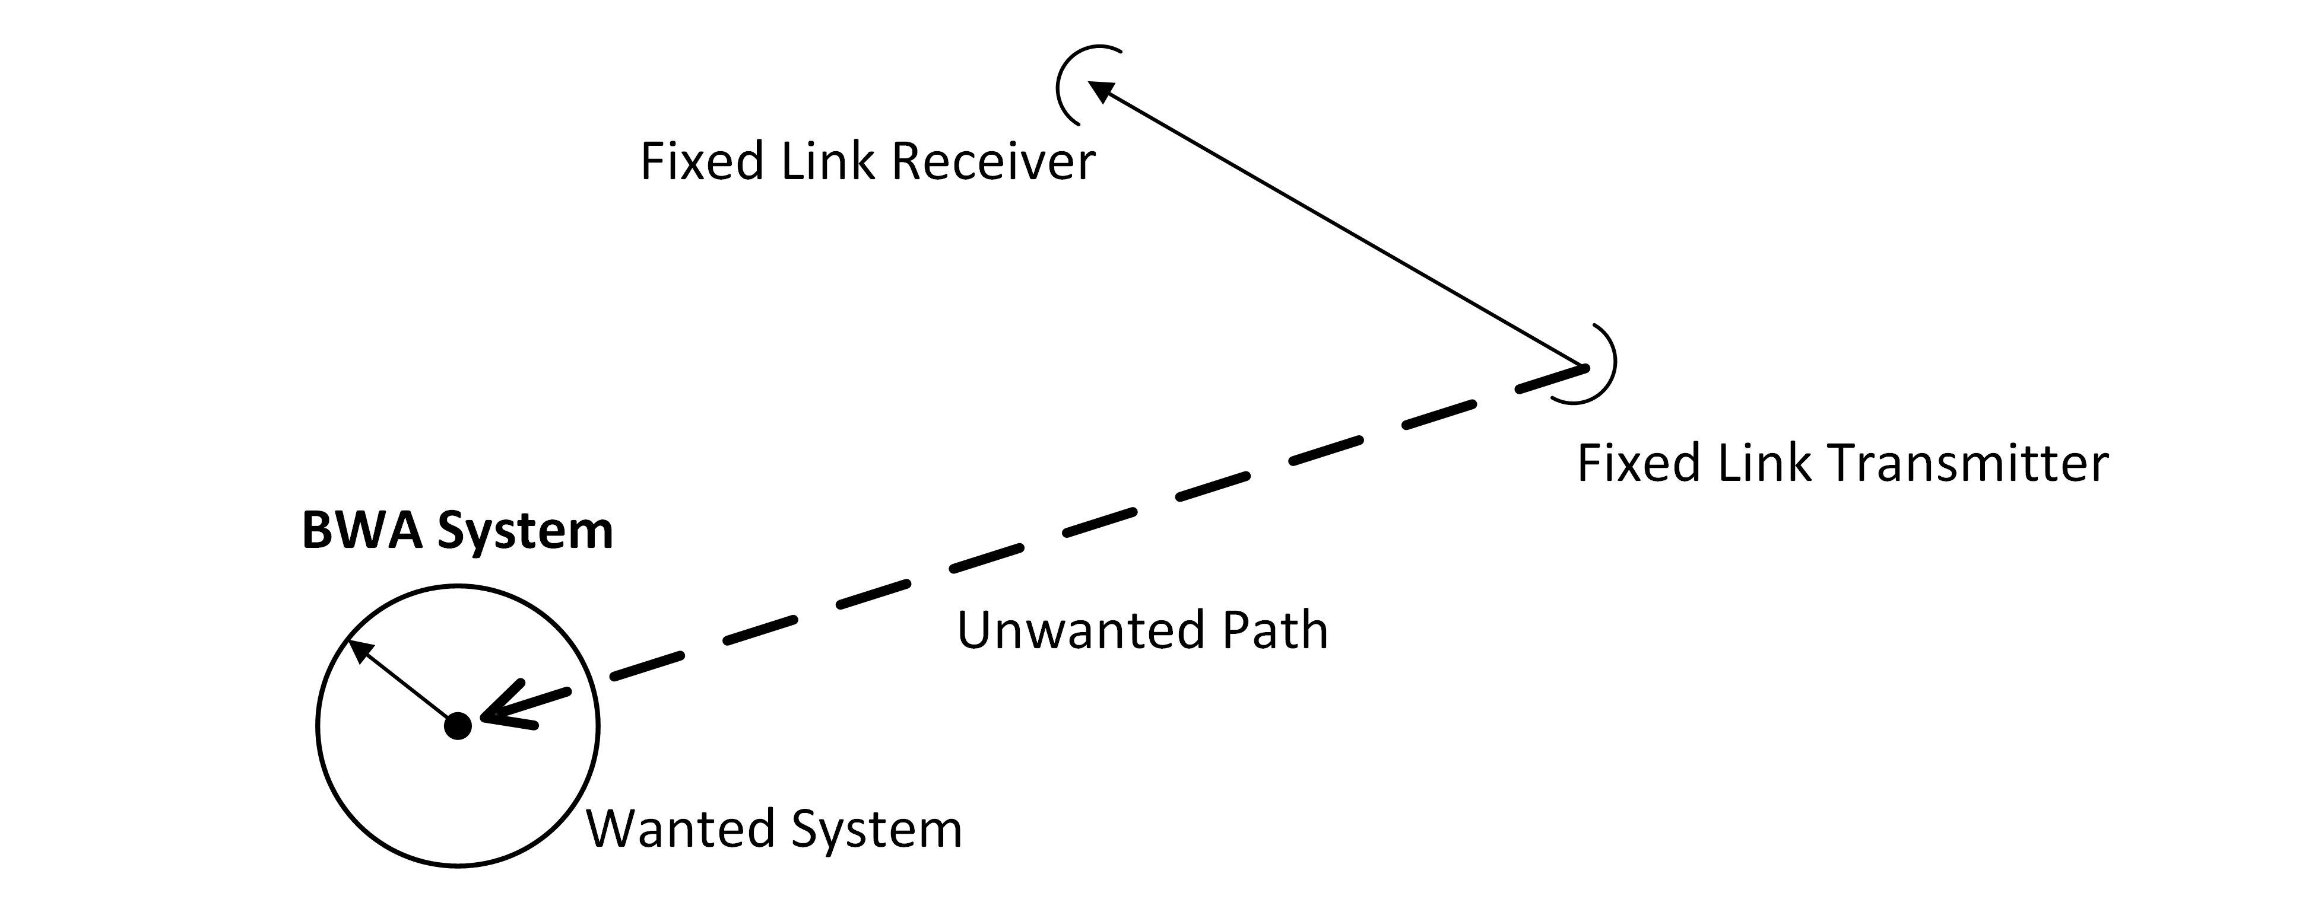
Figure 4: Fixed Link into BWA interference scenario.
Specific step clarification for fixed links into BWA interference
Step 1:
To identify potentially interfering fixed link transmitters, a recommended minimum distance cull around the site of the proposed BWA station of 200 km is required. Anything within this radius must be included in the following steps.
A frequency cull is then applied to further reduce the number of cases requiring more detailed coordination calculations. The required frequency cull is shown in Table 4 below.
Table 4: Fixed link receiver frequency cull range.
BWA band | Fixed Link Receiver Frequency Cull Range
1900–1920 MHz | 1874.5–1951 MHz
Step 3:
For a BWA receiver
Calculation of the BWA receiver antenna gain detailed in Step 3 is done based the licensed or proposed base station antenna data. Note that the BWA receiver gain value can be reduced by the amount of antenna discrimination (if any) at the given azimuth by using the actual RPE where available. If the RPE is not available, then the worst-case (maximum gain) value is to be used. Polarisation discrimination, if applicable, may also be considered.
For a fixed transmitter
The actual antenna discrimination of the fixed link transmitter must be used for the calculations.
Step 9:
A comparison of the relevant values in Appendix B, and the calculated unwanted signal levels (e.g. dBm/5 MHz) from Step 7 will determine if the level of interference into the BWA receiver is acceptable. It is important to note that the levels being compared must be measured in the same reference bandwidth.

Assessing BWA into BWA interference
Note that this process is not required between stations operated by the same licensee. It is expected that the licensees will manage interference between their own stations.
Interference from a BWA service transmitter into each potential victim BWA service receiver is assessed using the steps described in section 3.2. Steps 1 to 9, and then Steps 10 and 11 (if required) in conjunction with the additional clarifications given below are to be followed.
Two scenarios are considered together in this section:
- Interference from a proposed BWA transmitter to a licensed BWA receiver.
Interference from a licensed BWA transmitter to a proposed BWA receiver.
The coordination process is to calculate the unwanted signal level at the potential BWA victim receiver and compare it against relevant protection criteria given in the tables in Appendix B.
Figure 5 illustrates the wanted and unwanted paths based on the deployment model detailed in Appendix E.
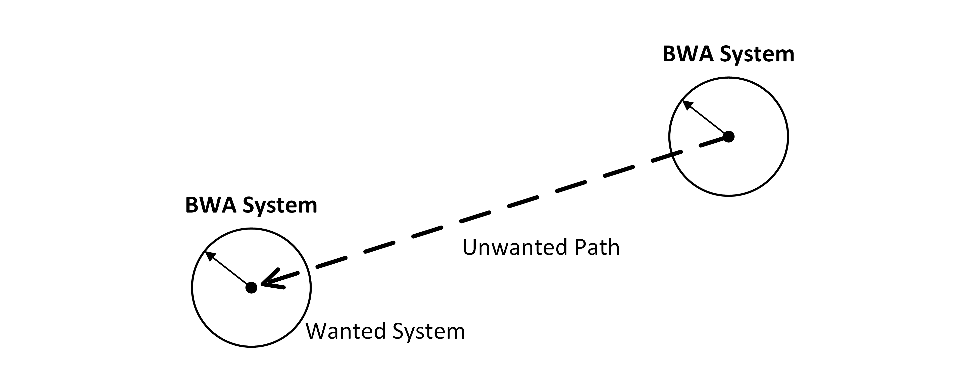
Figure 5: BWA to BWA interference scenario.
Specific step clarification for BWA into BWA interference.
Step 1:
To identify the potentially affected BWA receivers, a recommended minimum distance cull around the BWA transmitter site of 200 km is required. Anything within this radius must be included in the following steps. A minimum co-channel reuse distance of 30 km will be applied to BWA base stations operated by different licensees. Within this distance of an existing BWA base station location, other co-channel BWA applications will not be considered. Beyond this reuse distance of 30 km, the co-channel co-ordination procedure detailed in the following steps must be followed.
A frequency cull is also applied to further reduce the number of cases requiring more detailed coordination calculations. Given the range of current and future operating bandwidths feasible, a generic frequency cull range of 1.5 times the channel bandwidth can be applied. For the 1900–1920 MHz band, the wanted and unwanted services are assumed to have the same 5 MHz bandwidth, so the frequency culls are made at ±7.5 MHz from the centre frequency of the proposed channel.
Step 3:
For a BWA transmitter
Calculation of the BWA transmitter antenna gain detailed in Step 3 is done based the licensed or proposed antenna data.
Note that the BWA transmitter gain value can be reduced by the amount of antenna discrimination (if any) at the given azimuth by using the actual RPE where available. If the RPE is not available, then the worst-case (maximum gain) value is to be used.
For a BWA receiver
Calculation of the BWA receiver antenna gain detailed in Step 3 is done based on the licensed or proposed base station antenna data.
Note that the BWA receiver gain value can be reduced by the amount of antenna discrimination (if any) at the given azimuth by using the actual RPE where available. If the RPE is not available, then the worst-case (maximum gain) value is to be used. Polarisation discrimination, if applicable, may also be considered.
Step 7:
Calculate the unwanted power level base on the proposed or licensed details for the base transmitter using the above calculated antenna gain (with any discrimination considered) and the proposed or licensed transmitter power, considering the path loss calculated in Step 4.
Step 9:
A comparison of the relevant values in Appendix B, and the calculated unwanted signal levels (e.g. dBm/5 MHz) from Step 7 will determine if the level of interference into the BWA receiver is acceptable. It is important to note that the levels being compared must be measured in the same reference bandwidth.

Assessing BWA transmitter to spectrum licensed receiver adjacent channel interference
The assessment of potential interference from BWA transmitters to spectrum licensed receivers in this RALI is based on the process in section 4.9 of RALI MS33, but replaces the PTS base station receiver with the spectrum licensed base station receiver. The coordination process involves calculating the unwanted adjacent signal level at the victim spectrum licensed receiver and comparing it against the relevant criteria contained in Radiocommunications Advisory Guidelines (Managing Interference to Spectrum Licensed Receivers—2 GHz Band) 2023.
The clarifications for certain steps in section 4.9 of RALI MS33 are, however, to be replaced with the following clarifications:
Specific Step Clarification
Step 1: To identify potentially affected spectrum licensed base station receivers, a recommended minimum cull distance around the site of the proposed BWA base station transmitter of 50 km is required. Any 2 GHz spectrum licensed base station receiver within this radius must be assessed.
A frequency cull is then applied to further reduce the number of cases requiring more detailed coordination calculations. The required frequency cull is:
Table 5: Spectrum licensed receiver frequency cull range.
BWA Band | Spectrum Licensed Receiver Frequency Cull Range
1900–1920 MHz | 1920–1937.5 MHz
Step 3: Calculate the unwanted power level at the spectrum licensed base station receiver, using the proposed BWA base station application details including antenna gain (with any discrimination taken into account), the BWA base station transmitter power (EIRP) in the direction of the spectrum licensed base station receiver, propagation loss from the appropriate propagation model and the spectrum licensed base station receiver gain in the direction of the proposed BWA base station.
Step 4: The Radiocommunications Advisory Guidelines (Managing Interference to Spectrum Licensed Receivers—2 GHz Band) 2023 contains conditions under which 2 GHz spectrum licensed base station receivers are required to operate. Coordination of BWA base stations with 2 GHz spectrum licensed base station receivers is based on these conditions with some modifications. The conditions are specified in terms of a frequency offset with respect to the frequency limits of the spectrum licence. They are based on adjacent channel selectivity and receiver blocking requirements.
For frequency offsets of less than 5 MHz, a spectrum licensed base station is required to operate in the presence of –63.0 dBm/5 MHz of interference from a BWA base station. This is based on a protected receiver level of -108.5 dBm/5 MHz with an adjacent channel selectivity of 45 dB rather than -43.5 dB.
For frequency offsets of greater than 5 MHz, a spectrum licensed base station receiver is required to operate in the presence of –43 dBm/5 MHz of interference.
These values are considered the maximum permissible adjacent channel interference to 2 GHz spectrum licensed base station receivers from BWA base station transmitters.
Step 5: A comparison of the values from Step 4 above and the calculated unwanted signal levels (dBm/5 MHz) from Step 3 will determine if the level of adjacent channel interference into the spectrum licensed victim receiver is acceptable.

Site engineering aspects
At shared sites, or sites in the same vicinity, several potential interference mechanisms other than co-channel or adjacent channel interference may occur. These include intermodulation; transient and spurious emissions; receiver desensitisation; and, physical blocking. These mechanisms are caused by non-linear and often complex processes that are, usually, not readily predicted using information contained in the ACMA’s RRL. Nevertheless, several “site engineering” methods can be applied to address these potential interference scenarios. These include, but are not limited to, site shielding, frequency separation, site locations, aligning transmission and reception timing and power reduction.
Most of the methods mentioned above require co-operation and co-ordination between licensees. This is most easily achieved where the two services are owned by the same licensee. However, neighbouring services are seldom owned by the same licensee, and therefore formal discussions may be required.
In the case of co-siting with spectrum licensed devices, if the interference from the spectrum licensed device is not the result of operation of a radiocommunications device in a manner that does not comply with the respective conditions of the licence, then licensees must take reasonable steps to negotiate arrangements likely to reduce the interference to acceptable levels.
The ACMA expects that licensees (or their site managers) will work cooperatively and apply good site engineering practice to resolve problems.

Assignment rules
Where an applicant already has assigned 1900–1920 MHz band channels, that applicant must, wherever possible, be assigned the same channels. This is intended to promote efficient spectrum use by requiring self-management of co-channel, adjacent area interference to the greatest extent practical.
In addition to this, assignments in the 1900–1920 MHz band must be made with respect to the intended spectrum use. For example, although up to 20 MHz of spectrum is available at a single site, if the intention is to use two separate 10 MHz channels then the use must be recorded as such (whether for a directional or omni-directional service) rather than as one 20 MHz channel.
This requirement ensures coordination with other services such as PTS and point to point links is based as closely as possible on actual service characteristics. This will best ensure spectrum availability to all services operating in and around 1.9 GHz band.

Rules relating to applications for two or more 5 MHz channels
Applicants seeking two or more 5 MHz channels in the same area must, where possible, be assigned contiguous channels. Licensees in this situation will be expected to manage their frequency reuse arrangements within this constraint.
Where applicants seek two 5 MHz channels, assessments must be performed firstly on the 1910–1920 MHz pair and then the 1900–1910 MHz pair. This rule is intended to maximise separation from 1880–1900 MHz band DECT services.

Rules relating to applications for one 5 MHz channel
Where applicants seek a single 5 MHz channel assessments must be made in the following order:
1915–1920 MHz
1900–1905 MHz
1910–1915 MHz
1905–1910 MHz
This rule is intended firstly to maximise separation from other BWA services, current or potential future and, as a second priority, to maximise separation from 1880–1900 MHz band DECT services.

Rules relating to applications for one 10 MHz channel
Where applicants seek a single 10 MHz channel, assessments must be made in the following order:
1910–1920 MHz
1900–1910 MHz
1905–1915 MHz
This rule is intended to, as far as possible, ensure any remaining spectrum is in a contiguous 10 MHz lot. As a second priority, it is intended to maximise separation from 1880–1900 MHz band DECT services.

Rules relating to the application for one 15 MHz channel
Where applicants seek a 15 MHz channel, assessments must be made in the following order:
1905–1920 MHz
1900–1915 MHz
This rule is intended to maximise separation from 1880–1900 MHz band DECT services.

SR WBB coordination procedure
SR WBB services are expected to utilise DECT technologies, that provide for the dynamic allocation of channels within the frequency range 1900-1920 MHz. This means that while a specific channel being used for operation may be either co-channel with – or adjacent channel to – FRMCS, coordination is to be based on an assumption of co-channel operation, given the dynamic allocation of channels.
As detailed in the 1.9 GHz band outcomes paper, the frequency range 1900-1910 MHz is prioritised for FRMCS services. Accordingly, coordination is based on providing protection to a notional FRMCS base station receiver located at all locations along defined railway lines (defined railway lines are detailed in RALI [XX].
Every part of a defined railway line that is within 14 km of a proposed SR WBB assignment is to be afforded protection from the proposed SR WBB transmitter. The applicable protection criteria and notional FRMCS base station parameters from RALI [XX] are to be used.
No coordination is required for proposed SR WBB transmitters greater than 14km from defined railway lines.

Licensing

BWA licensing

Overview of licensing
All transmitters in a BWA service (comprising only one base station and any number of remote stations communicating with that base station) are to be licensed under one Fixed licence authorising a point to multipoint station.
A point to multipoint station is defined in the Radiocommunications (Interpretation) Determination 2025 as a station that:
- is operated under a fixed licence; and
- is operated principally for communication with more than 1 other fixed station; and
- is operated on frequencies specified in the transmitter licence that relates to the station.
To be licensed for operation, BWA point to multipoint fixed services must be located outside the area defined in Appendix A, and, outside the areas defined in relevant spectrum embargoes.

Licence conditions
The operation of radiocommunications equipment authorised by a Fixed licence is subject to:
- Conditions specified in the Radiocommunications Act 1992 (the Act), including an obligation to comply with the Act.
- Conditions specified in the Radiocommunications Licence Conditions (Transmitter Licence) Determination 2025, Radiocommunications Licence Conditions (Fixed Licence) Determination 2025 and any other determinations made by the ACMA under section 107(1)(f) of the Act.
- Conditions specified in this RALI.
- Conditions specified in the licence.
Any further conditions imposed by the ACMA under section 111 of the Act.
If interference occurs after a licence is issued and the issue cannot be resolved between the affected parties, licensees can expect the ACMA to have regard to this RALI and relevant legislative instruments in dealing with the dispute.

Advisory notes
The following user selectable advisory note FR must be attached to all licences authorising BWA services in the 1900–1920 MHz band:
“The shared spectrum arrangements and uncoordinated nature of class licensed radiocommunications devices in the 1880–1900 MHz band:
- may result in interference from nearby class licensed radiocommunications devices that may reduce system performance; and
- the likelihood of such interference is very low due to the dynamic channel allocation techniques inherent in cordless technologies used in the band; and
- protection from such interference cannot be afforded.”

Special conditions
The following user selectable special condition FA5 may optionally be attached to individual licences where the licensee proposes to deploy a fixed-to-mobile service:
Special Condition FA5: The fixed station to which this licence relates is authorised to communicate with mobile stations.

Spectrum access records
Technical details relating to the BWA service's base station, including, but not limited to, the actual operating transmit power, antenna, location, antenna height, antenna type and orientation and transmit/receive frequency band must be recorded. Noting that:
- Where sectored antennas are used, details of the antenna model, tilt, polarisation, and azimuth must be recorded for each sector.
- Where steerable beam antennas are used details of the highest gain achievable through antenna phasing must be recorded.
- One of the coordination processes described in section 3 requires that protection from remote stations be calculated based on assumed notional worst-case parameters for the remote station located at the base station location. However, it is not required that data for this hypothecated remote station location be recorded in the RRL.

SR WBB licensing

Overview of licensing
All transmitters in a SR WBB system (comprising only one base station and any number of mobile stations communicating with that base station) are to be licensed under a land mobile system apparatus licence, defined as follows:
land mobile system is defined in the Radiocommunications (Interpretation) Determination 2025 and means a system that comprises:
(a) one or more land stations; and
(b) one or more land mobile stations;
that:
(c) are operated under a land mobile licence; and
(d) are operated principally for two-way communications.
To be licensed for operation, SR WBB services must be located within the area defined in Appendix A, and, outside the areas defined in relevant spectrum embargoes.

Licence conditions
The operation of radiocommunications equipment authorised by a Land Mobile System Licence is subject to:
- Conditions specified in the Radiocommunications Act 1992 (the Act), including an obligation to comply with the Act.
- Conditions specified in the Radiocommunications Licence Conditions (Transmitter Licence) Determination 2025, Radiocommunications Licence Conditions (Land Mobile Licence) Determination 2025 and any other determinations made by the ACMA under section 107(1)(f) of the Act.
- Conditions specified in this RALI.
- Conditions specified in the licence.
Any further conditions imposed by the ACMA under section 111 of the Act.
If interference occurs after a licence is issued and the issue cannot be resolved between the affected parties, licensees can expect the ACMA to have regard to this RALI and relevant legislative instruments when mediating on the matter.

Assignment Rules
DECT technology, which is expected to be used for SR WBB services, operates by dynamically selecting a channel within the range 1900-1920 MHz. For purposes of an assignment, the frequency on the licence should be recorded as 1910 MHz and the channel bandwidth should be set to the largest channel supported by the device – also see special conditions in the next section.
Licences to authorise the operation of SR WBB services must not permit the operation at power levels greater than 30 dBm EIRP.

Special conditions
The following special conditions are to be applied to licences authorising the operation of SR WBB services in the range 1900-1920 MHz.
Special Condition [XX]: a radiocommunications transmitter operated under this licence must only be operated indoors
Special Condition 27: No interference shall be caused to any Radiocommunication station or service and no protection from interference by such stations or services shall be afforded.
As SR WBB services are expected to operate on a dynamically selected channel within the frequency range 1900-1920 MHz, the following user defined special conditions are to be included:
- The devices authorised under this licence are permitted to operate at a channel bandwidth of between [insert smallest channel bandwidth of the device] MHz and [insert largest channel bandwidth of the device] MHz.
The assigned frequency is 1910 MHz. However, the devices authorised under the licensed can operate between frequency range 1900–1920 MHz

Spectrum access records
Technical details relating to the SR WBB service's base station, including transmit power, antenna, location, antenna height, antenna type/orientation and transmit/receive frequencies must be recorded in the RRL.

Exceptions
Exceptions to the requirements of this RALI for prospective assignments require case-by-case consideration by the Manager, Spectrum Planning Section.
A request for exemption from the requirements of this RALI would need to be accompanied by evidence to support the request.
All requests for exemptions should be submitted to: freqplan@acma.gov.au

RALI Authorisation
[not approved] [insert date when made]

Manager
Spectrum Planning Section
Spectrum Planning and Engineering Branch
Communications Infrastructure Division
Australian Communications and Media Authority

List of acronyms
ACMA | Australian Communications and Media Authority
AL | Apparatus Licence
BWA | Broadband Wireless Access
DECT | Digital Enhanced Cordless Telecommunications (previously known as Digital European Cordless Telecommunications)
EIRP | Equivalent Isotropically Radiated Power
FDD | Frequency Division Duplex
FWA | Fixed Wireless Access
ITU | International Telecommunications Union
LCD | Licence Conditions Determination
MSS | Mobile Satellite Service
NFD | Net Filter Discrimination
PR | Protection Ratio
PTS | Public Telecommunications Service
RALI | Radiocommunications Assignment and Licensing Instruction
RPE | Radiation Pattern Envelope
RRL | Register of Radiocommunication Licences
Rx | Receiver
SL  SR WBB | Spectrum Licence  Short Range Wireless Broadband
TDD | Time Division Duplex
Tx | Transmitter
WAS | Wireless Access Service

- Area available for apparatus licensed BWA and SR WBB services in the 1900–1920 MHz band
In this RALI, the area available for apparatus licensed:
- BWA services in the 1900–1920 MHz band is defined as being anywhere outside the HCIS described areas in Table A1.
SR WBB services in the 1900–1920 MHz band is defined as being anywhere inside the HCIS described areas in Table A1.
HCIS area descriptions can be converted into a Placemark file (viewable in Google Earth) through the Convert HCIS area description to a Placemark facility on the ACMA website.
The HCIS is described in the Australian Spectrum Map Grid 2012.
Table A1: Areas available for SR WBB services and not available for apparatus licensed BWA services in 1900–1920 MHz.
Adelaide
IW3J, IW3K, IW3L, IW3N, IW3O, IW3P, IW6B, IW6C, IW6D, IW6F, IW6G, IW6H, IW3E5, IW3E6, IW3E8, IW3E9, IW3F4, IW3F5, IW3F6, IW3F7, IW3F8, IW3F9, IW3G4, IW3G5, IW3G6, IW3G7, IW3G8, IW3G9, IW3H4, IW3H5, IW3H6, IW3H7, IW3H8, IW3H9, IW3I2, IW3I3, IW3I5, IW3I6, IW3I8, IW3I9, IW3M2, IW3M3, IW3M5, IW3M6, IW3M8, IW3M9, IW6A2, IW6A3, IW6A5, IW6A6, IW6A8, IW6A9, IW6E2, IW6E3, IW6E5, IW6E6, IW6E8, IW6E9, JW1E4, JW1E7, JW1I1, JW1I4, JW1I7, JW1M1, JW1M4
Brisbane
NT9, NT5G, NT5H, NT5K, NT5L, NT5O, NT5P, NT6E, NT6F, NT6G, NT6H, NT6I, NT6J, NT6K, NT6L, NT6M, NT6N, NT6O, NT6P, NT8C, NT8D, NT8G, NT8H, NT8K, NT8L, NT8O, NT8P, NU3A, NU3B, NU3C, NU3D, NU3F, NU3G, NU3H, NT5C4, NT5C5, NT5C6, NT5C7, NT5C8, NT5C9, NT5D4, NT5D5, NT5D6, NT5D7, NT5D8, NT5D9, NT6A4, NT6A5, NT6A6, NT6A7, NT6A8, NT6A9, NT6B4, NT6B5, NT6B6, NT6B7, NT6B8, NT6B9, NT6C4, NT6C5, NT6C6, NT6C7, NT6C8, NT6C9, NT6D4, NT6D5, NT6D6, NT6D7, NT6D8, NT6D9, NU2C1, NU2C2, NU2C3, NU2D1, NU2D2, NU2D3, NU2D5, NU2D6, NU2D8, NU2D9, NU2H2, NU2H3, NU3E1, NU3E2, NU3E3, NU3E5, NU3E6, NU3E8, NU3E9, NU3I2, NU3I3, NU3J1, NU3J2, NU3J3, NU3K1, NU3K2, NU3K3, NU3L1, NU3L2, NU3L3
Canberra
MW4D, MW4H, MW4L, MW5A, MW5B, MW5E, MW5F, MW5I, MW5J, MW1P4, MW1P5, MW1P6, MW1P7, MW1P8, MW1P9, MW2M4, MW2M5, MW2M6, MW2M7, MW2M8, MW2M9, MW2N4, MW2N5, MW2N6, MW2N7, MW2N8, MW2N9, MW4P1, MW4P2, MW4P3, MW5M1, MW5M2, MW5M3, MW5N1, MW5N2, MW5N3
Darwin
GO7C, GO7D, GO7G, GO7H, GO7K, GO7L, GO8A, GO8E, GO8I
Hobart
LY8L, LY8P, LY9I, LY9J, LY9K, LY9L, LY9M, LY9N, LY9O, LY9P, LZ2D, LZ2H, LZ3A, LZ3B, LZ3C, LZ3D, LZ3E, LZ3F, LZ3G, LZ3H, LY8H4, LY8H5, LY8H6, LY8H7, LY8H8, LY8H9, LY9E4, LY9E5, LY9E6, LY9E7, LY9E8, LY9E9, LY9F4, LY9F5, LY9F6, LY9F7, LY9F8, LY9F9, LY9G4, LY9G5, LY9G6, LY9G7, LY9G8, LY9G9, LY9H4, LY9H5, LY9H6, LY9H7, LY9H8, LY9H9, LZ2L1, LZ2L2, LZ2L3, LZ3I1, LZ3I2, LZ3I3, LZ3J1, LZ3J2, LZ3J3, LZ3K1, LZ3K2, LZ3K3, LZ3L1, LZ3L2, LZ3L3
Melbourne
KX3J, KX3K, KX3L, KX3N, KX3O, KX3P, KX6B, KX6C, KX6D, KX6F, KX6G, KX6H, KX6J, KX6K, KX6L, LX1I, LX1M, LX1N, LX1O, LX4A, LX4B, LX4C, LX4E, LX4I, KX3F7, KX3F8, KX3F9, KX3G7, KX3G8, KX3G9, KX3H4, KX3H5, KX3H6, KX3H7, KX3H8, KX3H9, KX3M6, KX3M8, KX3M9, KX6A2, KX6A3, KX6A5, KX6A6, KX6A8, KX6A9, KX6E2, KX6E3, KX6E5, KX6E6, KX6E8, KX6E9, KX6I2, KX6I3, KX6I5, KX6I6, KX6I8, KX6I9, LX1E4, LX1E7, LX1E8, LX1E9, LX1J1, LX1J4, LX1J5, LX1J6, LX1J7, LX1J8, LX1J9, LX1K4, LX1K7, LX4F1, LX4F2, LX4F4, LX4F5, LX4F7, LX4F8, LX4J1, LX4J2, LX4J4, LX4J5, LX4J7, LX4J8
Perth
BV1I, BV1J, BV1K, BV1L, BV1M, BV1N, BV1O, BV1P, BV2I, BV2J, BV2M, BV2N, BV4A, BV4B, BV4C, BV4D, BV4E, BV4F, BV4G, BV4H, BV4I, BV4J, BV4K, BV4L, BV5A, BV5B, BV5E, BV5F, BV5I, BV5J, BV1E7, BV1E8, BV1E9, BV1F7, BV1F8, BV1F9, BV1G7, BV1G8, BV1G9, BV1H7, BV1H8, BV1H9, BV2E7, BV2E8, BV2E9, BV2F7, BV2F8, BV2F9, BV4M1, BV4M2, BV4M3, BV4N1, BV4N2, BV4N3, BV4O1, BV4O2, BV4O3, BV4P1, BV4P2, BV4P3, BV5M1, BV5M2, BV5M3, BV5N1, BV5N2, BV5N3
Sydney
NW1, MV9I, MV9J, MV9K, MV9L, MV9M, MV9N, MV9O, MV9P, MW3C, MW3D, MW3G, MW3H, MW3K, MW3L, MW3O, MW3P, NV4N, NV4O, NV4P, NV5M, NV5N, NV5O, NV5P, NV7B, NV7C, NV7D, NV7E, NV7F, NV7G, NV7H, NV7I, NV7J, NV7K, NV7L, NV7M, NV7N, NV7O, NV7P, MV9D6, MV9D9, MV9E4, MV9E5, MV9E6, MV9E7, MV9E8, MV9E9, MV9F4, MV9F5, MV9F6, MV9F7, MV9F8, MV9F9, MV9G4, MV9G5, MV9G6, MV9G7, MV9G8, MV9G9, MV9H3, MV9H4, MV9H5, MV9H6, MV9H7, MV9H8, MV9H9, MW3B2, MW3B3, MW3B5, MW3B6, MW3B8, MW3B9, MW3F2, MW3F3, MW3F5, MW3F6, MW3F8, MW3F9, MW3J2, MW3J3, NV4I5, NV4I6, NV4I8, NV4I9, NV4J4, NV4J5, NV4J6, NV4J7, NV4J8, NV4J9, NV4K4, NV4K5, NV4K6, NV4K7, NV4K8, NV4K9, NV4L4, NV4L5, NV4L6, NV4L7, NV4L8, NV4L9, NV4M2, NV4M3, NV4M5, NV4M6, NV4M8, NV4M9, NV5I4, NV5I5, NV5I6, NV5I7, NV5I8, NV5I9, NV5J4, NV5J5, NV5J6, NV5J7, NV5J8, NV5J9, NV5K4, NV5K5, NV5K6, NV5K7, NV5K8, NV5K9, NV5L4, NV5L5, NV5L6, NV5L7, NV5L8, NV5L9, NV7A2, NV7A3, NV7A4, NV7A5, NV7A6, NV7A7, NV7A8, NV7A9

- Protection criteria for BWA receivers in the 1900–1920 MHz band
For the purposes of this appendix, adjacent channels are defined with respect to the victim receiver’s channel size. For example, in the case of an interference assessment for a point to point transmitter using a 14 MHz channel into a BWA receiver using a 5 MHz channel, the first adjacent channel refers to the 5 MHz channels either side of the victim receiver’s occupied channel. The same logic is used to determine 2nd and 3rd adjacent channels.
  - Protection of BWA from fixed link transmitters
Table B1 defines protection criteria for BWA receivers from interfering 1.8 or 2.1 GHz Fixed link transmitters.
Table B1: BWA protection criteria from Fixed link transmitters.
Frequency offset | PROTECTION CRITERIA  Digital interferer Tx into digital victim Rx
Co-channel | –102 (dBm per 5 MHz channel)  –99 (dBm per 10 MHz channel)  –97.2 (dBm per 15 MHz channel)  –96 (dBm per 20 MHz channel)
1st adjacent channel | –72 (dBm per 5 MHz channel)  –69 (dBm per 10 MHz channel)  –67.2 (dBm per 15 MHz channel)  –66 (dBm per 20 MHz channel)
2nd adjacent channel | —
  - Protection of BWA from BWA
Table B2 defines protection criteria for BWA receivers from interfering BWA transmitters. Note that this only applies for protection between stations of different licensees, where a minimum separation distance of 30 km between base stations is applicable. No minimum separation distance applies to stations operated by the same licensee. In such cases, it is expected that the licensee would manage any self-interference between stations.
Table B2: BWA protection criteria from BWA transmitters.
Frequency offset | PROTECTION CRITERIA  Digital interferer Tx into digital victim Rx
Co-channel | –102 (dBm per 5 MHz channel)  –99 (dBm per 10 MHz channel)  –97.2 (dBm per 15 MHz channel)  –96 (dBm per 20 MHz channel)
1st adjacent channel | —

- Protection criteria for fixed point to point receivers in the 1.8 and 2.1 GHz bands
For the purposes of this attachment, adjacent channels are defined with respect to the victim receiver’s channel size. For example, in the case of an interference assessment of a BWA transmitter using a 5 MHz channel into a point to point receiver using a 14 MHz channel, the first adjacent channel refers to the 14 MHz channels either side of the victim receiver’s occupied channel. The same logic is used to determine 2nd and 3rd adjacent channels. The following protection ratios are to be used when assessing interference to fixed point to point receivers in the 1.8 and 2.1 GHz bands.
Table C1 defines protection ratios for 1.8 or 2.1 GHz Fixed link receivers from in interfering BWA transmitters.
Table C1: Fixed link protection ratios from BWA transmitters.
Frequency offset | REQUIRED PROTECTION RATIO (dB)  Digital interferer Tx into digital victim Rx
Co-channel | 60
1st adjacent channel | 30
2nd adjacent channel | 0
3rd adjacent channel | —
The protection ratios in Table C1 are based on a 60 km path length and P_{L} (Percentage of time that the average refractivity gradient in the lowest 100 m of the atmosphere is less than or equal to –100 N units/km) of 20. For other path lengths and P_{L} values refer to the correction factor graph at Appendix B.
Separate protection ratios for analog victims have not been defined. The above-mentioned protection ratios for digital services shall be applied in all cases.
Provisionally, protection ratio values quoted here are identical to those included in RALI FX3 for comparable cases. However, assigners should be advised that in future these values (and the comparable values in RALI FX3) may be revised downward to increase the density of spectrum usage in these bands.

- Protection ratio correction factors
MULTI PATH

P_{L}: Percentage of time that the average refractivity gradient in the lowest 100 m of the atmosphere is less than or equal to –100 N units/km.
For further details refer to Annex A to Appendix 1 of RALI FX3.
- BWA service model
  - Equipment types
The equipment types and technologies considered in developing this RALI were:
- IEEE 802.16a “Air Interface for Fixed Broadband Wireless Access Systems” A TDD/FDD system supporting point to multipoint and mesh network. TDD single frequency systems utilising OFDM/OFDMA. This also includes the amendments 802.16d and 802.16e. WiMAX systems will operate using this technology.
- HIPERMAN under the European BRAN (Broadband Radio Access Networks) project. It is similar to IEEE 802.16 (OFDM) for bands under 11 GHz. Parameters relevant to the technical framework as in the ETSI standard ETSI TS 102 177.
UMTS UTRA TDD, a TDD single frequency CDMA system supported in the 2 GHz spectrum auctions for IMT2000/3G. Relevant standards are ETSI TS 125 105 (base station) and ETSI TS 125 102 (user equipment).
  - Deployment model and general equipment characteristics
Deployment model values were chosen after considering typical BWA parameter values. The cell radius value (within which remote stations will be protected under the constraints of the deployment model) was chosen to provide a reasonable protected deployment area but at the same time to promote opportunities for frequency re-use in other areas (by not protecting weak edge-of-coverage signals). Tables E1 and E2 show deployment model parameter values for base stations and remote stations respectively.
Table E1: BWA base station deployment parameters.
Base station Parameter | Range | Deployment model value | Unit
Transmit power | 4–20 | 20 | W
Feeder loss | 2 | 2 | dB
Antenna gain | 11–19 | 19 | dBi
F/B | 0–30 | 28 | dB
EIRP | 45–60 | 60 | dBm
Rx Bandwidth | 5 | 5 | MHz
Rx Noise floor | –100 to –102 | –102 | dBm/5MHz
Antenna height | variable | 30 | m
Maximum cell radius | 10–30 | 15 | km
Adaptive transmit power control | not specified | enabled | —

Table E2: BWA remote station deployment parameters.
Remote station Parameter | Range | Deployment model value | Unit
Transmit power | 0.25–1 | 0.25 | W
Feeder loss | 0 | 0 | dB
Antenna gain | 0–18 | 14 | dBi
F/B | 0–25 | 25 | dB
XPD | 20–24 | 17* | dB
EIRP | 24–48 | 38 | dBm
Rx Bandwidth | 3.5–10 | 5 | MHz
Rx Noise floor | –100 to –102 | –102 | dBm/5MHz
Antenna height | 1.5–6 | 6 | m
  - Notional remote station
Maximum transmit power: | 250 mW (24 dBm)
Maximum antenna gain: | 14 dB
XPD: | 17 dB
Feeder loss: | 0 dB
Maximum height: | No higher than the base station antenna height ASL
Maximum cell radius: | 15 km
  - Deployment scenarios
It is expected that, in most cases, base stations will be deployed in a manner that provides 360° coverage around the base site. This could be achieved using an omni-directional antenna or a combination of sectored antennas as shown in Figure E1.
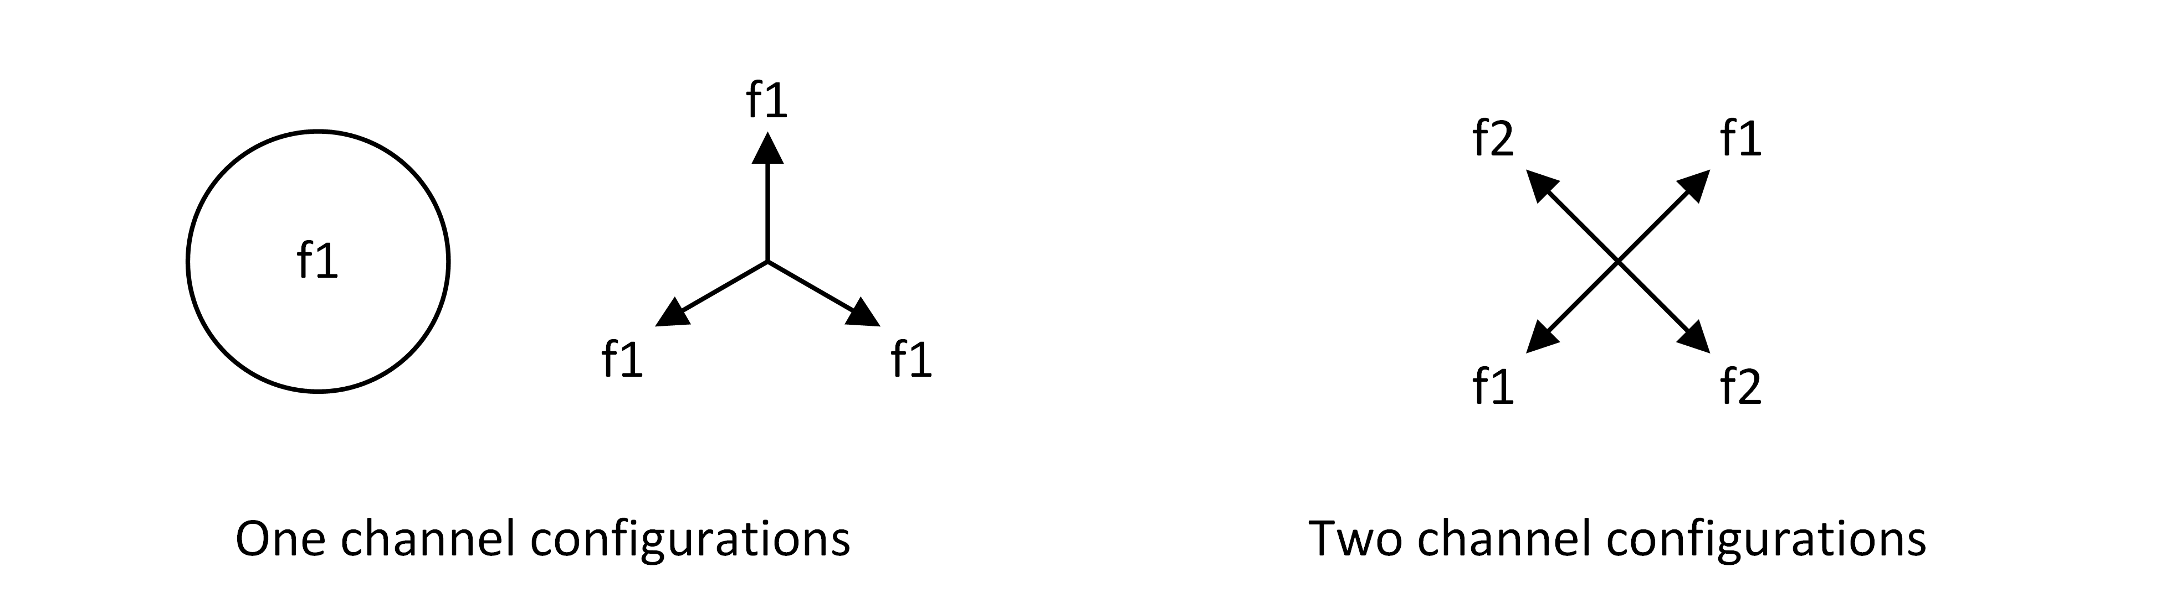
Figure E1: Examples of 360° coverage achieved with one or two channels.
In these cases, the base station is expected to be the dominant element when considering interference to and from other services. That is the remote stations need not be considered in the coordination process, as the coordination with the base station will provide protection to and from the remote stations.
However, in the deployment scenarios shown in Figure E2, it is possible for the remote station to have a greater interference potential due to the front-to-back characteristics of the base station antenna. In such cases, explicit protection from interference is not given to remote stations. The onus is on operators to ensure remote stations do not cause and do not receive harmful interference.
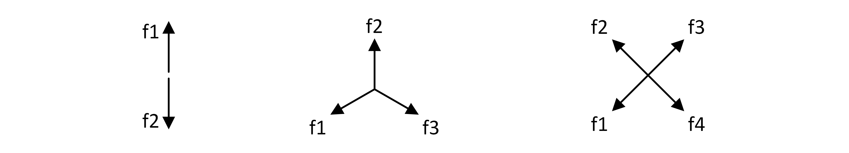
Figure E2: Base station configurations where remote stations have a greater interference potential.
  - Emission masks
Emission characteristics must conform to the relevant standard, paying particular attention to co-existence requirements.
  - Protection criteria
Unlike fixed link protection ratios, which until now have been conservatively based and in many cases provide considerable excess fade margin, the BWA protection criteria in this RALI are deliberately biased towards permitting a high level of spectrum re-use while affording reasonable, though not excessive, levels of protection to the notional BWA service areas.
The maximum unwanted signal level for BWA receivers has been based on a level equivalent to the noise floor of the receiver (with an assumed receiver system noise figure of 5 dB and noise temperature of 290 K). Within a nominal 5 MHz channel this level is –102 dBm. This provides an interference-to-noise ratio of 0 dB (i.e. I/N = 0 dB).
A summary of the protection levels for numerous common bandwidths is provided in Table E3 below. This list is not exhaustive, due to the potential for scalable operational bandwidths of many BWA devices.
Table E3: Protection criteria for various reference bandwidths.
Reference Bandwidth (MHz) | Protection Criteria  (dBm/Reference Bandwidth)
1 | –109
5 | –102
10 | –99
20 | –96

Various terms exist to describe the “remote stations” in a point to multipoint system. Examples include “subscriber terminals”, “outstations”, “subscriber modems”, “consumer premise equipment”, ‘subscriber station’. For the sake of consistency with regulatory terminology the term “remote stations” is used in this RALI.
See Appendix D.
Prospective licensees are reminded that remote stations operate on a ‘no interference’ basis as defined in the Radiocommunications Licence Conditions (Fixed Licence) Determination. The 10 km minimum separation distance requirement stated here is intended to reduce the potential for BWA remote stations to cause harmful interference into a fixed link receiver while also ensuring that BWA licensees have a reasonable chance to service the area surrounding the proposed BWA base station without causing interference to fixed link receivers.
Refer to RALI FX3 section 3.3 for further discussion.
If an applicant with an initial assignment applies for a further assignment(s) in the same area, the rules relating to applications for two or more 5 MHz channels shall apply to each subsequent application.
Where the sectored antennas are combined to achieve an effectively omni-directional coverage (on a single channel) it is not necessary to specify the azimuth of each sector antenna.
Cell radius for cases where the base station communicates with remote stations with external antennas. While practical systems may in some cases achieve greater ranges, such operation is regarded as fortuitous and will not be afforded protection. Similarly, such operation will be subject to a “no interference” condition in respect of interference to other licensed services.
The XPD is measured along the antenna boresight and reduces as the angle away from boresight increases. To account for this a value slightly less than the specified typical range is used. XPD is not available for systems using mixed polarisation.

