Commercial television compliance with Australian content requirements
2024 compliance report – metropolitan networks and regional licensees
AUGUST 2025
Canberra
Level 3
40 Cameron Avenue
Belconnen ACT
PO Box 78
Belconnen ACT 2616
T +61 2 6219 5555
F +61 2 6219 5353
Melbourne
Level 32
Melbourne Central Tower
360 Elizabeth Street
Melbourne VIC
PO Box 13112
Law Courts
Melbourne VIC 8010
T +61 3 9963 6800
F +61 3 9963 6899
Sydney
Level 5
The Bay Centre
65 Pirrama Road
Pyrmont NSW
PO Box Q500
Queen Victoria Building
NSW 1230
T +61 2 9334 7700
F +61 2 9334 7799
Copyright notice
https://creativecommons.org/licenses/by/4.0/
Except for the Commonwealth Coat of Arms, logos, emblems, images, other third-party material or devices protected by a trademark, this content is made available under the terms of the Creative Commons Attribution 4.0 International (CC BY 4.0) licence.
All other rights are reserved.
The Australian Communications and Media Authority has undertaken reasonable enquiries to identify material owned by third parties and secure permission for its reproduction. Permission may need to be obtained from third parties to re-use their material.
We request attribution as © Commonwealth of Australia (Australian Communications and Media Authority) 2025.

Executive summary 1
Compliance results for 2024 2
Transmission quotas 2
Points quota for first release Australian programs and acquired films broadcast in 2024 3
Part 1: Transmission quota metro results 7
Australian content transmission quota data over time 13
Part 2: Australian Content and Children’s Television Standards – metro results 15
Australian content ACS/CTS and ACCTS points quota data over time 21
Appendix A 24
Appendix B 28

Executive summary
Having access to Australian programs on our TVs contributes to creating strong and vibrant communities and a shared sense of who we are as Australians. These programs help to build a common understanding of Australian experiences and stories, enhancing our understanding of the Australian national identity.
Commercial TV licensees are required to meet certain minimum standards for broadcasting Australian content each year. They must report to the ACMA every year on their compliance with the:
Australian content transmission quotas imposed by section 121G of the Broadcasting Services Act 1992 (BSA) – referred to as the transmission quotas
new first release Australian program points quotas imposed by the Broadcasting Services (Australian Content and Children’s Television) Standards 2020 (ACCTS) – referred to as the points quota.
Notably, all licensees met all their obligations in 2024 for both the transmission quotas and the points quota.
This report provides the compliance results and related information for all 13 metropolitan and 62 regional commercial TV licensees for the 2024 calendar year. These results are also published as an interactive report, which allows customisable visualisations for greater insights into licensee performance against their obligations.
This was the fourth year of operation for the ACCTS, which was made by the ACMA in December 2020. The transmission quota requirements have remained unchanged.
Under these reporting obligations, metropolitan commercial TV licensees lodge content returns with the ACMA by the end of March each year, giving details for the preceding calendar year of both:
- broadcast hours and programs claimed towards the transmission quotas
- the annual points claimed for the broadcast of first release Australian programs. First release Australian programs are either commissioned Australian drama (including children’s drama), commissioned Australian documentary, commissioned Australian children’s non-drama programs, or acquired Australian films.
This report provides a summary of metropolitan and regional commercial TV compliance for 2024, through a series of figures and tables reporting how licensees have complied with the Australian content obligations set out in the BSA and ACCTS.

Compliance results for 2024

Transmission quotas

The rules
The Australian content transmission quotas in the BSA require commercial TV licensees to transmit:
- Australian programs for at least 55% of all programming broadcast between 6 am and midnight on their primary TV services, and
- at least 1,460 hours of Australian programs between 6 am and midnight on their non-primary TV services (multi-channels).

Deemed compliance
Australian content provisions can be impacted by infrastructure capacity and/or by affiliation agreements that exist between licensees.
As a result, regional and remote licensees can find it difficult to satisfy the Australian content obligations because they are reliant on metropolitan licensees for content provided through affiliation agreements.
Accordingly, section 121H of the BSA permits a regional commercial licensee to be deemed compliant with the multi-channel quota obligation to broadcast at least 1,460 hours of Australian programs in certain circumstances and if it provides the ACMA with a notice that meets relevant conditions set out in subsection 121H(1) of the BSA.
The ACMA must publish a copy of the notice on its website.

Metropolitan results
All metropolitan licensees reported meeting transmission quotas for their primary channels (55%) and non-primary channels (1,460 hours) for Australian content in 2024.
The amount of Australian content broadcast by metropolitan commercial TV licensees on their primary channels between 6 am and midnight remained high, with the Seven Network providing an average of 76.71% Australian programs, the Nine Network an average of 81.45% Australian programs and Network Ten an average of 63.93% Australian programs.
All metropolitan networks reported broadcasting more than the 1,460 hours quota for non-primary channels by broadcasting the following average hours for 2023:
- Seven Network averaged 5,079.00 hours
- Nine Network averaged 3,402.60 hours
- Network Ten averaged 2,235.44 hours.
More information about the transmission percentages and hours broadcast can be found at Part 1 of this report for metropolitan networks and licensees.
The report also provides information on sports versus non-sports Australian programs broadcast on non-primary channels, and on New Zealand programs being counted towards the transmission quotas, as well as some historical insights into the transmission quotas achieved by each of the networks (see Table 4 and Figure 9 in Part 1).

Regional results
The amount of Australian content broadcast by regional commercial TV licensees on their primary channels remained high. All regional licensees reported meeting 55% transmission quota for their primary channel. In 2024, the percentage of Australian content broadcast between 6 am and midnight by regional licensees on primary channels ranged from 63.79% to 81.79%.
All regional licensees reported broadcasting more than the 1,460 hours quota for non-primary channels. The level of Australian content ranged from 1,851.18 hours to 5,340.43 hours for 61 regional and remote licensees.
One regional licensee (MDV) handed back its broadcast licence on 30 June 2024 and met the quota on a pro rata basis.
No regional licensees sought to rely on the deeming provision for the 2024 results.
The full compliance results for regional licensees can be found at Appendix A.

Points quota for first release Australian programs and acquired films broadcast in 2024
The ACCTS requires commercial TV licensees to broadcast at least 250 points of first release Australian programs, across certain genres, each calendar year. The genres include:
- Commissioned first release Australian documentary programs
- Commissioned first release Australian children’s programs (non-drama)
- Commissioned first release Australian drama programs (including children’s drama)
- Acquired first release Australian films.
The ACCTS allocates points per broadcast hour, as detailed in Schedule 1 of the ACCTS. Commissioned first release drama programs with higher production budgets and acquired first release films with higher license fees attract a higher number of points per hour broadcast, and the relevant figures for production budgets and film licence fees may vary from year to year in accordance with changes in the Consumer Price Index (CPI).

When is a program commissioned?
‘Commissioned’, in relation to a program, is defined in section 8 of the ACCTS to mean that a licensee or its program supplier has made a material and meaningful financial contribution to a program (before completion). Commissioned programs may include in-house productions or domestic co-productions with national broadcasters, streaming video services or subscription broadcast channels.
The Explanatory Statement to the ACCTS states that for a financial contribution to be considered ‘material and meaningful’, it should be a contribution that is both significant and enables the program to be made. If the contribution of the licensee is not considered material and meaningful, quota points cannot be claimed for the program.
The significance of a financial contribution is assessed by looking at the licensee’s contribution as a proportion of the overall production budget for the commissioned program. The ACMA adopts the following approach:
- For all fully funded programs, licensees are considered to have made a significant financial contribution and this has enabled the programs to be made. A licensee’s contribution is material and meaningful as a result.
- For programs where a medium to high proportion of the total production budget has been supplied by the licensee, we have considered the contribution to be a significant financial contribution which has enabled the program to be made. A licensee’s contribution is material and meaningful as a result.
- For programs where a lower proportion of the total production budget has been supplied by the licensee, we have queried licensees on matters beyond direct funding, such as:
- broadcasting and streaming rights/entitlements
- the creative control the licensee has
- the type of program being produced
- the arrangements for co-commissioning or multiparty productions
- the overall budget of the program.
- These lines of additional inquiry assist us to further assess the extent to which the licensee’s contribution was meaningful and enabled the program to be made. Following assessment of further evidence, we have determined whether licensee contributions for programs were ‘material and meaningful’.

What points can be claimed?
Schedule 1 of the ACCTS provides for points allocation for 4 different program genres.
Section 15 of the ACCTS specifies a formula for calculating increases for the production budget and licence fee figures for 2024 and later years. The formula is based on movements in CPI, resulting in the following table of applicable CPI-adjusted production budget figures and genre point allocation for 2024:
Genre | Points per hour broadcast
Commissioned first release Australian documentary program (capped at a maximum 50 points per calendar year) | 1
Commissioned first release Australian children’s program (non-drama) | 1.5
Commissioned first release Australian drama program (less than or equal to $525,000 production budget per hour) | 1.5
Commissioned first release Australian drama program (more than $525,000 up to $815,000 production budget per hour) | 4
Commissioned first release Australian drama program (more than $815,000 up to $1,164,000 production budget per hour) | 5
Commissioned first release Australian drama program (more than $1,164,000 up to $1,630,000 production budget per hour) | 6
Commissioned first release Australian drama program (more than $1,630,000 production budget per hour) | 7
Acquired first release Australian film (licence fee per film less than $59,000) | 1
Acquired first release Australian film (licence fee per film equal to or more than $59,000) | 2

Deemed compliance: ACCTS annual points quota
Section 16 of the ACCTS provides that a regional licensee can be deemed compliant with the annual points quota under the standards. The Explanatory Statement to the ACCTS indicates that the deeming provision was introduced to protect regional and remote licensees that may have limited control over programming retransmitted under an affiliate agreement.

When received, we publish copies of the notices given under the ACCTS on our website.

Metropolitan results
All metropolitan licensees reported compliance with the annual points quota under the ACCTS. In 2024, the points reported were:
- Seven Network metropolitan licensees broadcast first release Australian content totalling 216.50 points
- Nine Network metropolitan licensees broadcast first release Australian content totalling 243.98 points
- Ten Network metropolitan licensees broadcast first release Australian content totalling 395.5 points.
Licensees may ‘carry over’ up to 50 points achieved in excess of the annual points quota from one calendar year to the next calendar year. The carry over provisions were utilised by licensees for 2024, so the average metropolitan licensees’ points for 2024 were:
- Seven Network – 266.5 points (216.50 points with an average of 50 points carried forward from 2023)
- Nine Network – 274.76 points (243.98 points with an average of 30.78 points carried forward from 2023)
- Network Ten – 445.50 points (395.50 points with an average of 50 points carried forward from 2023).
The average hours of ACCTS first release commissioned programs and acquired films broadcast by metropolitan licensees in 2024 were:
- Seven Network licensees – 157.50 hours
- Nine Network licensees – 149.25 hours
- Ten Network licensees – 172.50 hours.

Regional results
For 2024, all regional licensees met the annual points quota under the ACCTS, with:
- 40 licensees broadcasting in excess of the quota, claiming between 274.31 and 387.50 points of first release Australian content and claiming between 9.75 and 50.00 points carried forward from 2023.
- 21 licensees broadcasting 216.50 points of first release Australian content (less than the quota) and claiming carry forward points to meet their points quota for 2024.
- One licensee meeting the quota on a pro-rata basis (180.00 points for 182 days of broadcasting in 2024).
In relation to deeming:
- licensees with deemed compliance for points in 2023 carried forward 0 points towards their compliance in 2024, and
- no licensees relied on deemed compliance provisions to meet the 250 points requirement of the ACCTS in 2024.
The ACCTS quota points, program titles and hours broadcast are detailed in Part 2 of this report for metropolitan licensees and in Appendix A for each regional licensee. Appendix B contains details of carry over points available to each licensee in 2024 and how these impacted the points quota totals of licensees.

Part 1: Transmission quota metro results
Australian content transmission quota compliance 2024
Primary channels
Metropolitan primary channel transmission data
Network | Average transmission hours | Average transmission %
Seven | 5,053.88 | 76.71%
HSV MELBOURNE | 5,223.32 | 79.29%
SAS ADELAIDE | 5,188.53 | 78.76%
ATN SYDNEY | 5,013.37 | 76.10%
BTQ BRISBANE | 4,990.87 | 75.76%
TVW PERTH | 4,853.30 | 73.67%
Nine | 5,366.18 | 81.45%
TCN SYDNEY | 5,387.80 | 81.78%
QTQ BRISBANE | 5,367.73 | 81.48%
GTV MELBOURNE | 5,343.00 | 81.10%
Ten | 4,211.91 | 63.93%
TEN SYDNEY | 4,215.98 | 64.00%
ATV MELBOURNE | 4,216.49 | 64.00%
NEW PERTH | 4,202.41 | 63.79%
TVQ BRISBANE | 4,211.58 | 63.93%
ADS ADELAIDE | 4,213.07 | 63.95%

Non-primary channels
Metropolitan non-primary channel transmission data
Network | Average transmission hours
Seven | 5,079.00
SAS ADELAIDE | 4,963.50
BTQ BRISBANE | 5,134.63
HSV MELBOURNE | 4,847.12
TVW PERTH | 5,346.30
ATN SYDNEY | 5,103.12
Nine | 3,402.60
QTQ BRISBANE | 3,338.80
GTV MELBOURNE | 3,532.73
TCN SYDNEY | 3,336.28
Ten | 2,235.44
ADS ADELAIDE | 2,228.09
TVQ BRISBANE | 2,228.26
ATV MELBOURNE | 2,228.26
NEW PERTH | 2,264.34
TEN SYDNEY | 2,228.26

Primary channel transmission quota – Average hours claimed by networks, 2024
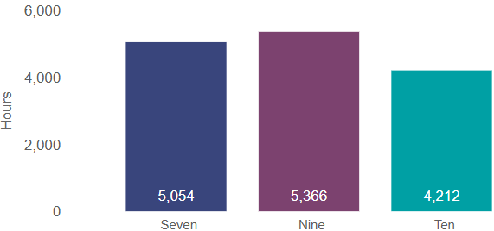
Note: Discrepancies may exist in figure due to rounding.

Primary channel transmission quota – Average hours claimed by licensees, 2024
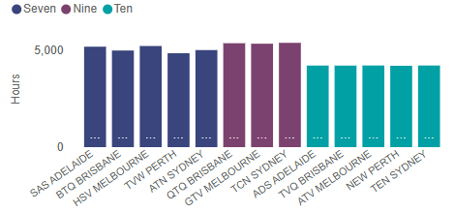
Primary channel transmission quota – Average percentage claimed by networks, 2024
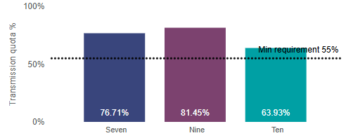

Primary channel transmission quota – Average percentage claimed by licensees, 2024
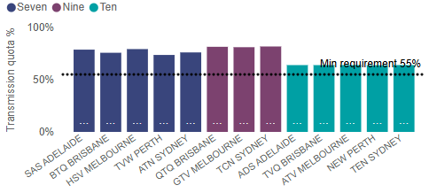

Non-primary channel transmission quota – Average hours claimed by networks, 2024
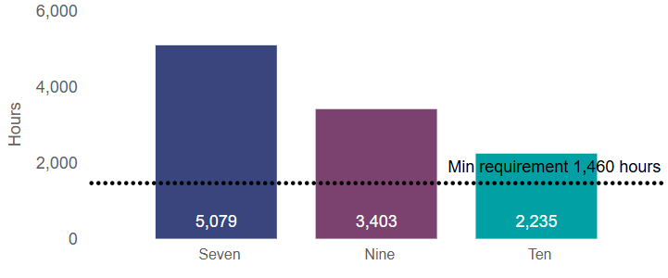
Note: Discrepancies may exist in figure due to rounding.
Non-primary channel transmission quota – Average hours claimed by licensees, 2024
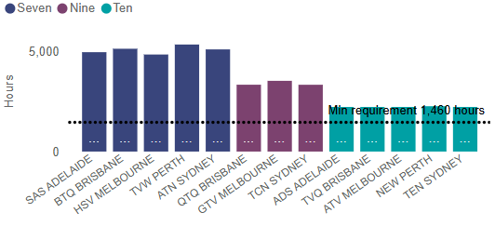

Non-primary channel transmission quota – Hours of sports v non-sports content, 2024
Non-primary channels
Sport v non-sport genres data for non-primary channel transmission quotas
Network | Australian content non-sports only | Australian content sports coverage
Seven | 3,961.46 | 1,117.32
SAS ADELAIDE | 4,023.42 | 940.08
BTQ BRISBANE | 3,943.02 | 1,190.83
HSV MELBOURNE | 3,999.38 | 847.73
TVW PERTH | 3,899.05 | 1,447.25
ATN SYDNEY | 3,942.42 | 1,160.70
Nine | 2,414.04 | 988.56
QTQ BRISBANE | 2,419.26 | 919.53
GTV MELBOURNE | 2,409.70 | 1,123.03
TCN SYDNEY | 2,413.17 | 923.11
Ten | 1,883.70 | 351.90
ADS ADELAIDE | 1,881.42 | 346.67
TVQ BRISBANE | 1,882.42 | 345.83
ATV MELBOURNE | 1,885.09 | 344.00
NEW PERTH | 1,884.51 | 379.83
TEN SYDNEY | 1,885.09 | 343.17

Non-primary channel transmission quota – Hours of sports v non-sports content, 2024
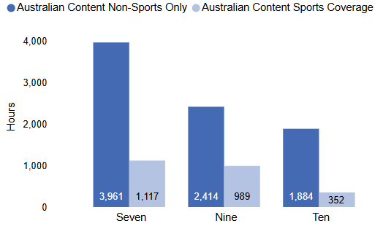
Note: Discrepancies may exist in figure due to rounding
Transmission quota – New Zealand Programs counted as Australian content in 2024
NZ content on primary and non-primary channels
Total counted towards transmission quota
Network | Average NZ hours counted primary | Average NZ hours counted non-primary | Average NZ hours counted
Seven | 17.67 | 45.48 | 63.16
TVW Perth | 25.05 | 47.12 | 72.17
BTQ Brisbane | 17.97 | 44.42 | 62.39
ATN Sydney | 13.38 | 44.40 | 57.78
SAS Adelaide | 17.73 | 45.55 | 63.28
HSV Melbourne | 14.23 | 45.93 | 60.16
Nine | 40.72 | 48.40 | 89.12
TCN Sydney | 41.07 | 48.07 | 89.14
QTQ Brisbane | 41.17 | 49.07 | 90.24
GTV Melbourne | 39.92 | 48.07 | 87.99
Ten | 0.00 | 2.00 | 2.00
TVQ Brisbane | 0.00 | 2.00 | 2.00
ATV Melbourne | 0.00 | 2.00 | 2.00
NEW Perth | 0.00 | 2.00 | 2.00
TEN Sydney | 0.00 | 2.00 | 2.00
ADS Adelaide | 0.00 | 2.00 | 2.00

Transmission quota – New Zealand programs counted as Australian content, 2024
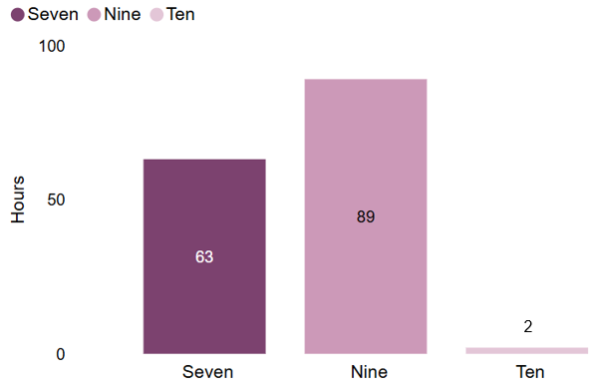

Australian content transmission quota data over time
Transmission quota – Average hours and percentages claimed by networks
for both primary and non-primary channels, 2015–24
Table of average hours and % data for primary and non-primary metropolitan channels, 2015-24
Network | Seven |  | Nine |  | Ten
Year | Average % of Aus content claimed by primary channels | Average hours of Aus content claimed by non-primary channels | Average % of Aus content claimed by primary channels | Average hours of Aus content claimed by non-primary channels | Average % of Aus content claimed by primary channels | Average hours of Aus content claimed by non-primary channels
2015 | 69.77% | 2,959.96 | 71.63% | 1,604.04 | 63.28% | 4,077.94
2016 | 72.55% | 4,162.95 | 71.98% | 2,364.53 | 64.99% | 2,707.29
2017 | 73.41% | 4,501.88 | 74.77% | 2,157.85 | 68.43% | 2,561.82
2018 | 77.33% | 5,210.20 | 73.81% | 3,696.44 | 68.70% | 2,696.83
2019 | 77.15% | 4,770.46 | 74.93% | 2,597.64 | 69.94% | 2,532.94
2020 | 72.14% | 4,422.21 | 73.18% | 2,519.95 | 66.76% | 2,063.53
2021 | 73.73% | 5,307.00 | 77.10% | 2,230.33 | 67.85% | 1,727.38
2022 | 75.88% | 5,521.57 | 79.46% | 2,664.62 | 70.54% | 2,428.45
2023 | 76.42% | 5,426.54 | 78.35% | 2,625.78 | 69.61% | 2,018.15
2024 | 76.71% | 5,079.00 | 81.45% | 3,402.61 | 63.93% | 2,235.44

Primary channel transmission quota – Average percentage of Australian content transmitted, 2018–24
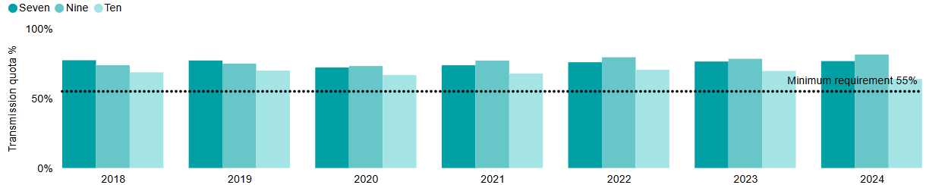
Non-primary channel transmission quota – Average hours of Australian content transmitted, 2018–24
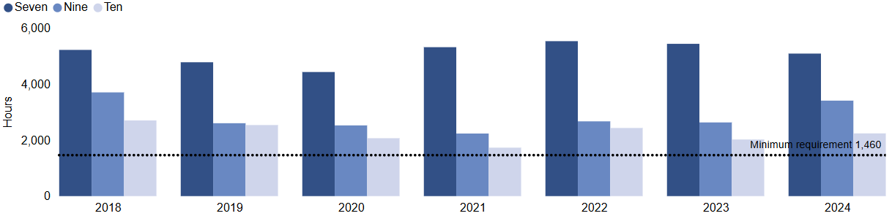

Part 2: Australian Content and Children’s Television Standards – metro results
Metropolitan ACCTS data, 2024
ACCTS points quota compliance data, 2024
Metropolitan ACCTS data 2024 (includes carry over points)
Network | Average hours ACCTS | Average points ACCTS
Seven | 157.50 | 266.50
SAS ADELAIDE | 157.50 | 266.50
BTQ BRISBANE | 157.50 | 266.50
HSV MELBOURNE | 157.50 | 266.50
TVW PERTH | 157.50 | 266.50
ATN SYDNEY | 157.50 | 266.50
Nine | 149.25 | 274.76
QTQ BRISBANE | 149.25 | 275.09
GTV MELBOURNE | 149.25 | 274.09
TCN SYDNEY | 149.25 | 275.09
Ten | 172.50 | 445.50
ADS ADELAIDE | 172.50 | 445.50
TVQ BRISBANE | 172.50 | 445.50
ATV MELBOURNE | 172.50 | 445.50
NEW PERTH | 172.50 | 445.50
TEN SYDNEY | 172.50 | 445.50

Total hours and points claimed towards the ACCTS points quota by metropolitan networks
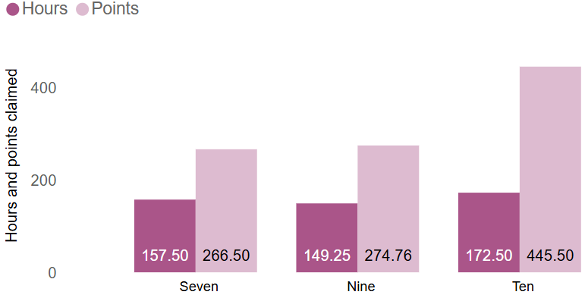

Total hours and points claimed towards the ACCTS points quota by licensees
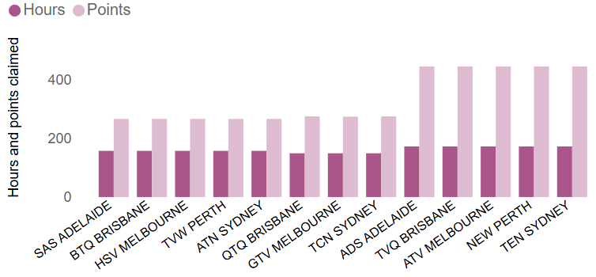

ACCTS points – First release Australian programs – Seven
Network | Genre | Points per hour of broadcast | Average broadcast hours claimed by licensees | Average ACCTS points claimed by licensees
Seven
Animals Aboard with Dr. Harry | Australian documentary | 1 | 2.00 | 2.00
Australia's Most Dangerous Prisoners | Australian documentary | 1 | 7.00 | 7.00
Border Security - Australia's Front Line | Australian documentary | 1 | 1.00 | 1.00
Highway Patrol (s12) | Australian documentary | 1 | 0.50 | 0.50
Highway Patrol (s13) | Australian documentary | 1 | 4.50 | 4.50
Home and Away (s36) | Australian drama | 1.5 | 61.00 | 91.50
Home and Away (s37) | Australian drama | 1.5 | 54.00 | 81.00
King Con: Life and Crimes of Hamish McLaren | Australian documentary | 1 | 2.00 | 2.00
Outback Crystal Hunters | Australian documentary | 1 | 8.00 | 8.00
Outback Outlaw Comedian | Australian drama | 1.5 | 3.00 | 4.50
Outback Truckers | Australian documentary | 1 | 13.00 | 13.00
The Hunters | Australian documentary | 1 | 1.50 | 1.50
Note: Discrepancies may exist in figures due to rounding.

ACCTS points – First release Australian programs – Nine
Network | Genre | Points per hour of broadcast | Average broadcast hours claimed by licensees | Average ACCTS points claimed by licensees
Nine
1 | Australian film | 1 | 1.75 | 1.75
A Remarkable Place to Die | Australian drama | 6 | 8.00 | 48.00
A Royal in Paradise | Australian film | 1 | 2.00 | 2.00
A Savage Christmas | Australian film | 1 | 2.00 | 2.00
Australian Crime Stories: The Investigators | Australian documentary | 1 | 3.17 | 3.17
Avarice | Australian film | 1 | 2.08 | 2.08
Beyond the Dream: Boiling Point – Swimming’s Greatest Rivalry | Australian documentary | 1 | 1.17 | 1.17
Beyond the Dream: Curtis McGrath Unstoppable | Australian documentary | 1 | 1.15 | 1.15
Beyond the Dream: Forged in Steel | Australian documentary | 1 | 1.08 | 1.08
Beyond the Dream: Race to Paris | Australian documentary | 1 | 1.08 | 1.08
Big Miracles | Australian documentary | 1 | 6.00 | 6.00
Blaze | Australian film | 1 | 2.08 | 2.08
Christmess | Australian film | 1 | 2.08 | 2.08
Do You Want to Live Forever | Australian documentary | 1 | 5.08 | 5.08
Emergency (s4) | Australian documentary | 1 | 4.00 | 4.00
Emergency (s5) | Australian documentary | 1 | 6.00 | 6.00
Everything In Between | Australian film | 1 | 1.92 | 1.92
Evicted: A Modern Romance | Australian film | 1 | 2.33 | 2.33
Human Error | Australian drama | 7 | 6.00 | 42.00
Isaac’s Dream | Australian film | 1 | 1.58 | 1.58
It Only Takes a Night | Australian film | 1 | 2.00 | 2.00
Jess Fox: Whitewater | Australian documentary | 1 | 1.00 | 1.00
Kane | Australian film | 1 | 1.67 | 1.67
Love Road | Australian film | 1 | 1.92 | 1.92
Murder Down Under | Australian documentary | 1 | 2.00 | 2.00
Our Heroes of Paris | Australian documentary | 1 | 1.83 | 1.83
Paramedics | Australian documentary | 1 | 13.00 | 13.00
Pieces | Australian film | 1 | 2.05 | 2.05
Radio Man | Australian film | 1 | 2.33 | 2.33
Red Shoes: Next Steps | Australian film | 1 | 2.33 | 2.33
Roadkill | Australian film | 1 | 2.00 | 2.00
Romance at the Vineyard | Australian film | 1 | 1.92 | 1.92
RPA | Australian documentary | 1 | 8.00 | 8.00
Saya Sakakibara: Ride to Redemption | Australian documentary | 1 | 1.00 | 1.00
Streets of Colour | Australian film | 1 | 2.12 | 2.12
Sweet Rhythm | Australian film | 1 | 2.33 | 2.33
Take Me Home | Australian documentary | 1 | 8.00 | 8.00
Taronga: Who’s Who in the Zoo (s3) | Australian documentary | 1 | 0.20 | 0.20
Taronga: Who’s Who in the Zoo (s4) | Australian documentary | 1 | 4.00 | 4.00
Taronga: Who’s Who in the Zoo (s5) | Australian documentary | 1 | 6.00 | 6.00
The Actually Really Very Difficult Show (s1) | Australian children’s (non-drama) | 1.5 | 12.50 | 18.75
The Actually Really Very Difficult Show (s2) | Australian children’s (non-drama) | 1.5 | 25.00 | 37.50
The Gift that Gives | Australian film | 1 | 1.83 | 1.83
The Lonely Spirits Variety Hour | Australian film | 1 | 1.58 | 1.58
Three Chords and the Truth | Australian film | 1 | 1.83 | 1.83
Wanda and Sully | Australian film | 1 | 2.00 | 2.00
Wild Moments | Australian documentary | 1 | 7.00 | 7.00
You, Me and the Penguins | Australian film | 1 | 2.00 | 2.00
Note: Discrepancies may exist in figures due to rounding.
ACCTS points – First release Australian programs – Ten
Network | Genre | Points per hour of broadcast | Average broadcast hours claimed by licensees | Average ACCTS points claimed by licensees
Ten
Ambulance Australia (s5) | Australian documentary | 1 | 8.00 | 8.00
Bondi Rescue (s18) | Australian documentary | 1 | 5.00 | 5.00
Dogs Behaving (Very) Badly (s2) | Australian documentary | 1 | 10.00 | 10.00
Five Bedrooms (s4) | Australian drama | 6 | 8.00 | 48.00
NCIS Sydney (s1) | Australian drama | 7 | 7.00 | 49.00
Neighbours (s41/42) | Australian drama | 1.5 | 102.00 | 153.00
Rock Island Mysteries (s3) | Australian drama (children’s) | 6 | 10.00 | 60.00
Thank God You’re Here! (s6) | Australian drama | 5 | 10.00 | 50.00
The Dog House Australia (s4) | Australian documentary | 1 | 12.50 | 12.50
Note: Discrepancies may exist in figures due to rounding.

Australian content ACS/CTS and ACCTS points quota data over time
Australian content transmission – Total average ACS/CTS or ACCTS hours claimed by all networks, 2019–24
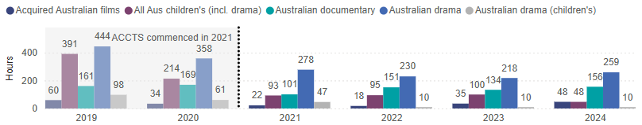
Total average hours of Australian drama programs claimed by all networks, 2019–24
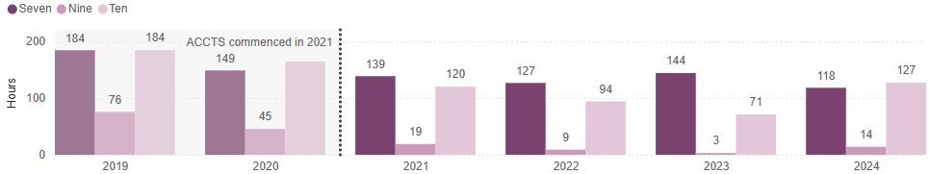

Total average hours of Australian children’s drama programs claimed by all networks, 2019–24
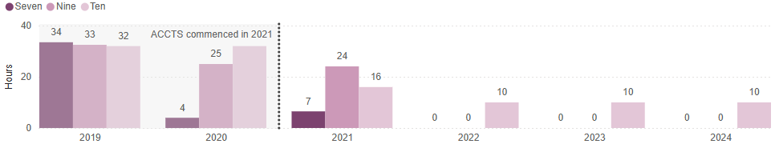

Total average hours of all Australian children’s programs (including drama) claimed by all networks, 2019–24
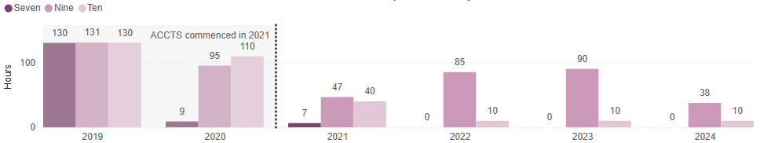
Total average hours of all Australian documentary programs claimed by all networks, 2019–24
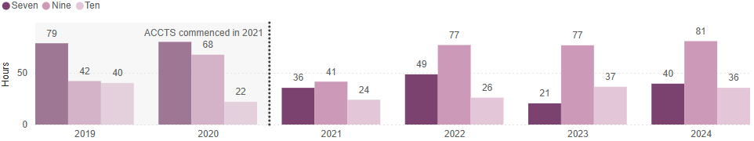
Total average hours of all Australian acquired films claimed by all networks, 2019–24
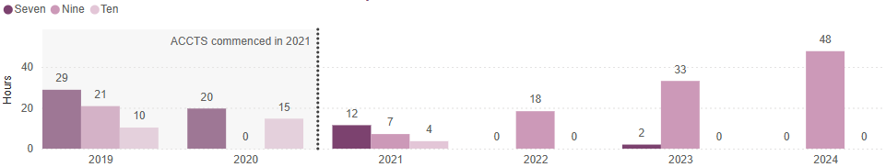

Appendix A
Transmission quota and ACCTS points quota – regional licensee results
1 January 2024 to 31 December 2024
Call sign | Licence no. | Company name | Primary channel transmission quota (%) | Non-primary channel transmission quota (hours) | First release Australian program quota points
Major source of programs: Nine (number of licences: 16)
BDN | 1130143 | Broken Hill Television Pty Limited | 81.32 | 3,794.85 | 274.50
GDS | 1130142 | Spencer Gulf Telecasters Pty Limited | 81.32 | 3,794.85 | 274.50
IMP | 2898 | Imparja Television Pty Ltd | 81.79 | 1,851.18 | 274.00
MTN | 10103 | Win Television Griffith Pty Ltd | 81.71 | 3,384.75 | 253.50
NBN | 94 | NBN Pty Ltd | 81.79 | 3,336.14 | 274.50
NTD | 10172 | Territory Television Pty Ltd | 81.35 | 3,379.93 | 275.50
NWS | 121 | Channel 9 South Australia Pty Limited | 81.32 | 3,795.14 | 274.86
RTQ | 116 | Win Television QLD Pty Ltd | 81.48 | 3,386.79 | 253.50
RTS | 10174 | Win Television SA Pty Ltd | 81.32 | 3,653.64 | 253.50
SES | 10330 | Win Television SA Pty Ltd | 81.32 | 3,653.64 | 253.50
STV | 10088 | Win Television Mildura Pty Ltd | 81.11 | 3,580.72 | 253.50
STW | 10162 | Swan Television & Radio Broadcasters Pty Ltd | 79.93 | 3,635.23 | 274.86
TVT | 132 | Win Television TAS Pty Ltd | 81.08 | 3,581.22 | 253.50
VTV | 107 | Win Television VIC Pty Ltd | 81.11 | 3,580.72 | 253.50
WIN | 99 | Win Television NSW Pty Limited | 81.71 | 3,384.75 | 253.50
WOW | 10048 | Win Television WA Pty Ltd | 79.93 | 3,673.27 | 253.50
Major source of programs: Seven (number of licences: 18)
AMN | 10104 | Win Television Griffith Pty Ltd | 76.10 | 5,106.12 | 266.50
AMV | 103 | Prime Television (Victoria) Pty Limited | 79.29 | 4,846.75 | 266.50
BKN | 10241 | Broken Hill Television Pty Limited | 78.75 | 4,963.10 | 266.50
CBN | 90 | Prime Television (Southern) Pty. Limited | 76.10 | 5,102.75 | 266.50
GTS | 10234 | Spencer Gulf Telecasters Pty Limited | 78.75 | 4,963.10 | 266.50
GTW | 10418 | Geraldton Telecasters Pty Ltd | 73.67 | 5,340.43 | 266.50
ITQ | 114 | Regional Television Pty Limited | 75.76 | 5,224.78 | 266.50
NEN | 95 | Prime Television (Northern) Pty Limited | 76.10 | 5,102.75 | 266.50
PTV | 10089 | Prime Television (Victoria) Pty Limited | 79.29 | 4,846.75 | 266.50
QQQ | 4285 | Regional Television Pty Limited | 75.76 | 5,224.78 | 266.50
RDS | 1130145 | Win Television Sa Pty Ltd | 78.73 | 4,975.58 | 266.50
SDS | 1130144 | Win Television Sa Pty Ltd | 78.73 | 4,975.58 | 266.50
SSW | 10417 | Golden West Network Pty. Limited | 73.67 | 5,340.43 | 266.50
STQ | 115 | Channel Seven Queensland Pty. Limited | 75.76 | 5,134.63 | 266.50
TND | 10173 | Regional Television Pty Limited | 79.29 | 4,846.45 | 266.50
TNT | 133 | Southern Cross Television (Tnt9) Pty. Limited | 79.29 | 4,846.45 | 266.50
VEW | 10416 | Mid-Western Television Pty Ltd | 73.67 | 5,340.43 | 266.50
WAW | 4747 | Golden West Satellite Communications Pty Ltd | 73.67 | 5,340.43 | 266.50
Major source of programs: Ten (number of licences: 19)
BCV | 104 | Southern Cross Communications Pty Limited | 64.00 | 2,228.22 | 437.50
CDT | 1130050 | Central Digital Television Pty Limited | 64.00 | 2,228.22 | 437.50
CTC | 85 | Australian Capital Television Pty Ltd | 64.00 | 2,228.22 | 437.50
DTD | 1130013 | Darwin Digital Television Pty Limited | 64.00 | 2,228.22 | 437.50
GDW | 1130046 | West Digital Television No.2 Pty Ltd | 63.79 | 2,025.42 | 377.50
GLV | 106 | Southern Cross Communications Pty Limited | 64.00 | 2,228.22 | 437.50
IDQ | 1130051 | Central Digital Television Pty Limited | 63.93 | 2,228.22 | 437.50
LRS | 1150796 | Win Television Sa Pty Ltd | 63.95 | 1,990.17 | 377.50
MDN | 1130146 | Win Television Griffith Pty Ltd | 64.00 | 1,990.34 | 377.50
MDV | 1150827 | Mildura Digital Television Pty Ltd | 65.09 | 1,060.00 | 180.00
MGS | 1150799 | Win Television Sa Pty Ltd | 63.95 | 1,990.17 | 377.50
NRN | 96 | Network Investments Pty Ltd | 64.00 | 1,990.34 | 377.50
SCN | 1150797 | Broken Hill Television Pty Limited | 63.95 | 2,227.72 | 437.50
SDW | 1130049 | West Digital Television  Pty Ltd | 63.79 | 2,025.42 | 377.50
SGS | 1150798 | Spencer Gulf Telecasters Pty Limited | 63.95 | 2,227.72 | 437.50
TDT | 1150806 | Tasmanian Digital Television Pty Ltd | 64.00 | 2,228.22 | 437.50
TNQ | 113 | Regional Television Pty Limited | 63.93 | 2,228.22 | 437.50
VDW | 1130048 | West Digital Television No.3 Pty Ltd | 63.79 | 2,025.42 | 377.50
WDW | 1130047 | West Digital Television No.4 Pty Ltd | 63.79 | 2,025.42 | 377.50
VAST licences: (9 callsigns)
Major source of programs: Nine
SVW (WIN9) | 1130166 | WA Satco Pty Limited | 79.93 | 3,673.27 | 253.50
VAN (IMP) | 1130136 | Eastern Australia Satellite Broadcasters Pty Ltd | 81.79 | 1,851.18 | 274.00
VAS (IMP) | 1130135 | Eastern Australia Satellite Broadcasters Pty Ltd | 81.79 | 1,851.18 | 274.00
Major source of programs: Seven
SVW (GWN7) | 1130166 | WA Satco Pty Limited | 73.67 | 5,340.43 | 266.50
VAN (SCT) | 1130136 | Eastern Australia Satellite Broadcasters Pty Ltd | 75.76 | 5,224.78 | 266.50
VAS (SCT) | 1130135 | Eastern Australia Satellite Broadcasters Pty Ltd | 79.29 | 4,936.85 | 266.50
Major source of programs: Ten
SVW (WIN10) | 1130166 | WA Satco Pty Limited | 63.79 | 2,025.42 | 377.50
VAN (CDT) | 1130136 | Eastern Australia Satellite Broadcasters Pty Ltd | 63.93 | 2,228.22 | 437.50
VAS (CDT) | 1130135 | Eastern Australia Satellite Broadcasters Pty Ltd | 64.00 | 2,228.22 | 437.50
Summary information |  | Lowest | 63.79 | 1,851.18 | 253.50
 |  | Highest | 81.79 | 5,340.43 | 437.50
 |  | Minimum Annual Requirement | 55.00 | 1,460.00 | 250.00

Appendix B
Carry over ACCTS points from 2023 – metropolitan licensees
Network | Licensee | First release Australian quota points claimed |  | Number of carry over points from 2023 available (max. 50) | Carry over points used in 2024 (max. 50) | Points claimed in Australian documentary (max. 50) | Deduct excess Australian documentary points |  | Total ACCTS points for 2024
Seven | ATN Sydney | 216.50 | 50.00 |  | 50.00 | 39.50 | 0 | 266.50
Seven | HSV Melbourne | 216.50 | 50.00 |  | 50.00 | 39.50 | 0 | 266.50
Seven | BTQ Brisbane | 216.50 | 50.00 |  | 50.00 | 39.50 | 0 | 266.50
Seven | SAS Adelaide | 216.50 | 50.00 |  | 50.00 | 39.50 | 0 | 266.50
Seven | TVW Perth | 216.50 | 50.00 |  | 50.00 | 39.50 | 0 | 266.50
Nine | TCN Sydney | 274.54 | 31.11 |  | 31.11 | 80.56 | 30.56 | 275.09
Nine | GTV Melbourne | 274.54 | 30.11 |  | 30.11 | 80.56 | 30.56 | 274.09
Nine | QTQ Brisbane | 274.54 | 31.11 |  | 31.11 | 80.56 | 30.56 | 275.09
Nine | NWS Adelaide | 274.54 | 31.11 |  | 31.11 | 80.56 | 30.56 | 275.09
Nine | STW Perth | 274.54 | 31.11 |  | 31.11 | 80.56 | 30.56 | 275.09
Ten | TEN Sydney | 395.50 | 50.00 |  | 50.00 | 35.50 | 0 | 445.50
Ten | ATV Melbourne | 395.50 | 50.00 |  | 50.00 | 35.50 | 0 | 445.50
Ten | TVQ Brisbane | 395.50 | 50.00 |  | 50.00 | 35.50 | 0 | 445.50
Ten | ADS Adelaide | 395.50 | 50.00 |  | 50.00 | 35.50 | 0 | 445.50
Ten | NEW Perth | 395.50 | 50.00 |  | 50.00 | 35.50 | 0 | 445.50

Carry over points from 2023 – regional licensees
Call sign | Licence no. | Company name | Eligible first release Australian quota points | Number of carry over points from 2023 available (max. 50) | Total ACCTS points for 2024
Major source of programs: Nine
BDN | 1130143 | Broken Hill Television Pty Limited | 243.75 | 30.75 | 274.50
GDS | 1130142 | Spencer Gulf Telecasters Pty Limited | 243.75 | 30.75 | 274.50
IMP | 2898 | Imparja Television Pty Ltd | 243.75 | 30.25 | 274.00
MTN | 10103 | Win Television Griffith Pty Ltd | 243.75 | 9.75 | 253.50
NBN | 94 | Nbn Pty Ltd | 243.75 | 30.75 | 274.50
NTD | 10172 | Territory Television Pty Ltd | 243.75 | 31.75 | 275.50
NWS | 121 | Channel 9 South Australia Pty Limited | 243.75 | 31.11 | 274.86
RTQ | 116 | Win Television QLD Pty Ltd | 243.75 | 9.75 | 253.50
RTS | 10174 | Win Television SA Pty Ltd | 243.75 | 9.75 | 253.50
SES | 10330 | Win Television SA Pty Ltd | 243.75 | 9.75 | 253.50
STV | 10088 | Win Television Mildura Pty Ltd | 243.75 | 9.75 | 253.50
STW | 10162 | Swan Television & Radio Broadcasters Pty Ltd | 243.75 | 31.11 | 274.86
TVT | 132 | Win Television TAS Pty Ltd | 243.75 | 9.75 | 253.50
VTV | 107 | Win Television VIC Pty Ltd | 243.75 | 9.75 | 253.50
WIN | 99 | Win Television NSW Pty Limited | 243.75 | 9.75 | 253.50
WOW | 10048 | Win Television WA Pty Ltd | 243.75 | 9.75 | 253.50
Major source of programs: Seven
AMN | 10104 | Win Television Griffith Pty Ltd | 216.50 | 50.00 | 266.50
AMV | 103 | Prime Television (Victoria) Pty Limited | 216.50 | 50.00 | 266.50
BKN | 10241 | Broken Hill Television Pty Limited | 216.50 | 50.00 | 266.50
CBN | 90 | Prime Television (Southern) Pty. Limited | 216.50 | 50.00 | 266.50
GTS | 10234 | Spencer Gulf Telecasters Pty Limited | 216.50 | 50.00 | 266.50
GTW | 10418 | Geraldton Telecasters Pty Ltd | 216.50 | 50.00 | 266.50
ITQ | 114 | Regional Television Pty Limited | 216.50 | 50.00 | 266.50
NEN | 95 | Prime Television (Northern) Pty Limited | 216.50 | 50.00 | 266.50
PTV | 10089 | Prime Television (Victoria) Pty Limited | 216.50 | 50.00 | 266.50
QQQ | 4285 | Regional Television Pty Limited | 216.50 | 50.00 | 266.50
RDS | 1130145 | Win Television SA Pty Ltd | 216.50 | 50.00 | 266.50
SDS | 1130144 | Win Television SA Pty Ltd | 216.50 | 50.00 | 266.50
SSW | 10417 | Golden West Network Pty. Limited | 216.50 | 50.00 | 266.50
STQ | 115 | Channel Seven Queensland Pty. Limited | 216.50 | 50.00 | 266.50
TND | 10173 | Regional Television Pty Limited | 216.50 | 50.00 | 266.50
TNT | 133 | Southern Cross Television (Tnt9) Pty. Limited | 216.50 | 50.00 | 266.50
VEW | 10416 | Mid-Western Television Pty Ltd | 216.50 | 50.00 | 266.50
WAW | 4747 | Golden West Satellite Communications Pty Ltd | 216.50 | 50.00 | 266.50
Major source of programs: Ten
BCV | 104 | Southern Cross Communications Pty Limited | 387.50 | 50.00 | 437.50
CDT | 1130050 | Central Digital Television Pty Limited | 387.50 | 50.00 |  | 437.50
CTC | 85 | Australian Capital Television Pty Ltd | 387.50 | 50.00 | 437.50
DTD | 1130013 | Darwin Digital Television Pty Limited | 387.50 | 50.00 |  | 437.50
GDW | 1130046 | West Digital Television No.2 Pty Ltd | 327.50 | 50.00 | 377.50
GLV | 106 | Southern Cross Communications Pty Limited | 387.50 | 50.00 | 437.50
IDQ | 1130051 | Central Digital Television Pty Limited | 387.50 | 50.00 |  | 437.50
LRS | 1150796 | Win Television SA Pty Ltd | 327.50 | 50.00 | 377.50
MDN | 1130146 | Win Television Griffith Pty Ltd | 327.50 | 50.00 | 377.50
MDV | 1150827 | Mildura Digital Television Pty Ltd | 130.00 | 50.00 | 180.00
MGS | 1150799 | Win Television SA Pty Ltd | 327.50 | 50.00 | 377.50
NRN | 96 | Network Investments Pty Ltd | 327.50 | 50.00 |  | 377.50
SCN | 1150797 | Broken Hill Television Pty Limited | 387.50 | 50.00 |  | 437.50
SDW | 1130049 | West Digital Television Pty Ltd | 327.50 | 50.00 | 377.50
SGS | 1150798 | Spencer Gulf Telecasters Pty Limited | 387.50 | 50.00 |  | 437.50
TDT | 1150806 | Tasmanian Digital Television Pty Ltd | 387.50 | 50.00 | 437.50
TNQ | 113 | Regional Television Pty Limited | 387.50 | 50.00 | 437.50
VDW | 1130048 | West Digital Television No.3 Pty Ltd | 327.50 | 50.00 | 377.50
WDW | 1130047 | West Digital Television No.4 Pty Ltd | 327.50 | 50.00 | 377.50
VAST licences:
Major source of programs: Nine
SVW (WIN9) | 1130166 | WA Satco Pty Limited | 243.75 | 9.75 | 253.50
VAN (IMP) | 1130136 | Eastern Australia Satellite Broadcasters Pty Ltd | 243.75 | 30.25 | 274.00
VAS (IMP) | 1130135 | Eastern Australia Satellite Broadcasters Pty Ltd | 243.75 | 30.25 | 274.00
Major source of programs: Seven
SVW (GWN7) | 1130166 | WA Satco Pty Limited | 216.50 | 50.00 | 266.50
VAN (SCT) | 1130136 | Eastern Australia Satellite Broadcasters Pty Ltd | 216.50 | 50.00 | 266.50
VAS (SCT) | 1130135 | Eastern Australia Satellite Broadcasters Pty Ltd | 216.50 | 50.00 | 266.50
Major source of programs: Ten
SVW (WIN10) | 1130166 | WA Satco Pty Limited | 327.50 | 50.00 | 377.50
VAN (CDT) | 1130136 | Eastern Australia Satellite Broadcasters Pty Ltd | 387.50 | 50.00 | 437.50
VAS (CDT) | 1130135 | Eastern Australia Satellite Broadcasters Pty Ltd | 387.50 | 50.00 | 437.50

An ‘Australian program’ is one that is produced under the creative control of Australians. This may include having Australian producers, directors, writers and cast.
In 2023 for primary channels, the corresponding figure for the Seven Network was 76.42%, for the Nine Network was 78.35%, and for Network Ten was 69.61%.
In 2023 for multi-channels, the corresponding figure for the Seven Network was 5,426.54 hours, for the Nine Network was 2,625.78 hours, and for Network Ten 2,018.15 hours.
Nine commissioned/acquired a total of 179.82 hours of first release programs/films, however 30.56 hours of that total was in excess of the 50 point/hour maximum for documentary programs.
This program was only claimed by Nine’s Adelaide licensee.
For first release Australian documentary programs, the ACCTS awards 1 point per broadcast hour, and the total documentary points that can be claimed in a calendar year is capped at 50. While a network may broadcast more than 50 hours of first release Australian documentary programs in a calendar year, only 50 points can be claimed towards the ACCTS points quota.
Figure includes carry over points used in 2024. See Appendix B for details of carry over points claimed by individual metropolitan and regional licensees.
MDV only broadcast in 2024 between 1 January and 30 June. These results are for that period of time only.
MDV is excluded from the highest and lowest totals as it did not broadcast for the entire year.
MDV only broadcast in 2024 between 1 January and 30 June. These results are for that period only.

