Proposal to vary the Grafton licence area plan
Consultation paper
August 2020

Canberra
Red Building
Benjamin Offices
Chan Street
Belconnen ACT
PO Box 78
Belconnen ACT 2616
T +61 2 6219 5555
F +61 2 6219 5353
Melbourne
Level 32
Melbourne Central Tower
360 Elizabeth Street
Melbourne VIC
PO Box 13112
Law Courts
Melbourne VIC 8010
T +61 3 9963 6800
F +61 3 9963 6899
Sydney
Level 5
The Bay Centre
65 Pirrama Road
Pyrmont NSW
PO Box Q500
Queen Victoria Building
NSW 1230
T +61 2 9334 7700 or 1800 226 667
F +61 2 9334 7799
Copyright notice
https://creativecommons.org/licenses/by/4.0/
With the exception of coats of arms, logos, emblems, images, other third-party material or devices protected by a trademark, this content is made available under the terms of the Creative Commons Attribution 4.0 International (CC BY 4.0) licence.
We request attribution as © Commonwealth of Australia (Australian Communications and Media Authority) 2020.
All other rights are reserved.
The Australian Communications and Media Authority has undertaken reasonable enquiries to identify material owned by third parties and secure permission for its reproduction. Permission may need to be obtained from third parties to re-use their material.
Written enquiries may be sent to:
Manager, Editorial Services
PO Box 13112
Law Courts
Melbourne VIC 8010
Email: info@acma.gov.au

Contents
Executive summary 3
Proposed changes to licence area plans (LAPs) 3
Issues for comment 4
Introduction 5
Planning of broadcasting services 5
AM–FM conversions 5
Overview of the Grafton LAP 7
Proposal 1: commercial radio––Grafton LAP 8
Proposal summary 8
Background 9
Proposal 2: community radio––Grafton LAP 12
Proposal summary 12
Background 12
Proposal 3: other amendments 14
Grafton LAP 14
Invitation to comment 15
Making a submission 15
Appendix A 16
Map of Grafton RA1 licence area 16
Appendix B 17
Proposed technical specification for new 2GF FM main transmitter
in Grafton 17
Appendix C 18
2GF Grafton RA1 coverage spread 18
Appendix D 19
Map of Maclean RA1 licence area 19
Appendix E 20
Proposed revised technical specification for Maclean community service 20

Executive summary

Proposed changes to licence area plans (LAPs)
The Australian Communications and Media Authority (the ACMA) is seeking comment on proposed changes to the following licence area plans:

Grafton radio LAP
The ACMA is proposing to vary the Licence Area Plan - Grafton (Radio) - August 1998 (Grafton LAP) to:
- Allow the commercial radio broadcasting service 2GF in the Grafton RA1 licence area to convert transmission from AM to FM (Proposal 1).
- Change the operating frequency of the 2TLC community radio broadcasting service in the Maclean RA1 licence area (Proposal 2).
Make various other amendments, including changing the name of the Grafton LAP, updating and modernising the drafting of the instrument, and making minor changes to technical specifications (Proposal 3).

Issues for comment
We welcome comment from interested stakeholders on the issues raised in this paper, or any other issues relevant to the LAP variations proposed.
Details on making a submission can be found at Invitation to comment at the end of this document.

Introduction

Planning of broadcasting services
The ACMA’s broadcasting planning functions are set out in Part 3 of the Broadcasting Services Act 1992 (BSA). We promote the objects of the BSA (section 3), including the economic and efficient use of radiofrequency spectrum, and have regard to the planning criteria set out in section 23 of the BSA. When planning analog broadcasting services, the ACMA refers to its General Approach to Analog Planning. The document provides an overview of the regulatory framework, policy objectives and planning process for analog broadcasting services.
Under section 26 of the BSA, the ACMA must, by legislative instrument, prepare LAPs that determine the number and characteristics, including technical specifications, of broadcasting services that are to be available in particular areas of Australia. The BSA also provides the ACMA with a discretionary power to vary LAPs.
The ACMA’s consideration of requests to vary LAPs from both licensees and third parties needs to also align with its broadcast spectrum planning priorities that include prioritising the conversion of commercial, community and national services from AM to FM in the areas where FM spectrum is readily available, and improving the coverage of incumbent commercial, community and national services. In deciding whether to vary any LAP, the ACMA considers all submissions received.
More information about AM and FM planning is available on the ACMA website.

AM–FM conversions
The ACMA’s policy about AM–FM conversions is set out in The ACMA’s approach to AM–FM conversions and infill transmitters for commercial radio broadcasting services (the AM–FM guidance). In summary, the ACMA will consider requests for variations to LAPs to enable AM–FM conversion of existing AM commercial radio broadcasting services when the requests are from licensees in:
- single licensee (solus) regional licence areas with less than 30 per cent overlap with any other commercial licence area
other licence areas where the ACMA considers that the circumstances do not put existing FM commercial radio broadcasting licensees at a competitive disadvantage.
The ACMA will have regard to the following when considering whether to exercise the discretion to vary any LAP to facilitate an AM–FM conversion for a commercial radio broadcasting service:
- That FM conversion should not result in any existing radio services being adversely affected in terms of their use of spectrum and the technical parameters of their radio transmissions. Other existing radio services should not have to be retuned, replanned, or cancelled, unless a solution can be found that mitigates these impacts without imposing any undue costs on the affected parties.
That FM conversion should not result in any significant coverage differences for radio listeners within the affected licence areas. The vast majority of radio listeners who were able to receive services in AM should be able to continue to do so following FM conversion.
The ACMA website contains further information about how the ACMA assesses coverage loss.

Overview of the Grafton LAP
The Grafton LAP currently specifies the licence areas of Grafton RA1, Grafton RA2, and Maclean RA1.
The following services are planned in the Grafton RA1 licence area:
- one national broadcast service
- two commercial broadcast services
one open narrowcasting service.
There are two community broadcasting services planned in the Grafton LAP—one in the Grafton RA2 licence area, and one in the Maclean RA1 licence area.

Proposal 1: commercial radio––Grafton LAP

Proposal summary
In relation to the commercial radio services within the Grafton RA1 licence area, the ACMA proposes to:
- Make spectrum available for a new FM transmitter for the 2GF commercial radio broadcasting service that is currently planned on the AM frequency 1206 kHz within the Grafton RA1 licence area.
- Include a new technical specification for the FM transmitter for the 2GF commercial radio broadcasting service with the same technical specifications (apart from frequency) as the existing 2CLR FM transmitter. The proposed technical specification will permit the new FM transmitter to operate on the frequency of 89.5 MHz at 40kW maximum effective radiated power (ERP), with a directional antenna pattern and a maximum antenna height of 60 m from the Broadcast Site Repeater Station Rd, Ilarwill (see Appendix B).
- Vary the existing 2GF AM technical specification such that it ceases to have effect 28 days after a service commences using the above 2GF FM technical specification at Grafton. This allows for a 28-day simulcast period, during which both the AM and FM transmissions may operate. This simulcast period will assist the licensee in informing listeners of the change to its radio service.
- Vary the existing 2GF FM technical specification for the Maclean FM infill transmitter such that it ceases to have effect 28 days after commencement of the proposed 2GF FM technical specification at Grafton. The need for the Maclean FM infill transmitter will become redundant when the proposed Grafton 2GF FM transmitter becomes operational.
The ACMA considers that this proposal is an economic and efficient use of spectrum that is likely to promote the objects in section 3 of the BSA. In particular, the proposal is likely to promote the availability of a diverse range of radio services (paragraph 3(1)(a) of the BSA, having regard to the matters listed in section 23 of the BSA, especially:
- Relevant demographics and social and economic characteristics (paragraphs 23(a) and (b)).
- The number of existing broadcasting services and the demand for new services (paragraph 23(c)).
The technical restraints relating to the delivery or reception of broadcasting services in the licence area (paragraph 23(e)).

Background

Grafton licence area
The Grafton RA1 licence area includes the urban centres of Corindi Beach, Grafton, Gulmarrad, Iluka, Junction Hill, Maclean and Yamba. It includes the areas of Coutts Crossing, Lawrence, Townsend, Waterview Heights and Woombah (see Appendix A).
This licence area overlaps with the Remote Commercial Radio Service North East Zone RA1 (RCRS NEZ) licence area to the north and south west. It is bounded by the Pacific Ocean to the east, is adjacent to the Coffs Harbour RA1 licence area to the south, and is adjacent to the RCRS NEZ licence area to the north and west. There are also small adjacent areas to the north and south which are not in any licence area. The Grafton RA1 licence area population is 52,442.

Commercial radio broadcasting services in Grafton
In the Grafton RA1 licence area the ACMA has planned for:
- one AM commercial radio broadcasting service (2GF) with transmitters in Grafton and Maclean
one FM commercial radio broadcasting service (2CLR) with a transmitter in Grafton.
Both commercial radio broadcasting services planned for the Grafton RA1 licence area are licensed to Broadcast Operations Pty Ltd (Broadcast Operations). The AM transmitter for the Grafton 2GF service is planned to operate on 1206 kHz, with a maximum cymomotive force (CMF) of 1010 V and a directional antenna radiation pattern. The nominal location of the transmitter is currently at Swan Creek and it serves the Grafton area and surrounds.
The 2GF service has another planned and operating infill transmitter at Maclean operating on 103.9 MHz. This Maclean transmitter will become redundant on commencement of the proposed 2GF FM transmitter at Grafton.
The proposed FM transmitter for the 2GF service is planned to operate on 89.5 MHz, with a maximum ERP of 40 kW. The antenna has a directional radiation pattern and a maximum height of 60 m. The nominal location of the transmitter is at Ilarwill identical to the s39 2CLR Grafton service and it will serve the same Grafton area.

Eligibility for AM–FM conversion of 2GF
The Grafton RA1 licence area is a solus licence area that has less than 30 per cent overlap with any other licence area. The 2GF service therefore meets the eligibility criteria for an AM–FM conversion for the purposes of the ACMA’s AM–FM guidance.

Coverage analysis of 2GF conversion
The 2GF AM transmitter, in conjunction with the Maclean FM infill transmitter is predicted to provide a daytime coverage to between 51,700 and 51,800 people within Grafton RA1, or between 98.6 and 98.8 per cent of the Grafton RA1 population.
When considering the proposed 2GF FM transmitter without the existing Maclean FM infill transmitter, coverage loss within the Grafton RA1 licence area is predicted to affect 2.4 to 6.0 per cent of the population in the Grafton RA1 licence area.
As the difference in coverage, with or without the Maclean infill transmitter, is negligible, it is proposed to remove the technical specification for this infill transmitter from the Grafton LAP.
Coverage predictions comparing the current hybrid AM/FM coverage with the proposed FM-only coverage are illustrated on the map at Appendix C.
Coverage loss within the Grafton RA1 licence area is predicted to occur on the fringe of the AM coverage contour, particularly in valleys shielded by terrain from the FM transmitter site. Most of the coverage loss is in relatively sparsely populated areas in the west of Grafton RA1 but there is some predicted coverage loss in populated areas in the south of Grafton RA1.
Impact on fortuitous reception
The rural contour of the 2GF AM transmitter extends beyond the Grafton RA1 licence area into the Coffs Harbour RA1, RCRS NEZ, the Lismore RA1 licence areas, and a small area that is not in any commercial licence area. The closure of the Grafton AM transmitter is predicted to cause some loss of fortuitous reception. The largest population affected is in Coffs Harbour RA1, which will have alternative coverage from the Coffs Harbour RA1 commercial radio services. The ACMA does not afford planning protection to fortuitous reception.

Interference and overspill assessments—2GF FM
Interference predictions
The frequency 89.5 MHz for the 2GF FM service is predicted to cause mutual interference with the 2TLC community radio broadcasting service. To address this potential interference issue, it is proposed that the 2TLC community service will move to the frequency 93.5 MHz to allow the 2GF FM service to operate on 89.5 MHz (this is discussed in more detail at Proposal 2).
No other interference to existing services has been identified.
Coverage overspill by 2GF Grafton service
An engineering analysis of the predicted overspill of coverage from the proposed 89.5 MHz FM transmitter indicates a small increase in overspill into adjacent licence areas, but an overall reduction in the overspill into the urban centres and localities of these adjacent licence areas. The signal overspill from the converted 2GF FM service will be equivalent to the Grafton 2CLR FM service as the two services will have equivalent transmission infrastructure. This overspill is not considered significant.

Preliminary view
As well as making spectrum available for a new FM transmitter for the 2GF commercial radio broadcasting service, the proposal is to implement the section 39 commercial FM transmitter for Grafton with the same technical specifications as the existing 2CLR FM transmitter. The ACMA also plans to vary the existing 2GF AM technical specification so that it ceases to be available 28 days after the commencement of the 2GF FM technical specification. A similar condition will also apply to the Maclean FM infill transmitter which will be made redundant due to the proposed Grafton 2GF FM transmitter.
By taking into account the matters outlined in section 23 of the BSA, this 2GF AM–FM conversion helps to promote the objects in section 3 of the BSA by continuing to provide a significant proportion of the Grafton RA1 population with a diverse range of radio services.

Proposal 2: community radio––Grafton LAP

Proposal summary
In relation to the Maclean RA1 licence area, the ACMA proposes to change the operating frequency of the incumbent 2TLC community radio broadcasting service by:
- Making spectrum available for an FM transmitter for the 2TLC community radio broadcasting service for the Yamba/Maclean area to operate on frequency 93.5 MHz at a 1kW maximum ERP, with a maximum antenna height of 16 m from Pilot Hill, Yamba (see Appendix E).
Varying the existing 2TLC technical specifications so that frequency 100.3 MHz ceases to have effect on commencement of the above 2TLC technical specification (see Advisory Note in Appendix E).
The ACMA considers that this proposal is an economic and efficient use of spectrum that promotes the objects in section 3 of the BSA, particularly the availability of a diverse range of radio services (paragraph 3(1)(a) of the BSA). In putting this proposal forward, the ACMA has considered the planning criteria in section 23 of the BSA, especially:
- relevant demographics and social and economic characteristics (paragraphs 23(a) and (b)).
- the number of existing broadcasting services and the demand for new services (paragraph 23(c)).
the technical restraints relating to the delivery or reception of broadcasting services in the licence area (paragraph 23(e)).

Background
The Grafton LAP provides for two community radio broadcasting services, one in each of the following licence areas:
- Grafton RA2 licence area with a transmitter in Grafton
Maclean RA1 licence area with a transmitter in Maclean.
In October 2018, the ACMA advertised for applications for long-term community radio broadcasting licences in four licence areas including the Maclean RA1 licence area. In May 2019, the ACMA decided to allocate a licence to Lower Clarence Community Radio Inc (2TLC) to serve the general community interest in the Maclean RA1 licence area (see Appendix D). Prior to this, the ACMA made the frequency 100.3 MHz available for temporary community broadcasting purposes in the Maclean area. A temporary community broadcasting licence was allocated to 2TLC for 12-month periods between 4 March 2011 and 3 March 2020, and the current service commenced on 4 March 2020.

Change in frequency for community service in Maclean
The ACMA has assessed that using the frequency 89.5 MHz for the proposed 2GF FM commercial service (see Proposal 1) is predicted to cause interference to the 2TLC community broadcasting service. Predictions indicate approximately 18,400 people in the 2TLC community broadcasting coverage area and 7,800 people for the proposed 2GF FM commercial broadcast coverage area would be affected.
The 2TLC community broadcasting service currently operating on 100.3 MHz is affected by some predicted aggregate interference to the fringes of its coverage and is predicted to be causing adjacent channel interference to reception of the 2ABCRN Grafton/Kempsey service in the vicinity of the towns of Yamba and Iluka. About 1,626 or 2,632 people are affected, so there would be further advantages in moving the Maclean 2TLC community broadcasting service to another frequency to mitigate this source of interference.
Both 93.5 MHz and 100.3 MHz are predicted to have similar levels of interference which is not considered significant.

Preliminary view
The ACMA considers that changing the operating frequency of the long-term community radio broadcasting service (2TLC) in the Maclean licence area to 93.5 MHz will represent an economic and efficient use of the radiofrequency spectrum. It is also expected to promote the objects of the BSA, in particular at paragraphs 3(1)(a) and (g) of the BSA, as it continues to provide diversity of programming and coverage of local significance in the Maclean area by enabling the conversion of the 2GF commercial radio broadcasting service and the continued operation of the 2TLC community radio broadcasting service.

Proposal 3: other amendments

Grafton LAP
The ACMA proposes making other amendments to the text, schedules and attachments of the Grafton LAP as follows:
- change the name of the Grafton LAP from ‘Licence Area Plan - Grafton (Radio) - August 1998’ to ‘Licence Area Plan – Grafton Radio’
- update and modernise the drafting of the ‘Determination’ and ‘Schedules’ sections of the LAP to align with recent amendments to LAPs
- update the headings and titles in Attachments 1.1, 2.1 and 3.1
- update various transmitter site nominal locations in Attachments 1.2-1.6, 2.2 and 3.2 to better reflect the current names of these sites
- transform all site coordinates to latitude and longitude format using the Geocentric Datum of Australia 1994 (GDA94)
- update all references to the Technical Planning Guidelines to Broadcasting Services (Technical Planning) Guidelines 2017
- change the title ‘Notes’ to ‘Special Conditions’ in Attachments 1.2 and 1.3. This is to more accurately reflect the current content which is proposed to remain unchanged
- add availability conditions to Attachments 1.3, 1.4 and 3.2 to specify that these technical specifications will cease to have effect after commencement of the operation of the proposed 2GF FM transmitter at Grafton
- add an ‘Advisory Note’ to Attachment 1.6 to state that the coverage area of the transmission of the existing open narrowcasting service is a circle of radius 10 km from a point that is the same as the nominal transmitter location. No service changes are proposed
- update the polarisation to ‘mixed’ for the current Yamba/Maclean community service in Attachment 3.2
- make consequential amendments to the schedules as a result of amendments to the attachments
make formatting changes to various attachments.

Invitation to comment

Making a submission
The ACMA invites comments on the issues set out in this consultation paper.
- Online submissions can be made via the comment function or by uploading a document. Submissions in Microsoft Word or Rich Text Format are preferred.
- Submissions by post can be sent to:
The Manager
Broadcasting Carriage Policy Section
Australian Communications and Media Authority
PO Box 78
Belconnen ACT 2616
The closing date for submissions is COB, 25 September 2020.
Consultation enquiries can be emailed to BCP@acma.gov.au.
Publication of submissions
The ACMA publishes submissions on our website, including personal information (such as names and contact details), except for information that you have claimed (and we have accepted) is confidential.
Confidential information will not be published or otherwise released unless required or authorised by law.
Privacy
View information about our policy on the publication of submissions, including collection of personal information during consultation and how we handle that information.
Information on the Privacy Act 1988, how to access or correct personal information, how to make a privacy complaint and how we will deal with the complaint, is available in our privacy policy.

Appendix A

Map of Grafton RA1 licence area
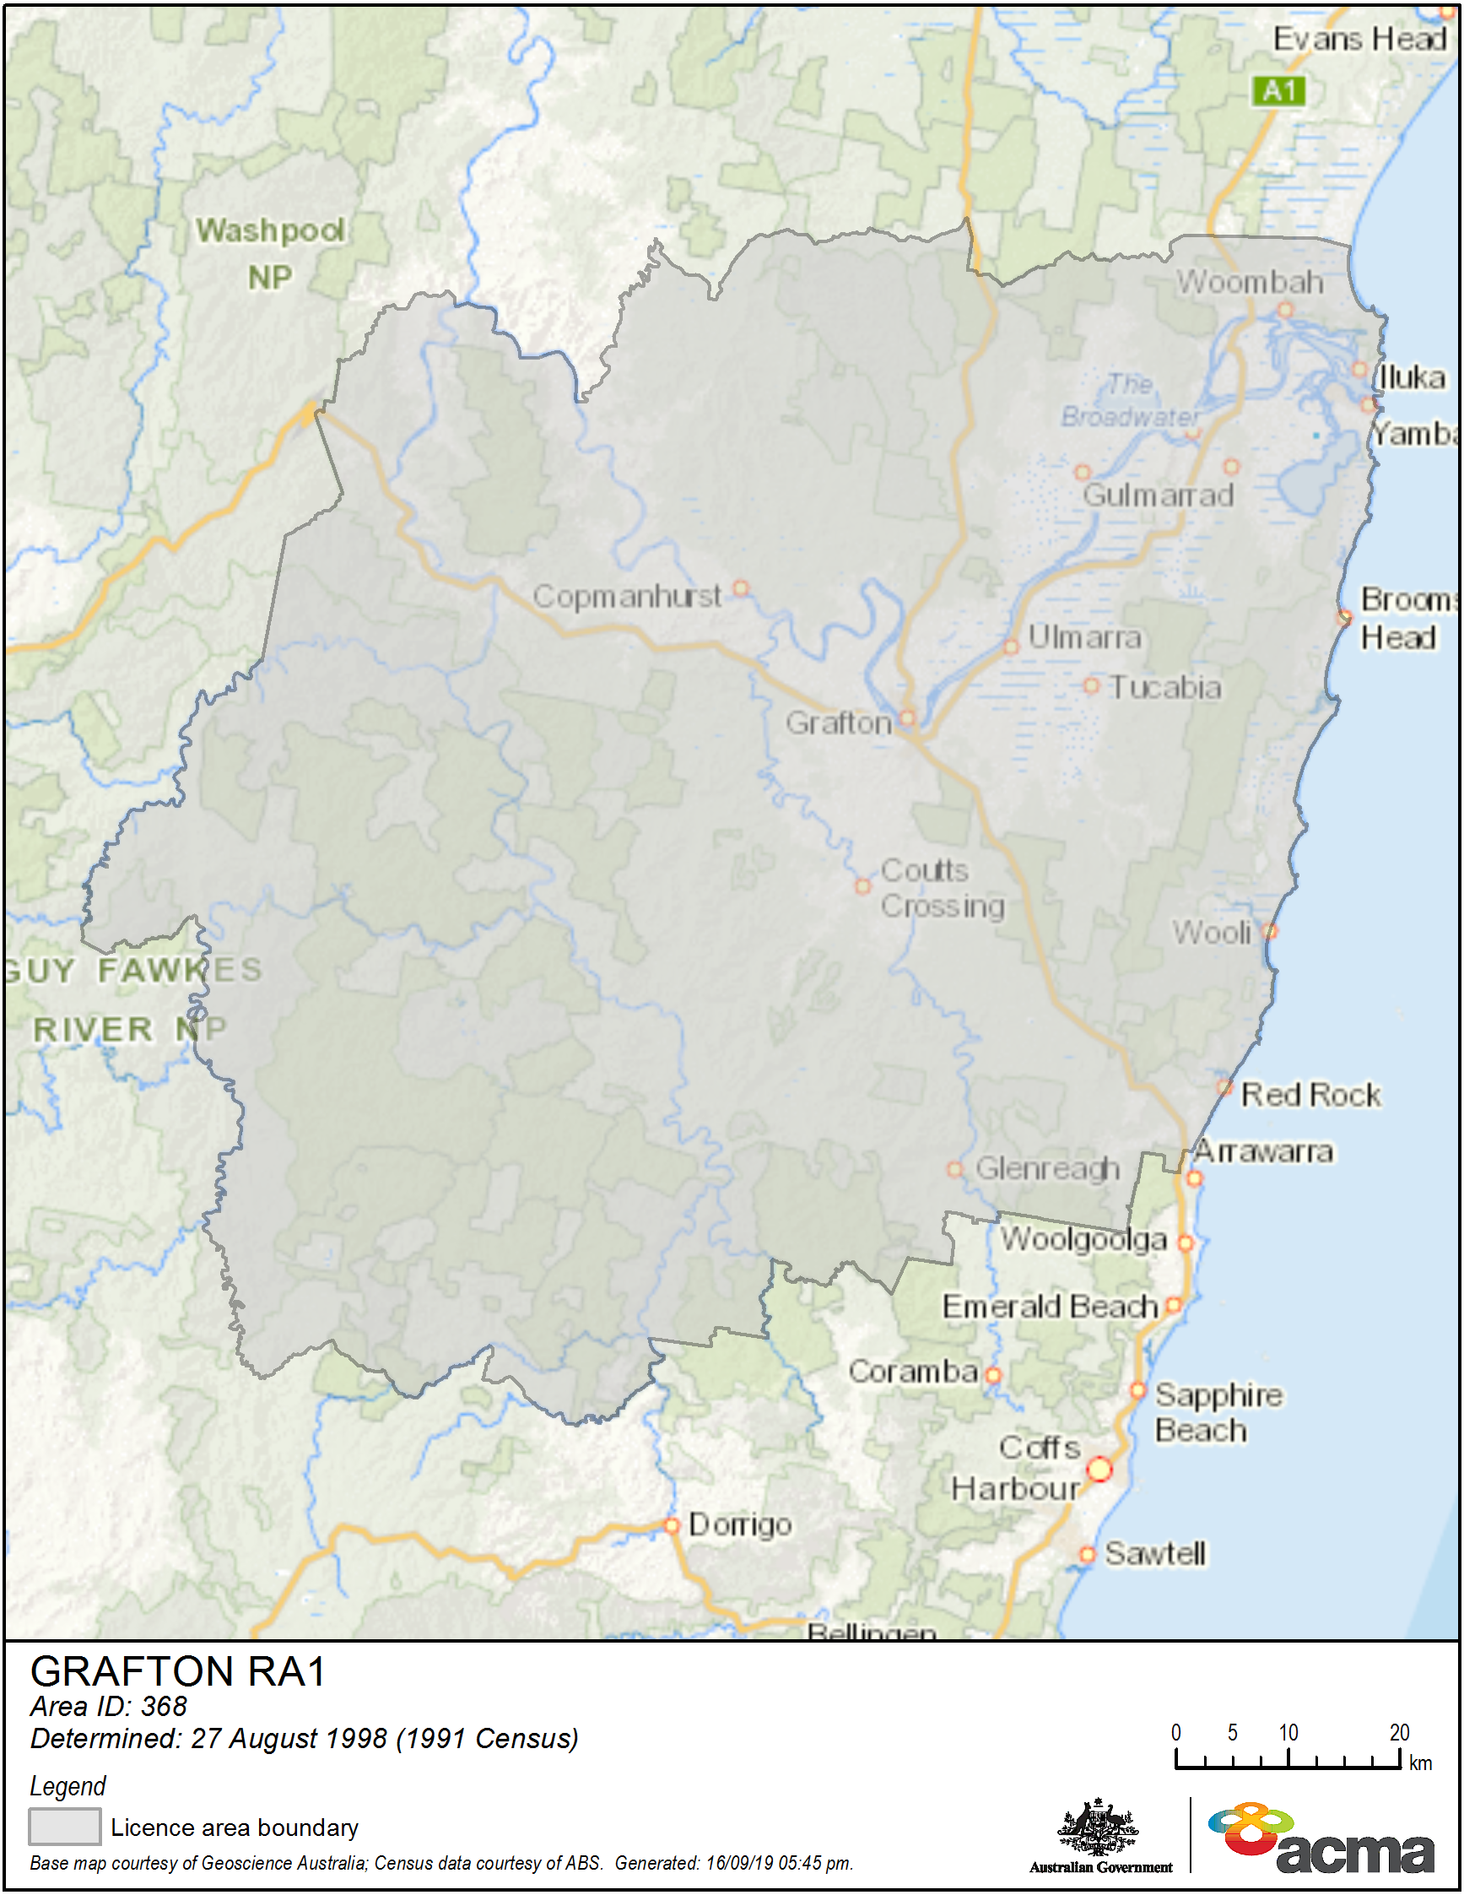Note: This map is provided for information only. No change to the licence area is proposed.

Appendix B

Proposed technical specification for new 2GF FM main transmitter in Grafton
This specification is to be added as an attachment to the Grafton LAP.
LICENCE AREA PLAN : Grafton Radio
Category : Commercial
General Area Served : Grafton (NSW)
Service Licence Number : SL4111
TECHNICAL SPECIFICATION - FM Radio
Specification Number : TS12000124
Transmitter Site :-
Nominal Location : Broadcast Site Repeater Station Rd
ILARWIL
Nominal Co-ordinates Latitude Longitude
(GDA94) : -29.489325 153.171289
Site Tolerance : Refer to Broadcasting Services
(Technical Planning) Guidelines 2017
Emission :-
Frequency Band & Mode : VHF-FM
Carrier Frequency : 89.5 MHz
Polarisation : Mixed
Maximum antenna height : 60 m
Output Radiation Pattern :-
Bearing or Sector (Clockwise direction) | Maximum ERP
0°T - 60°T | 5 kW
60°T - 120°T | 20 kW
120°T - 300°T | 40 kW
300°T - 360°T | 20 kW
Availability of TS12000124 :-
TS12000124 is only available for the transmission of a service under licence SL4111 when the transmission of a service under licence SL2189 by transmitter TS2189001 has ceased.

Appendix C

2GF Grafton RA1 coverage spread
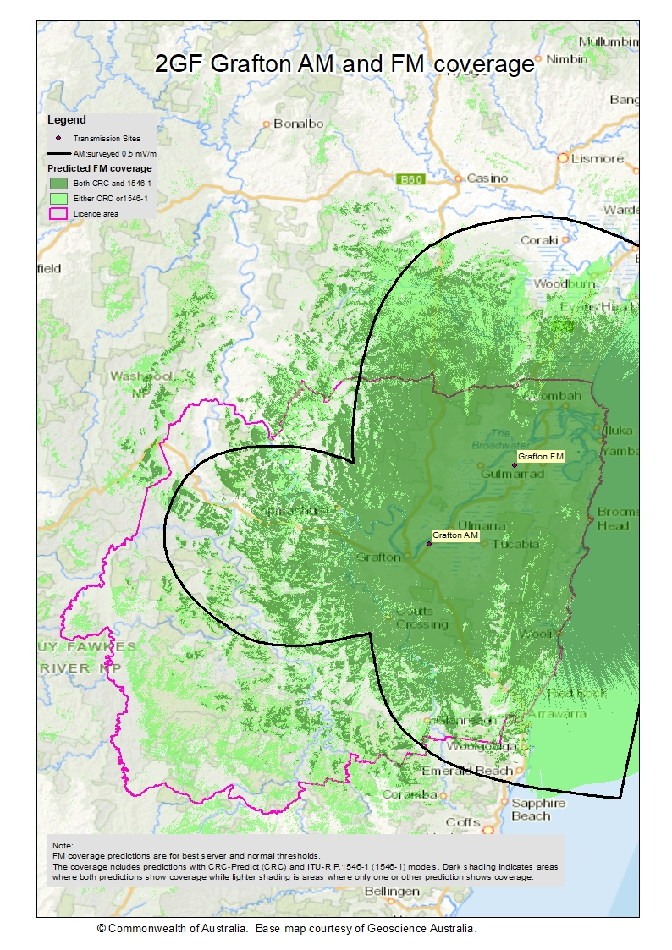

Appendix D

Map of Maclean RA1 licence area
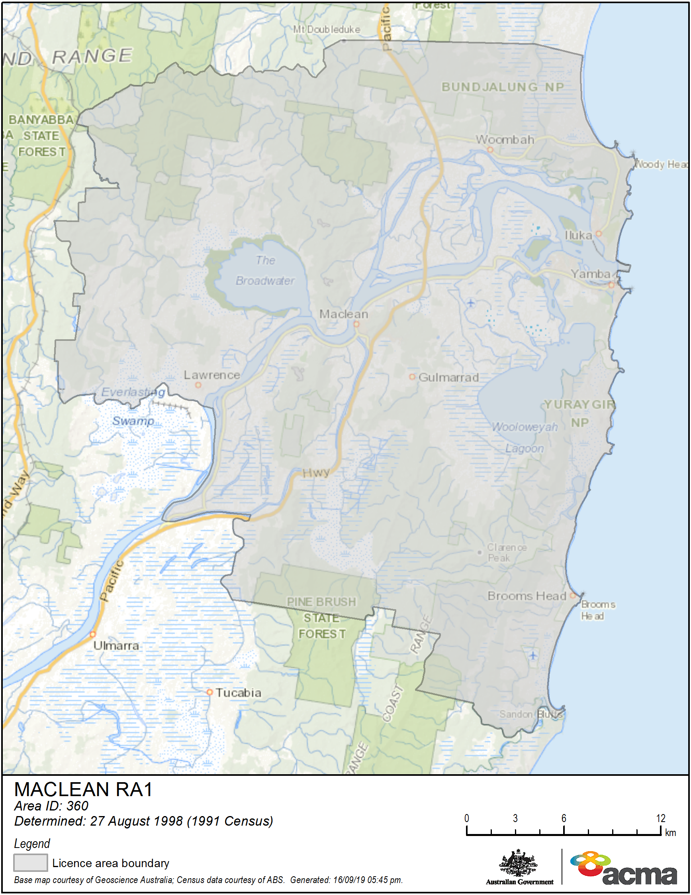 Note: This map is provided for information only. No change to the licence area is proposed.

Appendix E

Proposed revised technical specification for Maclean community service
This specification is to be added as an attachment to the Grafton LAP.
LICENCE AREA PLAN : Grafton Radio
Category : Community
General Area Served : Yamba/Maclean (NSW)
Service Licence Number : SL2189

TECHNICAL SPECIFICATION - FM Radio
Specification Number : TS12000608

Transmitter Site :-
Nominal location : Pilot Hill YAMBA
Nominal Co-ordinates Latitude Longitude
(GDA94) : -29.433354 153.362325
Site Tolerance : Refer to Broadcasting Services
(Technical Planning) Guidelines 2017
Emission :-
Frequency Band & Mode : VHF-FM
Carrier Frequency : 93.5 MHz
Polarisation : Mixed
Maximum antenna height : 16 m
Output Radiation Pattern :-
Bearing or Sector (Clockwise direction) | Maximum ERP
At all angles of azimuth | 1 kW
Availability of TS12000608 :-
TS12000608 is only available for the transmission of a service under licence SL2189 when the transmission of a service under licence SL2189 by transmitter TS2189001 has ceased.

ACMA, The future delivery of radio: Final report, March 2020, acma.gov.au/publications/2020-03/report/future-delivery-radio.
ACMA, The ACMA’s approach to AM–FM conversions and infill transmitters for commercial radio broadcasting services, April 2017, pages 6-7, acma.gov.au/publications/2017-11/guide/am-fm-conversion-and-requests-fm-fill-transmitters.
From 2016 Australian Bureau of Statistics (ABS) urban centre and localities data.
Grafton RA1 – RCRS NEZ overlap population estimated at 114 (2016 CHIRPlus_BC data).
Using 2016 ABS census data.
The 2GF and 2CLR commercial broadcast services are licensed under section 39 of the BSA.
Using the P.1546-1 model or the CRC Predict model.
Between 1,240 and 3,160 people using P.1546-1 model or the CRC Predict model.
This will affect 1,300 people in the urban centres/localities of Lismore RA1 and 2,300 people in the urban centres/localities of Coffs Harbour RA1, and no one in the urban centres/localities of RCRS NEZ.
The ACMA, 2019, acma.gov.au/long-term-community-radio-broadcasting-licence-allocations (accessed 15 July 2020).
To 74 dBµV/m coverage.
Using the CRC Predict model.
Using the ITU 1546-1 model.

