Frequency assignment practice
Guideline No. 7 — assigning rail industry spectrum in the 400 MHz band

MARCH 2020

Canberra  Red Building  Chan Street  Belconnen ACT  PO Box 78  Belconnen ACT 2616  T +61 2 6219 5555  F +61 2 6219 5353 | Melbourne  Level 32  Melbourne Central Tower  360 Elizabeth Street  Melbourne VIC  PO Box 13112  Law Courts  Melbourne VIC 8010  T +61 3 9963 6800  F +61 3 9963 6899 | Sydney  Level 5  The Bay Centre  65 Pirrama Road  Pyrmont NSW  PO Box Q500  Queen Victoria Building  NSW 1230  T +61 2 9334 7700  1800 226 667  F +61 2 9334 7799

Amendment History
Version | Date of Effect | Comments
1.0 | July 2013 | Internal only
2.0 | July 2013 | Discussion with Rail 30 July 13
3.0 | September 2013 | Updates based on feedback
3.1 | July 2014 | Addition of simplex channels and general revision
3.2 | October 2014 | Final version
3.3 | March 2015 | Minor updates to Appendix A
3.4 | November 2017 | Minor update to Purpose and Appendix B
3.5 | February 2020 | Update to reflect changes to rail transition requirements.

© Commonwealth of Australia 2015
This work is copyright. Apart from any use as permitted under the Copyright Act 1968, no part may be reproduced
by any process without prior written permission from the Commonwealth. Requests and inquiries concerning reproduction
and rights should be addressed to the Manager, Editorial Services, Australian Communications and Media Authority,
PO Box 13112 Law Courts, Melbourne Vic 8010.

Published by the Australian Communications and Media Authority

Purpose 1
Background 1
Introduction 1
RI Spectrum 1
Channel nomenclature 2
Use of RI Spectrum by Non-Rail Services 2
Assigning RI Spectrum 3
Appendix A – Australasian Railway Association Spectrum Arrangements 4
Appendix B – RI Assignment Process 6

Purpose
The purpose of this Frequency Assignment Practice (FAP) is to provide guidance on the assignment of Rail Industry (RI) spectrum in the 400 MHz band. This guideline applies to all rail users.

Background

Introduction
The review of the 400 MHz band, completed in 2010, was designed to:
- Provide rail industry spectrum for rail users;
- Address congestion in the band, in particular, in high density areas (HDAs) and medium density areas (MDAs),
- Increase allocative efficiency for spectrum; and
- Encourage utilisation of modern, efficient radiocommunications systems and equipment.
The updated 400 MHz plan RALI MS22 details the current arrangements for the 400 MHz implementation project
The Australasian Railway Association (ARA) is the peak body representing an array of rail organisations: private and public, passenger and freight operators, track owners and managers, manufacturers of rolling stock, construction companies and all other organisations supplying and contributing to the Australasian rail sector.
An Australian Rail Industry Entity means a rail user that is accredited by the Office of the National Rail Safety Regulator (ONRSR). The Rail Safety National Law requires that rail operators must apply for and be granted accreditation, before they commence undertaking railway operations. A list of the Australian Rail Industry Entities in Australia is maintained by ONRSR.

RI Spectrum
Australian Rail Industry Entities should initially seek access to RI spectrum through the Australasian Rail Association (ARA). If the accredited person, via consultation with the ARA, determines that the request cannot be accommodated within RI spectrum, the accredited person can then apply for the use of non-RI spectrum.
RI spectrum is a subset of the RALI MS22 segments F and N as well as six channels in G, H and P. All channels have a bandwidth of 12.5 kHz and may be sub-divided or aggregated as specified in RALI MS 22.
There are 32 two-frequency channels with a transmitter to receiver separation of 9.45 MHz, and six single frequency channels. Table 1 shows the channel centre frequencies and band limits for the RI spectrum.
Table 1: Channel centre frequencies and band limits for the RI spectrum
MS22 Segment | Ch | Centre Frequency (MHz) | Lower limit (MHz) | Upper limit (MHz) | Comments
F | n = 1 to 32 | 408.6375 + n (0.0125) | 408.6375 | 409.04375 | Two-frequency: paired with N
N | n = 1 to 32 | 418.0875 + n (0.0125) | 418.0875 | 418.49375 | Two-frequency: paired with F
G | 7 | 410.625 | 410.61875 | 410.63125 | Single frequency
H | 33 | 411.375 | 411.36875 | 411.38125 | Single frequency
H | 53 | 411.625 | 411.61875 | 411.63125 | Single frequency
H | 113 | 412.375 | 412.36875 | 412.38125 | Single frequency
P | 3 | 450.05 | 450.04375 | 450.05625 | Single frequency
P | 32 | 450.4125 | 450.40625 | 450.41875 | Single frequency

Channel nomenclature
For a paired channel, the base-transmit frequency is referred to by its channel number, for example Ch 1. The associated base-receive frequency is referred to by the same channel number with a prime symbol as the suffix, for example ‘Ch 1’.
Where a channel of bandwidth 12.5 kHz is sub-divided, the lower of the two 6.25 kHz channels created is designated by the suffix ‘a’ and, for the upper channel, by suffix ‘b’, for example Ch 1a and Ch 1b.

Use of RI Spectrum
The 400 MHz Plan (RALI MS 22) specifies that the RI spectrum is for use by rail users. The Australasian Railway Association should be consulted in considering the use of this spectrum. The process for consultation is described in the section Assigning RI spectrum.
If the accredited person, via consultation with the ARA, determines that the request cannot be accommodated within RI spectrum, the accredited person can then apply for the use of non-RI spectrum.

Use of RI Spectrum by Non-Rail Services
The RI spectrum is not for use by non-rail services in areas within 120km of any rail corridor. Use of RI spectrum by non-rail services outside these areas is not preferred but may be permitted by the ARA if use of other spectrum is not suitable. In these cases, users should be aware that they may be asked to vacate the spectrum with twelve months’ notice should it be required by rail services.
Future licences authorising the use of RI spectrum by non-rail services should have the following special condition attached:
“This licence authorises the use of RI spectrum by a non-rail licensee. Should the licensee be notified that this spectrum is required by rail services, the licensee must relinquish the licence or change the operating frequency at a date no later than 12 months after receiving the notice ”If a rail industry entity requires the channel licensed to a non-rail entity, it will approach the ARA. The ARA will then be responsible for giving notice of this to the ACMA. This does not prevent the ACMA from not renewing the licence at time of renewal.

Assigning RI Spectrum
Before a licence application is submitted to the ACMA, the ARA is to be consulted in writing by the applicant or the applicant’s agent. The full details of the proposed licensee and the proposed service should be provided. The ARA will subsequently advise the applicant in writing, within three weeks where possible, of the following:
- Whether or not the applicant is an Australian Rail Industry Entity,
- Whether or not the proposed service is appropriate to be accommodated in RI spectrum,
- If a rail entity is not to be accommodated, the reason why RI spectrum cannot be assigned.
If an assignment for a rail entity in RI spectrum is not possible, other 400 MHz spectrum may be assigned. In this case, appropriate spectrum should be selected based on whether the licensee is government or non-government.
The ARA advice should accompany the relevant licence application. The ACMA will have regard to the advice from ARA when making a decision on licensing a service.
The ARA spectrum arrangements are summarised in Appendix A and a flowchart of the process is included in Appendix B.
The contact details for the Australasian Railway Association are:
Australasian Railway Association
PO Box 4608
Kingston ACT 2604

Phone +61 2 6270 4501
Fax +61 2 6273 5581
Email spectrum@ara.net.au

Information relating to the 400 MHz band is published on the ACMA website.

Appendix A – Australasian Railway Association Spectrum Arrangements

This section includes information provided by the ARA on arrangements for RI spectrum. Rail users are government and non-government entities referred to as:

- below rail managers— entities that manage and operate rail track infrastructure and related facilities, and
- above rail operators— entities that operate the rolling stock on rail track infrastructure operated by Below Rail Managers.
- Or a company that is providing services to below rail managers or above rail operators.

A Local Operations service means a service that is for train to train and train to trackside communications relating to the operation of train services along the rail network.

This includes:
- Communications between passing trains or trains on adjacent tracks to advice of normal operation or observed malfunctions.
- Warning of hazards or malfunctions, including automated announcement messages from monitoring equipment.
- Communications between trains and trackside workers during the passing of the train through a worksite.
- Backup systems for communications to network/train control.
- Communications between train crew and locomotive during investigation of a train malfunction whilst on the rail network. This includes "repeater function" systems on locomotives that extend the communication from the train crew through to network/train control.

This does not include:
- Communications identified below as Type A, B or C rail services.

A Type A rail service means a service that is for automatic train protection, automatic train operation or network/train control.

A Type B rail service means a service that is for shunting operations, train loading or unloading operations and yard operations.

A Type C rail service means any other service relating to the rail operation including station communications, trackside/worksite/maintenance staff, security or local facility operations.

First priority channels will be assigned for the type of rail service local operations or type A, B or C. If the first priority channels are exhausted second or third priority channels will be assigned. Relevant priority channels will be assigned from the lowest to highest number.

Table 2 below details the assignment requirements and priority arrangements for rail services.

If an assignment within the RI spectrum is not possible it is recommended the assignment should be made within switching range of the RI spectrum. Within switching range typically means the range of 400 MHz to 470 MHz, however, the practical limits depend on the equipment.

Use of voting network arrangements with non-standard channel splits (for common base station RX frequency networks) and/or single frequency channels is allowed from within the two-frequency channels. In this case, single frequency services should only be assigned from the base transmit segment (i.e. segment ‘N’) and channels will be assigned using the priority arrangements for Type B Services as per Table 2 below.

The services for which RI spectrum is used will also conform to the policies, assignment rules, guidelines and procedures in relevant ACMA publications, which include:

- 400 MHz Plan RALI MS 22
- Point to Multipoint Fixed Services in the 400 MHz and 900 MHz bands, RALI FX16
- Frequency Assignment Requirements for the Land Mobile Service, RALI LM08
- Narrowband Assignments in the vicinity of 400 MHz Wideband Fixed Services, RALI FX01

Table 2: Rail service type and channel prioritisation

32 Channel Block
Service Type | First Priority Channels | Second Priority Channels
Local Operations services (as defined above) | P3 | G7, H53, H113, P32
Type A Services to be used in this category shall be limited to:  - Automatic Train Protection  - Automatic Train Operation;  - Network /Train Control | 2, 3, 4,  5, 7, 8,  9, 10, 11,  13, 14, 16,  18, 19, 20,  21, 23, 24,  25, 26, 27,  29, 30 & 32 | 1, 6, 12,  15, 17, 22,  28 & 31  G7, H53, H113, P32
Type B Services to be used in this category shall be limited to:  - Shunting Operations  - Train Loading and Unloading Operations  - Yard Operations | 1, 6, 12,  15, 17, 22,  28 & 31  H33 | 2, 3, 4,  5, 7, 8,  9, 10, 11,  13, 14, 16,  18, 19, 20,  21, 23, 24,  25, 26, 27,  29, 30 & 32  G7, H53, H113, P32
Type C Services in this category shall be rail operational functions that may include:  - Station Communications  - Trackside/Worksite/Maintenance Staff  - Security  - Local Facility Operations | Third priority for all channels, excluding channels P3 and H33

Appendix B – RI Assignment Process

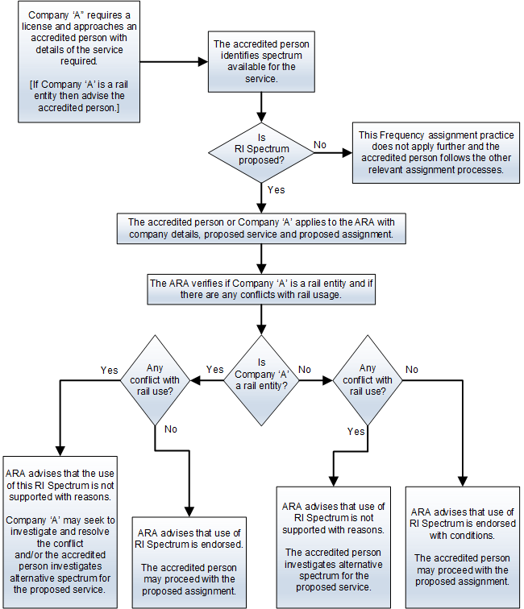

https://www.acma.gov.au/managing-spectrum-400-mhz-band
http://www.onrsr.com.au/operations/accreditation/new-accreditation
http://www.acma.gov.au/Industry/Spectrum/Spectrum-projects/400-MHz-band
Questions on the contents of this section should be sent to the ARA. Contact details for ARA are listed in the section Assigning RI Spectrum.
http://www.acma.gov.au/Industry/Spectrum/Spectrum-planning/Frequency-assignment-and-coordination/frequency-assignment-requirements-spectrum-planning-acma

