Proposal for variation to Licence Area Plan—Bathurst radio
Consultation paper
MAY 2018

Canberra
Red Building
Benjamin Offices
Chan Street
Belconnen ACT
PO Box 78
Belconnen ACT 2616
T +61 2 6219 5555
F +61 2 6219 5353
Melbourne
Level 32
Melbourne Central Tower
360 Elizabeth Street
Melbourne VIC
PO Box 13112
Law Courts
Melbourne VIC 8010
T +61 3 9963 6800
F +61 3 9963 6899
Sydney
Level 5
The Bay Centre
65 Pirrama Road
Pyrmont NSW
PO Box Q500
Queen Victoria Building
NSW 1230
T +61 2 9334 7700 or 1800 226 667
F +61 2 9334 7799
Copyright notice
http://creativecommons.org/licenses/by/3.0/au/
With the exception of coats of arms, logos, emblems, images, other third-party material or devices protected by a trademark, this content is licensed under the Creative Commons Australia Attribution 3.0 Licence.
We request attribution as: © Commonwealth of Australia (Australian Communications and Media Authority) 2018.
All other rights are reserved.
The Australian Communications and Media Authority has undertaken reasonable enquiries to identify material owned by third parties and secure permission for its reproduction. Permission may need to be obtained from third parties to re-use their material.
Written enquiries may be sent to:
Manager, Editorial and Design
PO Box 13112
Law Courts
Melbourne VIC 8010
Tel: 03 9963 6968
Email: candinfo@acma.gov.au

Executive summary 1
Proposed changes to Licence Area Plan—Bathurst Radio 1
Issues for comment 2
Background 3
Planning of broadcasting services and the preparation of LAPs 3
FM planning—protected field strengths 4
AM–FM conversions 4
Bathurst LAP 6
Preliminary view—commercial radio Bathurst LAP 7
Summary 7
Background 7
Engineering analysis 8
Proposed use of 95.1 MHz for converted 2BS service 8
Coverage prediction—proposed 95.1 MHz service compared with
AM service in Bathurst RA1 licence area 8
Coverage overspill by Bathurst 95.1 MHz service 10
Execution of AM–FM conversion 12
Simulcast period of AM and FM services 12
Special conditions in the LAP would execute the conversion 12
Preliminary view 12
Proposed minor amendments 13
Invitation to comment 14
Making a submission 14
Enquiries 14
Effective consultation 14
Publication of submissions 14
Release of submissions where authorised or required by law 14
Privacy 15
Appendix A—Consideration of AM–FM coverage loss 16
Signal characteristics 16
Adequate coverage levels 16
Evaluating coverage levels 17
Population estimates 17
Appendix B—Proposed technical specification for 2BS FM transmitter 18
Appendix C—Bathurst coverage spread 19
Appendix D—Bathurst RA1 licence area map 20

Executive summary
The Australian Communications and Media Authority (ACMA) is seeking comment on the specific draft proposals set out below.

Proposed changes to Licence Area Plan—Bathurst Radio
The ACMA is proposing to vary the Licence Area Plan – Bathurst Radio (Bathurst LAP) to enable the commercial radio broadcasting service 2BS in the Bathurst RA1 licence area to convert from AM to FM (preliminary view).
This proposal reflects our approach to AM–FM conversions as set out in our guidance document, The ACMA’s approach to AM–FM conversions and infill transmitters for commercial radio broadcasting services (the AM–FM guidance).
The ACMA considers that the proposed variations will promote the objects of the Broadcasting Services Act 1992 (BSA), as discussed in the preliminary views in this paper.

Issues for comment
The ACMA welcomes comment from interested stakeholders on the issues raised in this paper or any other issues raised relevant to the proposed LAP variation.
Details on making a submission can be found at Invitation to comment at the end of this document.

Background

Planning of broadcasting services and the preparation of LAPs
The ACMA’s broadcasting planning functions are set out in Part 3 of the BSA. In performing our planning functions, we must promote the objects of the BSA (section 3), including the economic and efficient use of radiofrequency spectrum. We will also have regard to the planning criteria set out in section 23 of the BSA.
When we consider the planning of broadcasting services, we refer to the General approach to analog planning, which sets out the legislative framework and planning criteria for broadcasting services.
Under section 26 of the BSA, the ACMA must, by legislative instrument, prepare licence area plans (LAPs) that determine the number and characteristics, including technical specifications, of broadcasting services that are to be available in particular areas of Australia with use of the broadcasting services bands.
Subsection 26(2) of the BSA gives us a discretionary power to vary, by legislative instrument, LAPs. There is no right to apply for a variation to a LAP; however, it is our practice to consider certain requests that LAPs be varied. The ACMA policy on assessing and prioritising requests to vary radio LAPs sets out the framework for our consideration of requests for variation to radio LAPs received from licensees or third parties. Initial consideration of requests to vary LAPs is conducted as part of our incidental powers and functions under the Australian Communications and Media Authority Act 2005. The ACMA’s planning functions (broadcasting services bands) in Part 3 of the BSA are not engaged unless and until we decide to propose a variation be made to the LAP, at which time we undertake consultation in accordance with section 17 of the Legislation Act 2003.
The ACMA is required to, and will, consider submissions received from stakeholders before making a final decision on whether we will vary a LAP.

FM planning—protected field strengths
For FM planning purposes, the protected field strength for adequate reception in the presence of man-made radio noise alone is:
- rural (stereo) environment: >54 dBµV/m
- suburban environment: >66 dBµV/m
urban environment: >74 dBµV/m.
Unless specified otherwise, all population figures in this paper are derived from the Australian Census 2011 (Australian Bureau of Statistics).

AM–FM conversions
The ACMA has received a request for AM–FM conversion relating to the commercial radio broadcasting service 2BS in Bathurst RA1.
In response to a proposal from the commercial radio industry, the Minister for Communications asked the ACMA in February 2016 to give priority to undertaking the planning and implementation work to facilitate AM–FM conversions of commercial radio broadcasting services in regional licence areas with one commercial licensee—known as ‘solus’ licence areas. In almost all cases, the commercial licensees in these solus licence areas hold two licences—a commercial radio broadcasting licence in AM mode (commercial licence) and a ‘supplementary’ commercial radio broadcasting licence in FM mode issued in the 1990s under section 39 of the BSA.
We consulted on a new approach to AM–FM conversions (and the related issue of infill transmitters) in December 2016. The new approach to AM–FM conversions, the AM–FM guidance, was finalised in April 2017.
In summary, the guidance document provides that the ACMA will consider requests for variations to LAPs to enable AM–FM conversion of existing AM commercial radio broadcasting services when the request is from licensees in:
- solus regional licence areas with less than 30 per cent overlap with any other commercial licence area
other licence areas where the ACMA considers that the circumstances do not put existing FM commercial radio broadcasting licensees at a competitive disadvantage.
In deciding whether to exercise our powers to approve AM–FM conversions, we will consider the following:
- FM conversion should not result in any existing radio services being adversely affected in terms of their use of spectrum and the technical parameters of their radio transmissions. So, other existing radio services should not have to be retuned, replanned or cancelled, unless a solution can be found that mitigates these impacts without imposing any undue costs on the affected parties.
FM conversion should not result in any significant coverage differences for radio listeners within the affected licence areas. The vast majority of radio listeners who were able to receive services in AM should be able to continue to do so following FM conversion.
When considering whether the ‘vast majority’ of listeners can still receive the service, we will have regard to the planning criteria at section 23 of the BSA, including:
- Demographics—whether any proportion of the population within the licence area who receive the AM service are predicted to no longer receive the service, and the distribution of that population. There is an assumption in the AM–FM guidance that communities with a population of 200 people or more are entitled to expect a service from a broadcaster that is licensed to provide one.
- The number of existing broadcasting services within the licence area—the extent of alternative services available to listeners may be a consideration, as will any available information on listening habits in the area.
- The technical constraints relating to the delivery or reception of broadcasting services.
Other matters we consider relevant.
Further background on the comparison of AM and FM coverage and population analysis is provided at Appendix A.
The methodology for coverage planning for the AM–FM conversion is to first determine the specifications for the proposed FM transmission so that, as a starting point, it will match the coverage for the existing commercial radio broadcasting service being provided by the commercial licensee in the relevant licence area (section 39 of the BSA). The proposed FM transmission is then assessed to determine any loss of coverage compared to the current AM commercial radio broadcasting transmitter. If required, the technical specifications are revised from the section 39 specifications in order to mitigate the loss.
In cases where an AM–FM conversion would still result in the FM signal providing significantly less coverage than the AM signal within the licence area, the ACMA will require the use of infill FM transmitters to mitigate the coverage loss, where practicable. We may not allow a service to start using the main FM transmitter unless it begins on any required infill transmitters at the same time.
Licensees may seek a simulcasting period of the AM and FM transmitters to transition listeners to the new service. Licensees would generally be permitted a 28-day simulcast period.
There may be limited circumstances where additional FM infill transmitters are not a practical, economically feasible or effective way to mitigate coverage loss. Consequently, there may be grounds for permitting continued simulcasting of AM and FM radio services. For example, ongoing AM coverage may be the best solution in licence areas where higher density population centres are surrounded by large areas of low-density and highly dispersed populations. In such circumstances, the ACMA may consider requests for dual coverage on a case-by-case basis.
If the ACMA does not permit dual coverage, transmission on the AM transmitter must cease at the end of the simulcast period.
An object of the BSA is to promote the availability to audiences throughout Australia of a diverse range of radio (and television) services (paragraph 3(1)(a)). An AM–FM conversion that maintains coverage equivalence while providing improved audio quality and reception quality for listeners in regional areas is likely to improve the effective availability of existing services.

Bathurst LAP
The Australian Broadcasting Authority (ABA) determined the Bathurst LAP in May 1997. Material variations to the LAP occurred in December 2004 and April 2012.
In the licence area described in Attachment 1.1 to the LAP (also known as the Bathurst RA1 licence area), the LAP provides for:
- four national radio broadcasting transmitters to serve the Bathurst (City) area
- two commercial radio broadcasting services
one open narrowcasting service.
In the licence area described in Attachment 2.1 to the LAP (also known as the Bathurst RA2 licence area), the LAP provides for one community radio broadcasting service to serve the Bathurst (City) and Orange areas.
In the licence area described in Attachment 3.1 to the LAP (also known as the Bathurst RA3 licence area), the LAP provides for one community radio broadcasting service to serve the Bathurst area.

Preliminary view—commercial radio Bathurst LAP

Summary
In the Bathurst LAP, the ACMA proposes to:
- Insert a new technical specification for an FM transmitter for the 2BS commercial radio broadcasting service that is currently planned on the frequency 1503 kHz within the Bathurst RA1 licence area. The proposed technical specification will permit the new FM transmitter to operate on the frequency of 95.1 MHz at 10 kW maximum effective radiated power (ERP), with a directional radiation pattern and a maximum antenna height of 45 metres to serve the Bathurst area (see Appendix B).
Vary the existing 2BS AM technical specification so that it ceases to have effect 28 days after a service commences using the 2BS FM technical specification.

Background
Bathurst is located in the Central Tablelands of New South Wales. It is approximately 200 km west of Sydney and is located within the Bathurst RA1 licence area, which is adjacent to, and overlaps with, the Orange RA1, Mudgee RA1, Mudgee RA3, Remote North East Zone RA1 and Lithgow RA1 commercial radio licence areas. The Bathurst RA1 licence area population is 48,268.
The two commercial radio broadcasting services planned for the Bathurst region in the Bathurst RA1 licence area are licensed to Bathurst Broadcasters Pty Ltd (Bathurst Broadcasters). The AM transmitter for the commercial radio broadcasting service ‘1503 2BS Gold’ (2BS) is planned in the Bathurst LAP to operate on the frequency 1503 kHz, with a maximum cymomotive force (CMF) of 1055 V from the transmitter site ‘Broadcast Site Freemantle Rd, Eglinton’ with a directional radiation pattern.
The transmitter for the section 39 commercial radio broadcasting service ‘99.3 BRock’ (2BXS) is planned in the Bathurst LAP to operate on frequency 99.3 MHz, with a maximum ERP of 10 kW from a nominal location ‘Bathurst Broadcasters Site Gulf Forest Rd 2 km North of Yetholme’, with an omni-directional radiation pattern and a maximum antenna height of 45 metres.

Engineering analysis

Proposed use of 95.1 MHz for converted 2BS service
In considering an AM–FM conversion, we study the impact the conversion may have on future planning options for other radio services. This includes a concurrent request for a variation to a LAP for an AM–FM conversion in an adjacent licence area where competition for suitable spectrum may arise (the AM–FM guidance, p. 4). To achieve the optimal planning outcome in each circumstance, we will give careful consideration to the competing use of broadcasting spectrum on a case-by-case basis. Such consideration of the most efficient use of spectrum will be undertaken with regard to the planning criteria in section 23 and the objects of the Act (the AM–FM guidance, p. 5).
Potential use of 95.1 MHz for a Remote North East Zone service
In July 2013, we consulted on a preliminary view to vary the Remote Central and Eastern Australia Radio LAP (remote LAP). The preliminary view proposed making available new spectrum for a broadcasting service in Bocoble, New South Wales, on the frequency 95.1 MHz. After reviewing the engineering assessment for the Bathurst AM–FM conversion request, we considered the high-powered frequency 95.1 MHz was more suitable for an AM–FM conversion. Alternative frequencies for Bocoble were subsequently consulted on and approved by the ACMA in December 2017.
Potential use for either Bathurst RA1 or Lithgow RA1 AM–FM conversion
The ACMA has also received a request for an AM–FM conversion from Midwest Radio Pty Ltd (Midwest), the commercial radio broadcasting licensee of the AM service 2LT, in the adjacent licence area of Lithgow RA1. Given the proximity of the two markets, we compared the spectrum efficiency of allocating the 95.1 MHz frequency to either the Bathurst (2BS) or Lithgow (2LT) services.
Engineering predictions indicated that, in general, a transmission on 95.1 MHz for a 10 kW ERP Bathurst FM service has lower potential for interference to (and from) other services, while providing greater geographic and population coverage, when compared to a transmission on 95.1 MHz for a 10 kW ERP Lithgow FM service.
The ACMA has formed the preliminary view that use of 95.1 MHz for Bathurst AM–FM conversion is a more economic and efficient use of spectrum than the alternative use for a Lithgow conversion.
Meanwhile, an industry consultant engaged by Midwest has identified an alternative frequency suitable for the Lithgow conversion. Accordingly, the issue of competition for suitable spectrum between Bathurst and Lithgow should no longer arise. We will consult separately on AM–FM conversion in Lithgow as a matter of priority, following receipt of an acceptable engineering proposal from the consultant.

Coverage prediction—proposed 95.1 MHz service compared with AM service in Bathurst RA1 licence area
Currently, the 2BS AM service has four FM infill transmitters planned and operating at Blayney, Burraga, Oberon and Sofala. To minimise any potential coverage loss, the licensee proposes to retain these four FM infill transmitters if the service converts to FM. Coverage loss predictions take account of these transmitters when comparing the current 2BS AM coverage with the predicted coverage of the proposed 2BS FM transmission.
When the coverage from these existing FM transmitters is taken into account, an assessment of the coverage of the proposed FM transmitter at the Yetholme site indicates there would be at-or-above rural-grade stereo coverage in much of the Bathurst RA1 licence area.
The 2BS AM transmission, in conjunction with the FM infills, is predicted to provide a daytime coverage of approximately 47,700–47,900 people, or 98.9–99.3 per cent of the Bathurst RA1 population. When compared with the proposed 2BS FM transmission, coverage loss within the entire Bathurst RA1 licence area is predicted to affect between 340 and 2,940 people, or 0.7–6.1 per cent of the population in the Bathurst RA1 licence area.
Coverage predictions comparing the current hybrid AM/FM coverage with the proposed FM-only coverage are illustrated on the map at Appendix C. We consider that conversion (when taken with the existing FM infills) does not result in any significant coverage differences.
Coverage loss on the western licence area boundary
The main coverage loss within the Bathurst RA1 licence area is predicted to occur along the western boundary of Bathurst RA1.
That area overlaps with the Orange RA1 licence area and includes the locality of Millthorpe. The overlap includes approximately 7,240 people, and the predicted coverage loss here is between 320 and 1,660 people or 0.7–3.4 per cent of the population in the Bathurst RA1 licence area. However, much of the overlap is predicted to receive adequate coverage from Orange commercial radio broadcasting services (2EL, 2OAG and 2GZF). Excluding those people with access to the Orange commercial services, the predicted 2BS FM coverage loss in the overlap is reduced to approximately 450 people, or 0.9 per cent of the population in the Bathurst RA1 licence area.
Other coverage loss
Further coverage loss is predicted in sparsely populated areas spread throughout the Bathurst RA1 licence area, particularly in the north-west and south-east parts in valleys shielded by terrain from the Yetholme FM transmission site. Areas include the localities of Hillside, Wattle Flat, Peel, Rockley and Newbridge. The coverage loss comprises between 20 and 1,280 people, or approximately 0–2.7 per cent of the population in the Bathurst RA1 licence area. As this coverage loss is in regions with no significant population centres over 200 people, planning additional repeaters would not be a feasible solution.
Fortuitous reception
It is predicted that, on conversion to FM transmission, a population of between 1,320 and 30,460 people outside of the Bathurst RA1 licence area may experience coverage loss. Reception outside the licence area is fortuitous; the ACMA does not afford planning protection to fortuitous reception. In any case, this population is adequately served by the local commercial services in the Orange RA1 and Lithgow RA1 licence areas.
Interference predictions
While the 95.1 MHz frequency is a relatively clear frequency in the Bathurst region, there is still some potential for mutual interference with the following services on nearby frequencies—2PTV Sydney (95.3 MHz), 2GCB Gosford (94.9 MHz) and 2WSK Nowra (94.9 MHz).
With the proposed 2BS Bathurst technical specification limiting the power of the transmitter toward these services, the potential for interference is predicted to be minor.

Coverage overspill by Bathurst 95.1 MHz service
An engineering analysis of the predicted overspill of coverage from the proposed 95.1 MHz service indicates a significant increase in overspill into the nearby Orange RA1, Lithgow RA1 and Katoomba RA1 commercial radio licence areas, when compared with the current omnidirectional 2BS AM transmission and FM infills. There is no difference in overspill to the Goulburn RA1 licence area.
The increase is, to a degree, due to the difference between what constitutes overspill in AM and FM. For AM, the ACMA regards suburban-grade field strength as overspill; for FM, fields strengths down to rural stereo-grade are seen as overspill. Additionally, the AM transmitter is in the centre of the licence area—close to Bathurst city—meaning weaker AM signals at the boundary. The FM transmitter site is near the eastern boundary of the licence area; there will inevitably be overspill, given the power needed to provide suburban-grade FM signal into Bathurst City.
However, the overspill will be less than that from the existing Bathurst 2BXS FM commercial radio transmitter. This is because the licensee has proposed operating the 2BS Bathurst FM transmitter using the same antenna as the existing 2BXS service but with reduced power.
An evaluation of the overspill of the proposed 2BS FM (95.1 MHz) service indicates that a field strength higher than rural stereo-grade is expected to be provided to the following licence area populations (excluding licence area overlaps, unless stated):
- 10,400 people within the Orange RA1 licence area, of whom 8,680 are in urban centres
- 5,000 people within the Lithgow RA1 licence area, of whom 3,100 are in urban centres
- 4,200 people within the Lithgow RA1 and Katoomba RA1 licence area overlap, of whom 3,000 are in urban centres
- 170 people within the Goulburn RA1 licence area, none of whom are in urban centres
160 people in other or no commercial licence areas, none of whom are in urban centres.
This compares with the estimated overspill of the current omnidirectional 2BS AM service (field strengths higher than 2.5 mV/m as per the Technical Planning Guidelines) and 2BS FM infills of (excluding licence area overlaps):
- 1,097 people within the Orange RA1 licence area, none of whom are in urban centres
- 200 people within the Lithgow RA1 licence area, none of whom are in urban centres
- 170 people within the Goulburn RA1 licence area, none of whom are in urban centres
170 people in other or no commercial licence areas, none of whom are in urban centres.
Consistent with the AM–FM guidance, the proposed technical specifications for the frequency 95.1 MHz in Bathurst RA1 largely mirror the technical specifications of the existing section 39 Bathurst FM (2BXS) service. The signal overspill from the Bathurst section 39 FM service 2BXS into the Orange RA1 and Lithgow RA1 licence areas (excluding the licence area overlaps) is estimated to be, at a rural or above grade:
- 15,400 people within the Orange RA1 licence area
- 6,400 people within the Lithgow RA1 licence area
- 4,800 people in the Lithgow RA1 and Katoomba RA1 licence area overlap
150 people in other areas.
The ACMA proposes to specify a directional radiation pattern for the FM transmitter for the 2BS-converted service in contrast to the omni-directional radiation pattern specified for the section 39 2BXS transmitter. This difference in antenna pattern is to mitigate the potential for interference with other broadcasting services in Sydney, Gosford and Nowra licence areas.

Execution of AM–FM conversion

Simulcast period of AM and FM services
The ACMA is proposing a 28-day simulcast period, where both the 2BS AM (on 1503 kHz) and the converted 2BS FM service (on 95.1 MHz) may operate. This period would allow the licensee to undertake a communications strategy on both services to inform listeners of the change to its radio service. It is expected the AM service would shut down at the end of the simulcast period.

Special conditions in the LAP would execute the conversion
The ACMA is proposing to attach special conditions to the relevant AM and FM technical specifications. These would provide for the simulcast period and require that the AM transmitter cease operation at the end of that period.

Preliminary view
The ACMA, in considering whether to make spectrum available for a new transmitter to facilitate the AM–FM conversion requested by the commercial radio broadcasting licensee in the Bathurst LAP, seeks to promote the objects of the BSA and has regard to the matters listed in section 23 of the BSA, including:
- relevant demographics and social and economic characteristics (paragraphs 23(a) and (b))
- the number of existing broadcasting services (paragraph 23(c))
- the demand for new services (paragraph 23(c))
the technical restraints relating to the delivery or reception of broadcasting services in the licence area (paragraph 23(e)).
We also consider all relevant available evidence.
The ACMA has formed the preliminary view that the proposal to add new technical specifications to allow for an AM–FM conversion of 2BS Bathurst, in accordance with the AM–FM guidance, is likely to promote the objects of the BSA. Further, the proposal is consistent with the planning criteria of the BSA; in particular, the demographic characteristics (paragraph 23(a)), the demand for new services (paragraph 23(c)) and the restraints relating to the delivery or reception of broadcasting services in those licence areas (paragraph 23(e)) for the reasons set out above.
We have considered the predicted coverage and interference potential of the proposed 2BS FM transmitter in the Bathurst RA1 licence area when assessing the proposed AM–FM conversion of the 2BS Bathurst commercial radio broadcasting service. We consider the proposal for the variation of the Bathurst LAP is an economic and efficient use of spectrum.

Proposed minor amendments
The ACMA proposes making minor amendments to the text, the schedules and attachments of the Bathurst LAP as follows:
- updating various transmitter site nominal locations to reflect the current naming of these transmitter sites
- updating the technical specifications to reflect correct output radiation patterns and coordinates
amending advisory notes to technical specification TS1133740 to provide more detailed information about the minimum median field strength level to which a transmission will be protected against interference.

Invitation to comment

Making a submission
The ACMA invites comments on the issues set out in this consultation paper.
- Online submissions—submissions can be made via the comment function or by uploading a document. The online consultation page provides details.
- Submissions by post—can be sent to:
Broadcasting Carriage Policy Section
Australian Communications and Media Authority
PO Box Q500
Queen Victoria Building
NSW 1230
The closing date for submissions is COB, Friday 8 June 2018. Please quote file reference ACMA2018/29 in your reply.
Electronic submissions in Microsoft Word or Rich Text Format are preferred.

Enquiries
- Consultation enquiries can be emailed to Rebecca Fung at LAPRequests@acma.gov.au.
Media enquiries can be directed to Emma Rossi on 02 9334 7719 or by email to media@acma.gov.au.

Effective consultation
The ACMA is working to enhance the effectiveness of its stakeholder consultation processes, which are an important source of evidence for its regulatory development activities. To assist stakeholders in formulating submissions to its formal, written consultation processes, it has developed Effective consultation—a guide to making a submission. This guide provides information about the ACMA’s formal written public consultation processes and practical guidance on how to make a submission.

Publication of submissions
In general, the ACMA publishes all submissions it receives, including any personal information. The ACMA prefers to receive submissions that are not claimed to be confidential. However, the ACMA accepts that a submitter may sometimes wish to provide information in confidence. In these circumstances, submitters are asked to identify the material over which confidentiality is claimed and provide a written explanation for the claim.
The ACMA will consider each confidentiality claim on a case-by-case basis. If the ACMA accepts a claim, it will not publish the confidential information unless authorised or required by law to do so.

Release of submissions where authorised or required by law
Any submissions provided to the ACMA may be released under the Freedom of Information Act 1982 (unless an exemption applies) or shared with various other government agencies and certain other parties under Part 7A of the Australian Communications and Media Authority Act 2005. The ACMA may also be required to release submissions for other reasons including for the purpose of parliamentary processes or where otherwise required by law (for example, under a court subpoena). While the ACMA seeks to consult submitters of confidential information before that information is provided to another party, the ACMA cannot guarantee that confidential information will not be released through these or other legal means.

Privacy
The Privacy Act 1988 imposes obligations on the ACMA in relation to the collection, security, quality, access, use and disclosure of personal information. These obligations are detailed in the Australian Privacy Principles.
The ACMA may only collect personal information if it is reasonably necessary for, or directly related to, one or more of its functions or activities.
The purposes for which personal information is being collected (such as the names and contact details of submitters) are to:
- contribute to the transparency of the consultation process by clarifying, where appropriate, whose views are represented by a submission
- enable the ACMA to contact submitters where follow-up is required or to notify them of related matters (except where submitters indicate they do not wish to be notified of such matters).
The ACMA will not use the personal information collected for any other purpose, unless the submitter has provided their consent or the ACMA is otherwise permitted to do so under the Privacy Act.
Submissions in response to this paper are voluntary. As mentioned above, the ACMA generally publishes all submissions it receives, including any personal information in the submissions. If a submitter has made a confidentiality claim over personal information that the ACMA has accepted, the submission will be published without that information. The ACMA will not release the personal information unless authorised or required by law to do so.
If a submitter wishes to make a submission anonymously or use a pseudonym, they are asked to contact the ACMA to see whether it is practicable to do so in light of the subject matter of the consultation. If it is practicable, the ACMA will notify the submitter of any procedures that need to be followed and whether there are any other consequences of making a submission in that way.
Further information on the Privacy Act and the ACMA’s privacy policy is available at www.acma.gov.au/privacypolicy. The privacy policy contains details about how an individual may access personal information about them that is held by the ACMA, and seek the correction of such information. It also explains how an individual may complain about a breach of the Privacy Act and how the ACMA will deal with such a complaint.

Appendix A—Consideration of AM–FM coverage loss
The Approach to AM–FM conversion states that the ACMA will consider coverage difference with the intent that:
FM conversion does not result in any significant coverage differences for radio listeners within the affected licence areas so that the vast majority of radio listeners who were able to receive services in AM can continue to do so following FM conversion.
In considering whether the ‘vast majority’ of listeners can still receive a service, the approach states that:
The ACMA will have regard to the proportion of the population within the licence area who receive the AM service that is no longer predicted to receive a service, and the distribution of that population, particularly in communities with a population of 200 people or more. The ACMA will assess the proportion of the population within the licence area likely to be covered by the new ‘main’ FM transmission, in comparison to the population coverage of the current AM transmitter. Approximating AM coverage may require FM in-fill translators as well as a main transmitter.
Factors that affect the potential coverage loss of an FM conversion compared to the original AM service include the nature of radio wave propagation, adequate signal levels, coverage evaluation methodologies, assessment of population covered and the presence of other signals that may provide alternative coverage.

Signal characteristics
AM and FM radio signals have different characteristics, which will inevitably lead to coverage differences:
- AM signals propagate by means of ‘ground waves’, which are dependent on the Earth’s conductivity. AM transmitters are therefore best sited in areas of good ground conductivity, often found near bodies of water. At night, changes in the ionosphere allow AM signals to also travel much greater distances as ‘sky waves’. These sky waves can result in interference that reduces the coverage of affected services. AM is more susceptible to interference due to electrical man-made noise from sources such as power lines, electric lighting and electric motors.
FM signals propagate through the atmosphere from a transmitter sited on a high location such as a hill, mountain, building or tower. FM signals are more immune to electrical noise interference.

Adequate coverage levels
Coverage is assessed at specified signal levels that are considered necessary for ‘adequate’ reception in different types of electrical noise environments. Levels for rural, suburban and urban environments are specified. In considering AM–FM conversion, the rural signal levels of 0.5 mV/m for AM signals and 54 dBµV/m for FM signals are a factor:
- Listenable AM and FM signals can be received at levels well below that considered to be adequate because signal quality gradually declines.
- Rural signal levels often extend well outside the licence area boundary, particularly for AM services, as the suburban (2.5 mV/m) signal level was typically used in determining the licence area boundary.
- Reception of signals outside the licence area boundary is considered to be ‘fortuitous’ and is not protected from interference in the planning of other services.
AM signal levels that would ordinarily meet the threshold for adequate reception could be inadequate if high levels of man-made electrical noise are present.

Evaluating coverage levels
The extent of coverage is evaluated through either measurements taken at various points within a coverage area, or computer predictions of signal levels using propagation algorithms and digital terrain elevation models:
- AM coverage has been evaluated based on field survey measurements conducted in the 1970s and 1980s, and plotted on maps as three contours equating to adequate reception thresholds in rural, suburban and urban environments. These contours generally indicate the extent of AM coverage, but with the limitation that they are based on measurements made on a particular date and time, and at a limited number of locations. This approach has been used, as the available data on ground conductivity has limited resolution and accuracy, leading to low confidence in computer coverage predictions.
FM coverage has been evaluated using computer propagation prediction models, as signal measurements are not generally available and there is higher confidence in the models. Coverage predictions for new FM services use digital terrain models, details of the transmission infrastructure and one or more different propagation prediction algorithms. Consequently, FM coverage predictions generally have a much greater geographical resolution. However, different prediction models will provide different coverage estimates. Experience with the models and knowledge of their underlying assumptions are needed to consider which model is likely to give the best result.

Population estimates
An estimate of the population within the area expected to receive an adequate AM or FM signal is used to identify the likelihood that the conversion will result in coverage loss. Calculating the population who may not receive adequate AM signals as a simple difference in estimated AM and FM coverage populations may be misleading; in some cases, there could be adequate FM signal levels where the AM signal level is inadequate.
The ACMA, broadcasters and external consultants may use different approaches to estimating the affected population. The simplest approach, often used by external consultants, is to classify the centroid point of each geographic unit and assign the entire population of that unit to the classification. This works reasonably well in populated areas and in aggregating populations in large geographic areas, but is less useful in analysis of small, sparsely distributed populations.
The ACMA has developed a more granular method of analysing the population covered. The census data for each geographic population unit is distributed across a grid. The population assigned to each cell in the grid is weighted by taking into account the distribution of address information contained in the Geocoded-National Address File (G-NAF). This method is likely to give a more accurate result than the centroid approach, or an approach that evenly distributes the population of a geographic unit across each grid cell.

Appendix B—Proposed technical specification for 2BS FM transmitter
This specification is proposed to be inserted as Attachment 1.2A to the Bathurst LAP.
Attachment 1.2A
LICENCE AREA PLAN: Bathurst Radio
Category: | Commercial
General Area Served: | Bathurst (NSW)
Service Licence Number: | SL10248
TECHNICAL SPECIFICATION - FM Radio
Specification Number: | TS12000080
Transmitter Site:-
Nominal Location: | Bathurst Broadcasters Site Gulf Forest Rd 2km North of YETHOLME
Australian Map Grid Reference: | Zone Easting Northing  55 760758 6297185
Site Tolerance: | Refer to Broadcasting Services (Technical Planning) Guidelines 2017
Emission:-
Frequency Band & Mode: | VHF-FM
Carrier Frequency: | 95.1 MHz
Polarisation: | Mixed
Maximum antenna height: | 45 m
Output Radiation Pattern:-
Bearing or Sector (Clockwise direction) | Maximum ERP
0°T–70°T | 10 kW
70°T–165°T | 5 kW
160°T–360°T | 10 kW
Special Condition:
The provision of a service under SL10248 by transmitter TS12000080 affects the availability of transmitter TS10004208.

Appendix C—
Bathurst coverage spread
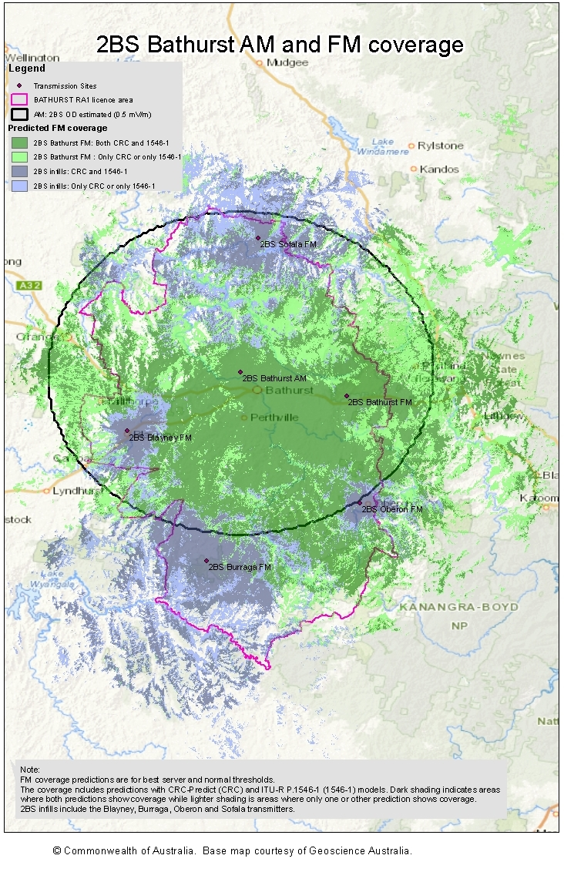

Appendix D—
Bathurst RA1 licence area map
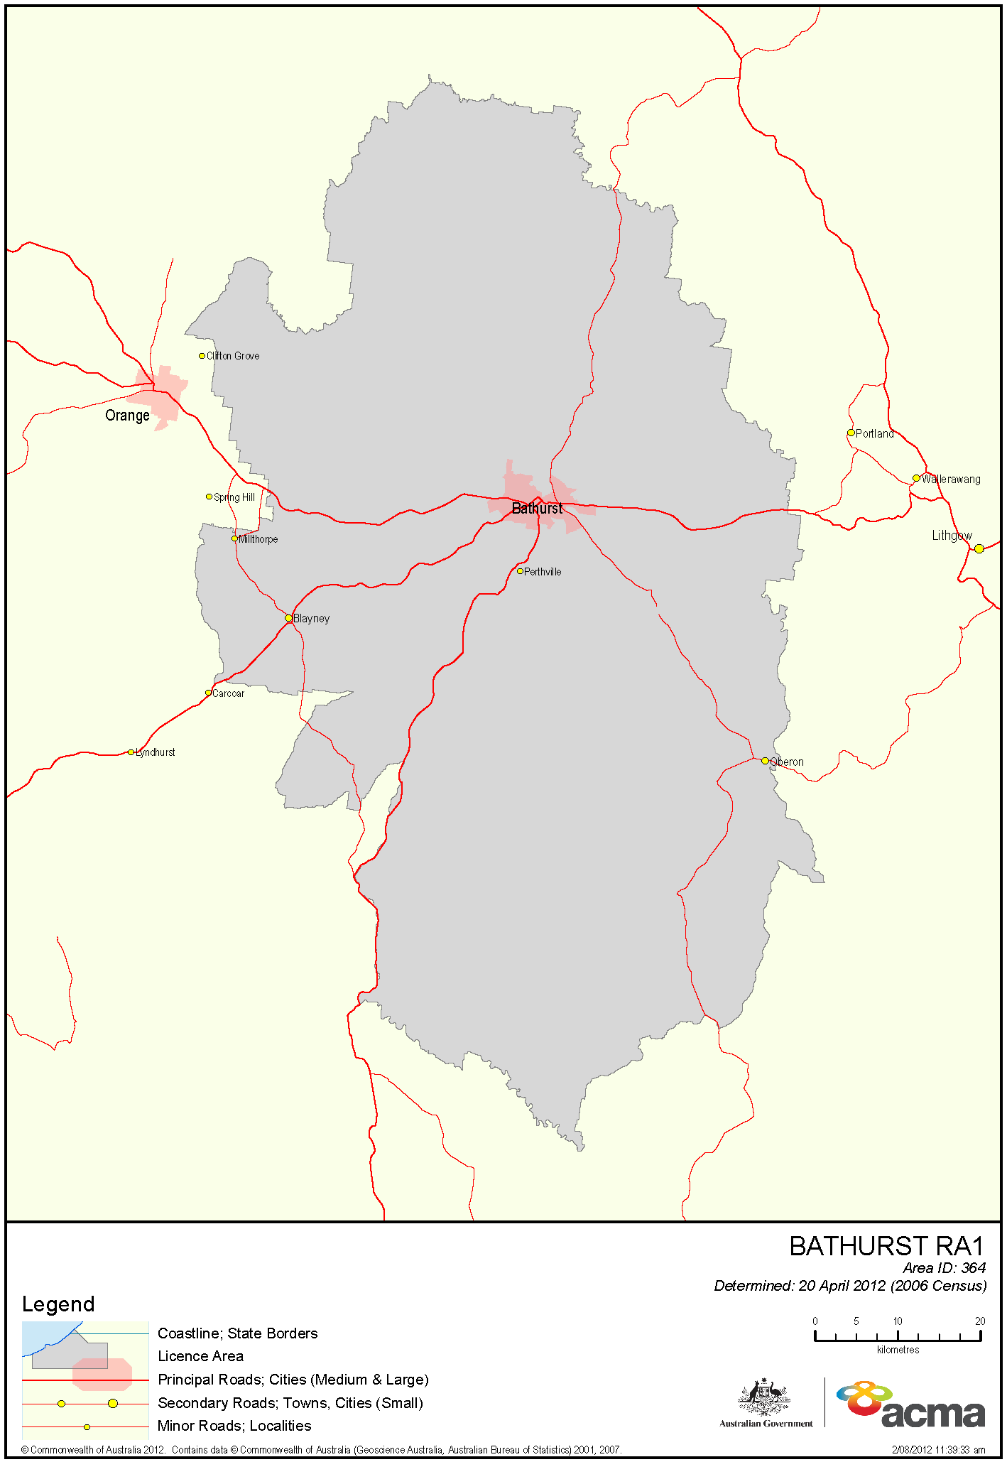

In summary, section 23 of the BSA provides that the ACMA is to consider social demographics, social and economic characteristics within the licence area, the number of existing broadcasting services and the demand for new broadcasting services within the licence area, developments in technology, technical restraints relating to the delivery and reception of broadcasting services, the demand for radiofrequency spectrum for services other than broadcasting services and such other matters as the ACMA considers relevant.
Section 17 of the Legislation Act 2003: Rule-makers should consult before making legislative instruments (1) Before a legislative instrument is made, the rule-maker must be satisfied that there has been undertaken any consultation that is: (a) considered by the rule-maker to be appropriate; and (b) reasonably practicable to undertake.
Australian Broadcasting Authority, Technical Planning Parameters and Methods for Terrestrial Broadcasting, April 2004.
Section 39 of the BSA provides that, under certain conditions—when a licence area is a solus market, a service is provided under a parent licence, the licence area for the parent licence does not have excess overlap area, the licensee requests it and the ACMA is of the opinion that suitable spectrum is available—the ACMA must allocate an additional licence to the applicant for that same licence area as soon as is practicable.
The ACMA issues transmitter licences for certain broadcasting services under section 102 of the Radiocommunications Act 1992.
Section 30 of the BSA provides for the ACMA, having regard to the census data prepared by the Australian Bureau of Statistics, to determine the population of a licence area. The ACMA section 30 schedule was published in 2016 and uses 2011 census population data.
The LAP variation Licence Area Plan – Remote Central and Eastern Australian Radio was registered on the Federal Register of Legislation in December 2017.
Coverage predictions have been made using best estimates of actual transmitting antennas rather than LAP masks. The Oberon transmission is predicted to be interference-limited and is only protected to 66 dBµV/m. All other transmitters are assumed to be protected to 54 dBµV/m.
47,900 people or 99.3 per cent of the total licence area population using P.1546 and lower threshold; 47,700 or 98.9 per cent using P.1546 and standard thresholds; 47,900 or 99.3 per cent using CRC and lower threshold; and 47,700 or 98.9 per cent using CRC and standard threshold.
Population predictions have been made for four scenarios—the ITU-R Recommendation P.1546-1 and CRC-predict propagation models with the standard FM planning thresholds and with the field strength thresholds lowered by 6 dB.
340 people or 0.7 per cent of the total licence area population using P.1546 and lower threshold; 620 or 1.3 per cent using P.1546 and standard thresholds; 1,600 or 3.3 per cent using CRC and lower threshold; and 2,940 or 6.1 per cent using CRC and standard threshold.
320 people or 0.7 per cent of the total licence area population using P.1546 and lower threshold; 540 or 1.1 per cent using P.1546 and standard threshold; 940 or 1.9 per cent using CRC and lower threshold; and 1,660 or 3.4 per cent using CRC and standard threshold.
20 people using P.1546 and lower threshold; 80 or 0.2 per cent of the total licence area population using P.1546 and standard threshold; 660 or 1.4 per cent using CRC and lower threshold; and 1,280 or 2.7 per cent using CRC and standard threshold.
1,660 people or 1.8 per cent of the estimated 2BS AM+FM population of 91,280 using P.1546 and lower threshold; 10,900 or 12.1 per cent of 90,115 using P.1546 and standard threshold; 16,900 or 18.7 per cent of 90,507 using CRC and lower threshold; and 33,400 or 37.2 per cent of 89,792 using CRC and standard threshold.
In particular, the availability of a diverse range of radio services (paragraph 3(1)(a) of the BSA).

