Chapter 4
Broadcasting and online content industry regulatory performance

4.1 Overview
Broadcasting legislation, program standards and licence conditions determine the regulatory obligations of commercial radio and television broadcasters in Australia. This chapter provides information on the performance of broadcasters in meeting their regulatory obligations. Information is also presented on the number of broadcasting-related complaints to the ACMA under broadcasting codes of practice and about prohibited and potentially prohibited online content under the Broadcasting Services Act 1992 (BSA).

Key outcomes relating to broadcasting compliance in the reporting period included:
- all major metropolitan free-to-air commercial network licensees meeting the Australian content transmission quotas for overall content, drama and documentaries
- all commercial and national television broadcasters complying with their quota requirements for High Definition Television (HDTV) transmission
- all regional commercial radio and television broadcasting licensees broadcasting the required amount of material of local significance
- completion of the switchover from analog to digital television broadcasting across Australia
- an increase of nearly 550 per cent in the number of items of online child abuse and other illegal material referred to law enforcement agencies.

4.2 Broadcasting in Australia
Setting the scene—Australians use of traditional broadcasting services
Traditional television and radio services remain integral to Australian life. During the reporting period, 93 per cent of adults (people aged 18 years and over) said they had watched pay TV or free-to-air television in the last seven days and 85 per cent said they had listened to commercial or community radio in the last seven days. The use of these services has remained relatively stable over the past five years (Figure 4.1).

Figure 4.1 Use of TV and radio
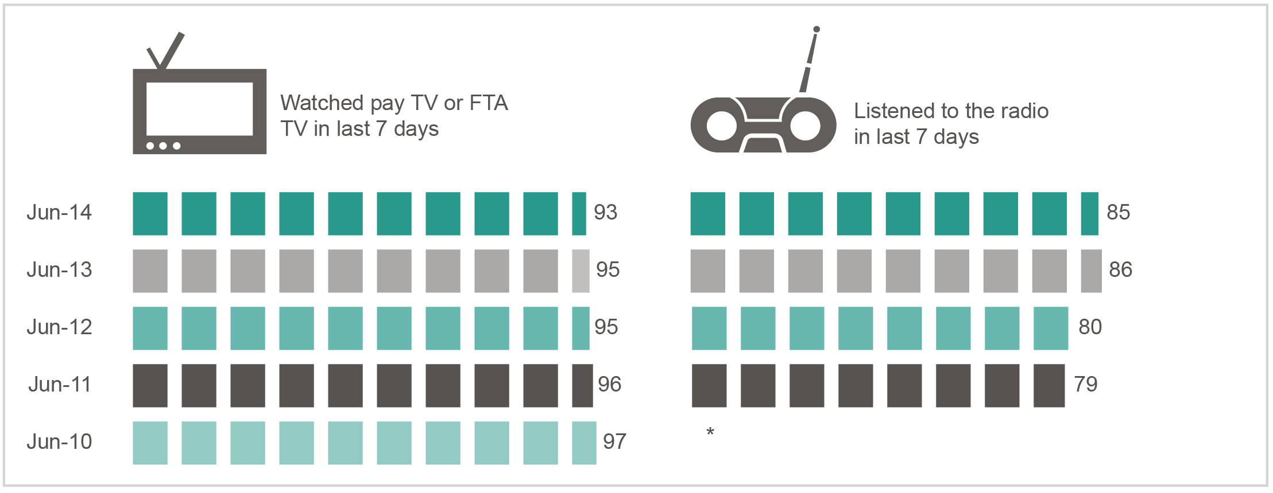
*Data not available.
Base: Percentage of Australians aged 18 years and over in an average seven-day period to June of each year.
Source: Roy Morgan Single Source.

Emerging professional online video content services
While Australians continue to access traditional content services, there is growing demand for more flexible ways of accessing video and audio services. In the six months to May 2014, half (51 per cent) of adult Australian internet users had streamed professionally produced video or audio content and 47 per cent had downloaded video and audio content. More specifically:
- 42 per cent watched catch-up TV online for free using free-to-air services such as Network 10
Catch-up, ABC iView or Plus 7
- 34 per cent streamed internet entertainment services such as Spotify (commercial music streaming service), Pandora (free ‘personalised’ internet radio), SBS on Demand or ABC iView
- 13 per cent paid to watch video on demand online via services such as Quickflix or Foxtel on Demand
- nine per cent watched commercial internet television, also known as IPTV, using services including Fetch TV or Apple TV.

4.3 Australian content on television
The BSA and the Broadcasting Services (Australian Content) Standard 2005 (Australian Content Standard) stipulates Australian content quotas for commercial television. Under the BSA, commercial television broadcasters must provide:
- 55 per cent Australian content, between 6.00 am and midnight across the year, on their core/primary broadcasting service
- a minimum level of Australian programming on television broadcasting services other than their core/primary broadcasting service (multi-channels). For 2013, this requirement is 730 hours, increasing to 1,460 hours in 2015 and beyond.
The Australian Content Standard requires commercial television broadcasters to:
- broadcast minimum amounts of first-release Australian drama and documentary programs
- broadcast minimum amounts of Australian-made children’s programs
- ensure that all preschool programs are Australian programs.
The major metropolitan free-to-air commercial network licensees all met the Australian content transmission quotas for overall content, drama and documentaries for the 2013 period (Table 4.1). Assessment for these quota requirements are calendar-year based. 2013 also marked the completion of a latest triennial period for Australian first-release drama.

Table 4.1 Major metropolitan free-to-air commercial network licensee requirements of the Australian Content Standard for the 2013 calendar year
 |  |  | Minimum quota* | Licensees
 |  |  | Minimum quota* | Seven Network | Nine Network | Ten Network
  Overall  Australian content | On primary/  core channel | (%) | 55 | 69 | 65 | 59
 | On non-primary/  non-core channel | (average hours) | 730 | 2,393 | 1,936 | 2,366
  Australian drama | 2013 | (points) | 250 | 350 | 332 | 344
 | Triennial | (points) | 860 | 911 | 876 | 870
 | Australian documentaries | (average hours) | 20 | 60 | 20 | 33

*Minimum transmission quota required to meet the Australian Content Standard.
Note: Overall Australian content relates to first release and repeat programs that must be broadcast between 6.00 am and midnight. Licensee requirements for each network are calculated by averaging across the following locations: Seven Network–five mainland state capital cities, Nine Network–Brisbane, Melbourne and Sydney, Ten Network–five mainland capital cities.
Australian drama and Australian documentaries relates to first-release programs only.

Children’s programs on commercial television
In conjunction with the Australian Content Standard, the Children’s Television Standards 2009 (CTS) are designed to give children under 14 years of age access to quality television programs that are specifically made for them and reflect their cultural experience.

The CTS requires licensees to provide at least 390 hours annually of children’s programs comprising:
- 260 hours of children’s (C) programs
- 130 hours of preschool (P) programs.
The Australian Content Standard sets out additional annual first release and C drama requirements within these quotas. For the 2013 calendar year, all Seven Network and Network Ten metropolitan free-to-air commercial television broadcasting licensees met all of these annual quotas. However, three licensees of the Nine Network failed to provide sufficient children’s C programming to satisfy annual first-release C programming and annual C programming requirements (Table 4.2). Remedial action for the
non-compliant licensees was yet to be finalised at time of publication.

Table 4.2 Major metropolitan free-to-air commercial network licensees children’s and preschool children’s program quotas (total annual hours), 2013 calendar year
 |  |  | Minimum annual requirement (hours) | Licensees
 |  |  | Minimum annual requirement (hours) | Seven Network | Nine Network | Ten  Network
 | Australian children’s  C drama | First release | 25 | 27 | 27.5 | 34
 | Australian children’s  C drama | Repeat | 8 | 104 | 99 | 65
 | Australian children’s  C programs | First release including C drama | 130 | 130 | 124 | 130
 | Children’s  C programs | All | 260 | 261.5 | 258.5 | 260.5
 | Australian preschool  P programs | All | 130 | 130.5 | 130.5 | 130.5

Note: Licensee requirements for each network are calculated by averaging across the following locations: Seven Network–five
mainland state capital cities, Nine Network–Brisbane, Melbourne and Sydney, Ten Network–five mainland capital cities.
Source: ACMA.

Subscription television drama expenditure
The new eligible drama expenditure scheme requires licensees and channel providers that provide subscription television drama services to spend at least 10 per cent of their annual total program expenditure on eligible drama programs during a financial year. If the 10 per cent expenditure requirement is not met in the relevant financial year, the shortfall amount must be made up the following year.

To be eligible, a drama program must be an Australian or New Zealand production or co-production, and must not have been televised in Australia or New Zealand on a broadcasting service at any time before the expenditure on the program is incurred.

The BSA defines a subscription television drama service as a service devoted predominantly to drama programs; that is, more than 50 per cent of the programming consists of drama programs.

For the 2012–13 compliance period, five licensees and eight channel providers supplied 33 eligible drama channels. All participants met their expenditure obligations for 2012–13, reporting an expenditure on new eligible Australian drama of $13.7 million (aggregated). Of that expenditure, $6.41 million was nominated to acquit the expenditure shortfall for 2011–12. For 2013–14, licensees and channel providers must spend a minimum of $25.76 million (in total) on new eligible programs to acquit the remaining
2012–13 obligation.

Australian advertising
Advertisements are classified as Australian or foreign by Commercials Advice Pty Ltd, (CAD), which is wholly owned by Free TV Australia. As part of reducing the regulatory burden on industry, from 2014 the ACMA no longer requests that licensees report this information to the ACMA.

Captioning
During 2012–13, television service providers reported a high level of compliance with annual captioning target requirements introduced in the BSA.

All free-to-air commercial television broadcasting services (72) and national television broadcasting services (ABC and SBS services in 20 coverage areas) complied with their annual captioning target requirements, broadcasting a total of 528,401 hours of captioned television programs in 2012–13 (6.00 am to midnight). This comprises 93 per cent of the programming broadcast.

Ninety-nine per cent of subscription television licensees (661 out of 667) met their annual captioning target requirements. During the year, there were captioning services on 394 subscription television services (or 80 distinct subscription television channels, as the same channels provided by different licensees are regarded as different services under the captioning legislation).

Television service providers also reported instances when they failed to meet captioning obligations during 2012–13. During this first year for licensees and broadcasters to comply with the new captioning requirements (2012–13), the ACMA sought to inform and educate television service providers about their compliance obligations. This approach is consistent with the ACMA’s stance towards the implementation of other new broadcasting regulations. Table 4.3 provides a summary of the self-reported breaches, excluding disregarded breaches (breaches resulting from unforeseen technical difficulties were disregarded as provided by the captioning legislation).

Table 4.3 Captioning obligations
Captioning obligations | Number of services in breach | Description of obligations in 2012–13
Free-to-air | Services
Annual captioning target | 0 | 90% captioning between 6.00 am and midnight across the year, with exceptions*
Emergency warnings | 0 | Transmit emergency warnings in text and speech and if practicable, with captioning
Designated viewing hours | 53 | Caption all programming between 6.00 pm and 10.30 pm each day (designated viewing hours) on main service
News and current affairs | 54 | Caption all news and current affairs outside designated viewing hours on main service
Multi-channel | 17 | Caption repeated programs on a multi-channel if those programs have previously been broadcast with captioning on the broadcaster’s main service in the licence or coverage area
Subscription | Services/channels
Annual captioning target | 6 services/  channels | 5–60% captioning across the year depending on service category, with exceptions*
Emergency warnings | 0 | Transmit emergency warnings in text and speech and if practicable, with captioning
Simulcast programming | 5 services/  1 distinct channel | Caption simulcast programs on the second service if the programs are simultaneously transmitted with captions on the first service
Repeat programming | 44 services/  9 distinct channels | Caption programs that have previously been transmitted with captions and then repeated on the same or another subscription television service provided by the licensee

*Captioning obligations do not apply to exempt programs, which include foreign programs (not wholly in English) and music programs that do not contain any human vocal content. In 2012–13, three commercial broadcasters had a reduced annual target of 80 per cent as a result of target reduction orders (unjustifiable hardship).Some subscription services were exempt from the annual captioning target as a result of exemption orders (unjustifiable hardship) and nominations under section 130ZX of the BSA (a transitional measure that allows exemption of certain services if the licensee has met the annual captioning target for the threshold number of services).
Source: ACMA.

4.4 Notification of changes in control
Commercial television licensees, commercial radio licensees and publishers of associated newspapers must notify the ACMA of any changes in control within five days of becoming aware of those changes (section 63 of the BSA). Persons who come into a position to exercise control of such licences and associated newspapers are also required to notify the ACMA within five days of becoming aware of the change in control (section 64 of the BSA).

During 2013–14, no infringement notices were given for late notifications of changes of control. Two formal warnings were given, relating to events that took place in the previous financial year.

Fifteen events affecting the control of media operations occurred during 2013–14.

For the fifth consecutive year, the licensees of all 327 commercial broadcasting licences and publishers of all 46 associated newspapers lodged their annual returns on time (as required under Part 5 of the BSA).

4.5 Local information on regional television
The following regional commercial television broadcasting licensees in Queensland, New South Wales, Victoria and Tasmania must broadcast minimum amounts of material of local significance (local content) as a result of an additional licence condition:
- Seven Qld, Southern Cross and WIN TV in regional Queensland
- NBN Ltd, Prime Television and Southern Cross in northern New South Wales
- Prime Television, Southern Cross and WIN TV in southern New South Wales
- Prime Television, Southern Cross and WIN TV in regional Victoria
- Southern Cross, WIN TV and Southern Cross/WIN joint venture in Tasmania.
For the period 21 July 2013 to 1 February 2014, all regional broadcasting licensees in Queensland, New South Wales, Victoria and Tasmania reported that they met the weekly and six-weekly minimum quota requirements of 90 points and 720 points respectively.

In June 2013, the ACMA was directed by the then Minister for Broadband, Communications and the Digital Economy to review the operation and effectiveness of the current regulatory arrangements for the provision of local content in certain regional commercial television areas. The Regional Commercial Television Local Content Investigation 2013 (the investigation) was completed on 24 December 2013 and the investigation report was sent to the Minister for Communications on 6 January 2014. Key investigation findings included that:
- Local content is important and valued by regional Australians.
- Regional Australians are largely satisfied with the current levels of local content available.
- Regional Australians access local content across a wide variety of sources.
- Television is the source most used by regional Australians for news and is the preferred source for local news. However, with some exceptions, the audience for commercial television local news bulletins is declining.
- There are commercial incentives for some regional broadcasters to provide local content.
- Providing local content on commercial television is a high-cost activity and is not necessarily profitable in all markets.
- Funding pressures affecting regional broadcasters are likely to continue.
The investigation report can be accessed at www.acma.gov.au/theACMA/Consultations/
Consultations/Completed/regional-television-local-content-investigation.

4.6 Local content, presence and information on regional commercial radio
The Broadcasting Services (Regional Commercial Radio—Material of Local Significance) Licence Condition 2012 requires 211 regional commercial radio licensees to broadcast prescribed amounts of material of local significance (local content) between 5.00 am and 8.00 pm on business days. Licensees are exempt from this obligation for a five-week ‘holiday’ period each year.

According to the annual returns for 2012–13, all licensees broadcast the prescribed amount of local content as required by the licence condition.

A regional commercial radio licensee affected by certain changes in ownership or control (known as a ‘trigger event’) is required to:
- broadcast specified amounts of local news and information for 47 weeks per year (minimum service standards)
- maintain existing levels of local presence (local staff and facilities) for 24 months from the date of the trigger event.
According to the annual returns for 2012–13, trigger event-affected licensees maintained a high level of compliance with their local content plans. Of the 95 trigger event-affected licensees reporting to the ACMA, all but two licensees complied with their approved local content plan.

On 16 April 2014, the 24-month local presence compliance period ceased for 88 regional commercial radio licences affected by trigger events.

4.7 Anti-siphoning provisions
The anti-siphoning scheme in the BSA restricts subscription broadcasters from acquiring anti-siphoning events in certain instances and also restricts the broadcast of anti-siphoning events by free-to-air broadcasters on their digital multi-channels.

In the reporting period, the ACMA investigated one commercial television licensee’s compliance with the licence condition restricting the broadcast of anti-siphoning events. The ACMA found the licensee breached the licence condition by broadcasting Game 1 of the 2014 National Rugby League State of Origin series on a HD multi-channel without simulcasting the event on the primary channel in the Perth TV1 licence area.

4.8 Digital broadcasting
Digitalisation of Australian broadcasting services included the phased transition of terrestrial television services from analog to digital services in the period June 2010 to December 2013 and the introduction of digital radio services. The switchover from analog to digital television broadcasting was completed across Australia on 10 December 2013.

Digital television
Following the initial switch-off of analog services in the Mildura and Sunraysia licence area in Victoria on 30 June 2010, switchover continued in stages across the remainder of Australia. During the 2013–14 reporting period, switchover was completed—final areas switching over from analog to digital television are outlined in Figure 4.2.

Figure 4.2 Switchover dates in 2013–14
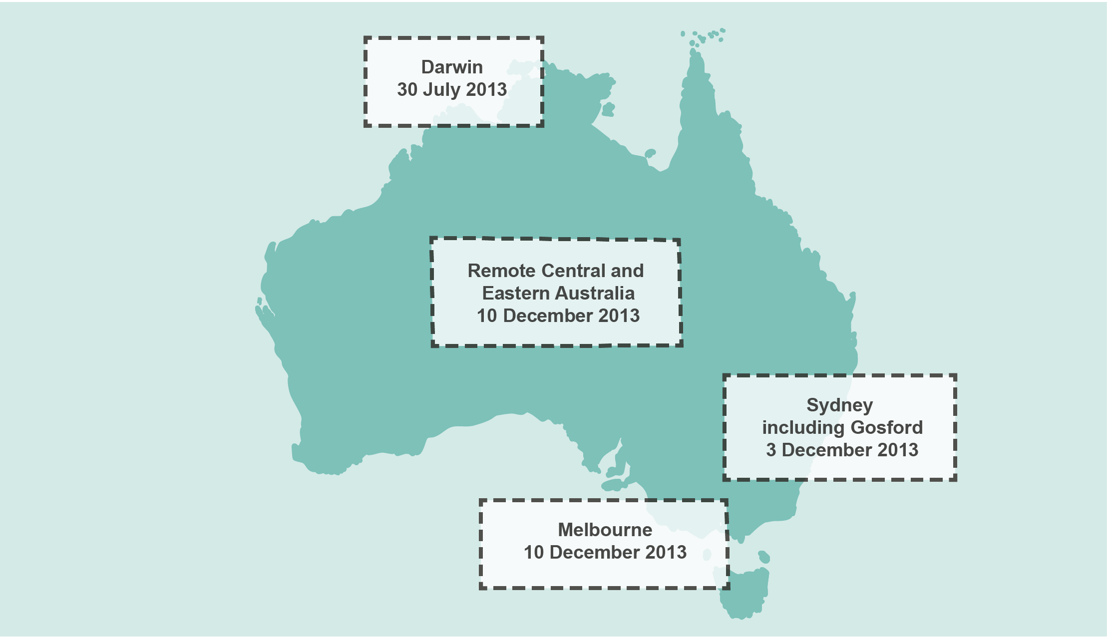
Source: ACMA.

High definition broadcasting
Commercial television broadcasting licensees and national broadcasters were required to meet a HDTV quota until the end of the simulcast period (analog switch-off) (Part 4 of Schedule 4 to the BSA). During this pre switch-off era, each commercial and national television broadcasting service in a mainland metropolitan area was required to transmit a minimum quota of 1,040 hours of HDTV programming per calendar year. The HDTV obligations also applied to a number of broadcasters in regional areas. Following the successful completion of analog switch-off in December 2013, the HDTV quota requirements are no longer applicable.

Digital radio
Digital radio services, using DAB+ technology in VHF Band III spectrum, have been running on a permanent basis in the metropolitan areas of Adelaide, Brisbane, Melbourne, Perth and Sydney since July 2009.

As at August 2014, there were over 2.8 million people listening to digital radio each week in Sydney, Melbourne, Brisbane, Perth and Adelaide. This compared with nearly 1.6 million listeners in the same period in 2013. The number of digital radios sold has also increased to 1.6 million at June 2014, from 1.3 million at June 2013.

In October 2013, the foundation digital radio multiplex transmitter licences were varied to authorise the operation of in-fill transmitters in 14 locations in Sydney, Melbourne, Brisbane and Perth, extending digital radio coverage to a potential 264,000 listeners.

Trials of DAB+ are being conducted in Canberra and Darwin by the peak commercial radio body, Commercial Radio Australia. The current trials expire on 30 June 2015.

Various technological and policy issues need to be resolved before planning and licensing for the rollout of digital radio to regional licence areas can commence, including determining the most appropriate digital radio transmission technology for regional licence areas.
The government is currently conducting two statutory reviews into digital radio services, in accordance with section 215B of the BSA and 313B of the Radiocommunications Act 1992 that consider the regulatory regime and technologies for digital radio.

4.9 Broadcasting complaints and investigations
The ACMA monitors the number and details of complaints it receives about possible breaches of the BSA, standards, licence conditions and code provisions. Not all complaints are investigated, either because the complainant chooses not to pursue the matter further or because the complaints are outside the ACMA’s jurisdiction.

There were 1,593 written complaints and enquiries made to the ACMA about broadcasting matters during 2013–14, a 27 per cent decrease from 2012–13. The number of investigations completed in 2013–14 was 180 (Table 4.4).

Table 4.4 ACMA broadcasting complaints and investigations by financial year
 |  | 2009–10 | 2010–11 | 2011–12 | 2012–13 | 2013–14
 | Written complaints and enquiries received | 1,676 | 1,512 | 2,273 | 2,178† | 1,593
 | Investigations completed | 189 | 197 | 231 | 212 | 180‡
 | Investigations resulting  in a breach finding* | 74 | 72 | 71 | 67 | 45
 | Investigations resulting  in a non-breach finding* | 111 | 115 | 155 | 135 | 132

*Investigations against a code of practice, licence condition, standard and/or provision of the Broadcasting Services Act 1992.
†This does not include 2,680 complaints and enquiries received about 2DAY’s Summer 30 program broadcast on 4 December 2012.
‡Two investigations resulted in no findings and a third investigation was concluded.
Note: Sum of categories does not equal total number of investigations completed due to exclusion of completed investigations with no finding; for example, where the complaint is withdrawn.
Source: Broadcasting complaints to the ACMA.

4.10 Investigating complaints about online content
The Online Content Scheme is established under Schedules 5 and 7 to the BSA and dovetails with industry codes of practice. Under the scheme, the ACMA must investigate all valid complaints about online content where the complainant considers that the content may be prohibited.

Prohibited online content is defined by reference to the National Classification Scheme established under the Classification (Publications, Films and Computer Games) Act 1995. Content that is classified RC (Refused Classification) and X 18+ is prohibited and, in certain circumstances, content that is classified R 18+ and MA 15+ is also prohibited. Content that has not been formally classified by the National Classification Board, but has been assessed by the ACMA as likely to be prohibited, is termed ‘potential prohibited’ content under the BSA.

During 2013–14, the ACMA received 4,051 complaints (compared to 4,633 during 2012–13) and finalised investigations into 11,164 items of content as at 30 June 2014 (a complaint may result in the investigation of multiple items of content). The introduction of new software and processes facilitated the investigation of a much greater number of items of child sexual abuse material with 8,981 individual items being assessed as prohibited or potential prohibited online content. Of these, approximately 88 per cent of online content items actioned were assessed and/or classified as RC.
If prohibited content is hosted in or provided from Australia, the ACMA must direct the content service provider to remove or prevent access to it (depending on its nature). If prohibited or potential prohibited content is hosted overseas, the ACMA notifies the suppliers of optional end-user (PC-based) industry accredited filters. These filters have been tested and accredited by the Internet Industry Association (whose functions have now been subsumed by Communications Alliance), as part of the Family Friendly Filter scheme, in accordance with the Internet and Mobile Content Code.

During 2013–14, a total of 8,980 overseas-hosted prohibited or potential prohibited items were referred to suppliers of optional end-user industry-accredited filters (Table 4.5). The ACMA also issued one final ‘take-down’ notice for an item of Australian-hosted prohibited content. The ISP issued with a notice removed the content within the required time frame, maintaining 100 per cent compliance with ‘take-down’ notices across the life of the Online Content Scheme.

Table 4.5 Internet content investigations by financial year
 |  | 2009–10 | 2010–11 | 2011–12 | 2012–13 | 2013–14 | % change from  2012–13  to 2013–14
 | Complaints
Received* |  | 3,212 | 4,865 | 5,026 | 4,633 | 4,051 | –13
Invalid† |  | 118 | 217 | 329 | 115 | 50 | –57
 | Investigations
Terminated‡ |  | 175 | 174 | 210 | 556 | 578 | +4
Completed§ |  | 2,782 | 3,994 | 5,403 | 3,143 | 10,586 | +237
Total items∥ investigated |  | 3,828 | 6,587 | 6,265 | 3,793 | 11,164 | +194
 | Action taken
Items actioned# (hosted in,  or provided from, Australia) |  | 25 | 12 | 7 | 8** | 1 | –88
Items actioned  (overseas-hosted) |  | 1,907 | 1,945 | 2,004 | 1,845 | 8,980 | +387
Items of online child abuse and other illegal material referred to law enforcement |  | 1,092 | 1,071 | 1,130 | 1,182 | 7,670 | +549

*A complaint may not reach investigation stage if the complainant is not eligible to make a complaint or if the complaint is about a matter that the ACMA cannot investigate.
†A complaint is not investigated if the complaint is invalid. A complaint is invalid if it does not contain the required information set out at subclause 37(4) of Schedule 7 to the BSA, or has been made by a person not entitled to make a complaint.
‡An investigation may be terminated if the ACMA is of the opinion that is does not have sufficient information to conclude the investigation.
§An investigation may relate to one or many items of content. An investigation may be terminated if the ACMA does not have sufficient information to conduct its investigation.
∥An item relates to an individual page, image or other file.
#Action is taken on items assessed as prohibited or potential prohibited.
**Three items of content were removed upon referral to law enforcement prior to any take-down notices being issued by the ACMA.
Source: Online content complaints actioned by the ACMA.


International cooperation to remove online illegal content
The ACMA places a high priority on acting promptly and effectively against child sexual abuse material. The ACMA refers this content to either an Australian law enforcement agency or a law enforcement-endorsed overseas agency through the International Association of Internet Hotlines (INHOPE), of which the ACMA is a long-term member. INHOPE coordinates a network of international hotlines to take swift action in response to reports of illegal content. INHOPE acts as a rapid law enforcement notification and take-down channel across international borders. In 2013–14, the ACMA referred 7,670 items of online child abuse and other illegal material to law enforcement agencies, nearly a 550 per cent increase on the previous year—7,540 items of child sexual abuse material were notified through INHOPE for take-down. The increase is a result of a rising number of complaints to the ACMA, coupled with the ACMA’s commitment to pursuing the removal of such material.

4.11 Interactive gambling
The Interactive Gambling Act 2001 (IGA) prohibits certain internet gambling content, as well as the advertising of such content. IGA complaints received and actioned by the ACMA in the reporting period are outlined in Table 4.6. Under the IGA, the ACMA must not investigate Australian-hosted content, but if it is warranted to do so, must refer complaints to an Australian police force for investigation. The total number of complaints and enquiries received by the ACMA during 2013–14 was 121, which was the same as received in 2012–13.

Table 4.6 Interactive gambling
 | Interactive gambling | 2013–14
Complaints and general enquiries |  | 121
Investigations of overseas-hosted gambling content |  | 23
Prohibited internet gambling content found to be in breach of the IGA, notified to accredited filter providers and the AFP |  | 11
Assessments of Australian-hosted gambling content |  | 25
Potential prohibited content referred to the AFP |  | 10
Investigations into the broadcast of interactive gambling advertisements* |  | 0

*Under the IGA, the ACMA only investigates interactive gambling advertisements that are broadcast on television or radio. The Department of Communications takes responsibility for all other advertising, such as online or in print.

Endnotes While the scheme imposes a spending obligation on licensees and channel providers for Australian and New Zealand programs, there is no broadcasting requirement.
This is the most recent available data at time of publication.
As above.
The investigation drew from a number of sources including a survey of regional Australian audience rating data, local content case studies, a peer-reviewed economic analysis and consultation process involving both the public and the regional broadcasting industry.
This number excludes regional commercial radio broadcasting services licensed under section 40 of the BSA, regional racing services, or remote licences as these services are exempt from the local content licence condition.
This is the most recent available data at time of publication.
Except regional commercial radio broadcasting services licensed under section 40 of the BSA, regional racing services, or remote licences that are exempt from the minimum service standards and local presence obligations that apply following a trigger event.
Potential prohibited content is defined at clause 21 of Schedule 7 of the BSA.

