Australian
Communications
and Media Authority
Communications report
2015–16

The ACMA Communications report 2015–16 (the Communications report) draws on data from a range of sources including the ACMA’s own databases, information reported by industry, the ACMA’s research using third-party public sources, and commissioned surveys and analysis.
The ACMA has a statutory reporting obligation under section 105 of the Telecommunications Act 1997 that requires it to collect data from industry for monitoring and reporting purposes. The ACMA will continue to work with industry participants to identify opportunities to streamline regulatory reporting arrangements as part of the Australian Government’s regulation reform agenda.
Disclaimer
The information in this document was obtained from sources the ACMA believes to be reliable. However, the ACMA does not guarantee the accuracy, completeness or adequacy of the information. To the maximum extent permitted by law, the ACMA is not liable for any errors, omissions or inadequacy in the information, or for any reliance on the information. Predictions and forward-looking statements in this document are based on information existing and known at the time of publication, and are subject to risks, uncertainties and changes in circumstances beyond the control of the ACMA. Opinions and positions stated in this document are subject to change without notice.
Comments
The ACMA welcomes feedback on the Communications report. Comments and enquiries about the scope, content and format of the report should be sent to research.analysis@acma.gov.au.
Further information
For further information about the ACMA and links to the Communications report, please go to www.acma.gov.au/commsreport.
Copyright notice
© Commonwealth of Australia 2016
ISSN: 1834-1519 (print) 2204-4256 (online)
With the exception of coats of arms, logos, emblems, images, other third-party material or devices protected by a trademark, this content is licensed under the Creative Commons Australia Attribution 3.0 Licence (http://creativecommons.org/licenses/by/3.0/au/).
We request attribution as the Australian Communications and Media Authority communications report 2015–16. All other rights are reserved.
The Australian Communications and Media Authority has undertaken reasonable enquiries to identify material owned by third parties and secure permission for its reproduction. Permission may need to be obtained from third parties to re-use their material.
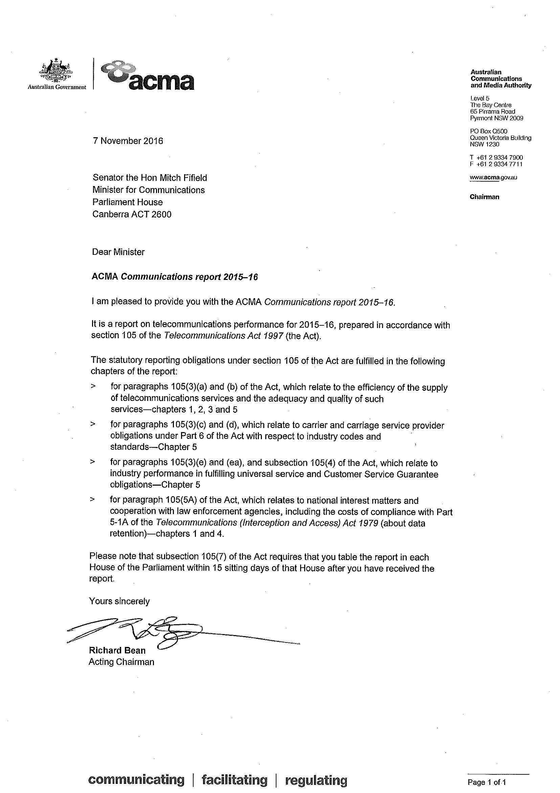

Chairman’s foreword 1
Introduction and executive summary 3
Key indicators—at a glance 7
1. Industry supply of communications services 13
1.1. Overview 13
1.2. Fixed-line service availability 14
Number of services in operation 14
Growth in mobile phone-only consumers 15
Use of fixed-line telephone and OTT communications services 15
1.3. Mobile service availability 17
Number of services in operation 17
Mobile network infrastructure 20
Strong supply and demand for 4G services 20
Mobile Black Spot Program 21
1.4. Infrastructure regulation 21
Mobile phone base stations 21
Objections and enquiries to the ACMA 22
Complaints to the TIO about facility installations 22
Interference 23
Radiocommunications compliance program 24
1.5. New developments in communications 25
The IoT and M2M 25
Other emerging mobile technologies 25
1.6. Internet service availability 27
Number of internet subscribers 27
Mobile-internet subscribers 27
Domain name registrations 28
Number of ISPs 28
National Broadband Network 30
Submarine cables 31
Copper network switch-off 32
Publicly accessible wireless internet 33
Software-defined networking (SDN) and the cloud 33
1.7. Communications mergers and acquisitions 34
1.8. Carrier licensing and CSPs 35
1.9. Allocation of numbers 36
Smartnumbers 36
Geographic numbers 36
Mobile numbers 37
Other numbers 37
1.10. Broadcasting services 37
Number of broadcasters by segment (radio/television/commercial) 37
Commercial broadcasting services 38
Cross-media ownership 41
Subscription television in Australia 41
Community radio broadcasting licences 41
Temporary community radio broadcasting licences 42
Community television services 42
Community television transition 42
Community television trials 42
Advertising expenditure in main media 42
2. Engagement with communications and media 49
2.1. Overview 49
2.2. Internet access 50
Connectivity—take-up of the internet 50
Offline Australians 51
Variety of internet access devices 51
Diversification of consumer internet access devices 51
Mobile-only users 53
2.3. Data trends 55
Frequency of internet use 55
Volume of data downloaded 55
Data allowance—mobile and tablet 56
2.4. Use of communications services 57
Australians’ diverse use of communications services 57
Social networking activities 59
Communications apps 59
2.5. Internet activities 62
Performing activities online 62
Accessing online video and audio content 63
Downloading versus streaming audio and video content 64
Growth in e-commerce activity 66
Online buying, selling and shopping 66
Australian businesses online 67
2.6. Consumer satisfaction with communications services 67
2.7. International trends 70
Communications services 70
Access to the internet 70
Internet access devices 70
Activities performed online 71
3. Television, radio and online content developments 73
3.1. Overview 73
3.2. Audio content 74
Industry developments in radio and audio content 74
3.3. Audience engagement 75
Time spent listening to radio 75
Music streaming services 76
Expanding audio measurement 77
3.4. Video content 77
Industry developments 77
Developments from content providers 78
Developments in audience measurement 79
Devices used to access video content 79
Online video traffic 80
3.5. Traditional broadcast and online video engagement 81
Engagement with broadcast content 81
SVOD subscribers 82
Accessing online content 83
Online viewer profile and perceived benefits 85
Technical experience 87
3.6. Online news services 88
Trust in news 89
Local news in regional Australia 89
3.7. Broadcasting in Australia 90
Australian content 90
Children’s programs on commercial television 91
Subscription television drama expenditure 92
Captioning 92
Notification of changes in control 94
Local information on regional television 94
Local content, information and presence on regional commercial radio 94
Anti-siphoning provisions 95
Digital broadcasting 95
3.8. Online content investigations 97
Interactive gambling 97
4. National interest issues 100
4.1. Overview 100
4.2. Emergency call service 100
Emergency call service—Triple Zero and 112 101
Telstra’s performance in answering emergency calls 101
Calls connected to emergency service organisations 101
Improved mobile location for emergency service organisations 102
Enquiries and complaints about the Triple Zero service 102
Emergency call service—NRS 102
4.3. Supporting law enforcement and national security agencies 104
Disclosure of customer information 104
Emergency suspension of carriage services 106
4.4. Interception 106
Providing assistance 106
Interception capability 106
Interception capability plan compliance 106
Data retention 107
4.5. Identity-checking requirements for prepaid mobile carriage services 107
4.6. Role of the Integrated Public Number Database (IPND) 108
CSP compliance with IPND requirements 108
IPND Scheme 109
4.7. Handling of life-threatening and unwelcome communications 109
5. Telecommunications consumer safeguards and quality
of service 110
5.1. Overview 110
5.2. Telecommunications Industry Levy and public policy outcomes 110
Industry levies and payments 111
Final TIL assessment 111
5.3. Public payphones 111
Numbers of payphones and payphone sites 111
Payphone fault repair performance 112
Payphones for people with disabilities 113
5.4. CSG Standard 113
New service and in-place connections 114
Appointments and fault repairs 115
CSG Standard payments 117
Exemptions from the CSG Standard 117
5.5. Network Reliability Framework 118
Level 1—national and field service area performance 118
Level 2—local cable run remediation 120
Level 3—individual service performance 120
5.6. Priority assistance 122
5.7. Number portability 124
Local number portability 124
Freephone and local rate number portability 124
Mobile number portability 125
5.8. Telecommunications codes—development and review 125
5.9. Industry compliance with telecommunications codes 125
Compliance with the TCP Code 125
5.10. Cabling 127
Registered cablers 127
Cabling compliance 127
5.11. Do Not Call Register 127
5.12. Unsolicited communications—spam and telemarketing 128
5.13. Australian Internet Security Initiative 129
5.14. Industry compliance with TIO scheme 130
5.15. Complaints to the TIO 131
Appendix—Research methodology 133
Glossary 135
Index 144


Chairman’s foreword
I am delighted to present the ACMA Communications report 2015–16.
This is the 11th consecutive edition of this report produced since the Australian Communications and Media Authority was formed in July 2005.
The Communications report provides a comprehensive overview of the evolving communications and media environment in Australia, with a particular emphasis this year on the continued investment in mobile and fixed broadband infrastructure, along with discussion of continued changes in the way Australians engage with digital content and devices.
Australians’ appetite for content and digital data is driving profound changes across all the key enabling elements of the communications sector. In this past year, data download volumes increased by 52 per
cent to over 2.2 million terabytes (a 114 per cent increase in two years).
Infrastructure investment in both fixed-line and mobile broadband networks has accelerated as network operators significantly expand the capacity of their communications networks. For example, we have seen increased interest in the submarine cable infrastructure connecting Australia to the rest of the world. All mobile network providers substantially extended their 4G network coverage, as well as announcing a commitment to work towards commercial 5G mobile network deployment by 2020. Network coverage for the National Broadband Network continues to expand, now with over one million premises activated.
Despite declines in the shipment of smartphones and tablets in the 12 months to June 2016, more and more activities undertaken online across a range of devices suggest future growth in online activity will be driven by change in usage patterns, rather than subscriber growth.
In the services market, this data-driven shift is most notable in the changing profile of service subscriptions. While fixed-line telephone services in operation continued to decline, mobile phone subscriptions grew, albeit at a slower rate than in previous years. Internet subscriptions continued to grow, with an increased share of that growth coming from fibre connections.
Content delivery and the viewing behaviours of Australians are driving significant developments, not only in the online content and broadcasting sectors, but more broadly across the communications industry. In fewer than two years, subscription video on demand services recorded around 2.7 million paid, free or trial subscriptions, reflecting that online content viewing is now firmly established in Australia. More than two-thirds of online Australian adults now go online to view video content and more than half listen to audio content online.
While the average time audiences spend watching free-to-air television continues to experience a slight decline, broadcast television remains the main source of news for adult Australians, with 36 per cent getting their news from television. While listening to the radio continues to be popular, Australians spend more time listening to traditional radio (AM and FM) than digital radio or the radio online.
I commend the ACMA Communications report to policy-makers, industry and interested citizens as a vital source of independent evidence, providing information about, and analysis of, the rapid change and innovation occurring in Australia’s communications and media environment.
As always, the ACMA welcomes feedback on this report.

Richard Bean
Acting Chairman

Introduction and executive summary

Introduction

Legislative basis
The Communications report 2015–16 fulfils the ACMA’s statutory reporting responsibilities under the Telecommunications Act 1997 (Telecommunications Act). Section 105 of the Act requires the ACMA to report annually on the performance of carriers and carriage service providers (CSPs) in meeting regulatory obligations with specific reference to consumer satisfaction, consumer benefits and quality of service. Information about the broadcasting industry’s performance in meeting regulatory obligations is also included in this report—a reflection of the ACMA’s regulatory remit and role as a converged communications and media regulator.

Scope and structure of report
The Communications report 2015–16 comprises the following chapters:
- Chapter 1—Industry supply of communications services presents a detailed analysis of key supply-side developments in the communications and media markets in Australia during the 2015–16 reporting period. This chapter focuses on the supply of communications and content services in Australia, including the number of carriers, CSPs and services in operation, and developments with the rollout of communications infrastructure.
- Chapter 2—Engagement with communications and media provides information about consumer engagement with communications services and the benefits derived from these services. This chapter notes changing consumer service preferences, reports on current levels of consumer satisfaction with communications services, and compares Australia with international trends in service take-up and use.
- Chapter 3—Television, radio and online content developments highlights the changes in delivery of audio and video content including viewing behaviours for television, subscription and online content. It also discusses the performance of Australian broadcasters in meeting their regulatory obligations for broadcasting Australian content, captioning, changes in media ownership and control, the digitalisation of broadcasting services, and complaints to the ACMA about broadcasting matters and prohibited online content.
- Chapter 4—National interest issues outlines information about the performance of the emergency call services, the cost of maintaining communications interception capabilities, the disclosure of customer information in support of law enforcement and national security investigations, submarine cable infrastructure protection and radiofrequency interference complaints.
Chapter 5—Telecommunications consumer safeguards and quality of service examines the performance of key communications safeguards. These include the Customer Service Guarantee Standard, priority assistance and the Network Reliability Framework, the Do Not Call Register, and related unwanted communications rules covering telemarketing and spam complaints. This chapter also examines number portability code compliance and complaints to the Telecommunications Industry Ombudsman (TIO).

Executive summary

Key highlights 2015–16
- The key enabling elements of the communications sector are being transformed by the intensifying take-up and use of online services and the corresponding strong growth in data traffic. Data download volumes increased by 52 per cent between the June 2015 and June 2016 quarters to over 2.2 million terabytes.
- Network operators continued to invest in expanding network capacity to address the growth of data volumes. All mobile network operators continued investments in 4G network upgrades. The National Broadband Network (NBN network) expanded its network coverage and increased its subscriber base to over one million premises activated, and there was increased planning activity for submarine cable infrastructure.
- Data traffic appears to be driven more by increasing intensity of usage, particularly downloading of video content, rather than significant growth in device subscriptions. While smartphone use is on the rise, shipments of smartphones declined by 18 per cent in the 12 months to June 2016. Tablet shipments declined by 12 per cent over the same period.
- Changing consumer use patterns are also transforming the profile of service subscriptions. The shift to mobile phone-only households continues, with 31 per cent, or approximately 5.78 million Australians, having only a mobile phone and no fixed-line telephone at home. The steady increase in mobile phone-only subscribers is matched by the steady reduction in fixed-line telephone subscribers—the number of adult Australians with a fixed-line telephone at home fell from 78 per cent in June 2012 to 68 per cent by June 2016. Mobile subscription numbers grew slowly, increasing by 2.6 per cent over 2015–16, with some providers reporting that machine-to-machine (M2M) communications drove part of the increase.
The majority of Australians are making online content services an established part of their communications routine. In the six months to June 2016, 63 per cent of adult Australians had watched online content. Over 2015–16, the professionally produced online content market became increasingly crowded, with launches of new subscription video on demand (SVOD) services, and free-to-air (FTA) broadcasters introducing additional live streaming and improved catch-up services.

Continued investment in communications networks
Telecommunications companies continue to invest in emerging mobile technologies and prepare their networks for increased data traffic. Operators of 4G mobile networks now cover up to 98 per cent of the population. There was a range of 5G-related announcements over 2015–16, including the commitment to work towards a commercial 5G mobile network deployment in 2020.
In 2015–16, the number of premises activated on the NBN network increased by 126 per cent to over one million. The total premises serviceable reached over 2.8 million over the same period, an increase of 146 per cent.
Internet access is available across multiple networks, devices and locations. In the six months to June 2016, 91 per cent of adult Australians had accessed the internet. Of those adult Australians who go online, 68 per cent access the internet several times a day.
In the six months to June 2016, 10 per cent of Australians did not have the internet in their home; of this group, 71 per cent were aged 65 or over. As services increasingly move online, reaching these unconnected Australians, and enabling them to participate effectively, will be an important challenge.

Online delivery platforms continue to grow
Service providers are expanding locations and platforms to meet their customers online, with consumers able to access content over a variety of devices, websites and apps. Australian communications service providers are offering voice over internet protocol (VoIP) services, communications apps and various types of online content services.
The expanded range of services available is reflected in an increasingly fragmented Australian audience, where households have an average of 6.4 screens on which to view content.
Digital platforms are an increasingly important component of revenues. For example, digital music, including music streaming, was a key driver in the first increase in Australian music sales in three years. During 2015–16, the number of Australian businesses with a web presence increased two percentage points to 49 per cent, and over a third had a social media presence. This is reflected in the increase in the number of domain names registered in Australia—in the 12 months to June 2016, the number of registered ‘.au’ domain names increased by two per cent to 3.04 million.

Australians still enthusiastic audiences for broadcast television
Australians spend the majority of their viewing time watching broadcast television on the day of the broadcast (live FTA). Live FTA television still holds the largest share among adult Australians—59 per cent—of time spent with television or professionally produced content. However, younger age groups are showing signs of moving away from live television. The 18–24 age group spent more time with online video (5.6 hours) than live FTA television (4.5 hours).
The average weekly cumulative reach of FTA television also continued a slow and steady decline in 2015–16, reflecting the multiple content platforms available to consumers. The average weekly cumulative reach of FTA television reduced four percentage points from 88.4 per cent in 2011–12 to 84.3 per cent in 2015–16.
As one of many response strategies, broadcasters are expanding their range of content services, offering live streaming services and content apps. The Seven Network launched 7live, a live streaming service of its main channel, in October 2015. The Nine Network launched a new catch-up TV and live streaming service, 9Now, in early 2016.
Over 2015–16, the boundaries between communications and media sectors continued to blur, with communications service providers buying content rights and offering or bundling content services, such as the Optus Sport service (10 streaming channels of English Premier League content), the Optus Sports app and Telstra TV.

Online viewing firmly established in Australia
The most popular online content is catch-up television, with 44 per cent watching in the six months to June 2016, but SVOD services are not far behind, with 32 per cent of Australians watching in the same period.
SVOD services are now an established part of the Australian media landscape, recording around 2.7 million paid, free or trial subscriptions as at June 2016. Foxtel and Presto had a combined 2.9 million subscriber base for the same period (separate totals for Foxtel SVOD and Presto were not available). Forecasts suggest that SVOD paid subscribers will overtake Foxtel’s subscriber base by 2019.
Online platforms have enabled new entrants, including global organisations, into the Australian media and communications sector. For example, the most popular online video service was the US-based SVOD service Netflix, with 50 per cent of online Australians watching in the six months to June 2016. YouTube, (excluding user-generated content) was the second-most popular at 43 per cent. The most popular communications apps are owned by global organisations such as Facebook, Apple and Microsoft.

Telecommunications consumer safeguards
Communications users benefit from a range of telecommunications consumer safeguards.
In 2015–16, the number of telephone numbers listed on the Do Not Call Register (DNCR) grew by more than 380,000, or four per cent, taking the total numbers listed to 10.65 million.
The number of complaints and reports the ACMA received about commercial electronic messages (spam) in 2015–16 increased by 44.6 per cent to 18,068.
There were 112,518 new complaints made to the TIO during 2015–16, a reduction of 9.6 per cent from 2014–15. All six categories of the TIO’s top complaints experienced a decline in this period. Complaints about credit management declined from a top of 52,907 in 2011–12 to 22,620 in 2015–16, a reduction of 57 per cent over that five-year period.
After increasing every year since 2011–12, the number of both local and mobile phone numbers ported decreased in 2015–16. Local numbers ported decreased by 19 per cent from 1.22 million to 991,011, while mobile phone numbers ported decreased by 18 per cent from 1.72 million to 1.42 million.
The decline in the number of payphones slowed over 2015–16—numbers fell by five per cent to 24,573 payphones.
All qualifying CSPs met the Customer Service Guarantee (CSG) performance benchmarks. Between 2011 and 2016, the number of services covered by the CSG has steadily declined. In the 12 months to June 2016, the number of fixed-line services covered by the Telecommunications (Customer Service Guarantee) Standard 2011 (CSG Standard) fell 3.6 per cent to 6.1 million services. At the same time, there was an increase of 18 per cent of customers waiving their rights under the CSG Standard. There was also a significant increase in the amount of compensation paid to customers as a result of failing to meet CSG Standard time frames, rising by 176 per cent to $16.17 million. This increase, in part, reflects both ongoing wet weather and the transition of consumers to NBN services, which has reduced the ability of CSPs to apply for exemptions from compliance with the CSG.

National interest issues
The percentage of calls to emergency services made from mobile phones increased from 66.9 per cent in 2014–15 to 68.7 per cent in 2015–16. In May 2016, all emergency services organisations (police, fire and ambulance) throughout Australia had implemented the functionality to automatically receive cell tower (or better) location information during a Triple Zero (000) call from a mobile phone.
During 2015–16, the number of disclosures, as reported to the ACMA under section 308 of the Telecommunications Act, was 667,792—a decrease of 157,049 (19 per cent) from 2014–15. Of these, 81 per cent were covered by an authorisation in force to access existing information or documents for the enforcement of the criminal law under section 178 of the Telecommunications (Interception and Access) Act 1979 (TIA Act).

Note on ACMA consumer survey methodology
The 2016 ACMA-commissioned survey uses a different methodology from previous ACMA-commissioned surveys. This means that differences between 2015 and 2016 may be explained by the methodology rather than any significant change. For example, results from surveys using online panels indicate more television watching and screen use generally than figures derived from computer-aided telephone interviews.
Care should therefore be taken when comparing 2016 consumer survey data with figures from previous years. Where this is the case, the tables and charts in the report show a dotted line between the 2016 figures and earlier results, as shown in the example below.
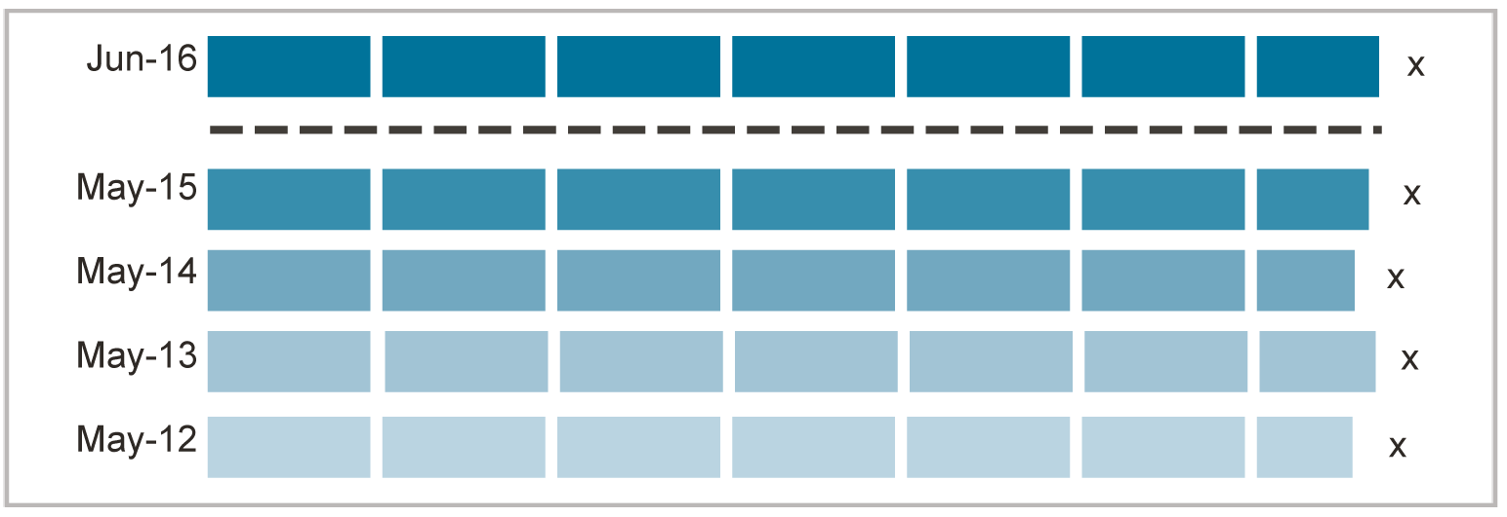
A more detailed explanation of the change in methodology is provided in the appendix to this report.

Key indicators—at a glance

Telecommunications services

Number of services
 | Jun 12 (million) | Jun 13 (million) | Jun 14 (million) | Jun 15 (million) | Jun 16 (million) | 2015–16 change (%)
Mobile services (voice and data)* | 30.20 | 31.09 | 31.01 | 31.77 | 32.59 | 2.6
Mobile handset internet subscribers | 16.19 | 19.65 | 20.57 | 20.99 | 21.97 | 4.6
Mobile wireless broadband (e.g., dongle/datacard) | 5.86 | 6.15 | 5.95 | 6.00 | 6.04 | 0.6
Total mobile internet services† | 22.05 | 25.80 | 26.52 | 27.00 | 28.01 | 3.7
Total internet service subscribers‡ | 28.23 | 32.00 | 33.05 | 33.76 | 35.26 | 4.5
Fixed-line telephone services§ | 9.67 | 9.42 | 9.19 | 8.50# | 8.18# | –3.8
*Change in data source from ACMA annual industry data request in June 2013 to company annual reports from June 2014.
†Sum of mobile phone handset and mobile wireless broadband subscribers.
‡Including mobile phone handset, mobile wireless broadband, fixed-broadband, satellite, fixed-wireless, other broadband and dial-up subscribers.
§Includes PSTN and other fixed-line telephone services. Due to a methodology change in 2014, data reported here differs from data reported in previous communications reports. From 2014, the total resale (retail services directly connected via another network) and retail services in operation are reported. In communications reports prior to 2014, wholesale and retail totals were reported.
#Change in data source in 2016 to ACCC retail and resale data collected from the providers stated in the Division 12 Record Keeping Rules. 2015 data has been revised to be consistent with the 2016 data collection method and differs from data reported in the previous Communications report.
Note: Counts of subscribers published in previous communications reports may vary due to revisions by the ABS. Percentage changes are calculated on non-rounded data.
Source: See Chapter 1. Further explanatory details for this data can be found in the source chapter.

Use of services
 | May 12 (million) | May 13 (million) | May 14 (million) | May 15 (million) | Jun 16 (million) | 2015–16 change (%)
Fixed-line telephone users | 13.83 | 13.34 | 13.37 | 13.07 | 12.56 | –4.0
Smartphone users | 8.67 | 11.19 | 12.07 | 13.41 | 13.75 | 2.5
Mobile phone users without a home fixed-line telephone* | 3.41 | 4.01 | 4.90 | 5.32 | 5.78 | 7.6
*At June for each year. June 2015 figure has been revised from previously published data due to change in methodology of Roy Morgan Single Source.
Note: Data relates to people aged 18 years and over. Percentage changes are calculated on non-rounded data.
Source: See Chapter 1. Further explanatory details for this data can be found in the source chapter.

Regulated or contracted services
 | Jun 12 | Jun 13 | Jun 14 | Jun 15 | Jun 16 | 2015–16 change (%)
Payphones (Telstra-operated and privately owned) | 31,032 | 29,523 | 28,068 | 25,876 | 24,573 | –5.0
 | (million) | (million) | (million) | (million) | (million) | (%)
Number of telephone services covered by the CSG Standard* | 7.12 | 6.68 | 6.54 | 6.34 | 6.11 | –3.6
CSP customers who have waived their rights under the CSG | 0.228 | 0.248 | 0.324 | 0.867 | 1.024 | 18.1
*Relates to the number and value of compensation payments made by CSPs to customers occurring during the financial year.
Source: See Chapter 5. Further explanatory details for this data can be found in the source chapter.

Communications network and service providers
 | Jun 12 | Jun 13 | Jun 14 | Jun 15 | Jun 16 | 2015–16 change (%)
Members of the TIO scheme* | 1,221 | 1,360 | 1,384 | 1,539 | 1,599 | 3.8
Licensed carriers | 187 | 201 | 208 | 229 | 250 | 9.2
Number of ISPs† | 81 | 77 | 71 | 69 | 66 | –4.3
*Carriers and eligible CSPs to join the TIO scheme. Eligible CSPs are those providers who supply fixed standard telephone, mobile or internet services to residential and small-business customers.
†ISPs with more than 1,000 subscribers operating in Australia as reported by the ABS.
Source: See Chapter 1. Further explanatory details for this data can be found in the source chapter.

Digital services and engagement

NBN network—premises serviceable and activated
 | 30 Jun 13 | 30 Jun 14 | 30 Jun 15 | 30 Jun 16 | 2015–16 change (%)
Premises serviceable | n/a | 552,618 | 1,153,077 | 2,835,687 | 145.9
Premises activated | 70,100 | 210,628 | 485,615 | 1,098,634 | 126.2
n/a=not available.
Source: See Chapter 1. Further explanatory details for this data can be found in the source chapter.

Volume of data downloaded
 | Qtr to Jun 12 (TB) | Qtr to Jun 13 (TB) | Qtr to Jun 14 (TB) | Qtr to Jun 15 (TB) | Qtr to Jun 16 (TB) | 2015–16 change (%)
Fixed-line broadband* | 389,130 | 629,964 | 963,429 | 1,349,975 | 2,049,553 | 52
Wireless broadband† | 25,301 | 27,232 | 32,731 | 38,673 | 48,100 | 24
Mobile handset internet | 9,943 | 19,636 | 38,734 | 71,572 | 121,147 | 69
Total volume of data downloaded‡ | 424,374 | 676,898 | 1,034,959 | 1,460,269 | 2,218,829 | 52
 | (GB) | (GB) | (GB) | (GB) | (GB) | (GB)
Average per fixed-line broadband subscriber | 69.4 | 107.9 | 155.0 | 207.0 | 291.9 | 41
Average per mobile phone handset internet subscriber | 0.6 | 1.0 | 1.9 | 3.4 | 5.5 | 62
TB=terabyte, GB=gigabyte.
*ADSL, cable, fibre and other fixed-line broadband.
†Includes satellite; fixed wireless; mobile wireless via a datacard, dongle or USB modem; and other wireless broadband.
Excludes subscriptions via mobile handsets.
‡Total includes dial-up volume.
Source: See Chapter 2. Further explanatory details for this data can be found in the source chapter.

Professionally produced online content services
 | May 13 (million) | May 14 (million) | May 15 (million) | Jun 16 (million) | 2015–16 change (%)
Accessed professionally produced online video content | 7.86 | 8.22 | 9.62* | 11.50 | n/a†
Accessed online news sites | 11.39 | 10.79 | 10.28 | 13.01 | n/a †
Paid for an online news subscription | 1.08 | 1.18 | 1.24 | 1.39 | n/a †
*Calculated on changed basis from 2015. Data is at June 2015.
†2016 data is not comparable with previous years due to a change in methodology.
Note: Content accessed in the six months to each date.
Base: Australians aged 18 years and over.
Source: See Chapter 3. Further explanatory details for this data can be found in the source chapter.

Online participation by Australians
 | Jun 12 (million) | Jun 13 (million) | Jun 14 (million) | Jun 15 (million) | Jun 16 (million) | 2015–16 change (%)
Have an internet connection at home | 13.97 | 14.24 | 14.72 | 15.80 | 15.78 | <–1
Have a broadband connection at home | 12.25 | 13.15 | 14.64 | 15.72 | 15.76 | <1
Accessed internet via mobile phone during last six months* | 5.62 | 10.91 | 12.50 | 13.21 | 12.75 | n/a*
Number of ‘.au’ domain name registrations† | 2.44 | 2.67 | 2.86 | 2.97 | 3.04 | 2.4
 | 2011–12 (billion) | 2012–13 (billion) | 2013–14 (billion) | 2014–15 (billion) | 2015–16 (billion) | 2015–16 change (%)
Value of internet commerce ($A)‡ | n/a | $246 | $267 | $286 | n/a | 7.1
n/a=not available.
*In six months to May 2013 and May 2014. Change of methodology in 2016 means that 2016 figure is not comparable to previous years.
†Excludes domain names registered under ‘.gov.au’.
‡The ABS defines internet e-commerce as the purchase/order of goods and services online regardless of whether or not the purchases were paid for online.
Note: Data relates to people aged 18 years and over.
Source: See Chapter 2. Further explanatory details for this data can be found in the source chapter.

Broadcasting licences

Commercial broadcasting and subscription television
 | 30 Jun 2012 | 30 Jun 2013 | 30 Jun 2014 | 30 Jun 2015 | 30 Jun 2016 | 2015–16 change (%)
Commercial radio | 273 | 273 | 273 | 273 | 273 | 0.0
Commercial television | 69 | 69 | 69 | 69 | 69 | 0.0
Subscription television* | 2,719 | 2,735 | 2,735 | 2,735 | 2,835 | 3.7
*Each subscription service is licensed separately.
Source: See Chapter 1. Further explanatory details for this data can be found in the source chapter.

Number portability

Local and mobile numbers ported
 | Jun 12 | Jun 13 | Jun 14 | Jun 15 | Jun 16 | 2015–16 change (%)
Local geographic numbers | 627,160 | 763,422 | 865,522 | 1,223,599 | 991,011 | –19.0
Mobile numbers | 2,627,350 | 1,743,485 | 1,668,163 | 1,721,284 | 1,416,500 | –17.7
Freephone and local rate | 12,814 | 13,096 | 11,088 | 12,495 | 11,991 | –4.0
Source: See Chapter 5. Further explanatory details for this data can be found in the source chapter.

National interest matters

Call volumes to emergency call service numbers Triple Zero and 112
 | 2011–12 | 2012–13 | 2013–14 | 2014–15 | 2015–16 | 2014–15 to  2015–16 change (%)
Total number of calls offered | 9,429,595 | 8,854,728 | 8,481,470 | 8,377,394 | 8,350,745 | <–1
Total percentage of calls answered | 96.0% | 96.0% | 96.0% | 96.0% | 96.0% | 0.0
Note: Calls offered refers to the number of calls waiting (at time zero) at the instant the four-second recorded voice announcement finished.
Source: See Chapter 4. Further explanatory details for this data can be found in the source chapter.

Disclosures of customer information by carriers and CSPs to support law enforcement and national security agencies
 | 2011–12 | 2012–13 | 2013–14 | 2014–15 | 2015–16 | 2014–15 to  2015–16 change (%)
Total number of disclosures | 697,431 | 685,757 | 748,079 | 824,841 | 667,792 | –19
Source: See Chapter 4. Further explanatory details for this data can be found in the source chapter.

Complaints and investigations

TIO, telemarketing and spam complaints/reports/enquiries
 | 2011–12 | 2012–13 | 2013–14 | 2014–15 | 2015–16 | 2014–15 to  2015–16 change (%)
TIO new complaints | 193,702 | 158,652 | 138,946 | 124,417 | 122,511 | –9.6
Telemarketing complaints and enquiries | n/a | 30,604 | 31,797 | 30,293 | 29,799 | –1.6
Spam complaints, reports and enquiries | 226,816 | 412,725 | 349,319 | 352,362 | 535,198 | 51.9
n/a=not available.
Source: See Chapter 5. Further explanatory details for this data can be found in the source chapter.

Broadcasting complaints
 | 2011–12 | 2012–13 | 2013–14 | 2014–15 | 2015–16 | 2014–15 to  2015–16 change (%)
Broadcasting written enquiries and complaints | 2,273 | 2,178* | 1,593 | 1,012 | 1,232 | 21.7
*This does not include 2,680 complaints and enquiries received about 2DAY’s Summer 30 program broadcast on 4 December 2012.
Source: See Chapter 3. Further explanatory details for this data can be found in the source chapter.

Industry supply of communications services

Overview
This chapter addresses regulatory requirements to report on the adequacy and efficiency of the supply of communications services. It examines the major developments that have occurred in the availability and use of communications and media services in Australia. This includes communications products and services, consumer take-up and use of services, and communications infrastructure developments.
In 2015–16, telecommunications companies continued to invest in emerging mobile technologies and prepare their networks for increased data usage, including from content downloads and the increased connectivity arising in the Internet of Things (IoT) environment.
While mobile phone and tablet sales are declining, mobile operators reported continued strong growth in M2M communications services, along with growth in broadband services. However, the downward trend in the number of fixed-line telephone services in operation continued in 2015–16. Increasingly, growth is being driven by increased data traffic rather than growth in access.
Some key infrastructure changes were announced during 2015–16 that reflect the ongoing investment in higher data rate broadband networks and rationalisation of networks supporting older technologies. In July 2014, Telstra announced that it would be closing its 2G (GSM) network before the end of 2016, with closure later confirmed for 1 December 2016. Optus and Vodafone have also announced plans to shut down their 2G networks, which are scheduled to take effect in April 2017 and September 2017, respectively. Many internet service providers (ISPs), including TPG and Telstra, have ceased to provide dial-up services.
In summary:
- There were 8.2 million fixed-line telephone services in operation at June 2016.
- The number of Australian adults with a mobile phone but without a fixed-line telephone service in the home continued to increase, reaching 5.8 million (31 per cent) at June 2016, an increase of two percentage points since June 2015.
- There was increased growth in the number of mobile handset internet services in operation, reaching 21.97 million at June 2016, up from 20.99 million in June 2015.
- Use of mobile phones to make calls and send text messages has remained steady since 2013, at 93 per cent.
- The geographic reach of key communications infrastructure continued to expand with:
- operators of 4G mobile networks covering 98 per cent of the population
- mobile operators committing to a commercial 5G mobile network deployment in 2020 and continuing to explore the use of emerging mobile technologies, including Voice over LTE (VoLTE), Wi-Fi calling and messaging, and LTE-broadcast (LTE-B) technology
- Round 1 of the Mobile Black Spot Program is underway, with 60 mobile base stations activated by Telstra and two by Vodafone (at August 2016)
- the continued rollout of the NBN, with over one million premises now connected—more than double the number connected last year
- the rollout of the NBN scheduled for completion by 2020, with plans to connect eight million premises.
- The number of internet subscribers grew by 4.5 per cent to reach 35.26 million at June 2016, largely attributable to the strong growth in fibre internet connections.
- The top four ISPs by number of subscribers in the Australian market all reported growth in the total number of broadband subscribers.
- The number of registered ‘.au’ domain names rose by two per cent to 3.04 million. The ‘.com.au’ domain now accounts for 88 per cent of second-level domains.
- Major operators launched new software-defined networking (SDN) and cloud-based solutions, including Cloud Gateway by Telstra and Cloud-N by Optus Wholesale. With global revenues from public cloud services set to reach $195 billion by 2020, the Australian public cloud infrastructure had an estimated value of $366 million in 2015.
- There was continued consolidation of the Australian telecommunications market, with the total value of mergers and acquisitions over 2015–16 totalling more than $7.5 billion.
- There were 27 per cent fewer radiocommunications interference complaints than in 2014−15, with the number dropping to 621 in 2015–16.
- The ACMA received and is considering a request to declare a new protection zone off the Sunshine Coast in Queensland.
- No changes were recorded in the number of commercial broadcasting licences in operation for television and radio over the 2015–16 reporting period—with the exception of community television licences, which reduced by one to 53, and community radio licences, which increased by two to 360.
Online advertising expenditure increased by 25 per cent to $6.02 billion over the 2015 calendar year, along with an increase in total advertising expenditure across the main media categories—print, television, radio, online, outdoor and cinema—which grew by 11.7 per cent in 2015 to $14.5 billion. Advertising expenditure for television and radio revenue remains generally stable.

Fixed-line service availability

Number of services in operation
Fixed-line services continued to decline in 2016.
There were 8.18 million retail and resale fixed-line telephone services in operation at June 2016, compared to 8.50 million services at June 2015 (Table 1.1), a net decline of four per cent. Telstra retail services accounted for 69 per cent of fixed-line telephone retail and resale services at June 2016.
In 2016, Telstra experienced a further decline in the number of retail fixed voice lines in operation, reporting a loss of 271,000 services—a reduction of 4.5 per cent. This was similar to the rate of decline in 2014–15 (Table 1.1).
Telstra’s fixed voice revenue decreased by 8.2 per cent to $3.4 billion. However, the decline in fixed-voice revenue was partially offset by the growth in fixed-data revenue of 5.6 per cent to $2.5 billion, which was the result of growth in subscribers.
Table 1.1 Number of fixed-line telephone services in operation
 | Jun 12  (million) | Jun 13  (million) | Jun 14  (million) | Jun 15  (million) | Jun 16  (million) | 2015–16 change (%)
Total retail  and resale | 9.67 | 9.42 | 9.19 | 8.50 | 8.18 | –3.8
Total Telstra  (retail only) | 6.88 | 6.53 | 6.25 | 5.98 | 5.71 | −4.5
*Due to a change in methodology in 2016, data reported here differs from data reported in previous communications reports. 2015 data has been revised to reflect this change.
Note: Percentage changes are calculated on non-rounded data.
Source: 2016 figure is ACCC retail and resale data collected from the providers stated in the Division 12 Record Keeping Rules. 2015 data has been revised to be consistent with the 2016 data collection method. 2014 is ACCC and ACMA retail and resale data collected from the top six service providers. 2012 and 2013 figures are ACMA retail and resale data collected from these service providers.

Growth in mobile phone-only consumers
In 2015–16, the number of adults with a mobile phone and no fixed-line telephone at home increased further (fixed internet not included, see Chapter 2 for fixed internet use). At June 2016, 31 per cent of the total adult population—5.8 million Australians aged 18 years and over—was estimated to be without a fixed-line telephone service in the home, an increase of two percentage points since June 2015 (similar to the previous year; see Figure 1.1).
Figure 1.1 Growth in population with a mobile phone and no fixed-line telephone (millions)
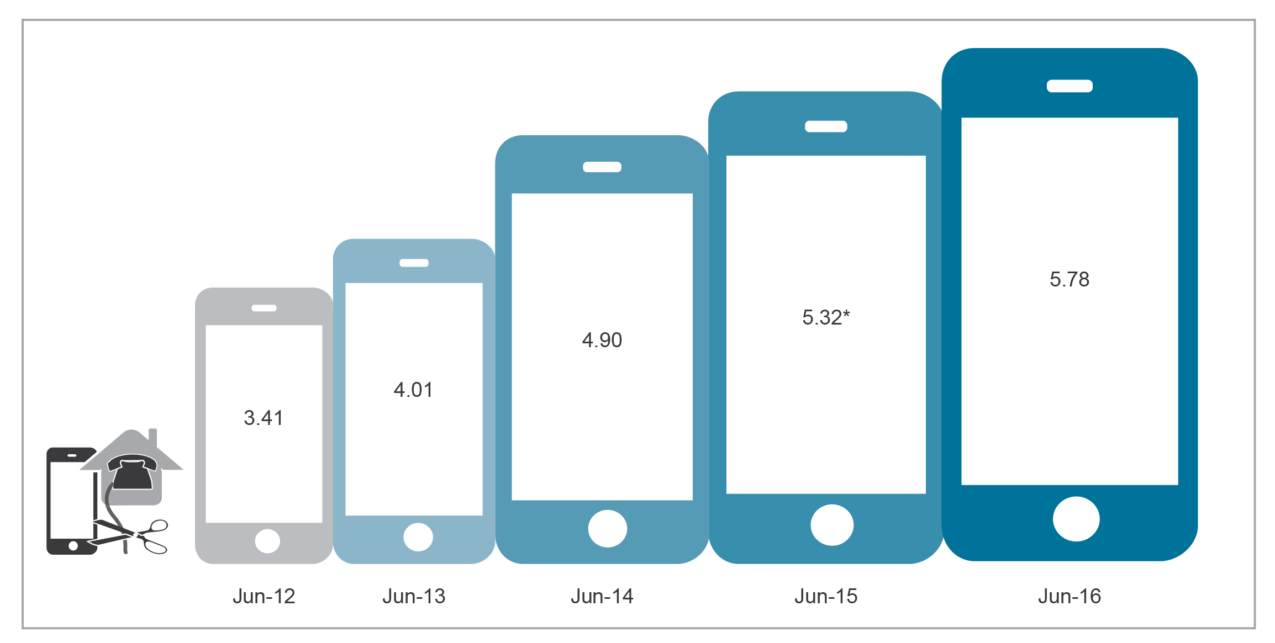
*Data measures reported may differ to measures reported in previous years due to a weighting methodology change.
Base: Data relates to people aged 18 years and over in the 12 months to June of each year.
Source: Roy Morgan Single Source.

Use of fixed-line telephone and OTT communications services
The use of fixed-line telephone services continued to further decline—68 per cent of adults had a fixed-line telephone at June 2016, down from 78 per cent five years ago (Figure 1.2).
In contrast, there has been a slow increase in the percentage of Australian adults using over-the-top (OTT) communications service. Some 4.6 million adult Australians (25 per cent) reported using some OTT communications service at June 2016—an increase from 24 per cent on the previous year (Figure 1.2).
OTT communication services include mobile phone or computer apps that offer messaging, voice or video call services that are not provided by the phone or ISP. Examples of OTT communications services include iMessage, Facetime, WhatsApp, Skype, Facebook Messenger and Viber.
Figure 1.2 Use of fixed-line telephone and VoIP services (percentage)
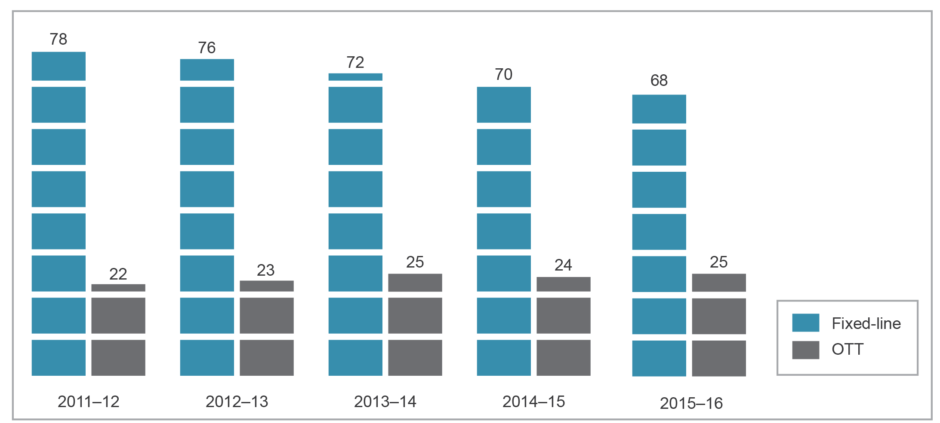
Base: Data relates to people aged 18 years and over, in the 12 months to June of each year.
Note: Fixed-line telephone services include managed VoIP services. Those who report using a home fixed-line telephone to access VoIP are understood to be using a managed VoIP service, while those using PC/laptop, tablet computer and mobile phone to access VoIP are understood to be using an OTT VoIP service.
Source: Roy Morgan Single Source.

Adult Australians still preferred the more traditional devices of PCs and laptop computers to access OTT VoIP services. However, mobile phones continued to increase in popularity as a preferred OTT VoIP access device, growing by three percentage points in the 12 months to June 2016. Tablet computers appeared to stabilise in use (Figure 1.3).
Figure 1.3 Devices used for OTT VoIP (percentage)
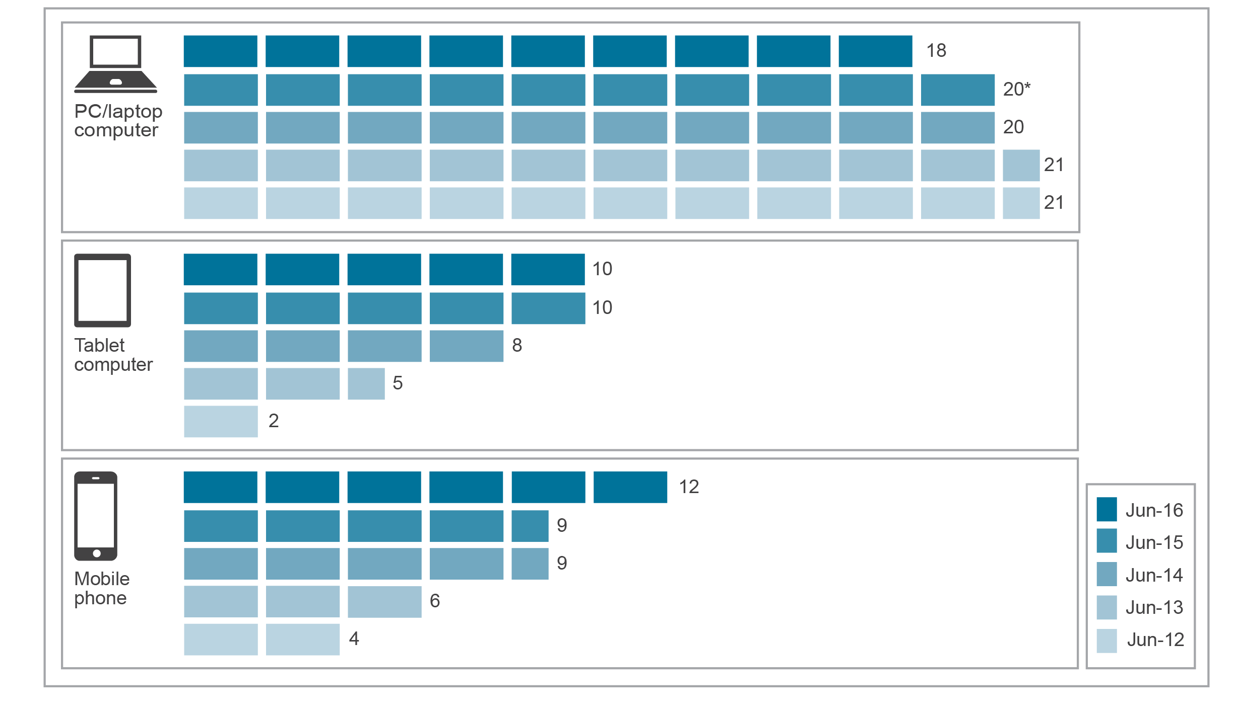
*Data measures reported may differ to measures reported in previous years due to a weighting methodology change.
Base: Data relates to people aged 18 years and over, in the 12 months to June of each year.
Source: Roy Morgan Single Source.
The shift towards an increased use of OTT services contributed to demand for more data, which saw telecommunications service providers respond with offers of more generous data plans for mobile phones. Mobile phone data plans reached double-digits in terms of gigabytes (GB) of data offered to customers on monthly plans.
This is consistent with the mobile data trends reported by the Australian Bureau of Statistics (ABS). The volume of data downloaded over mobile handsets has experienced exponential growth over the last four years. During the June quarter 2012, Australians downloaded 9,943 terabytes of data over mobile handsets. In 2016, this number had grown to 121,147 terabytes for the June quarter.
Despite the strong growth in the volume of data downloaded over mobile handsets, there are no unlimited mobile phone data plans on offer in Australia. Providers do, however, offer plans with unlimited calls and messages.
More information on data downloads can be found in Chapter 2.
However, with the growing popularity of video streaming, OTT services are only partially responsible for the increased appetite for more data. In August 2016, Telstra announced that it would offer free three-month access to the popular video streaming services Netflix, Stan and Presto on its more costly mobile plans. Optus launched its Optus Sport service in 2016. This service offers 10 streaming channels of English Premier League (EPL) content in 2016.
Telstra also reported continual customer migration to higher minimum monthly data plans, and noted that almost three in four post-paid mobile phone customers were on Extra Data plans (at June 2016).,

Mobile service availability

Number of services in operation
An estimated 32.59 million mobile voice and data services were in operation in Australia at June 2016 (Figure 1.4).
This total figure comprises all voice and data services available over 2G, 3G and 4G services, and includes retail (excluding resale) and wholesale mobile services. The retail services component includes post-paid and pre-paid mobile services, mobile broadband, M2M and satellite services.
As at June 2016, the number of mobile services in operation increased by 2.6 per cent on the previous financial year, with some service providers reporting that large increases in M2M communications and wholesale services contributed to the growth.,
Figure 1.4 Mobile services in operation (millions)
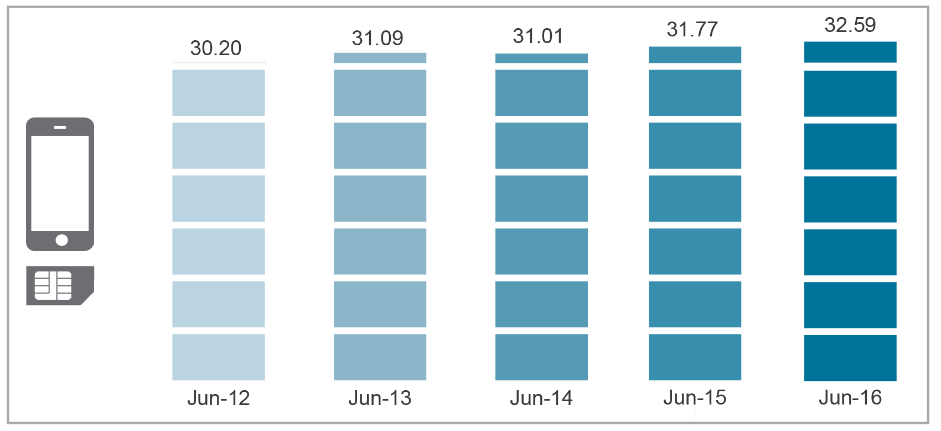
Note: Figures include wholesale and retail services and mobile wireless internet services provided via data cards, dongles or USB modems.
Source: Prior to 2013–14, data was sourced from an ACMA annual industry data request. From 2013–14, this data was sourced from company annual reports and press releases.

Smartphones continued to grow in popularity as a mainstream device for the majority of Australians. At June 2016, an estimated 13.75 million Australian adults (76 per cent) used a smartphone, compared to 13.41 million (74 per cent) at May 2015. Five years ago, just under half of adults (49 per cent) reported using a smartphone (Figure 1.5).
While smartphone use is still on the rise, overall growth has slowed compared to previous years. Shipments of smartphones declined by 18 per cent in the 12 months to June 2016—the number shipped to Australia fell to 1.8 million in the three months to June 2016, compared to 2.2 million shipments for the same period in 2015. Tablet shipments declined by 12 per cent—over five million devices—in 2016.
Figure 1.5 Use of mobile phones in the last six months to June (percentage)
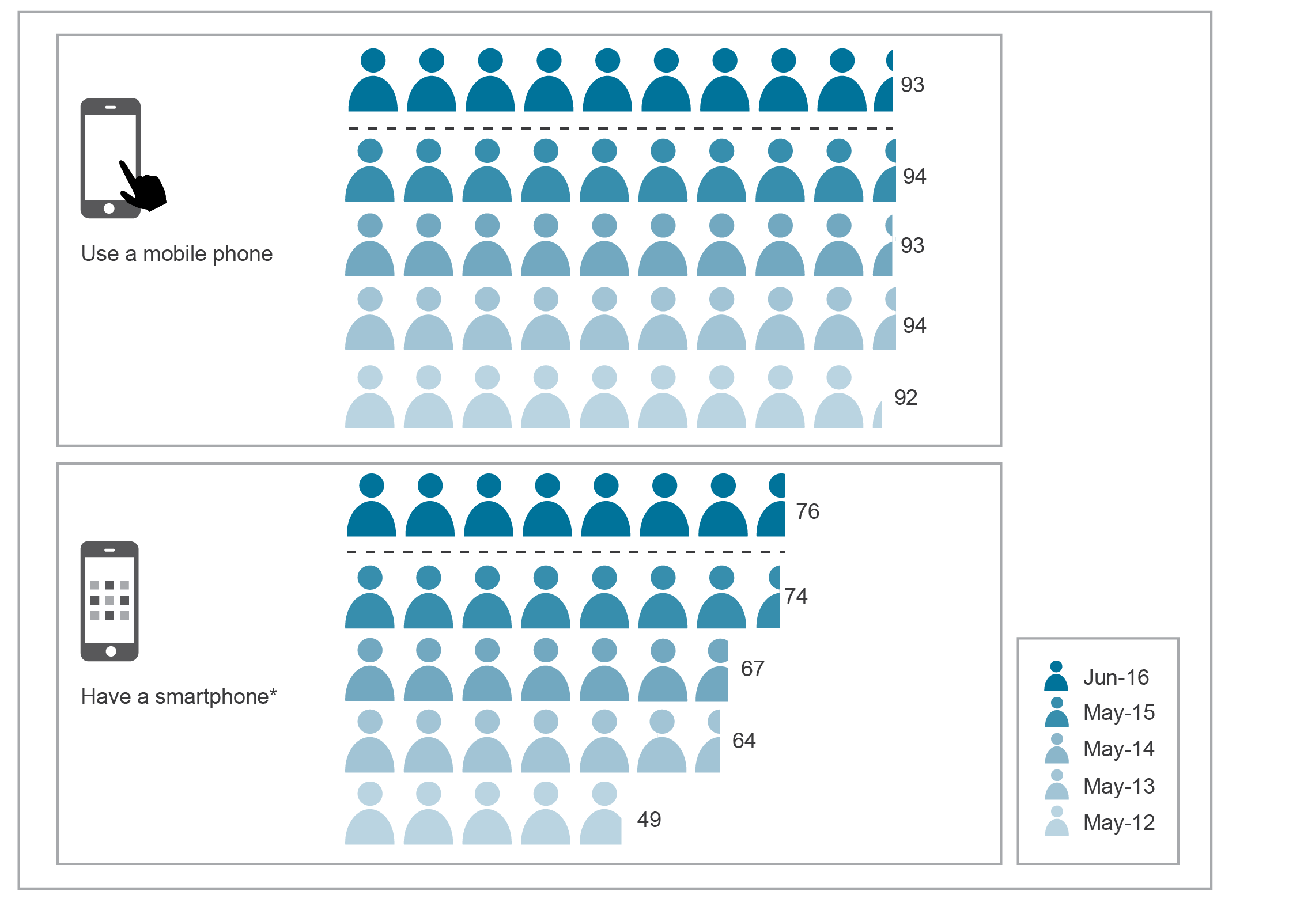
*The figure previously published for ‘Have a smartphone’ at May 2014 has been revised by the ACMA.
Base: Australians aged 18 and over in the last six months.
Note: A new methodology approach was implemented in 2016 (a transition from a full CATI model used in all previous years to largely an online survey in 2016).
Source: ACMA-commissioned survey.

During 2015–16, the market share for the three mobile carriers remained largely stable, although the mobile carriers faced increased competition for post-paid customers. Telstra’s share of mobile services in operation increased by 0.6 per cent to 54.5 per cent. In comparison, Optus’ market share declined by almost a percentage point to 28.6 per cent, while market share held by Vodafone Australia rose by 0.4 per cent to 16.9 per cent (Figure 1.6).
One of the main contributors to the increase in Vodafone’s mobile subscriber base was the commercial agreement with TPG Telecom to migrate TPG’s mobile wholesale customer base from Optus’s network to the Vodafone network. TPG’s 320,000 mobile customers began receiving invitations to move to the Vodafone network in October 2015, with the entire migration process expected to take several months.
Figure 1.6 Mobile services in operation—carrier share and customer base
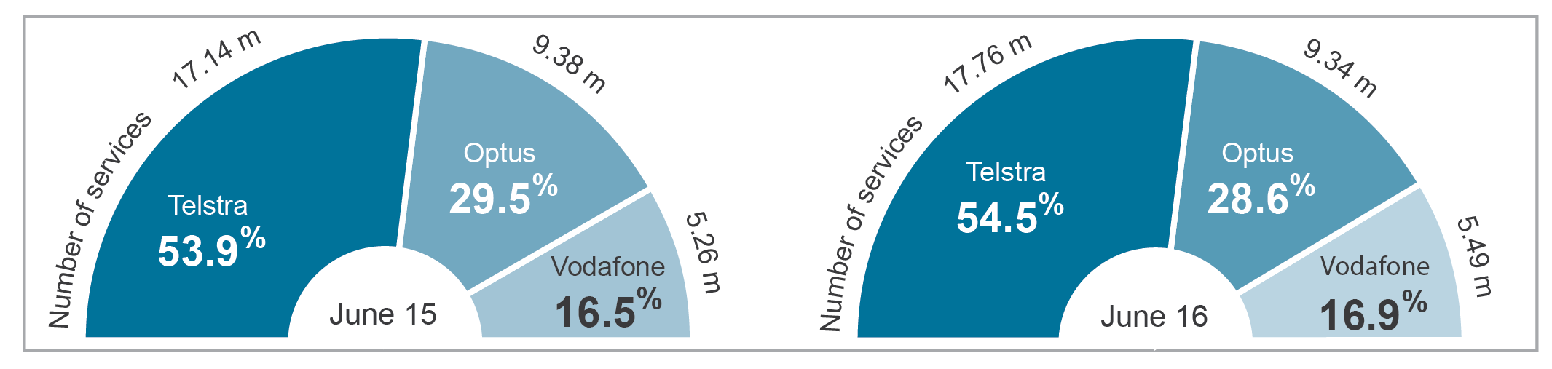
m=million.
Figures include retail services and wireless broadband data services provided via mobile handset, data cards, dongles or USB modems.
Note: Numbers may not add up due to rounding.
Source: Company annual reports and press releases.

Mobile network infrastructure
During 2015–16, all three mobile network operators continued to strengthen and extend the coverage of their networks. At June 2016:
- Telstra’s 4G network covered 98 per cent of the population. It is anticipated to increase to 99 per cent by the end of June 2017.
- Optus’s 4G network was available to 95 per cent of the population, up from 90 per cent over the previous year. The acquisition of new regional licences in the 1800 MHz spectrum band is expected to expand Optus’s 4G network even further.
Vodafone’s 4G network reached more than 22 million Australians (96 per cent of the Australian population), with plans to build more than 100 mobile base stations in regional areas by the end of 2017.
Telstra’s network experienced outages that caused disruptions to its mobile services in February and March 2016. In response, Telstra completed a network review in May 2016 and announced it would be investing $50 million in its mobile network to enhance resiliency, improve recovery time and create more effective real-time monitoring.
In July 2014, Telstra announced it would be closing its 2G (GSM) network before the end of 2016, with closure later confirmed for 1 December 2016. Optus and Vodafone have also announced plans to shut down their 2G networks in 2017, which are scheduled to take effect in April 2017 and September 2017, respectively.
Although the majority of consumers have handsets capable of accessing other mobile networks such as 3G and 4G, those Australians who are yet to upgrade to newer technologies may need to either change their mobile handset or their service provider.

Strong supply and demand for 4G services
Demand for 4G services continued to grow strongly. Optus reported 1.2 million new 4G customers over a 12-month period, reaching 4.93 million 4G subscribers at June 2016, compared to 3.8 million subscribers at June 2015.
In 2015–16, Telstra upgraded more than 2,000 network sites to 4GX, which is designed to deliver faster download speeds, wider coverage, and more reliable voice and data services.
Contributing to the growth in 4G mobile services was the opening of 4G networks to the wholesale customers of Telstra and Vodafone—mobile virtual network operators (MVNOs) that use Optus’s network were already able to offer 4G services. Telstra began rolling out its 4G mobile network to its MVNO partners in April 2016. Meanwhile, Vodafone offered 4G access to TPG in October 2015, followed by other MVNOs between May and July 2016.
The future ability of mobile carriers to extend the reach and performance of their 4G networks in regional and remote areas was bolstered by the completion of the ACMA’s auction of 1800 MHz band spectrum in February 2016. Four carriers (Telstra, Optus, Vodafone and TPG) secured spectrum that will be licensed for use from 30 May 2017.

Mobile Black Spot Program
In June 2015, the Australian Government announced the launch of its Mobile Black Spot Program, which aims to improve mobile phone coverage and competition in regional and remote Australia.
The government committed funding of $100 million for round one of the program, which is delivering 499 new and upgraded mobile base stations across Australia over three years—429 Telstra base stations and 70 Vodafone base stations. This funding leveraged co-contributions from mobile carriers Telstra and Vodafone, state and local governments, businesses and community organisations. In December 2015, Telstra and Vodafone activated the first cell towers under the program.
Under their respective rollout schedules, 66 Telstra base stations and seven Vodafone base stations were expected to be activated by June 2016. As at August 2016, Telstra had activated 60 mobile base stations, and another two were activated by Vodafone.
The government announced Round 2 of the Mobile Black Spot Program in June 2015, with an allocation of $60 million. The list of locations to be funded under Round 2 is expected to be announced by the end of 2016.
In May 2016, the government pledged a further $60 million investment for Round 3 of the program.

Infrastructure regulation
When installing large telecommunications facilities such as mobile phone towers, carriers generally need to obtain local council planning permission and comply with relevant state and territory planning laws. Schedule 3 to the Telecommunications Act allows licensed carriers to install a limited range of facilities referred to as ‘low-impact facilities’ without seeking state or territory approval. Low-impact facilities as defined in the Ministerial Telecommunications (Low-impact Facilities) Determination 1997 are considered to be unobtrusive.
While low-impact facilities are exempt from local government planning laws, carriers must still comply with Schedule 3 and the Telecommunications Code of Practice 1997, which includes notifying land-owners and occupiers of their activities, ensuring minimal detriment and damage is caused by the activity and restoring the land to a similar condition before the activity began.

Mobile phone base stations
Optus, Telstra and Vodafone are the three carriers that operate mobile phone networks in Australia. When installing mobile phone base stations, these carriers are required to comply with the C564:2011 Mobile Phone Base Station Deployment Code (the industry code). The industry code supplements the requirements already imposed on carriers under the existing legislative scheme by requiring them to consult with local communities and adopt a precautionary approach in planning, installing and operating mobile phone base stations.
The mobile communications industry has developed a national database of mobile phone base stations—the National Site Archive—to improve access to information about the deployment of mobile phone infrastructure across Australia. The archive contains information about most mobile phone towers deployed by carriers and includes electromagnetic energy reports about communications facilities. This information is available at www.rfnsa.com.au.

Objections and enquiries to the ACMA
Complaints about carriers’ compliance with the industry code are directed to the carriers in the first instance. The industry code specifies mandatory processes for complaints-handling by carriers. If a complainant is dissatisfied with a carrier’s response to their complaint, they are able to complain to the ACMA. The ACMA will assess the objection against the industry code and decide whether to formally investigate the matter under Part 26 of the Telecommunications Act. If the ACMA decides to investigate the matter, and a breach of the industry code is found, it will determine what, if any, compliance or enforcement action should be taken against the carrier.
During the reporting period, the ACMA received 48 objections and 10 enquiries about the industry code (Figure 1.7). Carriers undertook a total of 6,077 consultations during the reporting period.
The ACMA received 17 enquiries and one complaint about matters covered by Schedule 3 to the Telecommunications Act. Additionally, the ACMA received five enquiries about the deployment of fixed-wireless internet facilities not falling into other categories.
Figure 1.7 Industry code enquiries and objections received by the ACMA
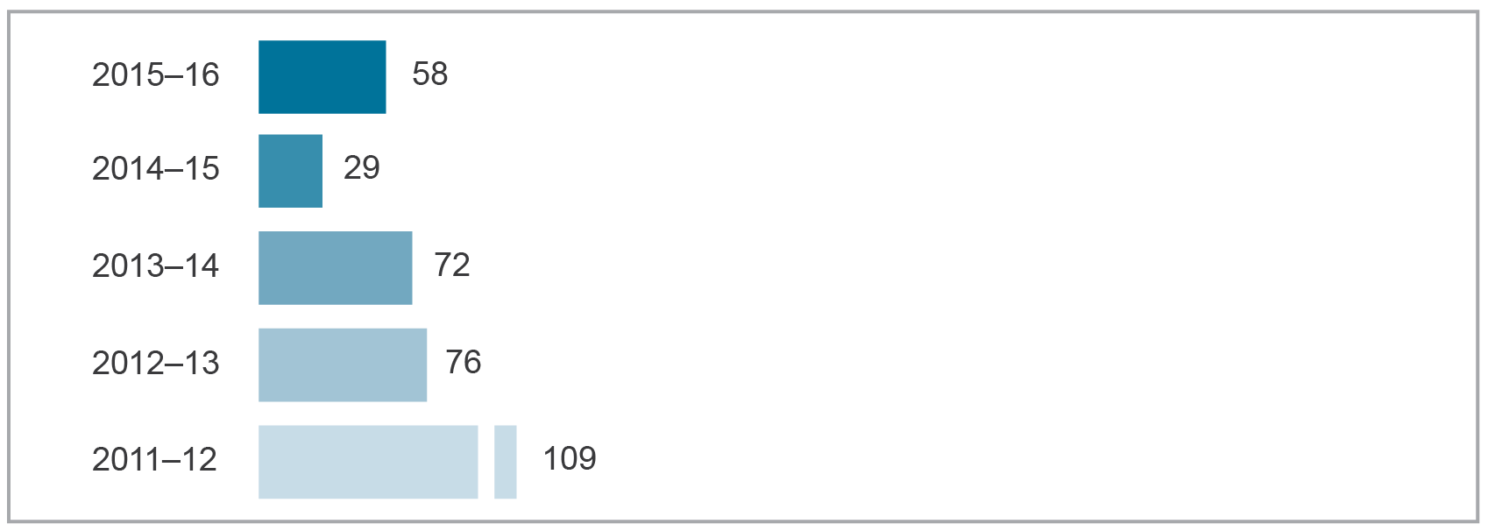
Source: ACMA.

Complaints to the TIO about facility installations
The TIO can consider objections to land access, and the installation and maintenance of low-impact facilities. The majority of land access complaints to the TIO relate to damage to property by carriers. During the reporting period, the TIO received a total of 544 new complaints (not including enquiries)—an eight per cent increase from the 2014–15 reporting period (Figure 1.8)—and completed 82 investigations.
Of the new complaints received by the TIO during 2015–16:
- 335 were from owners/occupiers of land about alleged damage to property by the provider
- 78 were from owners/occupiers of land about carriers billing them for damage to cables allegedly caused by the owner/occupier
- 21 related to the standard of service from providers when installing subscriber connections
- 91 related to the absence of carrier notice for land entry, failure to bring the notice to the land-owner/occupier’s attention, or where the land-owner/occupier was not allowed to object to the land entry
- six were formal objections to the low-impact facility activity by the land-owner/occupier
three were premature objections.
Of the six formal objections, the TIO made directions to carriers in nine cases, and in one case found that the carrier notice did not comply with legislative requirements and the land access activity could not proceed.
Figure 1.8 Facility installation complaints/land access complaints received by the TIO
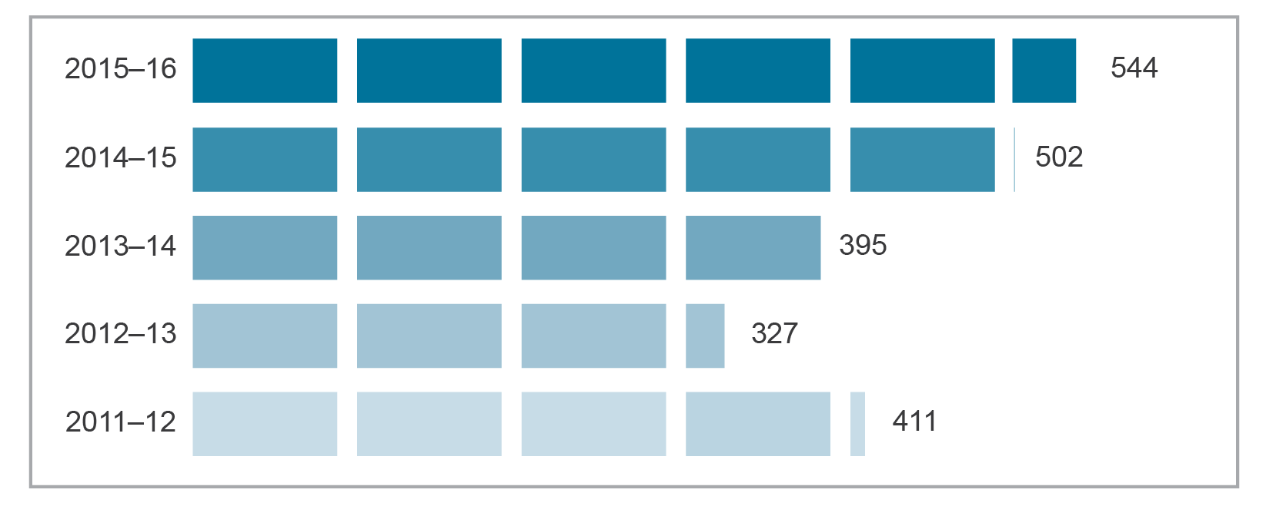
Source: TIO.

Interference
The performance of wireless services depends on the management of interference across wireless networks and devices. Under the Radiocommunications Act 1992, the ACMA investigates complaints about interference to licensed radiocommunications. The ACMA classifies interference as either domestic systems or radiocommunications interference.
Domestic systems interference
Domestic systems interference (DSI) refers to interference to the reception of FTA terrestrial radio or television broadcasting, usually in domestic premises. It also encompasses audio interference caused by nearby radio transmitters, such as those used by citizen band or amateur radio operators, or from other radio services with a transmitter located nearby. Household equipment is the major contributing source of DSI.
During 2015–16, there were 473 DSI complaints to the ACMA, comparable with complaint levels in 2014–15 (Figure 1.8). The majority of DSI complaints (75 per cent) were about television interference, with LED downlights and other household electrical items the most significant contributors to DSI interference.
Fifteen per cent of DSI complaints in 2015–16 resulted in compliance action by the ACMA. Most complaints are resolved by agreement and without the need for compliance action.
Radiocommunications interference
Radiocommunications interference (RCI) is interference affecting a radiocommunications receiver used for non-broadcasting purposes, such as public safety, commercial and recreational services.
During 2015–16, mobile telephone services continued to be more affected by interference than any other type of service. Compared to the previous year, complaints of interference to 3G and 4G services reduced slightly, while complaints about interference to 2G (GSM) services were similar.
Overall, there were 27 per cent fewer radiocommunications interference complaints than in the previous year, dropping from 847 in 2014–15 to 621 in 2015–16 (Figure 1.8). There were also 28 complaints about interference to public safety radiocommunications services. Radiocommunications transmitters continue to be the most significant source of interference. During the reporting period, 77 per cent of RCI complaints resulted in compliance actions such as the issue of advice and warning notices. These compliance actions were generally effective and required no further action.

Radiocommunications compliance program
The ACMA introduced priority compliance areas (PCAs) in 2012 to systematically identify areas of compliance concern and allocate resources to improve outcomes. As this approach has matured, the ACMA has been able to reduce the number of radiocommunications investigations conducted by adapting its resource allocation to reflect the variable risk levels associated with interference and harm in the communications environment. The reduction in the number of formal investigations and escalated enforcement actions has been accompanied by an increase in administrative compliance actions such as the issue of more warning notices and infringement notices.
Figure 1.9 DSI and RCI complaints and compliance actions
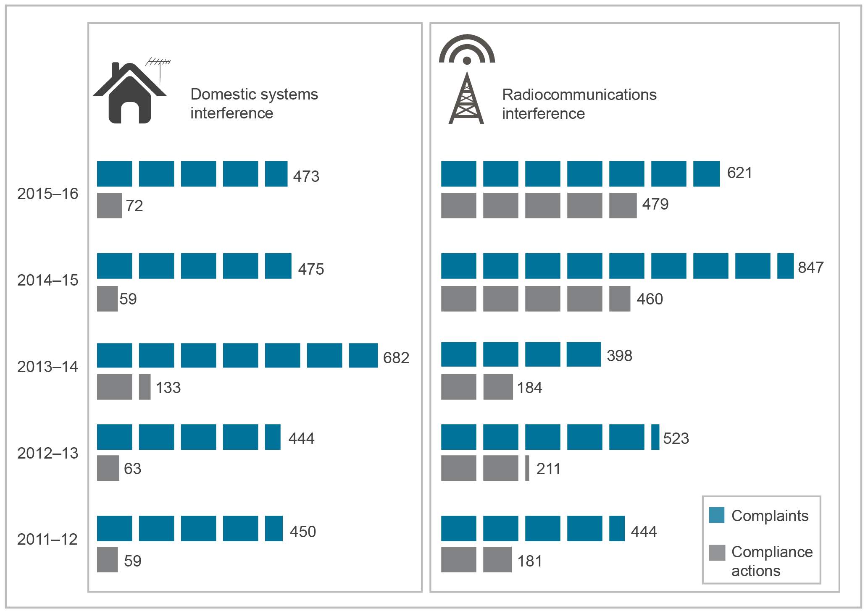
Base: Number of complaints and compliance actions.
Source: Domestic system interference and radiocommunications interference complaints to the ACMA.

New developments in communications
Over 2015–16, there were several new technological and service developments including network improvements and development of the Internet of Things (IoT).

The IoT and M2M
The 2015–16 reporting year witnessed a wide range of developments in the IoT, defined as the interconnection of many devices and objects using internet protocols. Machine-to-machine (M2M) connections form part of the IoT, along with big data analysis, cloud computing, and sensors and actuators that in combination can run autonomous machines and intelligent systems.
The Internet of Things and the ACMA’s areas of focus (released in November 2015) noted that the rollout of the IoT will result in a massive increase in connected devices accompanied by an evolution in the range of associated applications and services offered. It is estimated that 16 billion IoT-related connected devices will be in use by 2021. By 2018, IoT is forecast to overtake mobile phones as the largest category of connected devices. It is estimated that more than 25 per cent of companies worldwide use M2M technologies.
Mobile carriers experienced strong M2M growth. Between June 2015 and June 2016, Telstra M2M revenues increased by 16.8 per cent, from $113 million to $132 million. Telstra M2M services in operation (SIOs) reached 1.85 million in June 2016, an increase of 307,000 SIOs over 12 months, exceeding recent trends.
Mobile carriers are also preparing their networks for IoT. Vodafone undertook wireless network access trials across Melbourne in April 2016 using pre-standard Narrowband Internet of Things (NB-IoT) technology. Telstra’s 4G network now supports category one LTE standard. Category one is suitable for sensors, wearables and applications that need to send low to moderate amounts of data. The University of Technology Sydney, Meshed Pty Ltd and The Things Network launched a public access IoT network in Sydney’s CBD in 2016. The low-power, long-range, wide-area network will allow smart sensor devices to connect to the internet without needing mobile, Wi-Fi, bluetooth or other technologies.
Communications Alliance established a think tank in 2015 designed to maximise the potential of the IoT for Australian industry. The ACMA is a member, along with other government and industry entities. In 2016, the think tank became a standalone entity, now called the IoT Alliance (Australia). Work streams in this alliance include developing IoT open data and data-sharing principles and guidelines, spectrum availability, security guidelines and industry verticals.

Other emerging mobile technologies
With the expansion of 4G networks across Australia, mobile carriers have been exploring and implementing new technologies such as Voice over LTE (VoLTE), Wi-Fi calling and messaging, and LTE-broadcast (LTE-B) technology. Mobile operators have also been actively preparing for the next generation 5G mobile network deployment.
VoLTE
In 2015–16, VoLTE technology moved from trial to implementation stage. VoLTE can carry voice calls made using compatible devices over enabled 4G mobile networks that were previously limited to carrying only data. The benefits of VoLTE include faster call connection, higher audio quality and improved battery life.
Telstra began enabling VoLTE for its post-paid consumer customers in September 2015, with plans to extend the capability to its business and pre-paid customers in the future. Vodafone commenced its rollout of VoLTE in December 2015 and is planning to offer VoLTE to its entire 4G network by the end of 2016. Optus launched VoLTE across its 4G Plus network in Australia’s major capital cities in May 2016, with plans to expand to further locations in the future. Integration with multimedia services such as video calling (ViLTE) and conference calling is expected to follow.
Voice calls over Wi-Fi
In August 2015, Optus launched its WiFi Talk app, which allows a user to make calls and send text messages from a mobile device over Wi-Fi without a mobile signal. Unlike OTT VoIP apps such as Skype, Viber and WhatsApp, calls using WiFi Talk are made and received using standard phone numbers and the other party to the call does not need to be an Optus customer or have the WiFi Talk app activated.
These app-based services are not to be confused with Voice over Wi-Fi (VoWiFi) technology, which allows voice calls to be made and received using the native dialler on a compatible device connected to Wi-Fi. The main benefits of VoWiFi are better indoor coverage and call continuity—a call can be seamlessly offloaded between a mobile network and a Wi-Fi network. VoWiFi also has the potential to reduce roaming charge costs to consumers while travelling.
Both Telstra and Vodafone have indicated plans to offer VoWiFi to their customers in the near future; however, timelines are yet to be announced.
LTE-B
In April 2016, Telstra, along with South Korea’s KT, the UK’s EE and the USA’s Verizon, jointly formed the LTE-Broadcast Alliance, which will work to promote the LTE-B standard and increase global support for LTE-B services from device manufacturers.
LTE-B can reduce network traffic by enabling a single stream of data to be sent to multiple mobile users, as opposed to sending an individual stream to each user. After undertaking the world’s first stadium broadcast using LTE-B at the Melbourne Cricket Ground in 2014, Telstra has enabled LTE-B capability at over 3,000 of its 4GX sites and has conducted several demonstrations at major sporting events including the National Rugby League Grand Final in October 2015. In addition to alleviating congestion in areas with high demand for video traffic, LTE-B is expected to be used for mass device and application software updates in the future.
5G mobile network developments
5G represents the next evolution in mobile technologies. It is expected to support an immense increase in connections, lowered latency and much faster speeds across mobile networks.
There have been a range of 5G-related announcements made by Australian mobile operators in 2015–16, including a commitment to work towards a commercial 5G mobile network deployment in 2020. Australian mobile operators also continue to develop and enhance existing 4G networks on the upgrade pathway to 5G:
- Telstra has announced that, in partnership with Ericsson, it is planning to conduct its first 5G trial on its mobile network at the 2018 Commonwealth Games on the Gold Coast. In 2015, Telstra attained 1 Gbps mobile speeds with Ericsson during live commercial 4G mobile trials. Telstra has since announced that its mobile network will be enabled to support 1 Gbps speeds in selected sites across Melbourne, Sydney and Brisbane, in anticipation of a new device that will support these speeds being released later in 2016.
- Optus and Huawei have announced a successful live trial of 4.5G technology at Optus’ Gigasite in Newcastle, resulting in download speeds of 1.41 Gbps. Optus has said it will continue testing and moving from 4G towards a 4.5G mobile network before the arrival of 5G in 2020.
Vodafone has also indicated it is preparing for 5G in Australia, while continuing to invest in new applications of evolving 4G technology.
The new 5G mobile technologies are expected to enable many new applications (including ultra-low latency applications), autonomous driving and full connectivity through the IoT.

Internet service availability

Number of internet subscribers
There were 35.26 million internet subscribers in Australia at June 2016, an increase of four and a half per cent since June 2015 (Table 1.2). The increase reflects continued growth in NBN-related services and mobile-internet services.
Table 1.2 Internet subscribers by technology type (millions)
 | Jun 12 | Jun 13 | Jun 14 | Jun 15 | Jun 16 | 2015–16  change (%)
Mobile wireless (dongle, data card, USB modem services) | 5.86 | 6.15 | 5.95 | 6.00 | 6.04 | +0.6
ADSL | 4.63 | 4.79 | 5.07 | 5.11 | 5.03 | −1.4
Cable | 0.92 | 0.93 | 0.95 | 1.00 | 1.03 | +3.3
Dial-up | 0.44 | 0.23 | 0.18 | 0.10 | 0.09 | −5.3
Satellite | 0.09 | 0.09 | 0.08 | 0.07 | 0.06 | −10.1
Fixed wireless* | 0.03 | 0.05 | 0.05 | n/a | 0.08 | n/a
Fibre | 0.05 | 0.12 | 0.20 | 0.42 | 0.96 | +128.6
Other | 0.01 | 0.003 | 0.002 | n/a | 0.001 | n/a
Total (excluding mobile  handset subscribers) | 12.04 | 12.36 | 12.48 | 12.76 | 13.30 | +4.2
Mobile handset | 16.19 | 19.65 | 20.57 | 20.99 | 21.97 | +4.6
Total (including mobile handsets) | 28.23 | 32.00 | 33.05 | 33.76 | 35.26 | +4.5
n/a=not available.
*Fixed wireless: for example, WiMAX uses an air interface to connect an internet service. An antenna installed at the customer’s premises receives signals from the service provider’s base station.
Note: ABS subscriber statistics measure the number of ‘subscriber lines’ rather than the number of ‘users’. Counts of subscribers are not the same as counts of people/organisations with internet access as some subscribers may have accounts with more than one ISP or multiple accounts with a single ISP. Relates to ISPs with more than 1,000 subscribers. Subscriber numbers for ‘fixed wireless’ and ‘other’ were not available separately for June 2015 but are included in the total.
Source: ABS, 8153.0 Internet activity, Australia, June 2016.

In 2015, a number of service providers announced they would no longer be offering dial-up internet. TPG ceased sales of its dial-up internet plans at the start of 2015, while in June 2015 Telstra announced it would retire the last of its dial-up internet services by December 2015. Optus and Dodo continue to offer dial-up as part of their suite of internet service options. Dodo offers unlimited dial-up internet for $1 per month.

Mobile-internet subscribers
There were 21.97 million mobile-internet service subscribers at June 2016. This is an increase of four per cent over the year. There are two types of mobile-internet services reported here:
- mobile handset—such as smartphones
mobile wireless—using dongles, datacards or USB modems.
Mobile-internet subscribers account for 86 per cent of all mobile services in operation at June 2016.
The latest data from the ABS shows that mobile handset subscribers increased five per cent in the 12 months to June 2016 to reach 21.97 million subscribers. Mobile wireless internet subscribers increased by 0.6 per cent to reach just over six million subscribers (Figure 1.10).
Figure 1.10 Mobile-internet subscribers in Australia (millions)
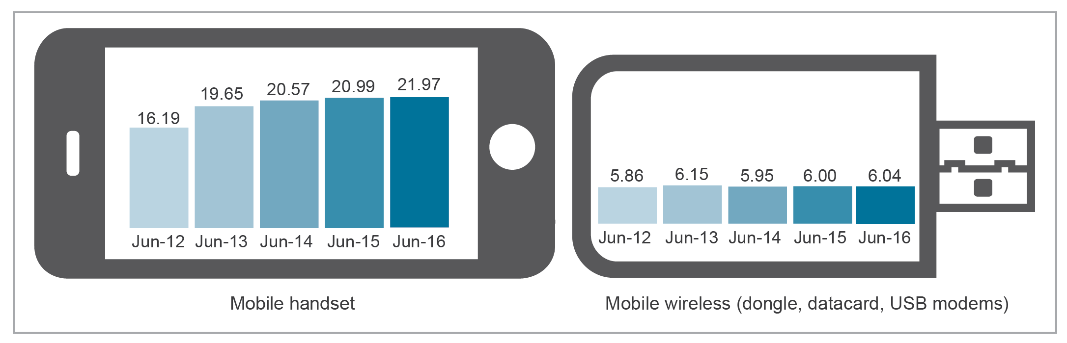
Base: Number of subscribers.
Note: The ABS has revised some mobile handset internet subscriber figures published in previous ACMA reports.
Source: ABS, 8153.0 Internet activity, Australia, June 2016.

Domain name registrations
The number of domain names registered in Australia continues to increase, providing evidence about internet use by businesses and organisations.
The ‘.au’ domain is used to identify the locality of a business. In the 12 months to June 2016, the number of registered ‘.au’ domain names increased by two per cent to 3.04 million.
The registration of ‘.au’ domain names is administered by the not-for-profit organisation .auDA (.au Domain Administration Ltd). The ‘.au’ country code for Australia covers the second-level domains (2LDs), which fall into three broad categories:
- ‘Open’ 2LDs—open to the general public—asn.au, com.au, net.au, id.au, org.au.
- ‘Closed’ 2LDs—closed to the general public, and only available to entities within a defined sector—edu.au, gov.au, csiro.au.
Community Geographic Domain Names (CGDNs)—reserved for use by community groups and only for Australian geographic locations—act.au, nsw.au and so on.
The ‘.com.au’ domain, designed for commercial entities, including companies and businesses, now accounts for 88 per cent of 2LDs, up from 86 per cent a year ago.
At June 2016, 4,704 ‘.gov.au’ domain names were registered (including all tiers of government), up from 4,632 at June 2015.

Number of ISPs
The 2015–16 financial year saw major changes in the market composition of the major ISPs in Australia.
At June 2016, there were 66 ISPs with more than 1,000 subscribers operating in Australia, down from 69 at June 2015. The distribution of ISPs by number of internet subscribers was:
- 33 with 1,001–10,000 subscribers, down from 39 at June 2015
- 23 with 10,001–100,000 subscribers, up from 20 at June 2015
10 with 100,001 or more subscribers, unchanged from the previous year.
Table 1.3 provides a snapshot of the internet services in operation (SIOs) for the top four ISPs by number of subscribers in the Australian market—Telstra, Optus, TPG (which includes iiNet) and Vocus Communications (which includes M2 Group). All four reported growth in the total number of broadband subscribers.
Previously the fourth-largest broadband provider in Australia, the Perth-based iiNet was acquired by TPG in August 2015. M2 Group, which owned Dodo and iPrimus, merged with Vocus Communications in February 2016. The Australian brands of this group include Dodo, iPrimus, engin and Commander.
Table 1.3 SIOs for key Australian ISPs
ISP | Internet SIO | 2014  (‘000) | 2015  (‘000) | 2016  (‘000) | Change  (%)
Telstra | Fixed-broadband retail | 2,956† | 3,145 | 3,379 | 7.4
Telstra | Fixed-broadband wholesale | 789 | 840 | 840 | −0.1
Telstra | ISDN access (basic line equivalents) | 1,225 | 1,137 | 1,049 | –7.7
Telstra | Total fixed internet subscribers | 4,970 | 5,122 | 5,268 | 2.9
Telstra | Mobile broadband (data card) | 3,679 | 3,866 | 3,960 | 2.4
Optus | On-net broadband customers* | 982 | 979 | 914 | –6.6
Optus | Off-net resale | 9 | 7 | 31 | 342.9
Optus | Off-net NBN | 13 | 54 | 136 | 151.9
Optus | Dial-up | 10 | 9 | 3 | –66.7
Optus | Total fixed internet subscribers | 1,014 | 1,049 | 1,084 | 3.3
iiNet  (TPG Telecom) | On-net† | 619 | 587 | 539 | –8.2
iiNet  (TPG Telecom) | Off-net | 266 | 258 | 212 | –17.8
iiNet  (TPG Telecom) | NBN + Fibre† | 65 | 144 | 232 | 61.1
iiNet  (TPG Telecom) | Total fixed internet subscribers | 950 | 989 | 983 | –0.61
TPG Telecom (excluding iiNet) | On-net bundle | 471 | 542 | 582 | 7.4
TPG Telecom (excluding iiNet) | On-net standalone | 205 | 173 | 141 | –18.5
TPG Telecom (excluding iiNet) | Off-net (includes NBN) | 72 | 106 | 162 | 52.8
TPG Telecom (excluding iiNet) | Total broadband subscribers | 748 | 821 | 885 | 7.8
Vocus  Communications** | Bundled | n/a | 349 | 385 | 10.3
Vocus  Communications** | DSL | n/a | 74 | 51 | –31.1
Vocus  Communications** | NBN | n/a | 26 | 68 | 161.5
Vocus  Communications** | Amnet | n/a | 16 | 16 | 0.0
Vocus  Communications** | Total broadband subscribers | 414 | 465 | 520 | 11.8
*Optus on-net includes HFC, ULL and business-grade broadband customers.
**The ACMA previously reported on M2 Group Ltd, which in February 2016 merged with Vocus Communications Limited. The Australian brands in this group include iPrimus, Dodo, engin and Commander.
†Revised from previous year.
Note: Includes resale figures. Terminology used is consistent with that used in company annual reports. The number of subscribers is measured using the number of subscriber lines rather than number of users. Subscribers may have multiple accounts with more than one ISP. Numbers presented in the table also includes SIO of subsidiaries. Numbers may not add up due to rounding.
Source: Company annual reports and press releases.

National Broadband Network
In 2015–16, the National Broadband Network (NBN network), operated by NBN Co Limited (NBN Co), continued to expand, with an increasing number of premises activated and enabled for NBN service. This year also saw an introduction of new NBN services.
The NBN is an Australian Government initiative intended to deliver high-speed and reliable phone and internet services across Australia via a multi-technology mix including:
- fibre to the premises (FTTP)
- fibre to the building (FTTB)
- fibre to the node (FTTN)
- Hybrid Fibre Coaxial (HFC)
- fixed wireless
satellite.
New NBN network services
In September 2015, NBN Co switched on its commercial FTTN network, promising to deliver speeds of up to 100 Mbps. Services were launched in Belmont, NSW with FTTN services becoming available in areas across the country by June 2016., NBN Co began offering HFC services in Redcliffe, Queensland on 30 June 2016.
In October 2015, NBN Co launched its first satellite, Sky Muster 1, set to provide access to fast and affordable broadband for regional and remote Australians. In April 2016, NBN Co announced it had commenced sales of wholesale broadband services via Sky Muster, targeting Australians living in remote regions.
NBN Co’s second broadband satellite Sky Muster II was successfully launched on 6 October 2016 to help provide additional data capacity to around 400,000 Australian homes and businesses.
In March 2016, NBN Co announced it was trialling a new technology—fibre to the distribution point (FttDp), thought to deliver faster broadband internet speeds, estimated at one Gigabit, or 1000 Megabits, per second. It uses a distribution point unit for the fibre-to-copper connection to enable the fibre to run to the front of customers’ premises.
NBN premises serviceable and activated
Table 1.4 provides an overview of premises serviceable or covered by the NBN and the number of premises with NBN services activated. For premises serviceable or covered by the NBN network at June 2016, NBN Co reported that:
- 2,835,687 premises were serviceable, an increase of 146 per cent since June 2015 (1,153,077). Of these, 2,005,204 premises were serviceable by the NBN fibre network and 420,524 premises were passed by the NBN fixed-wireless network, with 409,959 through the satellite.
1,098,634 premises had activated an NBN service, an increase of 126 per cent since June 2015. This includes 942,356 premises connected to the fibre network and 156,278 premises connected to fixed-wireless or satellite services.
Rollout of the NBN is scheduled for completion by 2020, with plans to connect eight million Australians.
Table 1.4 NBN services—cumulative premises serviceable and premises activated
 |  | 30 Jun 14 | 30 Jun 15 | 30 Jun 16 | Change  2015–16 (%)
Premises serviceable | Fixed-line footprint* | 392,410 | 836,680 | 2,005,204 | 147
Premises serviceable | Fixed wireless | 112,208 | 268,397 | 420,524 | 57
Premises serviceable | Satellite | 48,000 | 48,000 | 409,959 | 754
Premises serviceable | Total | 552,618 | 1,153,077 | 2,835,687 | 146
Premises activated | Fixed-line footprint* | 151,127 | 399,854 | 942,356 | 136
Premises activated | Fixed wireless | 16,553 | 47,473 | 117,514 | 148
Premises activated | Satellite | 42,948 | 38,288 | 38,764 | 1
Premises activated | Total | 210,628 | 485,615 | 1,098,634 | 126
*Fixed-line footprint refers to all non-fixed wireless or satellite connections.
Note: ‘Premises serviceable’ refers to brownfield (existing) premises in a rollout region that is ready for service, greenfield (new development) lots/premises passed (by the NBN network) and/or premises covered by fixed wireless and satellite. It does not include Service Class Zero (SC0). SC0 are premises in the NBN fibre network footprint that cannot presently be provided with an NBN fibre service.
‘Premises activated’ refers to premises that have an active service installed. Premises are activated after receiving and provisioning a service order from a retail service provider to install a new service.
Source: nbn Weekly Progress Report, www.nbnco.com.au/corporate-information/about-nbn-co/corporate-plan/weekly-progress-report.html; NBN Full Year Results, 2016.

Submarine cables
Submarine cables carry the bulk of Australia’s international voice and data traffic and contribute significantly to the Australian economy. At present there are nine international submarine cables connecting Australia to the rest of the world across three protection zones―two located off the Sydney coast and one located off the Perth coast. An almost complete international cable connects oil and gas platforms in the Browse Basin off the north-west coast to Port Hedland and Darwin.
Schedule 3A to the Telecommunications Act enables the ACMA to declare protection zones over nationally significant submarine cables and to prohibit or restrict activities that pose a risk of damaging cables in these zones. The legislation establishes offences for damaging a cable or for breaching prohibitions and restrictions, and sets out penalties for these offences.
Investment in undersea cables is underpinned by strong growth in data traffic. These investments also reflect the increasing importance of network resilience, as growing proportions of economic and business activity rely on data networks.
During 2015–16, the ACMA approved four separate requests to extend the duration of permits for a proposed international cable to be installed between Perth and Singapore. This included:
- APW-West Singapore to Perth link. It was announced in March 2016 that Telstra and Singtel, along with other entities, had entered into a memorandum of understanding to buy planned capacity on this link.
- Vocus and Nextgen announced in November 2015 they have partnered to build a new undersea cable connection between Australia and Singapore.
A third proposed undersea cable in the region is in the development phase.
Three other permit extensions were also approved for separate proposals by another cable provider for installation of international cables on the east and west coasts of Australia.
The ACMA received a request to declare a new protection zone off the Sunshine Coast in Queensland. The request remains under consideration by the ACMA.

Copper network switch-off
The NBN is replacing and upgrading the existing fixed-line telephone and internet network infrastructure. From 23 May 2014, it began replacing most existing fixed-line telephone links, ADSL internet and Telstra cable internet services (HFC) in the first 15 Fibre Serving Area Modules (FSAMs).
All premises within the NBN fibre footprint in each region are required to switch over to the NBN network before the designated switch-off date to continue receiving fixed-line telephone and internet services. Table 1.5 shows the locations disconnected from the copper network during the reporting period.
Table 1.5 NBN network rollout—locations/regions disconnected from the copper network,
2015–16
State/  territory | Location/region*
ACT | Acton (city), Braddon, Franklin, Gungahlin, Harrison, Lyneham, Mitchell, Nicholls, Palmerston, Watson
NSW | Agnes Banks, Armidale, Auburn, Bellambi, Berala, Berkeley Vale, Blacktown, Boambee, Boambee East, Brownsville, Coffs Harbour, Corrimal, Dapto, East Corrimal, East Gosford, Fountaindale, Glenning Valley, Gosford, Haymarket, Hobartville, Homebush, Homebush West, Jamisontown, Kanahooka, Kiama, Killarney Vale, Kingswood, Korora, Koonawarra, Lalor Park, Lidcombe, Londonderry, Long Jetty, Millers Point, North Boambee Valley, Penrith, Point Frederick, Prospect, Richmond, Richmond Lowlands, Regents Park, Riverstone, Sapphire Beach, Sawtell, Seven Hills, Shelly Beach, Springfield, South Penrith, Strathfield, Taree, The Rocks Tinonee, Toormina, Tumbi Umbi, West Gosford, Windsor
NT | Alawa, Anula, Casuarina, Darwin, Darwin City, Karama, Leanyer, Larrakeyah, Lyons, Malak, Marrara, Moil, Muirhead, Tiwi, Wagaman, Wanguri, Wulagi
Qld | Ascot, Aspley, Banyo, Bungalow, Cairns City, Cairns North, Castle Hill, Centenary Heights, Collingwood Park, Cranbrook, Eagle Farm, East Mackay, East Toowoomba, Fortitude Valley, Goodna, Hamilton, Harlaxton, Heatley & Vincent, Hermit Park, Ipswich, Kallangur, Kurwongbah, Mackay, Mount Kynoch, New Farm, Northgate, North Toowoomba, North Ward, Nudgee, Nudgee Beach, Nundah, Paget, Parramatta Park, Petrie, Pinkenba, Portsmith, Railway Estate, Redbank Plains, Redwood, South Mackay, South Toowoomba, South Townsville, Teneriffe, Toowoomba, Townsville, Townsville City, Virginia, West Mackay, West End, Westcourt, Withcott, Zillmere
SA | Aldinga, Aldinga Beach, McLaren Vale, Moana, Modbury, Port Noarlunga, Port Willunga South, Prospect, Seaford, Seaford Meadows, Seaford Rise, Willunga
Tas. | Battery Point, Bellerive, Blackmans Bay, Deloraine, Dynnyrne, East Launceston, George Town, Hobart, Invermay, Kingston, Launceston, Montagu Bay, Mowbray, Newstead, Rosny, Rosny Park, Smithton, Sorell, South Launceston, St Helens, Triabunna, West Hobart, West Launceston
Vic. | Airport West, Bacchus Marsh, Ballarat Central, Ballarat North, Black Hill, Brunswick, Brunswick East, Brunswick West, Bundoora, Carlton, Carlton North, Creswick, Darley, Docklands, Essendon Fields, Frankston, Gladstone Park, Invermay, Invermay Park, Keilor Park, Keysborough, Kurunjang, Lake Wendouree, Melbourne Airport, Melton West, Mill Park, Newington, Parkville, Princes Hill, Redan, Shepparton, Soldiers Hill, South Melbourne, South Morang, Tullamarine
WA | Applecross, Ardross, Beresford, Booragoon, Deepdale, Geraldton, Greenfields, Kensington, Madora Bay, Mandurah, Meadow Springs, San Remo, Silver Sands, South Perth, Utakarra, Victoria Park, Woorree, Wonthella
*Location provided may refer to part or whole of a suburb/town.
Source: Telstra Wholesale, NBN rollout and disconnection dates list, viewed 25 August 2016.

The coverage of the NBN network, including areas that are active or under construction, is published on the NBN Co website.

Publicly accessible wireless internet
Other internet access networks, such as Wi-Fi hotspots, continued to expand in Australia in 2015–16.
In December 2015, Telstra announced it would abolish data caps and time restrictions until September 2016 on its Telstra Air Network—a system of more than 4,000 Wi-Fi hotspots located at payphone sites, Telstra stores and home-located hotspots that Telstra users can connect to—allowing eligible Telstra mobile or broadband customers to gain free and unlimited access to the network. Previously, connections were restricted to 30-minute sessions and the data was counted against the customer’s home data limit.,
The inaugural World Wi-Fi Day was celebrated on 20 June 2016. As the Australian partner of the organisation behind the initiative, The Wireless Broadband Alliance, Telstra offered all Australian consumers free Wi-Fi at more than 400,000 of its hotspots around Australia from 17 June to 20 June 2016. Consumers did not have to be Telstra customers to use the service.
Wi-Fi services continued to be deployed in shopping centres and public areas around the country in the reporting period. In March 2016, Optus launched Wi-Fi services in Mirvac shopping centres in Sydney and Brisbane, while Telstra’s free Wi-Fi network was expanded in Brisbane’s CBD and surrounding suburbs in June 2016.
Qantas announced plans to trial in-flight Wi-Fi across its domestic fleet of A330 and B373 aircraft in late 2016 ahead of the provision of free in-flight Wi-Fi on all domestic flights in early 2017. Virgin announced it would also offer in-flight Wi-Fi for domestic Australian flights in late 2017, although the cost to consumers was not specified. Wi-Fi connectivity continued to be offered on Sydney harbour ferries.

Software-defined networking (SDN) and the cloud
In addition to fixed and mobile networks, software-defined networks are an increasing part of the communications market.
SDN and cloud providers include IT companies, start-up vendors, open-source technologies and telecommunications equipment vendors, such as Ericsson, Microsoft and Amazon. During 2015–16, Telstra and Optus launched SDN solutions, including cloud-based services.
Telstra introduced its first SDN products for both Australian and international markets, enabling businesses to rapidly deploy and configure services over Telstra’s network. Telstra also launched Cloud Gateway, which allows customers to connect multiple clouds with ease, including world-leading cloud platforms Amazon Web Services (AWS), Microsoft Azure, Office 365 and VMware’s vCloud Air, as well as IBM SoftLayer.
During the reporting period, Telstra’s revenue from cloud services increased by 35 per cent to reach $386 million at June 2016, in the aftermath of its acquisition of cloud specialist company Kloud.,
Optus Wholesale launched a white-label cloud SDN solution called Cloud-N, offered at Equinix datacentres in Sydney and Melbourne, with plans to expand the services later in 2016. The solution gives customers the freedom to design and control highly secure private Optus Cloud-N Services as their own.
On 19 August 2016, Vodafone Australia was selected to deliver cloud services to two major government agencies in New Zealand—the Ministry of Business, Innovation and Employment (MBIE) and the Ministry of Justice. The MBIE will adopt connectivity (mobile, PTSN and network) and unified communications, and both the MBIE and Ministry of Justice will adopt Vodafone’s cloud-based contact centre solution.
Revenues from public cloud services are expected to soar globally to reach more than $195 billion in 2020—more than double the $96.5 billion in revenue forecast for 2016 and representing a compound annual growth rate of 20.4 per cent over 2015–2020. One industry analyst forecasts that the total market value for public cloud infrastructure services in Australia will increase from $366 million in 2015 to $775 million in 2019.

Communications mergers and acquisitions
The 2015–16 financial year saw the continued consolidation of the Australian telecommunications market and an expansion of Australian communications providers operating in international markets. The combined value of the domestic mergers and acquisitions was over $7.5 billion (Table 1.6).
In August 2015, the Australian Competition and Consumer Commission (ACCC) approved the merger between TPG and iiNet, creating Australia’s second-largest retail broadband provider. Several weeks earlier, Vocus and Amcom’s shareholders voted to merge into a $1.3 billion company specialising in business communications. Vocus continued its expansion in February 2016 with its takeover of M2, including the Dodo and Primus Communications brands. In June 2016, Vocus announced it planned to acquire the fibre network specialist Nextgen and on 22 September 2016 the ACCC announced it would not oppose the proposed acquisition., This will provide Vocus with 17,000 km of backhaul fibre between capital cities and regional areas.
The financial year also saw the rapid expansion of Speedcast International Limited, a Hong Kong-based Australian-listed provider of satellite communication services. Its largest acquisition was announced in December 2015 with the $45 million takeover of NewCom International, a move that will allow Speedcast entry into the Central and South American market.
In 2015–16, Telstra expanded its presence in the mining communications technology sector with the creation of Telstra Mining Services and the purchase of CBO Telecommunications in June 2016. While the specific value of this acquisition remains undisclosed, the purchase indicates a shift beyond traditional residential communications services.
Telstra also expanded its presence in the cloud services environment. On 29 February 2016, Telstra acquired Kloud—a leading specialist in cloud and collaboration solutions enabling professional and managed service delivery to enterprises across Australia and the Asia–Pacific region.
Table 1.6 Key communications mergers and acquisitions
Purchaser | Target | Date | Value | Commentary
Vocus | AmCom | June 2015 | $1.2 billion | The merger increases Vocus’s on-net building count to more than 2,700 in Australia.
TPG Telecom | iiNet | August 2015 | $1.6 billion | This deal made TPG the second-largest retail broadband provider in Australia.
Speedcast International | NewCom International | December 2015 | $45 million | The takeover of NewCom International allows Speedcast, an Australian-listed satellite company, to enter the central and South American markets.
Amaysim | Vaya | January 2016 | $70 million | The purchase of Vaya provides Amaysim with an expanded customer base under the Optus banner.
Telstra | Kloud | January 2016 | $40 million | The acquisition of Kloud expands Telstra’s presence in the provision of cloud-based services and provides access to Kloud’s 80 corporate and government customers.
Vocus | M2 | February 2016 | $3.8 billion | The acquisition of M2 by Vocus will create the fourth-largest telecommunications company in Australia.
Telstra | CBO Telecommunications | June 2016 | Undisclosed | This purchase extends Telstra’s move into the mining telecommunications sector.
Vocus | Nextgen | June 2016 | $807 million | The acquisition of Nextgen provides Vocus with an additional 17,000 km of fibre network, enabling it to create a fully vertically integrated fixed-line telecommunications provider.
Source: Company annual reports, press releases and media coverage.

Carrier licensing and CSPs
There were 250 licensed carriers in Australia at the end of 2015–16, with the ACMA granting 31 carrier licences over the year (Figure 1.11). In the same period, 10 carriers surrendered their licences, with no licensed carriers being deregistered by the Australian Securities and Investments Commission.
At 30 June 2016, there were 84 nominated carrier declarations (NCDs) in force. In 2015–16, the ACMA granted nine NCDs and revoked four. During the same period, the ACMA issued four trial certificates compared with three in the previous period.
In the year to 30 June 2016, the total number of CSPs identified as members of the TIO scheme continued to rise, reaching 1,599 (a 3.9 per cent increase). While CSPs do not need to be licensed or registered, TIO scheme membership is mandatory for all eligible CSPs that provide or resell telecommunications services to consumers and small businesses.
Figure 1.11 Carrier licensing and nominated carrier declarations
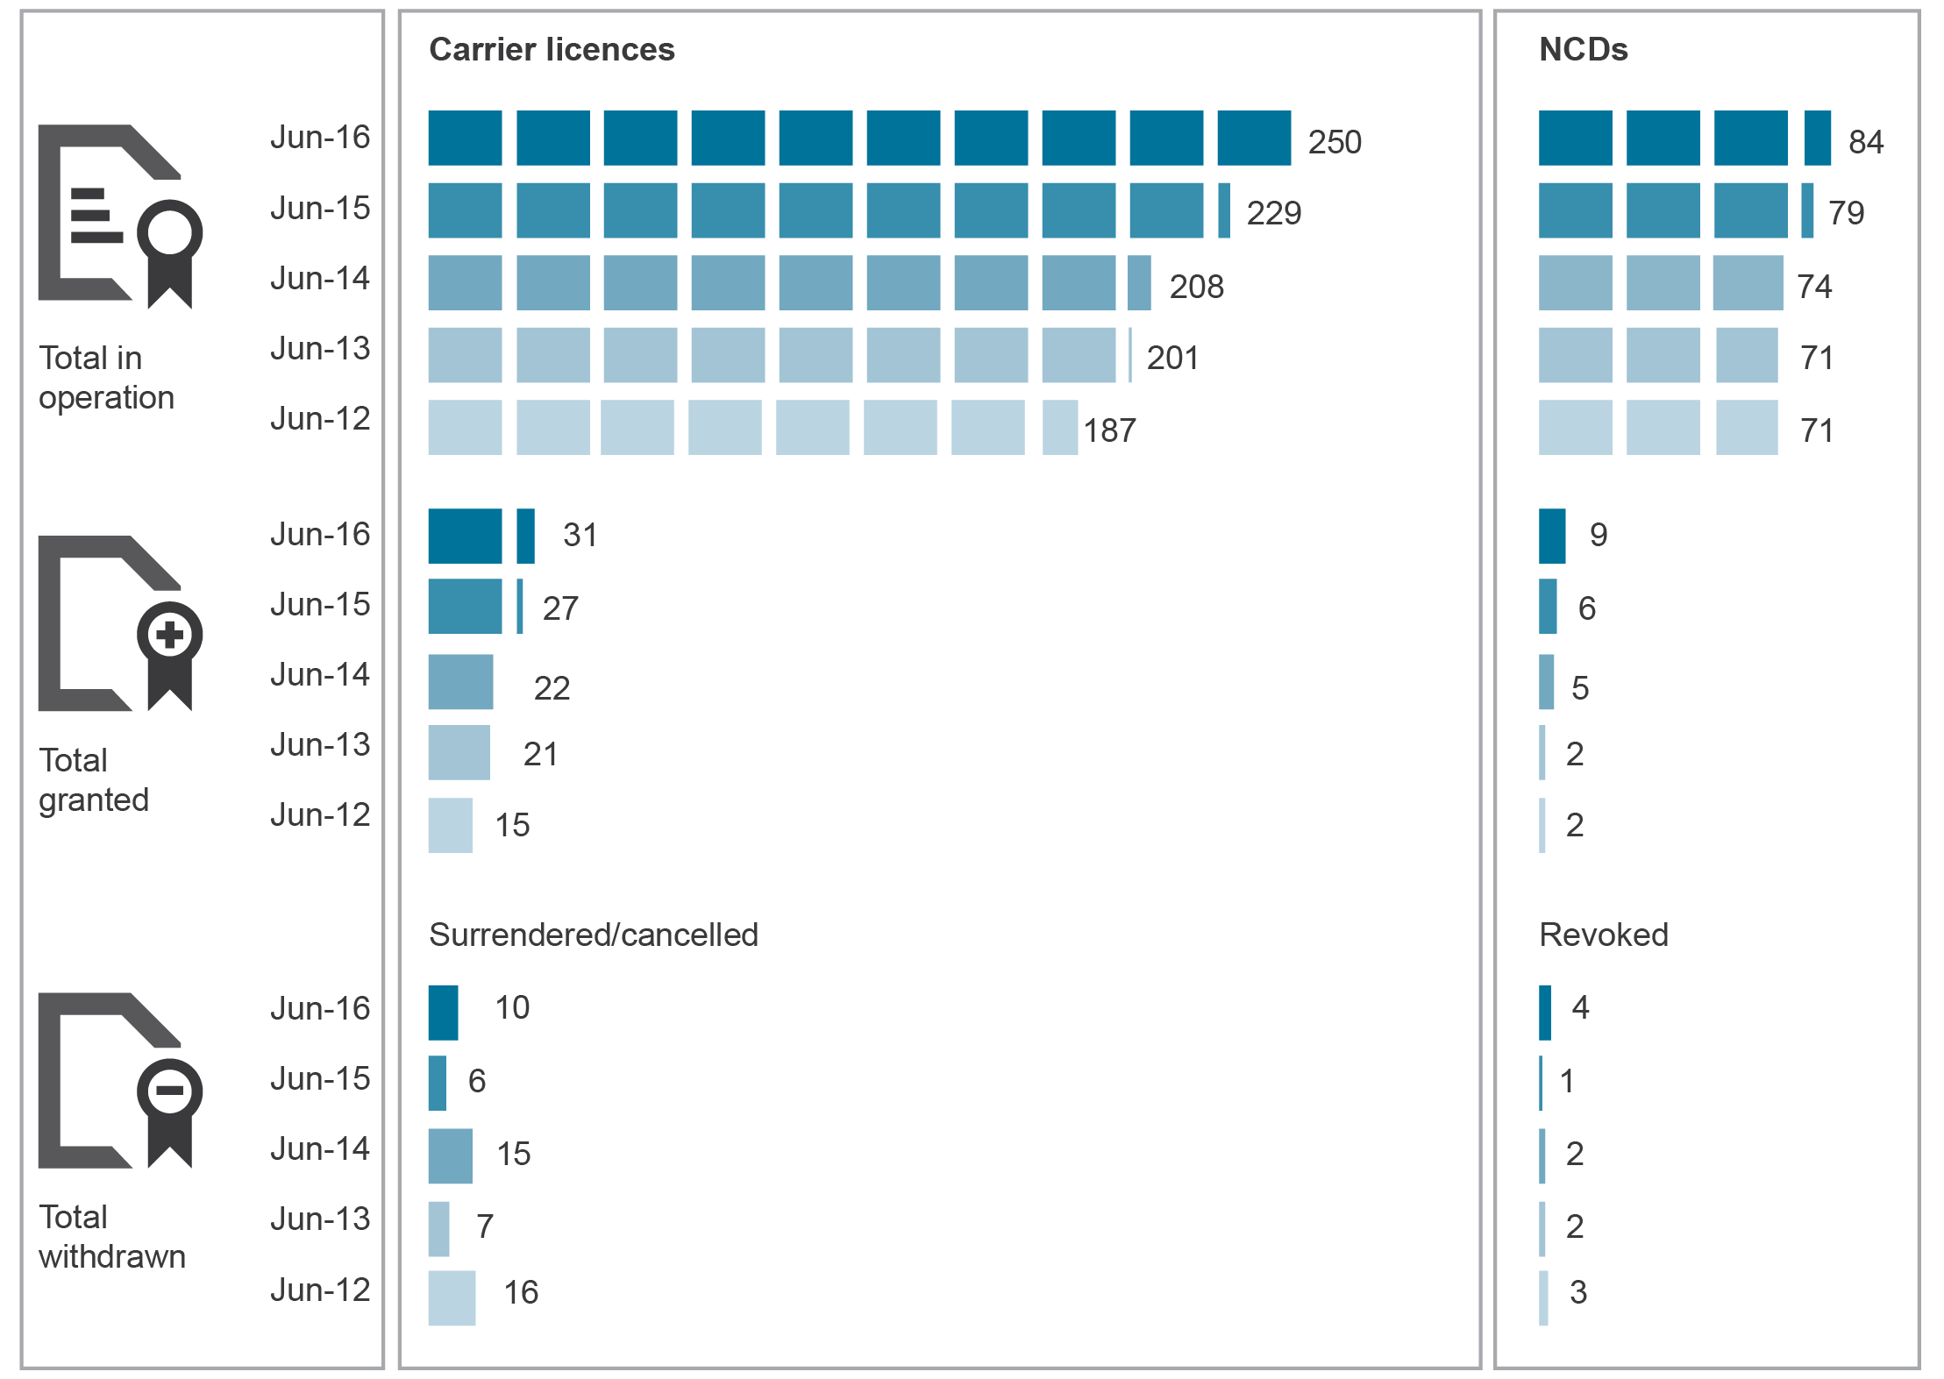
Source: ACMA.

Allocation of numbers

Smartnumbers
The smartnumbers auction system was introduced in 2004 as an efficient way to allocate freephone and local rate numbers (FLRNs)—numbers commencing with 13, 1300 and 1800—and to enable an appropriate return for this valuable and limited resource. In 2015–16, the ACMA sold 5,051 numbers, raising approximately $1.75 million in revenue. This quantity of numbers was a 17 per cent increase on the 4,330 numbers sold in 2014–15 (which raised approximately $1.66 million in revenue).
On 9 July 2015, the ACMA completed the last smartnumbers auction. From August 2015, the sale of smartnumbers changed from auction to immediate purchase. This change benefits individuals and organisations that purchase smartnumbers by reducing the delay, uncertainty and complexity inherent in the auction process.

Geographic numbers
In 2015–16, CSPs were allocated 3,083,200 geographic numbers—a 95 per cent increase on allocations in 2014–15 (Figure 1.12).
There were no geographic numbers surrendered during 2015–16 or 2014–15. During 2015–16, 1,825,000 geographic numbers were transferred between CSPs.
Figure 1.12 Trends in geographic numbers allocated
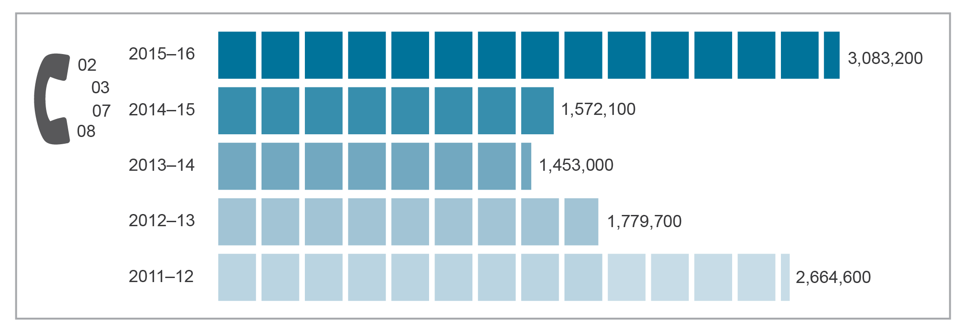
Source: ACMA.

Mobile numbers
During 2015–16, CSPs were allocated 1.24 million mobile numbers, 40,000 more than in 2014–15. At 30 June 2016, 70.2 per cent of available mobile numbers had been allocated.

Other numbers
During 2015–16, one interconnection and routing code, four mobile network codes, 1,000 data network services and two international signalling point codes were issued to network operators.

Broadcasting services

Number of broadcasters by segment (radio/television/commercial)
The number of commercial broadcasting licences in operation for television and radio saw minimal changes from the 2014–15 reporting period. At June 2016, the numbers of active licences in Australia were (Figure 1.13):
- 342 commercial broadcasting (radio and television) licences, unchanged from last year
- 2,835 subscription television licences, up by 100 in the year to June 2016
507 community radio and television licences (including temporary licences), up by one licence.
Figure 1.13 Number of broadcasting licences in operation in Australia
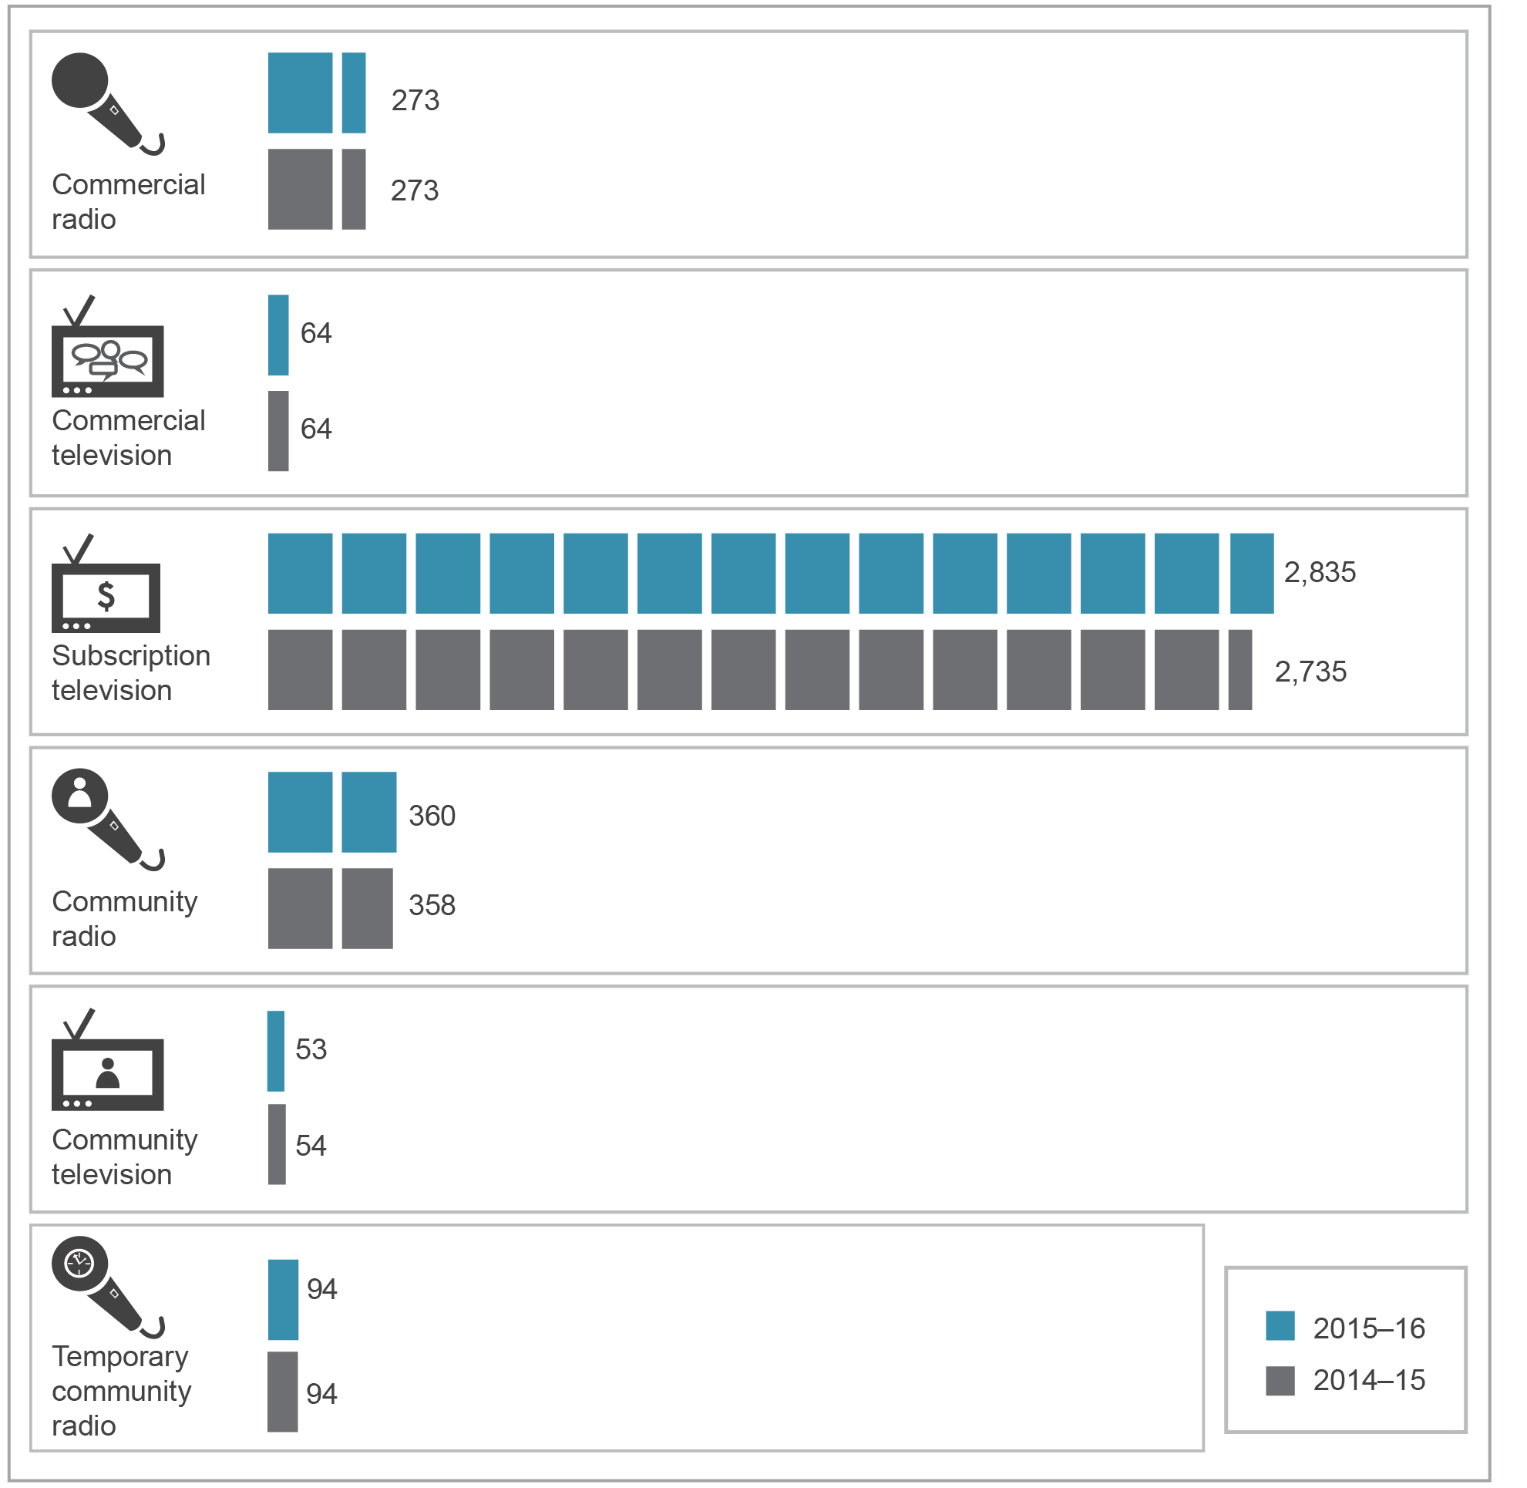
Source: ACMA.

Commercial broadcasting services
Commercial broadcasting services comprise FTA radio and television services that are made available to the general public. These services are licensed to operate within specified geographic areas and are subject to regulations to limit concentration of their ownership and control.
Ownership and control of commercial television services
During 2015–16, there were a number of ownership and control changes in the media. Some involved the transfer of licences to different media networks or groups while others were a result of financial or company restructures.
The Seven, Nine and Ten networks operate commercial television broadcasting licences predominantly in metropolitan markets. Their programming is also made available in regional markets through affiliation agreements with the regional television licences controlled by Prime Media Group Limited, Southern Cross Media Group Limited, WIN Corporation Pty Ltd and Imparja Television Pty Ltd.
Table 1.7 summarises ownership and control of these services in Australia.
The key change that occurred during 2015–16 was on 9 November 2015, when companies in the Apollo Group ceased to be in control of the commercial television licences held by the Nine Network.
Table 1.7 Ownership and control of commercial television services in Australia
Network | Licence type | Number | Ownership and control—licence areas
Seven Group Holdings Ltd | Metropolitan | 5 | Sydney, Melbourne, Brisbane, Adelaide and Perth
Seven Group Holdings Ltd | Regional | 1 | Regional Queensland
Nine Entertainment Co Holdings Ltd | Metropolitan | 5 | Sydney, Melbourne, Brisbane, Adelaide and Perth
Nine Entertainment Co Holdings Ltd | Regional | 3 | Darwin (one sole operation and one joint venture with Southern Cross Media Group Ltd) and Northern New South Wales
Ten Network Holdings Ltd | Metropolitan | 5 | Sydney, Melbourne, Brisbane, Adelaide and Perth
WIN Corporation Pty Ltd | Regional | 21 | Across regional Australia, including joint ventures in:  Tasmania with Southern Cross Media Group Ltd  Mildura, Geraldton, Kalgoorlie, Western Zone, South West and Great Southern television licence areas with Prime Media Group Ltd  Also includes three licences in each of Griffith, Riverland and Mount Gambier South-East licence areas
Southern Cross Media Group Ltd | Regional | 19 | Across regional Australia, including joint ventures in:  Darwin with Nine Entertainment Co Holdings Ltd  Tasmania with WIN Corporation Pty Ltd  Mt Isa and Remote Central and Eastern Australia TV2 licence areas with Imparja Television Pty Ltd  Also includes three licences in each of the Broken Hill and Spencer Gulf licence areas
Prime Media Group Ltd | Regional | 13 | Across regional Australia including joint ventures in:  Mildura, Geraldton, Kalgoorlie, Western Zone, South-West and Great Southern licence areas with WIN Corporation Pty Ltd
Note: Does not include licences for services provided by satellite allocated under section 38C and other licences allocated under subsection 40(1) of the Broadcasting Services Act 1992. The number of licences does not add up to the total number of commercial television broadcasting licences (69) due to double-counting of joint ventures.
Source: ACMA, Register of Controlled Media Groups and the Media Control Database.

Ownership and control of commercial radio services
Table 1.8 shows the ownership and control of commercial radio services in 2015–16:
- Southern Cross Media Group Limited, Australian Radio Network Pty Ltd, Nova Entertainment Pty Ltd and Macquarie Media Limited own the majority of capital city commercial radio broadcasting licences.
- Southern Cross Media Group Limited, Broadcast Operations Pty Ltd (Super Radio Network) and Grant Broadcasters Pty Ltd remain the three largest networks of regional commercial radio broadcasting licences.
- Nine different networks each control more than six commercial radio broadcasting licences, up from eight different networks in 2014–15.
These nine networks together control 225 licences out of a total of 261 commercial radio licences that are subject to the media diversity and control rules under Part 5 of the Broadcasting Services Act 1992 (BSA). This does not include commercial radio broadcasting licences allocated under subsection 40(1) of the BSA. The remaining 36 licences are held by 17 networks/owners, each with five or fewer licences.
The key change that occurred in 2015–16 was the acquisition by Resonate Regional Radio Pty Ltd of Macquarie Regional Radio Pty Ltd from Macquarie Media Limited (MML) (formerly Macquarie Radio Network Limited). As part of the transaction that took place on 30 October 2015, Resonate Regional Radio Pty Ltd acquired six commercial radio licences in regional Queensland, including 4LM in the Mt Isa RA1 licence area. The divestiture of 4LM by MML remedied the unacceptable media diversity situation (UMDS) that had arisen in the Mt Isa licence area when MML merged with the radio business of Fairfax Media Limited (Fairfax) on 31 March 2015. The ACMA had granted MML and Fairfax prior approval of the transaction and set a time frame of six months (extended to 31 October 2015) for the UMDS to cease. The ACMA had also accepted an enforceable undertaking from MML and Fairfax to divest 4LM within this time frame. The divestiture of 4LM was within this time frame.
Media ownership regulations stipulate that a single operator cannot own more than two commercial licences in a single metropolitan market. A merger between Macquarie Radio Network and Fairfax Radio in March 2015 resulted in the new entity breaching this requirement. Accordingly, the ACMA gave Macquarie a year to divest 2CH, with an extension granted to 30 September 2016. At the time of writing, 2CH had yet to change hands, and the sale process of 2CH has been handed to accountancy firm Deloitte.
A discussion of broadcasters’ compliance with notification of change-in-control requirements is in Chapter 3 of this report.
Table 1.8 Ownership and control of commercial radio services
Network group company | Total licences controlled | Ownership and control—licences and operations
ACE Radio Broadcasters  Pty Ltd | 13 | Licences in regional Victoria and one licence in the regional New South Wales licence area of Albury, which includes parts of regional Victoria
Australian Radio Network  Pty Ltd | 13 | Metropolitan licences in Adelaide (2), Brisbane (1), Melbourne (2), Perth (1), Sydney (1) and Western Suburbs, Sydney (1)  One regional radio licence in Katoomba, NSW  Two joint-venture licences with Nova Entertainment Pty Ltd, one in each of Brisbane and Perth, and two joint-venture licences with Southern Cross Media Group Ltd in Canberra
Nova Entertainment Pty Ltd | 10 | Metropolitan licences in Adelaide (2), Brisbane (1), Melbourne (2) and Sydney (2) as well as one regional radio licence in Gosford, NSW  Two joint-venture licences with Australian Radio Network Pty Ltd, one in each of Brisbane and Perth
Grant Broadcasters Pty Ltd | 52 | A metropolitan licence in Perth  Licences in regional areas in New South Wales, Northern Territory, Queensland, Victoria, South Australia and Tasmania, including five joint-venture licences with Kevin Blyton which are part of the Capital Radio Network
Macquarie Media Limited (formerly Macquarie Radio  Network Ltd) | 8 | Metropolitan licences in Brisbane (2), Melbourne (2), Perth (1) and Sydney (3)*
Redwave Media Ltd/  Seven Group Holdings Ltd | 9 | Licences in regional and remote areas in Western Australia
Southern Cross Media Group Ltd | 78 | Two metropolitan licences in each of Adelaide, Brisbane, Melbourne, Perth and Sydney  Licences in regional areas in New South Wales, Queensland, Tasmania, Victoria, South Australia and Western Australia  Two joint-venture licences with Australian Radio Network Pty Ltd in Canberra
Broadcast Operations Pty Ltd (Super Radio Network) | 36 | Licences in regional areas of New South Wales and Queensland. One metropolitan licence in Sydney
Resonate Broadcasters Pty Ltd and Resonate Regional Radio Pty Limited) | 10 | Ten licences in regional areas in Queensland, including six held by Resonate Regional Radio Pty Limited—Charleville (2), Emerald (1), Kingaroy (1), Mt Isa (1)*, and Roma (1)—and four held by Resonate Broadcasters Pty Ltd—Longreach (2) and Charters Towers (2)
*The ACMA granted prior approval of temporary breaches of the control rules in Sydney and Mt Isa—see commentary.
Note: Table includes networks with more than six licences.
Source: ACMA, Register of controlled media groups and Media control database

Cross-media ownership
A small number of entities control two types of media assets in the same market:
- Southern Cross Media Group Ltd controls a combination of radio and television broadcasting licences in 26 radio licence areas.
- Fairfax Media Limited controls two radio licences and a newspaper in Melbourne, and three radio licences and a newspaper in Sydney.
- Seven Group Holdings Limited controls a television licence and a newspaper in Perth.
- WIN Corporation Pty Ltd controls a radio and television licence in Wollongong.
Lachlan Murdoch, through his position as Co-Chairman of News Corporation and interests in Nova Entertainment Pty Ltd, controls two radio licences and an associated newspaper in each of the Sydney, Brisbane, Adelaide and Melbourne metropolitan licence areas.

Subscription television in Australia
In 2015–16, the ACMA allocated 100 new subscription television broadcasting licences to Austar Entertainment Pty Ltd.

Community radio broadcasting licences
At 30 June 2016, there were 360 long-term community radio broadcasting licences, representing a range of community interests (Table 1.9). Fifty per cent of community radio broadcasting services represent the general community in the licence areas where they broadcast.
During 2015–16, the ACMA:
- renewed 38 community radio broadcasting licences
- allocated three community radio broadcasting licences
decided not to allocate one community radio broadcasting licence.
Table 1.9 Community radio broadcasting services by community interest, June 2016
Community interest | Number of licences | Total (%)
Aboriginal and Torres Strait Islander | 95 | 26
Educational/special interest | 20 | 6
Ethnic | 6 | 2
General geographic area | 180 | 50
Music | 8 | 2
Religious | 35 | 10
Senior citizen | 8 | 2
Youth | 8 | 2
Total | 360 | 100
Source: ACMA.

Temporary community radio broadcasting licences
The temporary community radio broadcasting licence scheme allows the ACMA to allocate non-renewable community radio licences to eligible aspirant broadcasters. There were 94 temporary licences at 30 June 2016, unchanged from the previous reporting period.

Community television services
There were 53 long-term community television broadcasting licensees at 30 June 2016, of which two were in the metropolitan areas of Brisbane and Melbourne. The remaining 51 were remote Indigenous broadcasting services.

Community television transition
Community television services currently have temporary access to spectrum to broadcast to four mainland state capitals (Melbourne and Brisbane, as well as trials in Adelaide and Perth). Community television licences are only authorised to broadcast until 31 December 2016. The government has announced that it believes the best long-term outcome for community television is a transition to an online-only platform and has made funding available to assist community television broadcasting licensees with the initial set-up and service costs associated with the sector’s preferred online platform. Following this, the government intends that these broadcasting services will migrate to the internet.

Community television trials
During 2015–16, the ACMA decided to extend community television trials in Adelaide and Perth for a further 12-month period from 1 January 2016 to 31 December 2016.

Advertising expenditure in main media
Commercial Economic Advisory Service of Australia (CEASA) data for the year ended 31 December 2015 shows that combined advertising expenditure across the main media categories—print, television, radio, online, outdoor and cinema—increased by 11.7 per cent in 2015 to $14.5 billion.
Online and television media attracted the major share of advertising expenditure during this period, as shown in Figure 1.14. In 2015, these media platforms combined to account for more than two-thirds of total advertising expenditure (41.6 and 27 per cent respectively). The print media’s share of total advertising expenditure decreased to 16.1 per cent in 2015, compared to 19.1 per cent in 2014.
Online advertising expenditure continued to increase in 2015, growing by 25 per cent to reach $6 billion. There were also increases reported in outdoor advertising (increasing by 62.8 per cent) and cinema advertising (up 20.7 per cent).
Figure 1.14 Advertising expenditure by main media category ($ millions)
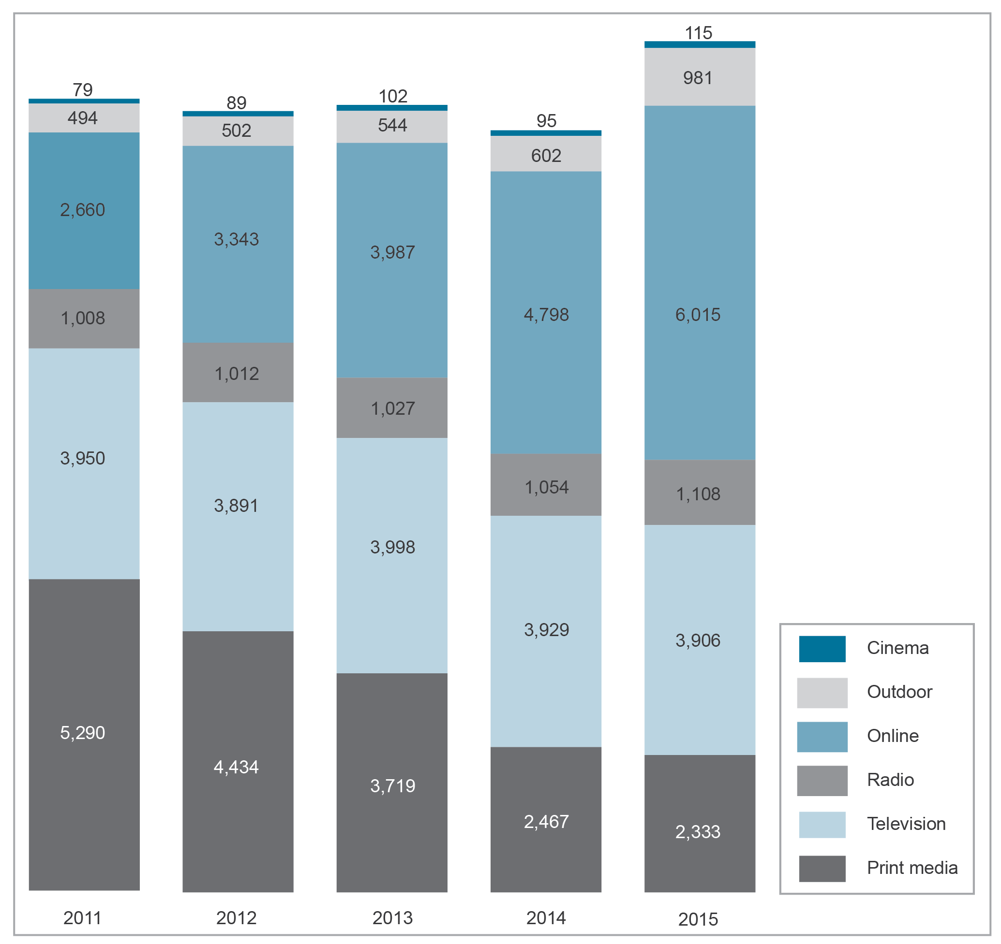
Note: Online advertising expenditure figure revised from previously reported.
Source: CEASA.

Figure 1.15 shows the television and radio sectors’ share of the advertising expenditure market over the last five years. The television sector’s share declined from 30.4 per cent in 2014 to 27 per cent in 2015. Radio saw its share of total advertising expenditure decrease slightly from 8.1 per cent in 2014 to 7.7 per cent in 2015.
Figure 1.15 Television and radio advertising expenditure ($ million)
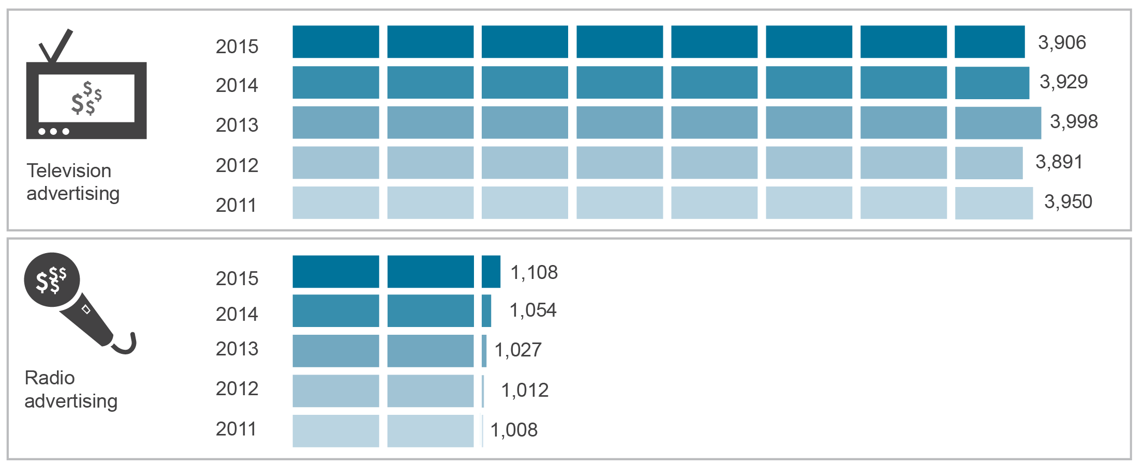Source: CEASA.

Expenditure on online advertising grew by 25.3 per cent to total just over $6 billion during the 2015 calendar year. This represented a 41.6 per cent share of total media advertising expenditure, compared to 37.1 per cent in 2014 (Figure 1.16). The 2015 calendar year was characterised by significant growth in all online advertising categories, with the online general category exhibiting the greatest proportional increase. Revenue in the classifieds online category increased by 22 per cent, and in the search and directories online category by 14 per cent, with the online general category reporting a year-on-year revenue increase of 46 per cent.
Figure 1.16 Online advertising expenditure ($ million)
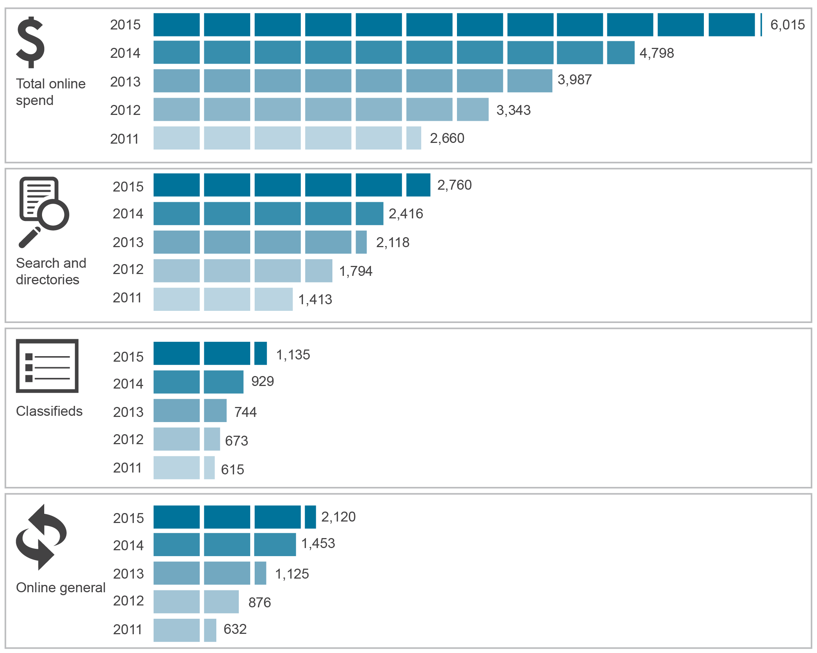
Note: 2014 figures revised from those previously reported.
Note: Numbers may not add up to total due to rounding.
Source: CEASA.

Engagement with communications and media

Overview
This chapter reports on CSPs’ efficiency, adequacy and quality of services by examining Australians’ participation in communications and media services. It focuses on Australians’ online activities, their take-up and use of devices that connect to the internet and other communications services, as well as the behaviours that Australian internet users adopt in an online environment. This chapter considers consumer benefits and engagement including satisfaction with communications services to address the regulatory requirements of section 105 of the Telecommunications Act.
Digital services are an established part of Australians’ lives, with consumer take-up of online communications and content driving strong growth in data traffic. An overwhelming majority of Australians are internet users, with 91 per cent going online at least once in the six months to June 2016. Communications apps are one of a suite of communications options, and the favoured choice for video calls. Australians are enthusiastic adopters of online entertainment. More than two-thirds of online Australian adults accessed online video content and more than half listened to audio content online.
ACMA research continues to show that Australians aged 18 and over experience high satisfaction with communications services, including fixed telephone, mobile and internet. However, of these services, Australian consumers are the least satisfied with internet services.
In summary:
- Ninety-one per cent of adult Australians accessed the internet in the six months to June 2016—meaning an estimated 1.58 million (nine per cent) had not been online during that period.
- Ten per cent of adult Australians (1.74 million) did not have the internet in their home in the six months to June 2016.
- The laptop became the most often used device to access the internet—with 34 per cent of online Australians using their laptop computer most often to access the internet—followed by the desktop computer, used most often by 30 per cent of online Australians.
- The use of fixed-line telephony continued to decline, with 67 per cent of adults making a fixed-line call in the six months to June 2016, down 11 percentage points from 78 per cent four years ago at May 2012.
- Online Australians continue to access audio and video content via downloading and streaming, with downloading becoming much more prevalent:
- more than two-thirds of online Australians accessed online video content (72 per cent) and more than half listened to audio content online (57 per cent)
- 73 per cent of online Australians used streaming to access online audio or video content, compared to only 51 per cent of online Australians who used downloading to access online audio or video content.
- Australian businesses earned more from using the internet, generating an estimated $285.5 billion in revenue from the online sales of goods and services during 2014–15 (the latest figures available)—an increase of almost $20 billion since 2013–14.
- Almost eight million adults made a purchase or sold something online in the four weeks to June 2016.
- The majority of Australians were generally satisfied with their communications services—92 per cent were satisfied or very satisfied with their fixed-line telephone and mobile phone services.
The highest levels of internet dissatisfaction were with data speeds and service costs (both 26 per cent), consistent with internet activity becoming a more important feature of communications activities.

Internet access

Connectivity—take-up of the internet
Internet access is available to Australians via a range of networks, devices and locations. In the six months to June 2016, 91 per cent of adult Australians accessed the internet. The rate of internet use is above 90 per cent among all adults aged 18 to 65, but drops to 62 per cent for those aged 65 and over.
Evidence indicates that the levels of home internet access are stabilising (Figure 2.1). In 2015–16:
- approximately 15.8 million Australians (85 per cent) had an internet connection in the home, similar to last year’s figure
- 85 per cent of Australians also had a home broadband connection—this figure has remained relatively stable since last year, and reflects that almost all home internet connections are now broadband
70 per cent of Australians accessed the internet via a mobile phone.
Figure 2.1 How consumers access the internet (percentage)
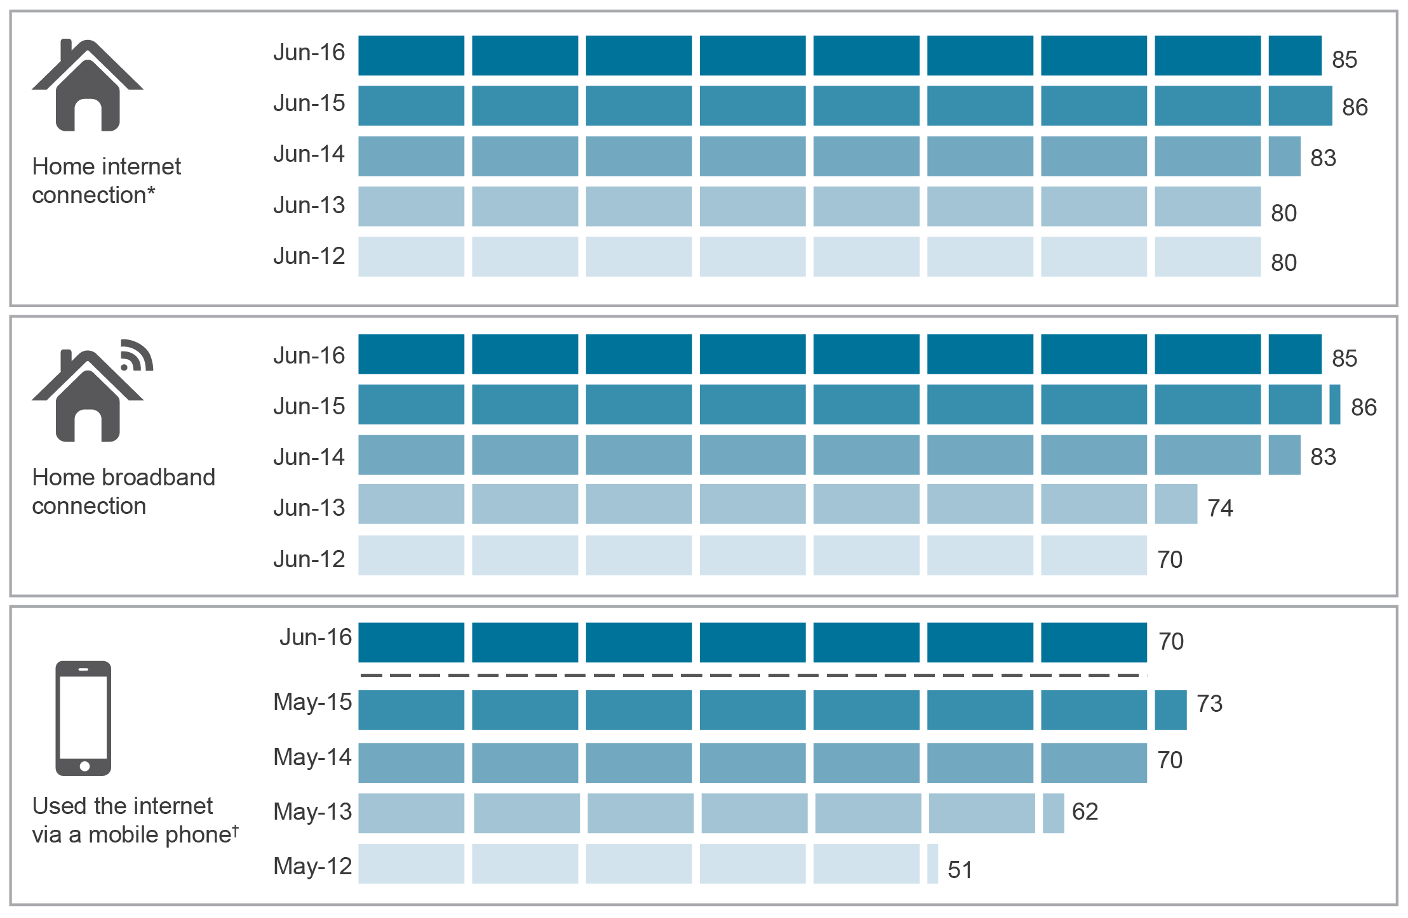
*Includes ADSL, cable, fibre, satellite, fixed wireless, mobile wireless internet services—using dongles, datacards or USB modems. It excludes mobile handset internet.
†Relates to use of the internet via a mobile phone handset in the six months to June.
Base: Australians aged 18 and over.
Note: Changes to Roy Morgan weighting methodology may have resulted in some differences to the 2014–15 data measures reported in the previous Communications report.
June 2015 data for home broadband connection has been revised from previously published data due to a change in weighting. June 2014, 2015 and 2016 broadband definitions include ADSL, cable, NBN, USB modem, portable Wi-Fi modem, SIM card for tablet, internet key. June 2014, 2015 and 2016 internet definitions include ADSL, cable, NBN, USB modem, portable Wi-Fi modem, SIM card for tablet, internet key and dial-up.
Source: Roy Morgan Single Source (Home internet connection and Home broadband connection), in the 12 months to June of each year and ACMA-commissioned survey (used the internet via a mobile phone).

Offline Australians
In the six months to June 2016, 91 per cent of adult Australians accessed the internet. This means an estimated 1.58 million (nine per cent) had not been online during that period—this has remained stable since June 2015.
In terms of household access to the internet, 10 per cent of adult Australians (1.74 million) did not have the internet in their home in the six months to June 2016. Of these, 71 per cent were aged 65 and over. The main reason for not having household internet access among all adult Australians was not having a need for it or not being interested in it (47 per cent). Other reasons included the internet being too complicated or not knowing how to use it (14 per cent), not having a computer at home (13 per cent) and the cost involved in having household internet access (12 per cent).

Variety of internet access devices
Australians are using a number of communications devices to go online. In the six months to June 2016, the majority of Australian internet users (26 per cent) accessed the internet via three devices (Figure 2.2).
Figure 2.2 Number of devices used to access the internet, in the six months to June 2016 (percentage)
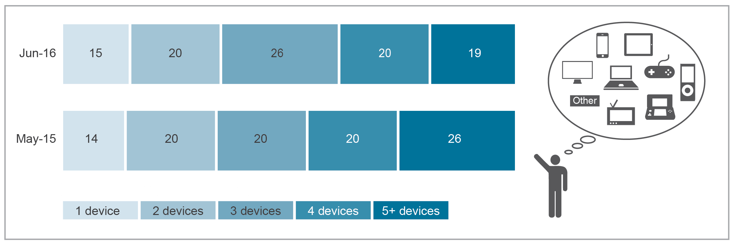
Base: Australians aged 18 and over who accessed the internet.
Note: The change in methodology in the 2016 ACMA-commissioned survey means that changes such as the drop in use of five or more devices to access the internet are likely explained by the methodology rather than any significant change.
Source: ACMA-commissioned survey, May 2015 and June 2016.

Diversification of consumer internet access devices
As illustrated in Figure 2.3, online Australians have a number of devices to choose from to access the internet. As at June 2016, mobile phones continued to be the most popular device used to go online for Australians (77 per cent of adults), followed by laptop computers (75 per cent), desktop computers (61 per cent) and tablet computers (54 per cent).
Figure 2.3 Devices used to access the internet in the six months to June 2016 (percentage)
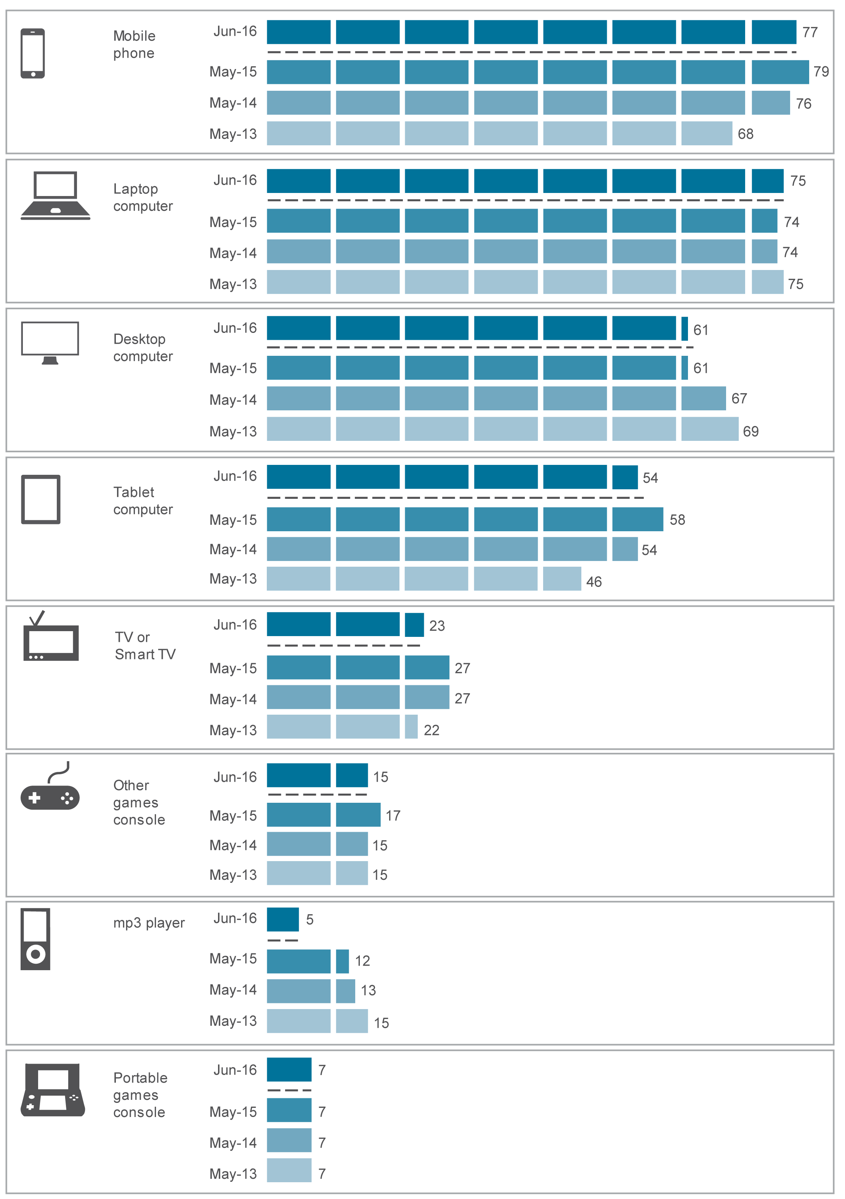
Base: Australians aged 18 and over who accessed the internet.
Note: The change in methodology in the 2016 ACMA-commissioned survey means that changes such as the slight drop in use of mobile phones and tablets to go online are likely explained by the preference that online panellists have to use a PC or laptop with a larger screen.
Source: ACMA-commissioned surveys, May 2013, 2014, 2015 and June 2016.

Although the mobile phone was the most popular device used to access the internet, the laptop was the most often used device to access the internet. In the six months to June 2016, 34 per cent of online adult Australians said a laptop was the device they used most often for accessing the internet, while 30 per cent used their desktop most often and 22 per cent used their mobile phone most often.
The choice of device most often used is influenced by age (see Figure 2.4)—while the laptop computer was the most often used device for those aged 18 to 65 (34 per cent), the desktop computer was the most often used device to access the internet for those aged 65 and over (51 per cent).
Figure 2.4 Devices used most often to access the internet, by age, in the six months to June 2016 (percentage)
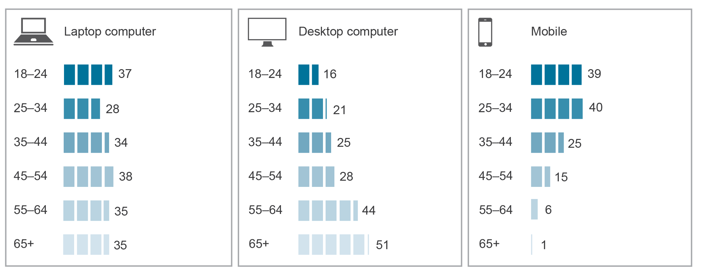
Base: Australians aged 18 and over who accessed the internet.
Source: ACMA-commissioned survey, June 2016.

Mobile-only users
The mobile phone is increasingly at the centre of online interaction and communications. Its growing popularity is reflected in the increased proportion of Australian adults—31 per cent, or approximately 5.78 million—who have only a mobile phone and no fixed-line telephone at home (mobile-only). This is an increase of two percentage points on the previous year.
At June 2016, mobile-only use was most prevalent among adults aged 25 to 34, with 59 per cent of this age group using only a mobile phone and having no fixed-line telephone at home. Those aged 18 to 24 showed the next largest prevalence, with 45 per cent of this group being mobile-only users (Figure 2.5).
Older Australians continued to use fixed-line telephones, particularly those aged 65 and over—just 12 per cent were mobile-only.
Figure 2.5 Mobile-only users, by age, June 2016 (percentage)
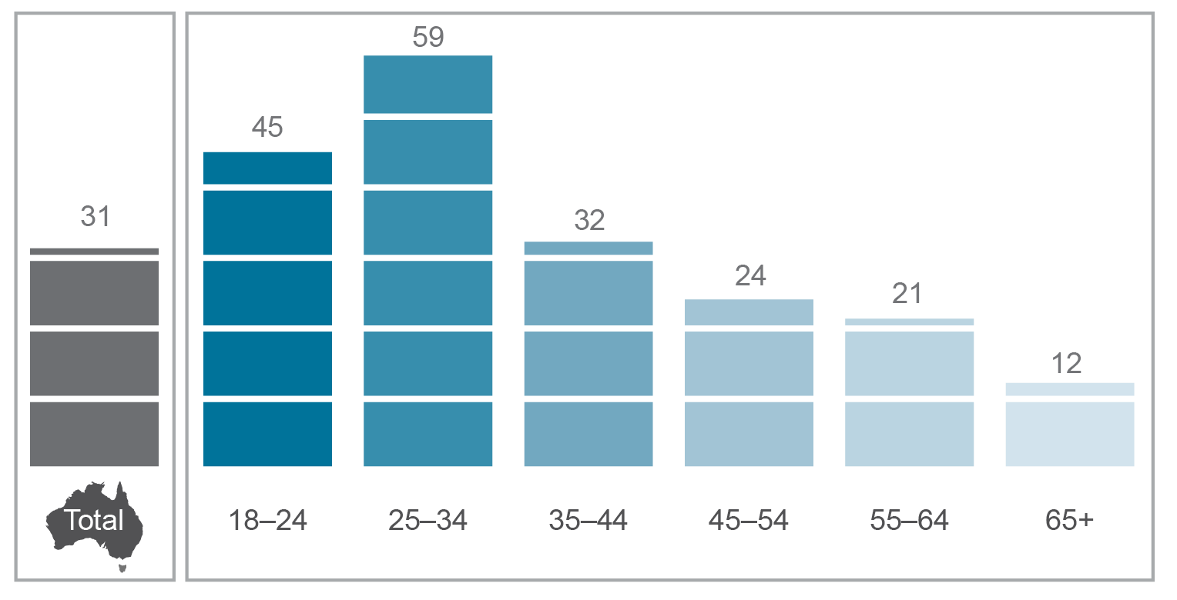
Base: Australians aged 18 and over.
Note: Relates to users of a mobile phone but no fixed-line telephone at home for the 12 months to June 2016.
Source: Roy Morgan Single Source, June 2016.

In terms of location, mobile-only use was slightly more prevalent in capital cities than regional areas—32 per cent of Australians living in capital cities were mobile-only, compared to 30 per cent of those living in regional areas. In terms of living arrangements, those who lived in a shared household were most likely to be exclusively mobile (63 per cent), followed by boarders (42 per cent) and those who lived alone (39 per cent) (Figure 2.6).
Figure 2.6 Mobile-only users, by living arrangement, June 2016 (percentage)
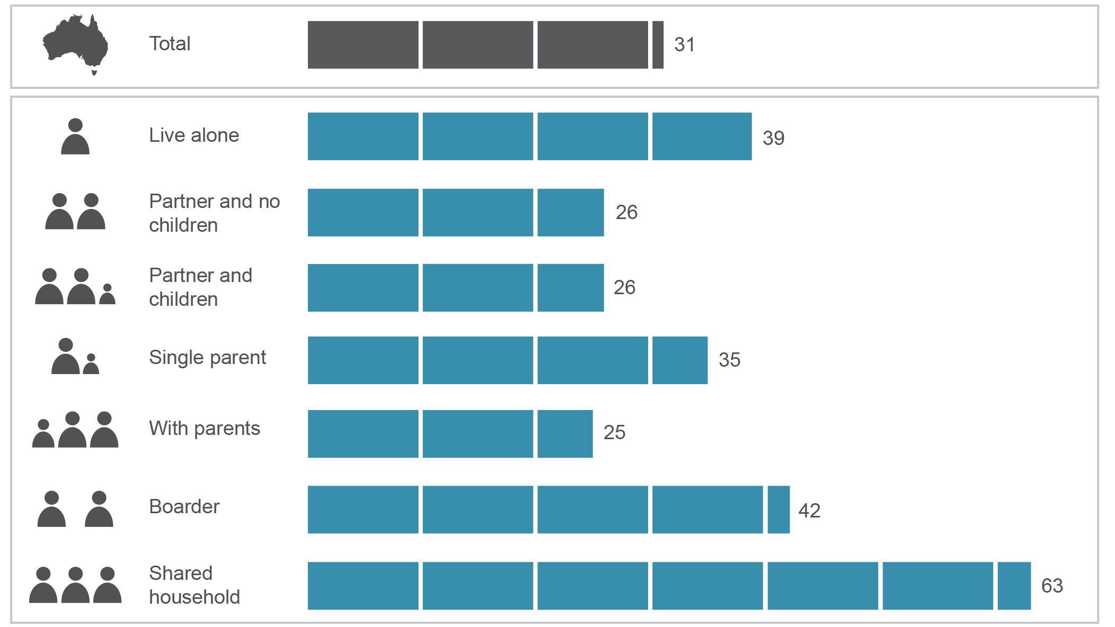
Base: Australians aged 18 and over.
Note: Relates to users of a mobile phone but no fixed-line telephone at home for the 12 months to June 2016.
Source: Roy Morgan Single Source, June 2016.

Data trends

Frequency of internet use
The majority of adult Australians are frequent internet users and access the internet several times a day. At June 2016, 12.5 million (68 per cent) went online three or more times a day, an increase of two percentage points from June 2015. Frequency of use was directly proportional to age—90 per cent of Australians aged 18 to 24 used the internet three or more times a day, while only 35 per cent of Australians aged 65 and over went online three or more times a day.
Figure 2.7 illustrates the devices used to go online three or more times a day. Among all adult Australians, mobile phones (46 per cent) and computers (44 per cent) were commonly used to access the internet three or more times a day, while a comparatively smaller proportion of people used tablets this frequently (19 per cent).
Figure 2.7 Australians accessing the internet three or more times a day, June 2016 (percentage)
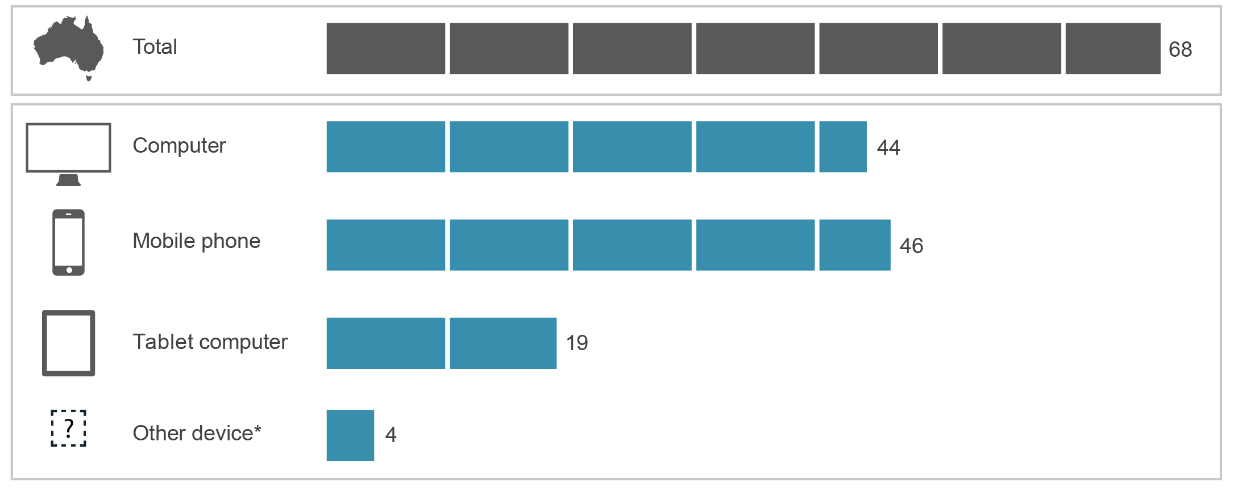
*‘Other device’ may include Smart TV or Xbox.
Base: Australians aged 18 and over.
Source: Roy Morgan Single Source, June 2016.

Volume of data downloaded
While the growth in take-up of internet services has steadied in recent years, the amount of data Australians consume via these services continues to increase significantly, particularly over mobile handsets.
The total volume of data downloaded in Australia during the June quarter of 2016 was 52 per cent higher than the volume downloaded during the June quarter of 2015 (Figure 2.8).
There is sizeable growth in data downloaded by fixed-line broadband users—contributing to 92 per cent of total growth during the June quarter of 2016—with fixed connections generally offering fast download speeds and large data plans. During the June quarter of 2016, the volume of data downloaded over:
- fixed-line broadband increased by 52 per cent
- wireless broadband increased by 24 per cent
- mobile handsets increased by 69 per cent
dial-up decreased by 43 per cent.
Figure 2.8 Volume of data downloaded by Australian internet users in the quarter to June (terabytes)
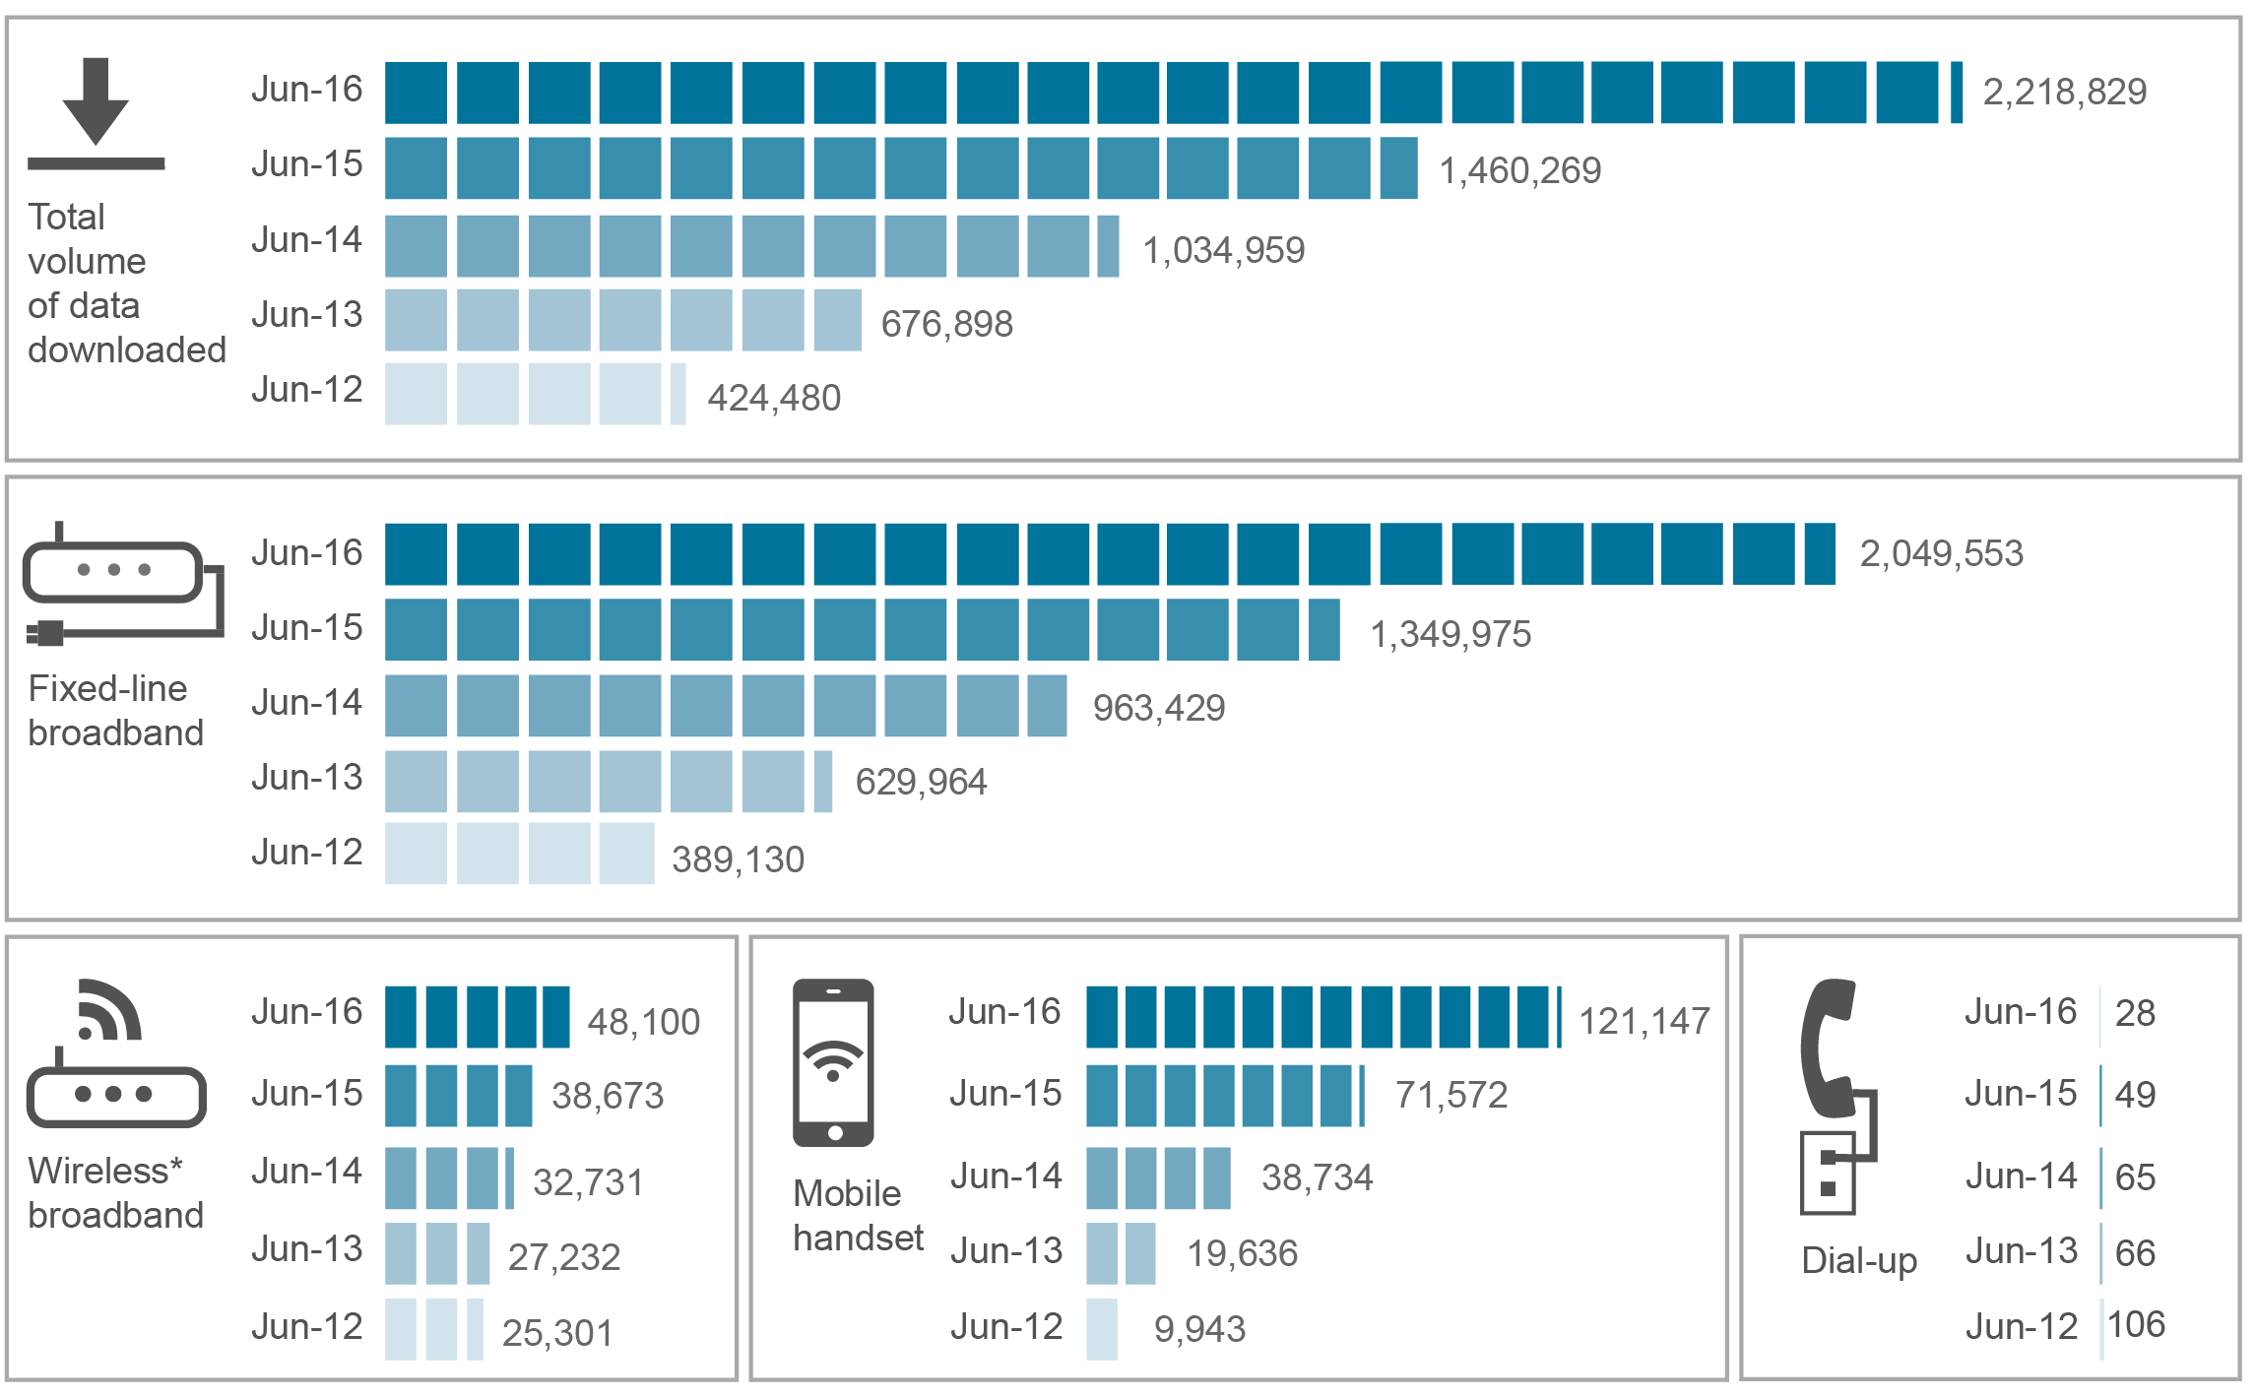
*Excludes downloads via mobile phone handsets. Includes mobile wireless services using dongle, USB modems and datacards, satellite and fixed wireless.
Note: Total volume of data downloaded is based on ABS published numbers and components may not add up due to rounding. The ABS reports that ‘… download data presented should only be considered an indicative measure of internet activity during the reference period.’
Source: ABS, 8153.0—Internet Activity, Australia, June 2016.

During the June quarter of 2016, the average amount of data downloaded by a subscriber over:
- fixed-line broadband increased by 41 per cent to 291.9 gigabytes
- wireless broadband increased by 22 per cent to 7.8 gigabytes
mobile handset internet increased by 62 per cent to 5.5 gigabytes.

Data allowance—mobile and tablet
Mobile phones remain entrenched in the lives of most Australians—93 per cent of adults use these portable devices to either send text messages or make calls. More than half (56 per cent) of adult Australians own or use a tablet.
In terms of monthly data allowance, the largest group of mobile phone users with a data plan (48 per cent) had an allowance of fewer than two gigabytes (Figure 2.9). Sixteen per cent of mobile phone users had an allowance of more than six gigabytes or an unlimited allowance—an increase of seven percentage points from May 2015.
A different pattern was observed among tablet users with a data plan. In comparison to mobile phone users, a larger proportion had a higher data allowances on their tablets—almost half of tablet users (46 per cent) had an allowance of more than six gigabytes or an unlimited allowance. Even so, more than half of tablet users (61 per cent) went over their monthly data allowance limit, at least occasionally.
Figure 2.9 Monthly data allowance on a mobile phone and tablet, June 2016 (percentage)
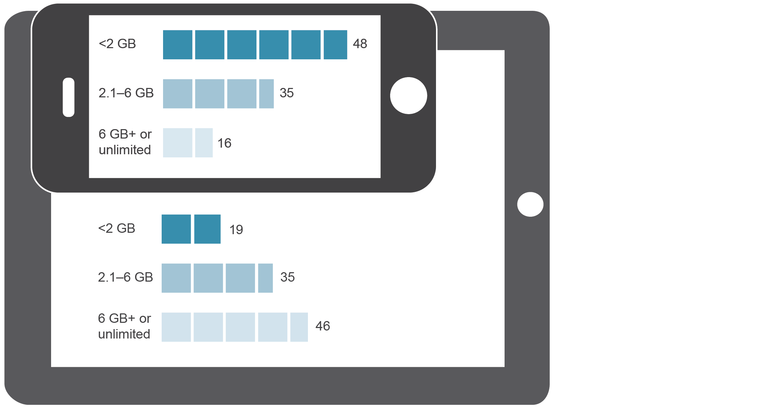
Base: Australians aged 18 and over with a monthly data allowance on their mobile phone (n=1,321), or tablet broadband plan (n=179).
Note: ‘Don’t knows’ are excluded from both categories.
Source: ACMA-commissioned survey, June 2016.

Use of communications services

Australians’ diverse use of communications services
Australians use a diverse range of communications services to fulfil their needs, with most combining multiple communications technologies and services.
Mobile phone calls continued to be at the forefront of consumer communications activity. At June 2016, 92 per cent of adult Australians had used a mobile phone to make a phone call in the last six months, while 83 per cent had sent an SMS from their mobile handset. Eighty-two per cent of adult Australians had used email.
Use of communications services was directly proportional to age—the most used type of communications service for those under 65 years of age was mobile phone calls, with 95 per cent of adults aged 18 to 65 using their mobile phone to make calls in the six months to June 2016. The most used communications service for those over 65 was the fixed-line telephone, with 92 per cent of adults aged 65 and over using their fixed-line telephone at home in the same period.
Figure 2.10 Communications services used in the six months to June 2016 (percentage)
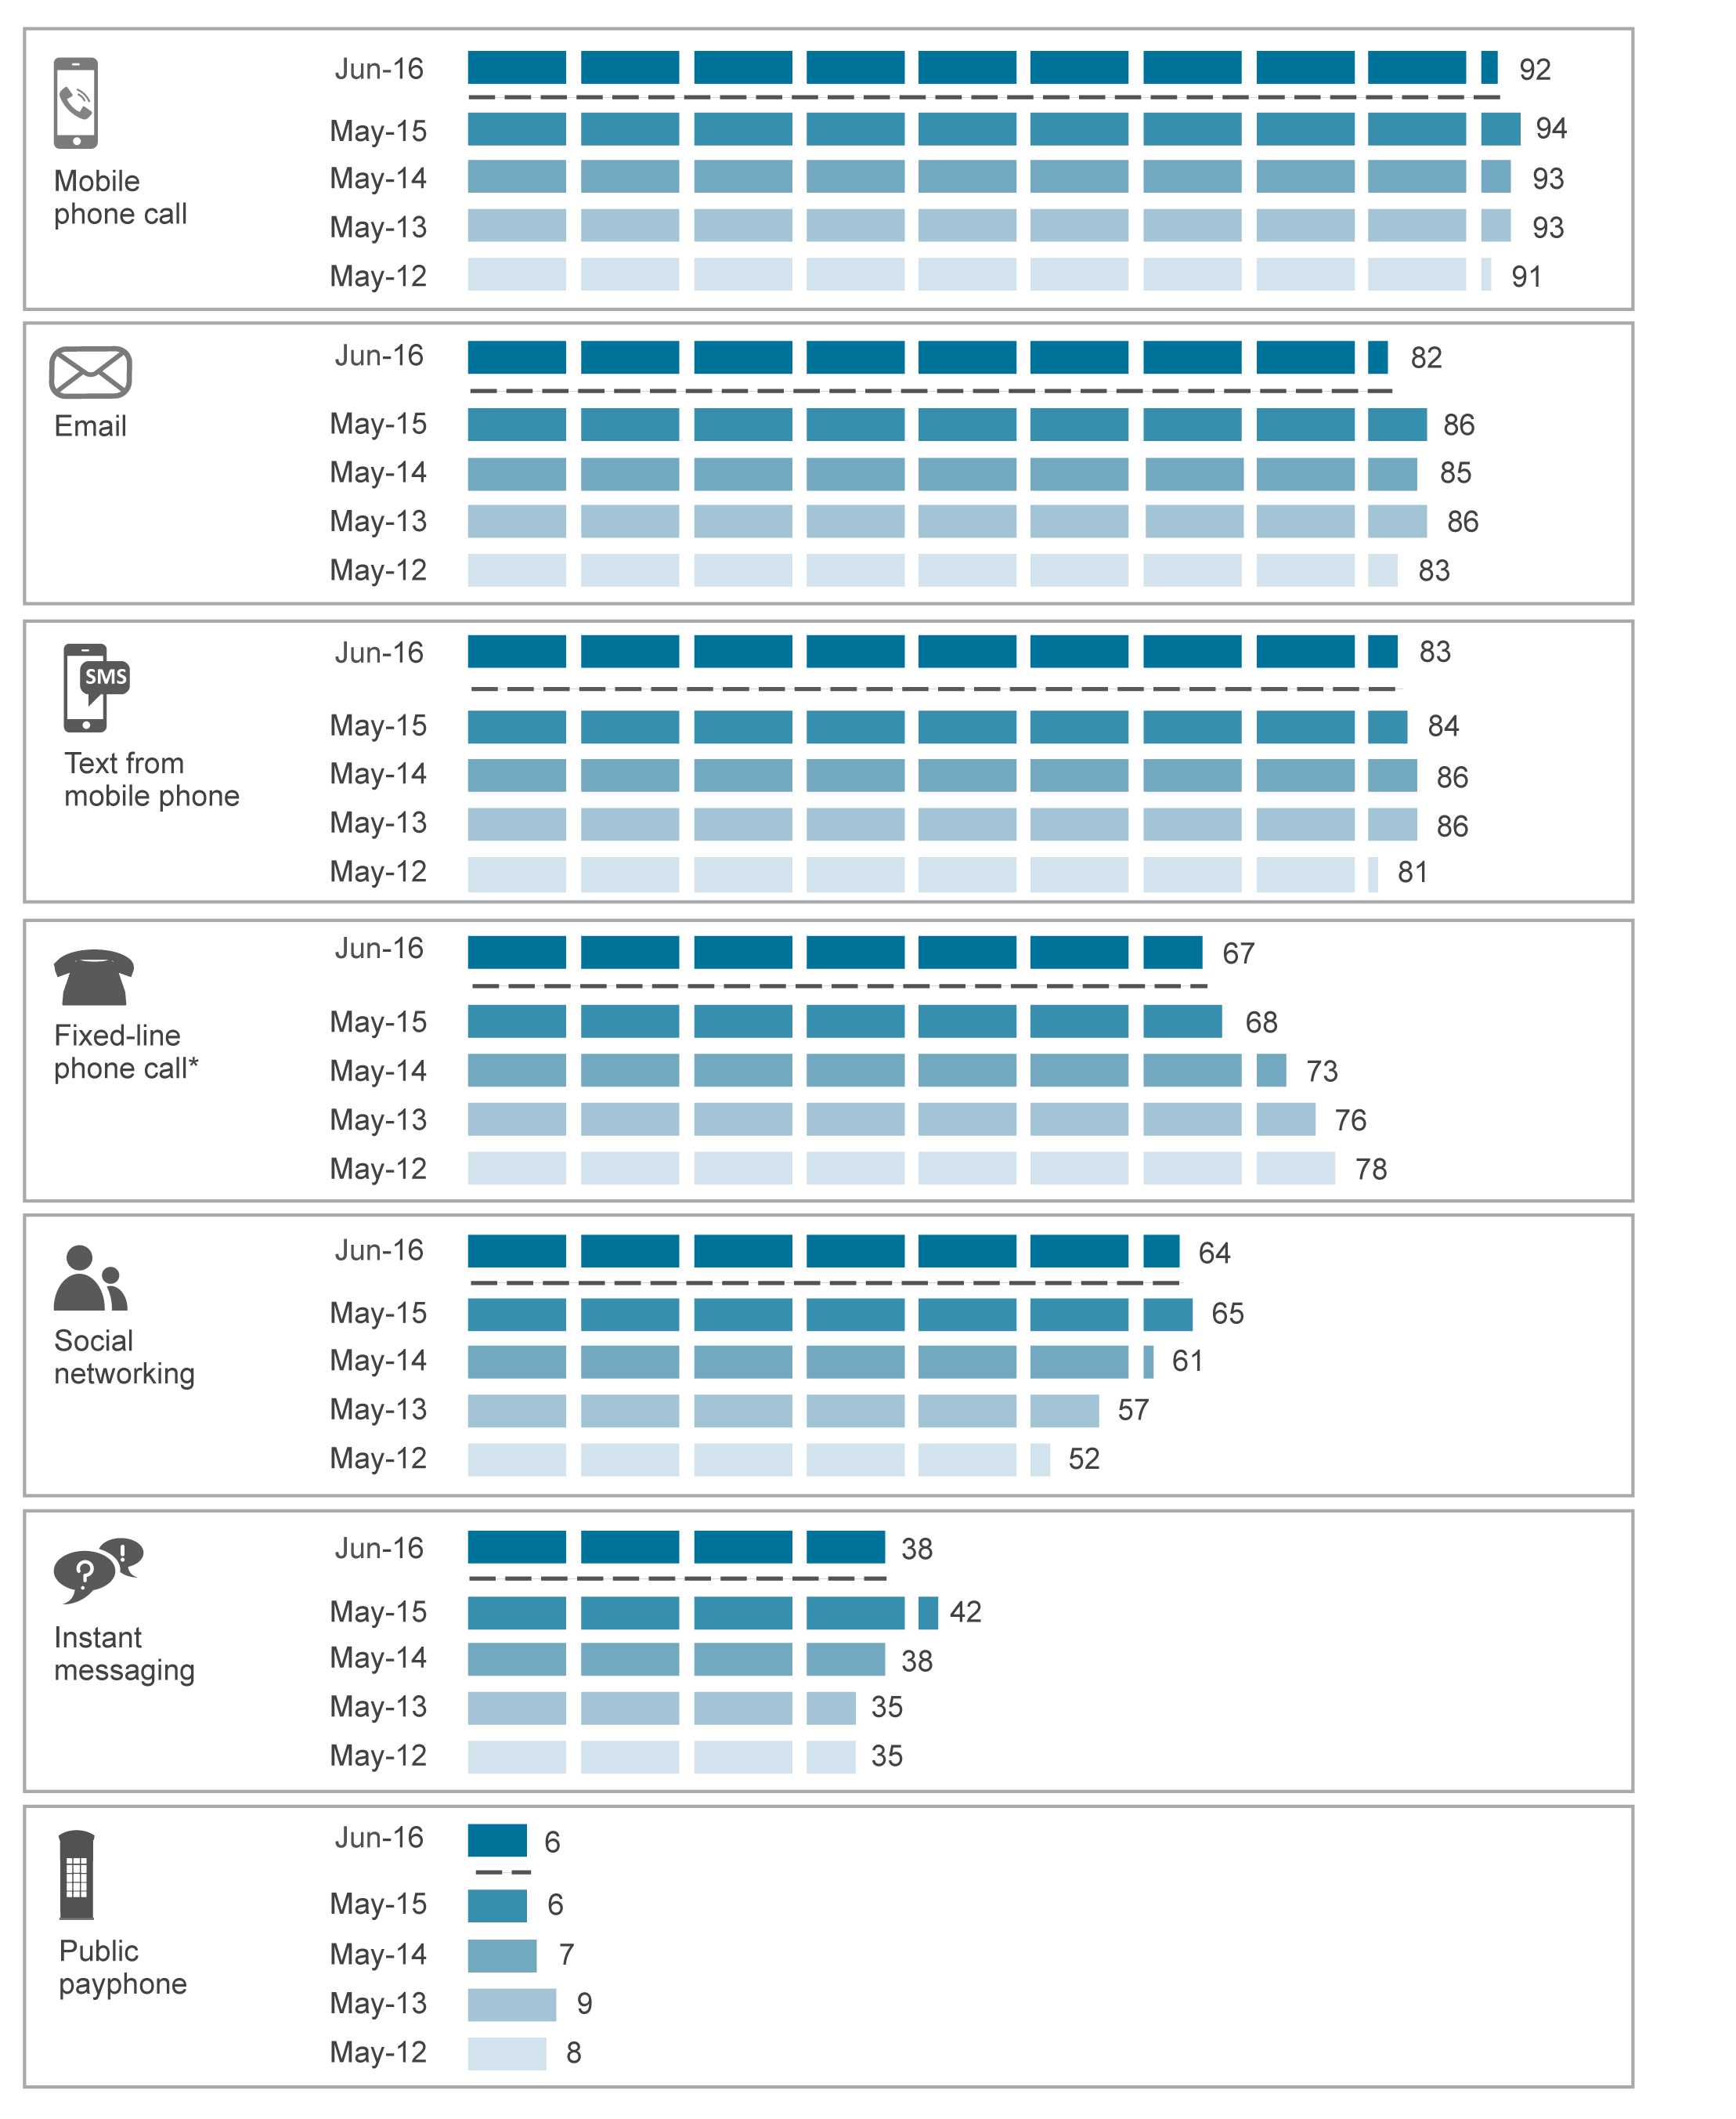
*Data not available prior to May 2012.
Base: Australians aged 18 and over.
Source: ACMA-commissioned surveys, May 2012, 2013, 2014, 2015 and June 2016.

In the six months to June 2016, over half of adult Australians (58 per cent) used five or more separate communications services, followed by 21 per cent who used four communications services (Figure 2.11).
Figure 2.11 Number of communications services used in the six months to June 2016 (percentage)
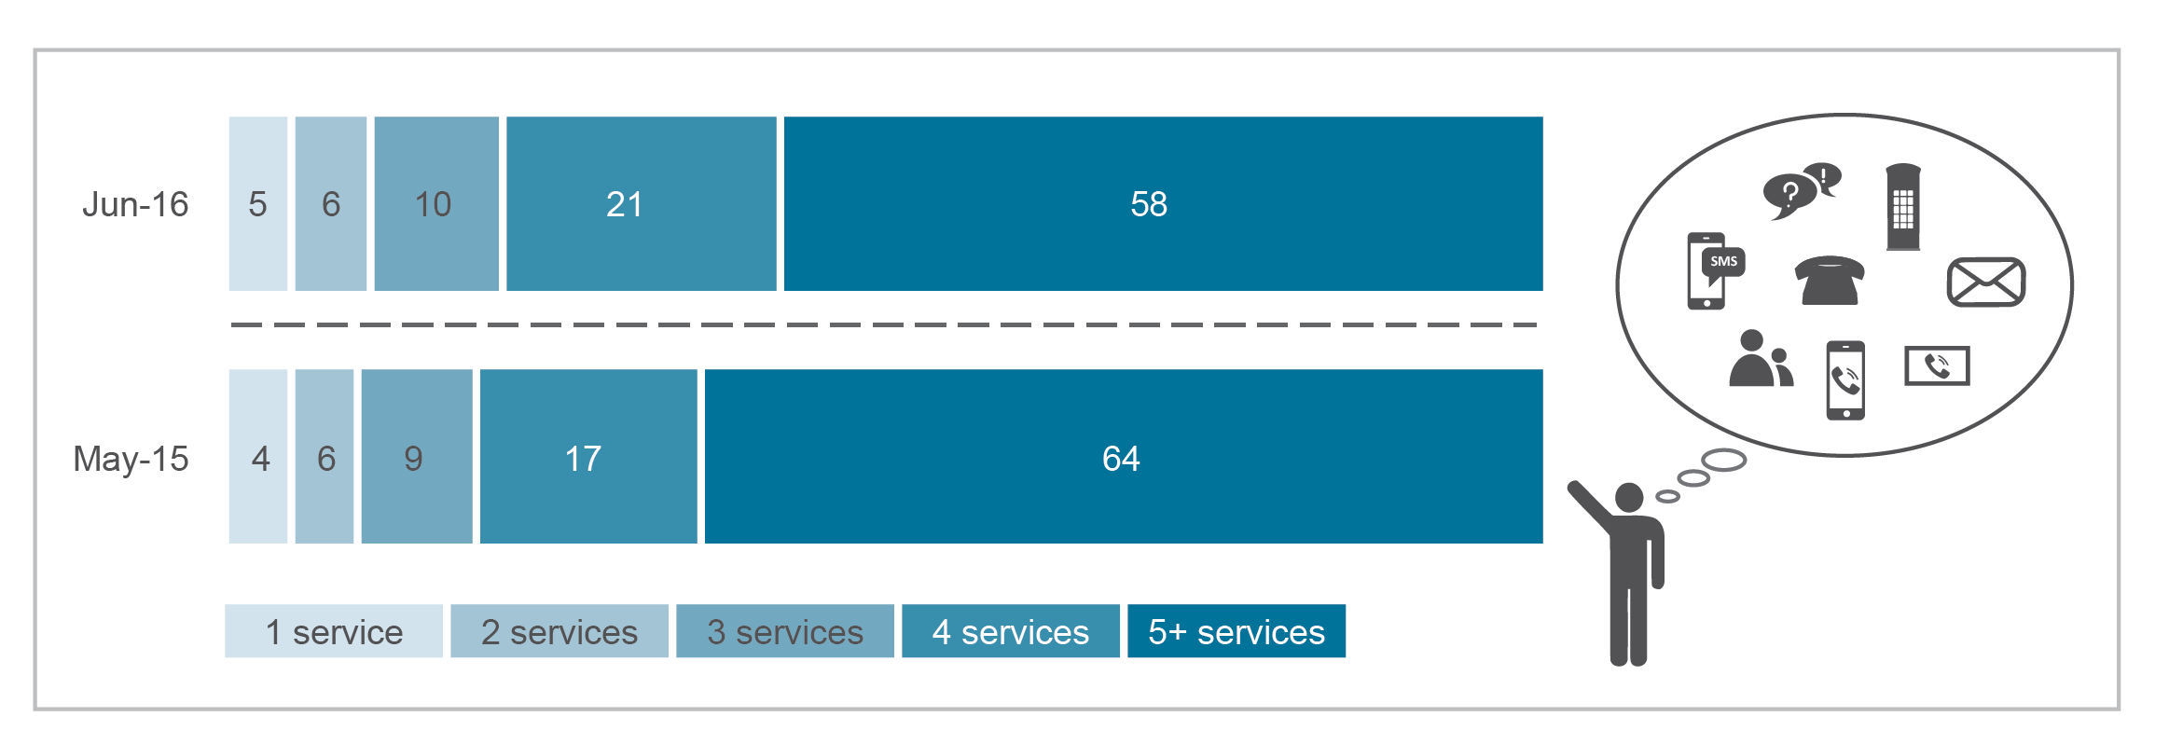
Base: Australians aged 18 and over.
Source: ACMA-commissioned surveys, May 2015 and June 2016.

Social networking activities
The majority of online Australians aged 18 and over (79 per cent) use social networking sites like Facebook (see Figure 2.12). In the six months to June 2016, 93 per cent of internet users aged 18 to 24 used social networking sites compared to only 62 per cent of internet users aged 65 and over. Females (83 per cent) were more likely than males (75 per cent) to use social networking sites.
Figure 2.12 Social networking site use, by age, in the six months to June 2016 (percentage)
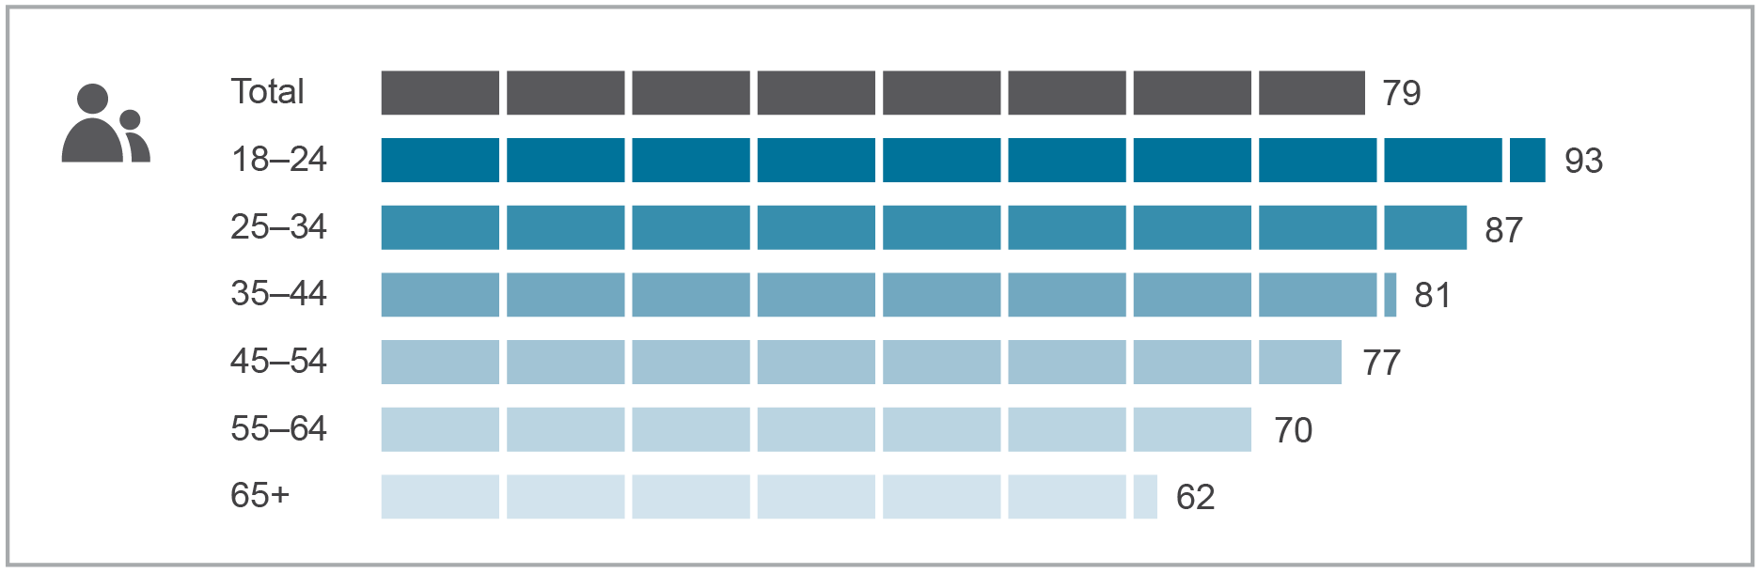
Base: Australians aged 18 and over who accessed the internet.
Source: ACMA-commissioned survey, June 2016.

Communications apps
In the six months to June 2016, 49 per cent (8.12 million) of online Australians had used an app to communicate with others online. When using apps to communicate with others, Australians preferred to send messages (44 per cent) than make voice or video calls. Just over a quarter of online Australians made voice calls via an app (27 per cent), while slightly less than a quarter made video calls via an app (23 per cent). Seventeen per cent of Australians engaged in all three activities. Those aged 18 to 44 were the most active users of communications apps (Figure 2.13).
Figure 2.13 Use of communications apps, by activity and age, in the six months to June 2016 (percentage)
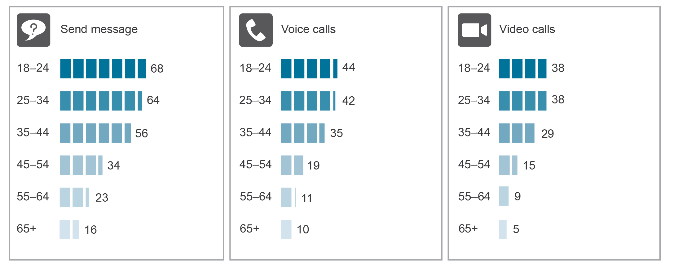
Base: Australians aged 18 and over who accessed the internet.
Source: ACMA-commissioned survey, June 2016.

Use of communications apps compared to other types of services
When communicating with others via video call, 79 per cent of adult Australians used apps rather than other types of services such as mobile phones or fixed-line telephones. Slightly more than a quarter of Australians preferred to use apps when sending text messages (27 per cent), while only 11 per cent did so when making voice calls (Figure 2.14).
Figure 2.14 Communications activity, by type of service, in the six months to June 2016 (percentage)
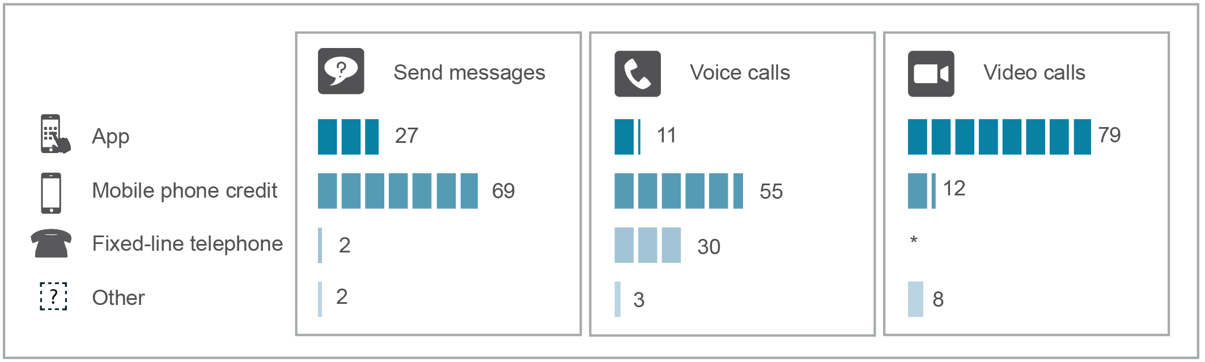
*Data not available
Base: Australians aged 18 and over who undertook the following activity: send messages (n=1,685), voice calls (n=2,056), video calls (n=505).
Note: Numbers may not add up due to rounding.
Source: ACMA-commissioned survey, June 2016.

The preference for using apps to send messages and make voice calls was related to age. Half of Australians aged 18 to 24 preferred using apps for sending messages (50 per cent), followed by 40 per cent of those aged 25 to 34 and 34 per cent of those aged 35 to 44. In terms of voice calls, 22 per cent of Australians aged 25 to 24 preferred using apps for voice calls, followed by 18 per cent of those aged 18 to 24 and 15 per cent of those aged 35 to 44. This number declined to only nine per cent of those aged 45 to 54.
However, preferring apps for video calls was high among all groups—83 per cent of Australians aged 18 to 24 preferred using apps for video calls, followed by 81 per cent of those aged 25 to 34 and 80 per cent of those aged 45 to 54.
Communications apps in use
Facebook Messenger remains the most preferred communications app—41 per cent of online Australians use it to either send messages or make voice or video calls (Figure 2.15). Skype is the next most preferred at 25 per cent, followed by WhatsApp (20 per cent) and FaceTime (14 per cent).
The choice of app was influenced by age. Facebook Messenger was the most preferred communications app for those aged 18 to 64. Skype and Facebook Messenger were the equal most preferred communications app for those aged 65 and over.
Figure 2.15 Top 10 communications apps used in the six months to June 2016 (percentage)
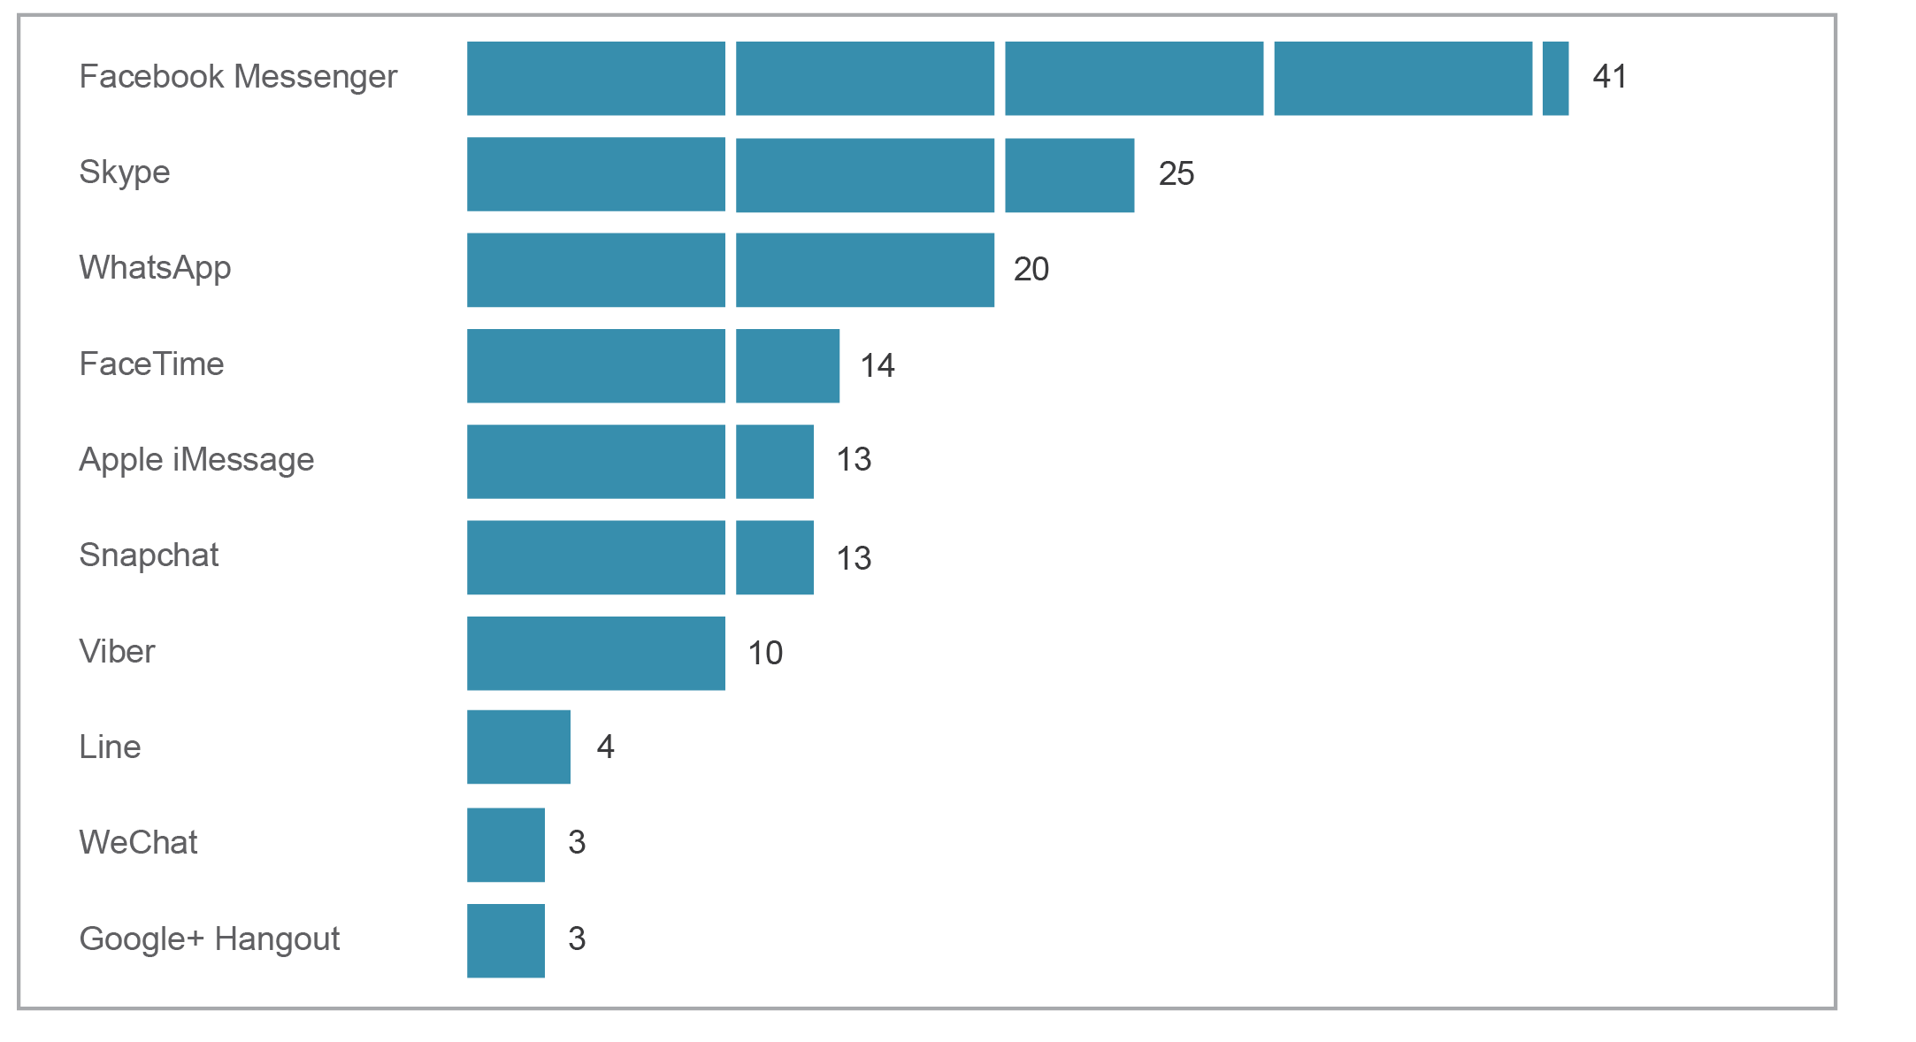
Base: Australians aged 18 and over who accessed the internet.
Source: ACMA-commissioned survey, June 2016.

Australians are using different apps for different types of communications activities (Figure 2.16). Facebook Messenger was the most popular app to send messages, preferred by 39 per cent of online Australians. Skype was the most used app for voice calls at 19 per cent, followed closely by Facebook Messenger at 18 per cent. Skype also led for video-calling, preferred by 15 per cent of online Australians.
Figure 2.16 Top 10 communications apps, by activity, in the six months to June 2016 (percentage)
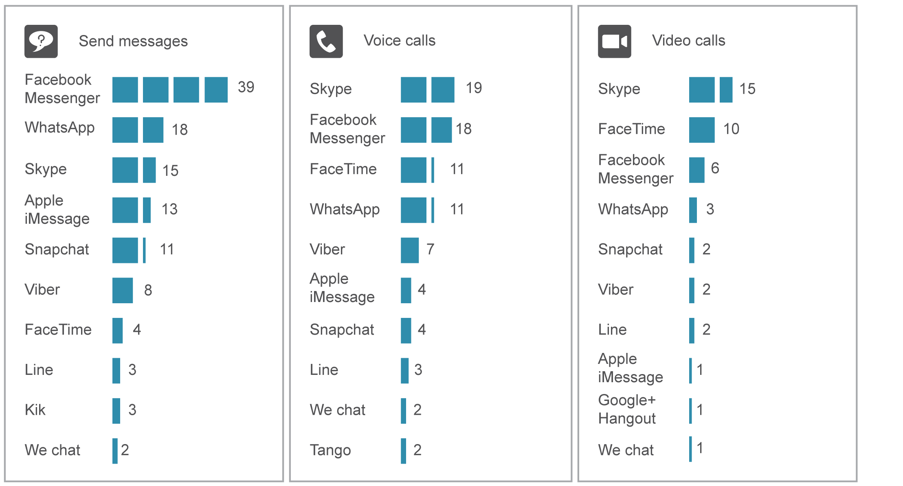
Base: Australians aged 18 and over who accessed the internet.
Source: ACMA-commissioned survey, June 2016.

Internet activities

Performing activities online
Further confirmation of Australians’ strong engagement online is reflected in the high levels of participation across a diverse range of online activities. Figure 2.17 shows the three most popular online activities for Australian adult internet users at June 2016 were sending and receiving email (97 per cent), general internet browsing (96 per cent) and using the internet to research or gather information (95 per cent). These traditional online activities indicate generally high levels of engagement across all age groups. At June 2016, more than nine in 10 (95 per cent) internet users aged 65 and over communicated using email—this represented 2.05 million people.
Additionally, more than 80 per cent of online Australian adults used the internet to do banking or pay bills (88 per cent).
Figure 2.17 Performing activities online, six months to June 2016 (percentage)
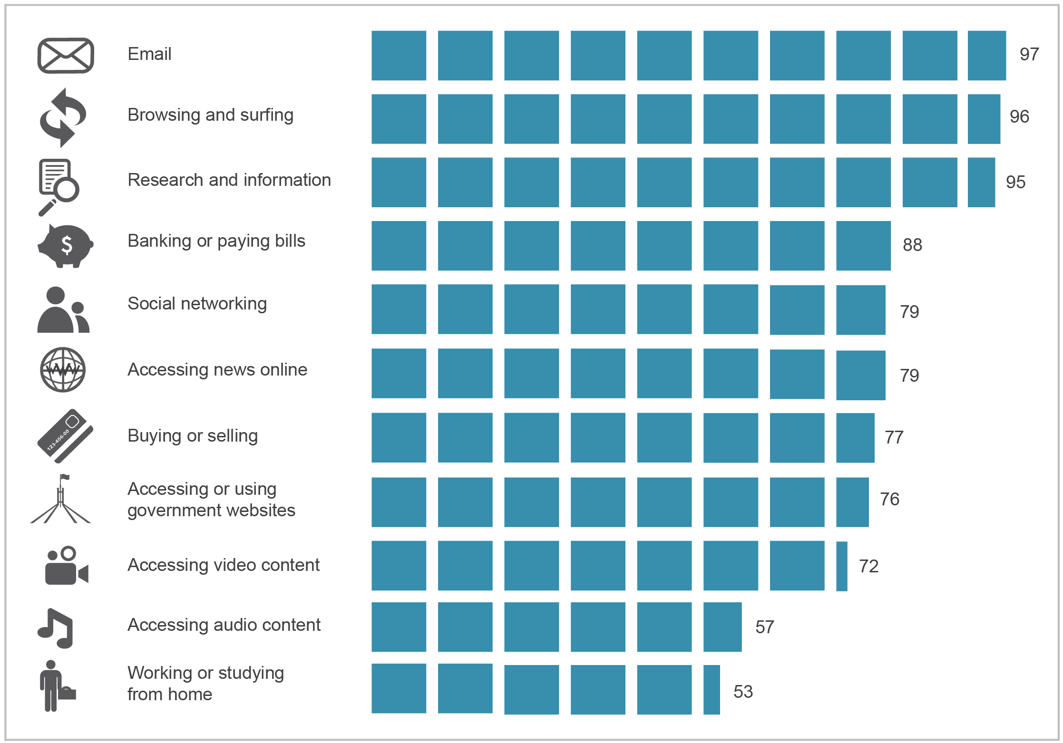
Base: Australians aged 18 and over who accessed the internet.
Source: ACMA-commissioned survey, June 2016.

Accessing online video and audio content
While traditional free-to-air (FTA) television continues to dominate content viewing, the way Australians access video and audio content is changing, with many now accessing similar content online.
As shown in Figure 2.18, more than two-thirds of online Australian adults accessed online video content (72 per cent) and more than half listened to audio content online (57 per cent). These activities were directly proportional to age. The vast majority of young people aged 18 to 24 accessed video content online (94 per cent), but this dropped to 42 per cent for those aged 65 and over. A similar pattern of diminishing participation with age was also observed in accessing audio content online.
Figure 2.18 Accessing online video and audio content, by age, in the six months to June 2016 (percentage)
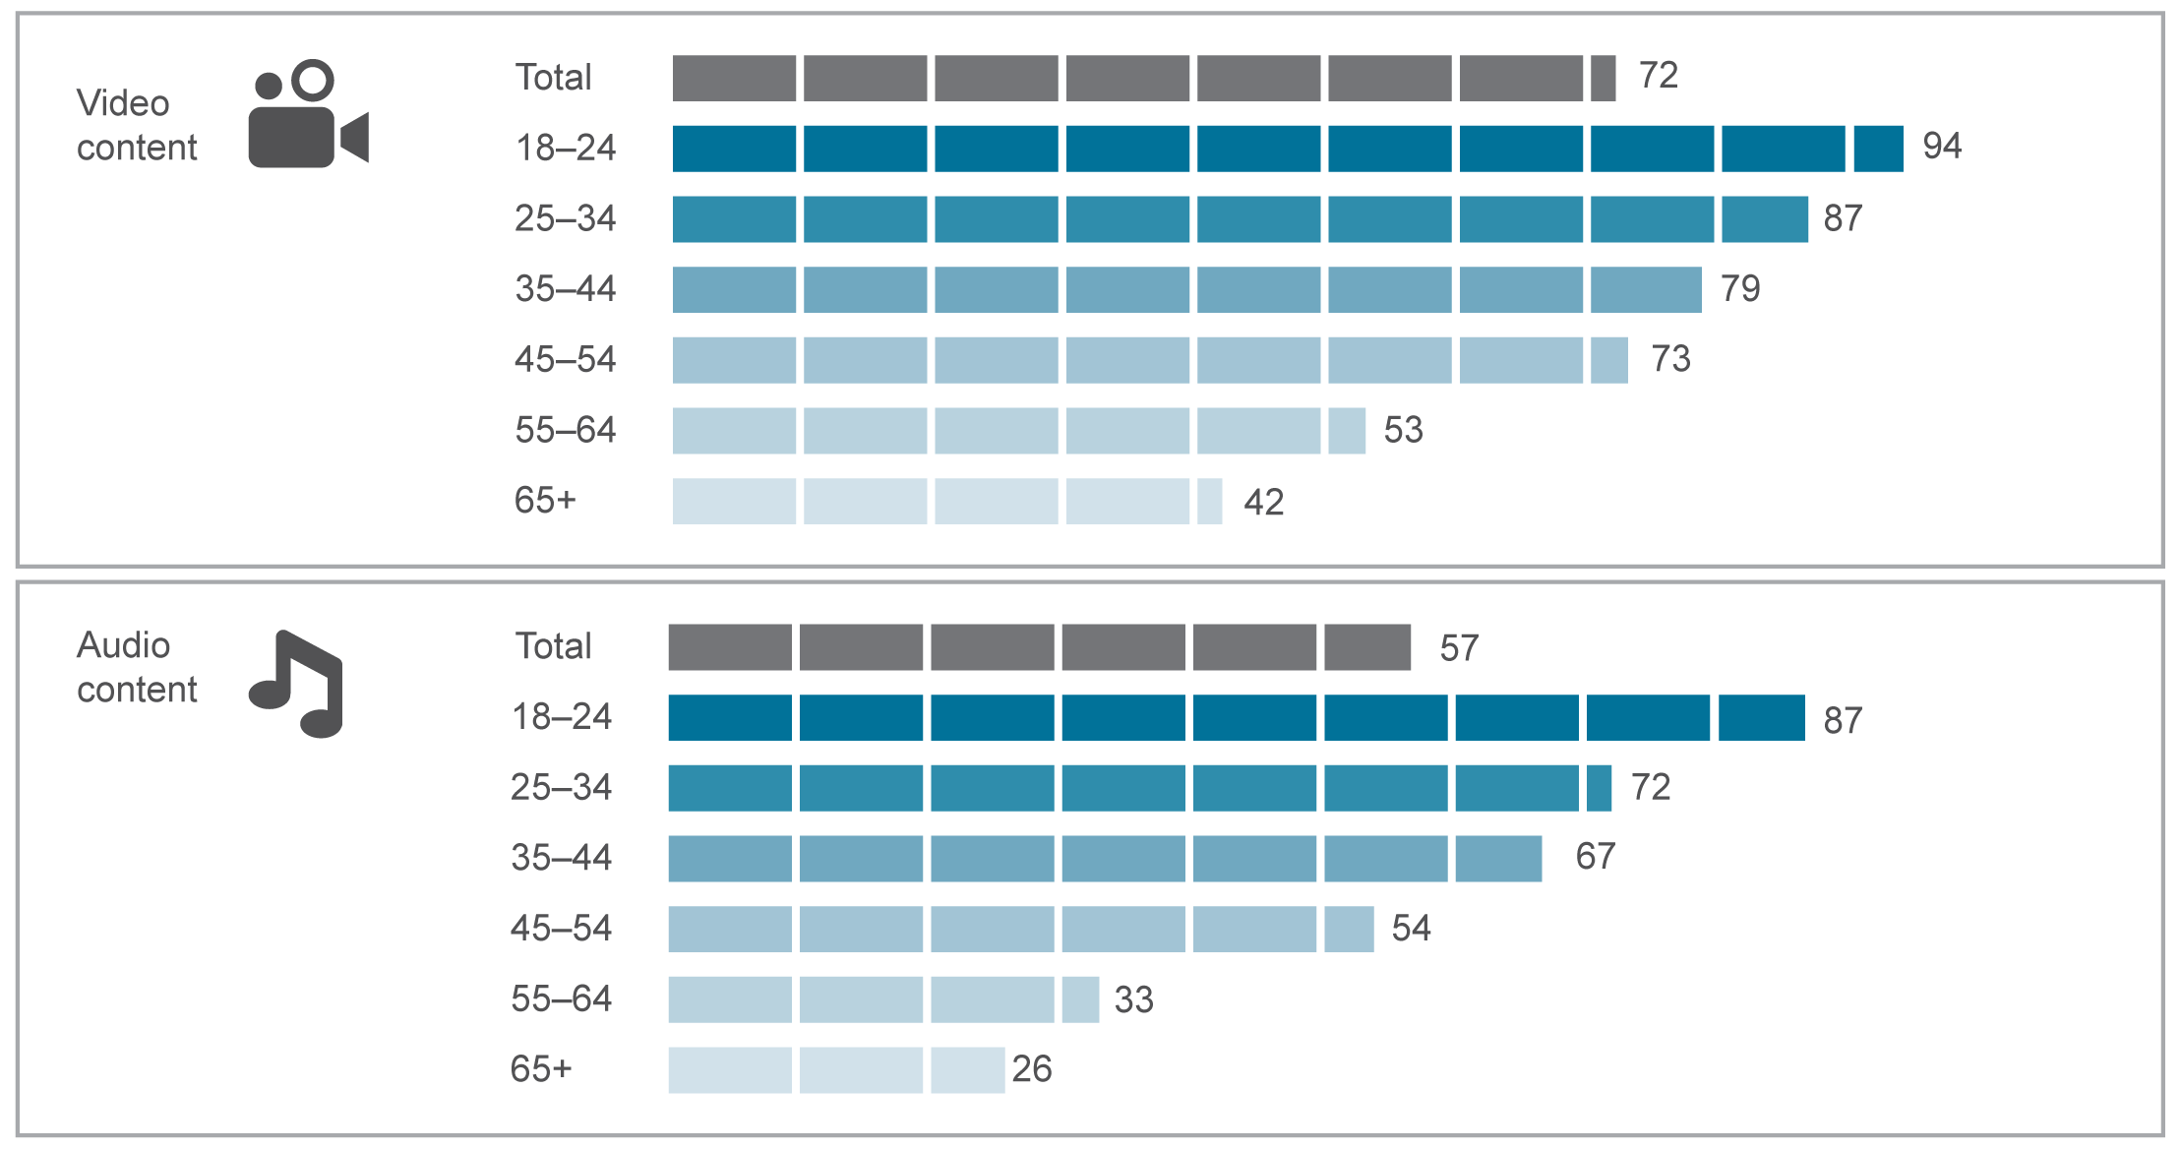
Base: Australians aged 18 and over who accessed the internet.
Note: ‘Accessing video content’ refers to downloading or streaming video. ‘Accessing audio content’ refers to downloading or streaming audio.
Source: ACMA-commissioned survey, June 2016.

Downloading versus streaming audio and video content
The two methods that Australians use to access audio and video content online—downloading and streaming—are also changing. Streaming audio or video content is becoming much more prevalent than downloading audio or video content (see Figure 2.19).
In the six months to June 2016, 73 per cent of online Australians used streaming to access online audio or video content, while only 51 per cent used downloading to access online audio or video content.
Figure 2.19 Downloading and streaming audio and video content in the six months to June 2016 (percentage)
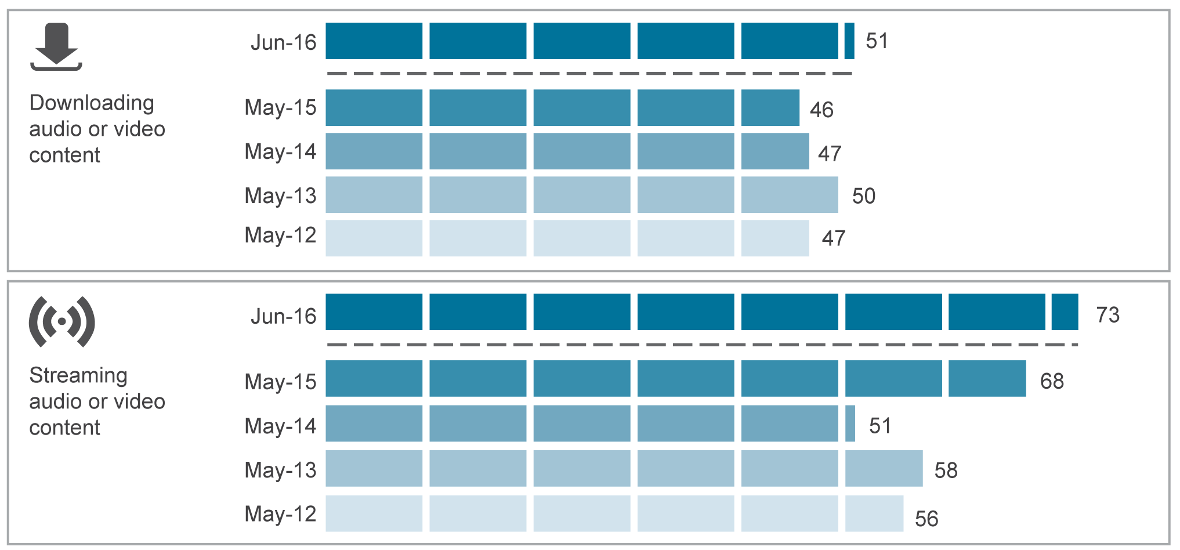
Base: Australians aged 18 and over who accessed the internet.
Source: ACMA-commissioned surveys, May 2012, 2013, 2014, 2015 and June 2016.

To further break down this preference for streaming over downloading, online Australians were more likely to prefer streaming over downloading when it came to video content rather than audio content (see Figure 2.20).
In the six months to June 2016, 70 per cent of online Australians streamed video content compared to just 32 per cent who downloaded video content, while 43 per cent of online Australians both streamed and downloaded audio content. Streaming video content was most prevalent among those aged 18 to 24, with 91 per cent of this group having streamed content in the six months to June 2016.
Figure 2.20 Downloading versus streaming content in the six months to June 2016 (percentage)
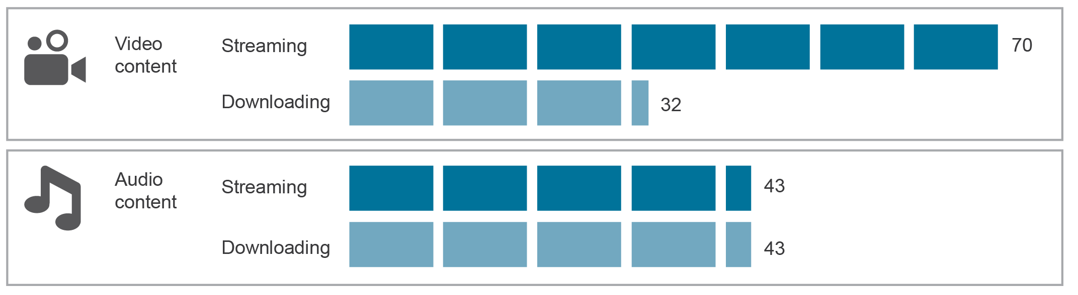
Base: Australians aged 18 and over who accessed the internet.
Source: ACMA-commissioned survey, June 2016.

See Chapter 3 for more detail on online access to audio and video content.

Growth in e-commerce activity
Data from the ABS shows that Australian businesses generated an estimated $285.5 billion in revenue from online sales of goods and services during 2014–15 (the latest figures available). This was an almost $20 billion increase on revenue received in 2013–14.
Growth in e-commerce activity was also reflected in the increase in the number of Australians who undertook online transaction activities. In the six months to June 2016, the majority of adult Australians (94 per cent or an estimated 15.64 million people) went online to conduct banking, pay bills, or buy and/or sell goods and services.

Online buying, selling and shopping
Many Australians are active participants in the online economy. In the four weeks to June 2016, 7.9 million adult Australians (43 per cent) purchased or sold something online—up two percentage points from June 2015. The most preferred device for these online activities was a laptop or desktop (34 per cent), followed by a mobile phone (17 per cent) and a tablet (eight per cent).
Those living in capital cities were more likely to buy online (45 per cent) than people in country areas (39 per cent).
As illustrated in Figure 2.21, those aged between 25 and 54 were most likely to be online shoppers, while the largest increase in online shopping was seen in those aged 25 to 34.
Figure 2.21 Online buying, selling and shopping, by age (percentage)
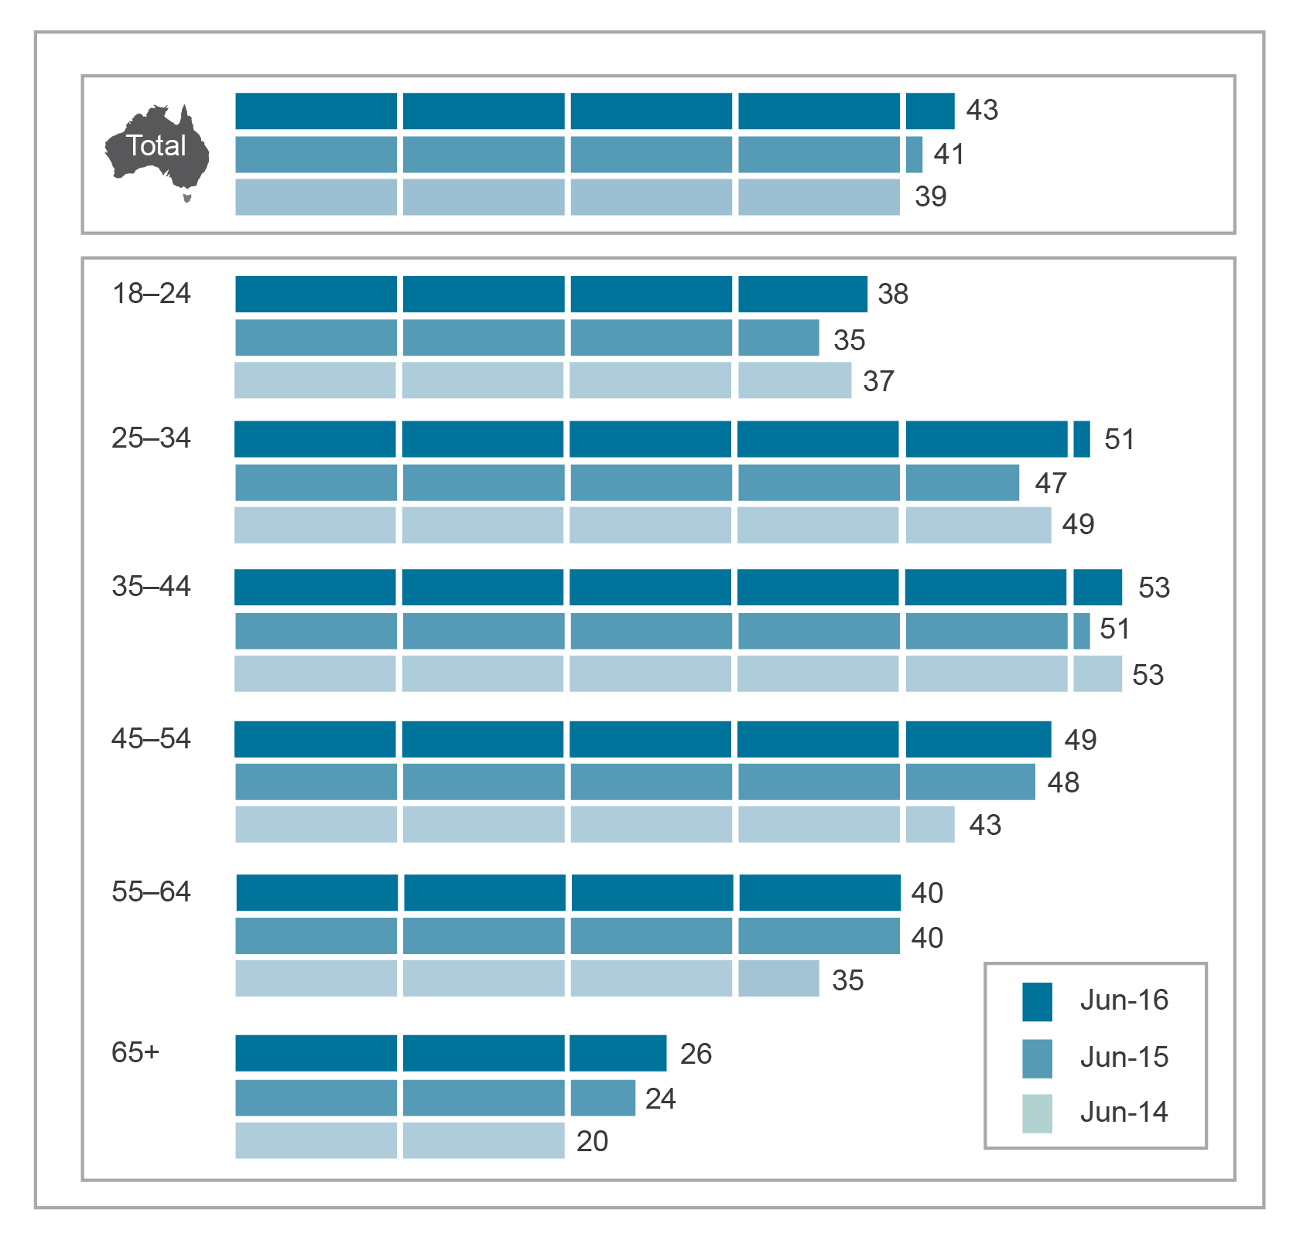
Base: Australians aged 18 and over.
Notes: Relates to transactional buying, selling and shopping activities undertaken online in the last four weeks, for the 12 months to June of each year.
Changes to Roy Morgan weighting methodology may cause some differences to 2014-15 data measures reported in the previous Communications report.
Source: Roy Morgan Single Source, June 2014, 2015 and 2016.

Australian businesses online
The latest available data from the ABS shows that Australian businesses grew their online presence during 2014–15. While the majority of Australian businesses had internet access (95 per cent)—stable compared to 2013–14—the number of businesses with a web presence increased two percentage points to reach 49 per cent. This is reflected in the increase in the number of domain names registered in Australia (see Chapter 1). In the 12 months to June 2016, the number of registered ‘.au’ domain names increased by two per cent to 3.04 million.
The number of Australian businesses on social media also increased during 2014–15, with 34 per cent of businesses reported having a social media presence, a three per cent increase on 2013–14.

Consumer satisfaction with communications services
Figure 2.22 shows that the majority of Australians are generally satisfied with their communications services. The highest levels of satisfaction—satisfied or very satisfied—were seen for fixed-line telephone and mobile phone services (both at 92 per cent).
Internet services had the highest levels of dissatisfaction with 12 per cent either dissatisfied or very dissatisfied.
Figure 2.22 Overall satisfaction with communications services in the six months to June 2016 (percentage)
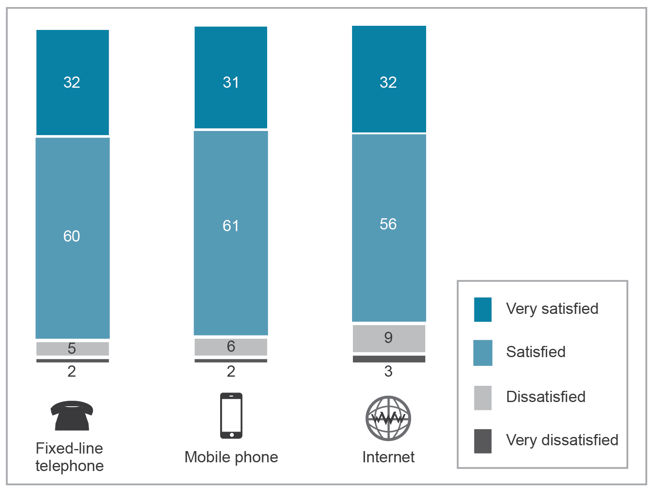
Base: Australians aged 18 years and over using a fixed-line telephone (n=1,442), mobile phone (n=1,904), internet (n=1,849).
Notes: Numbers may not add up due to rounding. Excludes ‘don’t know’ responses.
Source: ACMA-commissioned survey, June 2016.

Satisfaction with different aspects of communications services is outlined in Figure 2.23. The highest levels of satisfaction (very satisfied and satisfied) and dissatisfaction (very dissatisfied and dissatisfied) within each service were as follows:
 | Fixed-line service—the highest levels of satisfaction were for service reliability, with 93 per cent satisfied or very satisfied, up four percentage points since May 2015. Line rental cost recorded the highest levels of dissatisfaction (25 per cent dissatisfied or very dissatisfied).
 | Mobile phone—quality of voice calls recorded the highest levels of satisfaction (94 per cent), an increase of five percentage points on last year’s figure, while call/service costs (16 per cent) recorded the highest levels of dissatisfaction.
 | Internet—the highest levels of satisfaction were recorded for billing information (91 per cent), while data speeds and service costs (both 26 per cent) recorded the highest levels of dissatisfaction.

Figure 2.23 Consumer satisfaction with aspects of their communications services (percentage)
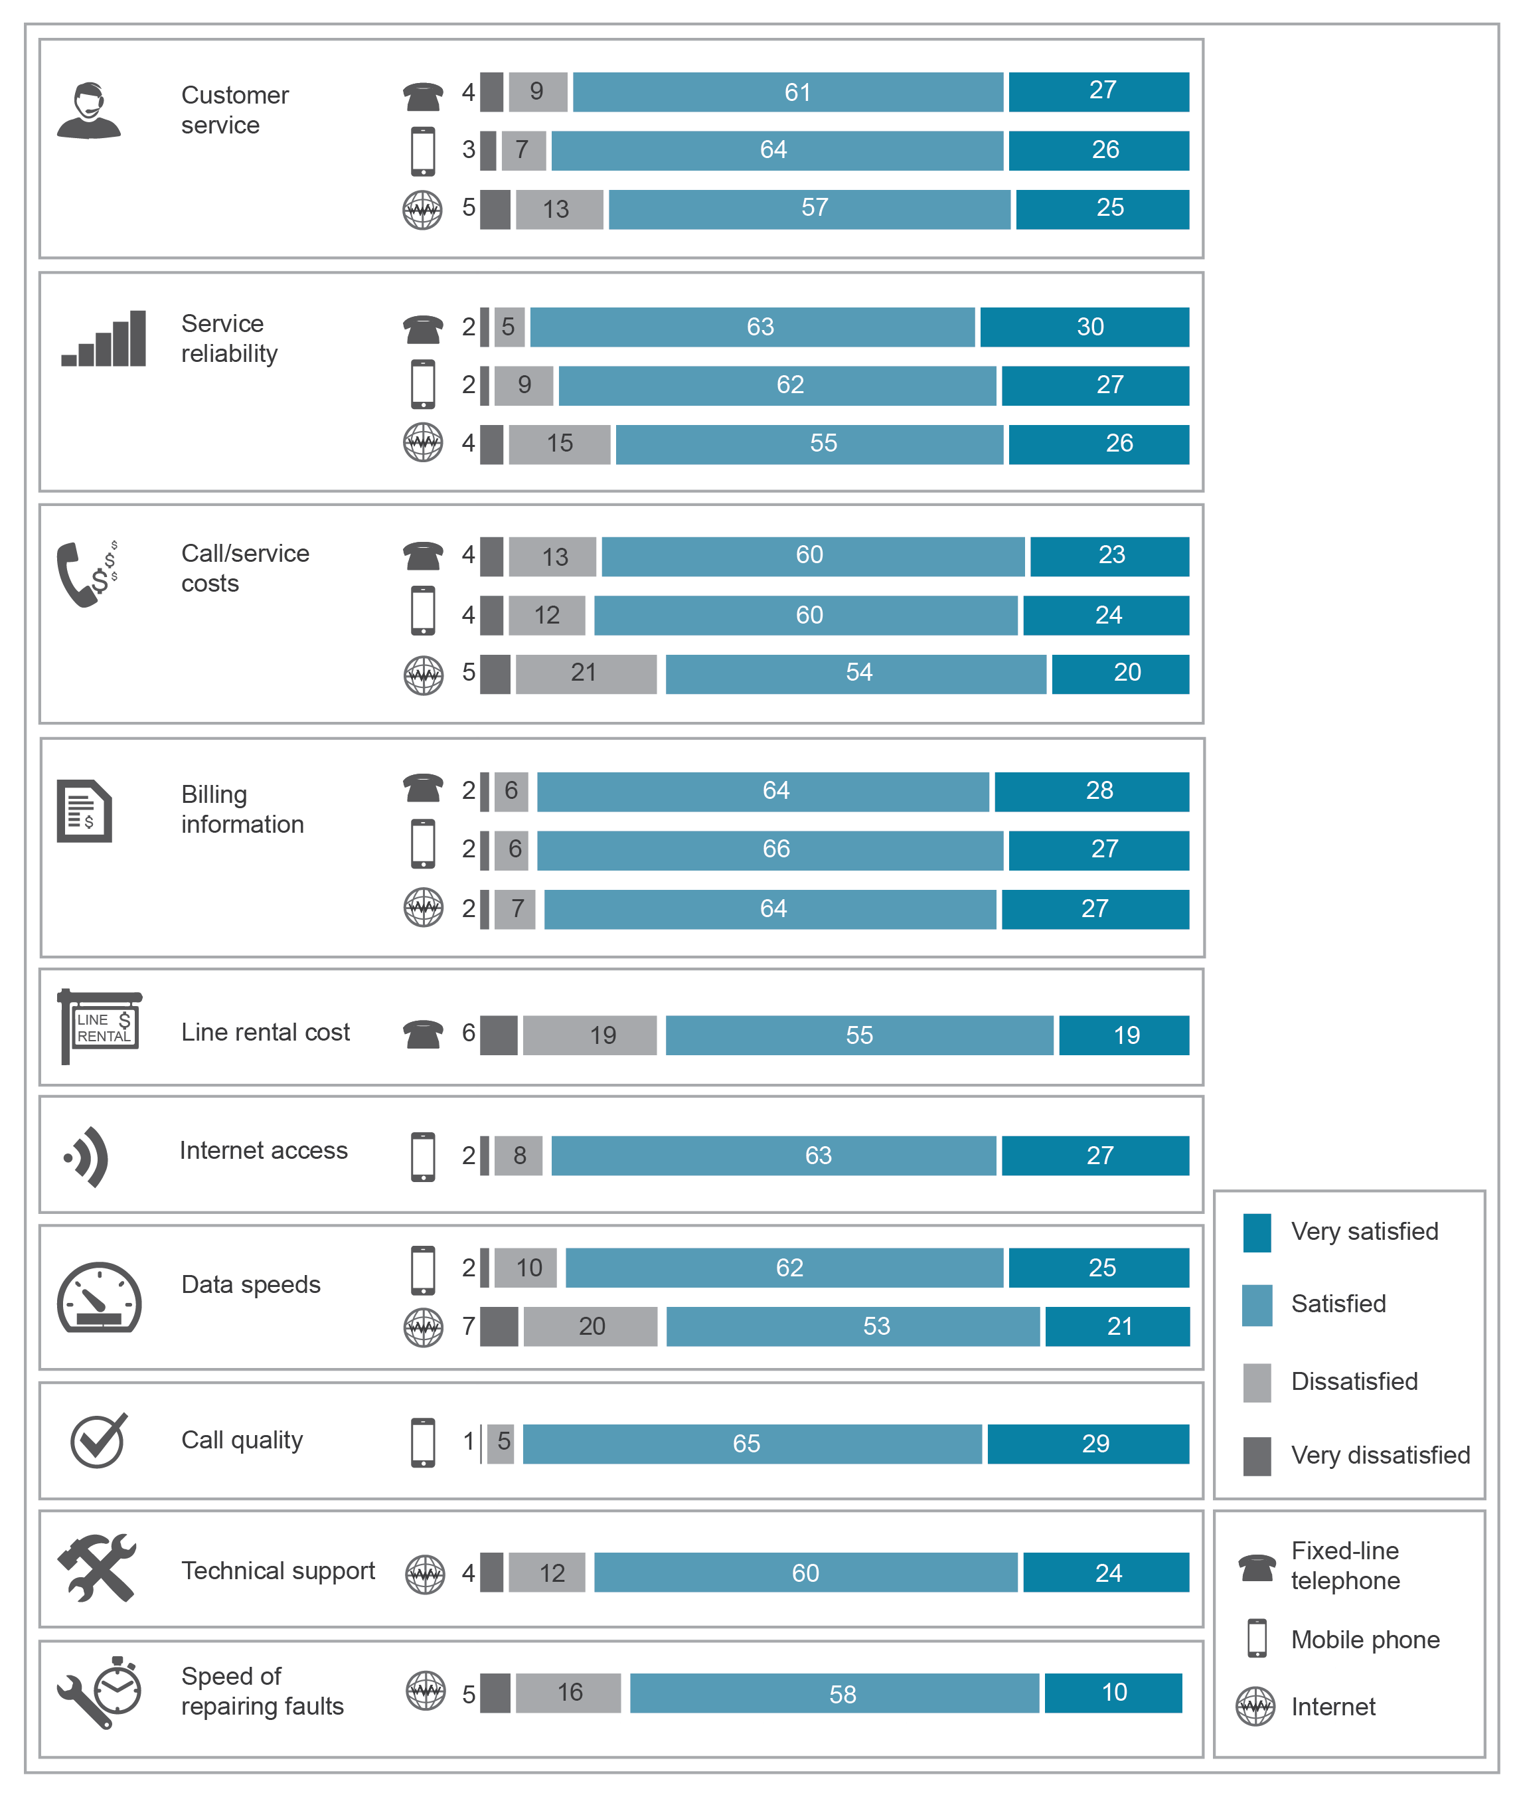
Base: Australians aged 18 years and over using a fixed-line telephone (n=1,442), mobile phone (n=1,904), internet (n=1,849).
Notes: Numbers may not add up due to rounding. Excludes ‘don’t know’ responses.
Source: ACMA-commissioned survey, June 2016.

International trends
International data that is currently available allows a broad-level comparison of the availability of communications services, internet adoption levels, and device take-up and usage across Australia, the United States (US), the United Kingdom (UK) and the European Union (EU).

Communications services
The recent Australian experience of the rise of mobile-only households is also reflected in other countries:
- 13 per cent of the US population was living in a smartphone-only household (a smartphone but no broadband internet connection at home)—an increase of five per cent since 2013
- in the first quarter of 2015, 15 per cent of adults in the UK lived in mobile-only households, a decrease of one percentage point since the same time in 2014
just over three in 10 households in the EU (33 per cent) had only mobile telephone access, with no fixed telephone access (October 2015).

Access to the internet
Table 2.1 suggests that Australia has similar or higher levels of general and mobile phone internet users than the US and UK.
Table 2.1 International trends in access to the internet (percentage)
 | Home broadband connection |  | Use mobile phone to access the internet |  | Use the internet
 | 2015 | 2016 | 2015 | 2016 | 2015 | 2016
Australia | 86 | 85 | 73 | 70 | 92 | 91
US | 67 | n/a | 64* | 70 | 84 | 89
UK | 80 | 81 | 61 | 66 | 85 | 86
*Relates to the use of smartphone.
Notes: Data for the UK broadband connection relates to households. UK data collected in January/February. Australian data for ‘Use the internet’ and ‘Use mobile phone to access the internet’ relates to six months to June; ‘Home broadband connection’ relates to 12 months to June.
Australian and US data refers to total population aged 18 and over. UK data refers to people aged 16 and over.
Sources: Data relating to Australia—Roy Morgan Single Source June 2015 and 2016 (Home broadband connection), and ACMA-commissioned survey May 2015 and June 2016 (‘Use the internet’ and ‘Used mobile phone to access the internet’); UK—Ofcom;
US—Pew Research Centre (‘Use mobile phone to access the internet [2015]’ and Use the internet [2015]’, Statista (‘Use mobile phone to access the internet [2016]’) and Internet Live Stats (‘Use the internet [2016]’).

Internet access devices
Increased reliance on mobile devices to access the internet is also evident in other countries:
- 72 per cent of adult Americans owned a smartphone in early 2015, an increase of eight percentage points from October 2014
- smartphone ownership in the UK rose to 70 per cent at October 2015, an increase of four percentage points from 2014
59 per cent of adults in the UK owned a tablet in early 2016, a five per cent annual increase.

Activities performed online
Greater access to the internet, and fast and reliable broadband services in Australia has facilitated a strong engagement with online activities. Similar online behaviours are evident internationally, as reflected in the range of activities undertaken online (Table 2.2). For example, popular online activities in the UK not only included activities such as sending email (93 per cent) and internet browsing (92 per cent), but also social networking (76 per cent).
Table 2.2 International comparisons—activities performed online (Australia and UK)
 |  | Australia—online aged 18 and over (%) | UK—online aged 16 and over (%)
 | Email | 97 | 93
 | Browsing and surfing | 96 | 92
 | Banking/paying bills | 88 | 67
 | Social networking | 79 | 76
 | Accessing government websites | 73 | 68
 | Playing games | 34 | 41
Base: Australia: internet users aged 18 and over; UK: internet users aged 16 and over.
Note: Australian data relates to performing activities online in the six months to June 2016.
UK (Ofcom) data was collected September to October 2015 and covers all adults aged 16 and over who go online at home or elsewhere.
Source: Australian data: ACMA-commissioned survey, June 2016. UK data: Ofcom, Adults’ Media Use and Attitudes Report, 2016.

Television, radio and online content developments

Overview
This chapter explores the developments in audio and video content, covering content delivered via broadcasting and over-the-top (OTT) content services. It looks at radio (traditional, online and digital) and music streaming, and examines changes in the technologies used to supply video content and services. This chapter also reports on viewing behaviours including television ownership, device usage, and engagement with traditional broadcast media, subscription and online viewing. It also looks at developments in online news services and the importance of news in regional Australia.
Information is also presented on the performance of broadcasters in meeting their regulatory obligations.
There are now a range of online content options for the Australian audience. Over 2015–16, the boundaries between communications and media continued to blur, with communications service providers buying content rights and offering or bundling content services, such as the Optus Sports app and Telstra TV. Broadcasters are expanding their range of content services, offering live streaming services and content apps. Subscription video on demand (SVOD) services are an established part of the Australian media landscape, recording around 2.7 million active subscribers at June 2016.
The expanded range of services available is reflected in an increasingly fragmented Australian audience, where households have an average of 6.4 screens on which to view content. At 59 per cent, live FTA television still holds the largest share among adult Australians of time spent with television or professionally produced content. However, younger age groups are showing signs of moving away from live television. The 18 to 24 age group spent more time with online video (5.6 hours) than live FTA television (4.5 hours).
Key points in the reporting period include:
- Listening to the radio remained popular among adult Australians, with 88 per cent listening to some radio in an average seven-day period to June 2015.
- Older Australians listened to the radio the most, at an average of 14 hours per week, while younger Australians listened to around six hours per week.
- In the first four months of 2016, the number of people listening to digital radio increased by 168,000 in Sydney, Melbourne, Brisbane, Perth and Adelaide, taking the reach of digital radio to 3.5 million people in metropolitan areas.
- In the last seven days, 19 per cent of adult Australians had used a streaming music service such as Spotify, Pandora or iTunes radio.
- The average time audiences spend watching live FTA television is continuing to experience a slight decline and fewer people are watching traditional broadcast television every year. Metropolitan broadcasters reached 84 per cent of their potential audience in 2015–16, down from 85 per cent in 2014–15, and regional broadcasters reached 81 per cent, down from 84 per cent.
- Australians watched on average 85 hours and 12 minutes of FTA television in the home per month, either live or played back within seven days of the original broadcast. While this represents a decline of four hours and 16 minutes from the same period in 2015, watching FTA television live still represents the largest share (59 per cent) of the weekly average time spent watching television or video content (excluding pre-recorded DVDs) among Australian adults.
- Ninety-seven per cent of Australian households receive digital terrestrial television on every television set, with an average of 1.9 sets per household. The television set remains the main way to watch video content, even online content, although free video content (such as YouTube) is more likely to be watched on computers or mobile devices.
- In the six months to June 2016, 63 per cent of adult Australians watched some online television or professionally produced online video content, up from 53 per cent in 2015.
- The uptake of SVOD services has increased by almost 46 per cent in the last year, with the number of Australians paying for subscriptions almost doubling to 32 per cent.
- With a range of new entrants offering on-demand content in 2015–16, the market has become increasingly crowded, as the number of providers offering different devices, services and products continues to increase.
- Social media is becoming an increasingly important source of news for Australians, particularly younger Australians, with 29 per cent of people aged 14 to 32 using social media as their primary source of news, compared to 18 per cent relying on television news.
- Broadcast television remains the main source of news for adult Australians, with 36 per cent accessing news via the television.
- Local news remains extremely important to those living in regional area of Australia—77 per cent believe access to local news is important, and 40 per cent believe it is very important.
- All FTA commercial television licensees met the Australian transmission quota and sub-quota requirements for drama, documentary and children’s programs for the 2015 calendar year.
All regional commercial radio and television broadcasting licensees broadcast the required amount of material of local significance.

Audio content

Industry developments in radio and audio content
Australians have access to a growing array of audio entertainment options, from radio to online music streaming.
The growing importance of digital audio options can be seen in the impact of the digital platform on the music sector. Music sales increased by five per cent in 2015—the first increase in three years—driven by a 10.6 per cent growth in digital content (including music streaming), which now accounts for 62 per cent of the overall market by value.
Spotify, Apple Music, Google Play and Pandora remain the leading music streaming services in Australia, but there was an overall consolidation in the number of music streaming services available. Australian-owned Guvera exited the market in August 2016, and Nokia’s MixRadio also closed in 2016 after citing performance issues and financial challenges posed by the music streaming market. In September 2015, Telstra closed its online streaming service Mog and entered into an agreement with Apple Music, offering its customers an introductory free 12-month subscription. In August 2016, Telstra announced that its mobile customers will be able to use Apple Music unmetered.
Access to radio
Audience numbers remained stable for traditional radio, while audio streaming services experienced strong growth from a smaller base.
Reach of radio remains stable
Listening to the radio remains popular with adult Australians, with 88 per cent listening to some radio in an average seven-day period to June 2016. This figure is consistent with the previous three years, with an increase from 2012 (Figure 3.1).
Figure 3.1 Listening to radio, last seven days (percentage)
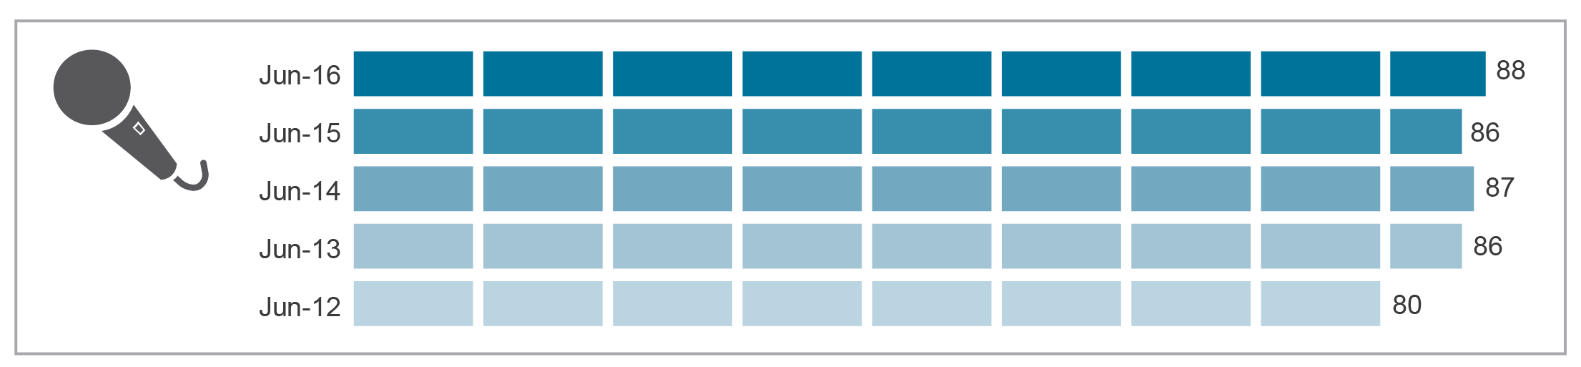
Base: Australians aged 18 and over.
Note: Changes to Roy Morgan weighting methodology may have resulted in some differences to the 2014–15 data measures reported in the previous Communications report.
Source: Roy Morgan Single Source.

ACMA research undertaken in June 2016 found that 79 per cent of adult Australians had a radio at home. Seventy-three per cent of those surveyed had listened to FM radio and 37 per cent to AM radio in the last seven days.
The use of digital radio is increasing, with listening figures rising by 168,000 in Sydney, Melbourne, Brisbane, Perth and Adelaide during the first three survey periods of 2016. Some 26.3 per cent of Australians listened to radio via a DAB+ digital radio, taking the reach of digital radio to 3.5 million in metropolitan areas.
Fourteen per cent of adult Australians have listened to the radio online in the last seven days. Younger Australians were more likely to listen to radio online—17 per cent of those aged 18 to 34 had listened to radio online compared with only six per cent of those aged 65 and over.

Audience engagement

Time spent listening to radio
More time is spent listening to traditional radio (AM and FM) than to digital radio or the radio online. A majority of time spent listening to the radio (traditional, digital and online) occurs at home. People spend, on average, an hour longer listening to AM radio in the home than in the car, while the average time spent listening to FM radio at home is 2.6 hours, compared to 2.4 hours in the car.
Older Australians (aged 65 and over) are the predominant radio audience, listening to an average of 14 hours per week, with six hours dedicated to listening to AM radio at home. Conversely, younger Australians are listening the least—six hours per week—with the most time spent listening to FM radio in the car (Figure 3.2).
Figure 3.2 Time spent listening to the radio (AM, FM, DAB+ or online) in the last seven days
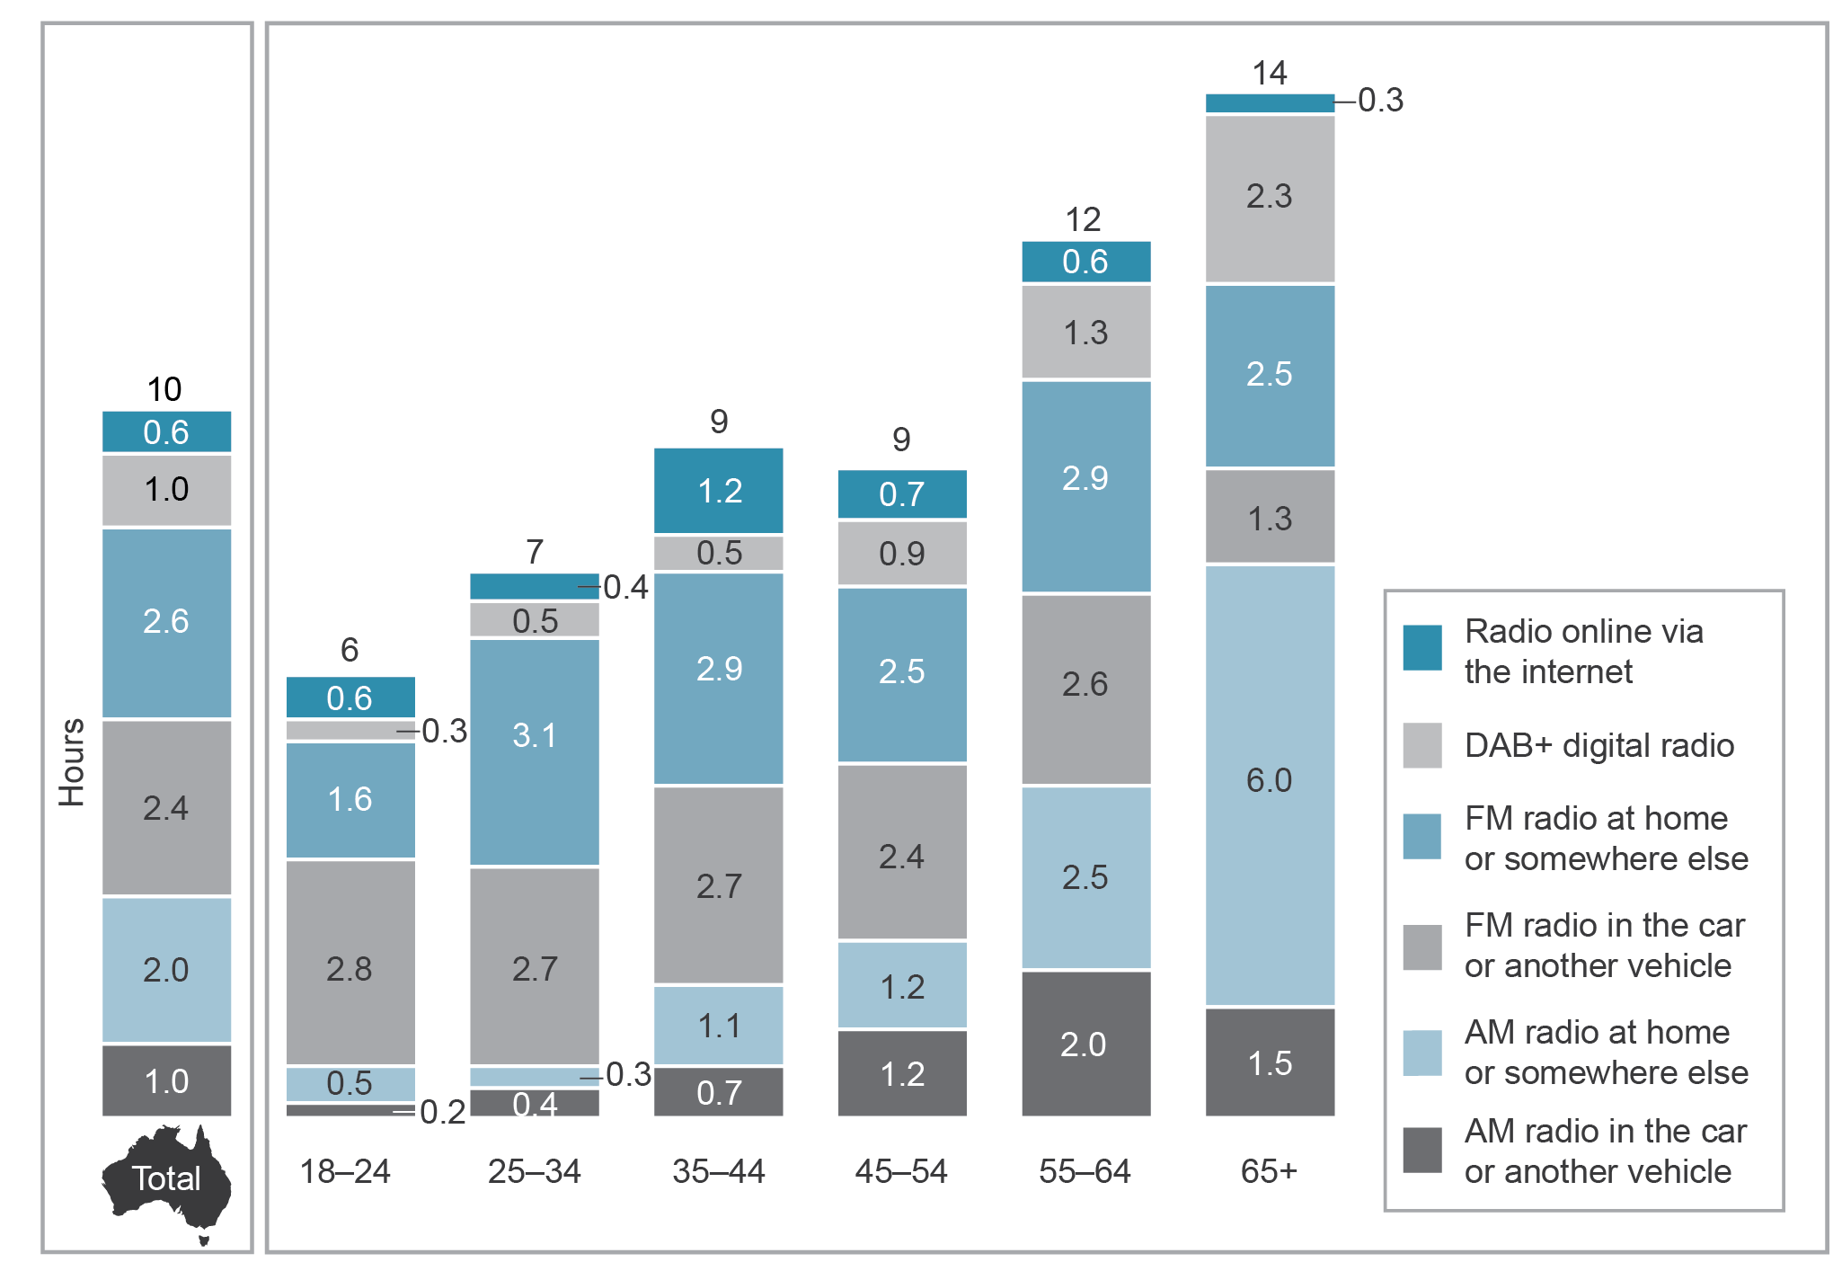
Base: Australians aged 18 and over who have listened to the radio in the last seven days (n=1,717).
Note: Numbers may not add up to category totals due to rounding.
Source: ACMA-commissioned survey, June 2016.

Music streaming services
Nineteen per cent of adult Australians had used a streaming music service such as Spotify, Pandora or iTunes radio in the last seven days. Spotify is the most used music streaming service, with 58 per cent of respondents using the service. The average time spent by Spotify users is 8.1 hours, with a total average time spent streaming online music of 6.6 hours (Figure 3.3).
Figure 3.3 Music streaming services used in the last seven days (percentage)
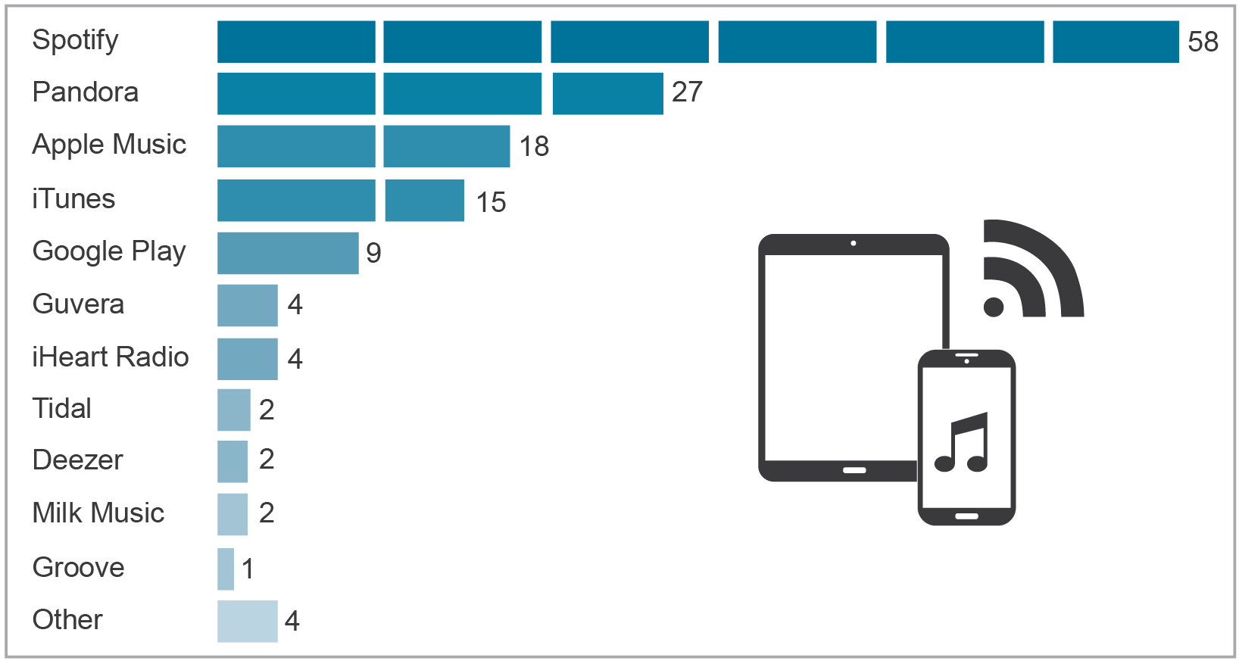
Base: Australians aged 18 and over who used streaming services in the last seven days (N=323).
Source: ACMA-commissioned survey, June 2016.

ACMA research shows that nine out of 10 Australians were satisfied with the technical quality of online audio and radio content, with more than half being very satisfied. Nevertheless, 28 per cent of respondents experienced technical problems in the last seven days. Many issues would appear to be easily remedied, with only slightly lower levels of satisfaction (73 per cent) for those who had experienced three or more technical issues in the last seven days.

Expanding audio measurement
Commercial Radio Australia is expanding surveys beyond metropolitan areas to monitor radio audiences in regional areas. The surveys, conducted by Xtra Research, will help businesses and government bodies to reach audiences by providing current information on the audience reach and listening habits of regional audiences, as some regional markets have not been surveyed in over 10 years.

Video content

Industry developments
Developments from traditional broadcasters, communications providers, online content providers and technology companies are providing more content via multiple services and devices to reflect the changing viewing habits of consumers. Viewers are now able to access more video content than ever before through a range of web-based services, applications and devices.
Traditional broadcasters providing new services
Traditional broadcasters are expanding the platforms on which their content can be accessed. In October 2015, Seven Network launched 7live to replace the previous 7Now catch-up service, becoming the first FTA broadcaster to provide live streaming of their main channel. At the beginning of 2016, the Nine Network also launched a new catch-up TV and live streaming service, 9Now, while the Ten Network rolled out live streaming.
In 2015–16, three new digital channels were launched. In November 2015, the Nine Network launched its third digital channel, 9Life, a lifestyle channel, and SBS launched the Food Network. Seven Network launched 7flix, a new film and entertainment digital channel, in February 2016.
In November 2015, the Nine Network restacked its digital channels to give audiences access to its main channel in HD. The Seven Network followed in May 2016, with the main channel simulcast in HD in Melbourne and Adelaide to provide HD coverage of AFL matches. In Sydney, Brisbane and Perth, 7Mate remained as the HD channel.
The Seven Network’s 2016 Rio Olympics coverage could be seen on all three of its digital channels, via a catch-up service and on a dedicated mobile app with 36 different streams available and the option to upgrade to a premium paid subscription for $19.99, giving unlimited access to more than 3,000 hours of HD coverage.
Changes in regional television
From 1 July 2016, both the Nine Network and Network Ten entered into new affiliation deals with regional networks. Nine signed a five-year affiliation deal with Southern Cross Ten, ending its 30-year affiliation with the WIN Network. In the new agreement, Southern Cross will pay Nine 50 per cent of its ad revenue to broadcast Nine programming into regional areas of Queensland, southern New South Wales, the Australian Capital Territory, Victoria, Tasmania, parts of South Australia, regional Western Australia, and solus markets Mildura in Victoria and Griffith in New South Wales. Network Ten and WIN Network have signed a five-year agreement that will see WIN pay approximately 36 per cent of its revenue to Ten with increases over the duration.
SVOD and streaming devices
SVOD and streaming service offerings continue to expand but other online video-on-demand services ceased in 2015–16.
In March 2016, NBC Universal-owned reality television SVOD service Hayu was launched in Australia, with a subscription fee of $5.99 per month. In June 2016, Foxtel partnered with NBC Universal to provide the service free for Foxtel subscribers who have the E Entertainment channel in their subscription package. Hayu is the only new SVOD service to launch in Australia since the arrival of Netflix, Stan and Presto in 2015.
While the SVOD services launched in 2015 have experienced a strong take-up from Australian households, other Australian online video-on-demand services have ceased operations. Quickflix went into administration in early 2016, following on from the closure of locally owned on-demand service EzyFlix in August 2015.
In addition, Foxtel announced in October 2016 the closure of local SVOD service Presto by January 2017, after acquiring joint venture partner Seven West Media’s stake. The closure was announced in conjunction with a remodel of their Foxtel Play subscription packages, with prices starting from $10 a month.
In contrast, Australian internet protocol television (IPTV) providers are expanding their services. Fetch TV launched a new streaming device, the Mini, on 4 July 2016 to accompany the Mighty service currently available through the Optus network. The Mini offers a budget alternative to the Mighty, while still providing access to streaming services Netflix, Stan, movie purchase/rentals, catch-up television and the recently added Presto, Spike and Comedy Central.,

Developments from content providers
Technology and telecommunications providers are developing new ways for consumers to access the vast amount of streaming services and online video content. Communications providers like Optus and Telstra are extending the content services they offer. Optus launched the Optus Sport app on 4 July 2016, giving consumers access to the English Premier League, with 10 channels streaming scheduled programming and live action. The service is also available through the ‘Yes TV’ app, via Fetch TV and Apple TV. In August 2016, Telstra launched a new mobile app, Telstra TV+, which provides access across Stan, Presto, BigPond Movies, Apple Music and catch-up services via a single search-and-launch point, while also allowing customers to use their mobile devices as remotes for the Telstra TV set-top-box.
In addition, a number of devices, such as Apple TV, Google’s Chromecast, Fetch TV and Telstra’s TV Product Roku and Roku 2 offer alternative ways to watch online content on a television set that is not itself internet-connected. LG’s latest generation of smart televisions will come with an additional 50 internet streaming channels, made available through a dedicated app with an integrated TV guide that allows users to stream content in a more traditional linear-like fashion, while still offering content on demand.

Developments in audience measurement
Because of the changes in the way content is supplied and viewed by Australians, new measures of audience measurement are being developed. At the beginning of 2016, OzTAM began reporting on
8–28-day playback on television sets, and launched the Video Player Measurement (VPM) report, measuring for the first time television playback ratings across a 28-day period and the number of devices used to stream broadcasters’ online catch-up video players. The first-quarter results showed that around 2.5 to three per cent was added to program ratings through 8–28-day playback and VPN.
In July 2016, OzTAM and RegionalTAM announced they will increase the number of homes on their television audience measurement panels by 50 per cent by the start of 2017, making Australia the world’s largest per capita people-metered market. With the changes in audience viewing habits, the additional homes on the panel will ensure television ratings are more representative of the overall population as people continue to spread their viewing across new channels. The number of homes across the five city metro panel will increase to 5,250, the STV panel to 2,120 and the regional panel to 3,000.

Devices used to access video content
The increase in online video content and access to SVOD services has seen a rise in the number of devices used to access the internet. However, despite the wide range of devices able to display broadcast and online content, the television set remains the most popular way of watching video content.
Ninety-seven per cent of Australian households receive digital terrestrial television on every television set, with an average of 1.9 sets per household. Forty-five per cent of television sets are smart televisions, although not all have been connected to the internet (28 per cent of all television sets are internet-connected).
Australians are increasingly using their televisions to view video-on-demand services, with 56 per cent of those aged 16 and over using their home television set to watch video on demand in 2015, compared to 44 per cent in 2014.
Each household now has an average of 6.4 screens per household, up from 5.4 in 2012, creating more opportunities to view broadcast television and other video. There are approximately 2.31 million connected devices accessing catch-up television each week; however, 88 per cent of Australians are still watching broadcast television on in-home sets each week.
Figure 3.4 shows that a television set remains the main way to watch video content—even online content—although free video content (such as YouTube) is more likely to be watched on computers or mobile devices.
Figure 3.4 Devices used for viewing different types of content (percentage)
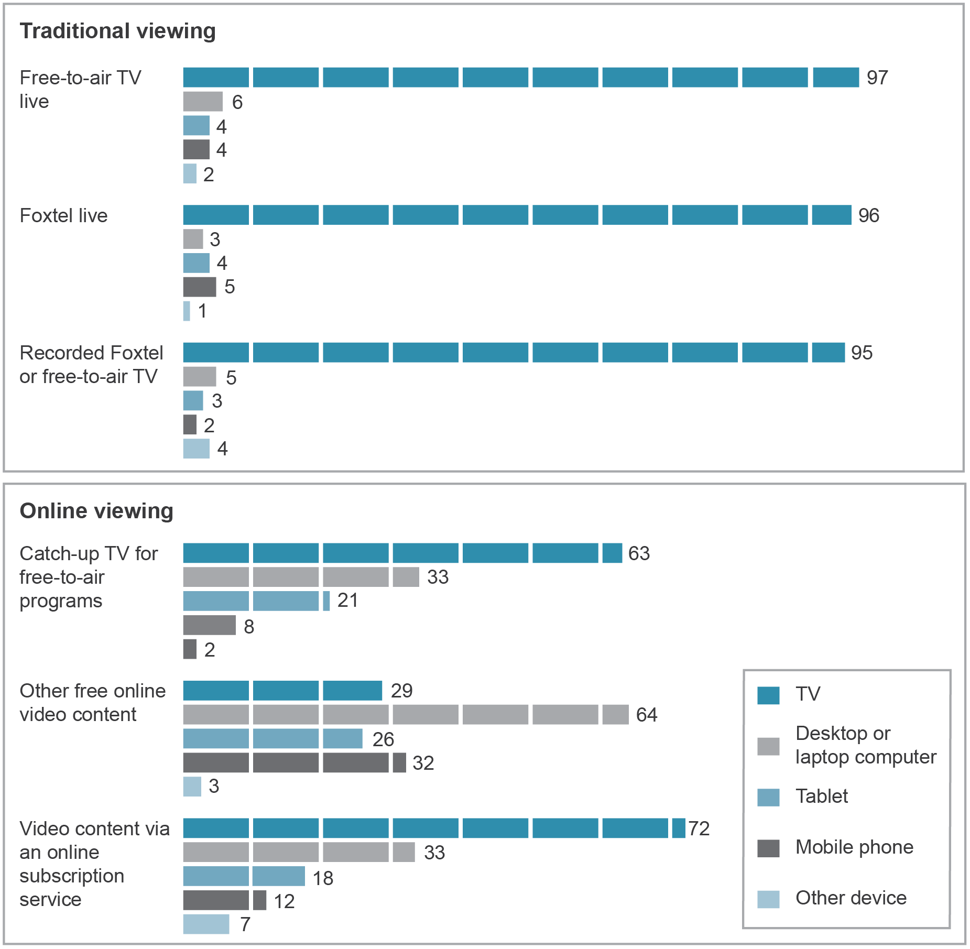
Base: Australians aged 18 and over who watched: Free-to-air live (n=1,706), Foxtel live (n=597), Recorded Foxtel or free-to-air TV (n=647), Catch-up TV for free-to-air programs (n=422), Other free online video content (n=411), Video content via an online subscription service (n=395).
Note: Data includes multiple responses. ‘Other free online video content’ excludes user-generated content.
Source: ACMA-commissioned survey, June 2016.

Online video traffic
With more Australians using the internet to stream and access video, there has been a rise in the amount of total internet traffic, with a higher proportion coming from video.
The ABS reported a 51.8 per cent increase in the total volume of data downloaded in 2015–16. In the June quarter 2016, Australians downloaded 2.1 million terabytes via a fixed or wireless broadband, a 23.5 per cent increase compared to the three months to 31 December 2015. Mobile phone downloads also grew over the same period, with 121,147 terabytes downloaded—an increase of 33.6 per cent. Data downloaded via fixed-line broadband accounted for 97.9 per cent of all internet downloads in the June quarter 2016.
Industry research forecasts that Australia’s internet protocol (IP) video traffic is set to surge from 488 petabytes per month to 1.5 exabyte per month in 2020, and consumer internet video traffic is expected to account for 85 per cent of consumer internet traffic by 2020, up from 76 per cent in 2015. Twelve billion minutes of video content is forecast to cross the internet each month by 2020, up from 11 billion minutes in 2015, with the average fixed broadband speeds in Australia expected to grow from 18.4 Mbps to 44.3 Mbps over the period.
Globally, IP video traffic is predicted to be 82 per cent of all consumer internet traffic by 2020, up from 70 per cent in 2015, with internet video-to-TV traffic accounting for 26 per cent of consumer internet video traffic by 2020, up from 24 per cent in 2015.

Traditional broadcast and online video engagement

Engagement with broadcast content
Australians are spending less time on traditional broadcast television viewing but live content viewing remains popular. Time spent watching live FTA television (viewed on the day of broadcast) is declining and so is the number of adult Australians watching traditional broadcast television every year.
In the first four months of 2016, Australians watched an average 85 hours and 12 minutes of FTA television in the home per month, either live or played back within seven days of the original broadcast. This was a decline of four hours and 16 minutes from the same period in 2015, and was eight hours and four minutes fewer than in the first quarter of 2014.,
The majority of time spent watching television is viewing live content. Live broadcast viewing makes up 77 hours and 44 minutes, with only seven hours and 28 minutes spent viewing playback content per month. Viewing playback content makes up less than nine per cent of total viewing.
There has been a gradual decline in FTA television viewing over the last six years, with 84 per cent of Australian adults in the five major cities watching at least five minutes of FTA television in an average week in 2015–16, compared to 89 per cent in 2010–11. Regional markets have seen a decline in audience viewing from 87 per cent to 81 per cent (see Figure 3.5).
Figure 3.5 FTA television viewing—average weekly cumulative reach (five minutes consecutive), five city metro and consolidated regional markets
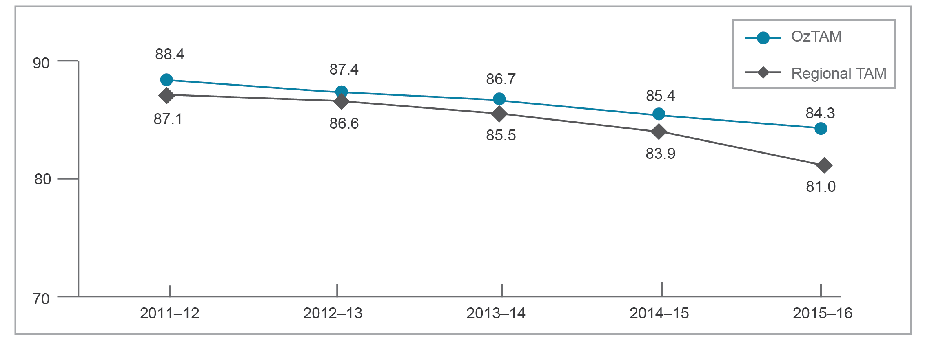
Base: People aged 18 and over in the five mainland metropolitan markets (Sydney, Melbourne, Brisbane, Adelaide and Perth) for OzTAM, and for the combined regional markets (RegionalTAM).
Note: Definition of reach—the cumulative percentage or total (usually expressed in thousands) of a population that has been counted as viewers at least once during a specified interval. From 27 December 2015, figures are consolidated to 28 days.
Source: ©OzTAM Pty Limited and Regional TAM Pty Limited 2016. Apart from any use permitted under the Copyright Act 1968, the data may not be reproduced, published or communicated (electronically or in hard copy) without the prior written consent of OzTAM and/or RegionalTAM.

Despite the decline in time spent viewing broadcast content, watching FTA television live still represents the largest share (59 per cent) of the weekly average time spent watching television or video content (excluding pre-recorded DVDs) among Australian adults.
Watching professionally produced online content (catch-up television, other free online video content, video content via a subscription service, or pay-per-view content) accounted for 15 per cent of time spent viewing content, and Foxtel accounted for 14 per cent. Programs recorded from Foxtel or FTA television accounted for 11 per cent of time spent viewing (Figure 3.6).
Figure 3.6 Share of time spent watching television (live or recorded) or professional online video content, in the last seven days (percentage)
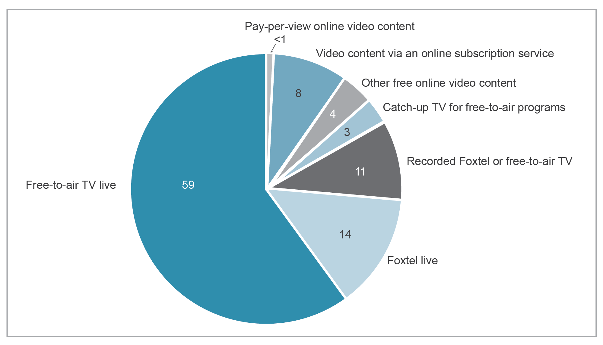
Base: Australians aged 18 and over.
Note: Numbers may not add up due to rounding. ’Other free online video content’ excludes user-generated content.
Source: ACMA-commissioned survey, June 2016.

SVOD subscribers
The number of SVOD subscribers has grown rapidly since the launch of Australian services in 2015. Since entering the Australian market in March 2015, Netflix quickly became the largest of the SVOD services available.
At the end of 2015, Netflix had just over one million subscriptions (including paid, free trials and special offers). By May 2016, the number of Netflix subscribers had risen to 1.878 million subscribers (or 11 per cent of households), reaching a potential audience of five million Australians. By comparison, Stan had 332,000 subscriptions reaching 891,000 Australians and Presto had 142,000 subscriptions reaching 353,000 Australians. There were approximately 2.7 million active online streaming subscriptions—including paid, free or trial—in Australia at the end of June 2016. While Netflix is still the market leader, at June 2016 both Stan and Presto were growing faster as more households subscribed to multiple services. The average number of SVOD subscriptions per household with at least one subscription increased from 1.5 to 1.7 by June 2016, with the top three SVOD services making up 85 per cent of all active SVOD subscriptions.
Foxtel’s subscriber numbers have also continued to increase, with a rise of 4.7 per cent to 2.9 million in the year ending 30 June 2016. The increase was driven by growth in broadcast subscribers and the inclusion of Presto-only subscribers.

Accessing online content
ACMA research shows that 63 per cent of adult Australians (11.5 million) had watched some online television or professionally produced online video content in the six months to June 2016, with 44 per cent watching in the last seven days. Forty-four per cent watched catch-up television in the last six months, while 32 per cent watched video content via an online subscription (Figure 3.7).
Figure 3.7 Online content watched in the last six months and last seven days (percentage)
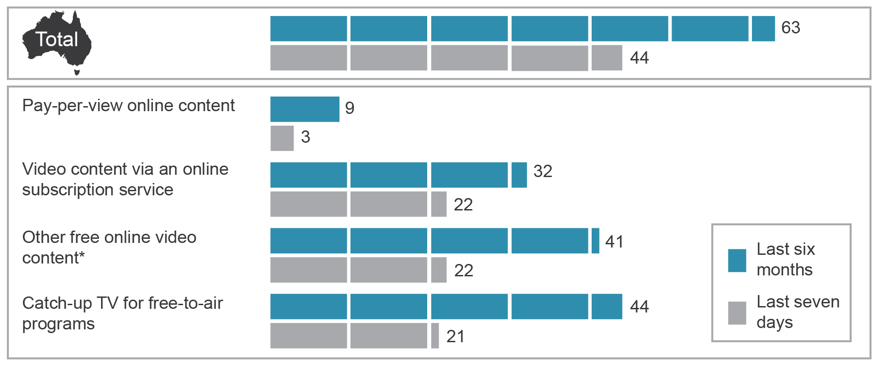
*Excludes user-generated content.
Base: Australians aged 18 and over.
Source: ACMA-commissioned survey, June 2016.

Netflix is more popular than YouTube as an online source for professional video content (Figure 3.8).
In June 2016, 39 per cent of Australian adults had watched Netflix in the last seven days, while 27 per cent had watched professional content on YouTube and 16 per cent had watched Foxtel.
Figure 3.8 Online video services used in the last seven days (percentage)
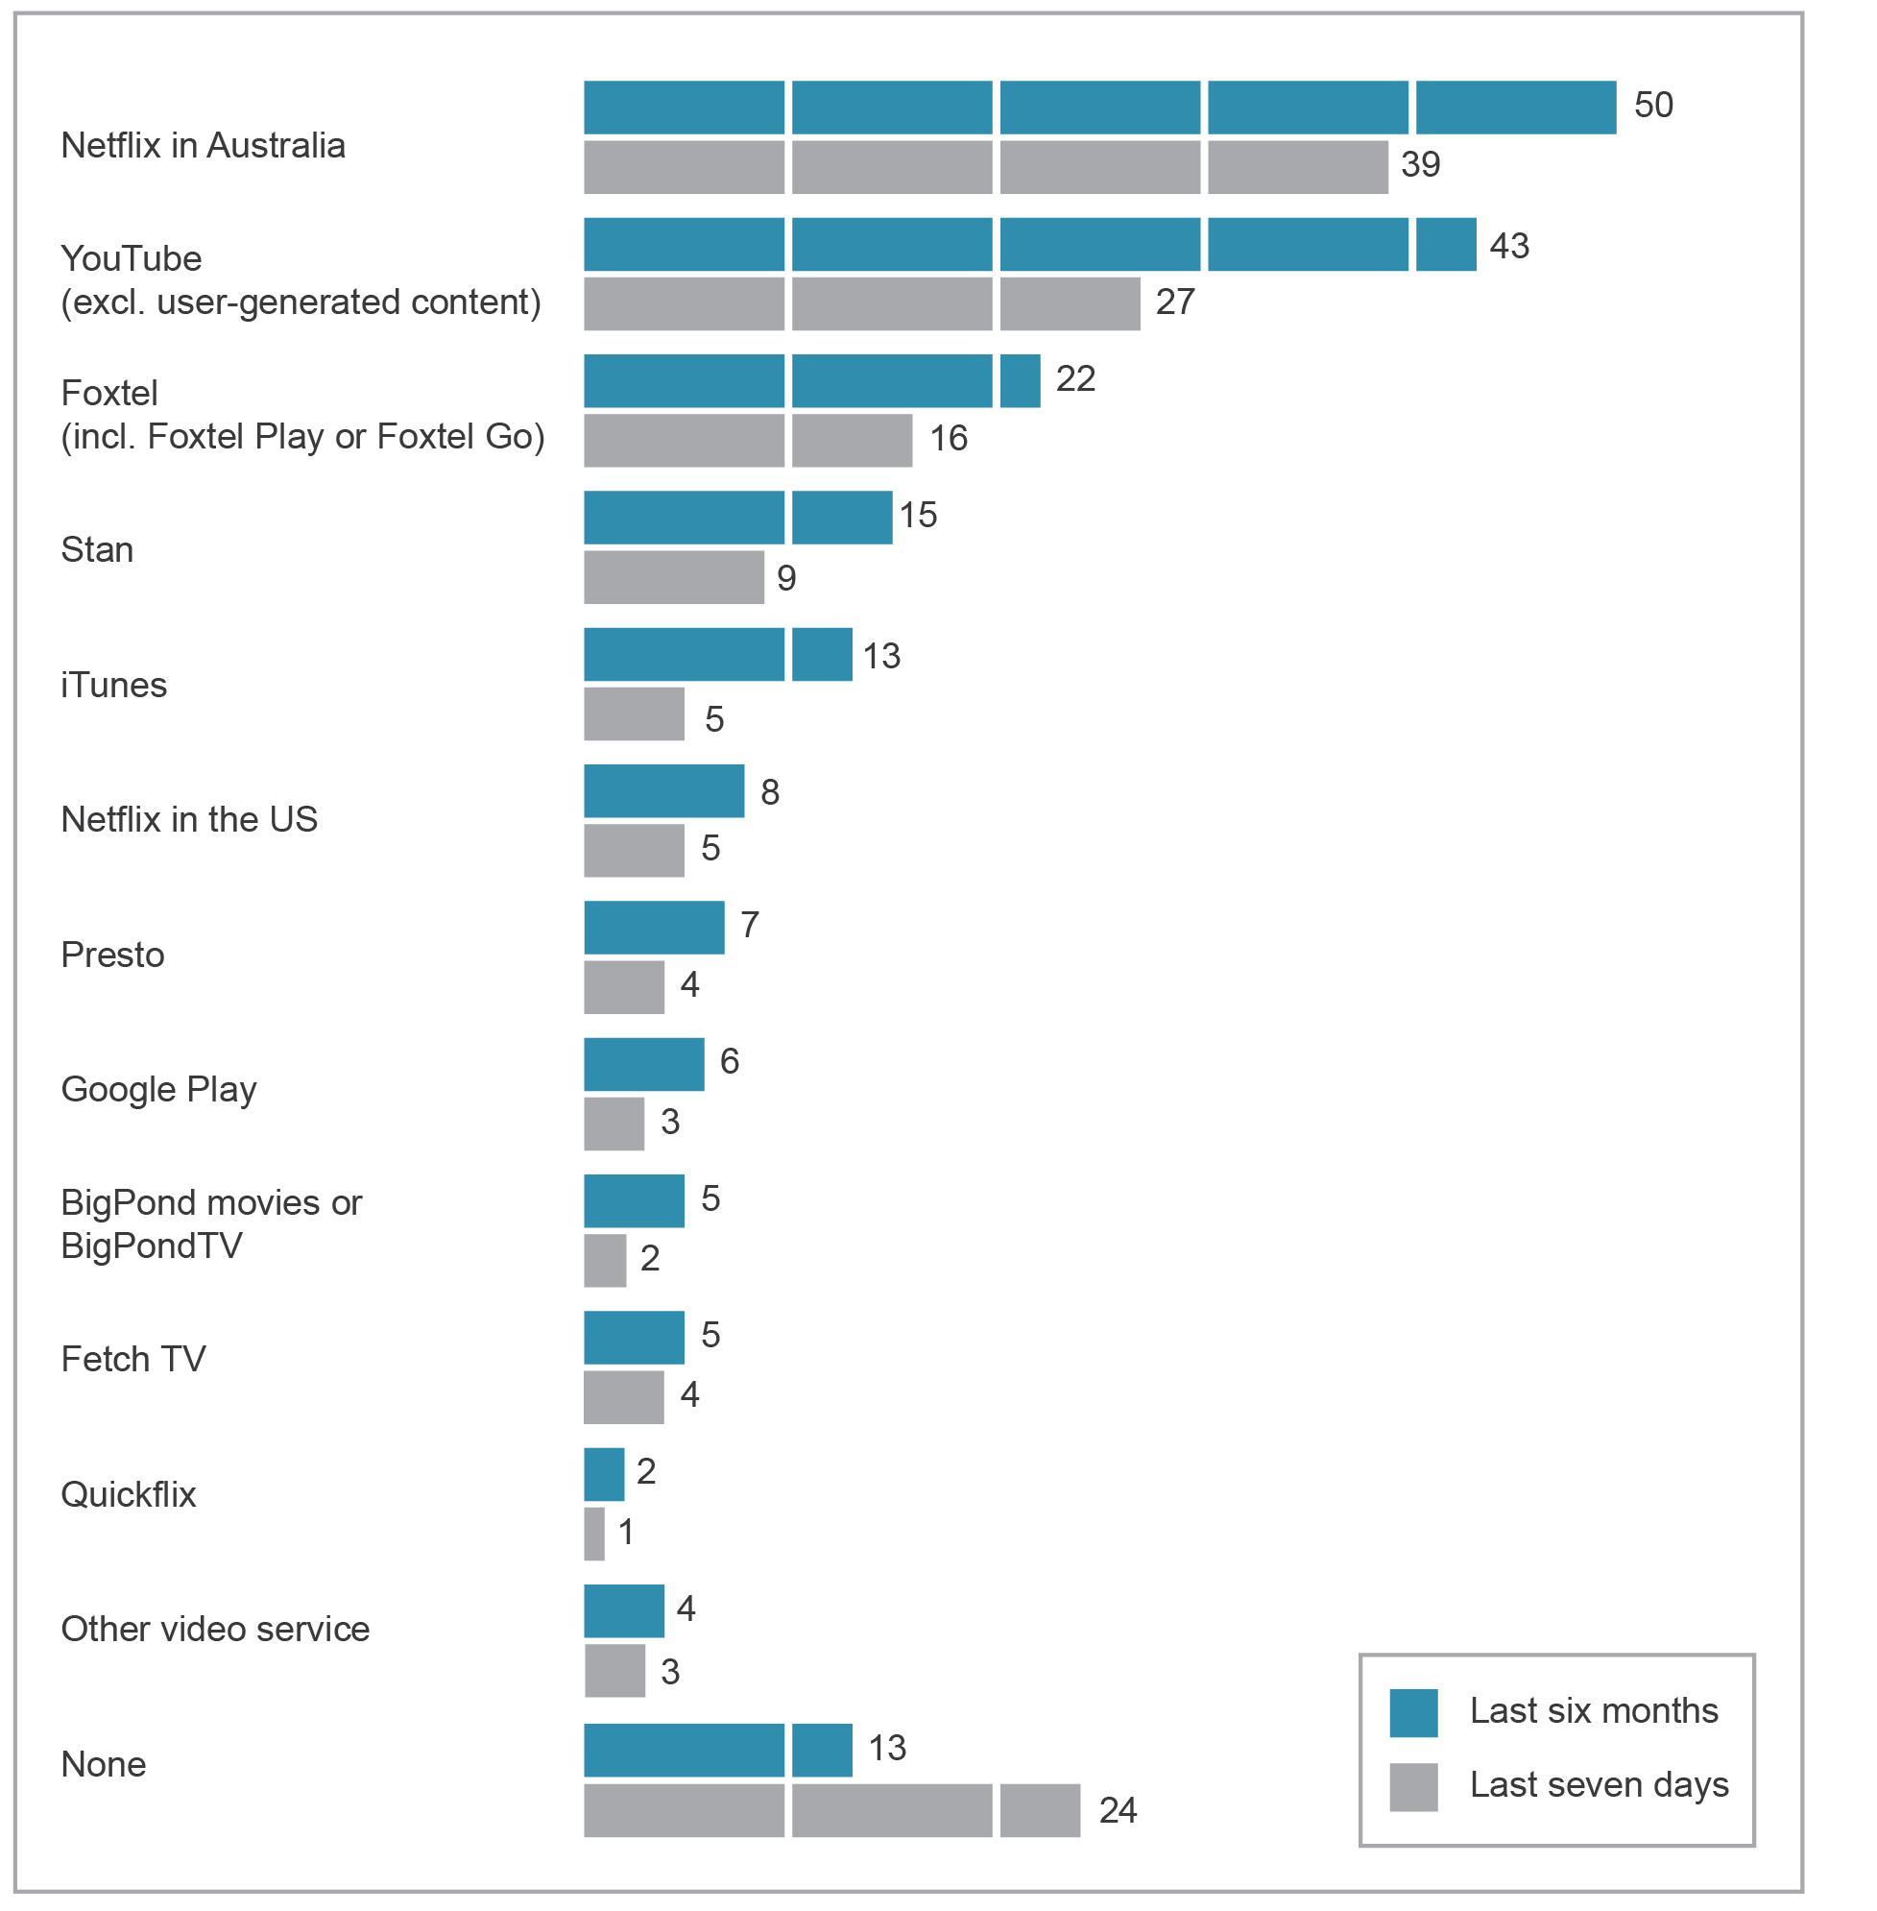
Base: Australians aged 18 and over who had watched online video, excluding catch-up, in the last six months (n=994).
Source: ACMA-commissioned survey, June 2016.

In June 2016, Channel 7’s catch-up service Plus7 was the most watched service for FTA programs, with 54 per cent using the service in the last seven days, while 43 per cent watched Ten Play and 42 per cent ABC iView (Figure 3.9).
Almost 60 per cent of consumers 65 and over had watched ABC’s iView in the last seven days, while only 19 per cent had watched 9Now. Plus7 was the most watched service for younger Australians aged 18 to 34.
Figure 3.9 Catch-up TV services used in the last seven days (percentage)
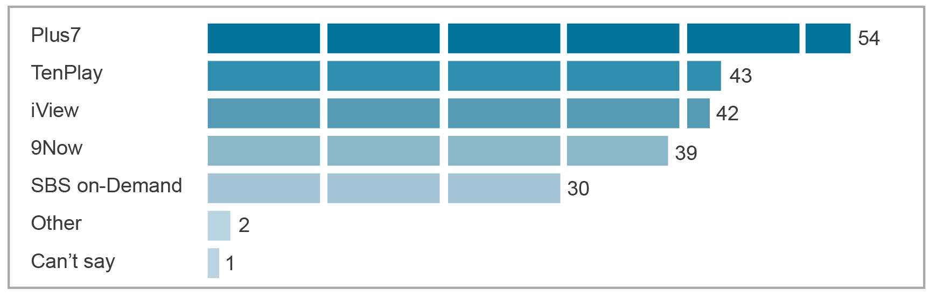
Base: Australians aged 18 and over who watched catch-up TV for FTA programs in the last seven days (n=422).
Source: ACMA-commissioned survey, June 2016.

Online viewer profile and perceived benefits
Younger people (aged 18 to 24) spent the largest proportion (43 per cent) of their viewing time watching online content (Figure 3.10). However, the total hours this age group had watched television and online video combined was among the lowest—a reported 13 hours during the week prior to the survey.
Industry research has reported that subscription video consumers are watching 30 minutes less commercial television than those without.
Figure 3.10 Time spent watching television (live or recorded) and online video content in the last seven days
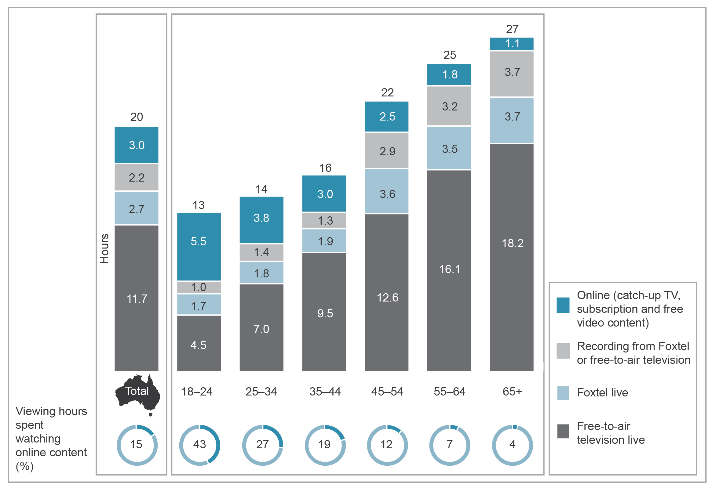
Base: Australians aged 18 and over. Ages: 18–24 (n=202), 25–34 (n=294), 35–44 (n=301), 45–54 (n=343), 55–64 (n=360), 65 and over (n=507).
Note: Numbers may not add up to category totals due to rounding. Online (catch-up TV, subscription and free video content) excludes user-generated content.
Source: ACMA-commissioned survey, June 2016.

Viewers of online content say that convenience, cost and flexibility are the top three benefits of accessing video content online (Figure 3.11). Of adults who watched online content:
- Convenience (‘can watch whenever I want’) was the main perceived benefit for 54 per cent of viewers.
- Cost or the absence of a contract was a benefit for 47 per cent of viewers.
Flexibility and the ability to stop, skip and pause were a benefit for 45 per cent of viewers.
Figure 3.11 Main benefits of accessing video content online (percentage)
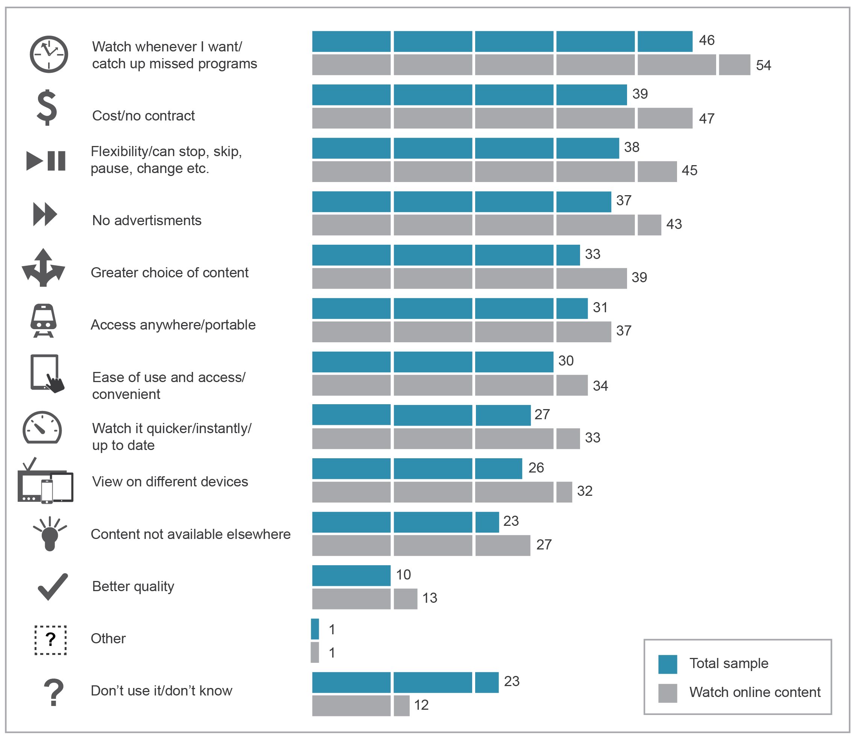
Base: Australians aged 18 and over and those who watched online video in the last six months (n=1,219).
Source: ACMA-commissioned survey, June 2016.

Technical experience
Ease of use and satisfaction with technical quality are important to consumers. While almost half of the respondents (48 per cent) who had watched streaming video reported that they had a problem in the last seven days, 86 per cent said that they were satisfied or very satisfied with the quality of online video.
Table 3.1 Satisfaction with technical quality of online video, including catch-up TV services
 | Technical quality satisfaction (%)
Very satisfied | 38
Satisfied | 48
Total satisfied | 86
Dissatisfied | 8
Very dissatisfied | 3
Total dissatisfied | 11
Don’t know/not applicable | 3
Base: Australians aged 18 and over who watched online content in the last six months (n=1,219).
Note: Data may not add up to category totals due to rounding.
Source: ACMA-commissioned survey, June 2016.

Forty-eight per cent of users of online video services had experienced one or more technical problems in the last seven days, with 19 per cent experiencing problems three times or more.
Table 3.2 Number of technical problems experienced in last seven days
 | Technical problems experienced (last 7 days) (%)
None | 45
Once | 12
Twice | 16
Three times or more | 19
Total experienced problems | 48
Don’t know | 7
Base: Australians aged 18 and over who watched online content in the last seven days (n=837).
Note: Data may not add up to category totals due to rounding.
Source: ACMA-commissioned survey, June 2016.

Online news services
The online news market has experienced significant growth. In the last few years, international news brands such as Huffington Post, BuzzFeed and Daily Mail launched Australian versions of their websites, redefining what many Australians consider news. In recognition of the move online, Fairfax, the owner of several Australian print newspapers, has announced it will pursue a more targeted, rather than a seven-day week, printing schedule in the future. In the six months to June 2016, the number of people who had accessed an online news site increased from 10.28 million in 2015 to 13.01 million in 2016.
Online platforms, such as Facebook and Twitter, are increasingly acting as a source of news, particularly for younger Australians. Industry research indicates that 29 per cent of those aged 14 to 32 use social media as their primary source of news, compared to 18 per cent for television news stations. Eighteen per cent of Australians listed social media as their primary source of news (up from nine per cent the previous year), ahead of the US (17 per cent) and Norway (13 per cent).
At the same time, print newspaper subscriptions are declining as new audiences appear to be moving to online sources. Household ownership of newspaper subscriptions has decreased from 21 per cent in 2015 to 17 per cent in 2016.
While there appears to be a shift towards accessing news online, consumers remain relatively unwilling to pay for online news. Those who are willing to pay for news has remained steady at nine per cent; and while Australians aged 27 to 32 are the most willing at 15 per cent, this has decreased from 24 per cent in 2015.
Despite this decline in print subscriptions and the availability of other online news sources, broadcast television remains the main source of news, with 36 per cent of Australians aged 14 plus frequently accessing news via television news stations. Television also had the highest weekly news reach with 65 per cent, ahead of radio with 40 per cent and print with 38 per cent.
This is reflected in the monthly digital ratings for news, where the online platforms of print newspapers or television broadcasters record the largest audiences in the current and global news sub-category (Table 3.3).
At June 2016, news.com.au had the biggest unique audience at 5.5 million, followed by ABC News websites (5,003,000) and smh.com (4,911,000). International news brands have been edging up the list, with Daily Mail Australia, The Guardian and the BBC in fourth, sixth and seventh place respectively.
Table 3.3 Top 10 by unique audience, current events and global news sub-category, June 2016
 | Unique audience
news.com.au | 5,463,000
ABC News websites | 5,003,000
smh.com.au | 4,911,000
Daily Mail Australia | 3,230,000
Yahoo7 News websites | 3,079,000
The Guardian | 3,043,000
BBC | 2,888,000
ninemsn news websites | 2,753,000
The Daily Telegraph | 2,520,000
Herald Sun | 2,519,000
Source: Nielsen Digital Ratings (Monthly), June 2016.

Trust in news
As more Australians are able to access multiple sources of news, industry reporting is showing a decline in trust for traditional news sources. Trust and a sense of reliability in news and opinion in daily newspapers has slowly declined over recent years, with only five per cent of adult Australians in February 2016 reporting a lot of trust in news—down from nine per cent at June 2015. Trust in commercial television news and current affairs also declined slightly in 2016, from 46 per cent in February to 42 per cent by August.

Local news in regional Australia
Local news remains extremely important to those living in regional areas of Australia—77 per cent believe access to local news is important and 40 per cent believe it is very important.
Traditional sources (print newspaper, radio, television) are the most used, with radio being the source of choice in emergency situations.
For local news, 52 per cent of respondents accessed print newspapers, followed by commercial television (43 per cent) and commercial radio (30 per cent), with commercial television being the most preferred.
In emergency situations, such as a bush fire, storm, flood or cyclone, 43 per cent get up-to-date information about what to do by contacting the fire and emergency services. For those who have experienced an emergency, only 10 per cent contacted the fire and emergency services—the most common source was listening to local ABC radio (33 per cent).

Broadcasting in Australia
Australian broadcasters are subject to certain content requirements as part of the licence conditions set out in the BSA. These requirements include meeting minimum amounts of Australian content, children’s program content, captioning, local content for regional broadcasters and Australian content expenditure for subscription television broadcasters.

Australian content
The BSA and the Broadcasting Services (Australian Content) Standard 2016 (Australian Content Standard) stipulate Australian content quotas for commercial television. Under the BSA, commercial television broadcasters must provide:
- 55 per cent Australian content, between 6 am and midnight across the year, on their primary channel
1,460 hours of Australian programming on other than their primary channel (multi-channels).
The Australian Content Standard requires commercial television broadcasters to:
- broadcast minimum amounts of first-release Australian drama and documentary programs
- broadcast minimum amounts of Australian-made children’s programs
ensure that all preschool programs are Australian programs.
Assessment of compliance with the quota requirements is calendar year-based. The metropolitan FTA commercial network licensees all met the Australian content transmission quotas for overall content, drama and documentaries for the 2015 calendar year (Table 3.4).
The ACMA made the Australian Content Standard to replace its predecessor, which was due to lapse under the sunsetting provisions of the Legislative Instruments Act 2003. The new standard commenced on 31 March 2016 and maintains the effect of the previous standard.
Table 3.4 Metropolitan FTA commercial network licensee compliance with the Australian Content Standard for the 2015 calendar year
 |  |  | Minimum quota* | Licensees
 |  |  | Minimum quota* | Seven Network | Nine Network | Network Ten
  Overall Australian content | On primary channel | (%) | 55 | 70 | 72 | 63
 | On non-primary channel | (average hours) | 1,460 | 2,960 | 1,604 | 4,078
 | First-release Australian drama | (points) | 250 | 311 | 269 | 251
 | First-release Australian documentaries | (average hours) | 20 | 63 | 22 | 30
*Minimum transmission quota required as per section 121G of the Broadcasting Services Act 1992.
Note: Overall Australian content relates to first release and repeat programs that must be broadcast between 6.00 am and midnight. Licensee requirements for each network are calculated by averaging across the following locations: Seven Network—five mainland state capital cities, Nine Network—Brisbane, Melbourne and Sydney, Network Ten—five mainland capital cities.
Australian drama and Australian documentaries relate to first-release programs only.
Source: ACMA.

Children’s programs on commercial television
In conjunction with the Australian Content Standard, the Children’s Television Standards 2009 (CTS) are designed to give children under 14 years of age access to quality television programs that are specifically made for them and reflect their cultural experience.
The CTS requires licensees to provide at least 390 hours annually of children’s programs comprising:
- 260 hours of children’s (C) programs
130 hours of preschool (P) programs.
The Australian Content Standard sets out additional annual and triennial first-release and C-drama requirements within these quotas. For the 2015 calendar year, all metropolitan FTA commercial television broadcasting licensees met all of these annual quotas (Table 3.5).
Table 3.5 Metropolitan free-to-air commercial network licensee’s compliance with children’s and preschool children’s program quotas (total annual hours), for the 2015 calendar year
 |  |  | Minimum annual requirement (hours) | Licensees
 |  |  | Minimum annual requirement (hours) | Seven Network | Nine Network | Network Ten
  Australian children’s  C drama |  | First-release | 25 | 27 | 32 | 27
 |  | Repeat | 8 | 97 | 48 | 75
 | Australian children’s  C programs | First-release including C drama | 130 | 130 | 131 | 131
 | Children’s  C programs | All | 260 | 261 | 376 | 261
 | Australian preschool  P programs | All | 130 | 131 | 131 | 131
Note: Licensee requirements for each network are calculated by averaging across the following locations: Seven Network—five mainland state capital cities, Nine Network—Brisbane, Melbourne and Sydney, Network Ten —five mainland capital cities.
Source: ACMA.

Subscription television drama expenditure
The new eligible drama expenditure scheme requires subscription television broadcasting licensees and channel providers that provide drama services to spend at least 10 per cent of their annual total program expenditure on eligible drama programs during a financial year. If the 10 per cent expenditure requirement is not met in the relevant financial year, the shortfall amount must be made up in the following year.
To be eligible, a drama program must be an Australian or New Zealand production or co-production, and must not have been televised in Australia or New Zealand on a broadcasting service at any time before the expenditure on the program was incurred.
The BSA defines a subscription television drama service as a service devoted predominantly to drama programs; that is, more than 50 per cent of the programming consists of drama programs.
For the 2014–15 compliance period, six licensees and five channel providers supplied 29 eligible drama channels. All participants met their expenditure obligations for 2014–15, reporting an expenditure of $36.4 million (aggregated) on new eligible Australian drama programs. Of that expenditure, $18.1 million was nominated to acquit the expenditure shortfall for 2013–14. For 2015–16, licensees and channel providers must spend a minimum of $15.4 million (in total) on new eligible programs to acquit the remaining 2014–15 obligation.
Annual licensee and channel provider returns for 2015–16 fall due on 29 August 2016 and results were not available at the time of publication.

Captioning
During 2014–15, television service providers reported a high level of compliance with annual captioning target requirements set out in the BSA:
- Ninety-two out of 95 commercial and national television broadcasting services achieved between 99.75 per cent and 99.99 per cent captioning between 6 am and midnight on their primary channels. The shortfalls against the 100 per cent captioning target were small, averaging four hours per service across the whole year.
- The remaining three services each exceeded their reduced captioning target of 90 per cent for the year. They had target reduction orders in place for 2014–15 on grounds of unjustifiable hardship.
- A total of 588,853 hours of television programs was broadcast with a captioning service on the primary channels of commercial and national television broadcasting services (6 am to midnight). This was an increase of 15,501 hours of captioning compared to the same period in 2013–14, when the captioning target was 95 per cent.
- Approximately 99.5 per cent of subscription television licensees (660 out of 663) met their annual captioning target requirements, while 67 per cent exceeded their captioning target.
A total of 2,530,004 hours of captioned content was broadcast on subscription television services in 2014–15. This was an increase of 449,452 hours compared to 2013–14.
All of the television service providers that did not meet their captioning targets have taken appropriate steps to prevent similar issues recurring, including resolving technical issues, enhancing procedures and undertaking staff training.
The ACMA did not take any enforcement action on these matters. This is consistent with the ACMA’s compliance and enforcement approach, which generally uses the minimum power or intervention necessary to achieve the desired result.
Table 3.6 provides a summary of the self-reported breaches, excluding disregarded breaches; that is, breaches solely resulting from unforeseen technical difficulties were disregarded as provided by the captioning legislation.
Table 3.6 Breaches of captioning target requirements reported by television services,
2014–15, excluding disregarded breaches
Sector | Captioning target | Number of services in breach | Causes of breaches
Commercial and national television | 100% captioning from 6 am to midnight each day on primary channels, with exceptions* | 71 services  Both national broadcasters and 50 commercial television licensees were involved | Largely caused by unforeseen technical difficulties, with some minor instances of human or procedural errors
Subscription television | 5–75% captioning across the year depending on service category, with exceptions* | 3 services  3 licensees (2 distinct channels) were involved | Technical issues or procedural errors
*Captioning obligations do not apply to exempt programs, which include foreign programs (not wholly in English) and music programs that do not contain any human vocal content. In 2014–15, three commercial television broadcasters had a reduced captioning target of 90 per cent as a result of target reduction orders (unjustifiable hardship). Some subscription television services were exempt from the annual captioning target as a result of exemption orders (unjustifiable hardship) and nominations under section 130ZX of the BSA—a transitional measure that allows exemption of certain services if the licensee has met the annual captioning target for the threshold number of services.
Source: ACMA.

Exemption orders and target reduction orders
In 2015–16, the ACMA approved 34 applications for exemption orders (for 34 separate subscription television services) and three applications for target reduction orders (for three separate commercial television services). During the year, the ACMA refused 15 applications for exemption orders and one application for a target reduction order (Table 3.7).
Table 3.7 Captioning exemption orders and target reduction orders
Application type* | Approved | Refused
Exemption order | 34 | 15
Target reduction order | 3 | 1
*The ACMA has the power to make an exemption order or a target reduction order for a specified commercial, national or subscription television service if it is satisfied that refusing to do so would cause unjustifiable hardship to the broadcaster or licensee.
Source: ACMA.

Review of captioning legislation
The ACMA is required, before 31 December 2016, to conduct a review of the captioning rules in the BSA. The ACMA released a consultation paper on 8 June 2016 seeking stakeholder submissions about the operation of the rules. The ACMA must provide a report to the minister before 30 June 2017.
Consumer use of captioning
ACMA research found that one in three Australians are regularly using captioning, with 52 per cent using it at least once a month. Thirty-five per cent cited the reason for using captioning was ‘to watch TV in a noisy environment’, while 29 per cent use it ‘to watch TV in a quiet environment’. Fifteen per cent of people use captioning due to a hearing impairment.

Notification of changes in control
Commercial television licensees, commercial radio licensees and publishers of associated newspapers must notify the ACMA of any changes in control within 10 business days of becoming aware of those changes (section 63 of the BSA). Persons who come into a position to exercise control of such licences and associated newspapers are also required to notify the ACMA within 10 business days of becoming aware of the change in control (section 64 of the BSA).
During 2015–16, no formal warnings or infringement notices were given for late notifications of changes of control, while there were eight events affecting the control of media operations.

Local information on regional television
The following regional commercial television broadcasting licensees in Queensland, New South Wales, Victoria and Tasmania must broadcast minimum amounts of material of local significance (local content) as a result of an additional licence condition:
- Seven Qld, Southern Cross and WIN TV in regional Queensland
- NBN Ltd, Prime Television and Southern Cross in northern New South Wales
- Prime Television, Southern Cross and WIN TV in southern New South Wales
- Prime Television, Southern Cross and WIN TV in regional Victoria
Southern Cross, WIN TV and Southern Cross/WIN joint venture in Tasmania.
For the period 1 July 2015 to 30 June 2016, the ACMA did not receive any complaints about compliance under the local content additional licence condition.

Local content, information and presence on regional commercial radio
Regional commercial radio licensees are required to broadcast prescribed amounts of material of local significance (local content) each year. For the period 1 July 2015 to 30 June 2016, the ACMA did not receive any complaints about compliance with local content.
Licensees are also required to comply with local content plans approved by the ACMA where there has been a change in ownership or control known as a ‘trigger event’. Approved local content plans require licensees to:
- broadcast specified amounts of local news and information (minimum service standards)
maintain existing levels of ‘local presence’ (that is, local staff and facilities) for 24 months from the date of the trigger event.
For the period 1 July 2015 to 30 June 2016, all 110 trigger event-affected licensees complied with their approved local content plans. The 24-month ‘local presence’ requirement also ceased for four regional commercial radio licences.
The ACMA conducted two investigations into the requirement for a licensee to take all reasonable steps to ensure compliance with a local content plan. The investigations related to two licences held by the same licensee. No findings were made as, in each case, the matters related to administrative errors made by the licensee. The licensee has since taken steps to improve its administrative process.
The ACMA did not receive any complaints about compliance with local presence obligations or minimum service standards.

Anti-siphoning provisions
The anti-siphoning scheme in the BSA restricts subscription television broadcasting licensees from acquiring anti-siphoning events in certain instances. The scheme also restricts the broadcast of anti-siphoning events by FTA broadcasters on their digital multi-channels.
During the reporting period, the ACMA did not commence any investigations into any commercial television licensee’s compliance with the licence condition restricting the broadcast of anti-siphoning events.

Digital broadcasting
Digital television
The ACMA seeks to ensure that all members of the community are getting the most from digital television. While issues of external interference (such as ducting, receiver overload or power line interference) may serve to trigger community complaints about reception, the experience of the ACMA over many years is that most poor TV reception across Australia is caused or exacerbated either by inadequate receive antenna systems (such as poorly maintained, broken or incorrectly installed antennas) or by viewers not taking advantage of the most appropriate transmission service for their area.
The ACMA has focused its strategies to inform and help affected viewers and, when required, to support broadcasters. The ACMA has also been working with industry to develop planning solutions to improve the reliability of television coverage into Apollo Bay, Victoria, and Springsure, Queensland.
Digital radio
Digital radio services, using DAB+ technology in VHF Band III spectrum, have been running on a permanent basis in the metropolitan areas of Adelaide, Brisbane, Melbourne, Perth and Sydney since July 2009.
Trials of DAB+ are being conducted in Canberra and Darwin by the peak commercial radio body, Commercial Radio Australia. The trial licences were to expire on 30 June 2016 and have subsequently been extended to 30 June 2017.
Following on from the recommendations of the 2015 report prepared by the Department of Communications on digital radio services in Australia, the ACMA established a joint government–industry Digital Radio Planning Committee. The committee has met four times since September 2015 and is providing a forum for the ACMA to work closely with the radio industry to facilitate the rollout of digital radio into regional areas of Australia.
AM to FM conversions in selected regional areas
The ACMA is coordinating the necessary planning and approvals to facilitate the conversion of the transmission of commercial radio services from the AM to the FM band in single licensee (solus) regional licence areas. The focus will be on areas where issues of equity with other FM incumbent commercial radio broadcasting licensees will not arise.
CRA has requested that AM to FM conversions be allowed in solus regional licence areas. The Minister for Communications and the Arts agreed in principle, subject to certain caveats. The minister subsequently requested that the ACMA give priority to these AM to FM conversions, subject to the ACMA’s statutory broadcast planning considerations under Part 3 of the BSA.
The AM to FM conversion in these regional areas has the potential to deliver a range of benefits, including improved audio quality, reduced signal interference and lower costs for regional broadcasters.

Broadcasting complaints and investigations
The ACMA monitors the number and details of complaints it receives about possible breaches of the BSA, of licence conditions imposed by or under the BSA, of program standards made under the BSA, or of provisions of broadcasting codes of practice registered under section 123 of the BSA. It may investigate following a complaint or on its own motion.
Since 17 October 2014, the ACMA has had a discretion as to whether to investigate complaints about broadcasting matters, having regard to the public interest. Since the introduction of this discretion, the ACMA has streamlined its investigation processes and leveraged off new IT systems to improve the quality and timeliness of outcomes, produce internal efficiencies and reduce the administrative burden on industry.
When deciding whether to investigate a particular matter, the ACMA considers a range of factors including the nature and seriousness of the issue raised; the applicability of any relevant legislation, code of practice or standard; the potential to affect the community at large and its priority in relation to other matters of public interest.
From 1 July 2015 to 30 June 2016, the ACMA exercised its discretion to investigate 149 complaints and declined to investigate 65 complaints (multiple complaints may concern a single broadcast or matter). The ACMA has continued to reduce the average time taken to conduct broadcasting investigations from 2.6 months in 2014–15 to 1.6 months in 2015–16.
There were 1,232 written complaints and enquiries made to the ACMA about broadcasting matters during 2015–16, an 18 per cent increase from 2014–15. There were 156 investigations completed in 2015–16 (Table 3.8).
Complaint trends and investigation outcomes indicate that compliance by industry with the legislative provisions, standards, conditions and codes of practice was high during the reporting period. The positive compliance outlook has also been supported by the ACMA’s Investigations concepts series and Privacy guidelines for broadcasters, which have made the ACMA’s regulatory approach to broadcasting investigations clearer and more accessible for both broadcasters and the wider community.
Table 3.8 ACMA broadcasting complaints and investigations, by financial year
 |  | 2010–11 | 2011–12 | 2012–13 | 2013–14 | 2014–15 | 2015–16
 | Written complaints and enquiries received | 1,512 | 2,273 | 2,178† | 1,593 | 1,012 | 1,232
 | Investigations completed | 197 | 231 | 212 | 180 | 145 | 156†
 | Investigations resulting in a breach finding* | 72 | 71 | 67 | 45 | 35 | 35
 | Investigations resulting in a non-breach finding* | 115 | 155 | 135 | 132 | 100 | 109
*Investigations against a code of practice, licence condition, standard and/or provision of the Broadcasting Services Act 1992.
†Five investigations resulted in no findings and seven investigations were concluded.
Note: Sum of categories does not equal total number of investigations completed due to exclusion of completed investigations with no finding; for example, where the complaint is withdrawn.
Source: Broadcasting complaints to the ACMA.

Online content investigations
The Online Content Scheme, established under schedules 5 and 7 to the BSA, dovetails with industry codes of practice. In 2014–15, the ACMA investigated valid complaints about online content, where the complainant considers that the content may be prohibited. On 1 July 2015, these responsibilities transferred to the Office of the Children’s eSafety Commissioner. Information about online content complaints and investigations is included in the Office’s 12-month report.

Interactive gambling
The Interactive Gambling Act 2001 (the IGA) prohibits certain internet gambling content, as well as the advertising of such content. IGA complaints received and actioned by the ACMA in the reporting period are outlined in Table 3.9. Under the IGA, the ACMA must not investigate Australian-hosted content but must refer complaints to an Australian police force, if it is warranted to do so. The ACMA received a total of 198 complaints and enquiries during 2015–16.
Table 3.9 Interactive gambling
 | Interactive gambling | 2014–15 | 2015–16
Complaints and general enquiries |  | 178 | 198
Investigations of overseas-hosted gambling content |  | 12 | 13
Prohibited internet gambling content found to be in breach of the IGA, notified to accredited filter providers and the AFP |  | 9 | 9
Assessments of Australian-hosted gambling content |  | 14 | 15
Potential prohibited content referred to the AFP |  | 5 | 9
Investigations into the broadcast of interactive gambling advertisements* |  | 0 | 0
* Under the IGA, the ACMA only investigates interactive gambling advertisements broadcast on television or radio. The Department of Communications and the Arts takes responsibility for all other advertising, such as online or in print.

National interest issues

Overview
This chapter addresses regulatory requirements to report on the performance of the emergency call service, national interest issues and cooperation with law enforcement agencies. It includes information about the communications industry’s support for law enforcement and national security agencies through the maintenance of communications interception capabilities and the authorised disclosure of information.
In summary:
- Telstra’s performance exceeded the performance benchmarks for the time taken to answer each emergency service call, although performance times were slightly lower than previous years.
- In 2015–16, 68.7 per cent of emergency calls (5,740,709 calls) were made from mobile phones, up from 66.9 per cent (5,606,275 calls) in the previous 12-month period.
- Calls from fixed-line telephones represented 32.7 per cent of emergency calls, while 2.4 per cent were made from public payphones.
- There was a very small decrease (0.32 per cent) in the number of calls (26,649) made to the emergency service numbers Triple Zero and 112.
- During 2015−16, all emergency service organisations (police, fire and ambulance) throughout Australia implemented the functionality to automatically receive cell tower (or better) location information during a Triple Zero call.
- The number of carriage services reported as suspended by CSPs decreased by three, falling from 31 in 2014–15 to 28 in 2015–16.
- The cost to industry of providing interception capabilities decreased by 1.3 per cent from $22.9 million to $22.6 million.
- The number of disclosures made by CSPs and carriers reported under section 308 of the Telecommunications Act also decreased, dropping by 19 per cent in the year to June 2016.
Anticipated capital costs of complying with new data retention obligations have been estimated by providers to be $69 million for the 2015−16 year.

Emergency call service
Under the Telecommunications (Emergency Call Service) Determination 2009 (the Emergency Call Service Determination), CSPs are required to provide free access to the emergency call service from standard telephone and mobile services. The emergency call service is an operator-assisted service that connects callers to an emergency service organisation (ESO)—police, fire or ambulance—in life-threatening or time-critical situations.
The emergency call service is provided by the emergency call persons (ECPs), who are:
- Telstra—for calls made to the primary emergency service number (Triple Zero) and to the international emergency number 112 from mobile phones
Australian Communication Exchange (ACE)—for calls made to the 106 text service for people who are deaf or have a hearing or speech impairment.
This section outlines the volume and type of calls to the emergency call service, along with the performance of the ECPs in answering emergency calls.

Emergency call service—Triple Zero and 112
When dialling Triple Zero, a recorded voice announcement (RVA) provides callers who have inadvertently dialled Triple Zero with the opportunity to hang up before the call is connected to the ECP. In 2015–16, 3.6 per cent of calls to Triple Zero were from callers who hung up after hearing the RVA before connection to the ECP, leaving 96.4 per cent of calls to be connected to the ECP.
ECP data shows the number of calls to the Triple Zero and 112 emergency service numbers fell by 26,649 (0.32 per cent) to 8,350,745 calls in 2015–16 (Table 4.1). There has been a steady decline in the number of emergency calls made over the past five years. The ECP has attributed this decline to the increased promotion of the appropriate use of the Triple Zero and 112 services and alternative numbers, such as 132 500, the State Emergency Service number.
In 2015–16, 68.7 per cent of emergency calls (5,740,709) were made from mobile phones (Table 4.1). Calls from fixed-line telephones represented 32.7 per cent of emergency calls, while 2.4 per cent were made from public payphones.

Telstra’s performance in answering emergency calls
Section 32 of the Emergency Call Service Determination sets out performance criteria for the ECPs answering of calls to Triple Zero and 112, as follows:
- 85 per cent of emergency calls answered within five seconds
95 per cent of emergency calls answered within 10 seconds.
As in previous years, Telstra performed well above the regulatory requirement in the reporting period (Table 4.1).

Calls connected to emergency service organisations
The ECP for Triple Zero and 112 transfers emergency calls to the relevant state or territory emergency service answering point that is responsible for arranging the dispatch of an emergency response. In 2015–16, 6,178,484 calls were transferred to an ESO, an increase of 4.9 per cent on the previous year (Table 4.1).
Calls identified by the ECP as being non-emergency calls are not connected to an ESO. Non-emergency calls include misdials, automatically generated calls from incorrectly programmed fax machines or modems, callers reporting matters that are not emergencies, and hoax and malicious calls.
The proportion of ECP-answered calls that were transferred to an ESO increased from 61.5 per cent in 2011–12 to 77.2 per cent in 2015–16. In the year 2015–16, the proportion of calls requiring transfer to an ESO rose by 5.4 per cent over the previous year (Table 4.1). This ongoing improvement reflects the efforts of the ECP in managing the number of non-emergency calls made to the Triple Zero service.
The ACMA is continuing to monitor the results of an escalated warning process that was introduced in July 2009, and is managed by Telstra (as the ECP for Triple Zero and 112) and the three mobile network carriers. This process can lead to a mobile handset being blocked from making most calls if it is used to make repeated non-emergency calls to Triple Zero. Experience is showing that the risk of account suspension and police referral is acting as a significant deterrent. On average, 99 per cent of callers making repeated non-emergency calls are deterred from further misuse after receiving a warning from the ECP.
Table 4.1 Call volumes to emergency call service numbers Triple Zero and 112,
and call answering times
 | 2011–12 | 2012–13 | 2013–14 | 2014–15 | 2015–16
Calls offered from mobile phones (%) | 67.3 | 66.9 | 66.5 | 66.9 | 68.7
Calls answered (%) | 96.0 | 96.0 | 96.0 | 96.0 | 96.0
Of calls answered, those that wait five seconds or fewer (%) | 95.8 | 95.8 | 95.4 | 97.3 | 94.9
Of calls answered, those that wait 10 seconds or fewer (%) | 98.9 | 99.1 | 99.3 | 98.7 | 98.4
Total number of calls offered | 9,429,595 | 8,854,728 | 8,481,470 | 8,377,394 | 8,350,745
Answered calls transferred to  an ESO (%) | 61.5 | 67.5 | 70.6 | 73.2 | 77.2
Calls transferred to an ESO | 5,561,072 | 5,727,411 | 5,738,061 | 5,888,050 | 6,178,484
Note: The term ‘calls offered’ refers to the number of calls received by the ECP after the RVA.
The RVA gives people who have inadvertently or otherwise dialled Triple Zero the opportunity to hang up before being connected to the ECP. Calls answered refers to the percentage of these calls that were answered.
Source: ECP (Telstra).

Improved mobile location for emergency service organisations
In May 2016, all ESOs (police, fire and ambulance) throughout Australia had implemented the functionality to automatically receive cell tower (or better) location information during a Triple Zero call.
Improved mobile caller location information assists ESOs to better locate callers and provide assistance as quickly as possible. In most situations, callers are aware of their location but some callers may be unaware of their location or unable to pass on information because they are stressed, disoriented or unfamiliar with the area.
The ACMA has facilitated this important public safety initiative, and recognises the significant contributions made by the mobile carriers and the ECP for Triple Zero in ensuring its successful delivery.

Enquiries and complaints about the Triple Zero service
During the reporting period, the ACMA received two complaints and enquiries about the Triple Zero service. All of these related to the handling of calls by the ESOs (and not to Telstra as the ECP for Triple Zero and 112) and were referred to the relevant organisation for a response. No formal investigations were undertaken by the ACMA.

Emergency call service—NRS
The relay service provider for the National Relay Service (NRS) is specified as an ECP in the Emergency Call Persons Determination. ACE is currently contracted by the Commonwealth as the NRS relay service provider and operates a text emergency service on the 106 number in this capacity. The 106 text emergency service is available for users with a teletypewriter (TTY). There were 100 genuine calls to ESOs via the 106 text emergency service in 2015–16, compared to 123 in 2014–15, 155 in 2013–14 and 199 in 2012–13.
As shown in Figure 4.1, a significant number of genuine calls were also relayed by the NRS to ESOs via the Triple Zero emergency services number. In these circumstances, TTY users contacted the NRS via normal access numbers and requested the call be relayed to Triple Zero, rather than dialling the 106 text emergency service number from their TTY. Calls to Triple Zero can also be relayed through the NRS for its internet relay and Speak and Listen (speech-to-speech relay) callers, as these users are unable to access the 106 number through these services.
A total of 605 calls were made to Triple Zero using SMS relay (web browser), video relay and captioned relay in 2015–16, compared to 332 calls using these three services in 2014–15 and 206 calls in
2013–14. This represents an 82 per cent increase in the use of this technology, with the use of the captioned relay alone increasing by more than five times in the year to June 2016.
The NRS launched a new app in December 2014 allowing internet relay and Speak and Listen users to make calls via the app rather than using an internet browser. The app also allows the caller to insert the location into the call using the GPS function of the device. There were 145 calls made via the app between in 2015–16, a four-fold increase on the previous year’s figure.
A total of 1,113 genuine emergency calls were made via the NRS across all modes (SMS relay, internet relay, captioned relay, video relay, Speak and Listen, and TTY) compared with 660 calls in 2014–15, 559 in 2013–14 and 475 in 2012–13.
Figure 4.1 Genuine emergency calls via the NRS
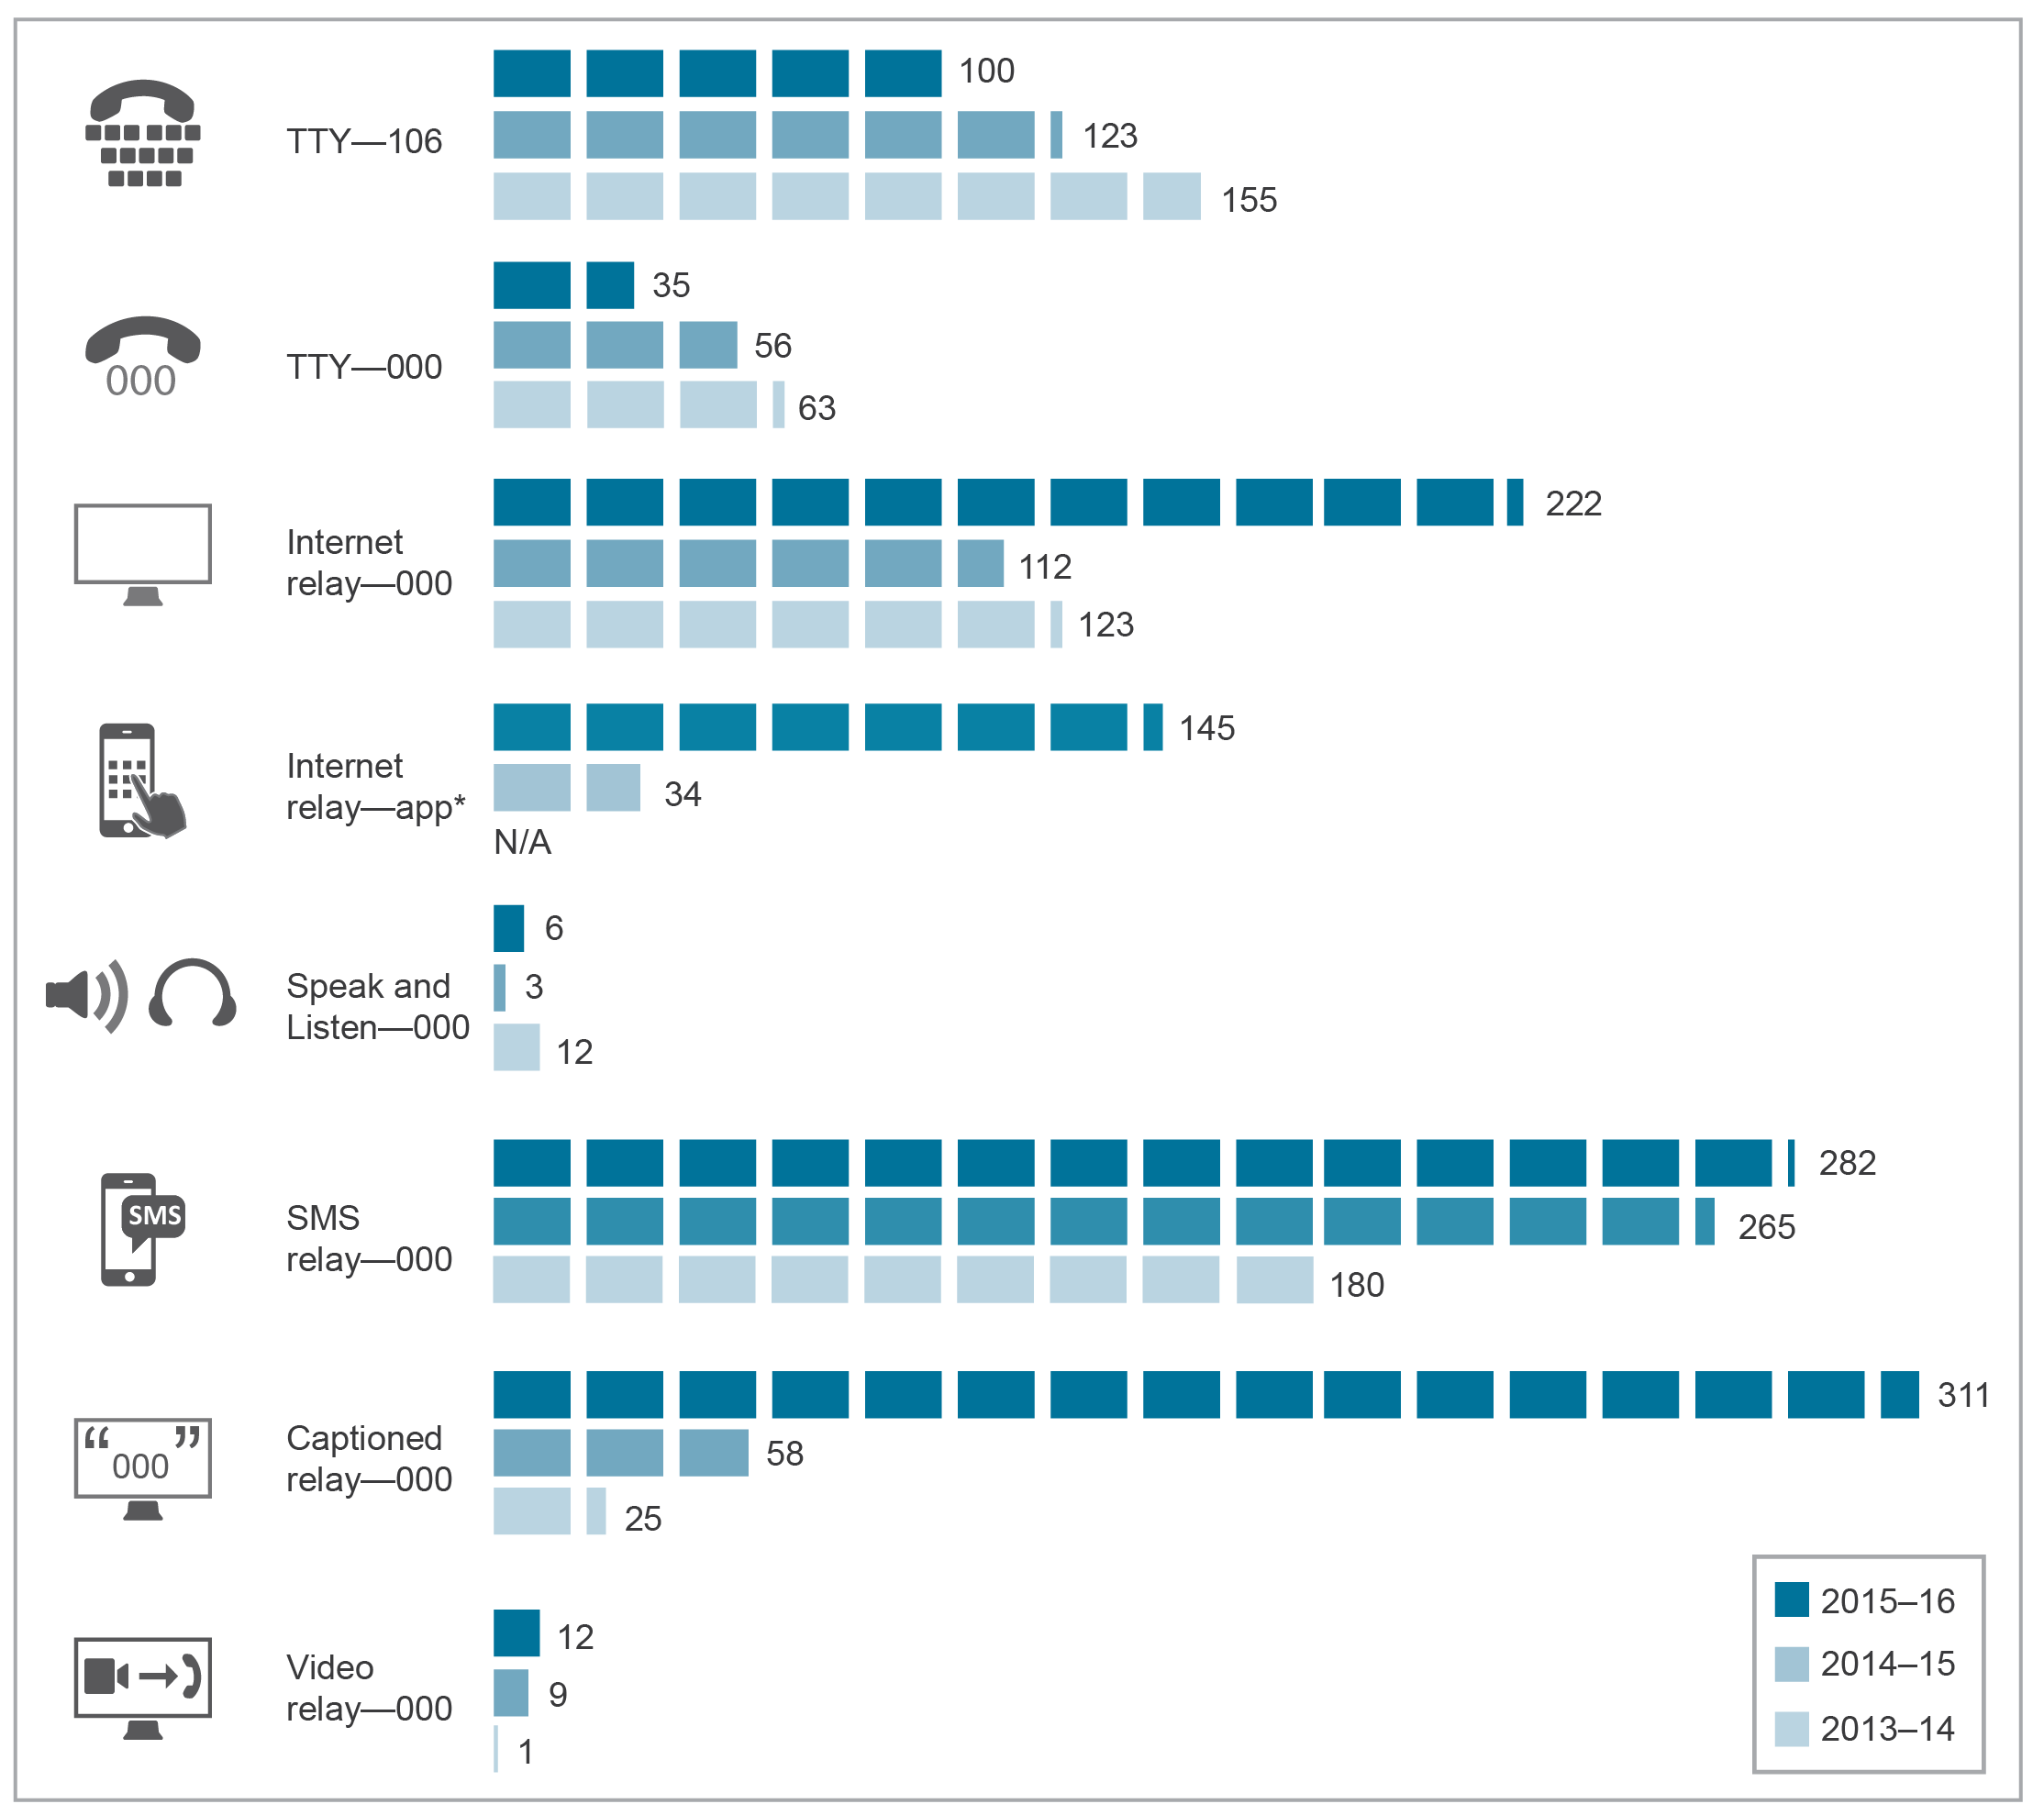
n/a=not available.
Base: Number of calls.
Source: NRS service provider (ACE).

Supporting law enforcement and national security agencies
The telecommunications industry, including ISPs, is obliged to provide reasonably necessary assistance to law enforcement and national security agencies under section 313 of the Telecommunications Act. This assistance can take many forms, but most commonly involves providing information about consumers of telecommunications services and their communications for the purposes of:
- enforcing the criminal law
- enforcing laws that impose a pecuniary penalty
- assisting the enforcement of the criminal laws in force in a foreign country
- protecting the public revenue
safeguarding national security.
During the reporting period, the Attorney-General’s Department (AGD) did not refer any carriers or CSPs to the ACMA for enforcement action for refusing to provide an agency with such assistance.

Disclosure of customer information
Customer information provided to telecommunications carriers, CSPs and telecommunications contractors is protected under Part 13 of the Telecommunications Act. Carriers, CSPs and telecommunications contractors are prohibited from disclosing information to other parties except in certain limited and restricted circumstances. Those circumstances include:
- where it is required or authorised by a warrant or under law
- disclosure to the ACMA, Australian Competition and Consumer Commission (ACCC), TIO or the Children’s eSafety Commissioner where the disclosure may assist those agencies to carry out their functions or powers or, in the case of the TIO, assist in the consideration of a complaint
- an imminent threat to a person’s life or health
satisfying the business needs of other carriers and CSPs, where the customer is or was a customer of a carrier or CSP.
Carriers and CSPs are required to report to the ACMA on any disclosures that are authorised under either Part 13 of the Telecommunications Act or Chapter 4 of the TIA Act.
During 2015–16, the number of disclosures, as reported to the ACMA under section 308 of the Telecommunications Act, was 667,792, a decrease of 157,049 (19 per cent) from 2014–15. Of these, 81 per cent were covered by an authorisation in force to access existing information or documents for the enforcement of the criminal law under section 178 of the TIA Act.
Carrier and CSP data also indicates that approximately 10 per cent of all disclosures were made with the knowledge or consent of the person concerned under section 289 of the Telecommunications Act. The number and reason for disclosures made during 2015–16, as reported to the ACMA under section 308 of the Telecommunications Act, are in Table 4.2.
Table 4.2 Disclosures
Reason for disclosure |  | (Sub)section | Number of disclosures
 |  | (Sub)section | 2014–15 | 2015–16
Under Part 13 of the Telecommunications Act 1997
Authorised by or under law |  | 280 | 13,106 | 13,334
Made as a witness under summons |  | 281 | 484 | 276
To assist the ACMA |  | 284(1) | 1,268 | 366
To assist the Children’s eSafety Commissioner |  | 284(1A) | n/a | 0
To assist the ACCC |  | 284(2) | 11 | 14
To assist the TIO |  | 284(3) | 8,749 | 7,774
Calls to emergency service number |  | 286 | 10,073 | 8,062
To avert a threat to a person’s life or health |  | 287 | 14,500 | 11,381
Communications for maritime purposes |  | 288 | 0 | 0
With the knowledge or consent of the person concerned |  | 289 | 171,926 | 66,629
In circumstances prescribed in the Telecommunications Regulations 2001 |  | 292 | 0 | 0
Connected with an exempt disclosure |  | 293 | 6 | 6
Subtotal |  |  | 220,123 | 107,842
Under the Telecommunications (Interception and Access) Act 1979
Voluntary disclosures |  | 177 | 437 | 43
Authorisations for access to existing information or documents | Enforcement of the criminal law | 178 | 584,029 | 541,318
 | Locating missing persons | 178A | 4,195 | 4,229
 | Enforcement of a law imposing pecuniary penalty or protection of the public revenue | 179 | 7,206 | 2,929
Authorisations for access to prospective information or documents |  | 180 | 8,784 | 11,427
Enforcement of the criminal law of a foreign country | Existing information | 180A | 52 | 4
Enforcement of the criminal law of a foreign country | Prospective information | 180B | 15 | 0
Subtotal |  |  | 604,718 | 559,950
Total |  |  | 824,841 | 667,792
Source: Carriers.

Information about enforcement agency use of powers under the TIA Act to obtain information from carriers and CSPs is contained in annual reports prepared by the Attorney-General under subsection 186(2) of the TIA Act.
For disclosures made under sections 177, 178, 178A, 179, 180, 180A and 180B of the TIA Act, law enforcement agencies (civil and criminal) must be satisfied that the information they request is reasonably necessary to perform their law enforcement functions. An authorised officer must also consider whether any interference with the privacy of any person or persons that may result from the disclosure is justifiable, having regard to the likely relevance and usefulness of the information or documents, and the reason why the disclosure concerned was authorised.

Emergency suspension of carriage services
Under section 315 of the Telecommunications Act, a senior police officer of a police force or service who holds a rank not lower than the rank of ‘Assistant Commissioner’ can request the suspension of a carriage service, if there is an imminent threat to someone’s life or health. CSPs reported the suspension of 28 carriage services in 2015–16, down from 31 in 2014–15.

Interception
The content of communications between users of telecommunications services is strictly protected in Australia as one of the most crucial areas of telecommunications privacy protection. Interception may only be authorised by law enforcement and national security agencies in accordance with a warrant under the TIA Act. Interception for other purposes is prohibited, with criminal penalties applicable for breaches of the TIA Act.

Providing assistance
Section 314 of the Telecommunications Act applies if a carrier or CSP is required to provide help to an officer or authority of the Commonwealth, a state or a territory. Such persons must comply with a requirement on the basis that the person neither profits from, nor bears the costs of, giving that help.

Interception capability
Chapter 5 of the TIA Act obliges carriers and CSPs to ensure that their networks, facilities and carriage services are capable of enabling communications to be intercepted upon presentation of an interception warrant. This obligation includes a requirement to develop, install and maintain an interception capability. Under section 207 of the TIA Act, carriers and CSPs are responsible for the costs associated with providing interception capability in their networks.
In 2015–16, the cost to industry of providing interception capability was reported to the ACMA as $22.6 million (Figure 4.2), a reported reduction of approximately 1.3 per cent from 2014–15.
Figure 4.2 Cost of providing interception capabilities ($ million)
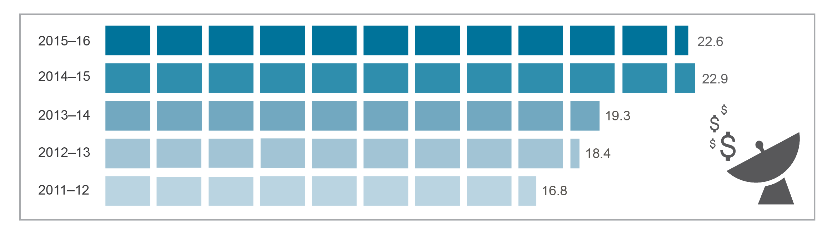
Source: ACMA annual industry data request.

Interception capability plan compliance
Under sections 196 and 197 of the TIA Act, carriers and nominated CSPs must lodge an interception capability plan by 1 July each year with the Communications Access Co-ordinator (CAC) in the AGD. The ACMA’s role is to enforce this obligation.
During the reporting period, the AGD referred nine carriers to the ACMA for enforcement action about these provisions. Of these referrals:
- five carriers submitted interception capability plans to the CAC following the ACMA’s request that they comply with their legislative obligations
- three carriers surrendered their carrier licences
one carrier made contact with the AGD, where it applied for, and was granted, an exemption from providing interception.

Data retention
Since 13 October 2015, carriers and service providers have been subject to data retention obligations under Part 5-1A of the TIA Act. The data retention obligations are enforceable by the ACMA under the applicable enforcement mechanisms set out in the Telecommunications Act.
Paragraph 105(5A)(b) of the Telecommunications Act requires the ACMA to report to the minister on the costs of compliance with the requirements of Part 5-1A of the TIA Act (data retention).
The AGD has program responsibility for the Data Retention Industry Grants Programme and has received grant applications that include information from industry about the anticipated capital costs of complying with data retention obligations. Costs that service providers detailed as part of their grant applications had to be incurred within the period 30 October 2014 to 13 April 2017. The AGD accepted applications for grants from industry between 7 January and 23 February 2016.
The AGD has advised that a total of 180 providers found eligible under the program submitted anticipated capital costs of $198,527,354. A breakdown of the anticipated capital costs of complying with the data retention obligations by financial year is set out in Table 4.3.
Table 4.3 Anticipated capital costs of complying with the data retention obligations
Financial year | Anticipated cost
2014–15 | $3,819,642
2015–16 | $68,977,652
2016–17 | $125,730,060
Total | $198,527,354
Note: The data represents the anticipated capital costs of 180 providers, not the actual total costs incurred by industry—it is likely that the cost information supplied by this significant group of providers covers the vast majority of costs to be incurred by industry. The data does not capture recurring or indirect costs.
Source: AGD.

The AGD has advised that a total funding pool of $128,351,400 will be made available to eligible providers under the program in 2016–17.
The Communications report 2016–17 will include information on the actual costs of compliance with the data retention obligations.
During the reporting period, the AGD did not refer any CSPs to the ACMA for enforcement action on their data retention obligations under the TIA Act.

Identity-checking requirements for prepaid mobile carriage services
Under the Telecommunications (Service Provider—Identity Checks for Prepaid Mobile Carriage Services) Determination 2013, CSPs are required to obtain and verify identity information about the purchasers or service activators of prepaid mobile services. The determination allows CSPs to use up to 10 methods to verify identity information.
In March 2016, the ACMA surveyed all known CSPs providing prepaid mobile services on their use of the different identity verification methods allowed under the determination.
The vast majority of identity verifications were being undertaken by CSPs themselves at the time the service was activated, rather than by third parties at the time of sale. CSPs were also making significant use of the government’s Document Verification Service—a national online system that allows organisations to compare a customer’s identifying information with a government record. The ACMA expects these positive developments will improve the quality of customer information collected by CSPs. This will benefit law enforcement and national security agencies, and enable industry to more efficiently manage these services.
In November 2015, the ACMA began a review of the determination, establishing a joint industry and government agency working group to contribute to the review. A report setting out recommendations to improve the effectiveness and efficiency of the regulatory arrangements is expected to be finalised in late 2016 for the ACMA’s consideration.
As part of its 2015–16 compliance program, the ACMA reviewed the written arrangements that a number of CSPs have in place to comply with the determination. The program resulted in potential compliance issues being raised with one of the six CSPs that was selected to participate in this compliance activity. The CSP contacted by the ACMA refined its processes to address the potential compliance issues.

Role of the Integrated Public Number Database (IPND)
The IPND is a telecommunications industry-wide database of all listed and unlisted public numbers and their associated customer data. Law enforcement agencies and emergency services regularly access customer data from the IPND and it is critical that the data is accurate for these purposes. The IPND is managed by Telstra.
Telstra reported that the IPND contained 67.7 million connected services at 30 June 2016, an increase of just over two per cent on the 66.2 million records held one year previously.

CSP compliance with IPND requirements
The ACMA’s compliance program includes a package of measures developed to improve CSP compliance with their IPND-related regulatory obligations and, in so doing, improve the quality and completeness of data contained in the IPND.
In 2015–16, the ACMA raised compliance issues with 13 CSPs. This included conducting two investigations under Part 26 of the Act. All 13 CSPs took steps to improve the quality of the customer data they provide to the IPND Manager.
SpinTel enforceable undertaking and direction to comply with IPND Code
In October 2015, the ACMA directed SpinTel Pty Ltd to comply with clause 5.12 of the Integrated Public Number Database Industry Code ACIF C555:2008 (IPND Code), following an investigation that found it failed to protect the privacy of its customers’ personal details by incorrectly classifying 426 silent numbers in the IPND. The ACMA also found that SpinTel had breached the Act by failing to provide accurate information to the IPND. The ACMA subsequently accepted an enforceable undertaking from SpinTel to address the non-compliance with the IPND requirements under the Act.
SpinTel cooperated fully with the ACMA during the investigation.
Macquarie Telecom Pty Ltd enforceable undertaking and direction to comply with IPND Code
In February 2016, the ACMA completed an investigation that found Macquarie Telecom Pty Limited had contravened the Act and the IPND Code by failing to upload customer data to the IPND for some of its services.
The ACMA subsequently directed Macquarie Telecom to comply with the IPND Code and accepted an enforceable undertaking offered by Macquarie Telecom to address the non-compliance with the IPND requirements under the Act.
Macquarie Telecom cooperated fully with the ACMA during the investigation.

IPND Scheme
The Telecommunications Integrated Public Number Database Scheme 2007 (IPND Scheme) enables the ACMA to grant authorisations to persons wishing to use and disclose IPND data for the publication and maintenance of a public number directory or to conduct research of a kind specified by the minister as being in the public interest.
During the reporting period, the ACMA varied the authorisations granted to The Local Phone Book Company and Geoffrey Mark Harris (formerly trading as Fleurieu Link) to publish and maintain public number directories. No authorisations to access IPND data for the purpose of conducting research were granted during the reporting period.
At 30 June 2016, six authorisations under the IPND Scheme were in operation. The ACMA granted the authorisations for the purpose of publishing and maintaining public number directories (see Table 4.4)
Table 4.4 Authorisations under the IPND Scheme
Person/entity | Authorisation granted
The Local Phone Book Company Pty Ltd | November 2008
Local Directories Pty Ltd | August 2009
Geoffrey Mark Harris | September 2009
Veda Advantage Limited | February 2010
Perceptive Communications Pty Ltd | August 2010
Acceleon Pty Ltd | April 2011
Source: IPND Manager.

Handling of life-threatening and unwelcome communications
The C525:2010 Handling of Life Threatening and Unwelcome Communications Industry Code sets out obligations on carriers, CSPs and the NRS provider in responding to requests from customers and police to resolve life-threatening situations and unwelcome communications.
During the reporting period, the TIO confirmed it had found no breaches under this code and that new complaint issues declined from 413 to 228, a 45 per cent decrease on the previous year.

Telecommunications consumer safeguards and quality of service

Overview
This chapter addresses regulatory requirements to report on the efficiency of the supply of telecommunications services, the adequacy and quality of these services, and carrier and CSP obligations for codes and standards. It presents analysis and information about the telecommunications industry’s performance in meeting key regulatory obligations, including the CSG Standard, the Network Reliability Framework (NRF), provision of priority assistance to customers, number portability, telemarketing and spam investigations, industry compliance with telecommunications codes and trends in TIO complaints.
In summary:
- The CSG Standard covers a declining number of services.
- There were falls in the total number of payphones (down five per cent in 2015–16 to 24,573) and fixed-line services (down 3.6 per cent to 6.1 million services).
- All qualifying CSPs met the CSG performance benchmarks.
- There was a significant increase in the amount of compensation paid to customers as a result of failing to meet CSG Standard time frames—up 176 per cent to $16.17 million. This in part reflects industry service supply changes occurring under the migration to the NBN network.
- The number of telephone numbers listed on the DNCR rose by four per cent in 2015–16. Increasing every year since 2011–12, the total amount of numbers listed rose to 10.65 million.
- After increasing every year since 2011−12, there was a fall in the amount of both local and mobile phone numbers ported during 2015–16. The amount of local numbers ported decreased by 19 per cent from 1.22 million numbers to 991,000, and mobile phone numbers ported decreased by 18 per cent to 1.72 million numbers.
- At 30 June 2016, there were 146 partners in the Australian Internet Security Initiative (AISI), with these partners estimated to cover more than 95 per cent of allocated Australian IP address ranges. A total of 62.5 million daily observations of malware infections were reported to AISI partners in
2015–16, averaging 5.2 million infections per month.
There was a 9.6 per cent decline in the number of complaints to the TIO, down from 124,417 in 2014−15 to 112,518 new complaints in 2015–16.

Telecommunications Industry Levy and public policy outcomes
The Telecommunications Industry Levy (TIL) funds the residual costs (after government funding) of the payment of contractors and grant recipients, and eligible administrative costs, to ensure continuity of key telecommunications safeguards. In particular, this levy provides funding for:
- reasonably accessible standard telephone services and payphone services to all Australians on an equitable basis, wherever they reside or carry on business (the universal service obligation or USO)
- a national telephone service to enable people who are deaf or have a hearing and/or speech impairment to make and receive telephone calls (the NRS) wherever they reside or carry on business
- end users of standard telephone services in Australia to have access, free of charge, to an emergency call service
delivery of other public policy telecommunications outcomes; for example, untimed local calls.
The ACMA is responsible for the billing and collection of the TIL, and the Department of Communications and the Arts (DoCA) manages contractual arrangements and service provider payments.

Industry levies and payments
The TIL amount for a licensed telecommunications carrier is the amount that the carrier must contribute to the cost of funding the activities described above. Carriers with eligible revenue of $25 million or more (‘participating persons’) are required to pay the TIL. Contributions are, in general, proportionate to the participating person’s share of the industry’s total eligible revenue for the relevant period.

Final TIL assessment
Following advice from DoCA, the Acting Secretary of the department determined on 26 October 2015 that the amount of TIL to be collected for the 2014–15 Eligible Levy Period (ELP) was $215,488,000 (Table 5.1). There were 223 licensed telecommunications carriers in the 2013–14 Eligible Revenue Period (ERP), with 52 determined as participating persons for the 2014–15 ELP. The ACMA subsequently issued invoices to those participating persons and the full amount of TIL was collected during 2015–16.
Table 5.1 Compliance statistics—eligible revenue submissions
ERP | ELP | Levy payment period | Number of carriers | Eligible revenue submissions received late (after 31 October) | TIL payment amount
2012–13 | 2013–14 | 2014–15 | 208 | 11 | $221,000,000
2013–14 | 2014–15 | 2015–16 | 223 | 13 | $215,488,000
2014–15 | 2015–16* | 2016–17 | 235 | 39 | To be invoiced Nov. 2016
*2015–16 ELP assessments have been made. However, carriers have not yet been invoiced for the 2016–17 TIL, which is due to occur in November 2016; payments will be due in December 2016.
Source: ACMA.

Public payphones
Payphone services in Australia are provided on either a commercial basis or as part of the USO. Telstra is the current primary universal service provider (PUSP) for payphones, and it must comply with payphone performance standards and benchmarks made by the minister under the Telecommunications (Consumer Protection and Service Standards) Act 1999 (TCPSS Act).
The ACMA monitors Telstra’s payphone performance and also receives information about the number of payphones supplied or operated on a commercial basis by other providers.

Numbers of payphones and payphone sites
During 2015–16, the total number of payphones (both Telstra-operated and privately operated) in Australia fell by five per cent from 25,876 to 24,573. This comprised a:
- net decrease of 2.4 per cent in the number of Telstra-operated payphones, from 17,511 to 17,093
net decrease of 10.6 per cent in the number of privately operated payphones, from 8,365 to 7,480.
While payphone numbers declined, payphones were available from more locations. During the reporting period, there was an increase of 2.6 per cent in the number of Telstra-operated payphone sites, from 15,170 to 15,568 sites (noting some sites have more than one payphone). At 30 June 2016, 69.6 per cent of payphones were operated by Telstra. The remaining payphones were provided by other companies, such as hotels, clubs and convenience stores.
Figure 5.1 shows that the total number of Telstra-operated and non-Telstra-operated payphones has decreased over the past five reporting periods. The net annual reduction in Telstra-operated payphones was 418 in 2015–16, compared to 294 in 2014–15.
Figure 5.1 Number of payphones in operation at 30 June 2016
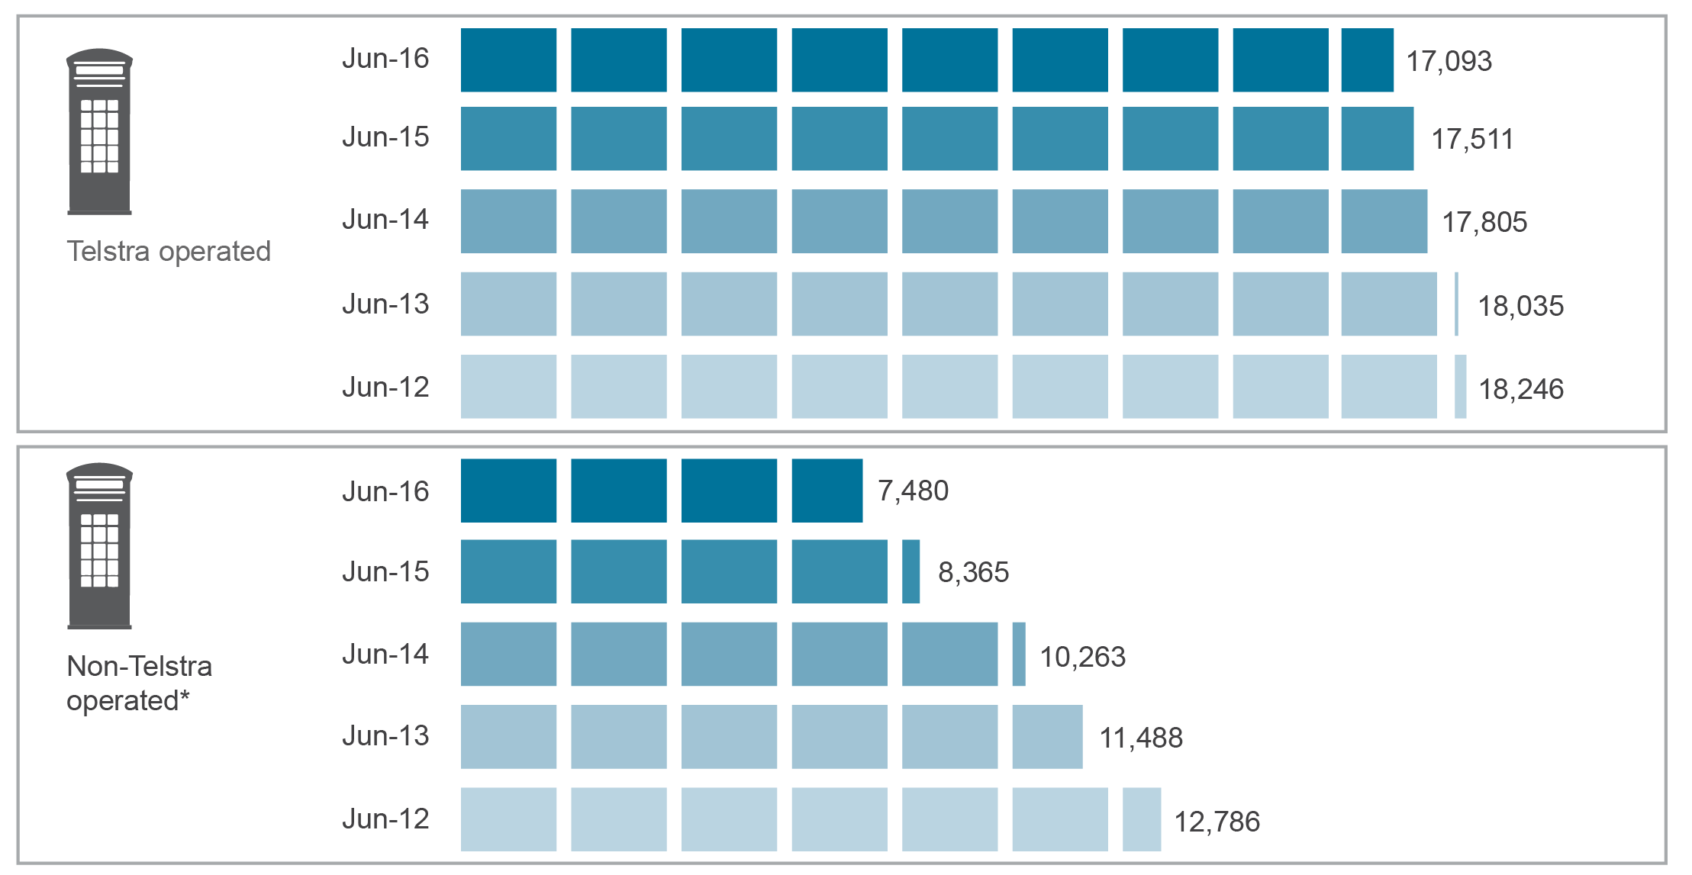
*Includes TriTel payphones (until June 2014) and payphones provided via Telstra access lines. June 2015 and June 2016 data includes Telstra access lines only as the number of TriTel payphones was not available.
Source: Telstra and TriTel.

Table 5.2 provides the geographic distribution of Telstra payphones and payphones provided via Telstra access lines as at 30 June 2016.
Table 5.2 Distribution of Telstra payphones by geographical category, 30 June 2016
 | Urban | Rural | Remote* | RIC
Telstra-operated payphones  % of total | 12,138  71.0 | 4,090  23.9 | 865  5.1 | 580  3.4
Other payphones (provided via Telstra access lines) | 5,922 | 1,211 | 347 | 285
*Including remote Indigenous communities (RIC).
Source: Telstra.

Payphone fault repair performance
Timely repair of payphone faults is an important component of the equitable provision of payphone services under the USO.
Regulatory benchmarks are in place to measure Telstra’s performance in remediating faults under the Telecommunications Universal Service Obligation (Payphone Performance Benchmarks) Instrument (No. 1) 2011 (Payphone Performance Benchmarks). The time frames vary according to the location of the service—one working day for urban locations, two for rural and three for remote locations (including remote Indigenous communities). Failure to meet a benchmark may result in the ACMA taking compliance action.
Table 5.3 shows that Telstra met the national Payphone Performance Benchmarks in urban, rural and remote areas in 2015–16.
Table 5.3 Telstra payphone fault repair performance, 2015–16
 | Urban  (%) | Rural  (%) | Remote  (%)*
Payphone fault repair benchmark | 90.0 | 90.0 | 80.0
Fault repair performance | 94.5 | 93.4 | 87.6
*Including remote Indigenous communities.
Source: Telstra.

Payphones for people with disabilities
At 30 June 2016, Telstra had 154 teletypewriter payphones in operation in metropolitan and regional areas, compared with 153 at 30 June 2015.

CSG Standard
The Telecommunications (Customer Service Guarantee) Standard 2011 (CSG Standard) sets minimum service standards for CSPs in installing, repairing and meeting appointments for standard telephone services for residential and small-business customers. The CSG Standard allows for exemptions from meeting service standards under certain circumstances. If a CSP fails to meet the minimum performance standards, compensation may be payable to the customer.
At 30 June 2016, there were 6.11 million services subject to the CSG Standard, compared to 6.34 million at 30 June 2015—a decline of 3.6 per cent (Table 5.4).
Table 5.4 Services subject to the CSG Standard, by provider, at 30 June
 | 2012  (‘000) | 2013  (‘000) | 2014  (‘000) | 2015  (‘000) | 2016  (‘000)
iiNet | 493 | 418 | 443 | 473 | 427*
Optus | 913 | 850 | 799 | 808 | 977
iPrimus | 103 | 101 | 95 | 49 | 57
Telstra | 5,608 | 5,314 | 5,038 | 4,757 | 4,361
Dodo | n/a | n/a | 159 | 249 | 283
Total | 7,117 | 6,683 | 6,534 | 6,336 | 6,105
n/a=not applicable.
*TPG acquired iiNet in September 2015.
Note: Numbers may not add up due to rounding.
Source: CSP data.

CSG performance benchmarks are established by the Telecommunications (Customer Service Guarantee—Retail Performance Benchmarks) Instrument (No. 1) 2011 and apply to ‘qualifying carriage service providers’ (QCSPs). QCSPs are those that have 100,000 CSG services or more, as at the last day of the preceding financial year. For 2015–16, the QCSPs were Telstra, Optus, iiNet, and Dodo.
The national CSG performance benchmarks set minimum compliance levels with the CSG Standard time frames, which are set out in Table 5.5 and relate to the following activities:
- installing new connections in urban, major rural, minor rural and remote areas
- installing in-place connections in all areas
- fault rectifications in urban, rural and remote areas
appointment-keeping in all areas.
The CSG Standard time frames vary according to the location of the customer and, in the case of connections, whether infrastructure is readily available and whether there is an existing in-place connection. There are nine annual benchmarks in total for connections, fault repair and appointment-keeping where QCSPs must meet a minimum 90 per cent benchmark.
If a QCSP fails to meet any of the annual CSG performance benchmarks, the ACMA may take compliance action, which includes the option to issue the QCSP with an infringement notice.
At 30 June 2016, there were 1,023,599 occasions nationally where customers of the major CSPs waived their rights under the CSG Standard compared to 867,270 at 30 June 2015—an increase of 18 per cent. TPG accounted for 57 per cent of waivers and iiNet for 33 per cent.
Table 5.5 CSG Standard time frames (working days)
 | In-place connection | New service connection |  | Fault repair
 | In-place connection | Close to infrastructure | Not close to infrastructure | Fault repair
Urban | 2 | 5 | 20 | 1
Major rural | 2 | 10 | 20 | 2
Minor rural | 2 | 15 | 20 | 2
Remote | 2 | 15 | 20 | 3
Note: ‘Urban’ is defined as communities with 10,000 or more people, ‘major rural’ is defined as communities with between 2,500 and 10,000 people, ‘minor rural’ is defined as communities with between 200 and 2,500 people, ‘remote’ is defined as communities with up to 200 people.
Source: CSG Standard.

New service and in-place connections
Table 5.6 shows CSP performance in 2015–16 in meeting CSG Standard time frames for new service connections and in-place service connections.
A ‘new service connection’ is the connection of a standard telephone service to premises where there is the need for additional work to be completed (for example, cabling) before a service can be connected. This excludes in-place service connections where there has been a previous working CSG service that is available for reconnection or reactivation by the CSP.
Table 5.6 Percentage and number of new service and in-place connections provided within CSG Standard time frames, 2015–16
 |  | New service* |  |  |  | In-place service*
 |  | Urban  areas | Major rural areas | Minor rural areas | Remote  areas | All areas
iiNet | % | 94.8 | 97.2 | 96.4 | 96.5 | 96.9
iiNet | No. | 64,817 | 3,788 | 1,645 | 55 | 76,879
Optus | % | 98.5 | 98.8 | 98.1 | NQCSP | n/a
Optus | No. | 264,962 | 1,507 | 817 | NQCSP | n/a
Dodo | % | 100 | 100 | 100 | NQCSP | 100
Dodo | No. | 24,281 | 1,954 | 1,186 | NQCSP | 85,778
Telstra | % | 90.9 | 95.1 | 92.9 | 92.6 | 94.3
Telstra | No. | 270,880 | 31,722 | 14,617 | 655 | 252,093
NQCSP=Not a qualifying CSP (QCSP).
n/a=not applicable.
*Service connections.
Note 1: Commencing in 2012–13, QCSPs were required to record the number of requests that were not complied with within the applicable performance time frames and to identify if the CSP’s failure to do so was wholly or partly attributable to one or more acts or omissions by another CSP.
Note 2: Location-specific thresholds are met if a QCSP supplied 10,000 or more CSG services in urban areas, 1,000 or more CSG services in major rural areas, 1,000 or more CSG services in minor rural areas, 500 or more CSG services in remote areas.
Source: CSP data.

Appointments and fault repairs
Table 5.7 shows CSP performance in 2015–16 in meeting the CSG Standard for fault repair time frames and appointment-keeping.
Table 5.7 Percentage and number of faults repaired within CSG Standard time frames and appointment-keeping performance, 2015–16
 |  | Fault repairs |  |  | Appointments*
 |  | Urban areas | Rural areas | Remote areas | All areas
iiNet | % | 100 | 100 | 100 | 100
iiNet | No. | 56,647 | 9,943 | 38 | 45,240
Optus | % | 92.7 | 93.2 | NQCSP | 99.2
Optus | No. | 155,199 | 932 | NQCSP | 223,398
Dodo | % | 100 | 100 | NQCSP | 100
Dodo | No. | 70,622 | 12,949 | NQCSP | 106,183
Telstra | % | 91.5 | 92 | 92.6 | 96.3
Telstra | No. | 413,769 | 135,661 | 2,492 | 458,769
NQCSP=Not a qualifying CSP (QCSP).
*New service connections and fault repairs.
Note 1: Commencing in 2012–13, QCSPs were required to record the number of requests that were not complied with within the applicable performance time frames and to identify if the CSP’s failure to do so was wholly or partly attributable to one or more acts or omissions by another CSP.
Note 2: Location-specific thresholds are met if a QCSP supplied 10,000 or more CSG services in urban areas, 1,000 or more CSG services in rural areas, 500 or more CSG services in remote areas.
Source: CSP data.

Table 5.8 shows the number of new service and in-place connections, fault repairs and appointments for iiNet, Optus, iPrimus, Telstra and Dodo over the previous two financial years (2014–15 and 2015–16). Most notably, the number of in-place connections by iiNet almost halved (49 per cent) in the year to June 2016. iiNet has advised this was due to the end of a previous sales promotion and increased competition in the market place resulting from the NBN rollout.
Table 5.8 Number of new service connections, in-place connections and fault repairs requested and appointments made at the national level
 | iiNet |  | Optus |  | Dodo |  | Telstra
 | 2014–15 | 2015–16 | 2014–15 | 2015–16 | 2014–15* | 2015–16 | 2014–15 | 2015–16
New service connections | 74,031 | 66,181 | 214,914 | 271,436 | 22,441 | 27,444 | 379,187 | 347,657
In-place connections | 79,341 | 40,325 | n/a | n/a | 85,371 | 87,778 | 273,050 | 267,258
Fault repairs | 79,926 | 66,644 | 157,292 | 168,403 | 40,712 | 83,642 | 699,072 | 602,492
Appointments† | 59,140‡ | 45,240‡ | 257,745 | 225,249 | 23,004 | 106,186 | 436,288 | 476,419
n/a=not available.
*Dodo has advised that figures provided prior to the 2015-16 reporting year are under revision.
†New service connections and fault repair.
‡Appointment activity in NSW/ACT and Victoria.
Source: CSP data.

CSG Standard payments
As a result of failing to meet CSG Standard time frames during 2015–16, CSPs made compensation payments to customers, as shown in Table 5.9.
Table 5.9 Volume and value of compensation payments made by CSPs to customers
 | 2014–15 |  | 2015–16
 | Volume | $ (million) | Volume | $ (million)
iiNet | 35,247 | 1.33 | 18,434 | 1.22
Optus | 19,712 | 1.36 | 32,093 | 4.88
iPrimus | 1,563 | 0.05 | 1,678 | 0.09
Telstra | 56,114 | 2.81 | 153,310 | 9.29
Dodo | 7,459 | 0.31 | 16,038 | 0.69
Total | 120,095 | 5.85 | 225,553 | 16.17
Note: Numbers may not add up due to rounding.
Source: CSP data.

Compensation payments totalled $16.17 million for 2015–16, compared to $5.85 million during
2014–15—an increase of 176 per cent.
This increase is, in part, a reflection of the transition to NBN services. As a wholesale-only provider of services, NBN Co is not required to comply with the CSG Standard time frames and so does not claim exemptions from compliance with the standard in circumstances where service provision may be affected (for example, during extreme weather conditions and natural disasters). This has reduced the CSPs’ ability to apply for exemptions. As illustrated in Table 5.10, exemptions from compliance with the CSG Standard decreased by 28 per cent over the past year.
In addition to this transition, other reasons for the increase in payment include ongoing wet weather causing a periodic increase in faults and, in one instance, a payment systems error.

Exemptions from the CSG Standard
During periods when circumstances beyond a CSP’s control affect its ability to comply with the CSG Standard, it may claim an exemption. Similarly, a CSP may also claim an exemption if there is a need to move staff or equipment to an area affected by circumstances beyond its control. Many exemptions are the result of extreme weather events or natural disasters.
In 2015–16, the major CSPs claimed a total of 228 exemptions (Table 5.10), a 28 per cent decrease on 2014–15 (317 exemptions). The median duration for which CSG exemptions applied decreased from 34 to 31 days over the past year.
Table 5.10 Numbers of CSG exemptions for the major CSPs, 2015–16
Reason for exemption |  | iiNet | Optus | Telstra | Vocus Communications*
 | Extreme weather conditions | 47 | 49 | 49 | 40
 | Natural disasters | 1 | 1 | 1 | 1
 | Other | 10 | 10 | 10 | 9
 | Total | 58 | 60 | 60 | 50
*Formerly M2 Group. Exemption notifications for iPrimus, Dodo, Eftel, Commander, aaNet and engin have been included in Vocus Communications notifications.
Source: CSP data.

Network Reliability Framework
The ACMA monitors the reliability of Telstra’s fixed-line telephone service network under the NRF. The NRF applies only to services that Telstra provides to its CSG Standard-eligible customers. Telstra is required to report to the ACMA on the performance of its network and to fix poorly performing cable runs and individual services.
The NRF requires monitoring and/or remedying network reliability performance at three levels:
- Level 1—national and geographical area level, based on Telstra’s 44 field service areas (FSAs)
- Level 2—local-level cable runs in disaggregated parts of the network
Level 3—individual service level that includes all Telstra services covered by the CSG Standard.
Level 1 is designed to inform the public about overall network reliability performance. Under levels 2 and 3, Telstra is required to remediate poorly performing parts of its network as a priority.

Level 1—national and field service area performance
Telstra’s national performance data is presented in Figure 5.2. Level 1a shows the percentage of CSG Standard services that did not experience a fault during the month reported. Level 1b shows the percentage of time in a month that CSG Standard services, on average, are available.
Figure 5.2 Telstra’s level 1a and 1b performance, based on monthly reports (percentage)
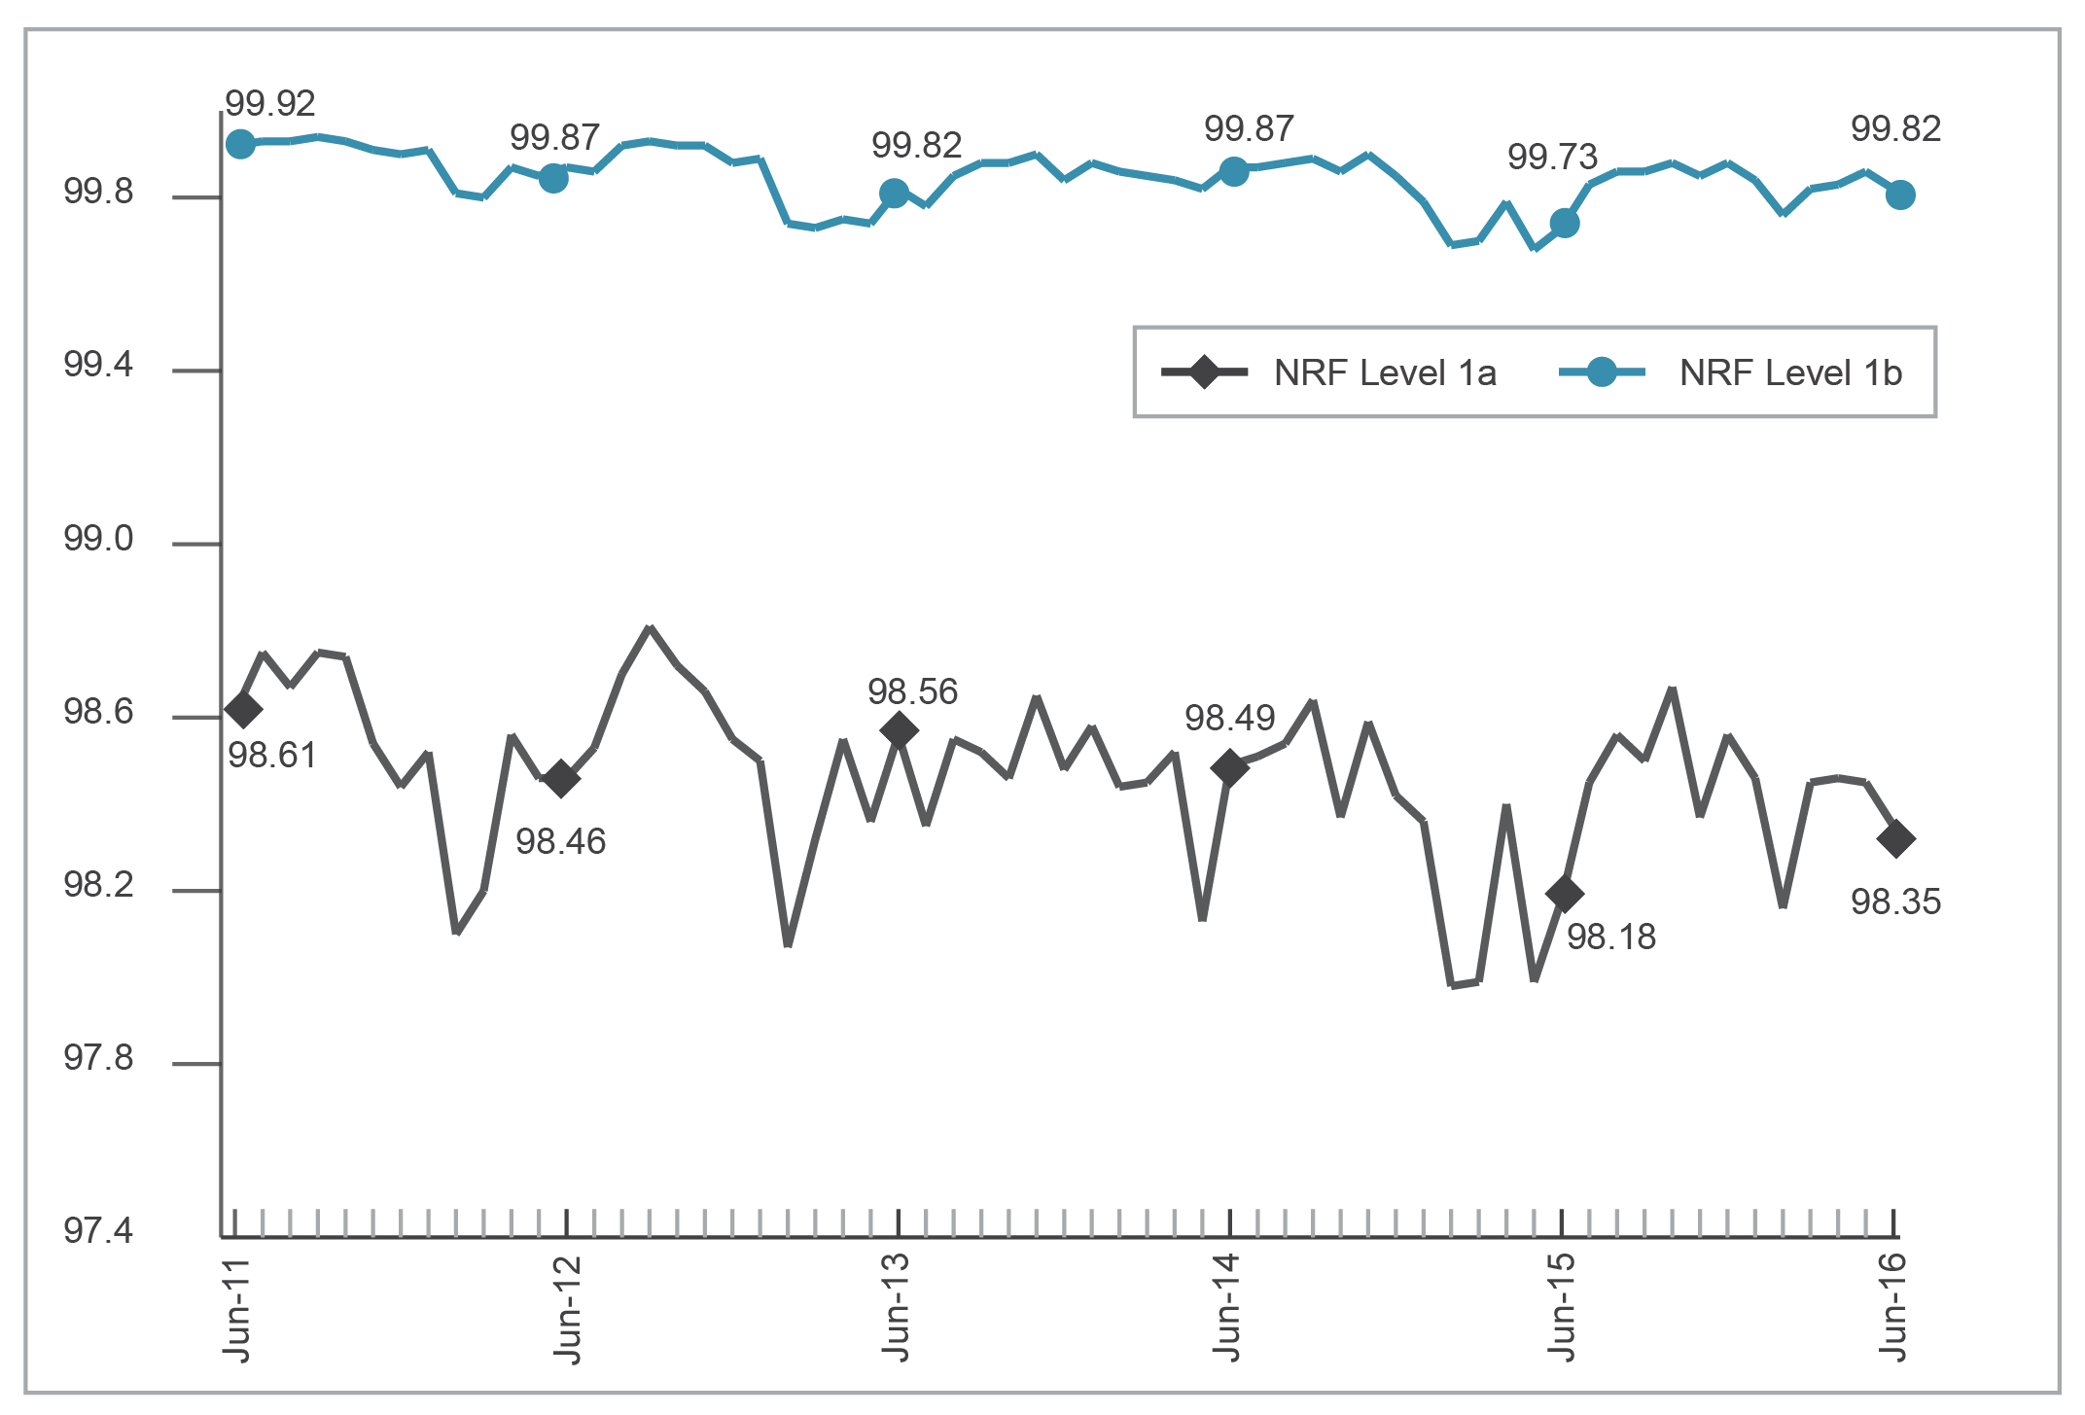
Base: Number in each category.
Source: ACMA, Telstra.

Under Level 1a, FSAs in urban areas experienced a lower percentage of faults than those in non-urban areas. On average, 1.46 per cent of services experienced a fault in any given month in urban areas, compared to 1.62 per cent in non-urban areas. Figure 5.3 shows the seasonal nature of NRF Level 1a performance. Small changes in this figure represent relatively large changes in the number of faults occurring on the network.
Level 1b measures the percentage of time in a month that services (on average) are available; that is, not awaiting repair. In 2015–16, services were available, on a monthly average, 99.84 per cent of the time (nationally). In 2014–15, services were available, on a monthly average, 99.80 per cent of the time (nationally).
The ACMA also uses data provided under Level 1 of the NRF to calculate the average time (in hours) for fault-affected CSG Standard services to be repaired for the month (Level 1c—Figure 5.3). Level 1c measures the average number of hours Telstra took to restore fault-affected services in the month. While Level 1b takes into account all services, Level 1c only considers services that experienced a fault.
In terms of elapsed time, it took an average of 76 hours to restore services that had a fault in 2015–16, compared to an average of 86 hours in 2014–15. It also took an average of 66 hours to restore fault-affected services in urban areas (76 hours in 2014–15) and 90 hours in non-urban areas (94 hours in 2014–15).
Figure 5.3 Level 1c—average time for Telstra to restore fault-affected services (hours)
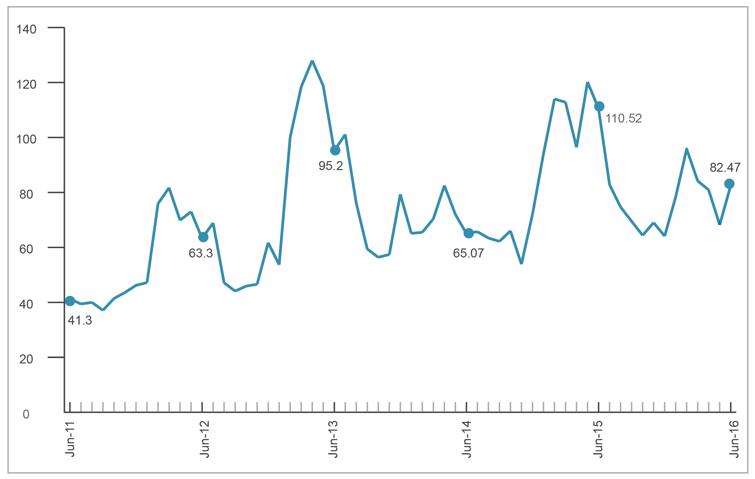
Source: ACMA, Telstra.

Level 2—local cable run remediation
Level 2 of the NRF requires Telstra to report on and undertake remediation work on the 40 poorest performing cable runs—a set of 10 or 100 copper wire pairs within a physical cable sheath—each month.
During 2015–16, Telstra completed remediation and monitoring of 473 cable runs, some of which were identified for remediation in previous reporting periods. For the year, Telstra identified the required 480 cable runs to be remediated. Telstra also remediated an additional 385 cable runs associated with the reported cable runs (417 in 2014–15). Telstra estimated that remediation work undertaken as part of Level 2 of the NRF in 2015–16 improved the reliability of 24,743 services (26,607 in 2014–15).

Level 3—individual service performance
Telstra is required to take action to prevent an individual CSG Standard-eligible service from experiencing more than either three faults in a rolling 60-day period (NRF Level 3a) or four faults in a rolling 365-day period (NRF Level 3b).
Telstra reports to the ACMA on any services that breach these thresholds, investigates the performance of the service and then undertakes necessary remediation.
Figure 5.4 shows that the number of services experiencing four or more faults in a rolling 60-day period (Level 3a) or five or more faults in a rolling 365-day period (Level 3b).
Figure 5.4 Telstra CSG Standard services with four or more faults in a rolling 60-day period (Level 3a) and five or more faults in a rolling 365-day period (Level 3b)
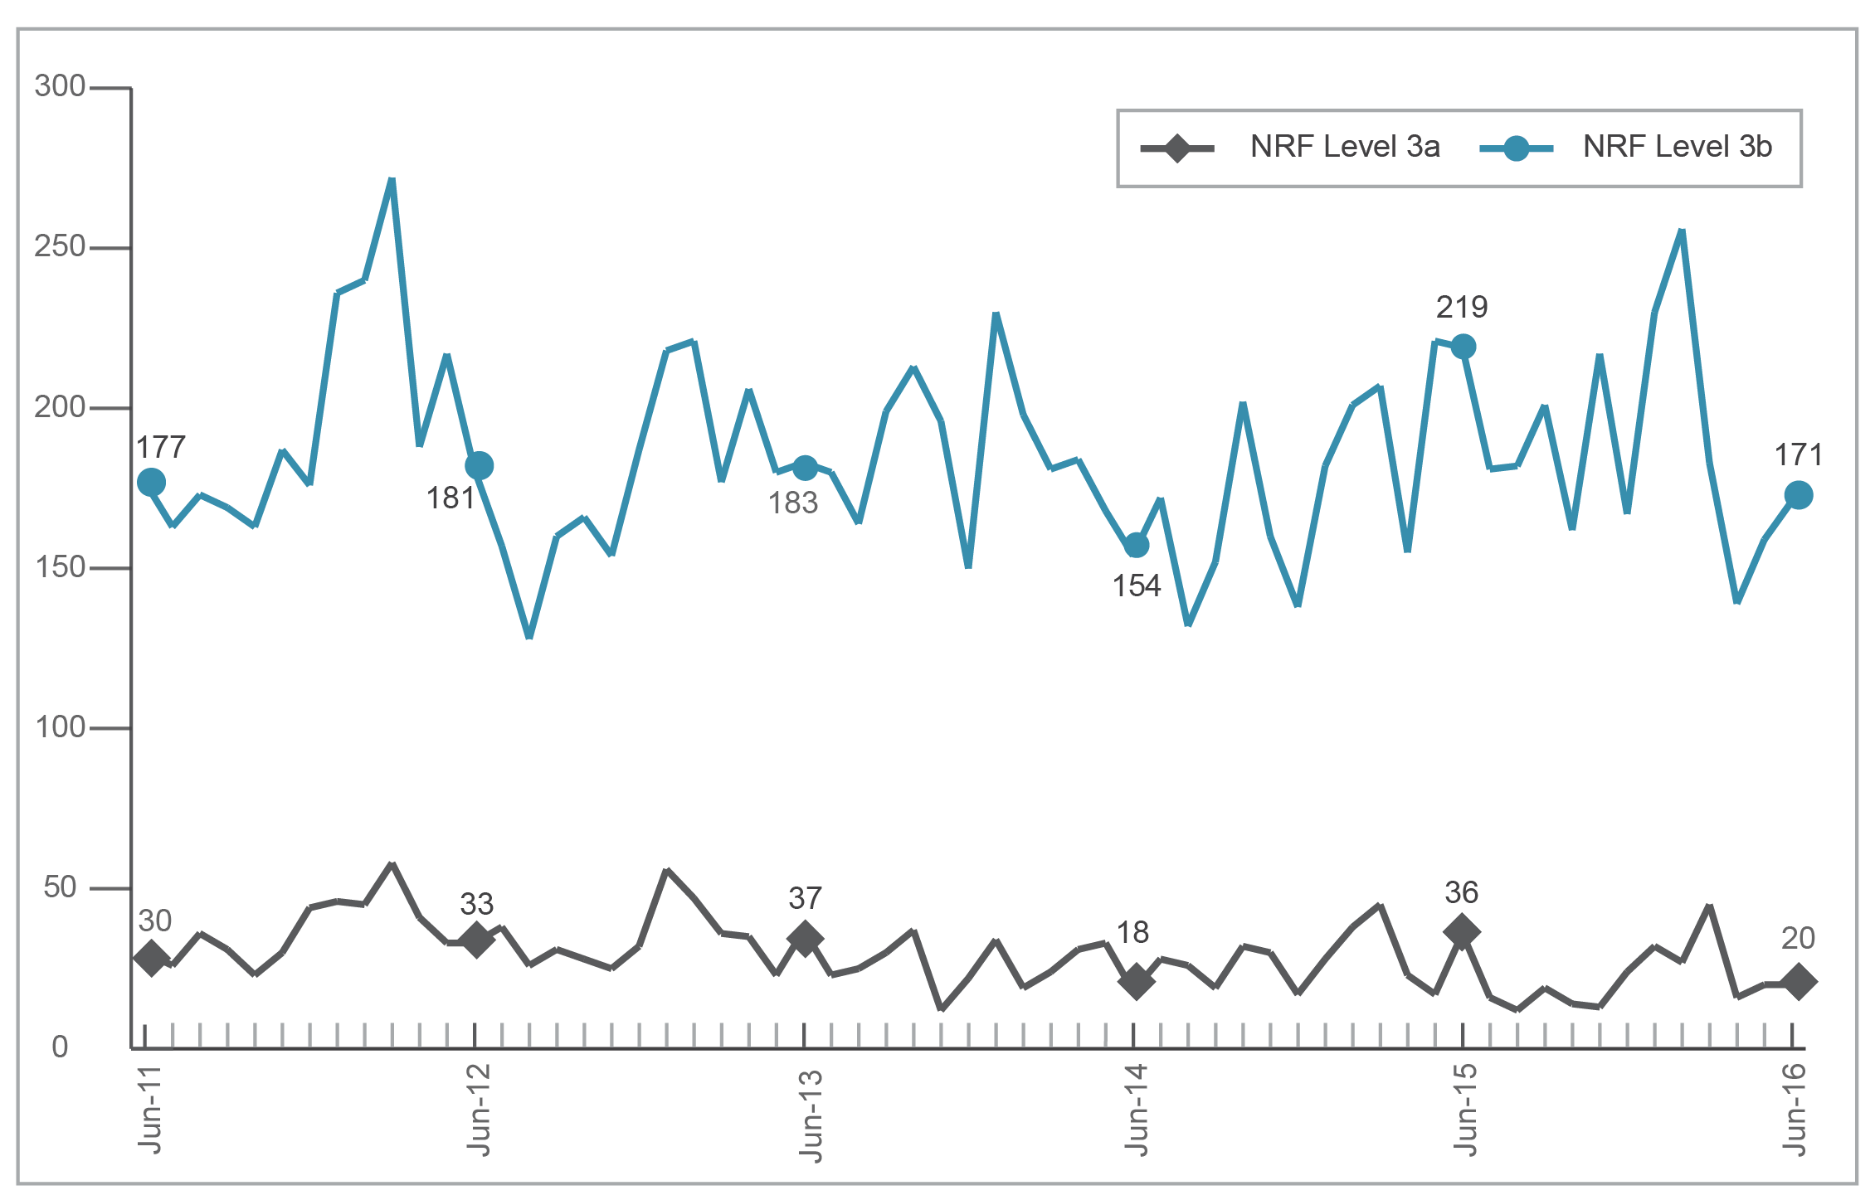
Base: Number of services.
Source: Telstra.

Telstra has reported a decrease in the number of services experiencing breaches of the 60-day threshold, with 22 breaches per month (on average) and a total of 258 for 2015–16. In 2014–15, Telstra reported an average of 28 breaches per month and a total of 339 for the year.
Telstra reported a slight increase in the number of services experiencing breaches of the 365-day threshold, with 187 breaches per month (on average) and a total of 2,248 for 2015–16. In 2014–15, Telstra reported an average of 178 breaches per month and a total of 2,141 for the year.
Telstra is required to remediate any service that breaches the fault thresholds and then monitor that service for an eight-month period. If a service experiences another fault (known as a monitoring-period fault) during the monitoring period, Telstra must report this to the ACMA, together with an assessment of whether the fault is related or unrelated to the original fault(s) that caused the contravention. In 2015–16, Telstra reported 937 monitoring-period faults (across 767 individual services) and assessed 24 faults as related to the original contravention. This compares to 809 monitoring-period faults (across 633 individual services) reported and 28 faults assessed as related to the original contravention in 2014–15.
Additionally, Telstra is required to report to the ACMA quarterly any services where remediation has not been completed within the expected time frames. In 2015–16, Telstra reported 190 delays to remediation, with an average reported delay of 119 days. This compares to 368 delays to remediation, with an average reported delay of 152 days, in 2014–15. Some services were reported as experiencing more than one delay.

Priority assistance
Priority assistance is a priority telephone connection and repair service for people with a diagnosed life-threatening medical condition, who are at risk of suffering a rapid and life-threatening deterioration in their condition. Telstra offers the service as a requirement of its carrier licence condition. Other CSPs may offer priority assistance services but are not obliged by regulation to do so. In 2015–16, iPrimus was the only CSP to voluntarily offer priority assistance services in line with industry code ACIF: C609:2007 Priority Assistance for Life Threatening Medical Conditions. However, according to the iPrimus website it does not support Priority Assistance for new customers or for customers who do not already have Priority Assistance active on their fixed-line service.
The number of priority assistance customers is presented in Table 5.11. During 2015–16, the number of priority assistance customers increased by 11.6 per cent. Telstra implemented its new priority assistance policy in 2015–16.
Table 5.11 Number of priority assistance customers, at 30 June
 | 2012 | 2013 | 2014 | 2015 | 2016
Provisional | 91,009 | 144,435 | 49,679 | 63,505 | 94,290
Validated | 130,341 | 112,114 | 154,940 | 123,240 | 116,969
Total | 221,350 | 256,549 | 204,619 | 186,745 | 211,259
Source: Telstra, iPrimus.

Priority assistance customers are given faster connections and fault repairs of their fixed-line telephone service than the connection and fault repair time frames mandated in the CSG Standard. A service must be connected or a fault repaired within 24 hours in urban and rural areas, or within 48 hours in remote areas. Tables 5.12 and 5.13 provide information about the performance of Telstra and iPrimus in meeting priority assistance time frames for connections and fault repairs since 2011–12.
Table 5.12 Priority assistance—percentage and volume of connection requests completed on time, by financial year
 |  | National |  | Urban |  | Rural |  | Remote
 |  | % | Volume | % | Volume | % | Volume | % | Volume
Telstra | 2011–12 | 91.6 | 40,881 | 91.8 | 30,618 | 91.5 | 9,970 | 83.8 | 295
Telstra | 2012–13 | 92.9 | 42,700 | 92.9 | 32,536 | 92.9 | 9,886 | 89.1 | 277
Telstra | 2013–14 | 93.2 | 34,675 | 93.3 | 26,980 | 92.9 | 7,467 | 88.8 | 222
Telstra | 2014–15 | 92.4 | 34,185 | 92.3 | 26,495 | 92.6 | 7,504 | 93.1 | 175
Telstra | 2015–16 | 90.8 | 41,418 | 90.2 | 31,995 | 92.8 | 9,229 | 89.9 | 178
iPrimus | 2011–12 | 100 | 63 | 100 | 56 | 100 | 7 | n/a | 0
iPrimus | 2012–13 | 100 | 112 | 100 | 90 | 100 | 22 | n/a | 0
iPrimus | 2013–14 | n/r | n/r | n/r | n/r | n/r | n/r | n/r | n/r
iPrimus | 2014–15 | 100 | 2 | n/a | 0 | 100 | 2 | n/a | 0
iPrimus | 2015–16 | 100 | 1 | n/a | 0 | 100 | 1 | n/a | 0
n/a=not available.
n/r=not requested.
Note: ‘Urban’ is defined as communities with 10,000 or more people, ‘rural’ is defined as communities with between 200 and 10,000 people, ‘remote’ is defined as communities with up to 200 people.
Source: Telstra, iPrimus.

Table 5.13 Priority assistance—percentage and volume of fault restoration requests completed on time, by financial year
 |  | National |  | Urban |  | Rural |  | Remote
 |  | % | Volume | % | Volume | % | Volume | % | Volume
Telstra | 2011–12 | 94.6 | 130,946 | 95.7 | 95,586 | 92 | 34,855 | 93.8 | 469
Telstra | 2012–13 | 95.5 | 155,378 | 96.6 | 114,800 | 92.3 | 40,045 | 92 | 502
Telstra | 2013–14 | 95.1 | 116,552 | 96.1 | 89,205 | 92.1 | 26,988 | 90.9 | 390
Telstra | 2014–15 | 94.6 | 133,563 | 95.7 | 102,803 | 91.1 | 30,348 | 94 | 425
Telstra | 2015–16 | 94.6 | 127,618 | 95.3 | 96,977 | 90.8 | 29,692 | 90.1 | 399
iPrimus | 2011–12 | 92.9 | 113 | 93.2 | 88 | 92 | 25 | n/a | 0
iPrimus | 2012–13 | 84 | 58 | 90 | 40 | 72.2 | 18 | n/a | 0
iPrimus | 2013–14 | n/r | n/r | n/r | n/r | n/r | n/r | n/r | 0
iPrimus | 2014–15 | 100 | 7 | 100 | 6 | n/a | 0 | 100 | 1
iPrimus | 2015–16 | 100 | 5 | 100 | 5 | n/a | 0 | n/a | 0
n/a=not available.
n/r=not requested.
Note: ‘Urban’ is defined as communities with 10,000 or more people, ‘rural’ is defined as communities with between 200 and 10,000 people, ‘remote’ is defined as communities with up to 200 people.
Source: Telstra, iPrimus

Number portability
Number portability allows a customer to take (keep) their existing telephone number when changing from one service provider to another. Number portability is available for:
- local numbers (numbers beginning with the area codes 02, 03, 07 and 08)
- freephone (1800 numbers) and local rate numbers (13 and 1300 numbers)
mobile numbers.

Local number portability
During 2015–16, 991,011 local numbers were ported, a 19 per cent decrease on the 1,223,599 local numbers ported in 2014–15. Table 5.13 shows this is the first year with a decrease in local number ports, with local number ports previously increasing each year since 2011–12. The Communications Alliance (CA) C540:2013 Local Number Portability Code sets out carrier/CSP operational procedures for porting local numbers.

Freephone and local rate number portability
The portability of freephone and local rate numbers (FLRNs) is referred to as Inbound Number Portability (INP). Since August 2015, ZOAK Pty Ltd has facilitated the portability of FLRNs on behalf of industry. There were 11,911 FLRNs ported during 2015–16, a four per cent decrease on the 12,495 FLRNs ported during 2014–15 (Table 5.14).
The C657:2015 Inbound Number Portability Code (INP Code) was developed by CA and registered with the ACMA on 21 March 2016. The INP Code filled a regulatory gap by codifying the operational requirements for porting inbound numbers.

Mobile number portability
The portability of mobile numbers is referred to as Mobile Number Portability (MNP), which is regulated by the C570:2009 Mobile Number Portability Code. During 2015–16, there were 1.41 million mobile numbers ported, a decrease of 18 per cent on the 1.72 million mobile numbers ported in 2014–15. Most mobile ports are completed within a few hours.
Table 5.14 Number portability
Numbers ported | 2011–12 | 2012–13 | 2013–14 | 2014–15 | 2015–16
Local | 627,160 | 763,422 | 865,522* | 1,223,599 | 991,011
Freephone and local rate | 12,814 | 13,096 | 11,088 | 12,495 | 11,991
Mobile | 2,627,350 | 1,743,485 | 1,668,163 | 1,721,284 | 1,733,834
*Figure revised due to one CSP submitting updated data.
Source: ACMA and INMS.

Telecommunications codes—development and review
Under Part 6 of Telecommunications Act 1997, the ACMA may register codes developed by industry bodies. At 30 June 2016, 21 codes were registered, comprising:
- 20 codes developed by Communications Alliance (CA)
the Cabling Requirements for Business Industry Code, developed by the Cabling Industry Committee.
In 2015–16:
- CA finalised a review of the Telecommunications Consumer Protections Code 2012 (TCP Code). This led to the ACMA registering an updated TCP Code on 3 December 2015, reducing unnecessary duplication with other legislation, and giving telecommunications companies greater flexibility in when and how key information is provided to customers.
- A minor update of Chapter 9 of the TCP Code was registered by the ACMA on 3 March 2016.
- CA developed the INP Code, which codifies the operational requirements for porting inbound numbers with the prefixes 13, 1300 and 1800. It was registered by the ACMA on 21 March 2016.
- The C513:2015 Customer and Network Fault Management Industry Code was changed to remove references to an unused local number porting process and some duplications. It was registered by the ACMA on 19 February 2016.
- The C515:2015 Pre-selection Industry Code, C540:2013 Local Number Portability Industry Code and C570:2009 Mobile Number Portability Industry Code were each amended to align with the customer authorisation process outlined in the TCP Code and the CA Customer Authorisation Guideline. All three codes were registered by the ACMA on 19 February 2016.
The C536:2011 Emergency Call Services Requirements Industry Code (incorporating Amendment No.1/2015) was amended to alter a reporting requirement and remove duplication of a customer information requirement that is included in the CA Prepaid Calling Card Guideline. The code was registered by the ACMA on 19 February 2016.

Industry compliance with telecommunications codes

Compliance with the TCP Code
Telecommunications companies demonstrated high levels of compliance with the TCP Code across a range of audits and investigations. For the period 1 July 2015 to 30 June 2016:
- Twenty-seven advertisements from 18 different providers were reviewed. Of these, 25 were found to be compliant with the advertising requirements of the TCP Code. Two providers were contacted, who amended their advertising to ensure compliance with the TCP Code.
Compliance with Critical Information Summary (CIS) requirements increased from 69 per cent in 2014–15 to over 75 per cent. Most of the non-compliant CISs required only minor changes to make them compliant. The ACMA will continue to monitor compliance in this area.
Communications Compliance (CommCom) requires providers to promote code awareness, lodge annual compliance documents, and prepare and maintain a compliance plan. In 2015–16, a review of Chapter 9 of the TCP Code was concluded that resulted in the ACMA approving a variation to this chapter, effective from 3 March 2016. Key changes to Chapter 9 include improving the operational effectiveness of CommCom and increasing the flexibility in reporting arrangements for smaller providers. During the reporting period, the ACMA also issued six directions and 25 formal warnings to providers who failed to lodge compliance attestations by 1 April 2015.
From 2016 onwards, all suppliers regulated by the TCP Code are required to undertake a ‘once-only’ registration with CA by 3 May 2016. In addition, smaller providers (those with fewer than 3,000 services in operation) are required to lodge their attestation documents in CommCom’s first lodgement window (29 April 2016 for this reporting period) or submit a deferral notice in that first window that allows them to lodge in a (new) second lodgement window (ending on 1 September 2016). Large providers are required to lodge documents in the second lodgement period.
In June 2016, the ACMA wrote to 23 providers who had not registered with CA by the due date to request that they do so immediately. The ACMA will monitor compliance with this requirement.
For the period 1 July 2015 to 30 June 2016, 27 formal warnings were issued and six telecommunications companies received directions to comply with the TCP Code for failing to lodge CommCom documentation the prior financial year (Table 5.15).
Table 5.15 ACMA compliance activity for the TCP Code
TCP Code provision | Enforcement action | Telecommunication company
Failing to comply with requirements to provide compliance statements to CommCom in 2015 | Direction | AussieSim Pty Ltd
Failing to comply with requirements to provide compliance statements to CommCom in 2015 | Direction | Btel Communications Pty Ltd
Failing to comply with requirements to provide compliance statements to CommCom in 2015 | Direction | Datawave Internet Pty Ltd
Failing to comply with requirements to provide compliance statements to CommCom in 2015 | Direction | Golden IT Pty Ltd
Failing to comply with requirements to provide compliance statements to CommCom in 2015 | Direction | Harbour Of Technology Pty Ltd
Failing to comply with requirements to provide compliance statements to CommCom in 2015 | Direction | MVoice Pty Ltd
Inadequate CISs | Formal warning | iTalkBB Australia Pty Ltd
Failing to comply with transfer provisions | Formal warning | Exceed Connect Pty Ltd
Referrals from CommCom for failing to lodge compliance statements in 2015 | Formal warning | 25 providers
Source: ACMA.

Cabling

Registered cablers
Every person who works on customer cabling connected to the telecommunications network, or intended for use on the customer side of the network boundary, must either be registered with an ACMA-accredited registrar as a cabling provider or supervised by a person who is registered. The ACMA’s regulatory requirements for customer cabling work are set out in the Telecommunications Cabling Provider Rules 2014 (Cabling Provider Rules). The Cabling Provider Rules require customer cabling work to comply with the technical requirements in AS/CA S009 – Installation Requirements for Customer Cabling (the Wiring Rules).
In 2015–16, there were five ACMA-accredited registrars providing registration and other associated services to cablers.
Table 5.16 shows that the total number of registered cablers in the industry has increased each year since 30 June 2012.
Table 5.16 Total number of licensed/registered cablers
 | Jun 12 | Jun 13 | Jun 14 | Jun 15 | Jun 16
Number of cablers | 67,637 | 69,155 | 71,057 | 71,288 | 72,302
Source: ACMA.

Cabling compliance
The ACMA investigates complaints about non-compliant cabling work or work performed by unregistered cablers. Where appropriate, the ACMA conducts investigations arising from these complaints.
During 2015–16, the ACMA received 12 cabling-related complaints and conducted 29 cabling inspections. The ACMA issued two warning notices under the Act for unregistered cabling work and one advice notice for non-compliant cabling. No telecommunications infringement notices were issued.

Do Not Call Register
The DNCR is a secure database that allows people to list their numbers to opt out of receiving most unsolicited telemarketing calls and marketing faxes. A number is eligible to be registered if it is:
- used or maintained primarily for private or domestic purposes
- used for transmitting and/or receiving faxes
- used exclusively by a government body
an emergency service number.
In 2015–16, the amount of numbers listed on the DNCR increased by 386,590, taking the total amount of numbers listed to 10.65 million.
To avoid breaching the Do Not Call Register Act 2006 (DNCR Act), telemarketers and fax marketers are able to submit their contact lists to the DNCR operator for checking, or ‘washing’, against the DNCR. During 2015–16, 1,022 telemarketers and fax marketers submitted over one billion numbers for checking (Figure 5.5).
Figure 5.5 Numbers submitted for checking against the DNCR (billions)
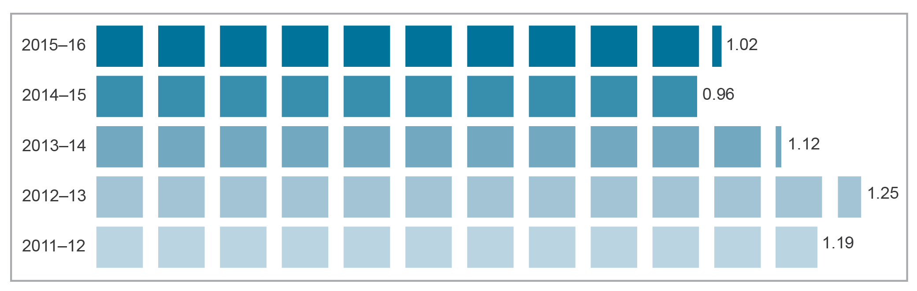
Base: Numbers submitted for checking.
Source: Register operator (Salmat Digital Pty Ltd) reports to the ACMA.

Unsolicited communications—spam and telemarketing
The ACMA is responsible for compliance and enforcement with respect to the DNCR Act, Spam Act 2003 (Spam Act), Telemarketing and Research Industry Standard 2007 and Fax Marketing Industry Standard 2011. This regulation is designed to minimise the impact on Australians of unsolicited telemarketing, fax marketing and commercial electronic messages including email, SMS, MMS and instant messaging.
In 2015–16, the number of complaints the ACMA received about telemarketing increased by 27.3 per cent. This increase is partly attributable to revised processes that changed how complaints and enquiries are recorded. Consequently, the increase in the number of complaints lodged is related to the decrease in the number of enquiries lodged, as indicated in Table 5.17.
The overall number of complaints about fax marketing remained very low, decreasing by a further 54.5 per cent in the period.
The number of complaints and reports the ACMA received about commercial electronic messages (spam) in 2015–16 increased by 44.6 per cent.
The ACMA uses complaints and reports from Australian consumers about unsolicited communications to identify businesses that may be in breach of the legislation. The ACMA generally takes a graduated approach to non-compliance by first educating, advising or warning businesses that may be in breach of the legislation.
The ACMA has found that the majority of businesses address compliance issues after one contact. When businesses do not respond favourably to these approaches, cases may be escalated, including to formal investigations and, where breaches are found, to compliance and enforcement action.
Table 5.17 summarises the number of complaints, reports and enquiries received by the ACMA, and the levels of compliance and enforcement activity.
Table 5.17 Summary of complaints, reports, enquiries, compliance activities and enforcement
 |  |  | 2014–15 | 2015–16 | Change (%)
Complaints and reports* | Telemarketing complaints |  | 18,081 | 23,014 | 27.3
Complaints and reports* | Fax marketing complaints |  | 99 | 45 | –54.5
Complaints and reports* | Spam* | Email complaints | 1,341 | 1,275 | –4.9
Complaints and reports* | Spam* | Email reports | 342,607 | 514,604 | 50.2
Complaints and reports* | Spam* | SMS complaints | 388 | 462 | 19.1
Complaints and reports* | Spam* | SMS reports | 6,689 | 17,606 | 163.2
Complaints and reports* | Total |  | 369,205 | 557,006 | 50.9
Enquiries† | Telemarketing and fax marketing |  | 12,113 | 6,740 | –44.4
Enquiries† | Spam |  | 1,337 | 1,251 | –6.4
Enquiries† | Total |  | 13,450 | 7,991 | –40.6
Compliance warning letters | Telemarketing and fax marketing |  | 962 | 1,691 | 75.8
Compliance warning letters | Spam |  | 6,918 | 2,412 | –65.1
Compliance warning letters | Total |  | 7,880 | 4,103 | –47.9
Investigations | Telemarketing |  | 5 | 9 | 80
Investigations | Fax marketing |  | 0 | 0 | n/a
Investigations | Spam |  | 4 | 5 | 25
Investigations | Total |  | 9 | 14 | 55
n/a=not available.
*Complaints are an expression of dissatisfaction made to the ACMA about unsolicited emails or SMS, whereas reports are an advice of spam activity directed to the ACMA’s anti-spam databases. Reports are not actioned individually but assist the ACMA in its anti-spam activities.
†The ACMA and the DNCR operator receive enquiries from the public and businesses on matters related to compliance with the DNCR Act and Spam Act, such as the legitimacy of calls or messages received, how to stop receiving calls or messages, how requirements of the DNCR Act or Spam Act affect their business, and whether particular marketing approaches are compliant with the DNCR Act or Spam Act.
Source: ACMA.

Australian Internet Security Initiative
The AISI is a voluntary program operated by the ACMA to assist AISI partners to address the problem of computing devices that are compromised by malware (malicious software). Malware can enable criminals or malicious parties to steal personal and sensitive information from devices and control them remotely for illegal or harmful purposes, without the user’s knowledge. These infections often enable activities causing harm to other internet users, including the mass distribution of spam, hosting of phishing sites, facilitation of identity theft, participation in dedicated denial-of-service attacks and dissemination of ransomware (malware that restricts access to files on a computer system until a sum of money is paid).
The AISI provides daily reports to partners—Australian ISPs and educational institutions—about malware-infected computing devices residing on their networks. When they receive a report of an infection, AISI partners are expected to contact their customers, inform them that their computing devices are infected and provide information to help restore these devices to safe operation. Partners can also access AISI data on compromises occurring on IP addresses on their networks through an online portal, which contains more comprehensive data than is in the daily AISI email reports.
At 30 June 2016, there were 146 partners in the AISI, with these partners estimated to cover more than 95 per cent of allocated Australian IP address ranges. A total of 62.5 million daily observations of infections were reported to AISI partners in 2015–16, averaging 5.2 million per month.
In March 2015, the ACMA began reporting services vulnerable to known exploits—such as websites, network-attached storage devices and home routers—that potentially allow a criminal or malicious actor to intercept communications occurring through that device in order to steal sensitive information (such as communications about a financial transaction). The majority of these services are vulnerable because they permit the use of outmoded and insecure encryption. During 2015–16, a further 11 vulnerability types were added to the daily AISI reports, including network services ‘openly’ accessible to the internet, such as ‘queryable’ databases. A total of 72.4 million daily observations of vulnerable IP addresses were reported to AISI partners in 2015–16.
Reporting vulnerable services assists home and business users by alerting them to the need to improve the security level of their internet-accessible services. The feedback from industry on the reporting of vulnerability data through the AISI program has been positive, with the data indicating significant issues exist for industry in maintaining security levels on these services.
In October 2015, the ACMA released a research paper, The Australian Internet Security Initiative: Interviews with industry participants. Based on interviews with 24 AISI partners, the paper examined internet provider use of the daily AISI malware infection reports and the associated AISI portal, which provides historical data on malware infections and service vulnerabilities occurring on their networks. The paper also examined how AISI partners interact with their customers when advising them of malware infections on their computing devices. The report found strong industry support for the AISI program.
The AISI is complemented by the CA C650:2014 iCode—Internet Industry Code of Practice (iCode), which began operating on 1 December 2010, and is designed to provide a consistent approach for Australian ISPs to help inform, educate and protect their customers against cybersecurity risks. The iCode specifies the AISI as one of the methods that ISPs should use to detect malware infections in their networks.
The ACMA also manages an automated system for reporting suspected ‘phishing’ URLs extracted from spam emails reported to the ACMA. These phishing emails direct internet users to fraudulent web pages that represent themselves as belonging to legitimate businesses, such as banks. Their main function is to obtain financial and personal information from unsuspecting internet users for criminal purposes.
Recipients of the ACMA’s phishing reports include the Australian Tax Office, Facebook, Telstra and a number of major financial institutions. A total of 44,271 reports of suspected phishing URLs were provided to these organisations in 2015–16, a slight increase of 751 over the number reported in 2014–15. To enable quick and early action, phishing reports are provided within minutes of being received by the ACMA.

Industry compliance with TIO scheme
Section 128 of the TCPSS Act requires carriers and eligible CSPs to join the TIO scheme. The scheme provides for the resolution of unresolved complaints about carriers or CSPs made by residential and small-business customers where those complaints are not resolved by the CSP/carrier. Eligible CSPs are those providers who supply fixed standard telephone, mobile or internet services to residential and small-business customers. TIO scheme members are required to comply with the scheme.
From 1 July 2015 to 30 June 2016, the TIO referred 12 companies that had not joined the TIO scheme to the ACMA. As at 30 June 2016, 11 of these firms joined the scheme as a result of TIO referrals to the ACMA, with one more company joining the TIO as a result of a referral given to the ACMA in the previous reporting year. An investigation into one of the companies referred to the ACMA by the TIO is ongoing.
Investigations into TIO scheme membership led to one direction to comply with section 128 of the TCPSS Act issued to LBM Australia Pty Ltd, which subsequently joined the TIO scheme.

Complaints to the TIO
There were 112,518 new complaints made to the TIO during 2015–16, a reduction of 9.6 per cent from 2014–15. The most significant decrease in complaints was for mobile services—down by 30.2 per cent on the previous year, and less than a third of the peak level recorded during 2011–12.
Complaints about fixed-line services were down by 6.4 per cent; however, complaints about internet services increased by 22.1 per cent, reversing the trend of previous years. Complaints about mobile premium services were up 11.1 per cent from 2014–15, although the numbers remain relatively low compared to complaints made about other services (Figure 5.6).
The TIO records a new complaint when it receives an expression of dissatisfaction from a consumer whose complaint has not been resolved by the service provider. The TIO identifies and allocates complaint issues within each new complaint from a choice of keywords that are aligned to industry codes or common complaint categories identified by the TIO. As such, each new complaint involves at least one complaint issue and often more than one.
Figure 5.6 Annual TIO new complaints by service type
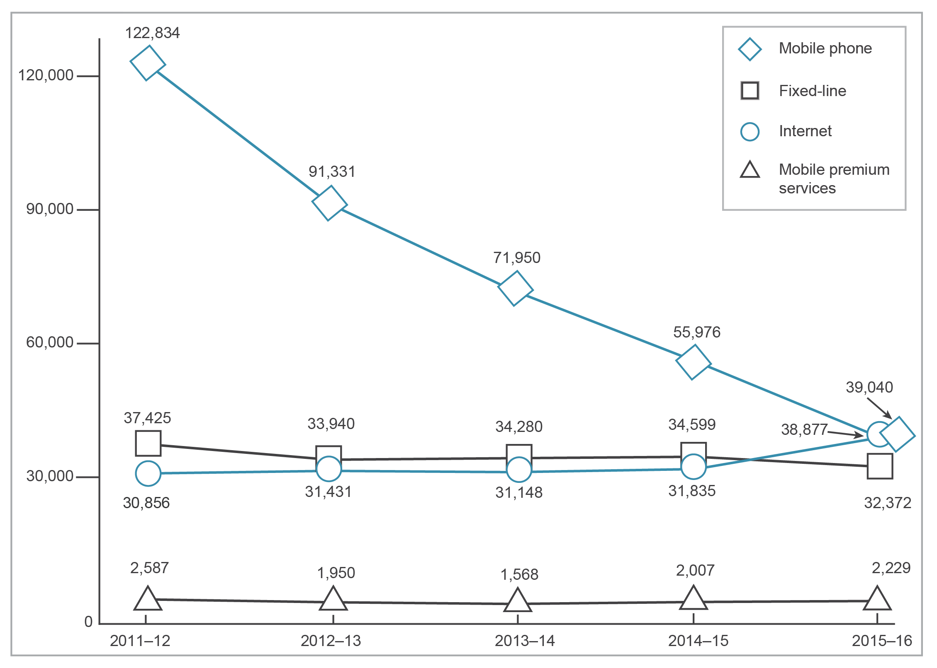
Source: TIO.

Table 5.18 shows the top six TIO new complaint issues for the last five financial years. Complaints about credit management, customer service, and billing and payments have fallen since 2014–15. Complaints about faults and complaints-handling have increased.
Table 5.18 Top six TIO new complaint issues
Complaint issue category | 2011–12 | 2012–13 | 2013–14 | 2014–15 | 2015–16 | 2014–15 to 2015–16 change (%)
Billing and payments | 109,502 | 78,160 | 76,587 | 66,128 | 60,240 | –9.77
Customer service | 93,941 | 94,639 | 75,033 | 58,674 | 53,324 | –10.03
Faults | 78,829 | 75,325 | 54,055 | 47,860 | 54,699 | 12.50
Complaints-handling | 65,818 | 50,504 | 46,469 | 36,938 | 39,888 | 7.40
Contracts | n/a | n/a | 37,430 | 34,021 | 31,033 | –9.63
Credit management | 52,907 | 46,138 | 40,040 | 29,999 | 22,620 | –32.62
n/a=not available prior to 2013–14.
Source: TIO.

Appendix—Research methodology

ACMA-commissioned surveys
The 2016 ACMA-commissioned surveys of consumers were conducted by OmniPoll. A new methodology was implemented in 2016, mixing online survey (for those who access the internet) and computer-aided telephone interviews (CATI) landline telephone survey (for those who have not accessed the internet in the past six months).
The telecommunications survey (survey one) comprised 1,855 online interviews with adult Australians plus 201 CATI surveys to reach the adult population who are not regularly online.
The second survey, primarily on media use, included 1,810 online interviews together with 197 CATI interviews for those not regularly online.
Fieldwork was conducted in May and early June 2016.

Weighting
To reflect the population distribution, the combined online results, together with landline results, were post-weighted and projected to the ABS population data on highest level of schooling completed, sex by age and by area, plus mobile-only (29 per cent) and internet usage in the past six months (91 per cent).
Australian population
For the 2016 ACMA-commissioned surveys, the total population estimate for Australian adults aged 18 and over is 18,202,000, based on ABS data table 3101.0 Australian Demographic Statistics, March 2015.

Roy Morgan Single Source
Roy Morgan Research data is taken from the Roy Morgan Single Source product unless otherwise specified. This data covers changes occurring from July 2015 to June 2016 unless otherwise specified.
The Roy Morgan Single Source research sample sizes for the past five years are provided in Table A3.

Changes to Roy Morgan database weighting
Roy Morgan data for 2014 and 2015 will differ to data reported in previous communications reports by one or two percentage points. This is due to a change in the method of weighting. Previously, Roy Morgan had weighted the data to ABS population estimates on a monthly basis. In 2015, Roy Morgan changed the frequency of weighting calculations to quarterly and included additional weighting criteria.
Table A1 Research sample subsets for Roy Morgan Single Source
 | Mobile-only phone | Australians aged 18 and over
Jun 16 | 3,247* | 14,300
Jun 15 | 3,392* | 15,241
Jun 14 | 3,619* | 15,998
Jun 13 | 3,783 | 19,365
Jun 12 | 3,000 | 19,798
*‘Don’t know/can’t say’ responses are included from June 2014 onwards due to change of survey methodology.
Note: 12 months to June for each year.

Australian population
For the 2016 Roy Morgan Single Source data, the total population estimate for Australian adults aged 18 and over is 18,504,000, based on ABS data table 6202.0 Labour Force, Australia.

Other sources
The endnotes list other information sources used in this publication.

Data analysis
Results from both data sets were analysed using descriptive analysis techniques, and by socioeconomic and demographic factors, to identify areas with significant patterns or differences.
Data presented in tables and figures may not add to 100 per cent (or the appropriate total) due to rounding. Percentage changes are calculated on non-rounded data.

Glossary
2G—second-generation mobile telecommunications
Mobile telecommunications services that use digital techniques, providing voice communications and a relatively low transmission rate for data. Denoted by the introduction of the digital encryption of telephone conversations and of mobile data services with SMS text messaging. See also GSM.
3G—third-generation mobile telecommunications
Broadband mobile telecommunications services with improved data rates over their 2G predecessors providing for applications such as web-browsing, video-conferencing and location-based services.
4G—fourth-generation mobile telecommunications
Enhanced broadband mobile telecommunications services that are expected to provide increased bandwidth to support voice, video, data and high-quality streaming multimedia content over an all-IP network. See also LTE.
5G—fifth-generation mobile telecommunications
The proposed next iteration of broadband mobile telecommunications services that is expected to provide increased data rates and reduced latency to support greater connectivity and enable machine-to-machine services and the Internet of Things. While trials of the technology are currently underway, 5G is not anticipated to be commercially available until around 2020.
ABC—Australian Broadcasting Corporation
Free-to-air national broadcaster of ABC radio and television channels, as well as online services, funded by the Australian Government.
ABS—Australian Bureau of Statistics
Commonwealth body responsible for collecting, analysing and publishing Australian demographic data.
ACCC—Australian Competition and Consumer Commission
Commonwealth regulatory body with responsibilities derived from the Competition and Consumer Act 2010 (formerly the Trade Practices Act 1974).
ACE—Australian Communication Exchange
A national non-for-profit organisation that currently provides the relay component of the National Relay Service.
ACMA—Australian Communications and Media Authority
Commonwealth regulatory authority for broadcasting, radiocommunications and telecommunications, with responsibilities under the Broadcasting Services Act 1992, the Radiocommunications Act 1992, the Telecommunications Act 1997 and related Acts.
ADSL—asymmetric digital subscriber line
A transmission technology that enables high-speed data services to be delivered over a twisted-pair copper line, typically with a download speed in excess of 256 kbit/s, but with a lower upload data speed.
AFP—Australian Federal Police
Australia’s national police force. The ACMA previously worked with the AFP on email spam and illegal internet content such as online child sexual abuse material that is hosted outside Australia. On 1 July 2015, these responsibilities transferred to the Office of the Children’s eSafety Commissioner.
AISI—Australian Internet Security Initiative
Collects data from various sources on compromised computers (sometimes referred to as ‘zombies’, ‘bots’ or ‘drones’). The ACMA analyses this data and provides free daily reports to participating Australian internet service providers (ISPs) identifying IP addresses operating on their networks that appear to be compromised.
auDA—.au Domain Administration
Independent industry self-regulatory body responsible for the ‘.au’ domain name space.
bit/s—bits per second
Rate of transfer of data. A bit (binary digit) is the basic unit of data able to represent one of two values. See also Gbit/s, kbit/s, Mbit/s.
broadband
High-speed internet access that is always on and faster than traditional dial-up access. Broadband is implemented through a range of technologies such as optical fibre, Digital Subscriber Line (DSL), hybrid fibre coaxial (HFC), cellular mobile, fixed wireless and satellite.
cable—hybrid fibre coaxial (HFC) cable
Transmission links consisting of optical fibre on main routes, supplemented by coaxial cable closer to the end user’s premises.
carrier
The holder of a telecommunications carrier licence in force under the Telecommunications Act 1997.
catch-up TV
Internet service typically provided on free-to-air and subscription broadcasters’ websites enabling users to watch a recent episode of a television program over the internet for a limited period of time.
CEASA—Commercial Economic Advisory Service of Australia
An information research company specialising in media, economic, marketing and advertising research, surveys and publications.
cloud computing
Internet-based computing where data and applications are hosted online, stored on remote servers and available to clients on demand through broadband internet-enabled devices.
Communications Alliance (CA)
Telecommunications industry organisation formed on 1 September 2006 from the merger of the Australian Communications Industry Forum (ACIF) and the Service Providers Association Network (SPAN).
CSG—Customer Service Guarantee
Standard providing for financial compensation to customers where requirements set out in the CSG Standard are not met.
CSG Standard—Customer Service Guarantee Standard
The CSG Standard establishes performance standards that telephone service providers must meet or exceed for appointments and the connection and repair of standard telephone services (and certain enhanced call-handling features).
CSP—carriage service provider
Person supplying or proposing to supply certain carriage services to a customer, including a commercial entity acquiring telecommunications capacity or services from a carrier for resale to a third party. Under the Telecommunications Act 1997, internet and subscription TV service providers fall within the definition of carriage service providers.
CTS—Children’s Television Standard
A standard designed to provide access for children (aged under 14 years) to quality television programs made specifically for them. The standard regulates timing and scheduling of children’s programs and content of adjacent programming.
DAB—Digital Audio Broadcasting
A digital radio broadcasting standard. Australia is using an upgraded version of this standard called DAB+ to broadcast digital radio in Adelaide, Brisbane, Melbourne, Perth and Sydney. DAB+ uses the same spectrum currently used to deliver both analog and digital television services.
data traffic
Volume of data transferred in both directions between a customer and their ISP. Data traffic is measured in bytes.
dial-up internet service
Service in which subscribers connect to the internet via a modem and dial-up software utilising the PSTN or an ISDN connection.
digital radio
Method for the digital transmission of radio signals for digital radio reception. Digital radio services have been operating in Sydney, Melbourne, Brisbane, Adelaide and Perth since July 2009.
digital television
The transmission of television (audio and video) via digital signals, serving as a replacement technology for analog services.
DNCR—Do Not Call Register
Register established by the ACMA that allows individuals to register their home and mobile numbers to opt out of receiving most unsolicited telemarketing calls and faxes, with limited exemptions for public-interest organisations.
DoC—Department of Communications
Former name of Commonwealth department responsible for, among other things, communications policy and programs. See DoCA.
DoCA—Department of Communications and the Arts
Since September 2015, Commonwealth department responsible for, among other things, communications policy and programs; formerly known as Department of Communications (DoC).
DSI—domestic systems interference
Interference to the reception of radio or television broadcasting, usually in domestic premises.
ECP—emergency call person
Nominated organisation responsible for handling emergency calls. For calls made to Triple Zero (the primary emergency call number) and 112 (the international emergency number for GSM and WCDMA mobile phones), the ECP is Telstra. For calls made to the 106 text service (for people who are deaf or have a hearing or speech impairment), the ECP is Australian Communication Exchange (ACE).
ESO—emergency service organisation
Organisation providing an emergency service—police, ambulance or fire service.
fixed-line telephone service
Covers the delivery of voice services over a copper pair-based PSTN access network or fixed-line broadband networks.
FLRN—freephone and local rate number
Telephone numbers commencing with the digits 1800 (freephone) or 13 (local rate).
Free TV Australia
Industry body that represents Australia’s commercial free-to-air television licensees, and is responsible for developing and reviewing the Commercial Television Industry Code of Practice.
FSA—field service area
One of 44 broad geographic regions in Telstra’s fixed telephone network.
FSAM—Fibre Serving Area Module
An area that is passed or intended to be passed by NBN fibre. From 23 May 2014, the NBN network began replacing most existing fixed-line telephone links, ADSL internet and Telstra cable internet services (HFC) in the first 15 Fibre Serving Area Modules (SAMs).
FTA TV—free-to-air television
Broadcast television services where the signal is delivered without charge to the viewer.
FTTB—fibre to the building
A type of broadband access network deployment where optical fibre is deployed to a communications cabinet in the basement of each building, which is typically a multi-dwelling unit. The final connection to each individual premises within the building is made by alternative technologies, typically using the building’s existing copper cabling.
FTTDp—fibre to the distribution point
A type of broadband access network deployment where the optical fibre line typically runs to a distribution point located at the street lead-in pit of individual end-user premises. From this distribution point, the final connection to the individual premises is provided by existing copper lead-ins.
FTTN—fibre to the node
A type of broadband access network deployment where the optical fibre line runs to a node (cabinet) located in the street. From this street cabinet, individual premises are connected via existing copper cabling networks.
FTTP—fibre to the premises
A type of broadband access network deployment where the optical fibre line extends directly to individual premises. Compared to other fibre-optic connections types, this type of connection results in the fibre-optic line running as close as possible to the end-user and subsequently results in the least reliance on existing copper cabling networks.
GB—gigabyte
One billion bytes. Each byte is eight bits.
Gbit/s—gigabits per second
Data transfer rate of a billion bits per second. See also bit/s.
geographic numbers
Numbers used to provide access to local telephone services, and related voicemail and facsimile services. Also known as local numbers.
GSM—global system for mobile communications
The second generation mobile digital technology originally developed for Europe, but now used globally.
interception
The interception of telecommunications services for the purpose of law enforcement and national security.
internet telephony
See VoIP.
IoT—Internet of Things
The inter-connection of many devices and objects utilising internet protocols.
IP—internet protocol
The main routing protocol used in the internet—it operates at the logical network layer and is a code used to label packets of data sent across the internet, identifying both the sending and receiving hosts. IP is also used to designate data, traffic, services and equipment supported by or used in the internet.
IPND—Integrated Public Number Database
Database of number, name and address information about customers of telecommunications services in Australia, for all carriers and CSPs.
IPTV—internet protocol television
High-end multimedia services such as television, video and graphics delivered over managed IP-based networks that provide an acceptable level of Quality of Service (QoS)/Quality of Experience (QoE), security, interactivity and reliability.
ISDN—integrated services digital network
A high-speed network for carrying voice and data services in digital format over the PSTN. Can be considered as an evolutionary step between dial-up and today’s broadband internet services.
ISP—internet service provider
A carriage service provider offering internet access to the public or another service provider.
kbit/s—kilobits per second
Data transfer rate of 1,000 bits per second. See also bit/s.
local numbers
See geographic numbers.
low-impact facilities
Communications facilities that are considered to have a low impact on their environment. They include underground cabling, small radiocommunications antennas and dishes, in-building subscriber connections and public payphones. The Telecommunications Act 1997 provides carriers with immunity from state and territory planning laws for the installation of ‘low-impact’ facilities.
LTE—Long Term Evolution
A suite of radio and core network specifications for the enhancement of mobile networks beyond 3G capabilities. Generally regarded as fourth generation mobile telecommunications (4G).
LTE-B—Long Term Evolution Broadcast
A technique of efficiently distributing the same content over the LTE network to multiple users. Rather than individual users downloading their own stream of data, the technique allows content to be provided to multiple users via a single stream of data, thus reducing data demands on networks.
M2M—machine-to-machine
M2M communications is used for automated data transmission and measurement between mechanical or electronic devices using wired and wireless networks. Much of the M2M information is delivered in the form of sparse data, which can come from sensors and other non-IT devices.
MB—megabyte(s)
One million bytes.
MHz—megahertz
One million hertz.
the minister—Minister for Communications and the Arts
Minister responsible for the ACMA and its governing legislation, and the legislation that the ACMA administers.
MMS—multimedia messaging service
Mobile telecommunications data transmission service for sending messages with a combination of text, sound, image and video to MMS-capable handsets.
MPS—mobile premium services
Content information and entertainment services delivered to a mobile phone that includes both premium SMS/MMS and mobile portal services.
NBN Co—NBN Co Limited
The company established to design, build and operate the national broadband network.
NBN network—National Broadband Network
The national wholesale-only open access data network in Australia offering high-speed broadband to all Australian premises using a multi-technology mix constructed by NBN Co Limited.
NB-IOT—Narrowband Internet of Things
A narrowband radio technology designed for the Internet of Things. NB-IOT technology is intended for applications that require a large number of devices that are low cost and have a long battery life.
NCD—nominated carrier declaration
Declaration made by the owner of a telecommunications network unit (facilities or infrastructure for delivery of telecommunications services) nominating a licensed carrier that will be responsible for the specified network unit.
NQCSP—Not a QCSP
See QCSP—Qualifying Carriage Service Provider.
NRF—Network Reliability Framework
Requirement on Telstra (since January 2003) to provide regular reports to the ACMA on the reliability of its fixed-line services, and to remediate the network in areas with particularly poor performance.
NRS—National Relay Service
Provides access to the standard telephone service for people with a hearing or speech impairment through the relay of voice, modem or TTY communications. Operates as a translation service between voice and non-voice users of the standard telephone service.
number portability
Arrangements allowing customers to transfer their telecommunications service from one service provider to another without changing their number. Number portability is available for local numbers, freephone and local rate numbers, and mobile numbers.
OTT—over-the-top services
A general term for services delivered over a network that are not offered by that network operator. These services ride on top of the infrastructure service and are provided independently of the network operator.
pay TV
See subscription television.
payphone
A public telephone where calls may be paid for with coins, phone cards, credit cards or reverse charge facilities.
portability
See number portability.
post-paid
A contract under which a user is charged on a periodic basis, depending on service usage during the previous billing period.
prepaid
A contract system by which users pay an amount up-front to purchase a certain amount of usage or credit.
PSTN—public switched telecommunications network
Public telecommunications network to provide telephone services to subscribers.
PUSP—primary universal service provider
See USP—universal service provider.
QCSP—Qualifying Carriage Service Provider
CSPs that have 100,000 or more services covered by the CSG Standard as at the last day of the preceding financial year.
RVA—recorded voice announcement
A pre-recorded audio message played to listeners; for example, the message now played to all callers to the Triple Zero (000) emergency service.
SAM—serving area module
Defined, by NBN Co as part of its network architecture, as a geographical subset of premises to be served by the NBN.
SBS—Special Broadcasting Service
Free-to-air national radio and television broadcasting service providing multilingual and multicultural programs that inform, educate and entertain all Australians and, in doing so, reflect Australia’s multicultural society. The SBS Online service also provides additional multilingual content through the internet.
SIO—services in operation
The number of services provided by a telephone company at a particular time. The term is used in the context of both fixed-line and mobile services.
smartnumbers
Specified freephone (1800) or local rate (13 or 1300) numbers that are considered desirable because they can be translated to a phoneword or they have a memorable pattern.
smartphone
A mobile phone built on a mobile operating system, with more advanced computing capability and connectivity.
SMS—short message service
A mobile telecommunications data transmission service that allows users to send short text messages to each other using a mobile handset.
Software-defined networking
An umbrella term encompassing several kinds of network technology aimed at making the network more flexible and agile to support the virtualised server and storage infrastructure of the modern data centre.
spam
Unsolicited commercial electronic messages that are sent by email, SMS, MMS and/or instant messaging.
standard telephone service
The telecommunications service defined as a carriage service providing voice telephony or an equivalent service that meets the requirements of the Telecommunications (Consumer Protection and Service Standards) Act 1999 and the Disability Discrimination Act 1992.
subscribers
ABS subscriber statistics measure the number of ‘subscriber lines’ rather than the number of ‘users’. Counts of subscribers are not the same as counts of people/organisations with internet access. This is because some subscribers may have accounts with more than one ISP or multiple accounts with a single ISP.
subscription television
Service providing access, for a fee, to television channels transmitted using cable, satellite or terrestrial microwave.
SVOD—subscription video on demand
An internet service that gives users unlimited access to a range of online video content at any time, for a flat monthly fee. Users can start and stop the program they are watching when they choose.
take-up
Adoption of a service or product by users.
TB—terabyte
One thousand gigabytes.
TIO scheme—Telecommunications Industry Ombudsman scheme
Industry-funded independent dispute resolution service, established in December 1993, for consumers unable to resolve complaints with their telecommunications carrier or CSP (including ISPs).
trigger event
Relates to commercial regional radio licences. Includes a transfer of a licence, formation of a new registrable media group that includes a regional commercial radio broadcasting licence, or change of controller of a registrable media group that includes a regional commercial radio broadcasting licence.
TTY—teletypewriter
Telephone typewriter that allows communication to be typed after a call is connected, enabling people with a hearing or speech impairment to use voice telecommunications. Calls can be connected to another TTY user or relayed and translated to voice by the NRS.
URL—uniform resource locator
A unique address for accessing information and services over the internet.
USO—universal service obligation
Obligation under the Telecommunications (Consumer Protection and Service Standards) Act 1999 to ensure that standard telephone services, payphones and prescribed carriage services are reasonably accessible to all people in Australia on an equitable basis, wherever they reside or carry on business.
USP—universal service provider
A nominated provider who receives government subsidies to provide a necessary service. Telstra is the primary USP and is responsible for fulfilling the universal service obligation throughout Australia.
ViLTE—Video over LTE
An extension of VoLTE, which enhances voice services with a high-quality video channel.
VoIP—voice over internet protocol
The transport of voice traffic inside data packets over an IP network―used to make telephone calls using a data network (such as the internet) instead of over a fixed-line PSTN service.
VoLTE—voice over LTE
A standard allowing voice calls to be placed over an LTE (Long Term Evolution) network. In the absence of VoLTE, LTE networks generally only support a data service, with 2G or 3G networks used to support voice and other services such as SMS. With VoLTE, voice calls (and SMS text messages) are integrated into the 4G LTE data stream rather than the previous arrangement of reverting back to 3G. VoLTE allows for multitasking, with simultaneous voice calls and 4G data connections. VoLTE also supports improved voice quality (HD Voice).
VoWifi—voice over Wi-Fi
A technology that allows voice calls originating from, or terminating on, mobile handsets to be carried over Wi-Fi networks in environments where mobile network coverage is limited. VoWiFi is fully integrated with modern smartphones and does not require any additional apps to be installed on a device. End-users are typically unaware when a transition from the mobile network to the Wi-Fi network occurs.
VPM—Video Player Measurement
Measurement tool to capture all online video content played on-demand via participating broadcasters’ video players.
WiMAX—Worldwide Interoperability for Microwave Access
The IEEE 802.16 standards for broadband wireless access networks for multimedia applications with a wireless connection.

Index

2G networks 13, 20
3G networks 20
4G mobile services 20–1
4G networks 1, 3–4, 13, 20–1, 25–6
coverage 1, 20
Voice over LTE (VoLTE) 25
4GX™ sites 20, 26
4.5G technology 26
5G mobile network developments 1, 4, 13, 26
7flix 77
7live 5, 77
7Mate 77
9Life 77
9Now 5, 77, 85
106 TTY (teletypewriter) text service 100, 102–3
112 emergency calls 11, 100–2
1800 MHz spectrum 21

A
ABC iView 84–5
Acceleon Pty Ltd 109
ACE Radio Broadcasters Pty Ltd 40
ACMA-commissioned surveys 4, 133–4
ACMA Communications report 2015–16 3
acquisitions 14, 34–5
advertising
expenditure 14, 42–5
online 14, 42–3, 44–5
radio 14, 44
TCP code 125
television 14, 44
allocation of numbers 11, 36–7
AM to FM conversions 96
Amaysim 35
Amazon Web Services (AWS) 33
AmCom 34–5
anti-siphoning provisions 95
app-based services 26
Apple iMessage 61–2
Apple Music 74, 77–8
Apple TV 78–9
appointments 115–16
apps see communications apps
APW-West 31
asymmetric digital subscriber line (ADSL) 20
Attorney-General’s Department (AGD) 104–7
.auDA (.au Domain Administration Ltd) 28
audiences
measurement 77–8
news sites 89
radio 75–7
audio content 74–5
accessing 1, 4, 49, 63–4
downloading versus streaming 49, 64–6
audio interference 23
audio streaming 4, 49, 63–4, 74–7
AussieSim Pty Ltd 126
Austar Entertainment Pty Ltd 41
Australian Communication Exchange (ACE) 100, 102
Australian Communications and Media Authority (ACMA), disclosures of customer information to 104
Australian Competition and Consumer Commission (ACCC) 34, 104
Australian content on television 74, 90–2
Australian Federal Police (AFP) 97
Australian Internet Security Initiative (AISI) 110, 129–30
Australian Radio Network Pty Ltd 39–41
Australian Tax Office 130

B
banking 62–3, 71
Bean, Richard 1–2
BigPond Movies 78
billing and payments
complaints 132
consumer satisfaction 69
Blyton, Kevin 40
broadband internet
data downloaded 9, 55–6, 80
home 10, 50
international trends 70
mobile wireless 7
Broadcast Operations Pty Ltd 39, 41
broadcasting complaints 12, 96–7
broadcasting licences see licences
broadcasting services 37–41
commercial 37–41
see also radio; television
Broadcasting Services Act 1992 (BSA) 39, 90, 92, 94–7
Broadcasting Services (Australian Content) Standard 2016 90–1
Broadcasting Services (Regional Commercial Radio—Material of Local Significance) Licence Condition 2014 95
browsing internet 62–3, 71
Btel Communications Pty Ltd 126
businesses online 4, 49, 67
buying online 49, 63, 66

C
cable internet 27
cable runs 120
cablers, registered 127
cabling compliance 127
Cabling Industry Committee 125
cabling regulation 127
Cabling Requirements for Business Industry Code 125
call quality, consumer satisfaction 69
call/service costs, consumer satisfaction 49, 69
Capital Radio Network 40
captioning television
breaches 92–3
compliance 92–3
exemption orders 93–4
Legislation review 94
target reduction orders 93–4
use of 94
carriage service providers (CSPs) 35
allocation of numbers 36–7
compliance 22
disclosures of customer information 11, 104–6
emergency call services 100
emergency suspension 100, 106
fixed-line telephone services 14
identity-checking 107–8
Integrated Public Number Database (IPND) 108
interception 106–7
life-threatening calls 109
number portability 124–5
priority assistance 122
Telecommunications Industry Ombudsman Scheme 130
see also Customer Service Guarantee Standard
carrier licensing 35–6
carriers, licensed 8
CBO Telecommunications 34–5
Chairman's foreword 1–2
children's programs 91–2
Children’s Television Standards 2009 91
Chromecast 79
Cloud Gateway 14, 33
Cloud-N Services 16, 33
cloud services 14, 33–4
Comedy Central 78
commercial broadcasting services 37–41
Commercial Economic Advisory Service of Australia (CEASA) 42
Commercial Radio Australia 77, 96
commercial radio broadcasting licences
AM to FM conversions 96
cross-media ownership 41
local information on 74, 94–5
notification of changes of control 94
numbers 10, 37–8, 40–1
ownership and control 39–41
commercial television broadcasters
Australian content 74, 90–2
children's programs 91–2
commercial television broadcasting licences
anti-siphoning events 95
cross-media ownership 41
local information on regional 94
notification of changes of control 94
numbers 10, 37–8
ownership and control 38–9
Communications Access Co-ordinator (CAC) 106
Communications Alliance 25, 124–26, 130
communications apps
activities undertaken 61–2
devices used 60–1
in use 61–2
use of 5, 59–60
Communications Compliance (CommCom) 126
Communications report 2016–17 107
communications services
accessing 50–7
consumer satisfaction 67–9
data trends 55–7
industry supply 13–48
international trends 70
number used 51, 59
take-up 4, 49–50
use diversity 57–67
used 4, 49, 57–8, 60
community radio broadcasting licences 41–2
numbers 14, 37–8, 41–2
temporary 38, 42
community television broadcasting licences, numbers 14, 37–8, 42
community television services 42
transition 42
trials 42
compensation payments, Customer Service Guarantee Standard 6, 110, 117
complaints-handling 132
complaints
to ACMA 22
billing and payments 132
broadcasting 12, 96–7
domestic systems interference (DSI) 23–4
e-marketing 128–29
facility installation 22–3
interactive gambling 97
interference 14, 23–4
mobile phone base stations 21
online content 5, 12, 97
radiocommunications interference 23–4
spam 12, 128–29
to Telecommunications Industry Ombudsman 5, 12,
22–3, 110, 131–32
telemarketing 12, 128–29
Triple Zero calls 102
compliance
cabling 127
captioning television 92–3
carriage service providers (CSPs) 22
Customer Service Guarantee Standard 110, 113–18
Integrated Public Number Database (IPND) 108–9
interception capability plan 107–8
notification of changes of control 94
Telecommunications Consumer Protection (TCP) Code 125–26
Telecommunications Industry Ombudsman scheme 130–1
computers
internet access 49, 51–3, 55
OTT VoIP services 16
connections 114–16
priority assistance 123
consumer engagement with communications 49–72
consumer safeguards, and quality of service 5, 110–32
consumer satisfaction 67–9
content regulation, Australian content 74, 90–2
contracts, complaints 132
copper network switch-off 32–3
credit management, complaints 132
Critical Information Summary requirements 126
cross-media ownership 41
Customer and Network Fault Management Industry Code 125
customer information disclosures 104–6
customer service, complaints 22–3, 132
Customer Service Guarantee Standard 110
appointments 115–16
benchmark performance 6, 110, 114–15
compensation payments 6, 110, 117
compliance 110, 113–18
connections 114–16
exceptions 117–18
fault repairs 114–16
in-place connections 114–16
new service connections 114–16
qualifying carriage service providers (QCSPs) 113
services subject to 113–14
telephone services covered by 8
time frames 6, 110, 114–17
waivers 6, 8, 114
cybersecurity 129–30

D
data allowances 56–7
data downloaded 1, 3, 55–6, 80
video 80–1
volumes 9, 80–1
data network service numbers 37
data plans 17, 55–7
data retention 100, 107
data speeds 81
consumer satisfaction 49, 69
Datawave Internet Pty Ltd 126
Deezer 77
Department of Communications 95
Department of Communications and the Arts 110
desktop computers, internet access 51–3
dial-up internet 13, 27
data downloaded 55–6
digital broadcasting 95–6
digital radio 73, 75, 95
Digital Radio Planning Committee 95
digital services 8–10
digital television 77–8, 95
interference 23
disclosures of customer information 6, 11, 100, 104–6
Do Not Call Register Act 2006 127–28
Do Not Call Register (DNCR) 127–28
numbers added 5, 110, 127
numbers submitted for checking 127–28
Document Verification Service 108
documentaries, Australian content 91
Dodo 29, 34
appointments 116
compensation payments 117
Customer Service Guarantee Standard 113, 115–17
dial-up internet 27
fault repairs 116
in-place connections 115–16
new service connections 115–16
as qualifying carriage service providers (QCSPs) 113
domain names registered 4, 10, 14, 28, 67
domestic systems interference (DSI), complaints 23–4
drama
Australian content 91–2
expenditure scheme 92

E
e-commerce 10, 49, 63, 66
eligible drama expenditure scheme 92
email 57–8, 60, 62–3, 71
Emergency Call Persons Determination 102
emergency call services 100–3
106 TTY (teletypewriter) text service 102–3
112 emergency calls 101
disclosures of customer information to 105
non-emergency calls 101
number of calls offered 11, 100
percentage of calls answered 11
teletypewriters (TTY) 102–3
Triple Zero calls 101–3
Emergency Call Services Requirements Industry Code 125
emergency calls
answering 101–3
from fixed-line telephones 101
genuine 101
and Global Positioning System (GPS) information 103
and mobile location 6, 100, 102
from mobile phones 6, 101–3
from payphones 101
transfers 101–2
via National Relay Service (NRS) 102–3
volumes 101, 103
emergency service organisations (ESO) 100
calls transferred to 101–2
emergency situations, news about 90
emergency suspension of carriage services 100, 106
Ericsson 26, 33
European Union 70
Exceed Connect Pty Ltd 126
exceptions, Customer Service Guarantee Standard 117–18
executive summary 3–6
EzyFlix 78

F
Facebook 59, 88, 130
Facebook Messenger 61–2
FaceTime 61–2
facility installation complaints 22–3
Fairfax Media Ltd 40–1, 88
fault repairs
consumer satisfaction 69
Customer Service Guarantee Standard 114–16
payphones 112–13
priority assistance 122, 124
faults 118–21, 132
fax marketing 128–9
Fax Marketing Industry Standard 2011 128
Fetch TV 78–9
fibre to the distribution point (FttDp) 30
fibre to the node (FTTN) network 30
financial institutions 130
fixed-line broadband
average download per subscriber 9
data downloaded 9, 55–6, 80–1
data speeds 81
fixed-line telephone services
availability 14–17
calls from 49, 57–8, 60
complaints 131
consumer satisfaction 49, 67–9
emergency calls from 101
Network Reliability Framework (NRF) 118–21
in operation 1, 7, 13–4, 110
replaced by NBN 31–2
shift away from 4, 7, 13–5, 53
Telstra retail only 14
use of 15–16, 60
users 7
fixed-line telephone services network, reliability 118–21
fixed wireless services 27, 31
Fleurieu Link 109
Food Network 77
Foxtel 5, 78, 82–4, 86
Foxtel Play 78
free-to-air television see television
freephone and local rate numbers (FLRNs)
allocation of numbers 36
portability 11, 124–5

G
gambling, interactive 97
games consoles, internet access 52
games online, playing 71
geographic number allocations 11, 36–7
glossary 135–44
Golden IT Pty Ltd 126
Google+ Hangout 61–2
Google Play 74, 77
government websites, accessing 63, 71
Grant Broadcasters Pty Ltd 39–40
Groove 77
Guvera 74, 77

H
Handling of Life Threatening and Unwelcome Communications Industry Code 109
Harbour Of Technology Pty Ltd 126
Harris, Geoffrey Mark 109
Hayu 78
home broadband connections 10, 50, 70
home internet connections 10, 50
homespots (Wi-Fi) 33
Huawei 26
Hybrid Fibre Coaxial (HFC) services 30

I
IBM 33
iCode—Internet Industry Code of Practice 130
identity checking 107–8
iHeart Radio 77
iiNet
appointments 116
compensation payments 117
Customer Service Guarantee Standard 113, 115–18
exceptions 118
fault repairs 116
internet services in operation 29
in-place connections 115–16
mergers and acquisitions 29, 34–5
new service connections 115–16
as qualifying carriage service providers (QCSPs) 113
waivers 114
Imparja Television Pty Ltd 38–9
in-flight Wi-Fi 33
in-place connections 114–16
Inbound Number Portability Code 124–25
Indigenous community television broadcasting services 42
industry codes see telecommunications codes
infrastructure regulation 21–4
Installation Requirements for Customer Cabling 127
instant messaging 58
instant messaging services 15
Integrated Public Number Database (IPND) 108–9
compliance 108–9
number of connected records 108
role of 108
interactive gambling 97
Interactive Gambling Act 2001 97
interception 106–7
capability 100, 106
capability plan compliance 106–7
providing assistance 106
interconnection and routing codes 37
interference, complaints 14, 23–4
international signalling point codes 37
international trends 70–1
communication services 70
internet access 70
internet access devices 70
internet use 71
internet
content complaints 5, 12, 97
domain names registered 4, 10, 14, 28, 67
security 130
internet access
businesses 4, 67
connectivity 4, 13, 49–50
home 10, 50
home broadband 10, 50, 70
international trends 70–1
mobile-only 53–4
no home access 4, 49, 51
via computers 49, 51–3, 55
via games consoles 52
via mobile phones 1, 10, 27–8, 50–5, 70
via mp3 players 52
via tablets 51–2, 55
via television 52
Wi-Fi hotspots 33
internet access devices
data allowances 56–7
diversification 51–3
frequency of use 55
international trends 70
number used 51
use by age 53
internet commerce 49, 63, 66
value of 10
Internet of Things and the ACMA’s areas of focus 25
internet of things (IoT) 25–6
internet protocol television (IPTV) 78
internet security 130
internet service providers (ISPs)
icode 130
numbers 8, 28–31
internet services
availability 27–34
complaints 131
consumer satisfaction 67–9
dial-up internet 13, 27
in operation 28–31
internet subscribers
by internet services in operation 29–31
mobile phone 1, 7, 13, 27–8
mobile wireless internet 27–8
numbers 1, 27
by technology type 27
internet use
activities performed online 62–7, 71
data downloaded 1, 3, 9, 55–6, 80
frequency 55
international trends 70–1
mobile-only 53–4
numbers 51
numbers offline 4, 49, 51
internet video see online video content
Investigations concepts series 96
IoT Alliance (Australia) 25
iPrimus 29
compensation payments 117
Customer Service Guarantee Standard 113
priority assistance 122–24
iTalkBB Australia Pty Ltd 126
iTunes 73, 76–7

K
key highlights 3–4
key indicators 7–12
Kik 62
Kloud 35

L
laptop computers
internet access 49, 51–3
OTT VoIP services 16
law enforcement 11, 100, 104–6
LBM Australia Pty Ltd 131
LED downlights, non-compliant 23
Legislative Instruments Act 2003 90
letter of transmittal iii
levies 110–11
LG 79
licences
broadcasting 10, 37–41
cablers 127
carriers 8, 35–6
commercial radio broadcasting 10, 37–41
commercial television broadcasting 10, 37–8
community radio broadcasting 14, 41–2
community television broadcasting licences 37–8, 42
cross-media ownership 41
notification of changes of control 94
subscription television 10, 41
temporary community radio broadcasting 38, 42
life-threatening calls 109
Line (app) 61–2
line rental costs, consumer satisfaction 69
Local Directories Pty Ltd 109
local number portability 5, 11, 110, 124
Local Number Portability Code 124–25
Local Phone Book Company Pty Ltd 109
Long Term Evolution Broadcast (LBT-B) 26
low-impact facilities 21
LTE-Broadcast Alliance 26

M
M2 Group 29, 35
machine-to-machine (M2M) communications 4, 13, 17, 25
Macquarie Media Limited 39–40
Macquarie Radio Network Ltd 40
Macquarie Telecom 108–9
malware 110, 129–30
media ownership 40–41
Melbourne Cricket Ground 26
mergers and acquisitions 14, 34–5
Meshed Pty Ltd 25
messages
instant 15, 58
SMS 57–8, 60–2
using communications apps 59–60
Microsoft 33
Milk Music 77
mining communications technology 34
Minister for Communications and the Arts 94, 96, 107, 109, 111
Ministerial Telecommunications (Low-impact Facilities) Determination 1997 21
Ministry of Business, Innovation and Employment (MBIE), NZ 33
Ministry of Justice, NZ 33
Mirvac 33
MixRadio 74
Mobile Black Spot Programme 13, 21
mobile-internet services 27
mobile-internet subscribers 27–8
mobile network codes 37
Mobile Number Portability Code 125
mobile numbers
allocation 11, 37
portability 5, 11, 110, 125
Mobile Phone Base Station Deployment Code 21
mobile phone base stations 21
mobile phone internet
access 10, 50, 55, 70
average download per subscriber 9
data allowances 56–7
data downloaded 9, 55–6, 80–1
international trends 70
living arrangements 54
only use 53–4
subscribers 1, 7, 13, 27–8
use by age 53–4
use of 17, 51–3
mobile phone services
complaints 131
consumer satisfaction 49, 67–9
identity checking for prepaid 107–8
interference 23
mobile phones
4G subscribers 20
calls from 57–8, 60
communications apps 59–61
consumer satisfaction 67–9
coverage 20–1
data plans 17
emergency calls from 6, 101–3
location for emergency service organisations 6, 100, 102
and no fixed-line telephone 4, 7, 13, 15, 53
OTT VoIP services 16
smartphones 1, 4, 7, 18–19, 70
SMS messages from 13, 57–8, 60
unlimited calls and messages 17
use of 4, 18–19
video calls 60
see also mobile phone internet
mobile premium services, complaints 131
mobile services
4G 20–1
availability 17–21
market share 19–20
and mobile location 6, 100, 102
number in operation 17–18
numbers 7
providers 19–20
mobile virtual network operators (MVNOs) 20
mobile wireless broadband 7
mobile wireless internet 27–8
mp3 players, internet access 52
Murdoch, Lachlan 41
music streaming see audio streaming
MVoice Pty Ltd 126

N
Narrowband Internet of Things (NB-IoT) technology 25
National Broadband Network (NBN) 1, 3, 6, 13, 30–1
network services 30
premises activated 4, 8, 30–1
premises serviceable 4, 8, 30–1
switch-off 32–3
national interest issues 6, 100–9
national interest matters 11
National Relay Service (NRS) 102–3
106 TTY (teletypewriter) text service 100, 102–3
app services 103
levies and payments 110–11
life-threatening calls 109
National Rugby League Grand Final 26
national security 104–6
National Site Archive 21
NBC Universal 78
NBN Co Limited 30, 117
NBN Ltd 94
Netflix 5, 17, 78, 82–4
Network Reliability Framework (NRF) 118–21
new service connections 114–16
NewCom International 34–5
news 1
in emergency situations 90
local 74, 89–90
online sites 74, 88–9
on social media 89
trust in 89
News Corporation 41
news sites
accessed 9
paid for subscription 9
newspapers 88–90
cross-media ownership 41
notification of changes of control 94
Nextgen
mergers and acquisitions 35
submarine cables 31
Nine Entertainment Co Holdings Ltd 39
Nine Network 38, 77–8, 91–2
Nokia 74
nominated carrier declarations (NCDs) 35–6
notification of changes of control 94
Nova Entertainment Pty Ltd 39–41
number allocations 11, 36–7
number portability 11, 124–5
freephone and local-rate number (FLRN) 11, 124–25
local numbers 5, 11, 110, 124
mobile numbers 5, 11, 110, 125

O
Office of the Children’s eSafety Commissioner 97
offline Australians 4, 49, 51
OmniPoll 133
online activities 62–7, 71
online audio 4, 49, 63–6, 74–7
online buying 49, 66
online content
complaints 5, 12, 97
prohibited 97
Online Content Scheme 97
online news services 9, 88–90
online participation 10
online radio content 74, 76–7
online selling 49, 66
online shopping 49, 63, 66
online usage see internet use
online video content 74, 78–80
accessing 1, 4, 9, 49, 63–4, 80–1, 83
benefits 85–7
downloading versus streaming 49, 64–5
technical quality of 87–8
time spent viewing 86
viewing 4, 5, 73–4, 77–87
see also subscription video on demand (SVOD)
online video services 77
technical experience 87–8
use of 83–4
Optus
2G networks 13, 20
4G networks 20–1
4.5G technology 26
1800 MHz spectrum 21
appointments 116
cloud services 14, 33
compensation payments 117
Customer Service Guarantee Standard 113, 115–18
dial-up internet 27
exceptions 118
fault repairs 116
internet protocol television (IPTV) 78
internet services in operation 29
in-place connections 115–16
market share 19–20
mobile phone base stations 21
mobile services 19–20
new service connections 115–16
as qualifying carriage service providers (QCSPs) 113
software-defined networking (SDN) 33
television streaming services 78
Voice over LTE (VoLTE) 25
Voice over Wi-Fi (VoWiFi) 26
Wi-Fi services 33
WiFi Talk app 26
Optus Sport 5, 17, 78
Optus Wholesale 33
over-the-top (OTT) VoIP services 15–17
OzTAM 78

P
Pandora 74, 76–7
pay TV see subscription television
payphones 8, 110, 111–13
emergency calls from 101
fault repairs 112–13
numbers 6, 111–12
for people with disability 113
removals 111
sites 111
teletypewriters 113
use of 58
as Wi-Fi hotspots 33
people with disability, payphones for 113
Perceptive Communications Pty Ltd 109
performance, Network Reliability Framework (NRF) 118–21
phishing 129–30
phishing reports 130
playing games 71
Plus7 84–5
police 97, 101, 106, 109
Pre-selection Industry Code 125
Prepaid Calling Card Guideline 125
prepaid mobile carriage services 107–8
Presto 5, 17, 78, 82
Prime Media Group Ltd 38–9
Prime Television 94
Primus Communications 34
priority assistance 122–4
Priority Assistance for Life Threatening Medical Conditions 122
priority compliance areas (PCAs) 24
Privacy guidelines for broadcasters 96
prohibited online content 97
protection zones 14, 31–2

Q
Qantas, Wi-Fi services 33
Quickflix 78

R
radio
advertising 14, 44
AM to FM conversions 96
audience engagement 75–7
audience measurement 77
digital 73, 75, 95
listening to 1, 73–6
local information on regional 74, 94–5
online usage 75
ownership and control of commercial 39–41
reach of 74–5
see also audio streaming
radio licences
AM to FM conversions 96
commercial broadcasting 10, 37–8, 39–41, 74, 94–5
community broadcasting 14, 37–8, 41–2
notification of changes of control 94
temporary community broadcasting 38, 42
radio transmitters 23
Radiocommunications Act 1992 23
radiocommunications compliance program 24
radiocommunications interference 23–4
radiocommunications transmitters 23
Redwave Media Ltd 40
regional news 74, 89–90
regional radio
AM to FM conversions 96
local information on 74, 94–5
regional television
changes in 78
local information on 94
RegionalTAM 78
registered cablers 127
reliability, fixed-line telephone services network 118–21
remote areas
appointments 116
Customer Service Guarantee Standard 114–16
fault repairs 114, 116
in-place connections 114
Mobile Black Spot Programme 21
new service connections 114–15
payphones 113
priority assistance 122–4
research methodology 4, 133–4
Resonate Broadcasting Pty Ltd 40–1
Rio Olympics, 2016 77
Roku 79
Roy Morgan Research 133–4
rural areas
appointments 116
Customer Service Guarantee Standard 114–16
fault repairs 114, 116
in-place connections 114
new service connections 114–15
payphones 113
priority assistance 122–4
S
satellite internet 27
satellite services 31
SBS 77
SBS on-Demand 85
selling online 49, 66
service costs, consumer satisfaction 49, 69
service reliability, consumer satisfaction 69
Seven Group Holdings Ltd 39, 41
Seven Network 5, 38, 77–8, 91–2
Seven Qld 94
Seven West Media 78
shopping centres 33
shopping online 49, 63, 66
Singtel 31
Sky Muster™ 1 30
Sky Muster™ II 30
Skype 61–2
smart televisions 52, 79
smartnumbers 36
smartphones 1, 4, 7, 18–19, 70
see also mobile phone internet
SMS messages 57–8, 60–2
Snapchat 61–2
social media
businesses on 4, 67
as source of news 74, 88
social networking 58–9, 63, 71
software-defined networking (SDN) 14, 33–4
Southern Cross 94
Southern Cross Media Group Ltd 38–41
Southern Cross Ten 78
spam 5, 12, 128–9
Spam Act 2003 128
spectrum auctions 21
Speedcast International 34–5
Spike 78
SpinTel Pty Ltd 108
Spotify 74, 76–7
Stan 17, 78, 82
State Emergency Service number 101
streaming devices 78–80
streaming music services see audio streaming
streaming television services 77–8
streaming video content see online video content
submarine cable protection 31–2
submarine cables 1, 14, 31–2
subscription television 41
captioning 92–3
drama expenditure scheme 92
subscription television licences, numbers 10, 37–8
subscription video on demand (SVOD) 1, 4–5, 17, 78, 80
accessing 83
subscribers 74, 82
technical experience 87–8
technical quality of 87–8
time spent viewing 85–6
surveys
ACMA-commissioned 4, 133–4
Commercial Radio Australia 77

T
tablets 1, 4
data allowances 56–7
international trends 70
internet access 51–2, 55
numbers 18
OTT VoIP services 16
ownership 70
Tango 62
technical support, consumer satisfaction 69
telecommunications services 7–8
numbers 7
Telecommunications Act 1997 3, 6, 21–2, 31, 49, 100, 104–7, 125, 127
Telecommunications Cabling Provider Rules 2014 127
Telecommunications Code of Practice 1997 21
telecommunications codes
development and review 125
enquiries and objections 22
see also specific codes such as Local Number Portability Code
Telecommunications (Consumer Protection and Service Standards) Act 1999 111, 130
Telecommunications Consumer Protection (TCP) Code
advertising 125
compliance 125–26
industry compliance 125–26
review 125
Telecommunications (Customer Service Guarantee–Retail Performance Benchmarks) Instrument (No. 1) 2011 113
Telecommunications (Customer Service Guarantee) Standard 2011 6, 113
see also Customer Service Guarantee Standard
Telecommunications (Emergency Call Service) Determination 2009 100
telecommunications industry levy (TIL) 110–11
Telecommunications Industry Ombudsman (TIO)
complaints to 5, 12, 22–3, 110, 131–32
disclosures of customer information to 104–6
facility installation 22–3
handling of life-threatening and unwelcome calls 109
Telecommunications Industry Ombudsman scheme
compliance 130–31
members 8, 35, 130
Telecommunications Integrated Public Number Database Scheme 2007 109
Telecommunications (Interception and Access) Act 1979 6, 104–7
telecommunications licences, cablers 127
Telecommunications (Low-impact Facilities) Determination 1997 21
Telecommunications (Service Provider—Identity Checks for Prepaid Mobile Carriage Services) Determination 2013 107
telecommunications services see communications services
Telecommunications Universal Service Obligation (Payphone Performance Benchmarks) Instrument (No. 1) 2011 112
telemarketing, complaints 12, 128–9
Telemarketing and Research Industry Standard 2007 128
telephone number allocations 11, 36–7
teletypewriters (TTY)
emergency call service numbers 102–3
payphones 113
television
advertising 14, 42, 44
anti-siphoning events 95
audience measurement 78
Australian content on 74, 90–2
captioning 92–4
catch-up services 4–5, 77, 83–5
digital 23, 77–8, 95
free-to-air viewing 1, 73, 79–80, 86
internet access 52
internet protocol television (IPTV) 78
live streaming 4, 5, 77
local information on regional 94
online usage 80–1
regional 78
streaming services 77–8
subscription 37–8, 41
time spent viewing 85–6
viewing 4–5, 73, 77–87
see also online video content; smart televisions; subscription video on demand (SVOD)
television licences
commercial broadcasting 10, 37–9, 41
community broadcasting 14, 37–8, 42
notification of changes of control 94
subscription 10, 37, 41
television sets 79
television streaming devices 78–80
Telstra
2G networks 13, 20
4G networks 20–1, 25–6
5G networks 26
1800 MHz spectrum 21
appointments 116
audio streaming 74
cable runs 120
cloud services 14, 33–4
compensation payments 117
Customer Service Guarantee Standard 113, 115–18
dial-up internet 13, 27
emergency call services 100
emergency calls 101
exceptions 118
fault repairs 116
faults 118–21
fixed-line telephone services 14
fixed-voice product revenue 14
Integrated Public Number Database (IPND) 108
internet of things (IoT) 25
internet services in operation 29
in-place connections 115–16
LTE-Broadcast Alliance 26
M2M services 25
market share 19–20
mergers and acquisitions 34–5
Mobile Black Spot Programme 13, 21
mobile data plans 17
mobile phone base stations 13, 21
mobile services 19–20
Network Reliability Framework (NRF) 118–21
new service connections 115–16
outages 20
payphones 111–13
phishing reports 130
priority assistance 122–4
as qualifying carriage service providers (QCSPs) 113
software-defined networking (SDN) 33
submarine cables 31
subscription video on demand (SVOD) 79
television streaming services 78
Voice over LTE (VoLTE) 25
Voice over Wi-Fi (VoWiFi) 26
Wi-Fi hotspots 33
Telstra Air Network 33
Telstra Mining Services 34
Telstra TV+ 78
temporary community radio broadcasting licences 38, 42
Ten Network 38, 77–8, 91–2
Ten Network Holdings Ltd 39
Ten Play 84–5
text messages (SMS) 13, 57–8, 60
The Things Network 25
Tidal 77
time frames 6, 110, 114–17
TIO see Telecommunications Industry Ombudsman (TIO)
TPG Telecom
4G networks 20
1800 MHz spectrum 21
dial-up internet 13
internet services in operation 29
mergers and acquisitions 29, 34–5
mobile services 19–20
waivers 114
Triple Zero calls 6, 11, 100–2
complaints 102
via National Relay Service (NRS) 102–3
Twitter 88

U
unacceptable media diversity situation (UMDS) 40
United Kingdom 70–1
United States 70
universal service obligation (USO), levies and payments 110–11
University of Technology Sydney 25
unsolicited communications 128–29
unwelcome calls 109
urban areas
appointments 116
Customer Service Guarantee Standard 114–16
fault repairs 114, 116
in-place connections 114
new service connections 114–15
payphones 113
priority assistance 122–24

V
Vaya 35
Veda Advantage Limited 109
Viber 61–2
video calls
from mobile phones 60–1
using communications apps 59–62
using Voice over LTE (VoLTE) 25
video content 4–5, 49, 63–5, 73–4, 77–81
downloading versus streaming 49, 64–6
see also online video content
video on demand see subscription video on demand (SVOD)
Video Player Measurement (VPM) report 78
video streaming services see subscription video on demand (SVOD)
Virgin 33
VMware 33
Vocus Communications 29
Customer Service Guarantee Standard 118
exceptions 118
mergers and acquisitions 34–5
submarine cables 31
Vodafone Australia
2G networks 13, 20
4G networks 20
5G networks 26
1800 MHz spectrum 21
cloud services 33
internet of things (IoT) 25
market share 19–20
Mobile Black Spot Programme 13, 21
mobile phone base stations 13, 21
mobile services 19–20
Voice over LTE (VoLTE) 25
Voice over Wi-Fi (VoWiFi) 26
voice calls 59–60
using communications apps 59–62
Voice calls over Wi-Fi 26
voice over internet protocol (VoIP) services 4
over-the-top (OTT) 15–7
Voice over LTE (VoLTE) 25
Voice over Wi-Fi (VoWiFi) 26

W
waivers, Customer Service Guarantee Standard 6, 8, 114
We chat 62
WhatsApp 61–2
Wi-Fi calling services 26
Wi-Fi hotspots 33
Wi-Fi services 33
WiFi Talk app 26
WIN Corporation Pty Ltd 38–9, 41
WIN Network 78
WIN TV 94
wireless broadband
data downloaded 9, 55–6, 80
mobile 7
Wireless Broadband Alliance 33
wireless internet
mobile 27–8
publicly accessible 33
subscribers 27
working from home 63
World Wi-Fi Day 33

X
Xtra Research 77

Y
YouTube 5, 73, 79, 83–4

Z
ZOAK Pty Ltd 124

Endnotes Telstra, Telstra Annual Report―Full year 2016 financial results, 11 August 2016.
Over-the-top (OTT) communications are those delivered by an application that is run over the top of another carriage service, and can be accessed using any compatible internet access device.
ACMA, ‘Australians are going OTT for video and communications’, 2 December 2015.
ABS, 8153.0—Internet activity, Australia, June 2015.
Hanlon, J., ‘Australia’s cheapest unlimited phone plans’, WhistleOut, 8 August 2016.
Simpson, C., ‘Telstra is giving away free Netflix, Stan and Presto on some mobile plans’, Gizmodo Australia, 18 August 2016.
Griffith, C., ‘Optus to offer 10 channels of streamed soccer on EPL app,’ The Australian, 17 June 2016.
Telstra, ‘Full year 2016 financial results – CEO/CFO Analyst Briefing Presentation’, 11 August 2016.
‘Extra Data’ gives customers the option to receive additional data in 1 GB blocks when they reach their monthly data limit for a flat rate of $10 per block.
For example, at June 2016 Telstra reported a 19.8 per cent increase in M2M services on the previous year.
For example, at June 2016 Vodafone reported a large increase in wholesale (MVNO) customers of 28.6 per cent on the previous year.
IDC, ‘Australian smartphone market holds its breath in anticipation of multiple vendor releases,’ press release, 18 August 2016.
IDC, ‘Worldwide tablet shipments decline more than 12% in second quarter as the market shifts its focus toward productivity, according to IDC,’ press release, 1 August 2016.
Telstra, ‘Full year 2016 financial results – CEO/CFO Analyst Briefing Presentation’, 11 August 2016.
Vodafone Australia, ‘Vodafone and TPG announce $1 billion deals’, media release, 30 September 2015.
TPG, ‘Moving to Vodafone Network FAQs’, accessed 10 August 2016.
Optus, ‘Optus delivers resilient Q1 results’, media release, 11 August 2016.
Telstra, ‘Full year 2016 financial results – CEO/CFO Analyst Briefing Presentation’, 11 August 2016.
Telstra Wholesale Blog, ‘Telstra delivers wholesale 4G ahead of schedule’, 29 April 2016.
Kogan Mobile, ‘4G-is-live’, accessed 26 May 2016.
Communications Day, ‘Vodafone open to more MVNO deals as it expands wholesale 4G’, 28 June 2016.
ACMA, ‘1800 MHz band auction strong result reveals high demand for regional spectrum’, 5 February 2016.
Department of Communications and the Arts, ‘Mobile Black Spot 101’, 11 January 2016.
Telstra, ‘Telstra progressing rollout of Mobile Blackspot Programme’, media release, 17 February 2016.
Vodafone Australia, ‘Vodafone announces Mobile Black Spot rollout schedule’, media release, 5 April 2016.
Osman, H., ‘Telstra activates another mobile base station’, ARN, 18 August 2016.
www.telstra.com/blackspots
McPhail, T., ‘Vodafone Mobile Black Spot investment’, Vodafone website, accessed 23 August 2016.
Department of Communications and the Arts, ‘Mobile Black Spot 101’, 11 January 2016.
Turnbull, M, ‘Turnbull Government commits $60 million to Mobile Black Spot Programme’, media release, 24 May 2016.
Enquiries to the ACMA may include requests for information about a site or carrier obligations under the industry code. Objections contain allegation(s) of an industry code breach and, as a result of an objection, the ACMA may undertake a Preliminary Assessment to determine whether a formal investigation under Part 26 of the Telecommunications Act 1997 is required.
The six formal objections covered multiple carriers, resulting in nine cases.
OECD Committee on Digital Economy Policy, ‘Emerging Issues: The Internet of Things’, Digital Economy Outlook 2015.
ACMA, Internet of Things and the ACMA’s areas of focus—Emerging issues in media and communications occasional paper, 3 March 2016.
Ericsson, Mobility Report, June 2016, page 10.
Vodafone M2M barometer cited in Key, M., ‘M2M and IoT: 2016 predictions from Vodafone’, 31 December 2016.
Telstra, ‘Full year 2016 financial results – CEO/CFO Analyst Briefing Presentation’, 11 August 2016.
Dinham, P., ‘Vodafone Readies for Internet of Things with ‘Successful’ NB-IOT Trial’, CommsWire Daily, 18 May 2016.
Telstra Exchange, http://exchange.telstra.com.au/2016/02/19/our-network-ready-to-support-the-internet-of-things/, 19 February 2016.
University of Technology, ‘Internet of Things network to benefit research, students and startups,’ media release, 20 July 2016.
Corner, S., ‘Comms Alliance IoT Think Tank morphing into stand alone IoT Alliance’, IoT Australia, 7 January 2016.
Pearce, R., ‘Industry group aims to help Australia realise IoT’s benefits,’ Computerworld, 20 July 2016.
Telstra Exchange, ‘The Next Generation of Voice Calling Starts Today—Telstra VoLTE’, 16 September 2015.
Vodafone, ‘Voice over LTE coming to Vodafone before Christmas’, media release, 14 October 2015.
Optus, ‘Optus launches VoLTE to major Australian cities’, media release, 9 May 2016.
Optus, ‘Optus launches WiFi calling app’, media release, 11 August 2015.
Telstra Exchange, ‘3 Reasons the Telstra Signature™ Premium should be your next smartphone’, 26 April 2016.
Pearce, R, ‘Vodafone to launch Voice over WiFi ‘shortly’, CEO says,’ Computerworld, 6 April 2016.
Telstra Exchange, ‘Five world-class technologies coming your way’, 22 February 2016.
Ibid.
Optus Media Centre, ‘Optus and Huawei trial 4.5 technology’, 19 February 2016.
Business Insider Australia, ‘Vodafone CEO says Australia will have 5G by 2020’, 13 January 2016.
Vodafone Media Centre, ‘Vodafone gears up for Internet of things’, media release, 17 May 2016.
Deloitte Access Economics, ‘Mobile nation: driving workforce participation and productivity, Australian Mobile Telecommunications Association, 2016’.
Sadauskas, A., ‘Telstra to kill off dial-up', iTnews, 19 June 2015.
Mobile-internet subscribers provided by the ABS as a proportion of the total mobile voice and data subscribers provided by the ACMA.
auDA, Registry Reports, 2015–2016, www.auda.org.au/industry-information/registry/ausregistry-reports/.
gov.au Domain Name Administration, Digital Transformation Office, July 2016.
ABS, 8153.0—Internet activity, Australia, June 2015.
Ramli, D., ‘How TPG’s David Teoh snared his prey iiNet’, The Sydney Morning Herald, 5 September 2015.
Vocus Communications, ‘Bringing M2 and Vocus together’, 19 February 2016.
Reichert, C., NBN switches on FttN network, ZDNet, 21 September 2015.
NBN Co, ‘nbn launches Fibre to the Node technology’, 21 September 2015.
Comms Wire Daily, ‘NBN switching on FTTN in South Australia’, 26 April 2016.
Palmer, D., ‘NBN launches first FTTN connections in Victoria’, Delimiter, 3 June 2016.
NBN Co, ‘Redcliffe HFC Launch’, 30 June 2016.
NBN Co, ‘The countdown is on: nbn announces second satellite launch’, 25 July 2016.
Communications Day, ‘NBN’s long-term satellite service officially launched’, 2 May 2016.
NBN Co, ‘We have lift off! nbn™ SkyMaster™ II launches into space’, 6 October 2016.
Sarumpaet, R., ‘New technology up to 10 times faster than existing technology’ says nbn co, SBS News [website], 12 April 2016.
Coyne, A., ‘NBN Co leaves door open for FTTdp in SAU’, iTnews, 31 May 2016.
NBN Co, Full Year Results 2016, 16 August 2016.
Wilson, P., ‘Telstra, Singtel and Bevan Slattery combine to build West Coast cable’, Communications Day, 1 April 2016, pp. 1–3.
Ibid.
Vocus Communications, ‘Vocus and Nextgen partner to invest in subsea cable’, media release, 16 November 2015.
Dinham, P., ‘Trident partners with Matrix on Perth, Jakarta, Singapore subsea cable link’, iTWire, 3 June 2016.
NBN Co, Explore the nbn™ network rollout map, accessed 23 August 2016.
Chester, R., ‘Telstra opens up Telstra Air wi-fi network to millions of Australians for summer of free data’, news.com.au, 15 December 2015.
Telstra Personal, ‘Free Wi-Fi for eligible Telstra customers’, accessed 11 August 2016.
Zaharoff-Reutt, A., ‘Telstra celebrates inaugural Wold Wi-Fi Day: free Wi-Fi from 17 to 20 June!’, iTWire, 16 June 2016.
Dinham, P., ‘Optus Wi-Fi up and running at Mirvac shopping centres’, iTWire, 10 March 2016.
McCosker, R., ‘Council to spend $1 million to expand its Wi-Fi network with eight new suburban hubs’, Courier Mail, 15 June 2016.
Zaharoff-Reutt, A., ‘Qantas finally bringing fast, free inflight Wi-Fi to Aussie skies from “early” 2017’, iTWire, 24 February 2016.
Zaharoff-Reutt, A., ‘In-flight Wi-Fi promised for Australian skies, again, for 2017’, iTWire, 22 July 2016.
Communications Day, ‘Tomizone renews Wi-Fi deals with Sydney ferries operator’, 12 May 2016.
Mavrakis, D., ‘The Telecoms Cloud Value Chain,’ Ovum, 25 May 2016.
Telstra, Telstra Annual Report—Full year 2016 financial results, 11 August 2016.
Ibid.
Ibid.
‘White label cloud service’ refers to a solution in which a cloud provider sells customers resources that they can, in turn, offer to their own customers under their own brand, enabling third-party company branding with control over appearance, policy, support and so on, along with access to infrastructure.
Talevski, J., ‘Optus Wholesale delivers white label Cloud SDN’, ARNnet, 31 May 2016.
Worthington, S., ‘Two big government contract wins for Vodafone’, IT Brief NZ, 19 August 2016.
Morgan, H., ‘Public cloud services spend to hit $195 billion by 2020’, ARNnet, 12 August 2016.
Wright, W., ‘Australian enterprise cloud spend to hit $775 million by 2019’, IT Brief, 17 June 2015.
An announcement from the ACCC is expected on 22 September 2016.
ACCC, ‘ACCC will not oppose Vocus Communications’ move on Nextgen’, 22 September 2016.
Mason, M., Vocus finally gets its man with $807 million Nextgen acquisition, Australian Financial Review, 29 June 2016.
Speedcast, Speedcast completes the acquisition of NewCom International, media release, 31 March 2016.
Telstra, Telstra Annual Report—Full year 2016 financial results, 11 August 2016.
A nominated carrier declaration permits the owner(s) of one or more network units to nominate a carrier to supply carriage services over those units to the public, subject to the carrier satisfying the ACMA that it would be in a position to comply with carrier-related obligations in respect of those network units.
A trial certificate permits the owner of one or more network units to trial new network units and services without the need for a carrier licence. A trial certificate may be issued for a period up to six months.
Imparja Television Pty Ltd and Southern Cross Media Group Ltd jointly control digital-only television licences, one in each of the remote central and eastern Australian television licence areas and the Mt Isa television licence area.
Thomsen, S., ‘ACCC gives the nod to $200 million Macquarie-Fairfax radio merger’, Business Insider, 27 February 2015.
McClymont, K., ‘Government regulator to force sale of radio station 2CH’, The Sydney Morning Herald, 17 October 2016.
The ACMA accepted an enforceable undertaking and granted prior approval of the temporary breach of the limit on a person being in a position to control more than two radio licences in a licence area, requiring one commercial radio licence in Sydney to be divested by 30 March 2016. That deadline was extended to 30 September 2016. See Section 1.10 on broadcasting services.
Commercial Economic Advisory Service of Australia (CEASA), Advertising expenditure in main media: Year ended 31st December 2015. April 2016, p. 1.
Endnotes ACMA-commissioned survey, June 2016.
Ibid.
Ibid.
Ibid.
Ibid.
Ibid.
Ibid.
Ibid.
Ibid.
Ibid.
ABS, Business Use of Information Technology, 16 June 2016.
ACMA-commissioned survey, June 2016.
Roy Morgan Single Source, June 2016.
auDA, Registry Reports, 12 August 2016.
ABS, Business Use of Information Technology, 16 June 2016.
Pew Research Center, Home broadband 2015, 21 December 2015.
Ofcom, CMR Facts & Figures 2015, accessed 12 August 2016.
European Commission, Special Eurobarometer 438 Report – E-Communications and the Digital Single Market, May 2016.
Ofcom, The Communications Market Report, 4 August 2016
Pew Research Center, Smartphone Ownership and Internet Usage Continues to Climb in Emerging Economies, 22 February 2015.
Ofcom, Adults’ media use and attitudes report 2016, April 2016.
Ofcom, The Communications Market Report, 4 August 2016
Ofcom, Adults’ media use and attitudes report 2016, April 2016.
Ibid.
Endnotes Pash, C., ‘Australian music sales are growing for the first time in years thanks to streaming’, Business Insider, 11 April 2016.
Boyd, T., ‘Guvera shareholders learn the hard way about ASX powers’, Financial Review, 20 June 2016.
Business News Australia, ‘Guvera switches off in Australia’, 29 July 2016.
Brian, M., ‘Former Nokia music service MixRadio is shutting down’, Engadget, 16 February 2016.
Hayes, A., ‘Telstra starts Apple Music push after quietly ditching its music streaming service Mog’, Mumbrella, 14 September 2016.
Reilly, C., ‘Unmetered Apple Music and free streaming subscriptions? Telstra, thanks!’ CNET, 18 August 2016.
Digital Radio Plus, ‘DAB+ digital radio reaches 3.5m listeners’, media release, 27 June 2016.
ACMA-commissioned survey, June 2016.
Ibid.
Ibid.
Ibid.
Commercial Radio Australia, ‘Regional radio in the spotlight in 2016,’ media release, 28 January 2016.
Zrim, L., ‘Video On Demand To Reach Two Thirds Of Online Population In 2016’, Nielsen, 2 May 2016.
Canning, S., ‘Seven Network launches live streaming nearly a week ahead of schedule’, Mumbrella, 29 October 2015.
Christensen, N., ‘Nine begins roll-out of catch-up and streaming service 9Now and registration system My9’, Mumbrella, 27 January 2016.
Burrowes, T., ‘Seven reveals new channel – 7flix’, Mumbrella, 7 February 2016.
Turner, A., ‘Seven's fragmented HD revival divides a nation of viewers’, Sydney Morning Herald, 11 May 2016.
Jager, C., ‘How To Watch The 2016 Rio Olympics In Australia Online And For Free’, Life Hacker Australia, 11 August 2016.
C-Scott, M., ‘Regional television set for a shake-up as Nine partners Southern Cross Austereo’, The Conversation, 2 May 2016.
Christensen, N., ‘NBC Universal and Foxtel agree to provide Hayu free to Foxtel subscribers’, Mumbrella, 7 June 2016.
Pash, C., ‘Local Netflix competitor Stan is heading to profit’, Business Insider, 6 May 2016.
Mason, M., ‘Foxtel to slash IP prices, shut down Presto’, Financial Review, 4 October 2016.
Turner, A., ‘Hands on review: Fetch TV Mini and Mighty’, The Sydney Morning Herald, 11 July 2016.
Mediaweek, ‘Presto arrives on Fetch TV’, 16 June 2016.
Griffith, C., ‘Optus to offer 10 channels of streamed soccer on EPL app’, The Australian, 17 June 2016.
Wilton, P., ‘Telstra ups the content ante with plan refresh’, Communications Day, 19 August 2016.
Roettgers, J., ‘LG’s New TVs Mix Streaming Channels from Buzzfeed, GQ & Vogue with Traditional Networks’, Variety, 8 January 2016.
Regional TAM, OzTAM, Nielsen, More Screens, Choice and Activates Across Devices: Q1 2016 Australian Multi-screen Report, 20 July 2016.
OzTAM, OzTAM television ratings panels to increase by 50 percent with Nielsen contract extension, media release, 20 July 2016.
Regional TAM, OzTAM, Nielsen, More Screens, Choice and Activates Across Devices: Q1 2016 Australian Multi-screen Report, 20 July 2016.
‘ACMA-commissioned survey, June 2015.
Zrim, L., ‘Video On Demand To Reach Two Thirds Of Online Population In 2016’, Nielsen, 2 May 2016.
Turner, Adam, SMH, Tablets killing bedroom televisions: Australian Multi-Screen Report, 8 June 2016.
ABS, 8153.0—Internet activity, Australia, June 2016.
Cisco, Cisco Visual Networking Index: Forecast and Methodology, 2015–2020, 1 June 2016.
Ibid.
Regional TAM, OzTAM, Nielsen, More Screens, Choice and Activates Across Devices: Q1 2016 Australian Multi-screen Report, 20 July 2016.
Ibid.
Roy Morgan, ‘Netflix finishes 2015 reaching 2,728,000 Australians’, 19 January 2016.
Roy Morgan, ‘Five million Australians now have Netflix; Stan and Presto are still well behind, but growing’, 15 June 2016.
Telsyte, ‘Strong SVOD growth creates opportunities for content providers and resellers in Australia’, media release, 27 June 2016.
Pash, C., ‘Stan and Presto are growing faster than Netflix’, Business Insider, 28 June 2016.
van der Draay, R., ‘Aussie SVOD subs to double by 2019 as local players outpace Netflix: Telsyte’, Communications Day, 28 June 2016.
Telstra, transcript from ‘Full Year 2016 Results – CEO/CFO Analyst Briefing Presentation’, 11 August 2016.
Roy Morgan, ‘1 in 7 Australians now watch no Commercial TV, nearly half of all broadcasting reaches people 50+, and those with SVOD watch 30 minutes less a day’, 1 February 2016.
Deloitte, Media Consumer Survey 2015—Australian media and digital preferences, 4th edition.
White, D. and Mason, M., ‘Greg Hywood flags future print changes as Fairfax embraces 24/7 digital,’ The Sydney Morning Herald, 6 May 2016.
ACMA-commissioned surveys, May 2015 and June 2016.
Deloitte, Media Consumer Survey 2016—Australian media and digital preferences, 5th edition.
Ibid.
Ibid.
Ibid.
Ibid.
Reuters Institute, ‘Reuters Institute Digital News Report 2016’, 14 June 2016.
Nielsen, ‘Social Media Brands Grow and Shifts in News Rankings’, media release, 27 July 2016.
Essential Report, ‘Trust in media’, 2 August 2016, 2 February 2016, 23 June 2015.
ACMA-commissioned survey, June 2016.
Ibid.
The scheme imposes a spending obligation on subscription television broadcasting licensees and channel providers on Australian and New Zealand programs, but there is no requirement to broadcast such programs.
This is the most recent available data at time of publication.
ACMA-commissioned survey, June 2016.
The following services are exempt from local content obligation—regional commercial radio broadcasting services licensed under section 40 of the BSA, regional racing services and remote licences.
Subject to certain exceptions, a ‘trigger event’ is defined as: (a) a change in control of a regional commercial radio licence, (b) the formation of a new registrable media group where a regional commercial radio broadcasting licence is in the group or (c) a change in controller of a registrable media group where a regional commercial radio broadcasting licence is in the group.
The following services are exempt from minimum service standards and local presence obligations—regional commercial radio broadcasting services licensed under section 40 of the BSA, regional racing services and remote licences.
Department of Communications, Digital Radio Report, July 2015.
Areas with less than 30 per cent overlap with another licence area.
Office of the Children’s eSafety Commissioner, 12 month report card, accessed 22 September 2016.
Endnotes The definition of a carrier under section 5 of the TIA Act includes CSPs for these provisions.
Nominated CSPs are CSPs covered by a declaration in force under subsection 197(4) of the TIA Act.

